Lab 9 Python Profiling Report
  - Hussein Yehia
EECE 435L Software Tools Lab
Fall 2026 to 2027 | 10 November 2026

Purpose and main findings
I used cProfile, line_profiler, memory_profiler, and coverage.py to examine the lab program before and after the manual's fast-function optimization. The optimized fast function had a lower measured line-profiler time, all three corrected tests passed in both versions, and total statement coverage remained 89%. Memory measurements did not demonstrate a reduction attributable to the optimization.

Program and environment
The program runs on Windows with Python 3.13. slow_function sleeps for two seconds and sums 10,000 squares; fast_function sums 100 squares; memory_intensive_function sums 10,000,000 squares. Each calculation accumulates one integer total. The original loop sizes and the deliberate sleep were retained. Baseline and optimized scripts are stored in the before and after folders of lab9_Hussein_Yehia.

Optimization applied
I replaced the explicit loop in fast_function with the manual's generator-expression example and updated the calls, profiler registration, and test import in all four optimized files. Both versions return 328350 for the fast calculation.
def optimized_fast_function():
return sum(i**2 for i in range(100))

Correction to the supplied test
The manual required process memory to increase after memory_intensive_function returned. The original run measured equal memory before and after, so that assertion failed even though the computation completed. A scalar calculation does not guarantee retained process-memory growth. I retained memory measurements and the five-second limit, and replaced the growth assertion with a correctness check. Both versions use the same corrected test.
n = 10000000
expected = n * (n - 1) * (2 * n - 1) // 6
self.assertEqual(result, expected)
The expected result is 333333283333335000000. The memory test uses time.perf_counter to measure elapsed execution time. The remaining supplied timing assertions were retained.

cProfile before and after optimization
python -m cProfile -s time profiler.py
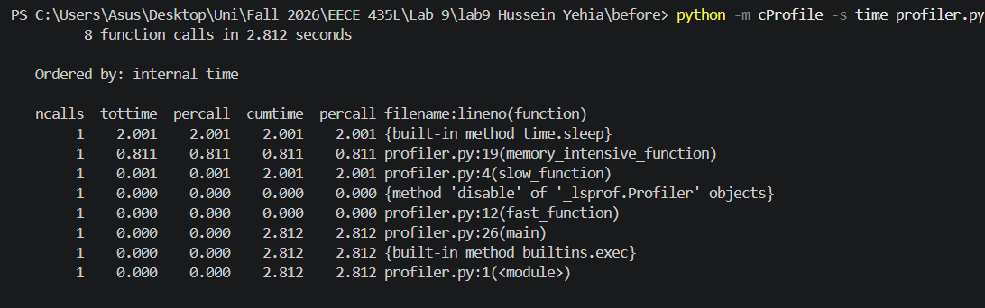
Figure 1. Baseline cProfile command and output in the before folder.
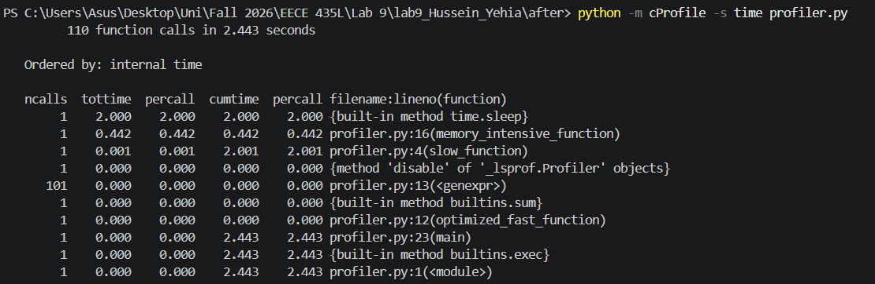
Figure 2. Optimized cProfile command and output in the after folder.

Analysis
Baseline execution took 2.812 s. time.sleep accounted for 2.001 s of internal time, and memory_intensive_function accounted for 0.811 s. slow_function had 2.001 s cumulative time because its sleep was a subcall. The fast function rounded to 0.000 s at the displayed precision.
Optimized execution took 2.443 s; sleep took 2.000 s and the unchanged large-loop function took 0.442 s. The apparent overall decrease was 0.369 s, or 13.1%. Almost the entire difference occurred in the unchanged large loop, so this single pair of runs does not establish a 13.1% benefit from optimizing the fast function.
Function calls increased from 8 to 110 because the optimized version introduced sum and generator resumptions. Both fast-function times still rounded to 0.000 s, so cProfile alone cannot resolve their small timing difference here. Internal time excludes subcalls; cumulative time includes them.

Line profiling before optimization
python profiler_lineprofiler.py
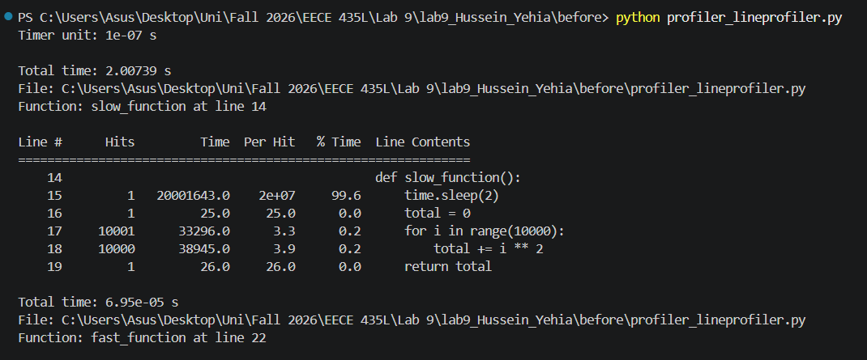
Figure 3. Baseline slow-function report and fast-function total time.
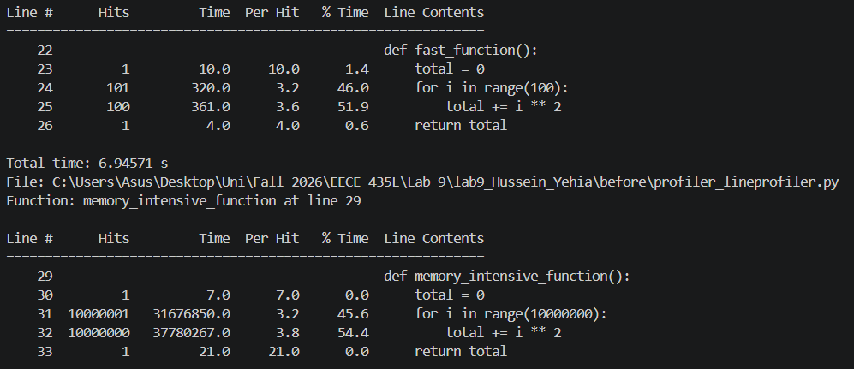
Figure 4. Baseline fast-function lines and large-loop report.

Analysis
The timer unit was 10^-7 s. slow_function totaled 2.00739 s, with 99.6% of its measured time on the sleep line. fast_function totaled 0.0000695 s, or 69.5 microseconds; its loop header and accumulation line accounted for 46.0% and 51.9% of measured time.
memory_intensive_function totaled 6.94571 s under line profiling. The loop header was hit 10,000,001 times and accumulation 10,000,000 times, accounting for 45.6% and 54.4% of time. Repeated line tracing adds overhead, so these times should not be compared directly with cProfile or ordinary execution times.

Line profiling after optimization
python profiler_lineprofiler.py
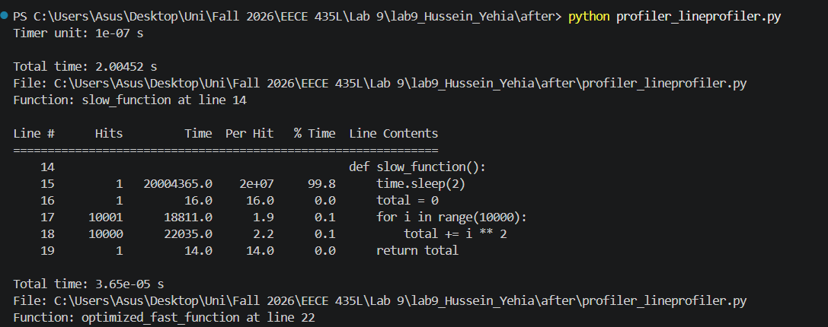
Figure 5. Optimized run with the slow-function report and optimized fast-function total.
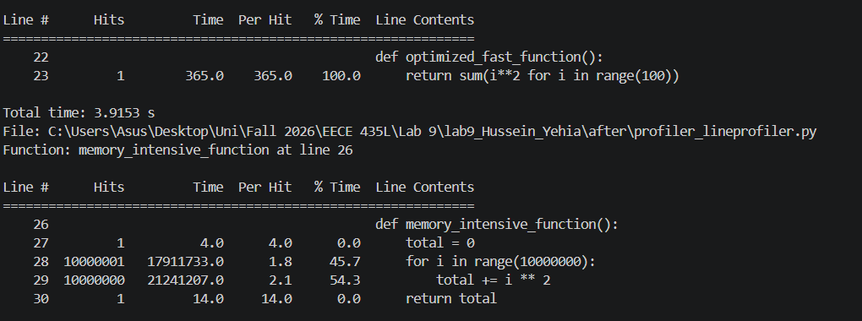
Figure 6. Optimized fast-function line and unchanged large-loop report.

Analysis
optimized_fast_function totaled 0.0000365 s, or 36.5 microseconds, compared with 69.5 microseconds before optimization. This is a measured reduction of about 47.5%, or a 1.90 times ratio, for these line-profiler observations. Its single return line accounts for all displayed function time. The change in traced source structure and single-run variability limit conclusions about ordinary execution speed.
slow_function remained near two seconds at 2.00452 s. The unchanged large-loop function measured 3.9153 s, with 45.7% on its loop header and 54.3% on accumulation. Its large variation from the baseline provides further reason to avoid attributing whole-program timing changes solely to the small fast-function edit.

Memory profiling before optimization
python -m memory_profiler profiler_memoryprofiler.py
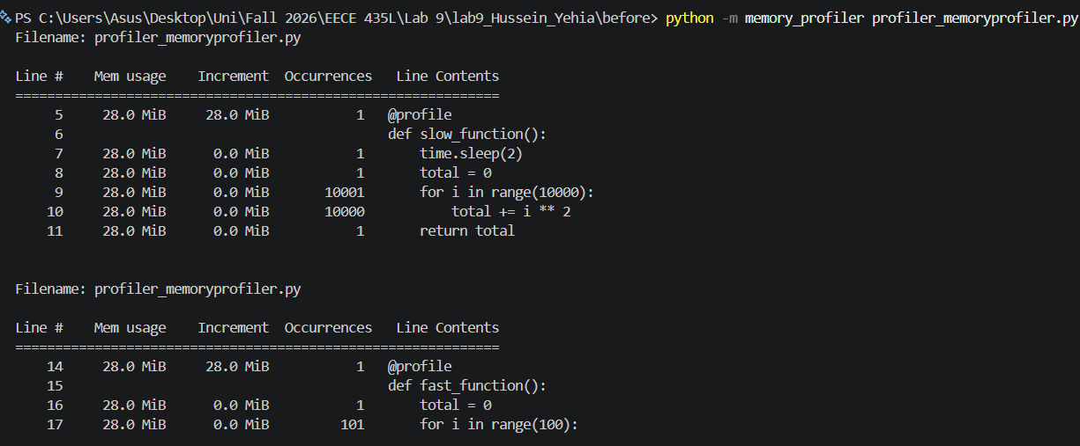
Figure 7. Baseline memory report for slow_function and the start of fast_function.
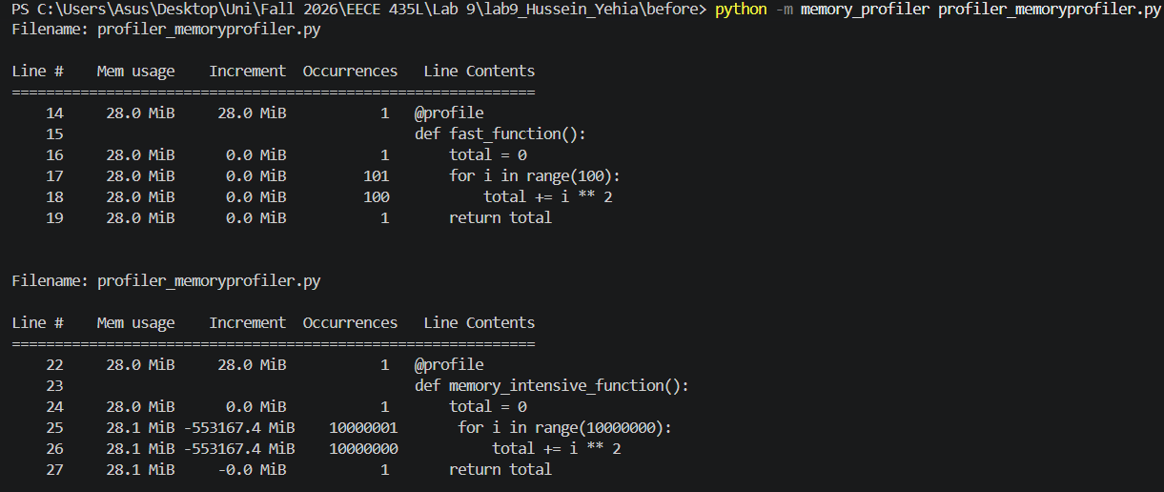
Figure 8. Baseline memory reports for fast_function and memory_intensive_function.

Analysis
The slow and fast functions reported about 28.0 MiB with 0.0 MiB body-line increments. The large-loop function reported about 28.0 to 28.1 MiB. Although the function performs many calculations, it does not retain ten million separate results, so the report shows little process-memory growth.
The repeated large-loop lines display increments of -553167.4 MiB. These are accumulated profiler statistics across millions of observations, not a literal release of that much memory. The installed profiler accumulates differences against stored line-memory values; repeated small differences can therefore produce a large negative total while the displayed memory remains near 28 MiB. These increments cannot support a claim of massive memory savings.

Memory profiling after optimization
python -m memory_profiler profiler_memoryprofiler.py
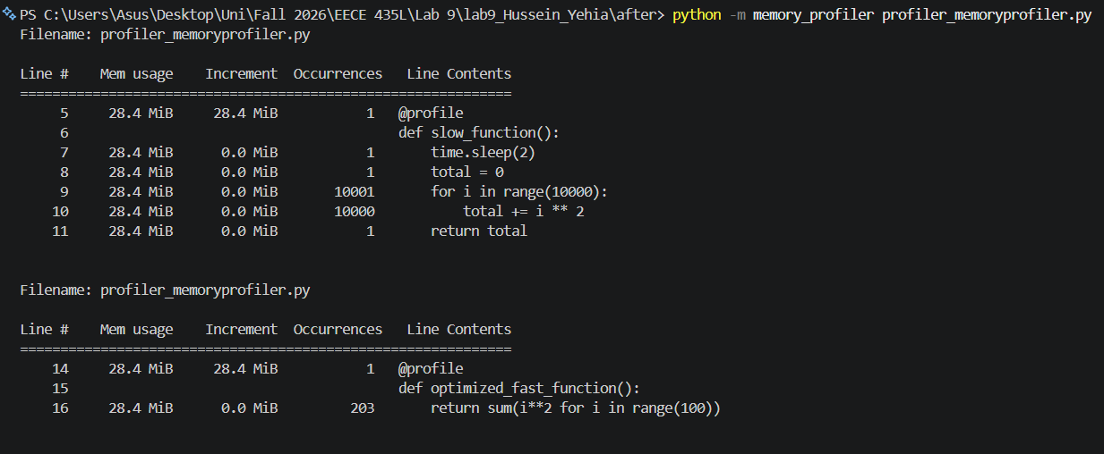
Figure 9. Optimized run showing slow_function and optimized_fast_function memory usage.
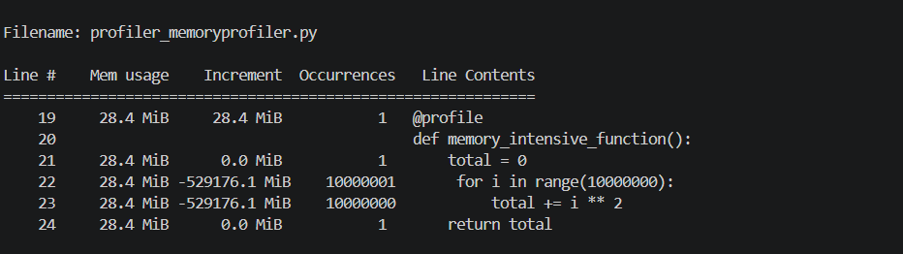
Figure 10. Optimized run showing the unchanged large-loop memory report.

Analysis
The optimized run reported about 28.4 MiB throughout the three functions. The optimized fast-function return line had a 0.0 MiB increment and 203 observations. The profiler can observe generator execution multiple times on the same source line; this count does not mean main called the function 203 times.
The baseline fast function was near 28.0 MiB and the optimized version near 28.4 MiB. Those are separate-process readings and do not demonstrate a memory improvement or a leak. Both implementations avoid constructing a list, and body-line increments showed no measurable retained allocation at the displayed precision.
The large loop again displayed a very large negative accumulated increment, -529176.1 MiB, while memory remained near 28.4 MiB. As in the baseline, this reporting artifact should not be interpreted as actual memory freed. Repeated memory checks also explain why this profiler ran much more slowly than the normal calculation.

Corrected tests before and after optimization
python -m coverage run -m unittest discover
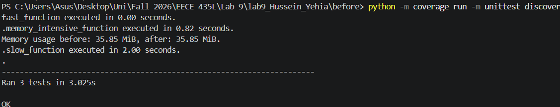
Figure 11. Baseline corrected test suite with three passing tests.
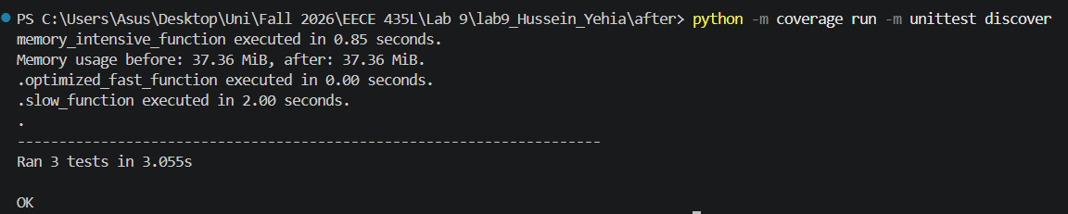
Figure 12. Optimized corrected test suite with three passing tests.
Measurement | Before | After
Tests | 3 passed | 3 passed
Suite elapsed time | 3.025 s | 3.055 s
Large-loop execution time | 0.82 s | 0.85 s
Memory before and after | 35.85 / 35.85 MiB | 37.36 / 37.36 MiB
Fast / slow printed time | 0.00 / 2.00 s | 0.00 / 2.00 s

Analysis
All three corrected tests passed before and after optimization. The large-loop calculation met the supplied five-second bound and returned the expected sum of squares. Equal memory readings in each run confirm why a strict memory-growth assertion was inappropriate.
The fast-function output rounds to hundredths of a second, which is too coarse to reveal its microsecond-scale change. Suite time increased by 0.030 s in the optimized run, so these tests provide no evidence of an overall runtime improvement. Timing-based assertions remain sensitive to system load and measurement overhead.

Coverage before optimization
python -m coverage report -m
python -m coverage html
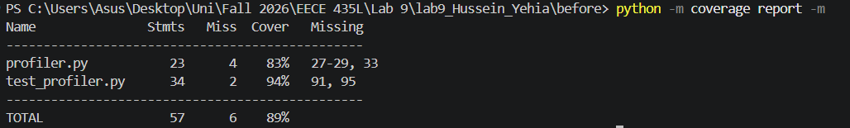
Figure 13. Baseline terminal coverage report with missing line numbers.
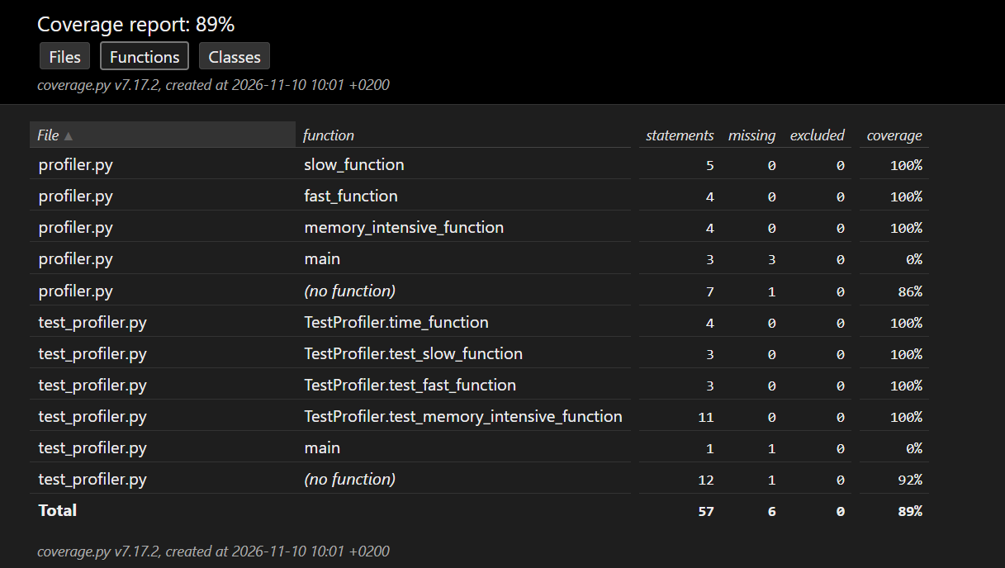
Figure 14. Baseline HTML function coverage report.

Analysis
profiler.py contained 23 statements with 4 missing, giving 83% displayed coverage. Missing lines 27 to 29 are the three calls inside main, and line 33 is the script-entry call. Tests imported the module and called individual functions directly, so those orchestration lines were not executed.
test_profiler.py had 34 statements with 2 missing and 94% coverage. Lines 91 and 95 are its unittest.main call and direct script-entry call, which discovery does not use. The HTML function view shows 100% statement coverage inside each computational function and 0% inside main.
Across both files, 51 of 57 statements were covered, displayed as 89%. The HTML report is stored at before/htmlcov/index.html with its supporting files. Statement coverage records executed lines; it does not prove that every result or edge case was asserted.

Coverage after optimization
python -m coverage report -m
python -m coverage html
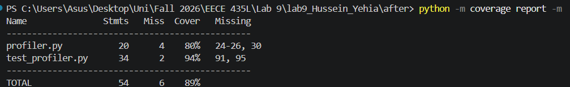
Figure 15. Optimized terminal coverage report with missing line numbers.
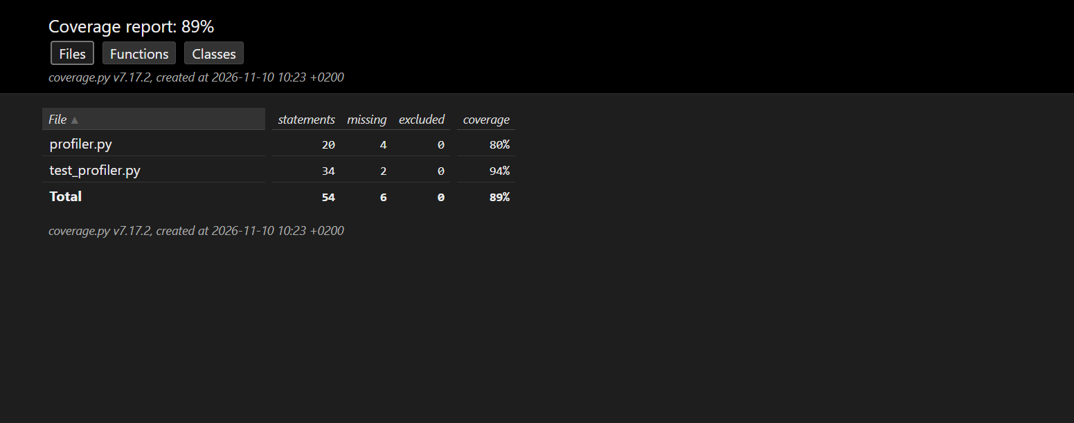
Figure 16. Optimized HTML coverage summary.
File | Before | After
profiler.py statements / missing | 23 / 4 | 20 / 4
profiler.py displayed coverage | 83% | 80%
test_profiler.py statements / missing | 34 / 2 | 34 / 2
test_profiler.py displayed coverage | 94% | 94%
Total covered / statements | 51 / 57 | 48 / 54
Total displayed coverage | 89% | 89%

Analysis
The optimized profiler.py has fewer statements because its four-statement fast-function body became one return statement. The same four orchestration statements remain uncovered, now at lines 24 to 26 and 30. Its coverage therefore changes from 19/23 to 16/20, displayed as 83% and 80%, without losing execution of a computational path.
The test file still misses lines 91 and 95. Total coverage changes from approximately 89.47% to 88.89%, but both round to 89% in the reports. The optimized HTML report is stored at after/htmlcov/index.html.

Comparison and conclusions
Recorded measure | Before | After
cProfile whole program | 2.812 s | 2.443 s
cProfile unchanged large loop | 0.811 s | 0.442 s
Line profiler fast function | 69.5 microseconds | 36.5 microseconds
Line profiler unchanged large loop | 6.94571 s | 3.9153 s
Fast-function memory body increment | 0.0 MiB | 0.0 MiB
Corrected tests | 3 passed | 3 passed
Total displayed statement coverage | 89% | 89%

The manual's generator-expression change shortened the fast-function implementation and reduced its measured line-profiler time in the captured runs. cProfile rounded both fast-function measurements to zero, and the tests rounded both to 0.00 s. Repeated measurements at higher precision would be needed to establish a reliable ordinary-execution speedup.
The largest visible whole-program timing change occurred in memory_intensive_function even though its implementation was unchanged. The sleep remained near two seconds, and the tests showed a slightly longer suite time after optimization. These observations limit any claim that the fast-function edit caused the full cProfile decrease.
Memory profiling showed no demonstrated memory reduction. Both fast-function implementations accumulate results without storing a list. The very large negative increments on repeated loop lines are accumulated reporting artifacts, while actual displayed memory stayed near 28 MiB. The corrected result assertion makes the memory test meaningful without requiring a process-memory increase.
Coverage retained the same six missing statements across the two measured files. The lower profiler.py percentage follows from reducing its statement count while leaving main untested. A future test that calls main could exercise the remaining orchestration lines; it was not added in this experiment.

Files and references
Baseline files: before/profiler.py, before/profiler_lineprofiler.py, before/profiler_memoryprofiler.py, and before/test_profiler.py. Optimized equivalents are in after. Coverage HTML and supporting assets are retained in each version's htmlcov folder. Figures 1 to 16 reproduce the saved terminal and browser screenshots.
Lab reference: Lab9 Profiling, Faculty of Engineering and Architecture, Software Tools Lab, Fall 2026 to 2027, Parts 1 to 6 and submission guidelines.
Repository: https://github.com/HusseinYehia24/Lab-9_435L

