

REGOSS  
E government website  
Senior Project  
By

**Hussein Raad**

Submitted to the School of Arts & Science of the

Lebanese International University

In part of fulfillment of the requirements for the degree of

**BACHERLOR OF SCIENCE IN**

**COMPUTER SCIENCE AND INFORMATION TECHNOLOGY**

**Supervised by: Dr. Nehme Rmeity**

Spring 2023-2024

# Abstract:

This project aims to revolutionize the process of accessing government services by creating a centralized platform that streamlines application procedures for users, particularly immigrants, and enhances communication between clients and service providers. The platform offers a wide range of services, from employment support to financial assistance, all accessible through an intuitive user interface. Users can easily apply for services, track their applications, and receive real-time support from specialized employees via chat. Additionally, the system provides comprehensive management tools for administrators, enabling efficient oversight of applications, employee management, and client communication. Through innovative features like real-time chat and automated document processing, this project seeks to improve accessibility, efficiency, and user experience in accessing essential government services.

Acknowledgment:  
I extend my sincere gratitude to Professor Nehme Rmeity for his invaluable guidance, unwavering support, and mentorship throughout the duration of this project. His expertise, encouragement, and dedication have been instrumental in shaping our ideas and steering us towards success. I am truly grateful for his constant supervision and provision of essential information, which have been crucial in the development and execution of our project.

Dedication:  
First and foremost, we give thanks to God for granting us the strength, opportunity, and knowledge to navigate our everyday lives.

To our beloved parents and friends, who have always supported us in our studies and work, and for helping us realize our potential.

Lastly, to our esteemed professor Nehme Rmeity, for guiding us step by step toward our goals and helping us overcome every obstacle during our project and throughout our journey of study.

Table of Contents

Chapter 1 3

Introduction 3

Problem: 3

Solution: 4

Aim of The Project: 4

The Benefit: 5

The Inputs 5

Technology Constraints 6

Chapter 2 7

Website Functionality 7

Use Case Diagrams and Scenarios 8

Use Case Diagram 8

Use case scenarios (narrative): 13

Chapter 3: Data Structure and Relationships 20

Entity relationship diagram (ERD): 20

Tables Mapping 22

Chapter 4 23

1. Non-logged User Home Page Overview 23

2. Login-Sign page 27

27

3. Client Home Page 28

4. Manager Dashboard 37

Figure 1/Client Use-case diagram 9

Figure 2/Non-register User Use-case diagram 10

Figure 3/Employee Use-case diagram 11

Figure 4/Manager Use-case diagram 12

Figure 5/Entity relationship diagram (ERD) 21

Figure 6/Tables Mapping 22

Figure ‑7/Home Page-1 23

Figure ‑8/our value 23

Figure 9/what we provide 24

Figure 10/service boxes 24

Figure 11/our team 25

Figure 12/footer 26

Figure 13/login 27

Figure 14/signup 27

Figure 15/ClientHomePage (ajax) 28

Figure 16/ClientHomePage Bildung 29

Figure 17/Chat with employee list 29

Figure 18/chatpanel 30

Figure 19/Client dashboard 32

Figure 20/Client personal Info-display/edit 32

Figure 21/Client address-display/edit 33

Figure 22/Client contact info-display/edit 33

Figure 23/Client changing password 34

Figure 24/Client deleting account 34

Figure 25/Client editing info enabled 35

Figure 26/Application form 36

Figure 27/Application form-2 36

Figure 28/displayin power of Attorney 36

Figure 29/ manager dashboard 37

Figure 30/ applications managin/Employee side 38

Figure 31/employee management-Manager 38

Figure 32/client chat-employee side 39

Table 1/Manage Application scenario 13

Table 2/Manage Employee scenario 14

Table 3/View Statistics scenario 15

Table 4/Chat support(Employee Side) 16

Table 5/Chat Support (Client Side) 17

Table 6/ Manage Account(Client) 18

# Chapter 1

In this chapter, we will outline the problem we have identified and how our project addresses it. We will also detail the aim of the project, the benefits it provides, the inputs required, and the expected results. Additionally, we will discuss the technology constraints and our objectives, followed by a detailed explanation of each element.

## Introduction

In today's increasingly interconnected world, access to government services plays a pivotal role in ensuring equal opportunities and support for all individuals, including immigrants seeking to integrate into a new society. However, navigating the intricacies of government bureaucracy can often be a daunting and cumbersome task, leading to inefficiencies, delays, and even rejections in the application process.

Recognizing these challenges, our project seeks to revolutionize the way individuals access government services by introducing a centralized platform that consolidates a myriad of services under one user-friendly interface. By addressing fragmentation and streamlining processes, our platform aims to not only simplify access but also enhance the overall experience for users, particularly immigrants facing unique barriers.

## Problem:

**High Application Rejection Rate at Job Centers:** Approximately 50% of applications submitted to “job centers” and other government entities are declined due to lack of information or incorrect information provided by applicants, often stemming from a lack of understanding of the application requirements and procedures.

**Delayed Application Processing Time at Job Centers:** Applications submitted directly to job centers take longer to be reviewed compared to those submitted through specialized companies or agencies, leading to delays in accessing employment support services and opportunities.

**Financial Uncertainty:** Immigrants often lack knowledge about financial matters specific to the host country, such as tax obligations and financial assistance programs.

**Complexity of Documentation:** Immigrants may struggle to gather and understand the required documentation for various government service applications due to differences in documentation requirements between countries and lack of familiarity with local procedures.

**These services provided by the state are not centralized on one platform or online business; instead, they are distributed across multiple institutions. This decentralized nature complicates the process for users seeking these services, as they must navigate through various institutions to access the services they need.**

## Solution:

**High Application Rejection Rate at Job Centers:** The website guarantees that applications submitted through our platform will be accepted. We ensure that all required documents are submitted accurately and completely, eliminating any data loss or omissions. This approach minimizes the chances of rejection and ensures a smooth application process for our users.

**Delayed Application Processing Time at Job Centers:** we propose giving priority to applications submitted by private companies. This is because these applications are thoroughly reviewed and free from errors, allowing job centers to process them more quickly and efficiently compared to individual submissions.

**Financial Uncertainty:** Our website will offer detailed information about the services available to customers, with a special focus on immigrants. This includes comprehensive descriptions of benefits and assistance programs. Additionally, users will have the option to chat directly with specialists on the website to address any questions or concerns related to the chosen service.

**Complexity of Documentation:** To simplify documentation complexity, our system will offer a user-friendly interface for customers to understand requirements easily. They can submit information through this interface without navigating complex processes. Additionally, we will oversee the entire application process, from initial contact with relevant parties to successful completion.

**create a centralized platform that consolidates all government services, simplifying access for users by eliminating the need to navigate multiple institutions.**

## Aim of The Project:

The aim of this project is to address the fragmentation of the services by collecting all these services onto one centralized platform for easier access and convenience for users, and address key challenges faced by applicants seeking government services, particularly immigrants, by streamlining the application process and improving accessibility to support services. To mitigate the high application rejection rate at job centers, our platform guarantees acceptance of applications by ensuring all required documents are accurately and completely submitted, thus reducing the likelihood of rejection. Additionally, we propose prioritizing applications submitted by private companies to expedite processing times, as these undergo thorough review and are free from errors. Our website will provide comprehensive information about available services, with a focus on addressing financial uncertainty for immigrants, including detailed descriptions of benefits and assistance programs, and offering direct chat support with specialists for personalized guidance. To simplify the documentation process, our user-friendly interface allows customers to easily understand requirements and submit information without navigating complex processes, while we oversee the entire application process from initiation to successful completion, ensuring a seamless experience for users.

## The Benefit:

* Improved Access to Government Services by streamlining the application process and providing comprehensive information, the project enhances accessibility to government services for immigrants and applicants.
* Reduced Application Rejection Rates guaranteeing acceptance of applications through the platform helps minimize rejection rates caused by lack of information or incorrect submissions, ensuring a higher success rate for applicants.
* Faster Processing Times by prioritizing applications submitted by private companies expedites processing times, enabling quicker access to employment support services and opportunities for applicants.
* Empowered Decision-Makingby providing detailed information and direct chat support with specialists empowers users, particularly immigrants, to make informed decisions about financial matters and navigate the host country's landscape with confidence.
* The user-friendly interface simplifies the documentation process, reducing complexity and facilitating smoother application experiences for users.
* Direct communication with specialized employees via chat allows users to receive tailored assistance and guidance, enhancing their experience and ensuring their specific needs are addressed effectively.
* The appropriate benefit of centralizing government services onto one platform is improved accessibility and convenience for users. This streamlines the process, saves time, and enhances overall user experience, leading to better communication and coordination between government entities.

## The Inputs

* Signup Information: Users provide their name, email, and password to create an account on the website.
* Payment Information: Users may need to input payment information, such as credit card details, for any applicable fees or services provided through the website.
* FAQs and Help Center: Users can interact with specialists and support staff in real-time through the website's chat feature, where they can ask questions, seek guidance, and communicate any messages related to the services provided.
* Search: Users have the ability to search for specific information or services within the website, such as finding employees or locating a particular service offered.
* Document Upload: Users may be required to upload documents as part of the application process, such as identification documents, proof of address, or relevant certificates.

Application Requirements: Each service type on the website will have specific requirements. Users will provide common inputs such as identification information, location, marital status, financial status, postal code, etc. When a user selects a service type, the system will match it with the corresponding requirements. If the user does not meet certain requirements, the system will provide guidance on how to fulfill them. This may include directing the user to apply for additional documents or information if necessary.

## Technology Constraints

* A web server software(Microsoft edge)
* A database server software(Mysql)
* A programming language (PHP, JS)
* Web development Programming (HTML, CSS, SQL).
* Frameworks & libraries: ajax, bootstrap, composer, php pdftk,
* PDFtk server
* Hardware: laptop.

# Chapter 2

This chapter describes how the website operates, detailing its features and functionalities. It also includes use case diagrams and scenarios (narratives) to illustrate the user interactions and processes.

## Website Functionality

User Interface:

1. Homepage

* **Header**: Provides navigation links to different sections of the page, including login, about the company, team details, provided services, and contact information.
* **Login Button**: Allows users to log in or sign up.
* **General Information**: Brief introduction about the company.
* **Team Details**: Information about the team members and their contact details.
* **Provided Services**: Detailed descriptions of the services offered by the platform.
* **Contact Information**: Company contact details displayed at the bottom of the page.

1. Login and Account Creation

* Users can log in using their email. If they don’t have an account, they can sign up by providing their email address and receiving a verification code.
* Post-login, users can:
  + View and edit their account information.
  + Access details of their applications and services they have applied for.
  + Track the status of their applications and see pending services with estimated completion times.

1. Service Selection and Application

* Users can choose from three general service categories, each containing multiple specific services.
* Upon selecting a service, the system displays the specific requirements.
* If a user lacks a required document, they can indicate this, and the system will prompt them to provide additional information to obtain the missing document.

1. Application Submission

* Users fill out the application form and submit it, marking their application as pending.
* To proceed, users must pay the required fee and contacting with the company, to mark the application as paid.
* If users encounter any issues during form submission, they can use the live chat feature to communicate with the employee responsible for that service.
* After acceptance by a specialized employee, the system automatically generate a pdf form and save it to database, to be forwarded by the employee to the corresponding governmental entity.

Employee Interface:

1. Login and Account Information

* Employees use the same login page as customers but cannot sign up.
* Upon login, employees can view their account information, including their position, location, service field, email, and phone number.

1. Client Communication

* Employees can view and initiate chats with clients directly from their accounts.

1. Application Management

* Employees access and manage applications submitted by customers within their field and position.
* They can filter applications by submission time, view application details, check statuses, and download selected applications.

1. Forwarding Applications

* Employees can grant permission to forward applications to the corresponding governmental entity if needed.

1. User Management

* Employees have the capability to add new users to the system.

1. CEO Functionality

* The CEO can track employee status (online or offline), add employees, assign roles, and view all applications across different fields.
* The CEO can access statistics related to applications and perform various administrative tasks.

## Use Case Diagrams and Scenarios

### Use Case Diagram

The use case diagrams below illustrates the primary interactions between users and the system, including both customer and employee interactions.

Figure 1/Client Use-case diagram

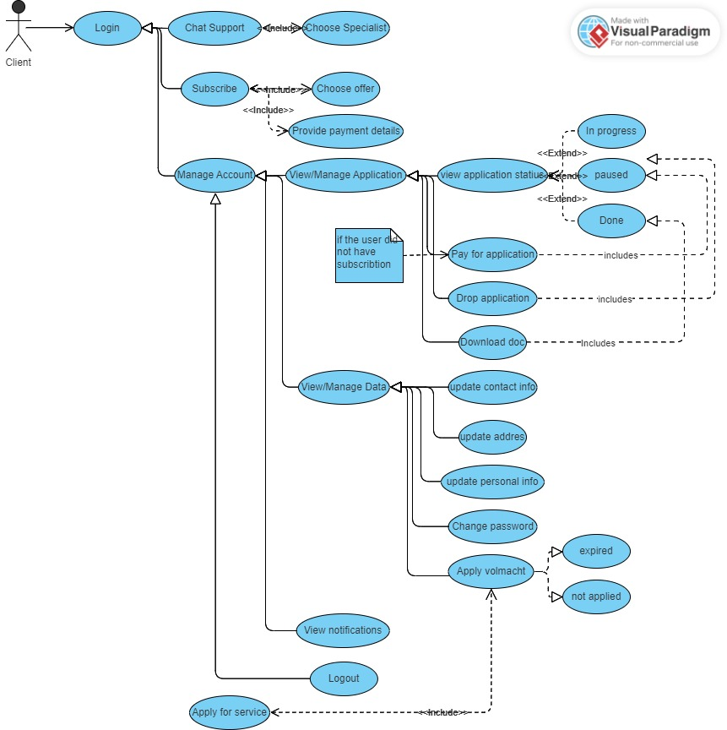

Figure 2/Non-register User Use-case diagram

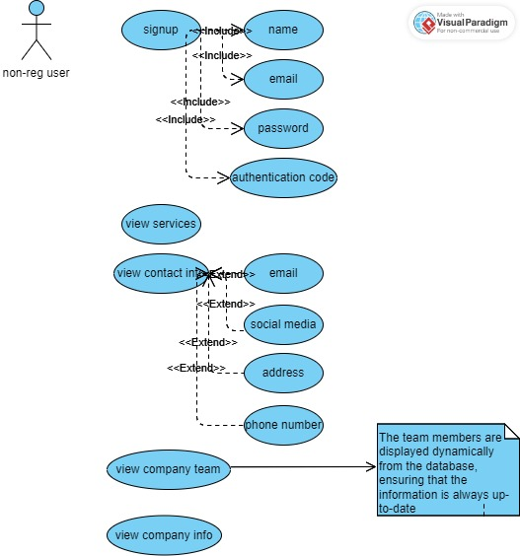

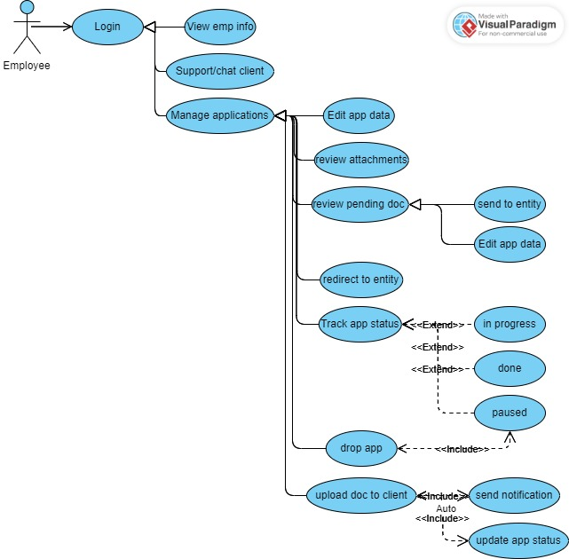

Figure 3/Employee Use-case diagram

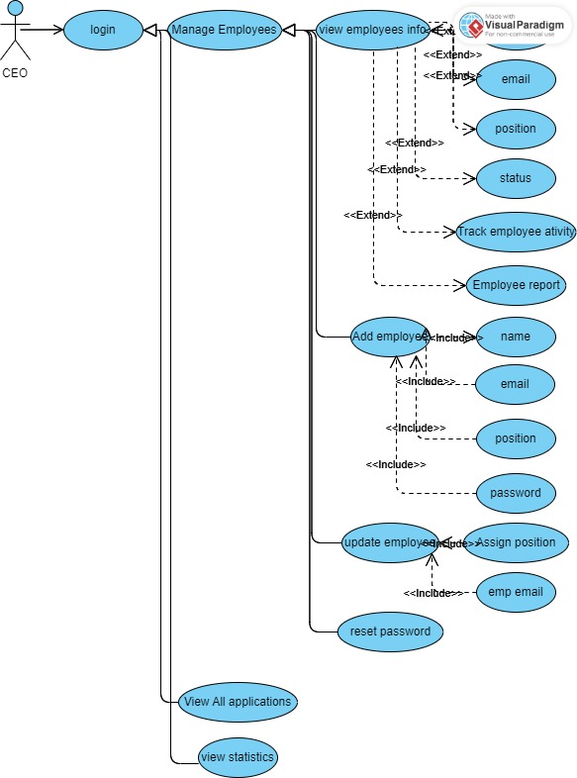

Figure 4/Manager Use-case diagram

### Use case scenarios (narrative):

Table 1/Manage Application scenario

|  |  |
| --- | --- |
| **Use-case Name:** | Manage Applications |
| **Actor:** | Employee (CEO) |
| **Description:** | The "Manage Applications" use case involves the CEO overseeing the application process within the system. It includes reviewing, verifying, and submitting applications, managing associated documents, and facilitating communication between clients and relevant authorities. |
| **Pre-condition:** | The employee must be logged in using their unique email and password. |
| **Basic Flow:** | 1. The CEO navigates to the application management section to view all applications. 2. The CEO selects a specific application from the list to review and check if it is complete. 3. If the application is complete and correct:  * The CEO opens a PDF form containing attached files and enables editing. * The CEO verifies the application details and attached documents. * If satisfied, the CEO enters the email address of the specific entity to send the application by email, including attached files. * After the government service is completed, the corresponding entity sends an email to the CEO with the necessary document. * The CEO uploads this document to the client application  1. If the application depends on a document that the client doesn't have but has applied for through the website:  * The CEO reviews the document and redirects it to the specific government entity. * Upon receiving a response from the government entity via email, the CEO edits the entire document and uploads the file. * After completing the main application, the CEO sends it to the specific entity by entering their email address, along with all attached documents and requirements. * After the government service is completed, the corresponding entity sends an email to the CEO with the necessary document. * The CEO uploads this document to the client. |
| **Post-condition:** | 1. The client receives a notification prompting them to check their account. 2. The application status is updated in the system to reflect changes made by the CEO. It can be categorized as "in progress," indicating that the application is under review by the government entity. Once the process is complete and successful, the status changes to "done," allowing the client to download the acceptance. Alternatively, if the client fails to pay for the service, the status may be marked as "paused. |

Table 2/Manage Employee scenario

|  |  |
| --- | --- |
| **Use-case Name:** | Manage Employees |
| **Actor:** | Employee (CEO) |
| **Description:** | This use case outlines how the CEO oversees employee information in the system, facilitating various actions such as viewing employee details, adding new employees, updating employee positions, resetting passwords, and monitoring employee activity. |
| **Pre-condition:** | * The CEO must be logged into the system. * Access to the employee management section is available to the CEO. |
| **Basic Flow:** | 1. View Employee Information:  * The CEO navigates to the employee management section. * A comprehensive list of employees, encompassing their details like name, email, position, and status, is displayed. * The CEO can select individual employees to view additional details and track their activities within the system.  1. Add New Employee:  * The CEO initiates the process to add a new employee. * Required information such as name, email, position, and password is entered. * Optional personal details like date of birth, address, and contact information may also be provided. * Upon submission, the new employee is added to the system.  1. Update Employee Position:  * The CEO selects an employee whose position needs to be updated. * The CEO modifies the employee's position information as required. * Changes are saved, and the employee's position is updated in the system.  1. Reset Employee Password:  * The CEO selects an employee who needs their password reset. * A password reset option is triggered for the selected employee. * The CEO sets a new password for the employee within the system. |
| **Post-condition:** | 1. Upon adding a new employee, the employee's details are visible on the main page for both non-logged-in users and clients, allowing easy access to employee information. 2. Upon changing the password, the employee's password is updated within the system, and they receive a notification regarding the change. 3. The employee's new position is updated and visible in their dashboard, ensuring they are aware of their updated role within the organization. |

Table 3/View Statistics scenario

|  |  |
| --- | --- |
| **Use-case Name:** | View Statistics |
| **Actor:** | Employee (CEO) |
| **Description:** | This use case describes how the CEO views statistical data related to the company's operations and performance. |
| **Pre-condition:** | * The CEO must be logged into the system. * The CEO has appropriate permissions to access statistical data. |
| **Basic Flow:** | 1. The CEO navigates to the statistics section of the system. 2. The system presents various statistical metrics and performance indicators, such as application submission rates, processing times, employee productivity, and service utilization. 3. The CEO selects specific metrics or time periods to view detailed statistics. 4. The system generates and displays the requested statistical data in graphical or tabular format. 5. The CEO analyzes the presented statistics to gain insights into the company's performance and identify areas for improvement. |
| **Post-condition:** | The CEO gains valuable insights into the company's operations and performance based on the viewed statistics. |

Table 4/Chat support(Employee Side)

|  |  |
| --- | --- |
| **Use-case Name:** | Chat Support (Employee Side) |
| **Actor:** | Employee |
| **Description:** | This use case outlines how employees engage in chat sessions with clients to provide support or assistance.. |
| **Pre-condition:** | * The employee must be logged into their account. * The employee is listed as available for chat in the system. |
| **Basic Flow:** | 1. The employee navigates to the chat support section from their designated area. 2. The system displays a list of active chat conversations, including both ongoing and new chats. 3. The employee selects a specific chat conversation from the list or starts a new chat with a client. 4. If starting a new chat, the employee enters the client's name or selects them from a list of available clients. 5. The employee views the client's message in the chat interface and can respond accordingly. 6. If the client is online and available, the employee's response is sent instantly and a real-time chat session ensues. 7. If the client is offline, the employee's response is saved to the database, and the client will receive it upon their next login. 8. The employee continues the chat session, exchanging messages and providing assistance as needed. |
| **Post-condition:** | The CEO gains valuable insights into the company's operations and performance based on the viewed statistics. |

Table 5/Chat Support (Client Side)

|  |  |
| --- | --- |
| **Use-case Name:** | Chat Support (Client Side) |
| **Actor:** | Client |
| **Description:** | This use case outlines how clients initiate and engage in chat sessions with company employees for support or assistance. |
| **Pre-condition:** | The client must be logged into their account. |
| **Basic Flow:** | 1. The client navigates to the chat support section from their dashboard or designated area. 2. The system opens a dashboard displaying all company employees along with their roles. 3. The client selects a specific employee to chat with by clicking on their name or role. 4. The system prompts the client to start a new chat session with the selected employee. 5. The client enters their message in the chat interface and sends it to the employee. 6. If the employee is online and available, they receive the message instantly and can respond in real-time. 7. If the employee is offline, the system saves the message to the database and notifies the employee upon their next login. 8. The employee receives a notification indicating the new message when they log in to their account. |
| **Post-condition:** | The chat history is saved to the database, allowing both parties to access and review past conversations at any time. |

Table 6/ Manage Account(Client)

|  |  |
| --- | --- |
| **Use-case Name:** | Manage Account |
| **Actor:** | Client |
| **Description:** | This use case describes how clients manage their accounts on the platform, including viewing and updating personal information, managing applications, accessing notifications, and logging out. |
| **Pre-condition:** | The client must be logged into their account. |
| **Basic Flow:** | 1. The client navigates to the account management section from their   designated area.   1. The system displays options for managing the client's account, including viewing and updating personal information, managing applications, accessing notifications, and logging out. 2. The client selects a specific option from the menu to proceed with the desired action. 3. If the client chooses to view or update personal information:  * The system displays the client's current information, such as contact details, address, and password. * The client can edit or update their personal information as needed. * After making changes, the client confirms the updates, and the system saves the changes to the database.  1. If the client chooses to manage applications:  * The system displays a list of applications submitted by the client, along with their current status (e.g., in progress, paused, done). * The client can view detailed information about each application, including any pending actions required (e.g., payment, document submission). * The client can take appropriate actions, such as paying for pending applications, submitting required documents, or downloading completed documents.  1. If the client chooses to access notifications:  * The system displays a list of notifications related to the client's account activity, such as application updates, messages from support staff, or reminders. * . The client can view the details of each notification and take necessary actions if required.  1. f the client chooses to log out:  * The system logs the client out of their account and redirects them to the login page. |
| **Post-condition:** | Any changes made to the client's account information are saved to the database for future reference. |

# Chapter 3: Data Structure and Relationships

This chapter provides a detailed explanation of the data structure and relationships within the system. It includes an Entity Relationship Diagram (ERD) and table mappings to illustrate how data is organized and interconnected.

## Entity relationship diagram (ERD):

The Entity Relationship Diagram (ERD) visually represents the data entities, their attributes, and the relationships between them. It provides a blueprint for understanding the database structure and how different entities interact within the system.

1. Users

* Attributes: userID, username, email, password, date_registered
* Relationships: One-to-Many relationship with Applications, One-to-One relationship with Personal Information, One-to-Many relationship with Addresses

1. Applications

* Attributes: appID, applicationPath, vollmachtPath, serviceName, uploadPath, clientID, status, paid, submissionDate
* Relationships: Many-to-One relationship with Clients

1. Chat

* Attributes: msg_id, incoming_msg_id, outgoing_msg_id, msg, timestamp
* Relationships: Many-to-One relationship with Users

1. Client

* Attributes: clientID, FN, LN, email, password, status, country, state, district, street, houseNumber, postalCode, DOB, gender, nationality, maritalState, phoneNumber
* Relationships: One-to-Many relationship with Applications

1. Employees

* Attributes: employeeID, FN, LN, email, password, position, picLoc, status, lastLogin, lastLogout
* Relationships: One-to-one relationship with Addresses, One-to-One relationship with Personal Information

1. Personal Information

* Attributes: personalInfoID, userID, DOB, gender, nationality, phoneNumber
* Relationships: One-to-One relationship with Employees

1. Address Table

* Attributes: AddressID, userID, country, state, district, street, houseNumber, postalCode

## Tables Mapping

The table mappings provide a detailed breakdown of each database table, including its fields, data types, and descriptions. This information aids in understanding how data is stored and retrieved within the database.

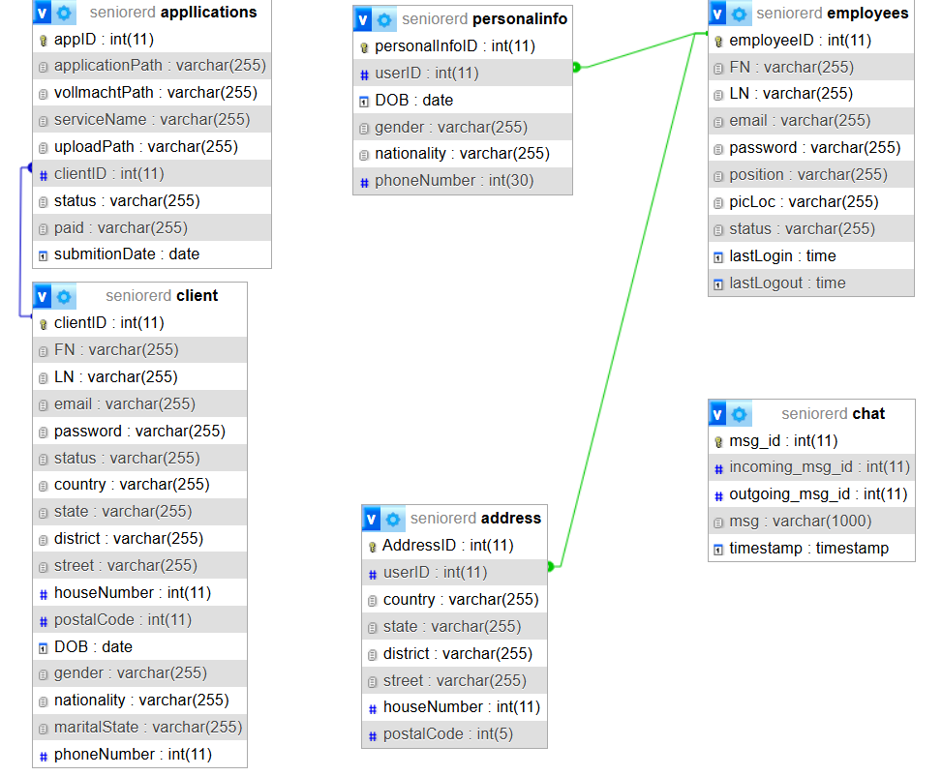

Figure 6/Tables Mapping

# Chapter 4

In this chapter, we present an overview of our website's design and functionality. Each page and button's main role is outlined to provide a comprehensive understanding of how users interact with the platform.

## Non-logged User Home Page Overview

* 1. **Overview Introduction:** The homepage begins with a brief introduction to our websiteThis introduction gives users an immediate understanding of how our platform can assist them. The header contains navigation tags that allow users to quickly access different sections of the page:

Figure ‑7/Home Page-1

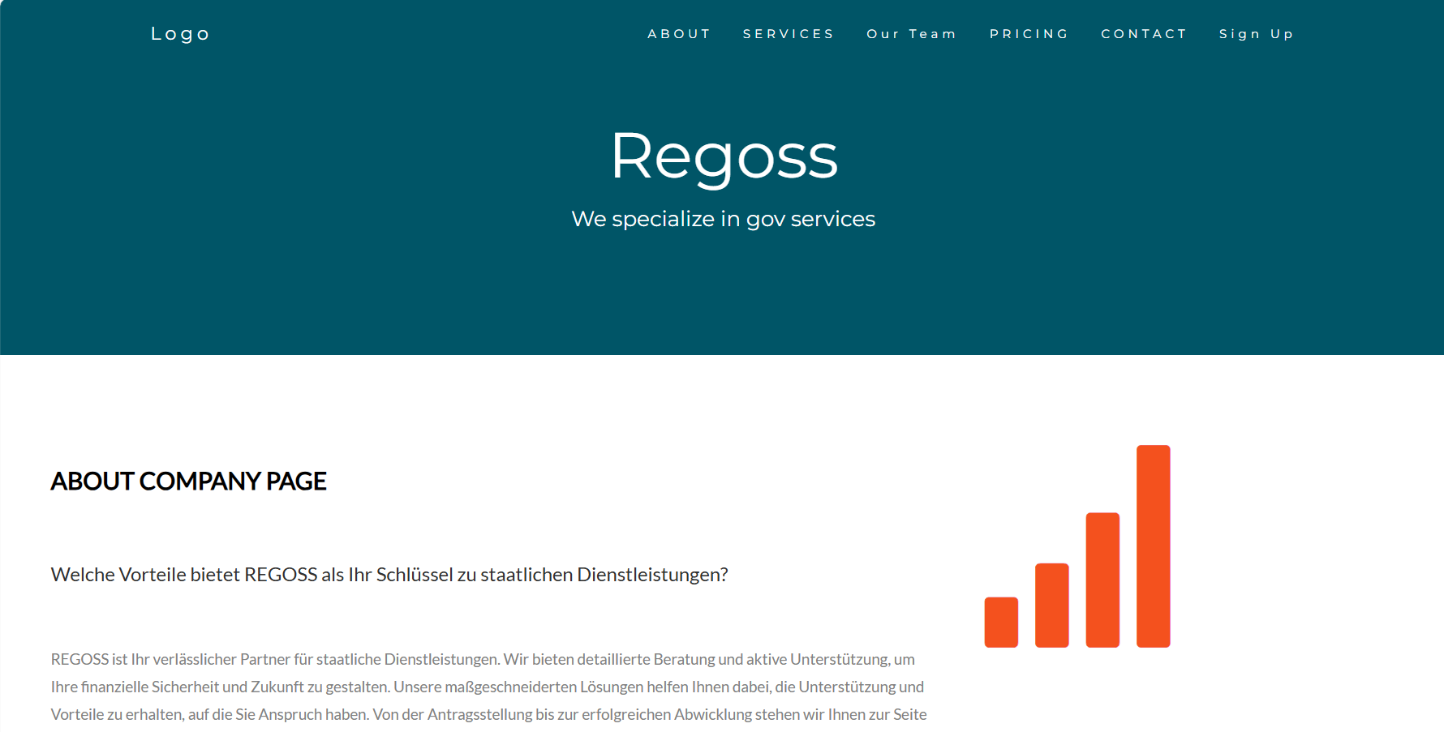

* 1. The homepage of our website prominently features our core values, encapsulated in our mission and vision statements.

Figure ‑8/our value

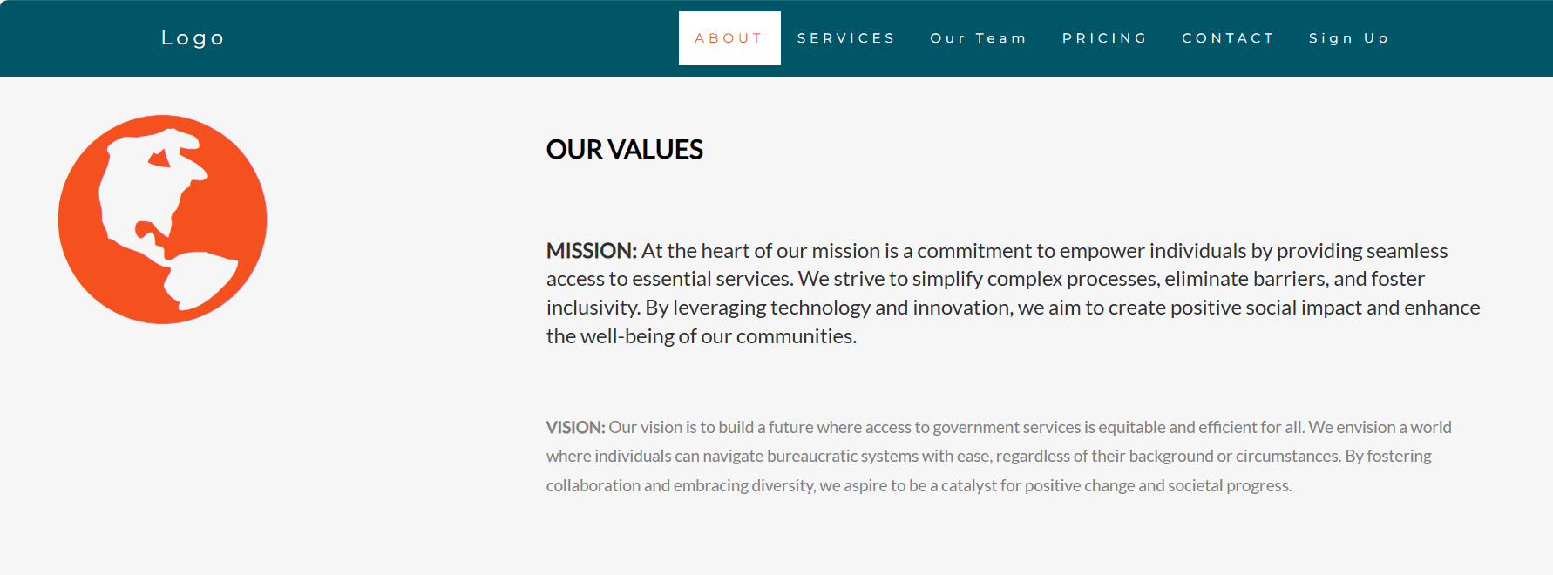

* 1. What we provide

Figure 9/what we provide

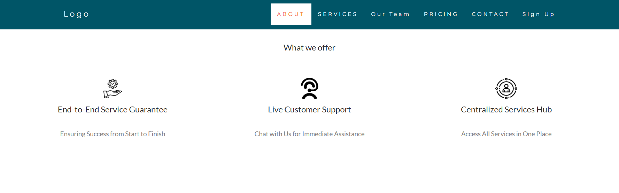

* 1. Our platform offers a range of services grouped into three main categories, each designed to address specific needs and streamline processes for our users.

Figure 10/service boxes

* 1. Meet Our Team: information about each team member, including their photo, name, position, and contact details. When clicking on contact it navigate the user to login page to be able to contact with the selected employee after logging. Info in the team boxes are dynamically displayed from the data base so that when new employee is added it will be displayed to user

Figure 11/our team

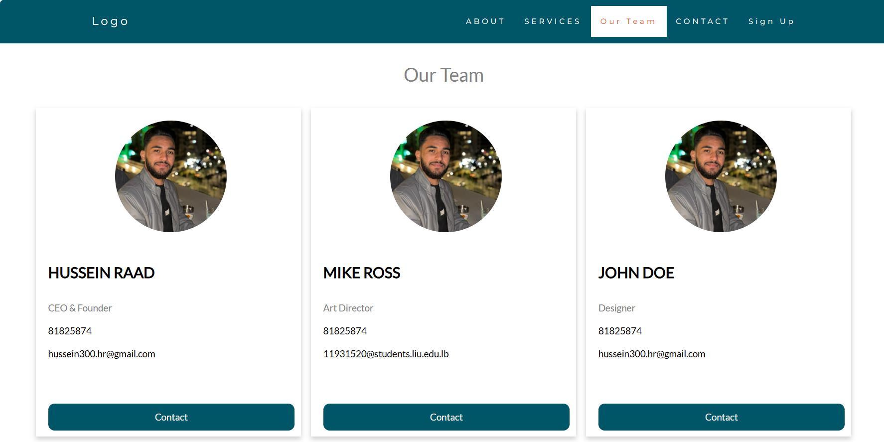

* 1. Our footer section provides essential contact information, including our email address and phone number, as well as our company's physical locations. Users can also connect with us through various social media platforms. Additionally user can add comment , or question to be viewed by the employee.

Figure 12/footer

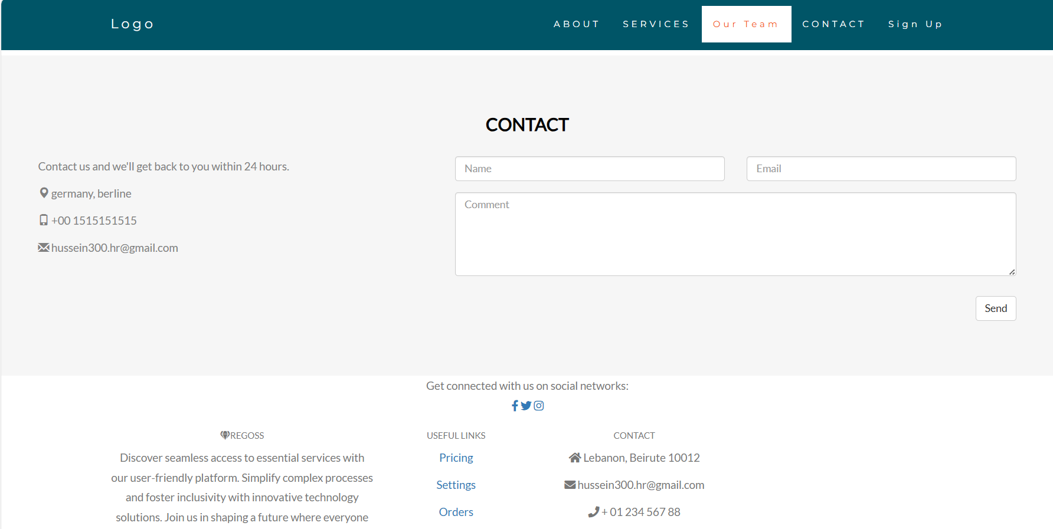

## Login-Sign page

when users interact with the "Sign Up" button depicted in Figure ‑7/Home Page-1 ,it triggers a navigation sequence to redirect them to the login or signup page.

Figure 13/login

## 

Figure 14/signup

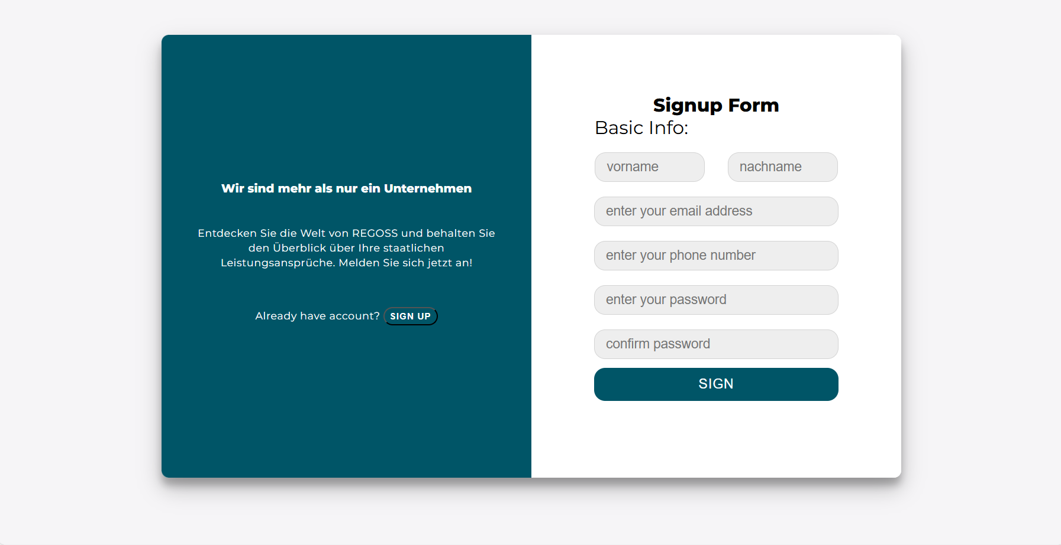

## Client Home Page

* 1. More Services info at client home page: Following the login process, our system performs a user role check to distinguish between clients and employees. Upon verification, clients are directed to a tailored home page, enhancing their experience with additional features. This customized home page mirrors the standard user interface, with the inclusion of a "My Profile" option in the header for easy access to personal information and settings. Furthermore, clients gain access to expanded service details, including pricing information, empowering them to make informed decisions about their interactions with our platform.

Figure 15/ClientHomePage (ajax)

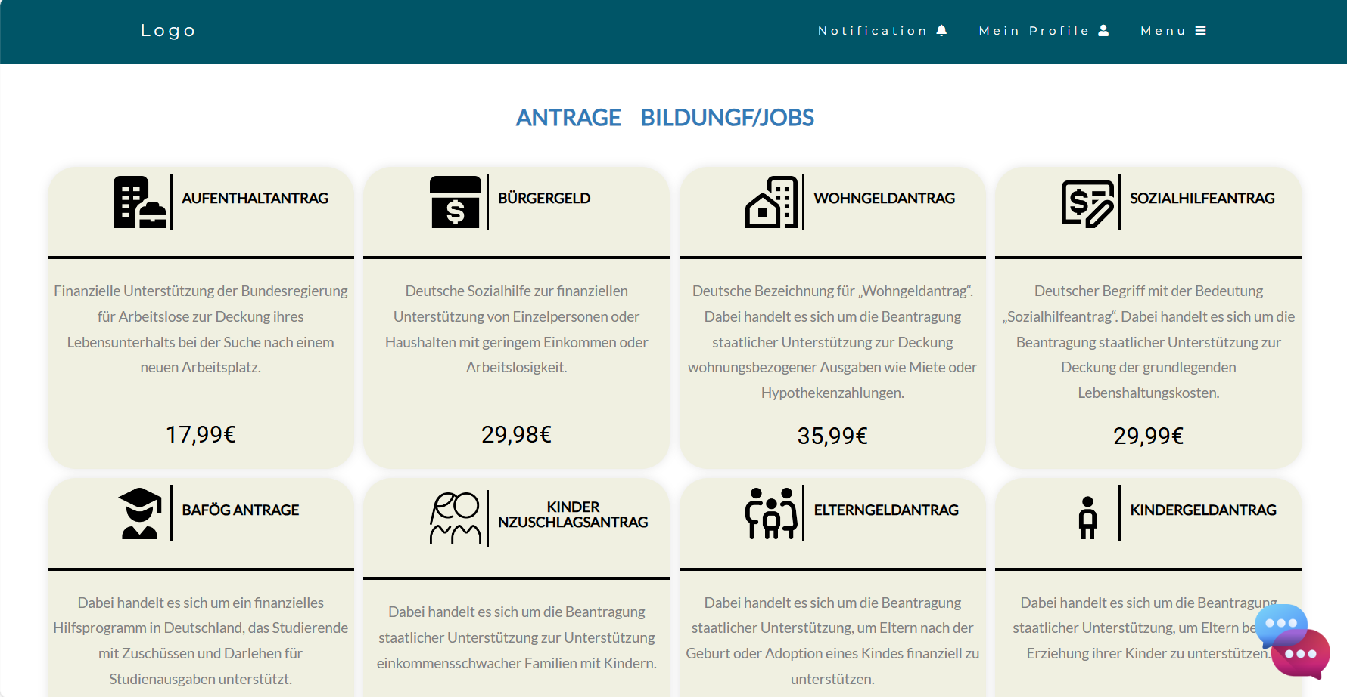

* 1. When users click on the "Bildung/Jobs" tag in Figure 15/ClientHomePage (ajax), the system dynamically updates the service types section to display Bildung/Jobs -related services in a visually appealing manner using AJAX for a seamless browsing experience. This feature enhances user engagement by instantly presenting relevant content without the need for page refreshes, ensuring a smooth and efficient navigation process.

Figure 16/ClientHomePage Bildung

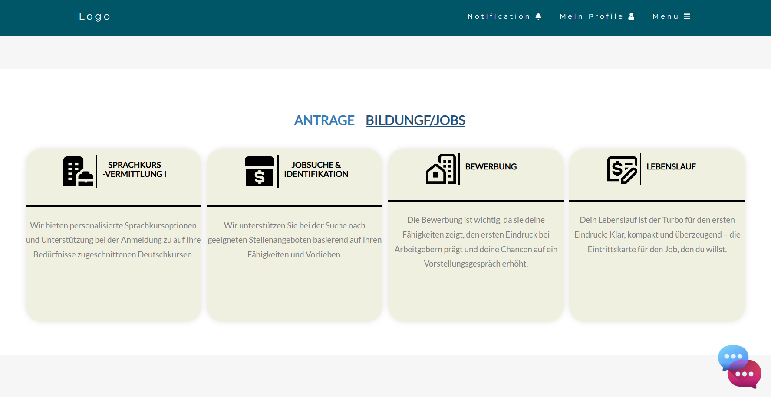

* 1. Chat with employees: On the client home page, clicking the chat icon located at the bottom right corner of Figure 15/ClientHomePage (ajax) opens a list of employees available for chat. This list includes each employee's current status (online or offline). This feature allows clients to quickly identify and connect with the appropriate employee for assistance, ensuring efficient and personalized support through real-time communication.

Figure 17/Chat with employee list

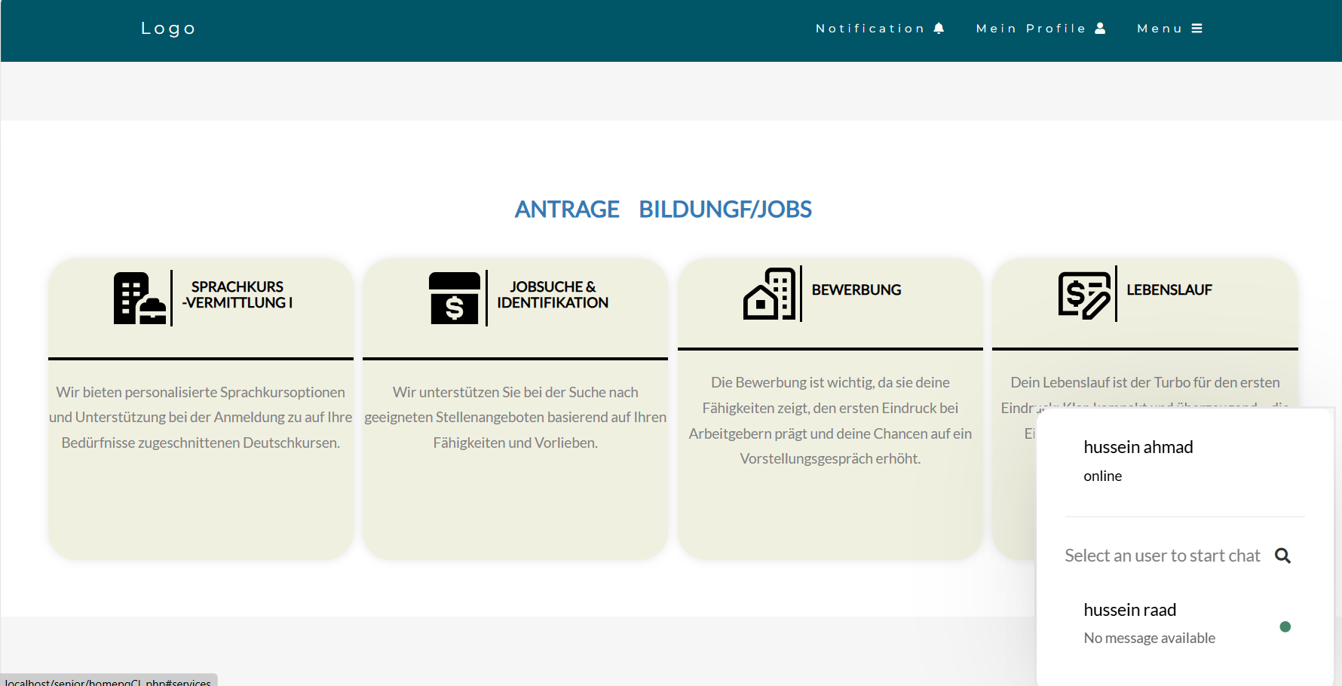

* 1. Real-Time Chat: After selecting an employee from the list, clients can engage in real-time chat. This feature facilitates immediate and interactive communication between clients and employees. Clients can ask questions, seek guidance, and resolve issues promptly, enhancing the overall user experience by providing timely and effective support.

Figure 18/chatpanel

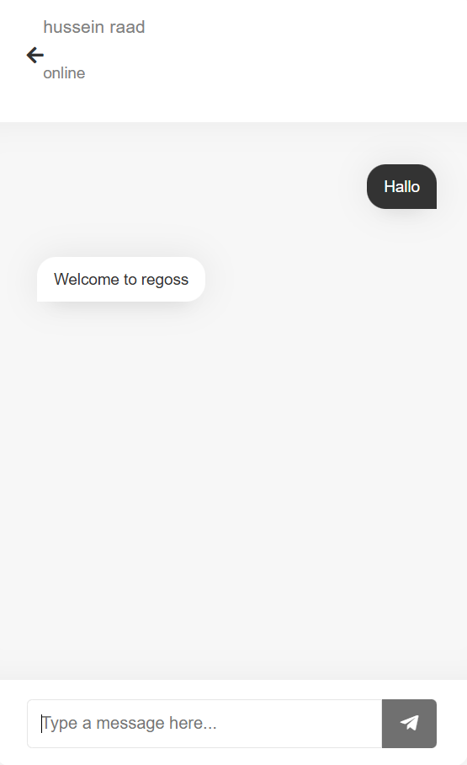

* 1. My profile: When users click on the "My Profile" tag shown in Figure 17, their profile page is displayed. This page includes detailed information about the user's submitted applications, such as: Application ID, Date of Submission, Application Status(The current status of the application (e.g., pending, approved, paused), Payment Status(Whether the application service fee has been paid or not).  
     Additionally, there is a "Drop Application" button available next to applications with a paused status. Users can use this button to cancel applications that haven't been paid for, streamlining their application management process.

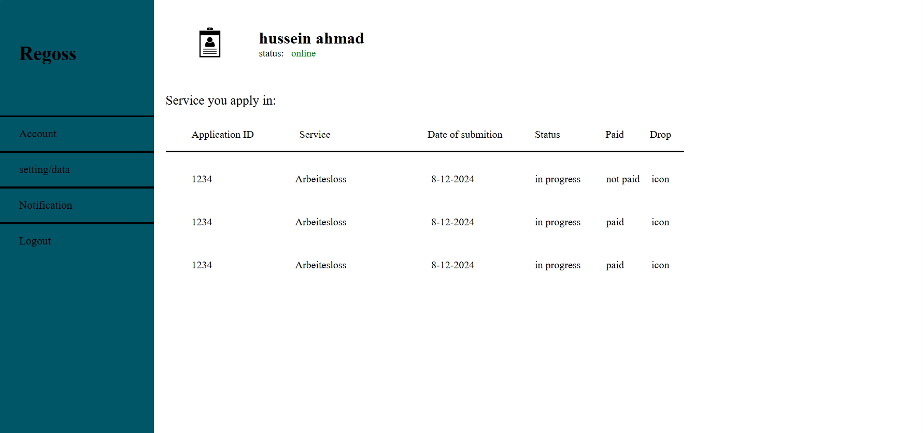

* 1. Account Settings: Clicking on "Settings" or "Data" in the left navbar triggers an AJAX request, replacing the current container with a new one for a smoother and faster user experience. This new container contains 6 clickable boxes, Personal Information, Address, Contact, Password Change, Account Deletion. Users can update and edit their personal data.  
     This intuitive design allows users to easily access and manage their account settings, enhancing user control and satisfaction.

Figure 19/Client dashboard

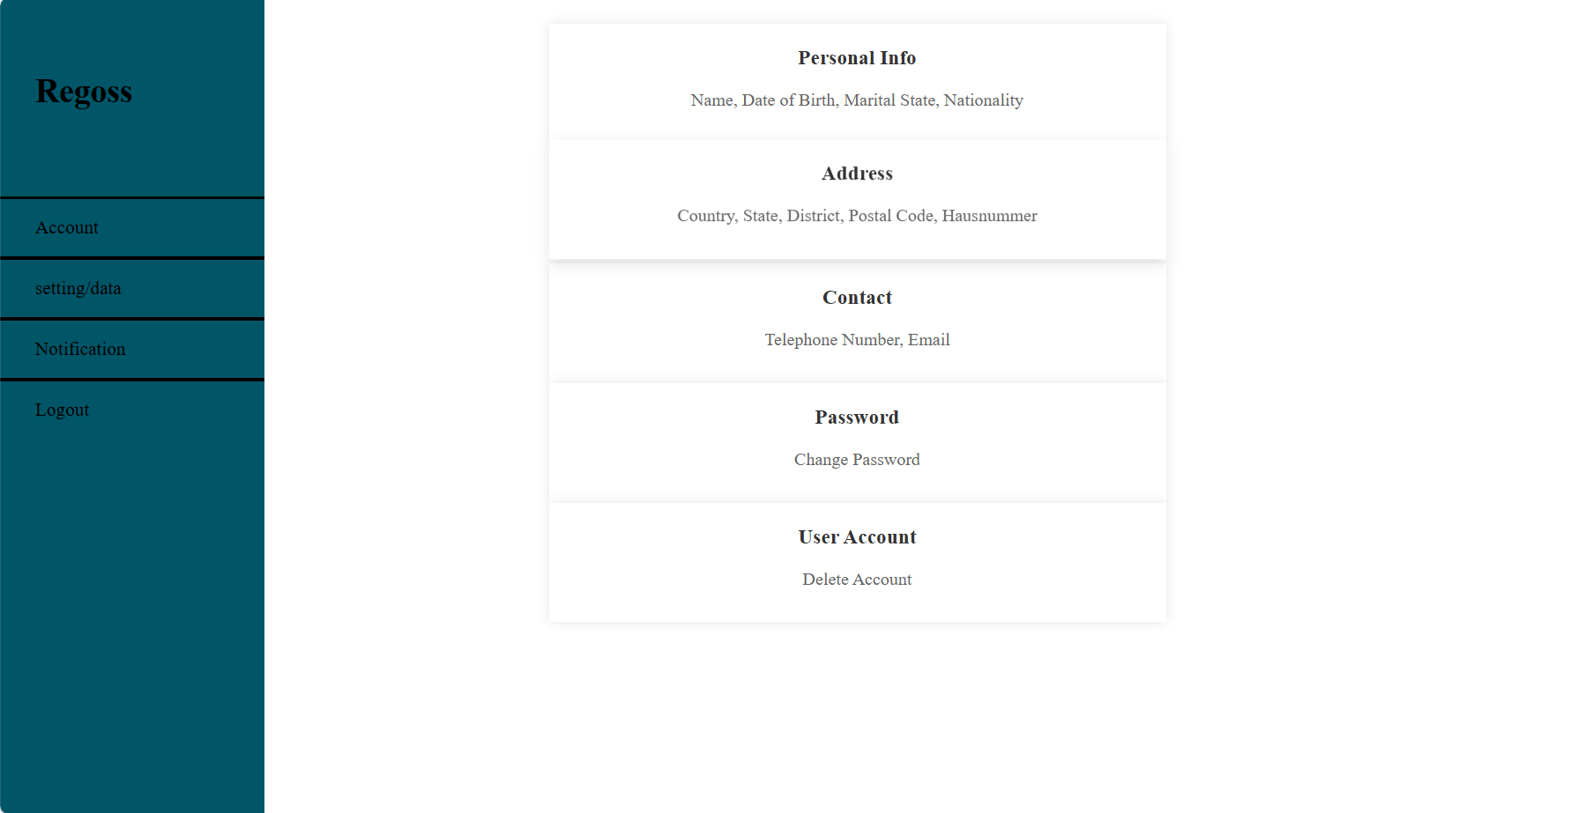

Figure 20/Client personal Info-display/edit

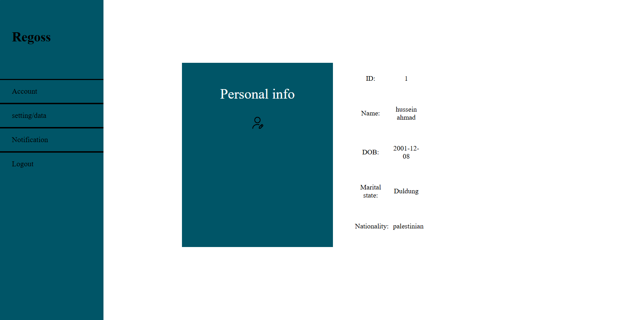

Figure 21/Client address-display/edit

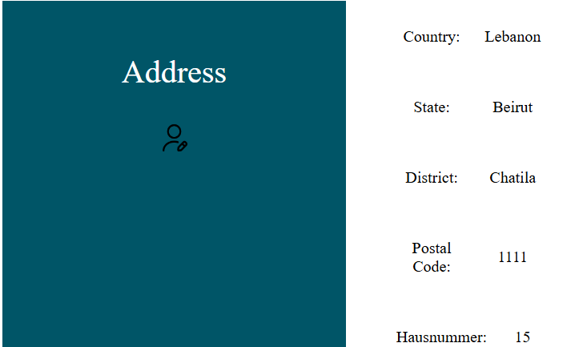

Figure 22/Client contact info-display/edit

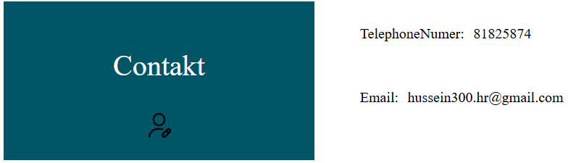

Figure 23/Client changing password

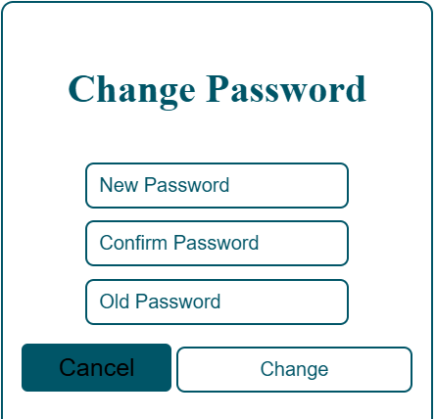

Figure 24/Client deleting account

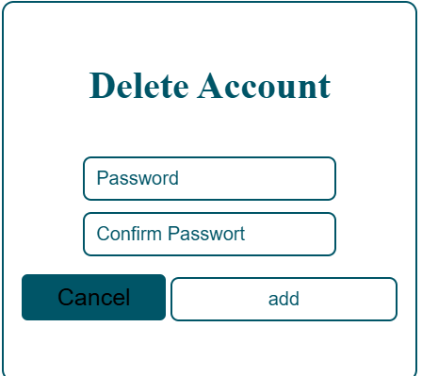

Figure 25/Client editing info enabled

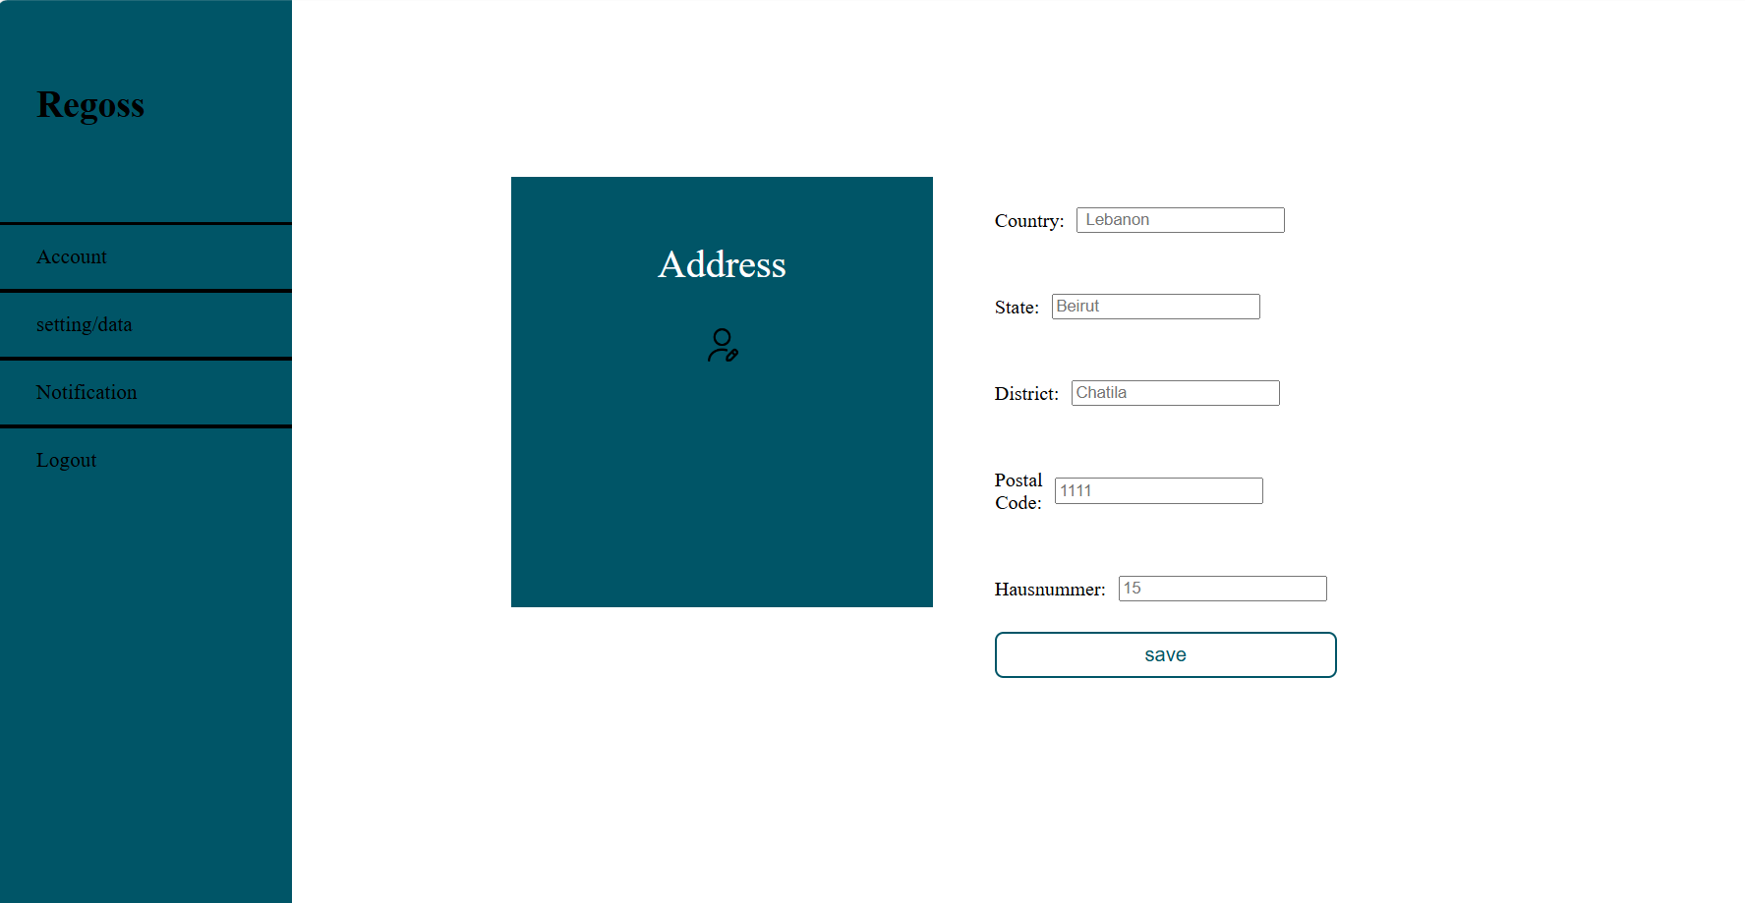

* 1. Apply for Service: Clients can apply for services by clicking on the desired service box, which navigates them to a translatable application form. This form contains:
* Questions and Well-Explained Fields: The form is designed to be user-friendly, with clear instructions and explanations for each field to ensure accurate completion.
* Power of Attorney (Vollmacht): Clients can click on the "Vollmacht" link to read the power of attorney document. They must acknowledge and digitally sign this document by typing their name and submitting the application.

Upon submission, the application data is processed using the Composer library, pdftk server, and PHP pdftk. These tools fill the official PDF application form with the client's data, which is then saved into the database. This streamlined process ensures that all necessary documents are accurately completed and stored, facilitating efficient service provision.

Figure 26/Application form

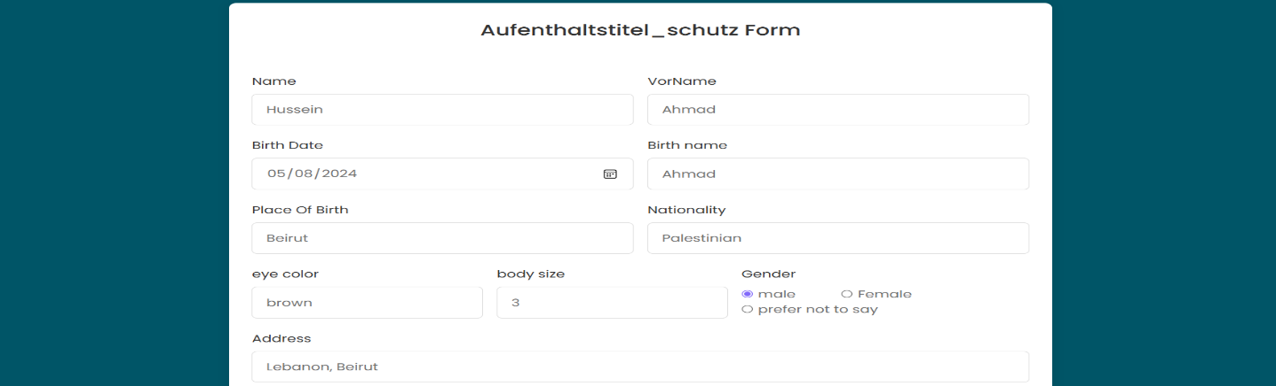

Figure 27/Application form-2

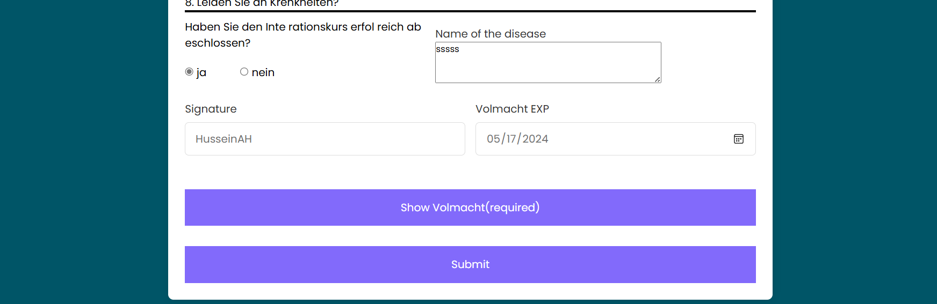

Figure 28/displayin power of Attorney

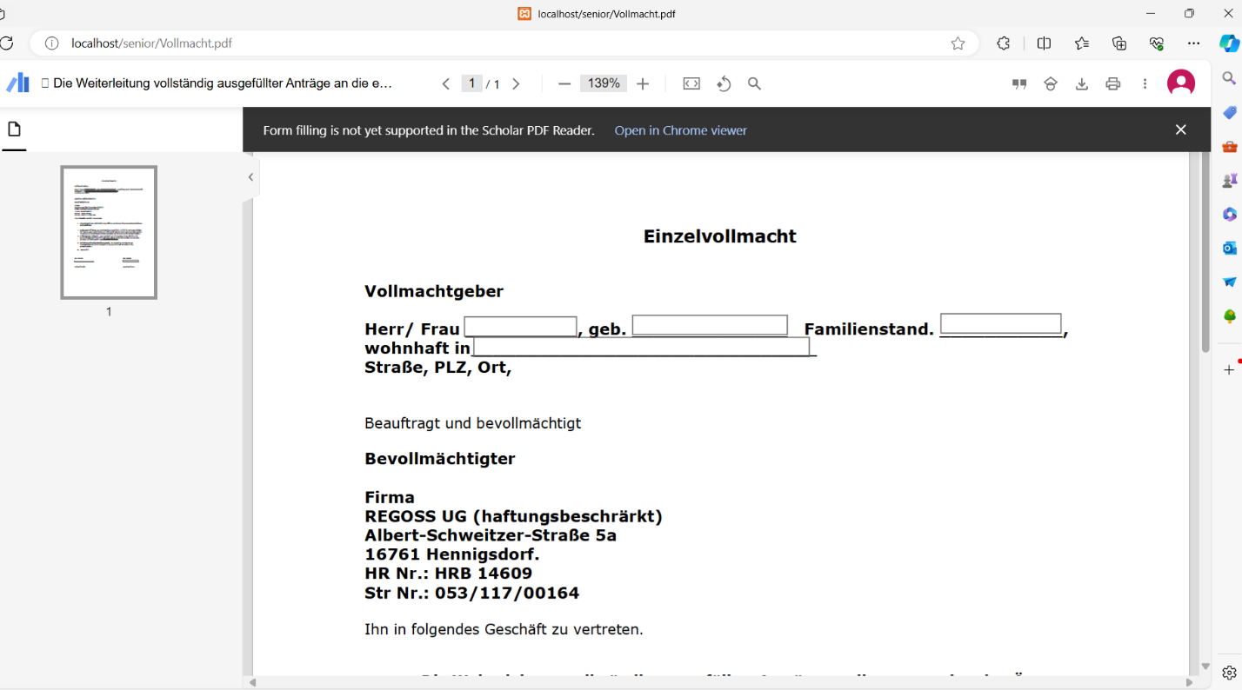

## Manager Dashboard

Upon logging in with a manager's unique account, the system navigates the manager to the dashboard. Initially, the dashboard displays the manager's personal information and data, including their position and picture. This personalized view allows the manager to quickly access and verify their details before proceeding to manage other administrative tasks and oversee the system's operations effectively.

Figure 29/ manager dashboard

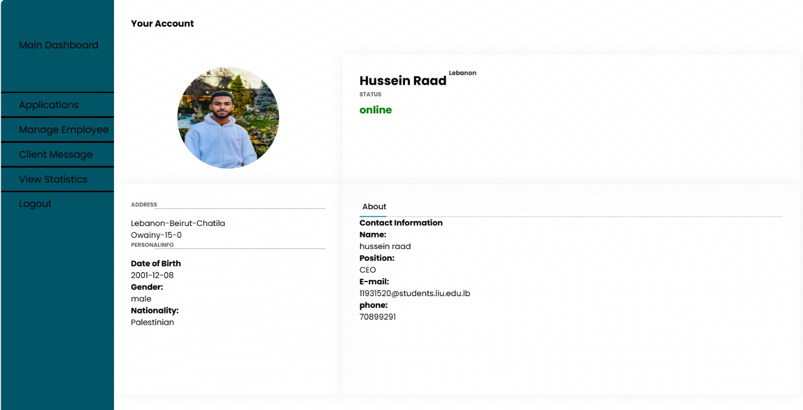

* 1. Viewing Applications:

When the manager clicks on the "Applications" tag in the left navigation bar, the system displays all applications submitted by clients. The displayed information includes Application ID, Service Name, Client Name, Status of the Application, Payment Status. Additionally, the manager has the ability to both view and download the Power of Attorney form, and same as to the corresponding application. The manager can also upload files, such as the response and result of the application, directly to the system. This feature ensures efficient application management and communication between the clients and the management team.

Figure 30/ applications managin/Employee side

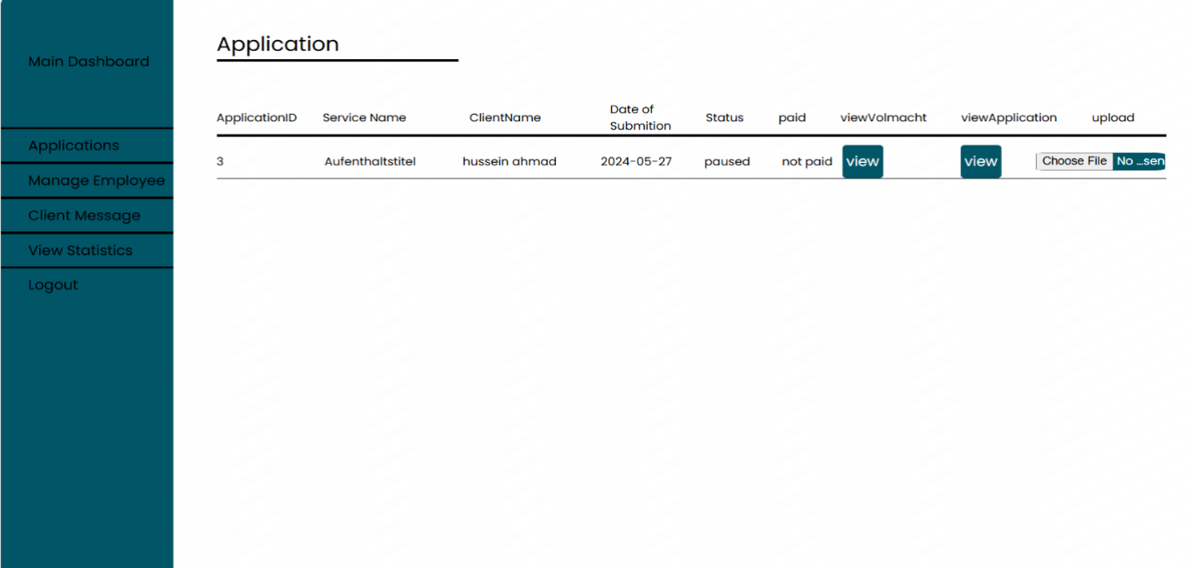

* 1. When the manager clicks on the "Manage Employees" tag in the left sidebar, the system displays a comprehensive list of all company employees. The displayed information includes: name, email, position, status, last login and last logout. Additionally, the manager has several functionalities at their disposal
* Add New Employee: The manager can input new employee details to add them to the company roster.
* Delete Employee: The manager can remove an employee from the system.
* Update Employee Position: The manager can change the position or role of an existing employee.

These features ensure that employee management is streamlined and efficient, providing the manager with full control over the personnel data within the system.

Figure 31/employee management-Manager

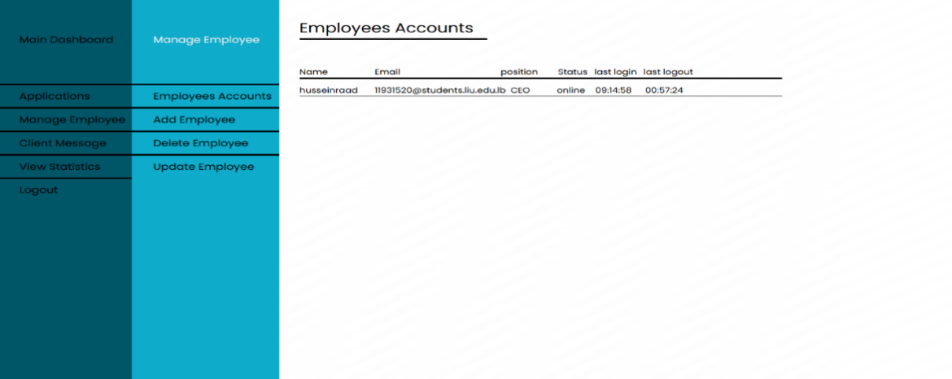

* 1. Client message : mployees have the ability to view and respond to client messages through the real-time chat feature. When clients send messages, employees can View Incoming Messages and engage in live, real-time conversations with clients, providing immediate assistance and support.

This functionality ensures that clients receive timely and effective responses to their inquiries, enhancing customer service and satisfaction.

Figure 32/client chat-employee side

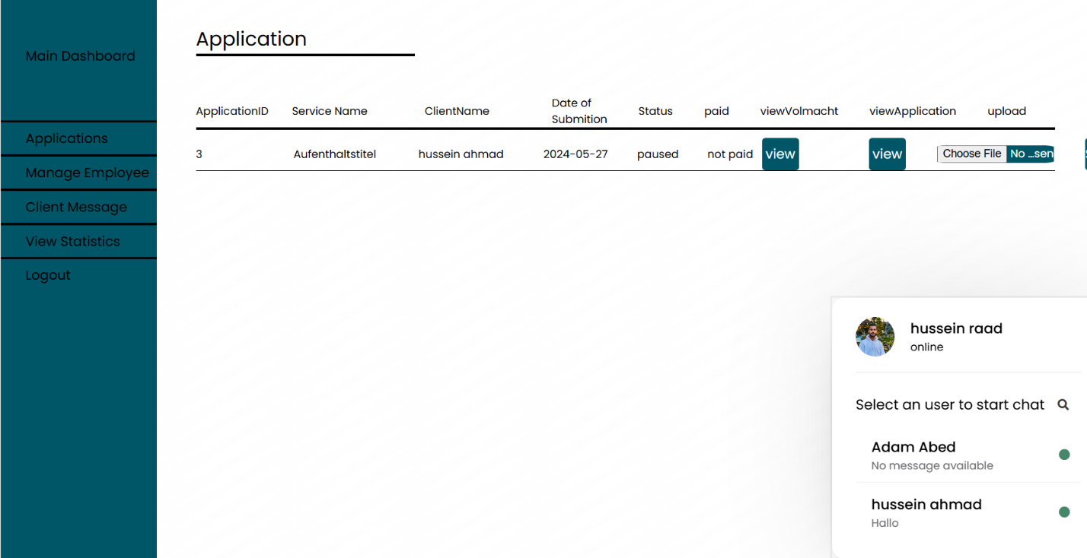

* 1. Logout: Users can log out from their accounts by clicking on the corresponding "Logout" tag. This action will:
* Set User Status to Offline: The system will update the user's status to indicate they are no longer online.
* Record Logout Time: The exact time of logout will be recorded for tracking purposes.

This ensures that the system accurately reflects user activity and maintains up-to-date information on user availability.

# Chapter 5

## Conclusion:

My project represents a comprehensive solution designed to streamline service applications and improve the user experience for both clients and employees. Through detailed planning and implementation, we have developed a website that facilitates efficient communication, application processing, and real-time support. The integration of various functionalities, such as user profiles, service applications, real-time chat, and employee management, ensures a seamless and intuitive interaction for all users. This project not only demonstrates our technical capabilities but also our commitment to creating user-centric solutions that address real-world needs. We are confident that our system will enhance productivity and satisfaction for both clients and employees, paving the way for future advancements and innovations.  
  
Future Work:  
Looking ahead, our vision for the project is to transform Regoss into a globally recognized platform where governments worldwide can offer their services seamlessly. The future work involves expanding the website’s capabilities to accommodate various international governmental services, ensuring compliance with different countries’ regulations and standards.