Gallery X
Gallery X
How to start the program 2
Artist 3
Creating Artist 3
Editing artist 3
Loading Artist 4
Artwork 5
Creating new artwork 5
Loading all artwork 6
Changing Artwork price 6
Searching a artist for their artwork 7
Adding artwork to display 7
Gallery 8
Display tab 8
Remove Artwork from display 8
Customer 9
Creating a new customer 9
Editing customer information 9
Previous Purchases 10
Purchases 11

How to start the program

To start the gallery x program, access the GalleryXnew application. To open the application double click on the icon GalleryXnew.

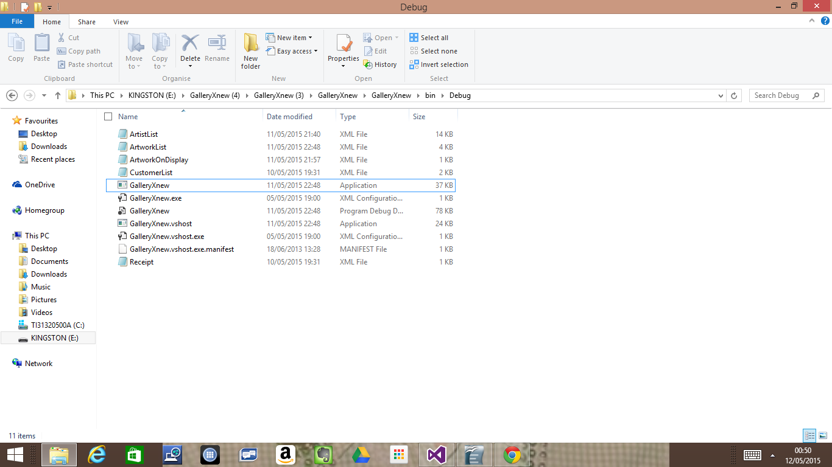
This loads up the program and causes the application to start
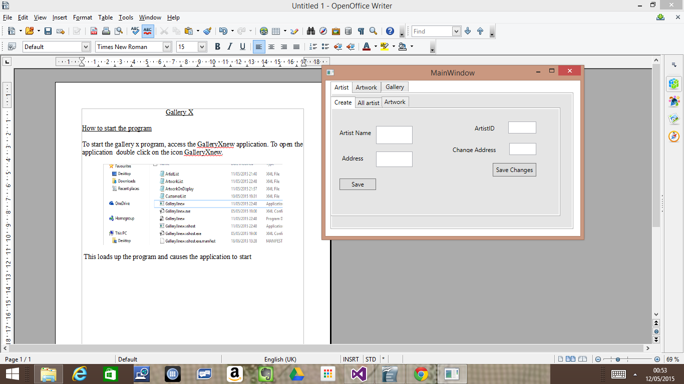

Artist

Creating Artist
To create a artist, we locate the artist tab and select the create tab. This will cause the user to view either the creation or editing of the artist. We input a name into the field and address when creating a new artist

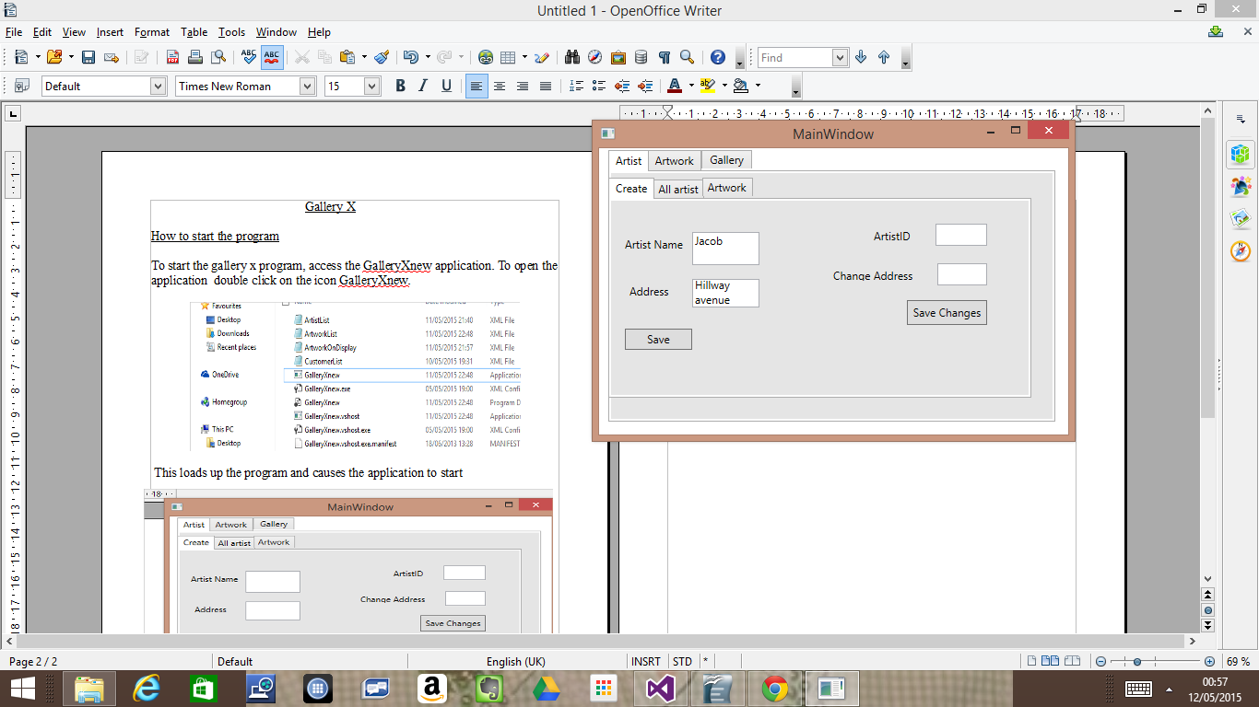
To save the new artist we click save

Editing artist
To edit a existing artist, we need their artist ID number and the new address they moved to, then click save changes to make the new address permanent
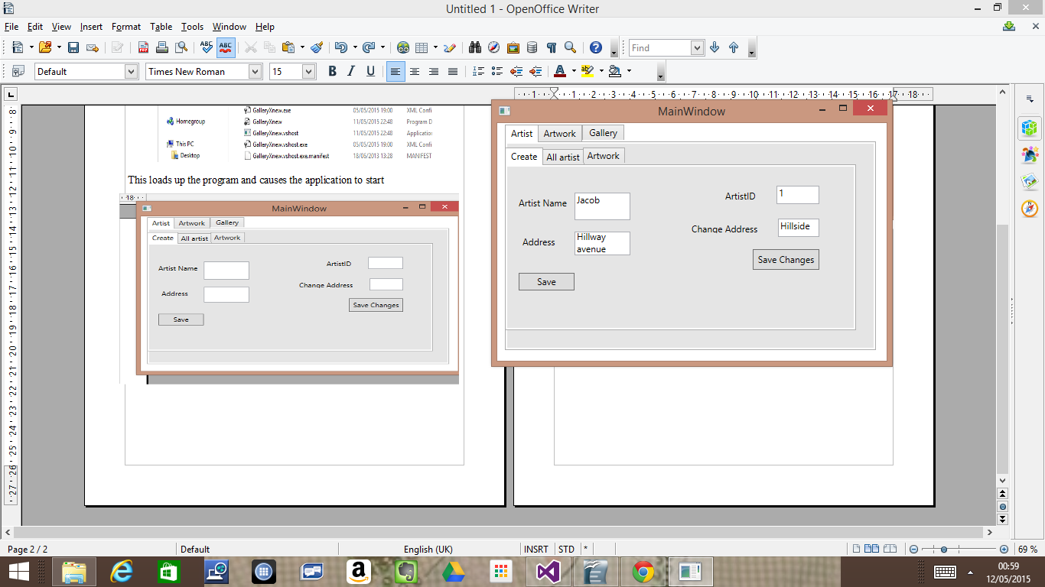

Loading Artist

To view all the artist in the gallery we enter the artist tab and then access the all artist tab. Then you press the load button to load all the artist in the gallery

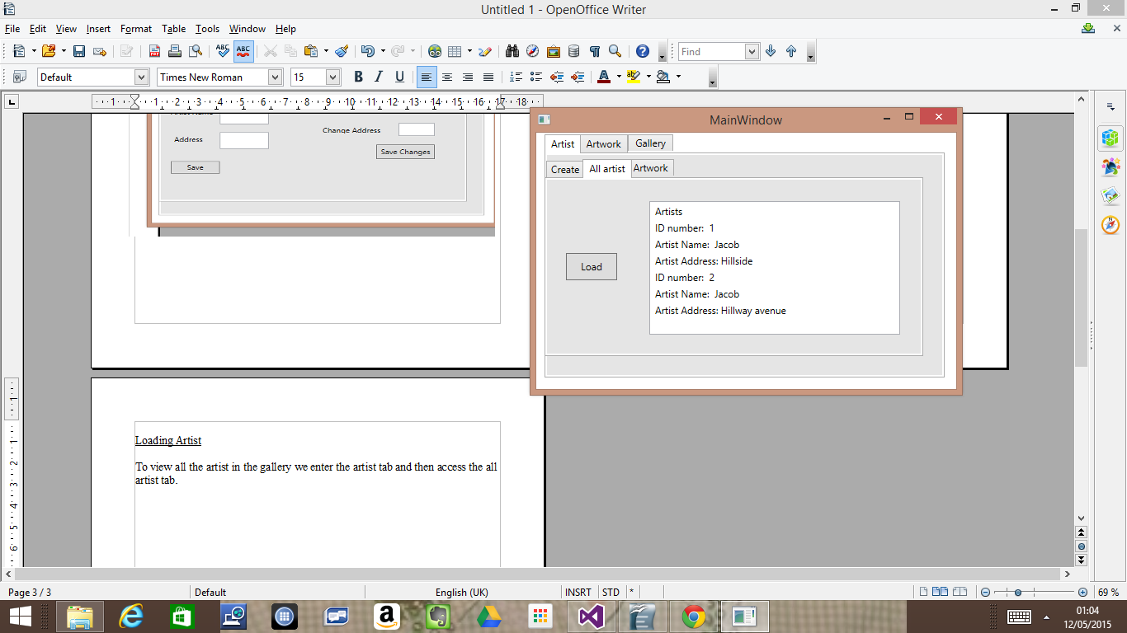

Artwork
This is the artwork tab where we can save a new artwork with the artist ID, the artwork price and description. To load all the artwork the gallery has we click the load all artwork button.

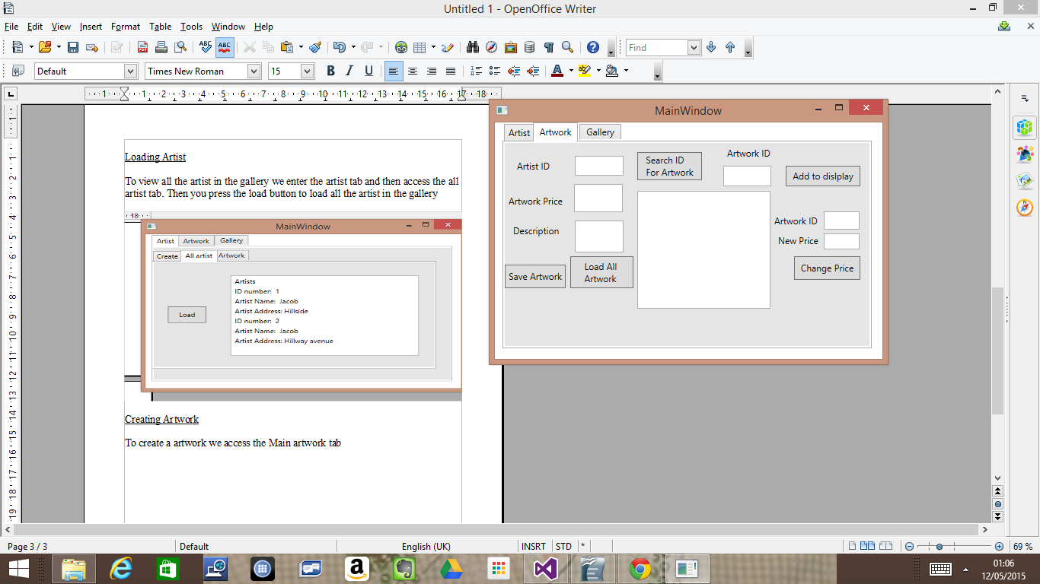

Creating new artwork
To create a new artwork we need the artist ID, the selling price and the description, then when all of this is provided we can click save artwork.
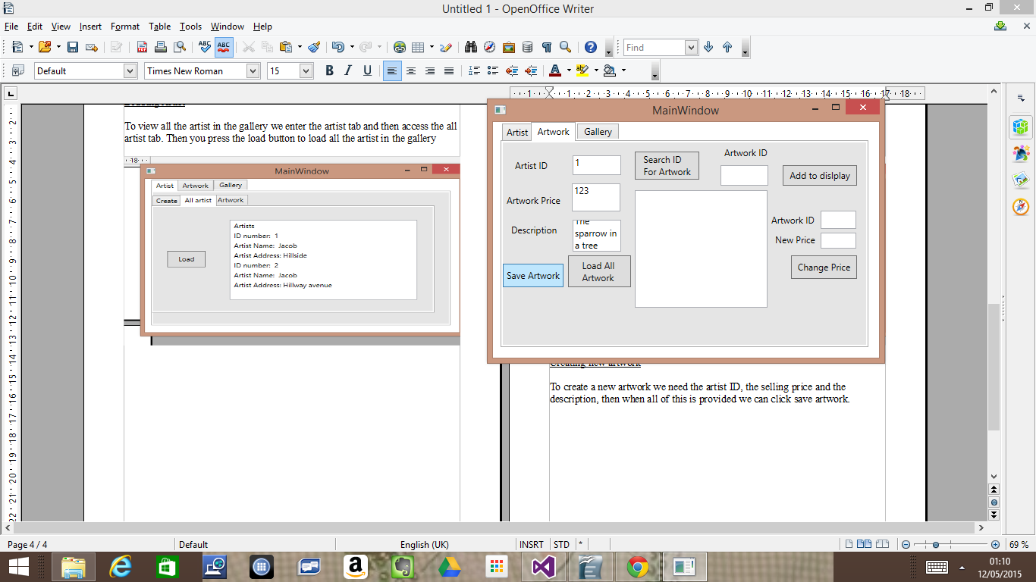

Loading all artwork

To load all the artwork in the gallery we press load artwork
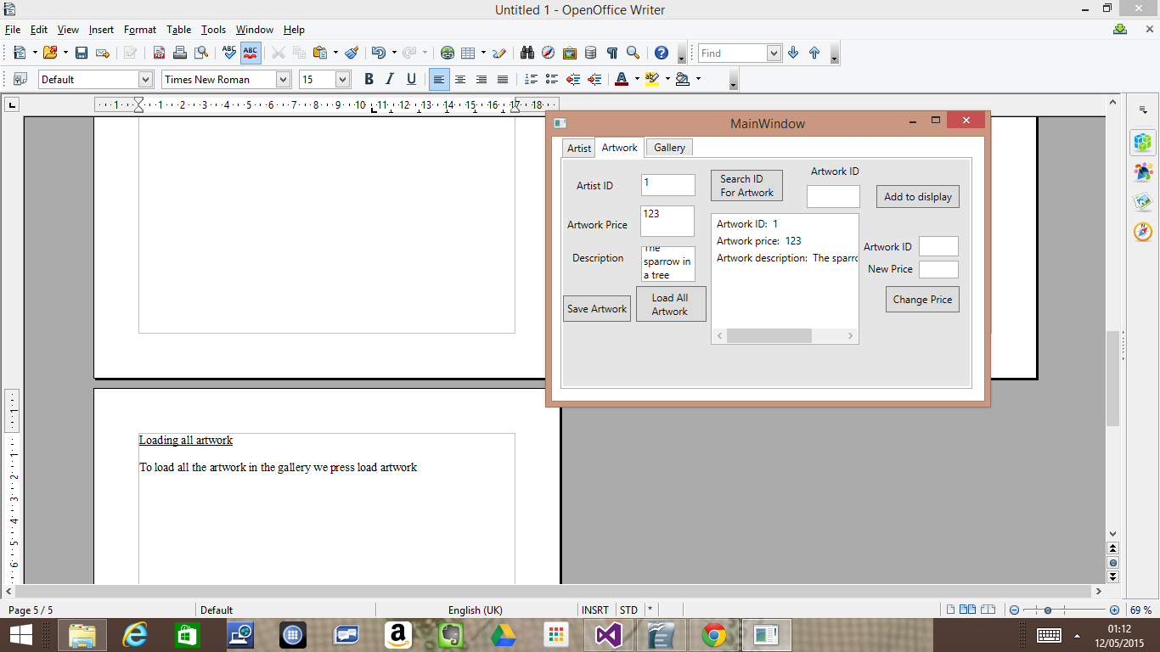

Changing Artwork price

To change a artwork's price we provide the artwork ID and the new price then click change price
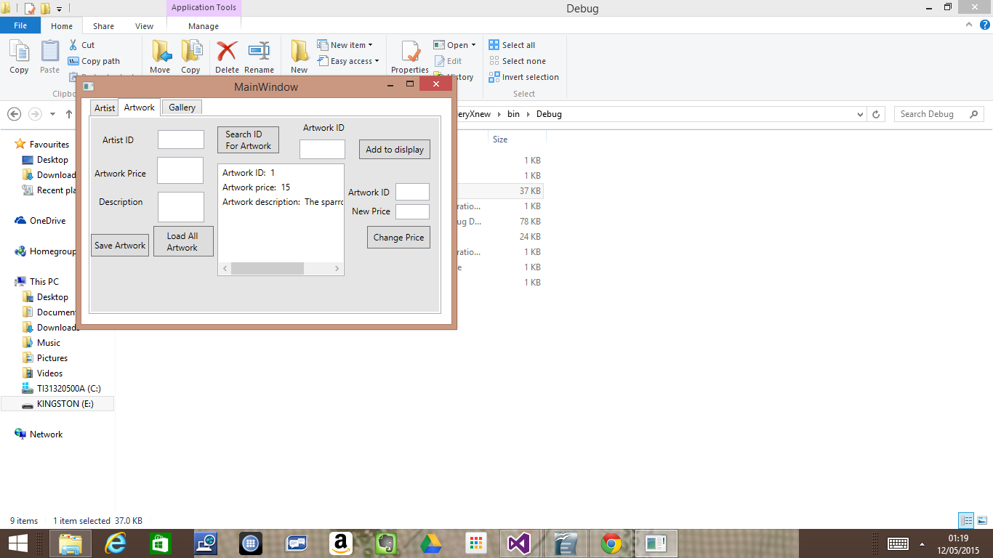

Searching a artist for their artwork

We enter their ID number on to the artist ID input box then click the search ID for artwork
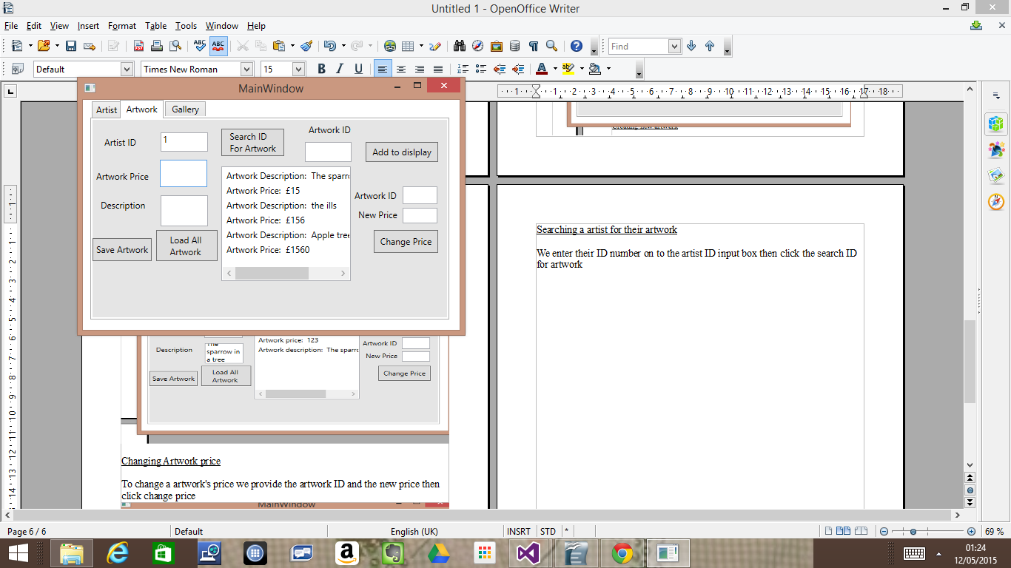

Adding artwork to display
We enter the artwork ID number into the artwork ID input box then click add to display
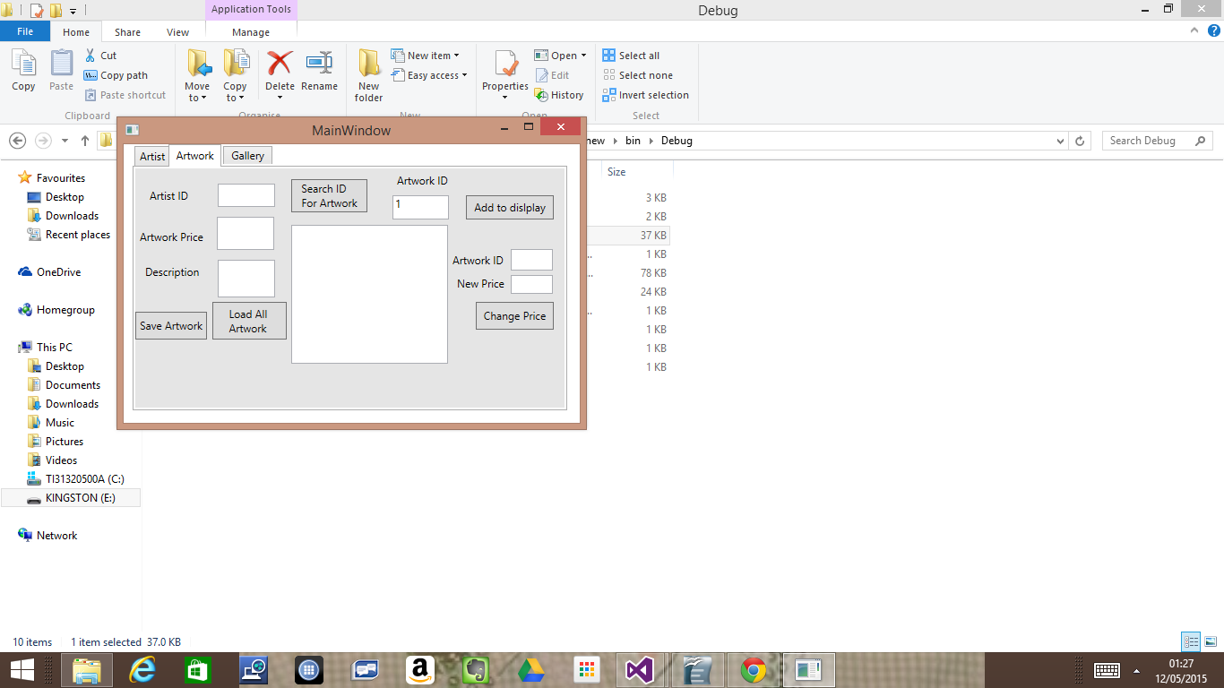

Gallery

Display tab

All the artwork in the display will be loaded and the date added to the display will be shown.
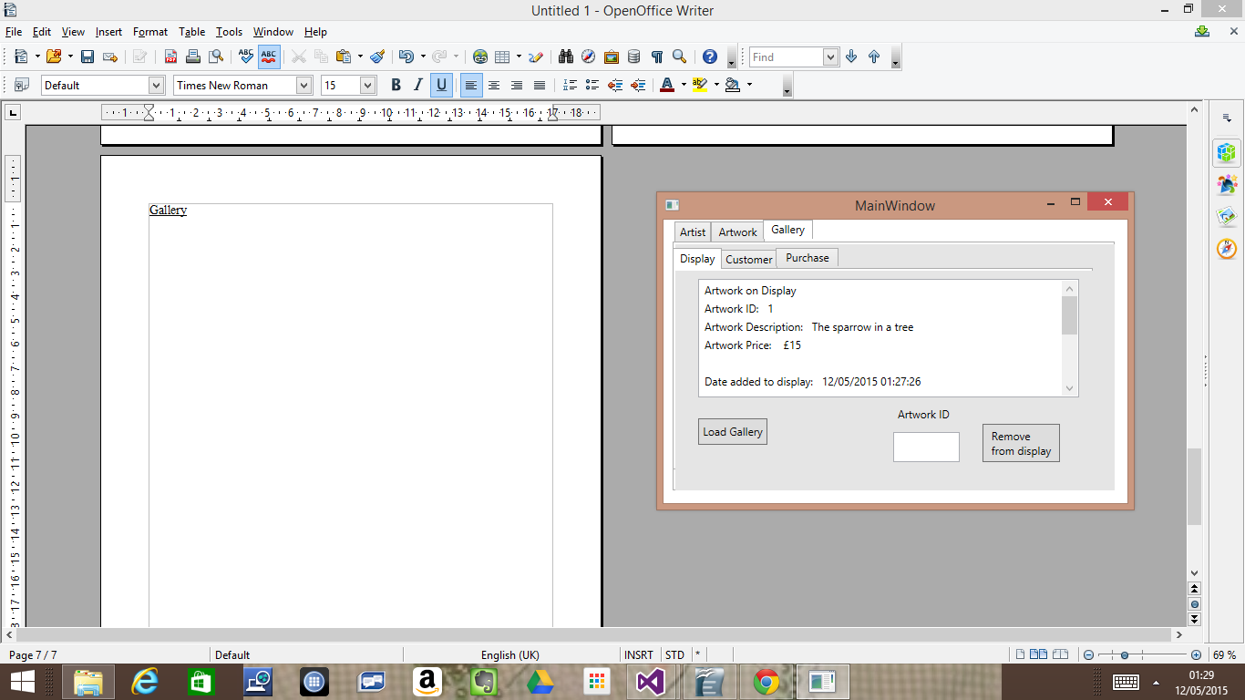

Remove Artwork from display

To remove a artwork from display enter the Artwork ID and press the remove from display button.

Customer

Creating a new customer
To create a new customer we input their name and address into the following user defined input boxes.
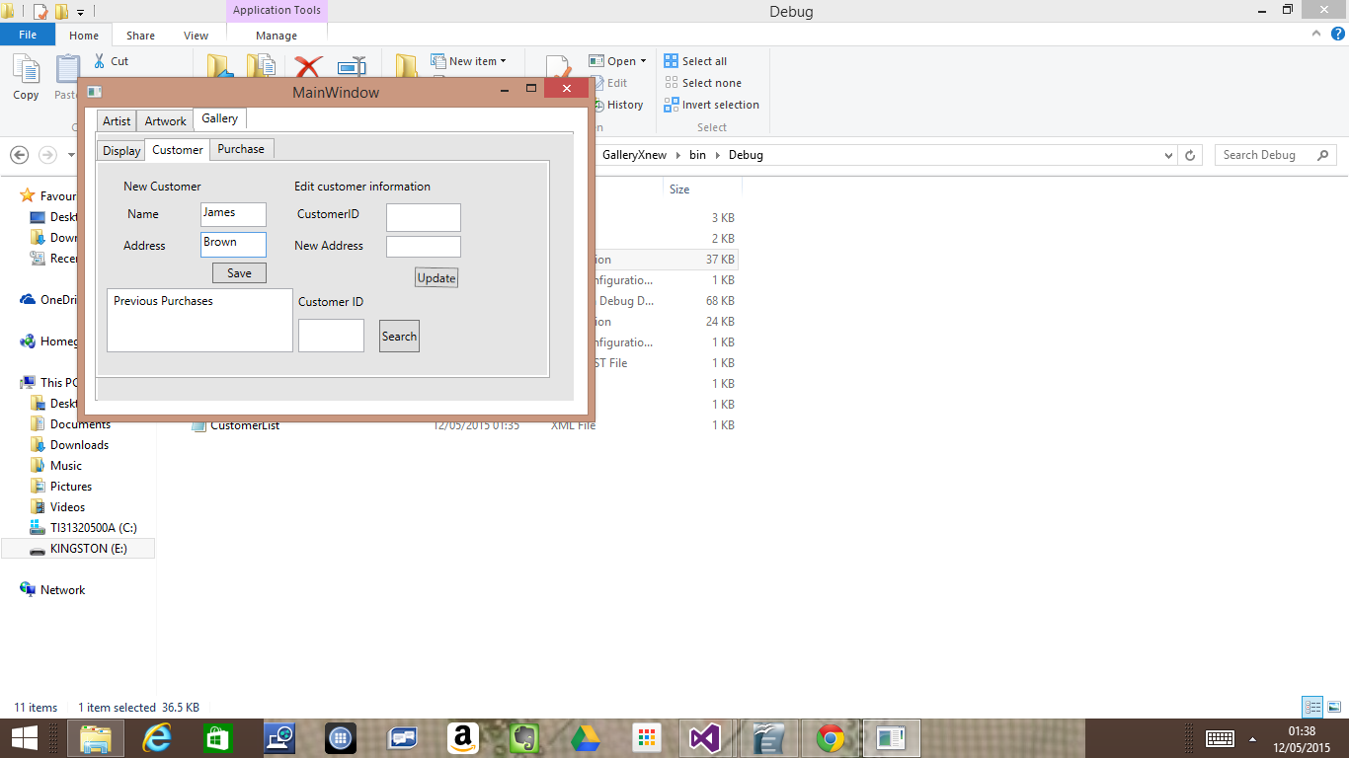

Editing customer information

To edit a customer's information we enter the customer's information and their new address then we click the update button.

Previous Purchases
To search a customer for their previous purchases we enter the customer's ID then press search.
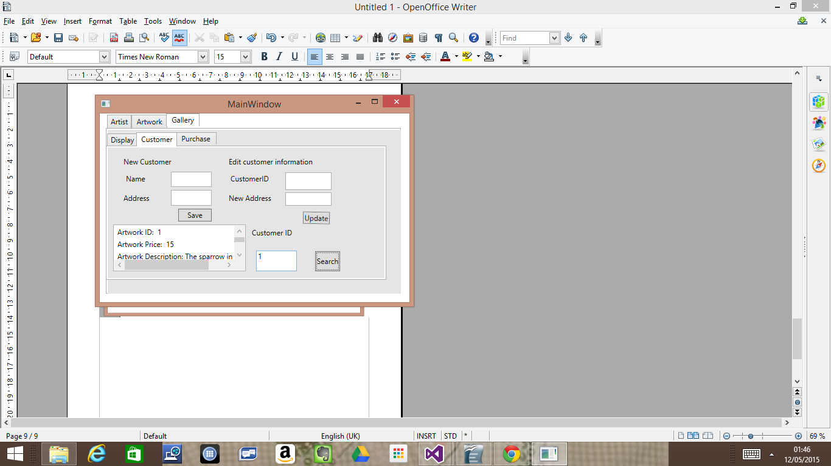

Purchases
To purchase a product, the user inputs the artwork ID and the customer ID number then press the purchase button. This causes the customer's receipt to flash up on the screen.
