

Prepared by: Hussain Akhtar

Amazon Prime User’s

# Executive Summary

This report provides a comprehensive analysis of Amazon's customer purchasing behavior based on device usage, with a focus on optimizing product offerings and enhancing Amazon Prime membership benefits. By examining the relationships between device types (mobile, desktop, tablet) and consumer shopping patterns, the report identifies opportunities to target product promotions, incentivize Amazon Prime subscriptions, and boost overall sales.

# Introduction

In the highly competitive e-commerce landscape, Amazon's success hinges on its ability to deliver personalized shopping experiences that resonate with its diverse customer base. With 2500 of customers using a variety of devices (mobile, desktop, tablet) to browse and purchase products, understanding how device preferences influence purchasing behavior is critical. Furthermore, Amazon Prime, the company's subscription-based loyalty program, plays a significant role in driving customer engagement. Thus, optimizing both product offerings and promotional strategies across devices, while enhancing Prime membership benefits, presents a valuable opportunity for growth.

# Objective

• **Identify Device Usage Patterns**: Understand how customers interact with Amazon across different devices (mobile, desktop, tablet) and how these preferences influence purchasing behavior.

• **Develop Targeted Marketing Strategies**: Use insights from customer behavior to create personalized marketing campaigns and promotions that align with user preferences, driving increased engagement and sales.

• **Boost Sales and Customer Satisfaction**: Recommend strategies to increase overall sales through targeted offers, better product alignment, and enhanced customer satisfaction with Amazon’s services.

# Data Preparation

In order to conduct a meaningful analysis of Amazon's customer purchasing behavior, device preferences, and the impact of Amazon Prime membership, it was essential to prepare the dataset carefully. The data preparation process involved several key steps to ensure the quality and integrity of the data, making it suitable for analysis and visualization. Below is a report:

* **Data Collection**:
* The data used for this analysis was sourced from Amazon’s internal databases, which track customer interactions, purchases, and device usage.
* The dataset includes information on customer IDs, customer e-mail ID, product categories, purchase amounts, device types (mobile, desktop, tablet), purchase dates, and whether or not the customer is an Amazon Prime member.
* **Data Cleaning**:
* Handling Missing Values: Missing or incomplete records were not identified and data is correct.
* Duplicate Entries: Duplicate records, which could skew the analysis, were no dublicate values are identified.

• **Data Validation**:

* After transforming and cleaning the data, validation checks were conducted to ensure the integrity and reliability of the dataset.

• **Data Aggregation**:

* The data was aggregated at various levels (by customer, by gender, by payment, by renewal status, Usage Frequency, Purchase History, Favorite Genre, Device Usage, Engagement Metrics, by device, by Prime status) to allow for meaningful trend analysis. This aggregation was essential for generating visualizations that would help uncover actionable insights.

# Tools and Technology

The project utilize the following tools and technologies:

* Programming language: Python
* Libraries: Pandas, Numpy, Plotly, Matplotlib
* IDE: Jupiter Notebook
* Data Source: Kaggel.com

# Problem Statement:

Amazon aims to enhance customer satisfaction and increase sales by optimizing product offerings and promotions. The goal is to analyze customer purchase behavior based on the devices they use and provide targeted suggestions for product promotions and Amazon Prime memberships. The company seeks insights on how to better align their product offerings with customer preferences, device usage patterns, and incentivize Prime subscriptions.

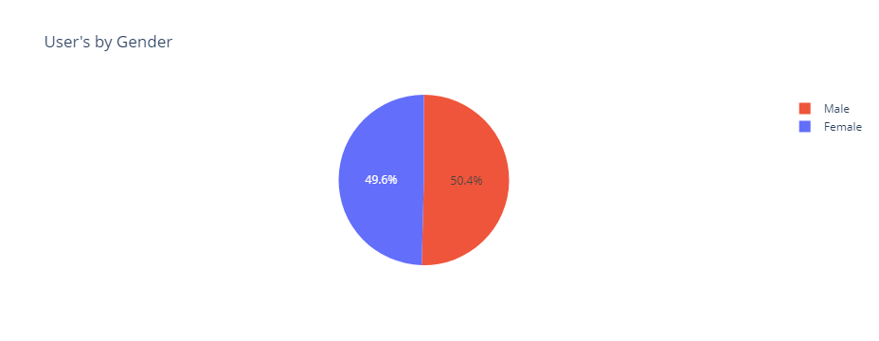

As per data, the almost equal gender distribution that using the amazon prime, the product or service appeals equally to both male and female users. This balance indicates that the platform is inclusive and does not heavily skew towards a particular gender.

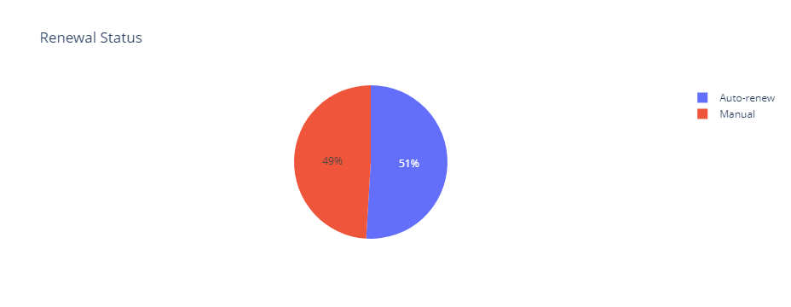

The majority, although only slightly, prefer auto-renewal, suggesting that users value convenience and may prefer not to manage renewals manually. This indicates trust in the platform's services, as users are comfortable with the subscription automatically renewing.

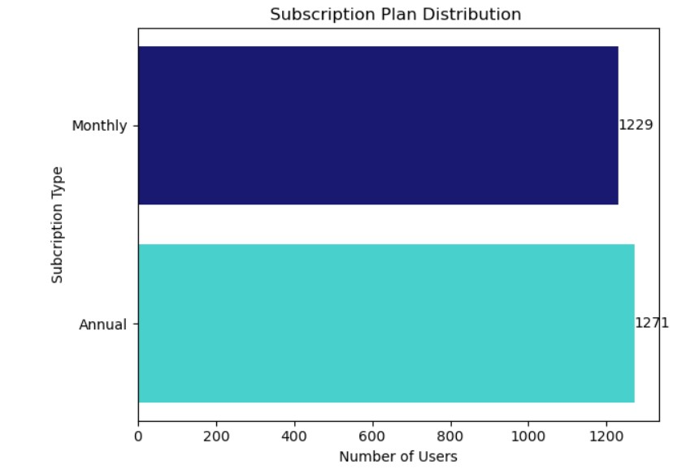

This balance indicates that users are divided in their subscription preferences, with some preferring the flexibility of monthly payments, while others find value in committing to an annual plan, likely for long-term savings or benefits.

Since annual subscriptions likely generate more upfront revenue, Amazon may benefit from nudging more users toward the annual option by highlighting its cost-effectiveness or offering additional incentives.

Annual subscription give’s the additional benefits product discount, free delivery, offers with cards.

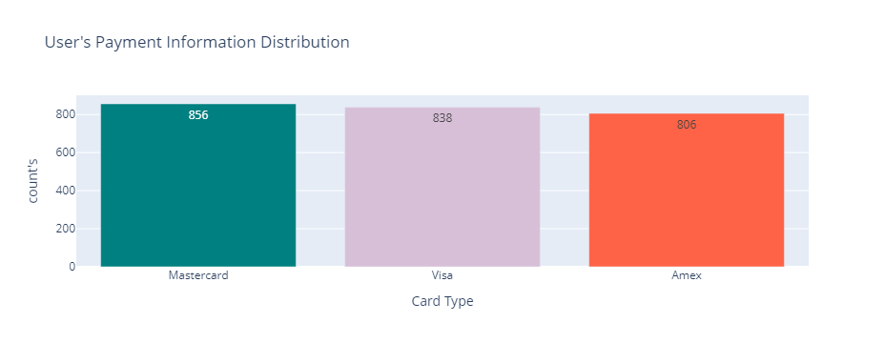

All three card types have a relatively even distribution, with no significant outlier.

You offer deeper strategic angles that can guide marketing, product offerings, and partnership decisions based on card usage distribution.

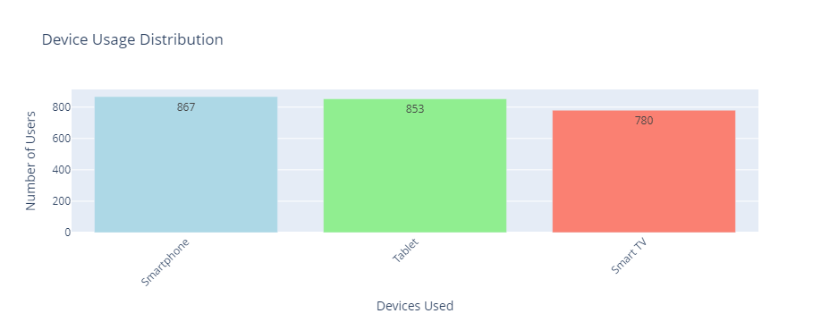

Balanced usage across devices, with smartphones slightly leading due to their portability and multifunctionality. Tablets are also widely used, likely for more immersive experiences, while Smart TVs are primarily used for media consumption.

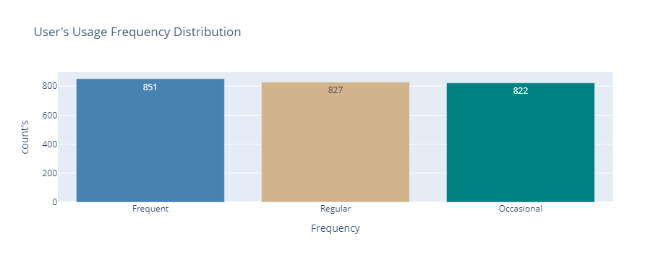

The fairly balanced distribution indicates strong user engagement across all frequency levels, with potential to further increase user activity by focusing on converting occasional and regular users to more frequent interaction.

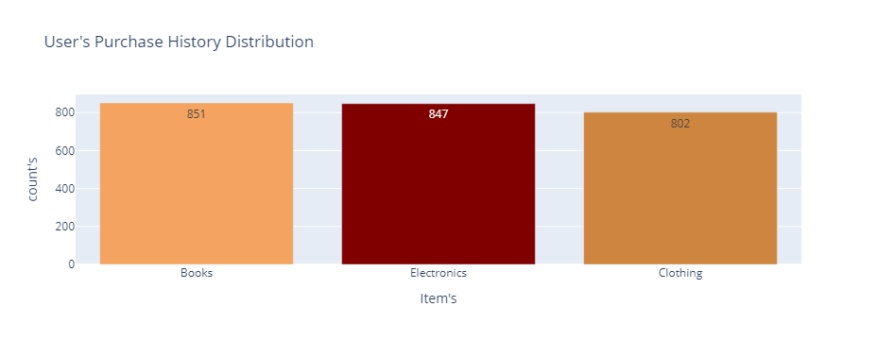

The purchasing distribution shows that users are interested in a variety of items, with books and electronics leading slightly. There is an opportunity to drive more purchases in the clothing category through targeted strategies.

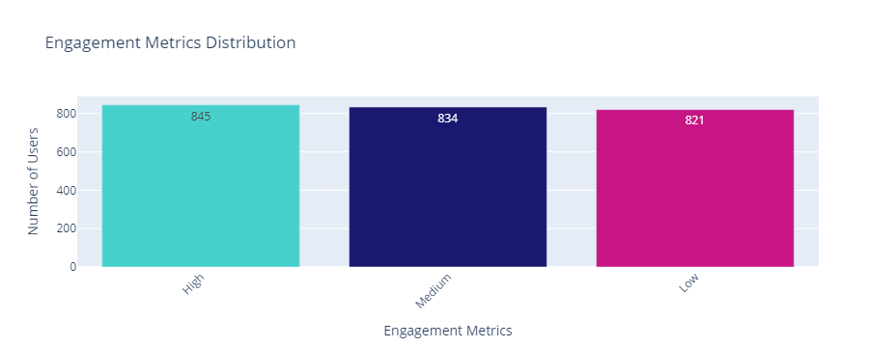

This insight provides valuable information for understanding user interaction patterns and can guide Amazon in developing focused marketing and engagement strategies to maximize customer retention and activity across all user segments.

# Recommendations

### **Personalized Marketing Campaigns**:

* **Data-Driven Recommendations**: Use customer purchase history and browsing patterns to tailor product recommendations. For instance, suggest related items for users who recently purchased electronics or offer complementary products for high-value purchases.
* **Email and App Notifications**: Send personalized emails or app notifications highlighting trending products or exclusive deals based on past interests. This helps bring back low-engagement users and encourages them to explore new categories.

### 2. **Targeted Offers for Different Engagement Levels**:

* **Low-Engagement Users**:
  + **Special Discounts or Free Trials**: Offer limited-time discounts or free trials for Amazon Prime to attract users who have not yet subscribed.
  + **Product Bundling**: Create bundles of popular items with attractive discounts, especially in categories these users have shown interest in, like electronics or books.
* **Medium-Engagement Users**:
  + **Loyalty Programs**: Introduce loyalty points for frequent purchases, which can be redeemed for discounts on future purchases.
  + **Time-Limited Offers**: Send timed discounts (e.g., "24-hour flash sale") to create a sense of urgency and encourage immediate purchases.
* **High-Engagement Users**:
  + **Exclusive Member-Only Offers**: Provide early access to sales, exclusive deals, or member-only events. Highlight the benefits of being a valued Amazon Prime member.
  + **Surprise Gifts**: Occasionally send surprise gifts or credits to their accounts as a way of appreciation, reinforcing loyalty.

### 3. **Subscription-Based Incentives**:

* **Upgrade Campaigns**: For users with monthly subscriptions, offer a discount or bonus credits for switching to an annual plan. Highlight the long-term savings and added benefits.
* **Cross-Promotion with Amazon Prime Benefits**: Promote lesser-known Amazon Prime features (e.g., exclusive access to streaming content, faster shipping options) through targeted ads, making the subscription more appealing.

### 4. **Engagement through Gamification**:

* **Rewards for Interaction**: Implement a points system where users earn points for activities such as writing reviews, making purchases, or referring friends. These points can be redeemed for discounts or exclusive products.
* **Leaderboards and Challenges**: Create seasonal challenges (e.g., “Shop and Win” contests) where users earn rewards for making a certain number of purchases during a promotional period.

### 5. **Seasonal and Event-Based Promotions**:

* **Seasonal Sales (Black Friday, Prime Day, Holiday Season)**: Use these periods to run large-scale marketing campaigns offering significant discounts for Prime members, early access to deals, or exclusive time-limited offers.
* **Targeted Product Promotions**: During key shopping periods, run campaigns promoting categories like electronics during back-to-school seasons or fashion during spring.

### 6. **Social Media and Influencer Campaigns**:

* **Promote Success Stories**: Share testimonials from high-engagement Prime members about the benefits they enjoy. This could encourage low-engagement users to subscribe and explore more features.
* **Influencer Partnerships**: Collaborate with influencers to promote new product launches or Prime benefits, targeting younger demographics or those active on social platforms.

# Conclusion

Amazon can significantly enhance customer engagement and boost sales by implementing targeted marketing strategies and optimized offerings. By leveraging customer data for personalized recommendations and promotions, Amazon can better align its product offerings with user preferences. Focused strategies such as tailored offers for low and medium engagement users, exclusive perks for high-engagement customers, and subscription upgrade incentives can help retain loyal customers and attract new ones. Additionally, seasonal promotions, gamification, and social media campaigns will further strengthen Amazon's market position and drive higher user satisfaction, ultimately leading to increased revenue and sustained growth in the competitive e-commerce space.