Foundation of BackEnd
V1

🔁 Request-Response:
Definition
A communication model where:
- The client sends a request (some data, or a command)
- The server processes it and sends a response back
This model is synchronous and forms the basis for many protocols (like HTTP, DNS, SQL, RPC).
🧱 Anatomy of Request-Response

1. Client Sends a Request
- Request includes:
  - Method (GET, POST, etc.)
  - Headers
  - Path/URL
  - Body (data, like JSON/image)

2. Server Receives and Parses
- The server reads a stream of bytes and must:
  - Identify the boundaries (start & end) of the request
  - Parse headers and metadata
  - Extract and deserialize the body (from JSON/XML/protobuf/etc.)

3. Server Processes the Request
- This is the business logic:
  - Route the request
  - Execute DB queries
  - Perform computations
  - Authenticate user, etc.

4. Server Sends the Response
- Structured similarly:
  - Status code (200 OK, 404 Not Found)
  - Headers (e.g., Content-Type)
  - Body (JSON, HTML, etc.)
- Must also mark boundaries clearly for the client

5. Client Parses and Uses the Response
- Deserialize the body (e.g., JSON.parse)
- Display, store, or use the response

🧪 Parsing & Serialization
Stage | Description
Parsing | Understanding where the request/response begins and ends
Deserialization | Converting raw payload (e.g., JSON, XML) into an object the language understands
Serialization | Opposite: Converting an object to a format suitable for transmission
- JSON is human-readable but slower.
- Protocol Buffers (protobuf) are fast and compact (good for performance).
- XML is verbose and expensive to parse (hence not favored now).

🗃️ Use Cases of Request-Response
- HTTP APIs (REST, GraphQL)
- DNS queries (UDP-based but still request-response)
- SQL Queries (send a query, get results)
- RPC (call a method on another server)
- File Uploads (especially with chunked uploads)

🧩 Limitations
- Client must initiate → not ideal for real-time updates (e.g., chat, notifications)
- Can lead to polling overhead
- Can be inefficient for large file uploads or high-frequency calls

⚙️ Chunked Uploads (Example)
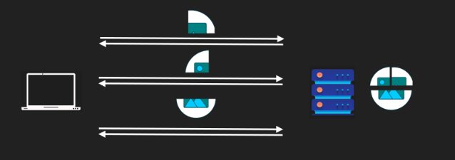
- Break large files into parts (chunks)
- Each chunk is sent as a separate request
- Server reconstructs the full file
- Benefits:
  - Resumable uploads
  - Lower memory usage
  - Better error recovery

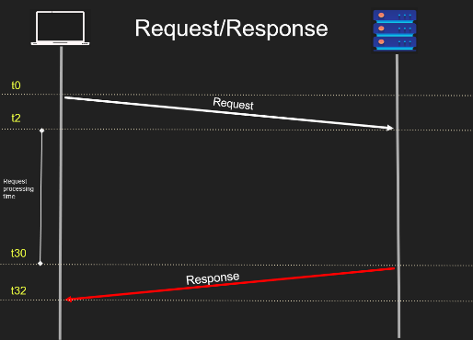
• T-2 to T0: Client serializes and sends the request (e.g., converts a JavaScript object to JSON).
• T0 to T2: Network transfer time (TCP segments, IP packets, potential reordering).
• T2 to T3: Server parses the request to understand its structure.
• T3 to T10: Server processes the request (e.g., database query).
• T30 to T31: Server serializes and sends the response.
• T31 to T32: Network transfer time for the response.
• T32 to T33: Client parses and consumes the response.

Think of the acronym SPPPR (Serialize, Parse, Process, Parse, Respond) to remember the flow:
- Serialize (client prepares request).
- Parse (server reads request).
- Process (server executes request).
- Parse (client reads response).
- Respond (server sends response).

V2

🚀 Push Pattern: Core Idea
The server pushes updates to the client without the client needing to request them every time.

✅ Perfect Use Cases:
- Real-time notifications (e.g., "user X just liked your tweet")
- Chat apps
- Live game scores
- Collaborative editing (e.g., Google Docs updates)

🔄 How It Works
- Connection is established (usually long-lived).
- The server holds this connection open.
- When something important happens (e.g., video uploaded), the server pushes data to all connected clients.
Think of it like the server whispering directly into the client's ear without being asked first.

⚙️ Examples of Protocols & Tools
- WebSockets – Bidirectional protocol used heavily in chat apps and multiplayer games.
- Server-Sent Events (SSE) – Unidirectional (server → client), simpler for streaming updates.
- gRPC (server-streaming) – Client makes one request, then gets a stream of responses.
- RabbitMQ – Queues messages and pushes them to consumers.
- Kafka – Chooses a pull model (for reasons we’ll cover).

📈 Push Pros
- ⚡ Real-time delivery: Instant updates without polling.
- 💬 Natural for events: Makes sense for chat, notifications, feeds.
- 📉 Reduced latency: No need to wait for periodic polling.

⚠️ Push Cons
- ❌ Client must stay online: Otherwise, it misses the data.
- 🔥 Resource-heavy on server: Imagine pushing updates to 100M YouTube subscribers.
- 📉 Overload risk: If the server sends too much, slow clients may crash or fall behind.
- 🧠 Server lacks client state awareness: Can't always tell if client is struggling.
That's why Kafka uses a pull model — consumers control when they fetch data, which avoids overloading them.

🧠 Mental Model (Push vs Pull)
- Push = Server speaks first. Like a teacher broadcasting announcements.
- Pull = Client asks first. Like a student raising a hand to ask a question.
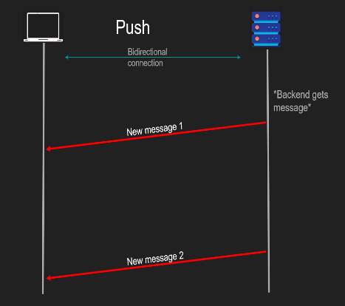

🧪 Bonus Visualization
text
CopyEdit
[Server] →→→ Push data →
← Connection ←
[Client]
The key is the connection. Push requires it to be live -like a pipe you can instantly shoot data through.

✅ Summary
Feature | Request-Response | Push (WebSocket/SSE)
Initiated by | Client | Server (once connected)
Real-time | ❌ | ✅
Works offline | ✅ | ❌
Good for events | ❌ | ✅
Risk of overload | ❌ | ✅
Protocols | HTTP | WebSocket, SSE, gRPC

🔁 Short Polling (a.k.a. Polling)

🔍 What is it?
A design pattern where:
- The client sends repeated requests at short intervals to ask:
"Is my task done yet?"
- The server replies:
  - No, not yet.
  - Or Yes, here’s the result.

🧠 When is it used?
- When backend tasks take time (e.g., video processing, file uploads).
- When real-time feedback is not critical, but eventual result is.
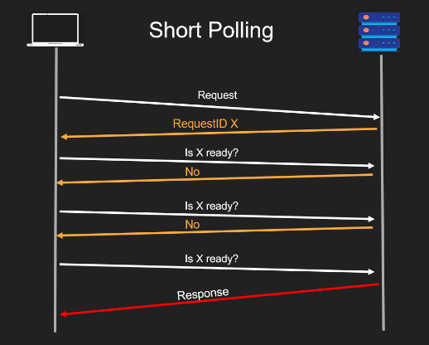

⚙️ How it Works:
- Client sends a request to initiate a task (e.g., video upload).
- Server replies immediately with a handle (job_id, task_id, etc.).
- Client uses this handle to repeatedly ask:
  - “Is the task done yet?”
- Server checks and replies:
  - If not done → return "no"
  - If done → return the result

✅ Pros:
- Simple to implement.
- Works well for asynchronous long-running tasks.
- Client can disconnect and check back later.
- Backend and client are decoupled — less blocking.

❌ Cons:
- Too chatty (frequent network requests).
- Wastes network bandwidth and backend resources.
- Doesn’t scale well when many users are polling frequently.
- High chance of polling for no result (most polls return “not yet”).

📌 Real-World Example:
Imagine uploading a video to YouTube:
- You upload, and get back an upload_id.
- YouTube processes it asynchronously.
- The frontend polls:
“Is processing complete for upload_id XYZ?”
- When it is, the response returns success and processed video info.

🧪 Push vs. Polling Comparison:
Feature | Push | Polling
Real-time | ✅ Yes | 🚫 No (depends on interval)
Network load | ❌ High (server-driven) | ❌ High (client-driven)
Offline support | 🚫 No (client must be online) | ✅ Yes (can resume later)
Scalability | ⚠️ Difficult (stateful) | ⚠️ Difficult (chatty)
Use Case | Chat apps, live updates | Long-running jobs, uploads

🟢 LONG POLLING — "Don’t Talk Until You Have News"
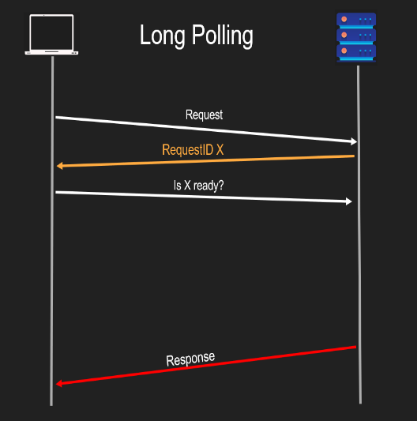
🕓 Pattern:
- Client sends request.
- Server does NOT reply immediately.
- Server waits until there’s new data or status is done, then responds.
- If no data comes before timeout, server responds with "nothing yet."
📦 Use Case:
- Event-driven systems.
- Notification services.
- Message queues (like Kafka consumers).
✅ Pros:
- Less chatty: One request stays open.
- Efficient: No repeated false checks.
- Back-end friendly: Saves bandwidth and CPU.
- Client controls flow: Helps slow clients avoid overload.
❌ Cons:
- Not 100% real-time: If the client gets a message, disconnects, and more data arrives, it may miss them until it reconnects.
- Complex timeout logic: Server/client both need timeout strategies.
- May require connection pooling: Open sockets are limited resources.

🔄 Visual Metaphor
Pattern | Visual | Analogy
Short Polling | ⏰⏰⏰⏰⏰ | “Are we there yet?” every few minutes
Long Polling | 🛎️ (waits silently) | “Tell me when dinner is ready”

🔑 Remember This:
- Short Polling: Frequent pulls regardless of whether there's anything new.
- Long Polling: Persistent pull, server responds only when something new is available.
- Both are still technically based on request-response, just structured differently.

* Quiz:
1. What happens after a client sends a request in the request-response pattern?
A) The client continues without waiting
B) The server sends a response, and the connection stays open
C) The server sends a response and the connection usually closes
D) The server pushes data when it is ready
2. Which of the following best describes the request-response model?
A) Asynchronous communication initiated by the server
B) One-time synchronous communication initiated by the client
C) Real-time, persistent communication
D) One-way communication only
3. In the push model, who initiates the data transfer?
A) Client
B) Server
C) Database
D) Message queue
4. What is a potential problem with the push model?
A) It is too slow for real-time systems
B) It uses long polling underneath
C) The client may be overwhelmed with unsolicited data
D) The server waits too long to respond
5. What is typical behavior in basic polling?
A) The server repeatedly checks for updates
B) The client sends repeated requests to check for updates
C) The server sends updates without a request
D) The client waits silently for changes
6. Why is frequent polling considered inefficient?
A) It delays server response
B) It increases real-time speed
C) It consumes unnecessary bandwidth and CPU
D) It requires a database
7. What does the server do in long polling when data is not ready?
A) Responds with "not ready" immediately
B) Pushes dummy data
C) Waits without responding until data is ready
D) Terminates the connection
8. What is a key advantage of long polling over basic polling?
A) It provides persistent connections
B) It reduces client-side complexity
C) It avoids flooding the server with frequent requests
D) It is faster than WebSockets

