AI_LAB # 03

Github Link: https://github.com/HussnainShah72/AI_LAB
Task_01

Add Label To Message

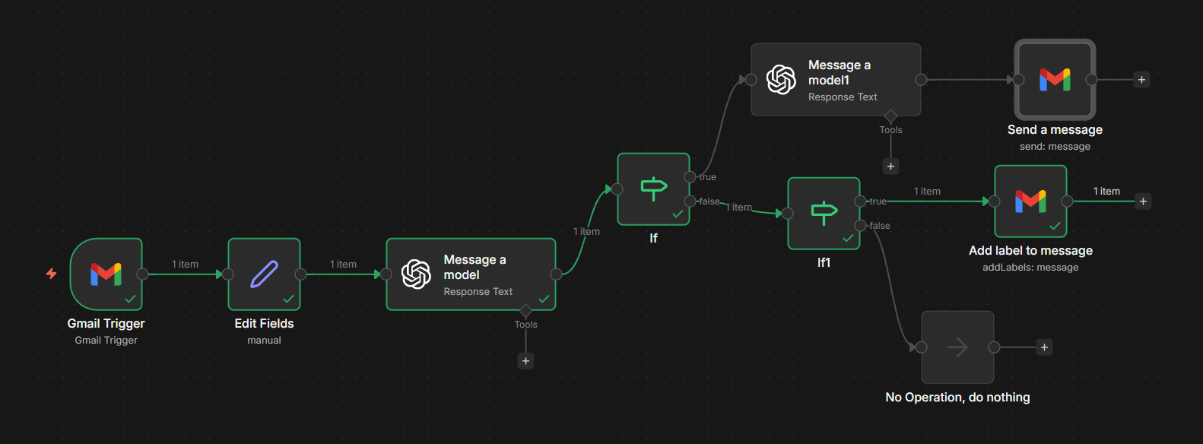

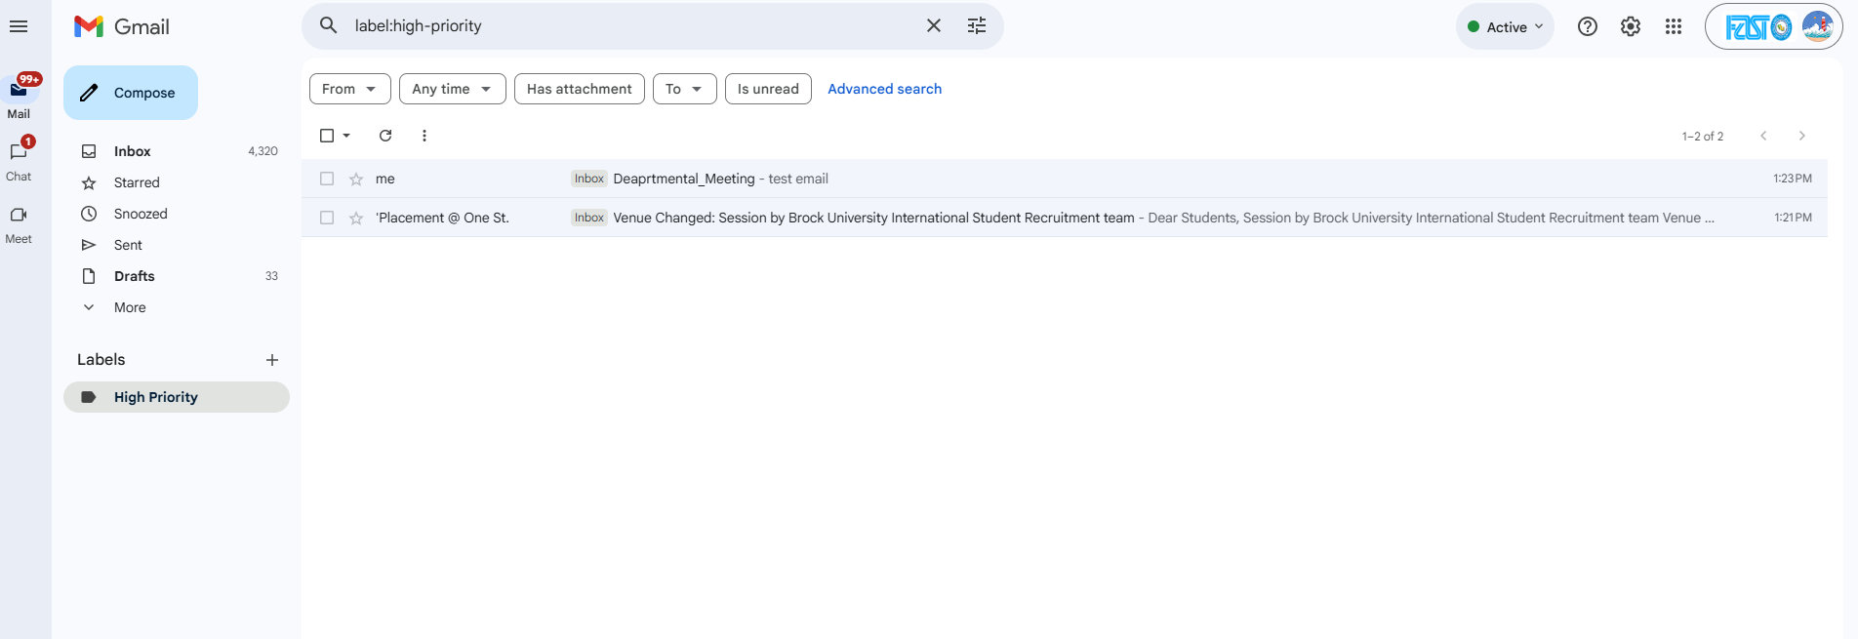

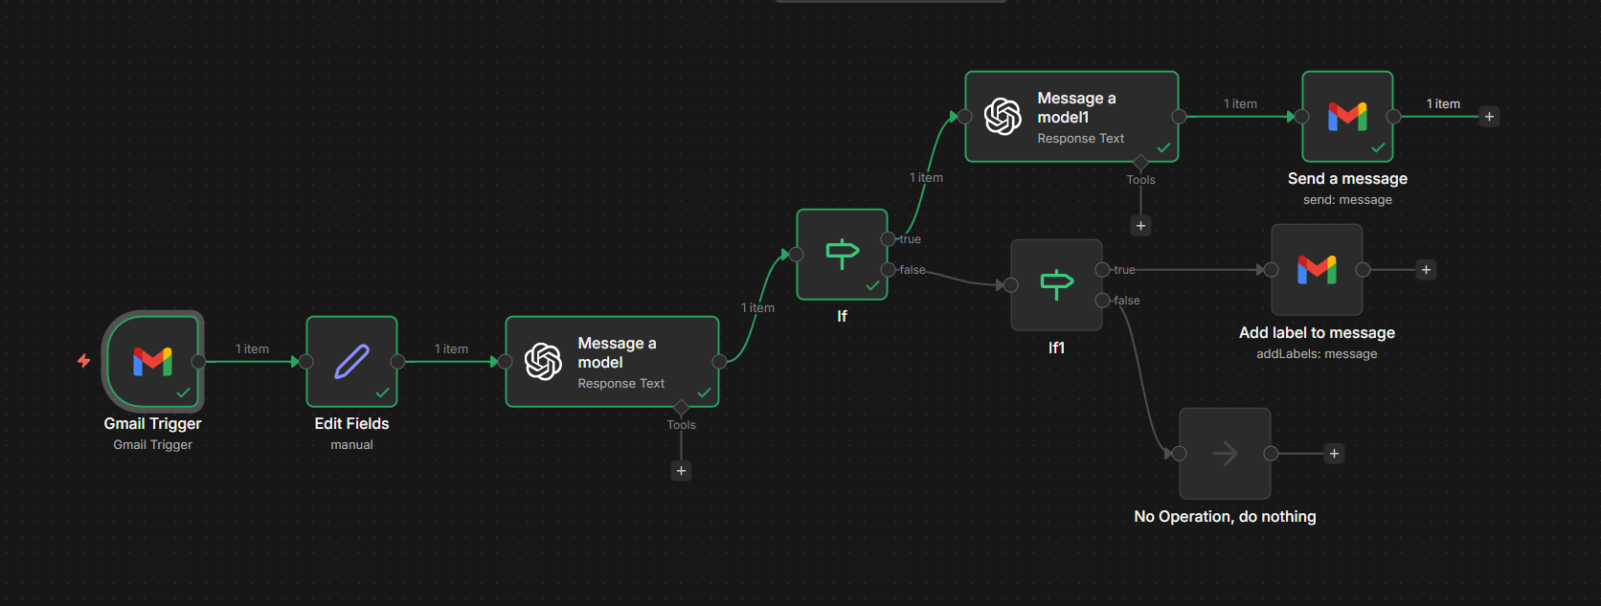

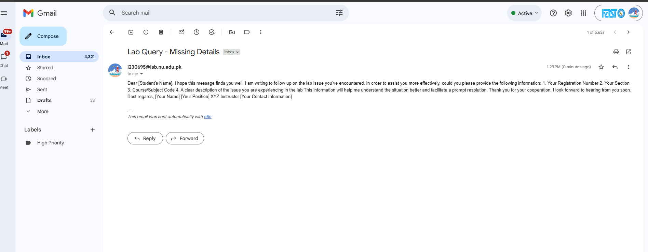

Gmail Account Set
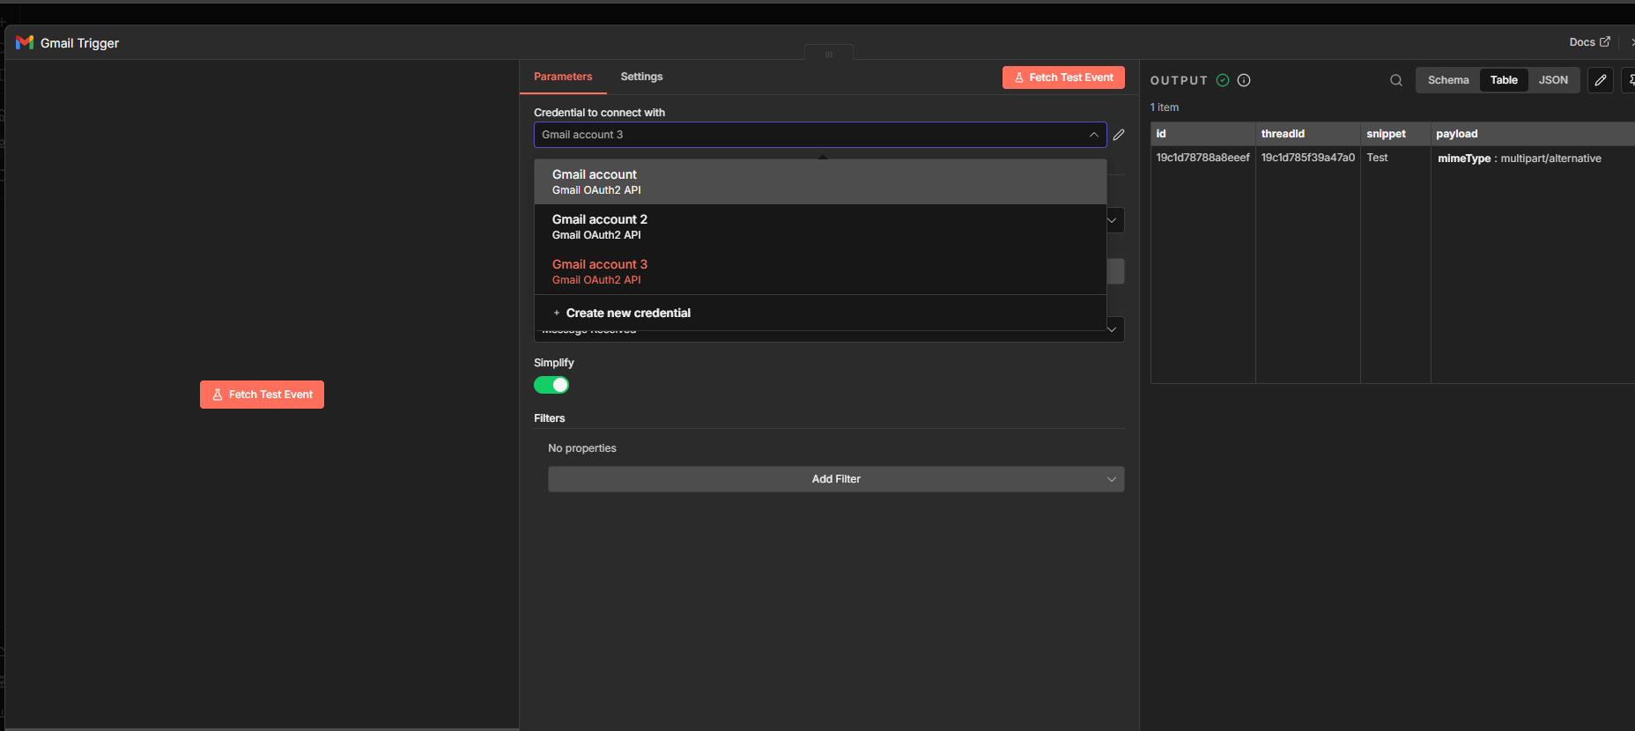

Connected to edit field and add fields of From, Subject and To.

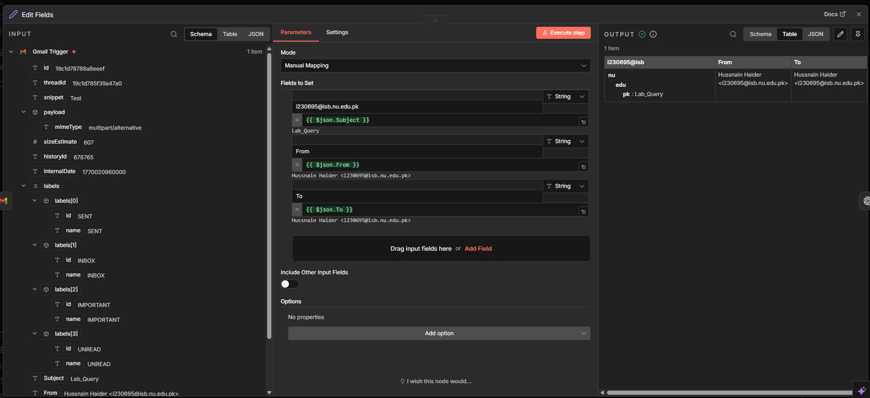

Connected to open ai model 4O.mini and write the given prompt in it.
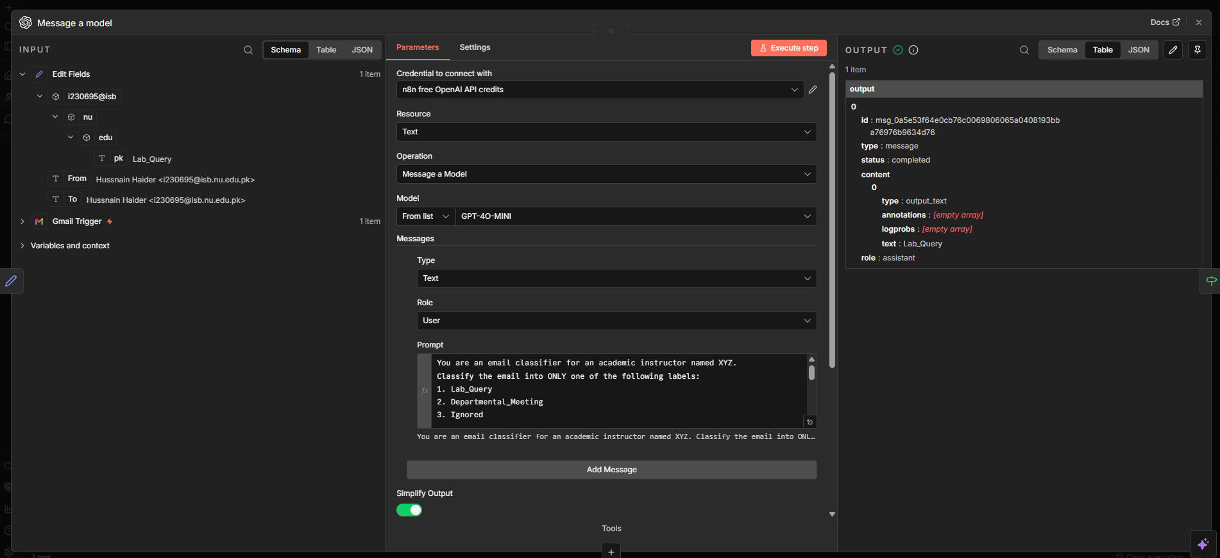

Added the if node in it and added the condition {{ $json["output"][0]["content"][0]["text"] }}.
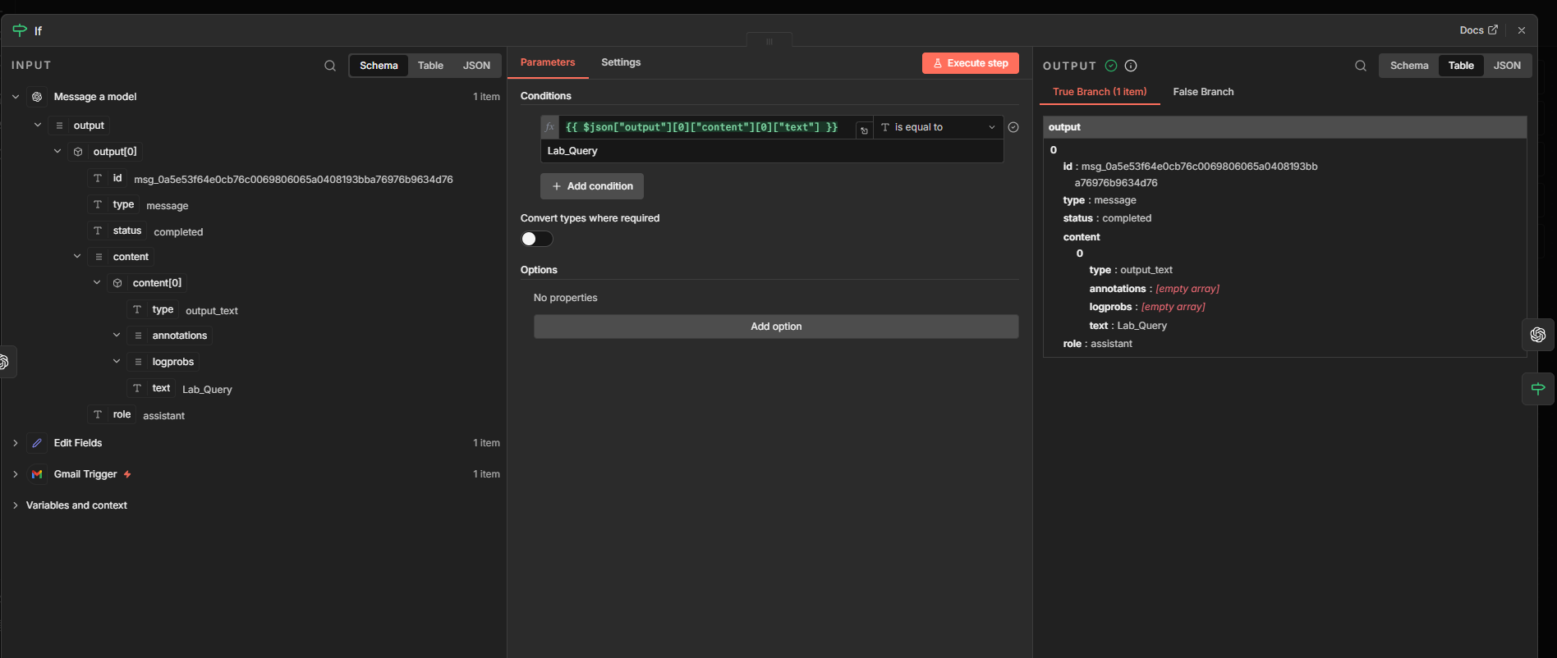

When if node is true it will proceed to another open ai model and added the prompt to generate sample email .
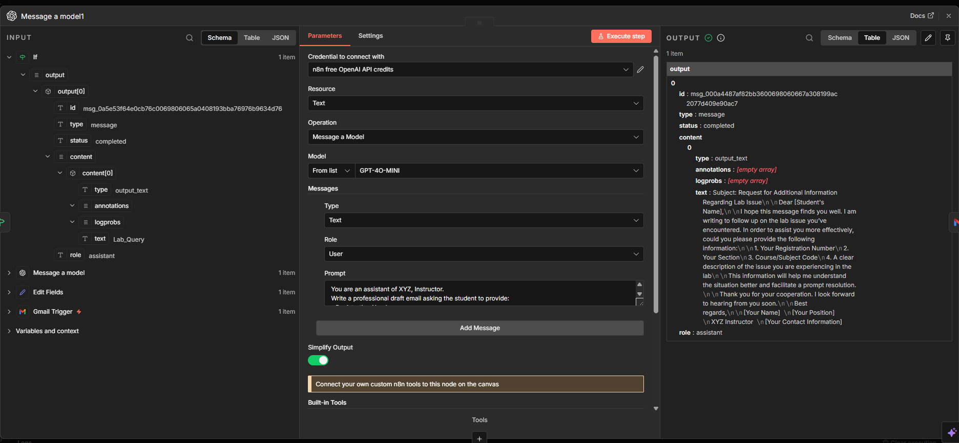

Connect a send a message gmail label .

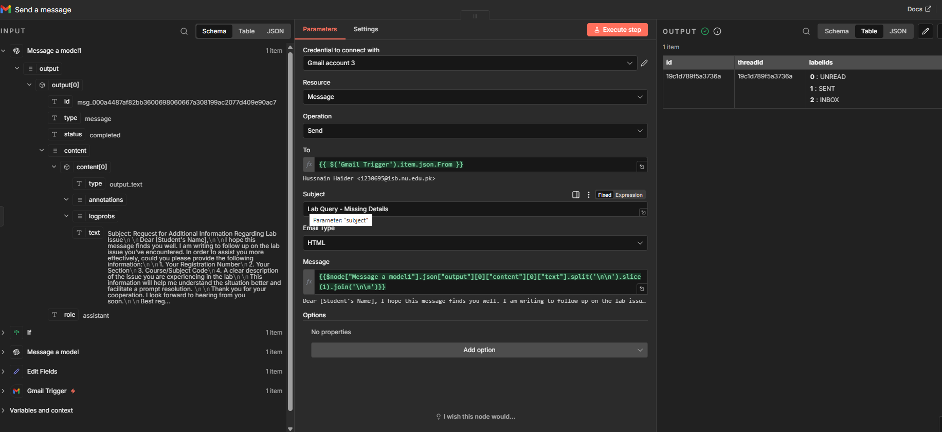

When the first if is false it is connect to add a label to message gmail node
