# Table of contents

# List of graphics

# List of tables

# iris outputs

## Plot

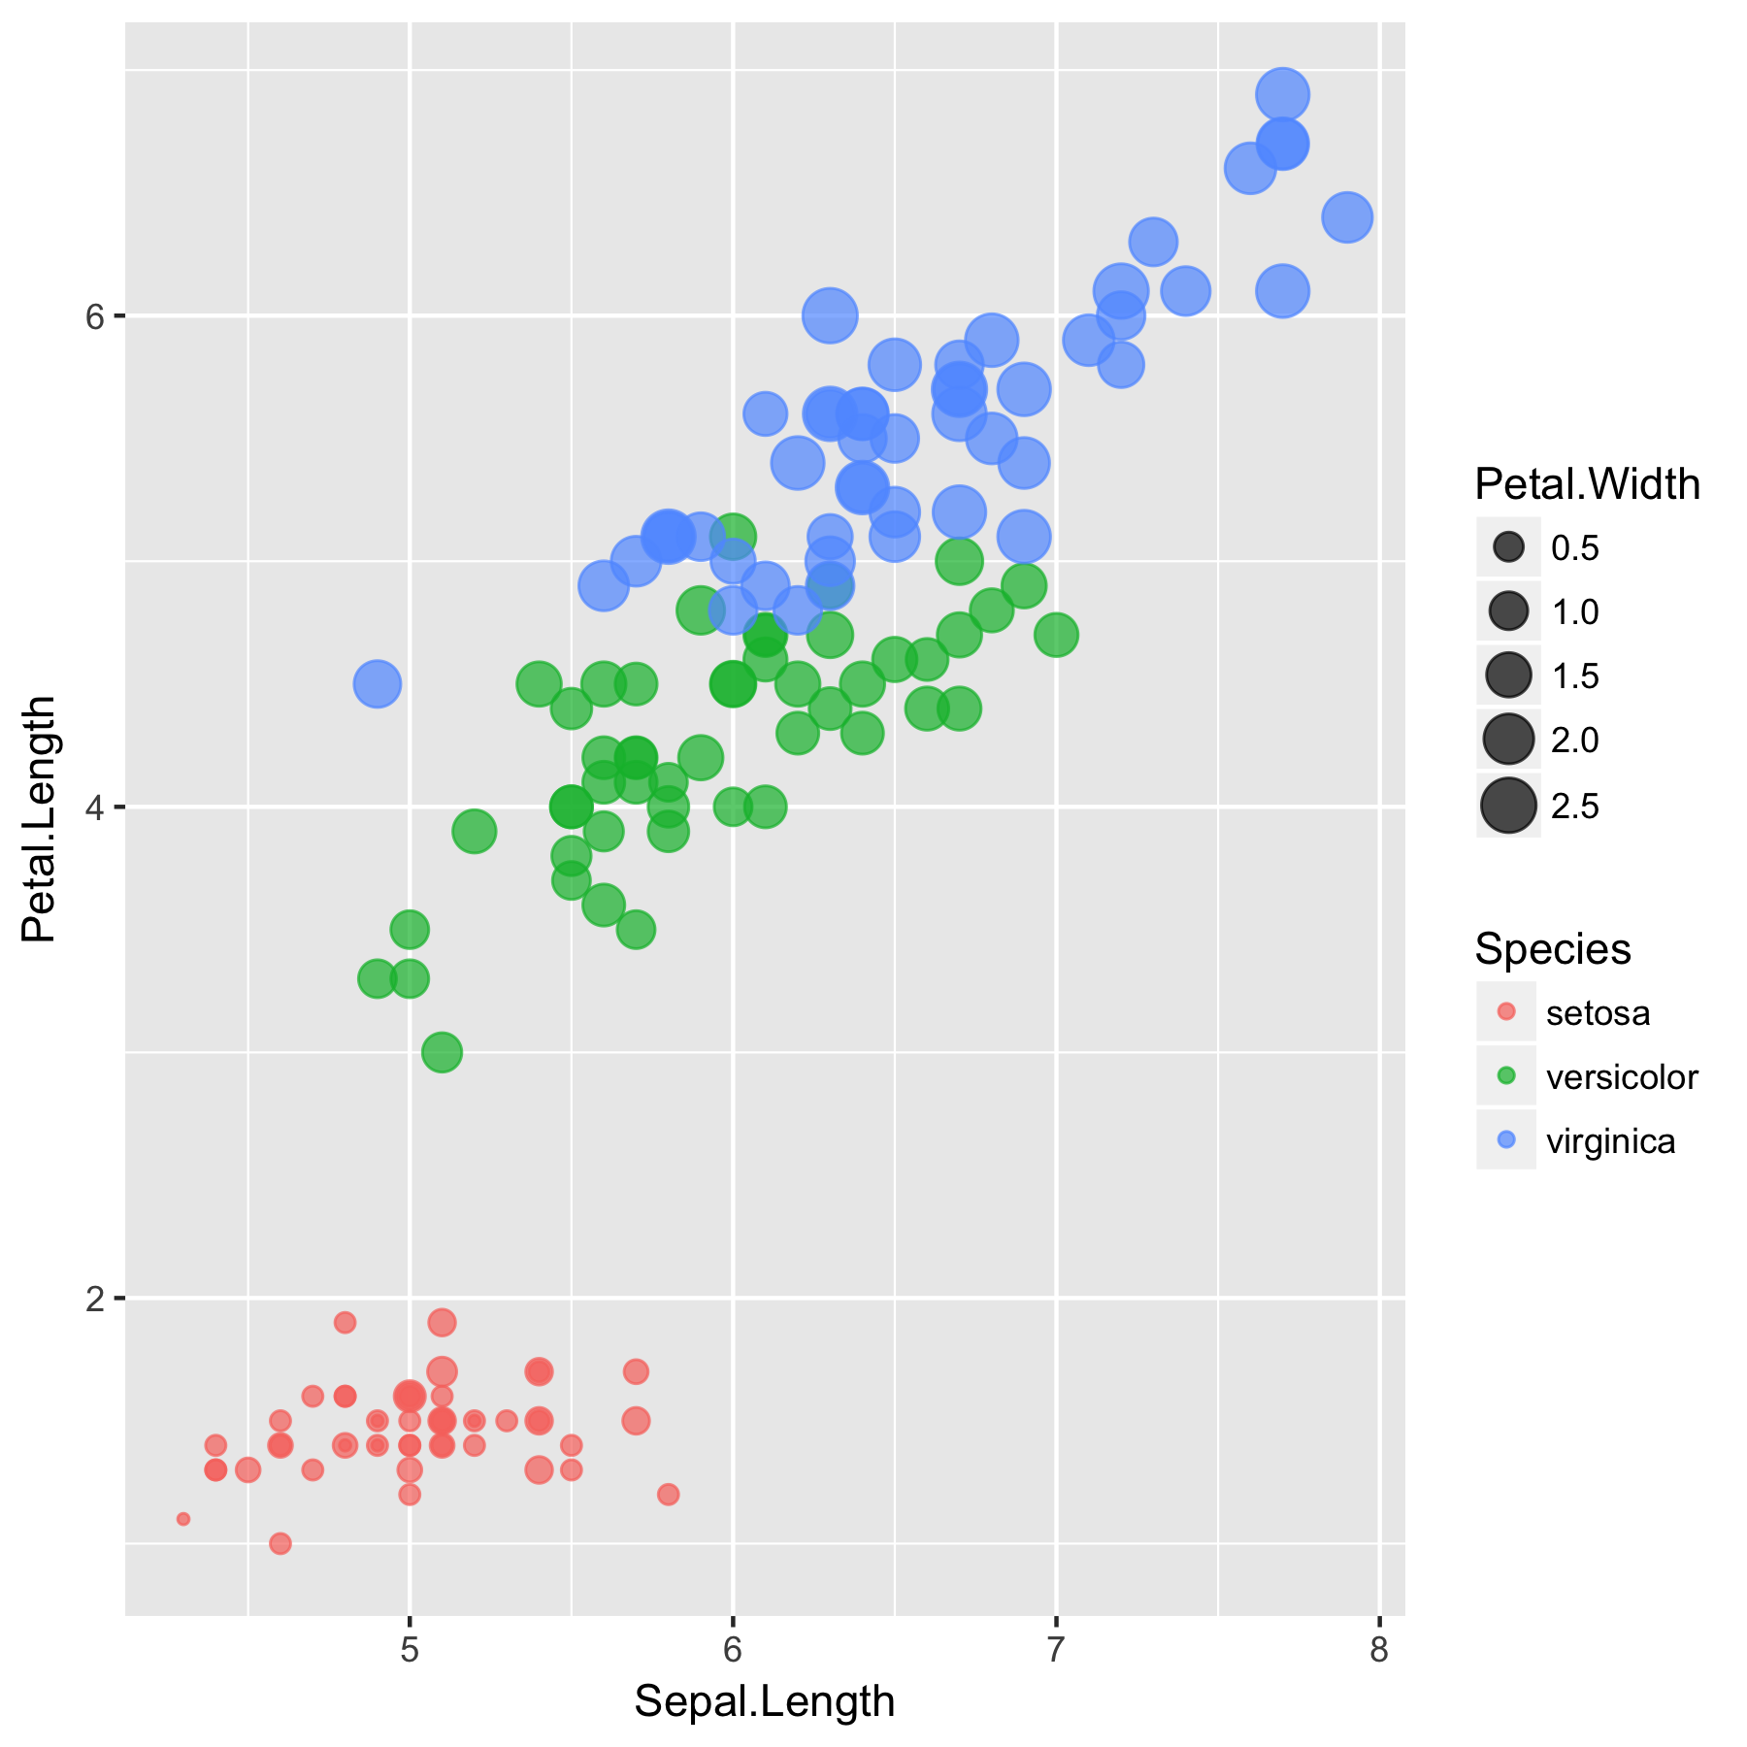

1. iris plot

## Table

| **Sepal.Length** | **Sepal.Width** | **Petal.Length** | **Petal.Width** | **Species** |
| --- | --- | --- | --- | --- |
| 5.1 | 3.5 | 1.4 | 0.2 | setosa |
| 4.9 | 3.0 | 1.4 | 0.2 | setosa |
| 4.7 | 3.2 | 1.3 | 0.2 | setosa |
| 4.6 | 3.1 | 1.5 | 0.2 | setosa |
| 5.0 | 3.6 | 1.4 | 0.2 | setosa |
| 5.4 | 3.9 | 1.7 | 0.4 | setosa |

1. iris table

# mtcars outputs

## Plot

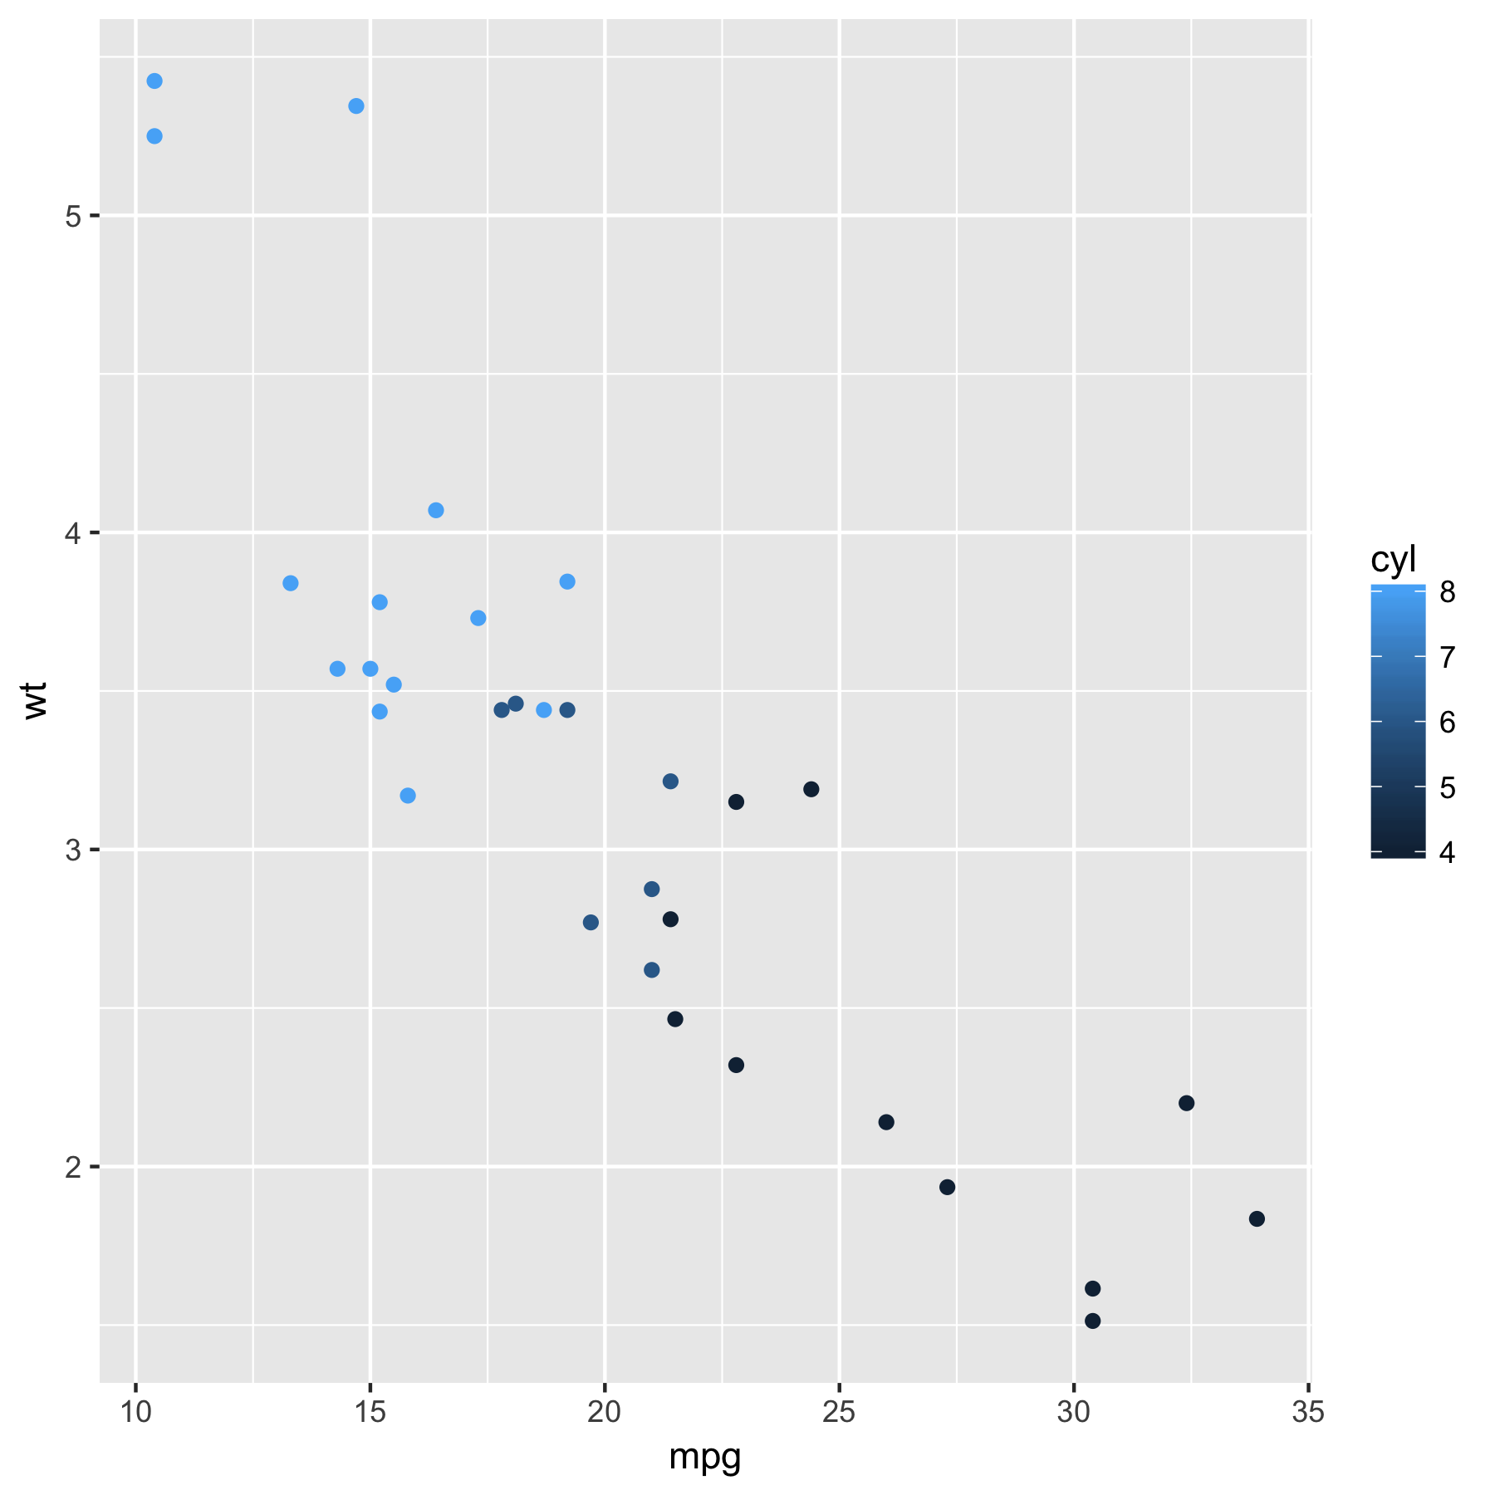

1. mtcars plot

## Table

| **mpg** | **cyl** | **disp** | **hp** | **drat** | **wt** | **qsec** | **vs** | **am** | **gear** | **carb** |
| --- | --- | --- | --- | --- | --- | --- | --- | --- | --- | --- |
| 21.0 | 6 | 160 | 110 | 3.90 | 2.620 | 16.46 | 0 | 1 | 4 | 4 |
| 21.0 | 6 | 160 | 110 | 3.90 | 2.875 | 17.02 | 0 | 1 | 4 | 4 |
| 22.8 | 4 | 108 | 93 | 3.85 | 2.320 | 18.61 | 1 | 1 | 4 | 1 |
| 21.4 | 6 | 258 | 110 | 3.08 | 3.215 | 19.44 | 1 | 0 | 3 | 1 |
| 18.7 | 8 | 360 | 175 | 3.15 | 3.440 | 17.02 | 0 | 0 | 3 | 2 |
| 18.1 | 6 | 225 | 105 | 2.76 | 3.460 | 20.22 | 1 | 0 | 3 | 1 |

1. mtcars table