Hanoi University of Science & Technology

PROJECT REPORT

Demonstration of sorting algorithms on array

Object – Oriented Programming

Instructor: Prof. Nguyen Thi Thu Trang

Group 21

Nguyễn Việt Trung 20214934

Phạm Quang Trung 20214935

Nguyễn Trung Trực 20214936

Phan Đình Trường 20214937

1. Assignment of members

Nguyen Viet Trung- 20214934:

* DataController class
* QuickSort class
* Write report
* Make powerpoint presentation
* Combine code

Nguyen Trung Truc- 20214936

* InsertionSort class
* BubbleSort class
* Make demostration video
* Combine code

Pham Quang Trung- 20214935:

* MenuScreenController
* DemonstrationController
* Combine code

Phan Dinh Truong- 20214937

* MenuScreen.fxml
* Demonstration.fxml
* Combine code

*We make the transaction of the demostration base on:

*https://github.com/chriszq/VisualSortingAlgorithms*

2. Description

2.1 Requirement of the project

A sorting algorithm arranges the items in a list in a specific order. The effectiveness of several different algorithms can be increased by performing efficient sorting. It is challenging to comprehend and recall every sorting algorithm that has been invented to yet. The goal of this project is to provide a graphical application that demonstrates each step of three fundamental sorting algorithms: Bubble sort, Insertion sort, and Quick sort. The GUI was made using JavaFX while the program was constructed in Java.

2.2 Use case explanation

After the user start launching the application, a main menu screen will be shown. In the main menu screen user can:

* Help: Help menu show the basic usage and aim of the program
* Choose a sorting algorithm: Click in one of three buttons corresponding to three algorithms to see the visualization of the sorting

After choosing one of 3 algorithm, the demostration screen will show up. In this screen, user can:

* Create an array randomly: by choosing the length and the type of the array
* Input an array: input the array using a textfield. The application only accepts arrays with elements are integers.
* View sorting steps: after creating an array either randomly or through input, user can click the sort button to see each step of the chosen sorting algorithm on the created array.

3. Design

Relation ship between package:

- DemonstrationController class is associate with DataController class, Unit class, Sort class

- Demonstration associate with DemonstrationController, MenuScreen with MenuScreenController

- Sort class is associated with Unit class

3.2 Several class diagrams

**Package**: data

*Some important method:*

* randomArr: create a random array of elements with given length
* createArr: create an array of Unit with given int array
* move : Move unit to a place with given x value on coordinate axis

**Package**: algorithm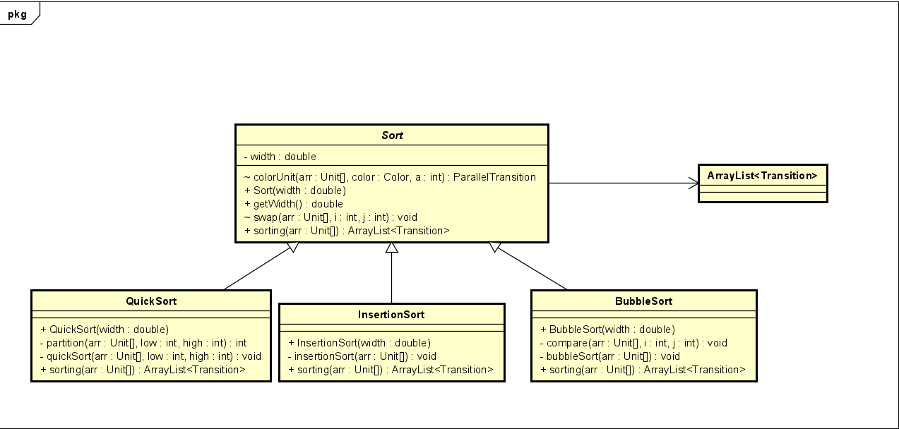*Some important method*:

* swap: Swap two elements in the array and add a parallel transition swapping two corresponding rectangle on the screen.
* colorUnit: add a parallel transition, contains fill transitions of some specific elements.
* BubbleSort: repeatedly comparing swapping the adjacent elements if they are in wrong order
* InsertionSort: The array is virtually split into a sorted and an unsorted part. Values from the unsorted part are picked and placed at the correct position in the sorted part
* QuickSort: It picks an element as pivot and partitions the given array around the picked pivot. In this program, we pick the last element as pivot.

**Packages**: controller + application

*Some important method:*

* handleSortBtn : we set the screen title of the Demonstration screen after the name of algorithm which user clicked at the Menu Screen. So we use that to check whick algorithm user picked and choose correct one to sort.
* HanldeSpeedSlider: you can change the sorting speed