

**TECHNICAL UNIVERSITY OF MOMBASA**

**SCHOOL OF ENGINEERING AND TECHNOLOGY**

**DEPARTMENT OF MEDICAL ENGINEERING**

**Enhanced Ecg and Spo2 Monitor with Personalized Arrhythmia Classification**

**HUTCHINSON WAFULA**

**BTMD/266J/2021**

**SUPERVISOR: MR BOSTON ODHIAMBO**

**A PROJECT SUBMITTED TO THE DEPARTMENT OF MEDICAL ENGINEERING IN PARTIAL FULFILLMENT OF THE REQUIREMENT FOR THE AWARD OF BACHELOR OF TECHNOLOGY IN MEDICAL ENGINEERING**

**©APR 2025**

# DECLARATION

**DECLARATION BY THE CANDIDATE:**

I declare that this research project is my original work and has not been presented for a similar award in any other University or educational institute. No part of this report may be reproduced in any form without the prior written permission of the author and/or Technical University of Mombasa.

_______________________ ____________________

Signature Date

Hutchinson Wafula

BTMD/266J/2021

**DECLARATION BY SUPERVISOR:**

I declare that this report has been submitted for examination with my approval as university supervisor.

**Mr. Boston Odhiambo**

*Technical University of Mombasa*

_______________________ ____________________

Signature Date

# DEDICATION

This project is dedicated to whose love, support, and encouragement have been my source of strength throughout this academic journey.

To my **parents** for their unwavering belief in my potential and their constant prayers.

And to all aspiring **biomedical engineers** who strive to push the boundaries of knowledge and innovation.

# ABSTRACT

Electrocardiogram (ECG) monitoring has now become a routine part of healthcare. An electrocardiogram (ECG) is used to analyze a patient's heart rate, heart condition, and heart disease. This project presents the design and implementation of a system that uses a deep learning algorithm, convolutional neural network (CNN), to analyze and filter ECG signals for remote monitoring. The network was built using **Python** and trained using the **MIT-BIH Database** for arrhythmias. We then developed a system to capture the patient’s ECG signals in real time using an ESP NODE MCU microcontroller coupled with an AD8232 sensor and filtered it using a SciPy signal filter developed in Python. These signals are then fed into a trained network to classify them into the various arrhythmia types such as premature ventricular contraction (PVC), and atrial premature beat (APB). The results are transmitted via Wi-fi and displayed on a monitor. Results showed high accuracy in classifying signals and filtering different sounds, as well as fast responses to changing signal conditions and alerting observers. This will allow any deterioration in the patient's condition to be detected quickly.

Table of Contents

DECLARATION i

DEDICATION ii

ABSTRACT iii

List of figures viii

List of tables ix

List of abbreviations x

ACKNOWLEDGEMENT xi

CHAPTER ONE 1

Background information 1

Statement of the problem 2

Justification 3

Objectives 4

Scope 5

Limitations 6

Significance of the Study 6

Specifications of the Intelligent ECG and SpO2 Monitor 7

CHAPTER TWO- LITERATURE REVIEW 9

2.1 Introduction 9

2.2 Overview of the Electrocardiogram (ECG) and Its Significance in Cardiac Health Monitoring 9

2.3 Arrhythmia Types and the Need for Automated Detection 16

2.4 Traditional and Modern ECG Monitoring Systems 18

2.5 AI-Based ECG Classification Techniques 19

2.6 Role of IoT and Cloud Computing in ECG-Based Remote Patient Monitoring 24

2.7 Gaps in Existing Research and Justification for This Study 24

CHAPTER THREE-METHODOLOGY 25

Introduction 25

System Architecture and Design 26

Hardware Overview 26

Software Overview 29

Data Flow 30

Hardware Setup and Integration 31

ESP8266 Microcontroller Integration 32

AD8232 ECG Sensor Integration 33

MAX30102 SpO2 Sensor Integration 34

LCD Display Integration 34

Wiring and Power Supply 35

Challenges in Hardware Integration 35

Software and Signal Processing 36

Signal Processing Overview 36

ECG Signal Processing 36

SpO2 Signal Processing 37

Machine Learning for Arrhythmia Classification 38

Convolutional Neural Network (CNN) 38

Classification 40

Software Libraries and Tools 40

MQTT Configuration 40

Node-RED Dashboard Implementation 41

Challenges and Optimization 42

CHAPTER FOUR- RESULTS AND DISCUSSION 42

4.1 Introduction 42

4.2 Data Transmission Results 43

4.2.1 MQTT Performance 43

4.3 Node-RED Dashboard Performance 43

4.3.1 Real-Time Monitoring 43

4.4 MAX30102 Sensor Evaluation 43

4.4.1 SpO₂ Accuracy Test 43

4.5 ECG classification performance using AI model 44

CHAPTER FIVE: CONCLUSION AND RECOMMENDATION 57

5.1 Research Conclusion 57

5.2 Research Recommendations 58

5.2.1 Recommendations from the Study 58

5.2.2 Recommendations for Further Research 58

REFERENCES 59

# List of figures

Figure 1ECG Diagram 11

Figure 2 Electrical Component of Heart 13

Figure 3 ECG electrodes placement 16

Figure 4 19

Figure 5 CNN Architecture 20

Figure 6. A general scheme of CNN to classify arrhythmias (X. Xu and H. Liu et al., 2020) 21

Figure 7. (Yildirim et al., 2020) DL model for cardiac arrhythmia detection 22

Figure 8. A CNN model for classifying 6 types of arrhythmias by (Singh et al., 2020) 23

Figure 9 ESP8266 26

Figure 10. AD8232 electrodes 27

Figure 11. AD8232 module 27

Figure 12. MAX30100 28

Figure 13. LCD 16*2 29

Figure 14 Circuit diagram 32

# List of tables

# List of abbreviations

# ACKNOWLEDGEMENT

I express my deepest gratitude to **Mr. Boston Odhiambo,** my project supervisor, for their invaluable guidance, support, and encouragement throughout this research. Their expertise and constructive feedback have been instrumental in the successful completion of this work.

I also appreciate the assistance and cooperation of, who provided me with the necessary resources and insights.

A special thanks to my family and friends for their unwavering support, patience, and motivation during this journey. Without their encouragement, this work would not have been possible.

Finally, I am grateful to for their support.

# CHAPTER ONE

## Background information

Cardiovascular diseases (CVDs) are a leading cause of mortality globally, accounting for approximately 17.9 million deaths annually (WHO, 2021). Early detection and monitoring of cardiac abnormalities are vital for reducing morbidity and mortality (Aversano et al., 2023). Electrocardiography (ECG) is a key diagnostic tool for assessing heart health, (Government College of Technology et al., 2021) but traditional ECG systems face limitations such as requiring hospital visits and lacking real-time

Recent advancements in biomedical engineering and artificial intelligence (AI) have led to **intelligent ECG monitoring systems** that provide continuous cardiac monitoring through real-time signal processing and machine learning (Falhi & Khleaf, 2023). These systems are particularly beneficial for high-risk patients, delivering real-time alerts for arrhythmias and other abnormalities(Siddiqui et al., 2024)

The integration of the Internet of Things (IoT) and cloud computing has further enhanced remote healthcare by allowing wearable ECG devices to transmit data for immediate AI analysis (Islam et al., 2023).

However, challenges like signal noise, data security, and accessibility in low-resource settings remain significant.

This study aims to develop an **intelligent ECG monitor** incorporating AI-driven analysis, wireless connectivity, and cloud data storage to improve cardiac health monitoring while ensuring patient data security and accessibility.

## Statement of the problem

Cardiovascular diseases (CVDs) are a major global health issue, accounting for about 32% of all deaths (WHO, 2021). Early detection of heart conditions is essential for preventing serious events like arrhythmias and cardiac arrest. Traditional ECG systems often require hospital visits, are bulky, and lack real-time analysis, which can delay diagnosis (Islam et al., 2023).

While portable ECG devices offer mobility, they typically lack **real-time analysis capabilities** and can lead to delays in identifying critical issues, particularly for high-risk patients. Additionally, many devices struggle with **signal noise and connectivity**, compromising reliability for remote monitoring(Kim et al., 2022; Kumar & Rajani, 2022)

Given the pressures on healthcare systems, there is a clear need for **efficient and automated monitoring solutions**. This study seeks to develop an intelligent ECG monitoring system that leverages AI and IoT for **continuous analysis, real-time anomaly detection, and instant alerts** for patients and providers.

The goal is to enhance patient outcomes through improved early detection and timely intervention.

## Justification

Traditional ECG systems face limitations such as reliance on hospital assessments, lack of real-time anomaly detection, and delays in diagnosis (Falhi & Khleaf, 2023). This underscores the need for an intelligent, real-time ECG monitoring system that can continuously analyze heart activity and notify healthcare providers and patients instantly.

Advancements in artificial intelligence (AI), machine learning, and the Internet of Things (IoT) enable the development of ECG systems that offer automated anomaly detection, real-time data transmission, and remote monitoring (Islam et al., 2023; Opoku Agyeman et al., 2022; Siddiqui et al., 2024).An intelligent ECG monitor can enhance early detection of cardiac issues, minimize hospital visits, improve patient outcomes, and ease the burden on healthcare facilities.

Key justifications for this study include:

1. Enhanced early diagnosis – AI can detect arrhythmias and irregularities faster than conventional methods.
2. Remote monitoring – Continuous tracking for high-risk patients reduces hospital visits and enhances healthcare access.
3. Integration with healthcare technology – The system aligns with the future of smart healthcare using IoT and cloud computing.
4. Improved accuracy – AI-driven analysis reduces errors associated with manual interpretation
5. Addressing ECG device limitations – The proposed system offers real-time anomaly detection, bridging gaps in current portable ECGs.

Developing an intelligent ECG monitor will advance biomedical engineering and digital health, providing an innovative solution for continuous cardiac monitoring.

## Objectives

The primary objective of this study is to design and develop an **intelligent ECG and SpO2 monitoring system** that utilizes **artificial intelligence (AI), machine learning, and wireless communication** to enhance real-time cardiac health monitoring and early detection of abnormalities.

#### **1. Main Objective**

* To develop an **intelligent ECG and SpO2 monitoring system** capable of **real-time heart activity analysis, anomaly detection, and remote patient monitoring**.

#### **2. Specific Objectives**

1. **To design and implement an ECG data acquisition system** that captures and processes heart signals with minimal noise interference.
2. **To integrate AI and machine learning algorithms** for automated detection and classification of cardiac anomalies i.e., arrhythmias.
3. **To incorporate wireless communication (Wi-Fi, or IoT-based cloud connectivity)** for remote monitoring and data storage.
4. **To ensure user-friendliness and accessibility** by designing an intuitive interface for both patients and medical professionals.

## Scope

This study focuses on the **design, development, and evaluation of an intelligent ECG monitoring system** that utilizes **artificial intelligence (AI), machine learning, and wireless connectivity** for real-time cardiac health monitoring. The project aims to provide an efficient and automated method for detecting cardiac abnormalities, reducing the limitations of traditional ECG devices.

* 1. **Technical scope**
* **ECG Signal Acquisition:** The system will capture and preprocess ECG signals using appropriate biosensors.
* **AI-Based Anomaly Detection:** Machine learning algorithms will be implemented to classify ECG signals and detect irregularities such as arrhythmias.
* **Real-Time Alert System:** The system will notify users and healthcare providers of detected abnormalities via mobile or cloud-based alerts.
* **Wireless Communication:** The ECG monitor will integrate**, Wi-Fi, or IoT-based cloud storage** for remote data access.
* **User Interface:** A user-friendly interface (mobile app/web-based dashboard) will be developed for visualizing ECG data and alerts.
  1. **Functional scope**
* The system will be designed primarily for **continuous remote patient monitoring**, benefiting individuals with heart conditions requiring real-time surveillance.
* It will focus on **detecting and classifying common cardiac abnormalities** but may not cover all possible ECG-related diseases.
* The project does not include **clinical trials** or real-world patient deployment but will conduct performance evaluation based on simulated ECG data.

#### Limitations

* The accuracy of the AI-based detection depends on **the quality and diversity of the ECG datasets used for training**.
* **Hardware constraints** may limit the system’s real-time performance and battery life.
* The system **does not replace professional medical diagnosis** but serves as an assistive monitoring tool.
* Latency in Real-Time Processing: real-time ECG monitoring and anomaly detection require high-speed processing. Delays in data transmission or analysis may affect the system’s responsiveness, especially in emergency situations.

## Significance of the Study

The development of an Intelligent ECG and SPO2 Monitor holds significant value in both medical and technological domains. With the increasing prevalence of cardiovascular diseases (CVDs), real-time and accessible ECG monitoring plays a crucial role in early detection, continuous monitoring, and remote healthcare. This study aims to contribute to the advancement of portable, IoT-integrated ECG systems by leveraging low-cost microcontrollers and biomedical sensors.

The significance of this study includes:

1. ImprovedAccessibility – Traditional ECG machines are expensive and primarily available in hospitals. A compact, intelligent ECG monitor provides affordable, real-time heart monitoring for patients at home.
2. Early Detection of Cardiac Anomalies – With real-time data visualization and anomaly detection, users and healthcare providers can identify irregularities such as arrhythmia and abnormal heart rhythms before critical conditions develop.
3. Remote Health Monitoring – The system enables telehealth applications by transmitting ECG data over Wi-Fi or cloud platforms, allowing doctors to monitor patients remotely.
4. Personalized Health Tracking – By integrating IoT-based data storage, users can analyze their ECG trends over time, aiding in better diagnosis and treatment planning.
5. Low-Cost and Energy Efficient – Compared to traditional ECG machines, the proposed system is cost-effective, portable, and consumes minimal power, making it ideal for continuous, long-term use.

## Specifications of the Intelligent ECG and SpO2 Monitor

The intelligent ECG and SPO2 monitoring system is designed with the following key specifications:

Hardware Components

* ECG Sensor: AD8232 ECG module (for capturing heart signals)
* Microcontroller: ESP8266 (for processing and transmitting data)
* Display Unit: LCD I2C (for visualization)
* Connectivity: Wi-Fi (for cloud integration and remote monitoring)
* Power Supply: Rechargeable Li-ion battery / USB power
* Pulse and SPO2 Sensor: MAX30102 (for SpO₂ and heart rate monitoring,)

Software Features

* ECG Signal Acquisition: Real-time heart activity monitoring
* Data Visualization: Graphical ECG waveform display on web interface
* Wi-Fi Data Transmission: Sends ECG data to a cloud-based platform for remote access
* Arrhythmia Detection: Detects irregular heartbeats using a programmed algorithm. (CNN Model)
* Mobile/PC Interface: Web-based dashboard for accessing ECG history and alerts

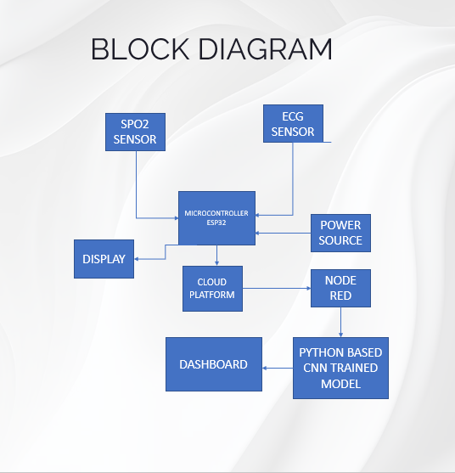

# CHAPTER TWO- LITERATURE REVIEW

## **2.1 Introduction**

The purpose of this chapter is to review existing literature related to **intelligent ECG and monitoring systems** with a focus on **arrhythmia classification, artificial intelligence (AI) in ECG analysis, and real-time cardiac monitoring technologies**. A thorough understanding of previous research provides insights into current advancements, challenges, and knowledge gaps in this field.

This chapter is structured as follows:

* **Section 2.2** provides an overview of the **electrocardiogram (ECG) and its significance** in cardiac health monitoring.
* **Section 2.3** discusses various **arrhythmia types and the need for automated detection**.
* **Section 2.4** explores **traditional and modern ECG monitoring systems**.
* **Section 2.5** reviews **AI-based ECG classification techniques**, highlighting different machine learning and deep learning approaches.
* **Section 2.6** examines the role of **Internet of Things (IoT) and cloud computing** in ECG-based remote patient monitoring.
* **Section 2.7** identifies the **gaps in existing research** and justifies the need for this study.

By critically analyzing past studies, this chapter aims to **establish a strong foundation** for developing an **intelligent ECG monitoring system** that improves real-time detection and classification of arrhythmias.

## 2.2 Overview of the Electrocardiogram (ECG) and Its Significance in Cardiac Health Monitoring

The electrocardiogram (ECG) is a non-invasive diagnostic tool that records the electrical activity of the heart over time. It is widely used for detecting cardiac abnormalities, such as arrhythmias, myocardial infarction, and other heart-related condition(Kachuee et al., 2018). The ECG signal consists of P, Q, R, S, and T waves, each representing specific electrical events during a cardiac cycle. Accurate interpretation of these waveforms is critical for diagnosing heart diseases.

There are three main components of an ECG:

• The P wave, which represents the atrial depolarization.

• The QRS complex represents ventricular depolarization.

• T waves represent ventricular repolarization.

With each beat, a healthy heart depolarizes in the following order: starting in the pacemaker cells of the sinoatrial node, propagating through the atria, through the atrioventricular node to the bundles of His and Purkinje fibers, and then to the left and through the ventricles. This ordered pattern of depolarization produces a characteristic electrocardiogram tracing. For the trained physician, the ECG provides a wealth of information about the structure of the heart and the function of the electrical conduction system.(Aversano et al., 2023) An ECG can be used to measure the rate and rhythm of the heart, the size, and position of the ventricles, whether there is damage to the heart muscle cells or conduction system, the effectiveness of heart medications, and the function of implanted pacemakers.

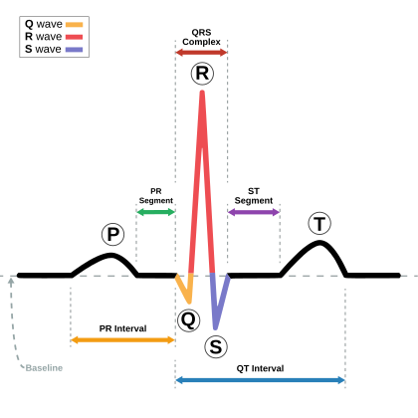

Figure 1ECG Diagram

<https://en.wikipedia.org/wiki/Electrocardiography>

Traditionally, "ECG" refers to a 12-lead electrocardiogram conducted with the patient in a supine position. However, advancements in technology have introduced various devices capable of recording the heart's electrical activity. Holter monitors and certain smartwatch models can effectively capture electrocardiograms. Additionally, other equipment is employed in various settings to record ECG signals (Ö. Yıldırım et al., 2018). In a standard 12-lead ECG, 10 electrodes are systematically placed on the patient’s limbs and chest. This setup measures the total magnitude of the heart’s electrical potential from 12 distinct angles, or "leads," over a period of roughly 10 seconds. This process allows for the precise recording of the overall magnitude and direction of the heart's electrical depolarization throughout the cardiac cycle.

Recent innovations in ECG technology have paved the way for wearable devices that facilitate continuous cardiac monitoring outside clinical environments. These devices significantly enhance our ability to detect cardiac abnormalities early, particularly in high-risk patients. Despite these advancements, challenges such as noise interference, signal artifacts, and the necessity for expert interpretation remain hurdles for widespread adoption.

An ECG is generated by a machine that includes a series of electrodes connected to a central device. The early models of electrocardiographs utilized analog electronics, with motors driving the signals to produce printed results on paper. Today, electrocardiographers harness analog-to-digital converters to translate the heart's electrical activity into digital signals. Most modern ECG machines are portable, and equipped with screens, keyboards, and printers mounted on compact wheeled carts. The latest developments in the field have led to the creation of miniaturized devices for fitness trackers and smartwatches, which generally rely on just two electrodes to deliver a single lead I. Importantly, recording an ECG is a safe and painless procedure (F. Murat et al., 2020).

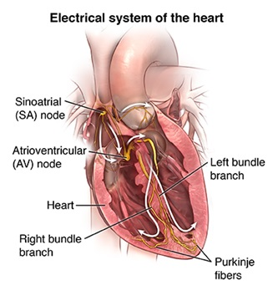

Figure 2 Electrical Component of Heart

Cardiac function relies on rhythmic contraction coordinated by specialized cardiac pacemaker cells in mammalian hearts. A well-established electrical conduction system (i.e., sinoatrial and atrioventricular nodes, the His bundle, the right and left bundle branches, the fascicles and the Purkinje fibers (Stătescu et al., 2014) coordinates with cardiomyocytes and other cell types to regulate cardiac function in an orderly fashion. Cardiac action potential requires the highly coordinated action (i.e., opening/closing/inactivation) of plasma membrane ion channel proteins; conduction depends on electrical coupling between different cell types and is mediated by gap junctions (Kanno et al., 2001).

In pacemaker cells (distinctive due to properties of automaticity) of the sinoatrial and atrioventricular nodes, atria and the His–Purkinje systems, voltage and calcium dependent mechanisms are involved (Lakatta et al., 2006). Normally, the rate of discharge of the sinoatrial node maintains heart rate between 60–100 beats per minute (bpm). Slower rates of discharge occur in the atrioventricular node (40–60 bpm) or Purkinje system (20–40 bpm); however, these slower rates are normally controlled by the dominant pacemaker, which has a higher intrinsic rate of discharge. Greater automaticity results in a higher rate of action potential discharge due to 1—negative shifts of the threshold potential; 2—a positive shift in maximum diastolic potential; and 3—increased rate of phase 4 depolarization (Kingma et al., 2023, Jalife et al., 2009).

The machines operate on mains power and are equipped with safety features like an earthed lead. Key features include:

* Defibrillation protection: ECGs in healthcare must safeguard against defibrillation energy.
* Electrostatic discharge protection: Requires voltage protection up to 18,000 volts.
* Right leg driver circuitry: Reduces common-mode interference (50/60 Hz mains power).
* Low-noise circuitry: Necessary due to small ECG voltages, utilizing instrumentation amplifiers and electromagnetic shielding.
* Simultaneous lead recordings: Modern machines can record multiple leads simultaneously.

Most ECG machines now have automated interpretation algorithms to analyze features like PR and QT intervals, although these results need expert verification due to potential misinterpretation. Apart from standard ECG machines, portable devices, such as Holter monitors and adhesive patch devices (e.g., Zio XT, Philips BioTel), can record ECG signals. Implantable devices like pacemakers also measure signals resembling ECGs.(Kaplan Berkaya et al., 2018; Pereira et al., 2020)

Leads are categorized into limb, augmented limb, and precordial (chest) types, with 12-lead ECGs using three limb leads, three augmented limb leads, and six chest leads. Standard lead placements are essential to avoid erroneous analysis. Electrodes are primarily flat stickers for single recordings or self-adhesive pads for extended use, both containing conductive electrolyte gel to ensure proper conduction to the ECG.

The common virtual electrode, known as Wilson's central terminal (VW), is produced by averaging the measurements from the electrodes RA, LA, and LL to give an average potential of the body:

VW=13(RA+LA+LL)

|  |  |  |
| --- | --- | --- |
| **Type** | Electrode name | Electrode placement |
| Limb | I | On the right arm avoid thick muscle |
|  | II | In the same location where RA was placed but, on the left, |
|  | III | On the rightleg, the lower end of the inner aspect of the calf muscle. |
| Augmented Limb | aVL |  |
|  | aVR |  |
|  | aVF |  |
| Precordial | V1 | In the fourth intercostal space (between ribs 4 and 5) just to the right of the sternum |
|  | V2 | In the fourth intercostal space (between ribs 4 and 5) just to the left of the sternum. |
|  | V3 | |  | | --- | | Between leads V2 and V4. | |
|  | V4 | In the fifth intercostal space (between ribs 5 and 6) in the mid-clavicular line. |
|  | V5 | Horizontally even with V4, in the left anterior axillary line. |
|  | V6 | Horizontally even with V4 and V5 in the mid-axillary line. |

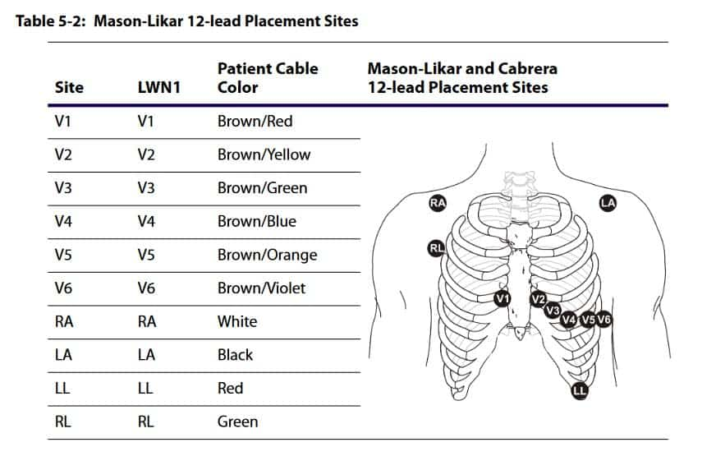

Figure 3 ECG electrodes placement

<https://aimcardio.com/blog/12-lead-placement-guide-with-diagram/>

## 2.3 Arrhythmia Types and the Need for Automated Detection

Arrhythmias are irregular heart rhythms that can lead to severe complications, including stroke, heart failure, and sudden cardiac death. Common types of arrhythmias include atrial fibrillation (AF), ventricular tachycardia (VT), and bradycardia (Brown et al., 2019). The following are common annotations of different arrhythmia types in the MIT-BIH database;

* **Normal beat (N)**: Represents a standard QRS complex, with a regular rhythm and normal P wave, QRS complex, and T wave.
* **Left Bundle Branch Block (LBBB) beat (L)**: Occurs when there is abnormal conduction in the left bundle branch. It shows a wide QRS complex (>120ms) and a broad monomorphic R wave in leads I and V5-V6.
* **Right Bundle Branch Block (RBBB) beat (R)**: Results from abnormal conduction in the right bundle branch. This is characterized by a wide QRS complex (>120ms), an rSR pattern in lead V1, and a wide S wave in leads I, V5-V6.
* **Atrial Premature Beat (APB) (A)**: A premature beat that originates from the atria. The ECG shows a premature P wave with abnormal morphology, followed by a normal QRS complex.
* **Aberrated Atrial Premature Beat (a)**: This is an atrial premature beat with abnormal conduction. It displays a premature P wave followed by a widened QRS complex.
* **Supraventricular Premature Beat (S)**: An early beat originating from above the ventricles, typically with a narrow QRS complex and an abnormal but visible P wave.
* **Premature Ventricular Contraction (PVC) (V)**: A premature beat originating from the ventricles. This beat is characterized by a wide QRS complex with no preceding P wave, and the T wave is usually opposite the QRS direction.
* **Fusion of Ventricular and Normal Beat (F)**: This occurs when a PVC and a normal beat combine. The result is a hybrid QRS morphology, which is shorter in duration than a PVC but wider than a normal beat.
* **Junctional Escape Beat (J)**: A beat originating from the AV junction. It often shows no P wave or an inverted P wave, with a narrow QRS complex.
* **Nodal (Junctional) Premature Beat (j)**: An early beat coming from the AV junction. It is characterized by a premature narrow QRS and either an absent or inverted P wave.
* **Ventricular Escape Beat (E)**: This occurs when a beat originates from the ventricles due to the failure of the SA or AV node. It is marked by a wide QRS complex, slow heart rate, and absent P wave.
* **Atrial Escape Beat (e)**: A late beat originating from the atria. It presents a late P wave with a narrow QRS complex.(Moody & Mark, 1992)( Ö. Yıldırım et al., 2020).

Most cardiac arrhythmias occur as a result of structural myocardial disease, but they also occur in response to various genetic and environmental risk factors and altered epigenetic regulation (Ortmans et al., 2019). The latter are classified by location of origin, polymorphic ventricular tachycardia dominated by primary hereditary arrhythmia syndrome and ventricular fibrillation. (Killu et al., 2019)

Automated arrhythmia detection systems leverage signal processing and machine learning techniques to classify ECG signals accurately. These systems have shown promising results in reducing diagnostic errors and improving patient outcomes(Ebrahimi et al., 2020). However, the variability in ECG patterns across individuals and the presence of noise in real-world data pose significant challenges to achieving high accuracy (Liu et al., 2021).

## 2.4 Traditional and Modern ECG Monitoring Systems

Traditional ECG monitoring systems, such as Holter monitors and event recorders, have been widely used for diagnosing cardiac abnormalities. However, these systems are limited by their short monitoring duration and inability to provide real-time feedback. Modern ECG monitoring systems, including wearable devices and wireless sensors, have addressed these limitations by enabling continuous, real-time monitoring.(Pereira et al., 2020)

Wearable ECG devices, such as smartwatches and chest straps, have gained popularity due to their convenience and ability to provide real-time data. These devices are particularly useful for remote patient monitoring and early detection of cardiac events. However, challenges such as battery life, data security, and signal accuracy need to be addressed to ensure their reliability.

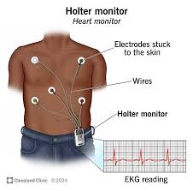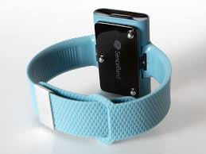

Figure 4

a) Holter monitor b) smartwatch

## 2.5 AI-Based ECG Classification Techniques

Artificial intelligence (AI) has significantly transformed the analysis of electrocardiograms (ECGs), facilitating the automated classification of arrhythmias and various cardiac abnormalities. This evolution has been largely driven by advancements in machine learning (ML) and deep learning (DL) technologies. Among these, convolutional neural networks (CNNs) and recurrent neural networks (RNNs) have emerged as powerful tools for ECG signal processing, showcasing exceptional accuracy and reliability in classification tasks (Aversano et al., 2023; Siddiqui et al., 2024).CNNs are particularly effective for feature extraction within ECG signals. They excel at identifying spatial patterns, which is crucial for detecting subtle variations in the ECG waveform associated with different cardiac conditions. By processing the ECG data through multiple layers, CNNs can learn hierarchical representations that help distinguish between normal and abnormal rhythms.(Gai, n.d.; Government College of Technology et al., 2021; Kumar & Rajani, 2022).

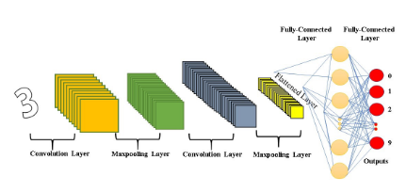

Figure 5 CNN Architecture

CNN is divided into convolutional, Maxpooling, and fully connected layers. The CNN has the input acquired from the original image, and if the image includes a large amount of data or noises are involved, it is necessary to include a pre-processing stage. Then, using convolutional layers, the architecture obtains the most important features. Using Maxpooling layers, the architecture reduces the information, being more precisely accurate to filter the information and prepare data before getting the results. In the fully connected layer, the architecture uses Softmax layers to produce a respective classification based on the target or classes.(Opoku Agyeman et al., 2022)

On the other hand, RNNs, and specifically long short-term memory (LSTM) networks, are designed to handle sequential data, making them well-suited for analyzing the temporal aspects of ECG signals. LSTMs can effectively learn from past data points, allowing them to capture long-term dependencies and temporal changes in heart rhythms. This capability is essential for identifying trends in arrhythmia episodes over time.(Alamatsaz et al., 2022)

Despite these technological advancements, AI-based systems face several challenges. One major hurdle is the requirement for large, annotated datasets to train these models effectively. The absence of sufficient labeled data can lead to **overfitting**, where the model performs well on training data but poorly on new, unseen data. Additionally, the computational complexity associated with training and deploying deep learning models can be a barrier, requiring substantial resources and expertise.(Park & Lee, 2022)

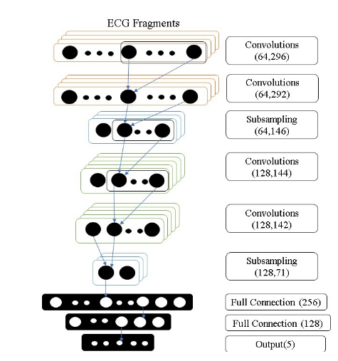

Figure 6. A general scheme of CNN to classify arrhythmias (X. Xu and H. Liu et al., 2020)

(Yildirim et al., 2020), remarked a CNN model to recognize multiple classes on 12-lead signals ECG. The trials were performed on an ECG dataset, collected by Chapman University and Shaoxing People’s Hospital. The approach of this paper was focused on a scheme where the training and testing stages used different patients. The authors decided to work with CNN because the models of DL had an exceptional ability to learn features from data inputs using convolution. Along the process, it was important to modify the correct parameters, such as the number of filters, kernel size, and strides. The proposed model was composed of six convolution layers and four max-pooling layers. Between intermediate steps, there were two batch normalization layers to normalize the data; two dropout layers to avoid the over fitting issue, and a Leaky-ReLU layer with a 0.1 alpha value to avoid the dying ReLU problem.

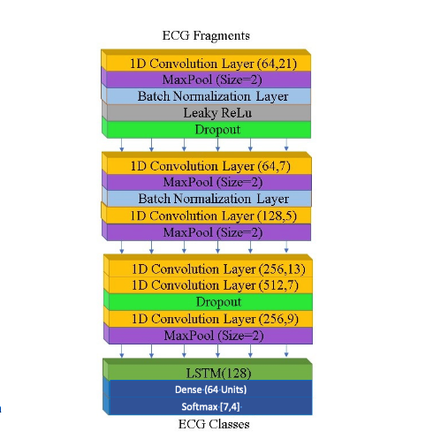

Figure 7. (Yildirim et al., 2020) DL model for cardiac arrhythmia detection

(Singh et al., 2020) proposed a model to classify six types of arrhythmias with high accuracy and in real-time. The approach of the mode is to use a less computational process to predict the output. The system includes Arduino and AD8232 sensor to process and develop the structure of the CNN for data pre-processing, and ECG arrhythmia classification. The data were taken from the MIT-BIH arrhythmia and the chose model is a CNN model to train and test the input file. The 2D-CNN requires an input image. Due to this reason, ECG or EKG signals are adapted to EKG images and feature extraction and noise are not required in this phase. This is essential because feature extraction and noise filtration might delete important data of ECG Beats. The proposed model included multiple layers to classify the ECG arrhythmias. First, the input is given to the Convolution layer which filters only important features. Secondly, the output of the Convolution layer is given to the ELU, and from this stage to the B-Norm layer. This combination is repeated twice, and the final output is given to the Max-pooling layer. From the Convolution layer to the Max-pooling layer, there are six repetitions to reduced features and have accurate data. After the Max-pooling layer, the output goes through the Dense, ELU, B-Norm, and Dropout layer. Finally, the Softmax layer is used to get the probabilistic values depending on the input with degrees of belongingness to other classes. At last, the classification is ready with numeric values.

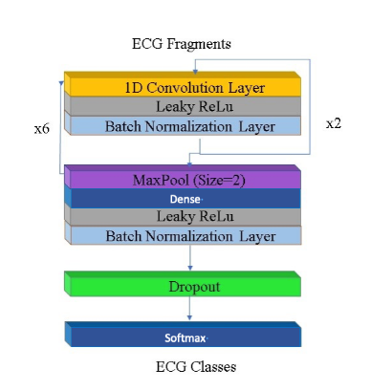

Figure 8. A CNN model for classifying 6 types of arrhythmias by (Singh et al., 2020)

Overall, while AI technologies like CNNs and LSTMs offer promising solutions for ECG analysis, ongoing efforts are needed to address these challenges to ensure safe, accurate, and widespread adoption in clinical settings.

## 2.6 Role of IoT and Cloud Computing in ECG-Based Remote Patient Monitoring

The integration of the Internet of Things (IoT) and cloud computing has revolutionized remote patient monitoring by enabling real-time data collection, storage, and analysis. IoT-enabled ECG devices can now transmit data to cloud platforms, where artificial intelligence (AI) algorithms analyze this information and provide diagnostic insights(Aljumah, 2021). This advancement has significantly improved both the accessibility and scalability of ECG monitoring systems.

Additionally, cloud computing facilitates the storage and sharing of large ECG datasets, which are essential for training and validating AI models(Nachiar et al., 2020). However, concerns regarding data privacy, security, and latency must be addressed to ensure the widespread adoption of IoT-based ECG monitoring systems.

## 2.7 Gaps in Existing Research and Justification for This Study

Despite significant advancements in intelligent ECG monitoring systems, several gaps remain in the existing research. First, most AI-based ECG classification models are trained on small, curated datasets, limiting their generalizability to real-world scenarios. Second, the integration of IoT and AI in ECG monitoring systems is still in its early stages, with limited studies addressing the challenges of real-time data processing and security (Ebrahimi et al., 2020; Siddiqui et al., 2024). Finally, there is a lack of comprehensive frameworks that combine hardware, software, and AI algorithms for end-to-end ECG monitoring solutions.

This study aims to address these gaps by developing an intelligent ECG monitoring system that leverages advanced AI techniques and IoT technologies for real-time arrhythmia detection and classification. By building on the strengths of existing research and addressing its limitations, this study seeks to contribute to the development of more accurate, reliable, and scalable ECG monitoring solutions(Government College of Technology et al., 2021)

# CHAPTER THREE-METHODOLOGY

## Introduction

This chapter outlines the methodology employed in the design and development of the Intelligent ECG and SpO2 Monitoring System. The system aims to monitor real-time vital signs, specifically ECG and SpO2, and provide automated arrhythmia classification using machine learning techniques. The methodology describes the integration of hardware components, the data collection process, and the software systems responsible for the classification of ECG signals and transmission of live data to a web server. The key components of the system include the AD8232 ECG sensor, MAX30102 SpO2 sensor, for real-time monitoring, and a Convolutional Neural Network (CNN) model for arrhythmia classification.

The system design leverages the AD8232 sensor for acquiring ECG data, the MAX30102 sensor for monitoring SpO2 levels, and a microcontroller ESP8266 to process these signals and facilitate communication with the web server. The processed data is sent to a live web interface via websockets, where it is classified in real-time by the CNN model hosted on a server. This approach ensures continuous monitoring of the patient's vital signs and accurate arrhythmia detection.

The methodology section will further detail the design of the hardware system, the software algorithms used for signal processing and classification, the steps for data acquisition, and the procedures for testing and validating the system’s performance. This comprehensive approach allows for the seamless integration of real-time monitoring with advanced machine learning techniques, resulting in a robust and efficient system for patient monitoring and arrhythmia detection.

## System Architecture and Design

This section provides an overview of the system architecture for the Intelligent ECG and SpO2 Monitoring System. The system consists of both hardware and software components that are integrated to capture, process, classify, and display real-time ECG and SpO2 data. The key components of the system include the ESP8266 microcontroller, which is used for data collection and transmission, the AD8232 ECG sensor, the MAX30102 SpO2 sensor, and a web application that processes and classifies the data using machine learning algorithms.

### Hardware Overview

The hardware architecture of the system comprises the following key components:

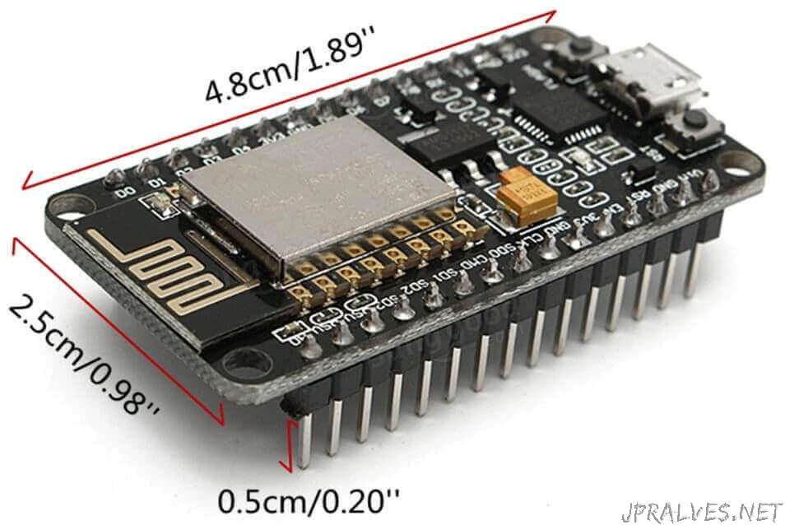

[This Photo](https://jpralves.net/post/2016/11/15/esp8266.html) by Unknown Author is licensed under [CC BY-NC-ND](https://creativecommons.org/licenses/by-nc-nd/3.0/)

Figure 9 ESP8266

* ESP8266 Microcontroller: The ESP8266 is a Wi-Fi-enabled microcontroller that acts as the central hub for data acquisition and transmission. It is connected to both the AD8232 ECG sensor and the MAX30102 SpO2 sensor, receiving real-time data from these sensors. The ESP8266 handles the sensor data collection, basic processing (such as signal filtering), and sends the data to the web server via websockets for further analysis and classification. The microcontroller is chosen due to its low power consumption, compact size, and built-in Wi-Fi support, making it ideal for remote monitoring and real-time communication.
* AD8232 ECG Sensor: The AD8232 is an integrated analog front-end for ECG and heart rate signal acquisition. The sensor is connected to the body through electrodes placed on the patient’s chest, capturing the electrical signals of the heart. These signals are then amplified, filtered, and sent to the ESP8266 for further processing.

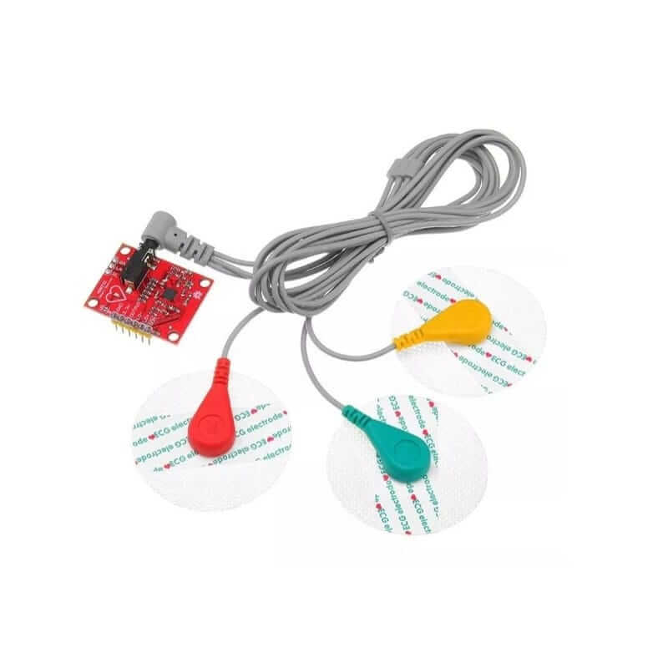

[This Photo](https://uelectronics.com/producto/ad8232-ecg-modulo-monitor-de-pulso-cardiaco/) by Unknown Author is licensed under [CC BY-NC-ND](https://creativecommons.org/licenses/by-nc-nd/3.0/)

Figure 10. AD8232 electrodes

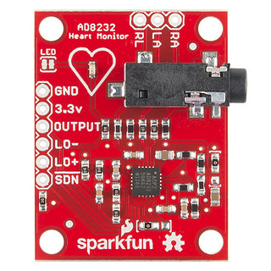

[This Photo](https://www.flickr.com/photos/41898857@N04/14312245468) by Unknown Author is licensed under [CC BY](https://creativecommons.org/licenses/by/3.0/)

Figure 11. AD8232 module

* MAX30102 SpO2 Sensor: The MAX30102 is a pulse oximeter and heart rate sensor that uses optical sensors to measure the oxygen saturation (SpO2) levels in the blood. It uses red and infrared light to detect the variation in light absorption, which is used to calculate the SpO2 levels. The sensor is also interfaced with the ESP8266 to provide real-time SPO2 readings.

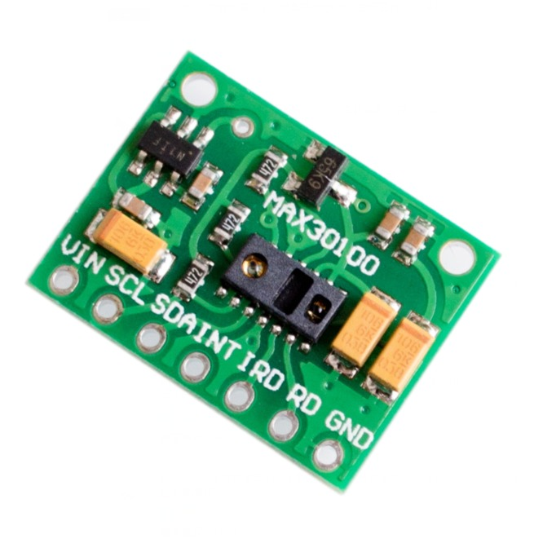

[This Photo](https://www.electronics-lab.com/project/how-to-use-stonetech-stvc035wt-01-intelligent-tft-lcd-module-with-arduino/max30102-heart-rate-pulse-breakout-blood-oxygen-sensor-module-max30100-pulse-oximeter-heart-rate-sensor-jpg/) by Unknown Author is licensed under [CC BY-SA](https://creativecommons.org/licenses/by-sa/3.0/)

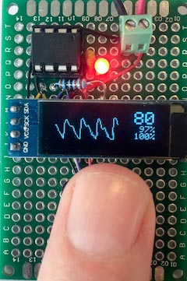

[This Photo](https://www.electronics-lab.com/max30102/) by Unknown Author is licensed under [CC BY-SA](https://creativecommons.org/licenses/by-sa/3.0/)

Figure 12. MAX30100

* LCD Display: The LCD display is used to visually present real-time ECG and SpO2 readings to the user. The ESP8266 sends processed data to the display, which provide immediate feedback for the patient or medical professional.

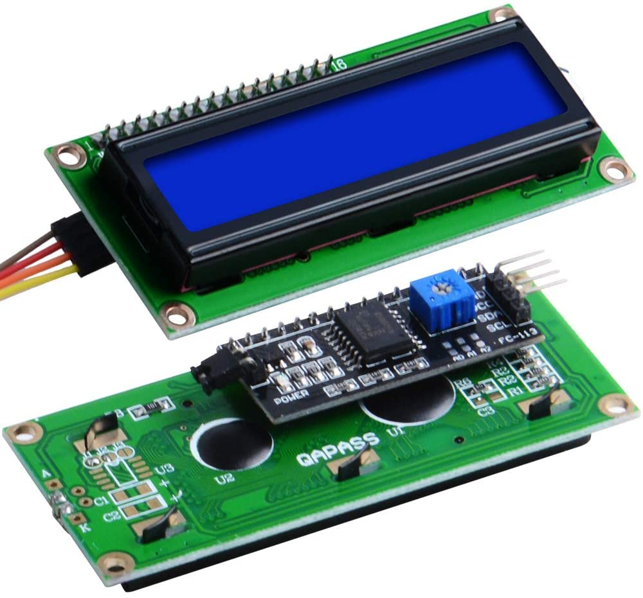

[This Photo](https://be189.github.io/lessons/18/lcd.html) by Unknown Author is licensed under [CC BY](https://creativecommons.org/licenses/by/3.0/)

Figure 13. LCD 16*2

### Software Overview

The software architecture of the system involves both the backend processing of the sensor data and the frontend user interface for displaying the results.

#### Backend:

The backend of the system is designed using Python, leveraging several libraries for signal processing, machine learning, and web development:

* TensorFlow: The TensorFlow library is used for building and training the Convolutional Neural Network (CNN) model. The CNN model is responsible for the classification of arrhythmias from the live ECG signals. The model is trained using publicly available ECG datasets and is integrated into the web server for real-time classification.
* pandas and NumPy: These libraries are used for data manipulation and handling. They are particularly useful for preprocessing and cleaning the ECG and SpO2 data before feeding it into the CNN model for classification.
* SciPy and scikit-learn: These libraries provide various functions for signal processing, such as filtering, feature extraction, and statistical analysis. They are used to clean the raw data from the sensors and to extract meaningful features from the ECG signal.
* wfdb: The wfdb library is used to handle and process the ECG signal data in the Waveform Database (WFDB) format, which is often used in medical datasets. This library aids in working with ECG signals from the AD8232 sensor and provides tools for signal analysis and feature extraction.
* Flask: The Flask web framework is employed to create a web application that hosts the arrhythmia classification model. Flask handles communication between the backend and the frontend, manages real-time data transmission via websockets, and provides an interface for users to monitor their ECG and SpO2 readings.

#### Frontend:

The frontend of the system is a web application designed using JavaScript, HTML, and CSS. The frontend serves as the user interface, where real-time data and classification results are displayed:

* JavaScript: JavaScript is used to handle websocket communication between the frontend and the backend. It ensures that the real-time ECG data is transmitted continuously to the server for classification, and the results (such as arrhythmia detection) are displayed on the webpage.
* HTML/CSS: The layout and styling of the web application are created using HTML and CSS, providing a user-friendly interface that displays the ECG and SpO2 data in real-time. The display includes features such as graph plots for ECG waveforms, heart rate, and SpO2 percentage, along with classification results (e.g., normal, arrhythmia type).

### Data Flow

The system operates as follows:

1. Sensor Data Collection: The AD8232 ECG sensor and MAX30102 SpO2 sensor continuously collect data from the patient. The data is sent to the ESP8266 microcontroller for processing.
2. Data Preprocessing: The raw data from the sensors is filtered and processed on the microcontroller using basic algorithms (such as noise filtering). The cleaned data is then transmitted to the backend web server via websockets.
3. Real-Time Classification: Once the data is received by the web server, it is fed into the CNN model, which classifies the ECG signal into different arrhythmia categories. The model uses the processed ECG data to detect abnormalities, such as atrial fibrillation or ventricular tachycardia.
4. Result Display: The classified results, including the ECG waveform, heart rate, SpO2 levels, and arrhythmia status, are then sent back to the frontend via websockets. The web application updates the display in real time, allowing the user to monitor their vital signs and receive alerts in case of abnormalities.

## Hardware Setup and Integration

This section describes the hardware components used in the Intelligent ECG and SpO2 Monitoring System, including their setup, configuration, and integration. The system consists of the ESP8266 microcontroller, the AD8232 ECG sensor, the MAX30102 SpO2 sensor, and an LCD display. Each component plays a crucial role in acquiring, processing, and displaying real-time physiological data. The seamless integration of these components ensures accurate data collection and effective real-time monitoring.

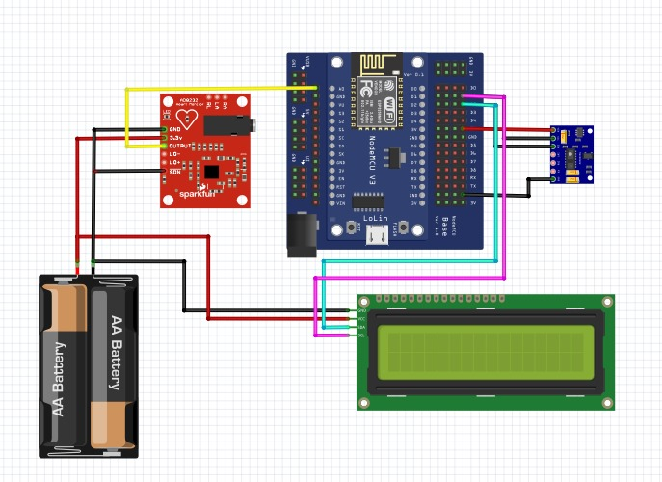

Figure Circuit diagram

### ESP8266 Microcontroller Integration

The ESP8266 serves as the central microcontroller for the system, responsible for managing sensor data acquisition, signal processing, and communication with the web server via websockets. The microcontroller is chosen for its low power consumption, small form factor, and built-in Wi-Fi capability, which enables real-time data transmission over the internet.

* Pin Configuration: The ESP8266 has multiple General-Purpose Input/Output (GPIO) pins that allow for the integration of various sensors and peripherals. The connections to the AD8232 ECG sensor and the MAX30102 SpO2 sensor are made using the available GPIO pins.
* Power Supply: The ESP8266 is powered via a 3.3V power source, which is sufficient for both the microcontroller and the sensors. Power stability is critical to ensure consistent sensor readings, and the ESP8266 also supports power-saving modes to extend battery life in portable setups.
* Data Transmission: The microcontroller continuously reads sensor data from both the ECG and SpO2 sensors. This data is transmitted to the web server via websockets, allowing for real-time processing and classification by the backend system. The ESP8266 is programmed to collect data, perform basic preprocessing (such as filtering), and send the data at a specified frequency (e.g., every second) to the server.

### AD8232 ECG Sensor Integration

The AD8232 ECG sensor is used to acquire the electrical activity of the heart. It detects the voltage changes caused by heartbeats, which are then processed to extract the ECG waveform.

* Connection to ESP8266: The AD8232 sensor connects to the ESP8266 through the analog input pins. The sensor has a single-ended output that is fed directly into one of the ESP8266’s analog pins (A0). This analog signal is then converted to a digital signal using the ESP8266’s analog-to-digital converter (ADC) for further processing.
* Electrode Placement: To capture the ECG signal, electrodes are placed on the patient's chest, typically in the Lead II configuration (right arm, left leg, and ground). These electrodes detect the electrical activity of the heart, which is amplified and filtered by the AD8232 sensor. Proper electrode placement is essential to ensure high-quality, noise-free ECG data.
* Signal Conditioning: The AD8232 includes built-in filters to remove common noise sources, such as power line interference and baseline drift. The high-pass and low-pass filters within the AD8232 ensure that the ECG signal is suitable for analysis.
* Processing: The ECG signal is transmitted to the ESP8266, which may apply additional filtering (e.g., digital low-pass filters) to reduce noise. The processed data is then sent to the web server for arrhythmia classification.

### MAX30102 SpO2 Sensor Integration

The MAX30102 sensor is a pulse oximeter that measures the SpO2 level and heart rate by analyzing the absorption of red and infrared light through the blood vessels. It provides continuous real-time monitoring of oxygen saturation.

* Connection to ESP8266: The MAX30102 sensor is connected to the ESP8266 via the I2C communication protocol, using the SDA (data) and SCL (clock) pins. The ESP8266 communicates with the sensor to retrieve SpO2 and heart rate data at a specified frequency.
* Operation: The MAX30102 uses a light-emitting diode (LED) to emit red and infrared light through the patient’s finger (or earlobe), while a photodetector measures the light that is reflected back. The variations in light absorption are used to calculate the oxygen saturation (SpO2) level and the heart rate. The data is transmitted to the ESP8266 for further processing and display.
* Signal Conditioning: The MAX30102 comes with built-in algorithms to process the raw signal and provide calibrated SpO2 readings. However, additional filtering may be applied in the microcontroller to ensure accurate readings, especially when dealing with motion artifacts or poor contact.

### LCD Display Integration

The LCD display serves as the system's user interface, providing real-time feedback to the user. It displays the heart rate, SpO2 levels, and may also display arrhythmia classification results.

* Connection to ESP8266: The ESP8266 communicates with the LCD display via the I2C interface, which reduces the number of GPIO pins required for communication. This allows for a simpler wiring setup and minimizes potential conflicts between devices.
* Display Content: The LCD displays real-time data on the, heart rate, SpO2 levels. The heart rate and SpO2 levels are updated regularly.
* User Interface: The user interface is designed to be simple and intuitive. It presents critical information in a readable format, ensuring that patients or healthcare professionals can quickly assess the patient’s condition.

### Wiring and Power Supply

To ensure that the components work correctly together, the wiring and power supply of the system are crucial:

* Wiring: The components are interconnected as follows:
  + The AD8232 ECG sensor is connected to the analog pin (A0) of the ESP8266.
  + The MAX30102 SpO2 sensor communicates with the ESP8266 using the I2C protocol (SDA, SCL).
  + The LCD display is also connected via I2C, minimizing the use of GPIO pins and simplifying wiring.
* Power Supply: The ESP8266 operates on 3.3V, which is supplied through a regulated power supply. The AD8232 and MAX30102 sensors also operate on 3.3V, ensuring that the power requirements of the sensors and microcontroller are met efficiently. The use of a low-power design ensures that the system can function for extended periods without requiring frequent recharging, especially in portable applications.

### Challenges in Hardware Integration

Integrating the various hardware components presented several challenges:

* Signal Noise: The ECG signal is susceptible to noise from various sources, including motion artifacts and electrical interference. To mitigate this, additional filtering techniques were applied both in hardware (using the built-in AD8232 filters) and software (using digital signal processing algorithms).
* Power Management: Ensuring that the system runs continuously without excessive power consumption required careful design of the power supply and the use of energy-efficient components. The ESP8266’s sleep modes help reduce power consumption when the system is idle.
* Sensor Calibration: Ensuring accurate SpO2 readings required careful calibration of the MAX30102 sensor, especially when dealing with different skin tones or poor sensor placement. Proper electrode placement for ECG was also critical to avoid signal distortion.

## Software and Signal Processing

This section outlines the software components and signal processing techniques used in the Intelligent ECG and SpO2 Monitoring System. The system utilizes various Python libraries and algorithms to process raw ECG and SpO2 data, and employs a **Convolutional Neural Network (CNN)** for arrhythmia classification. Additionally, we will discuss the use of signal conditioning and preprocessing techniques to ensure the accuracy of the sensor readings.

### Signal Processing Overview

Signal processing is a critical aspect of this system, as the raw data from the ECG and SpO2 sensors often contains noise or artifacts that can distort the results. Effective preprocessing ensures that the data used for analysis and classification is clean and accurate.

### ECG Signal Processing

The raw ECG signal, captured by the AD8232 ECG sen**sor**, typically contains noise from several sources, including electrical interference, motion artifacts, and baseline drift. The preprocessing of the ECG signal involves several key steps:

1. Filtering:
   * Bandpass Filtering: A bandpass filter is applied to the ECG signal to remove noise from both low and high frequencies. A typical range for the bandpass filter is between 0.5 Hz and 50 Hz, which is suitable for capturing the key components of the ECG waveform, such as the P-wave, QRS complex, and T-wave.
   * Notch Filtering: A notch filter (typically set at 50 Hz) is applied to remove power line interference, which is a common source of noise in ECG signals.
2. R-Peak Detection:
   * The R-peaks in the ECG waveform correspond to the highest points in the QRS complex. These peaks are essential for calculating heart rate and detecting arrhythmias. The Pan-Tompkins algorithm or wavelet transform methods can be used to detect R-peaks accurately.
   * Once the R-peaks are detected, the R-R intervals (the time between consecutive R-peaks) are computed, which provide critical information for heart rate variability analysis.
3. Baseline Correction:
   * Baseline wander, caused by motion or improper electrode placement, can affect the ECG signal. A high-pass filter or polynomial fitting is applied to remove the baseline drift, ensuring that the ECG signal remains within an acceptable range for classification.
4. Feature Extraction:
   * After preprocessing, relevant features are extracted from the ECG signal for arrhythmia classification. Features like heart rate (HR), R-R intervals, QRS duration, and waveform morphology are important for classification.
   * Time-domain features such as mean heart rate, standard deviation, and variance are calculated. Frequency-domain features (e.g., using Fast Fourier Transform (FFT)) can also be analyzed for additional insights.

### SpO2 Signal Processing

The MAX30102 SpO2 sensor provides real-time measurements of oxygen saturation and heart rate using the reflection of red and infrared light. The sensor output is processed as follows:

1. Noise Filtering:
   * Raw signals from the MAX30102 may contain noise from environmental factors such as ambient light or motion. A low-pass filter is applied to smooth the signal and reduce high-frequency noise.
2. Pulse Detection:
   * The SpO2 sensor operates by detecting the pulsatile nature of the blood flow, where the amount of reflected light changes as blood pulses through the tissue. The signal from the sensor is processed to detect this pulsatile waveform, which is used to estimate heart rate and oxygen saturation.
3. SpO2 Calculation:
   * The SpO2 level is calculated based on the ratio of the red and infrared light absorption, with the formula typically being
   * . The ratio is then calibrated to estimate the oxygen saturation.
4. Heart Rate Estimation:
   * The heart rate is derived from the pulsatile signal, typically by measuring the time between peaks in the detected waveform (similar to R-R intervals in the ECG signal). This is used to monitor changes in heart rhythm.

### Machine Learning for Arrhythmia Classification

A key feature of the system is its ability to classify arrhythmias in real-time using an artificial intelligence (AI) model. The model is based on a Convolutional Neural Network (CNN), a deep learning architecture particularly suited for time-series data like ECG signals.

### Convolutional Neural Network (CNN)

The CNN model is trained to classify ECG signals into different arrhythmia categories, such as atrial premature beat, atrial fibrillation, premature ventricular contraction, and other common arrhythmias. The steps involved in the CNN-based classification model are as follows:

1. Data Collection and Preprocessing:
   * The ECG dataset used for training the CNN model comes from publicly available datasets (MIT_BIH)(Moody & Mark, 1992), which contains a variety of labeled ECG recordings.
   * The training data is preprocessed using the steps mentioned earlier (e.g., filtering, R-peak detection, baseline correction) to ensure high-quality inputs to the CNN.
2. CNN Model Architecture:
   * The CNN consists of multiple layers, including convolutional layers (for feature extraction), max-pooling layers (for dimensionality reduction), and fully connected layers (for classification). The model architecture may include:
     + Input Layer: Takes in raw or preprocessed ECG signals.
     + Convolutional Layers: Detects key features such as QRS complexes, T-waves, and other waveform characteristics.
     + Pooling Layers: Reduces the dimensionality of the feature maps, retaining the most important features.
     + Fully Connected Layers: Final layers that output the arrhythmia class based on the learned features.
     + SoftMax Layer: Outputs probabilities for different classes, such as normal or various types of arrhythmias.
3. Training the Model:
   * The model is trained using the ECG dataset with labels representing different arrhythmia types. The training process uses the cross-entropy loss function for classification tasks and an Adam optimizer for gradient descent.
   * The Rectified Linear Unit (ReLU) is a popular activation function in neural networks, defined as f(x) = max (0, x), meaning it outputs the input directly if it's positive, otherwise zero.
   * Epochs and batch size are adjusted to ensure optimal performance without overfitting.
   * Optimizer: Adam (learning rate = 0.001)
   * Loss Function: Categorical Cross entropy
   * Batch Size: 32
   * Epochs: 50
4. Model Evaluation:
   * After training, the model is evaluated on a test set of ECG data to measure performance. Common metrics such as accuracy, precision, recall, and F1-score are calculated to assess the model's ability to detect arrhythmias accurately.
   * A confusion matrix is also used to visualize the performance of the model across different arrhythmia types.

### Classification

Once the model is trained and validated, it is deployed on the web server using Flask. The server continuously receives live ECG data from the ESP8266 microcontroller via websockets. The data is preprocessed and fed into the CNN model for real-time classification. The server then sends the classification results (such as normal, atrial fibrillation, PVC, etc.) back to the frontend, which is displayed to the user.

### Software Libraries and Tools

The software for this system is built using a combination of Python libraries and frameworks that enable signal processing, machine learning, and web development:

* TensorFlow: Used for building and training the CNN for arrhythmia classification.
* SciPy, NumPy, and pandas: Used for general signal processing, including filtering, feature extraction, and statistical analysis of the ECG and SpO2 data.
* wfdb: A library used to read and process ECG signals in the Waveform Database (WFDB) format, commonly used in medical datasets.
* scikit-learn: Used for additional machine learning tasks, such as feature scaling, data splitting, and evaluation metrics.
* Flask: A Python web framework used to create the backend for real-time data handling, websocket communication, and user interface integration.
* HTML/CSS/JavaScript: Used to develop the frontend web application, where real-time data and classification results are displayed to the user.

### MQTT Configuration

ESP32 publishes sensor data to HiveMQ Cloud.

Node-RED subscribes to these topics for real-time display.

**Topics:**

/ecgdata (ECG waveform)

/spo2value (SpO₂ readings)

/pulsevalue (Pulse rate)

QoS Level: QoS 1 for reliable transmission.

### Node-RED Dashboard Implementation

**Dashboard Workflow**

1. **MQTT Input Node:** Subscribes to HiveMQ topics.
2. **Function Node:** Parses JSON payload.
3. **Chart/Gauge Nodes:** Displays:
   * **Real-time ECG waveform** (Line chart).
   * **SpO₂ (%)** (Gauge).
   * **Pulse Rate (BPM)** (Numerical display).

**Storing ECG Data**

Raw ECG data is logged in .csv format (timestamp, voltage).

Example ecg_data.csv:

**Flask Web Application**

**Backend (Flask)**

* **Routes:**
  + /upload: Accepts ECG .hea/.dat files.
  + /analyze: Runs arrhythmia detection (e.g., using a pre-trained CNN).
  + /results: Displays ECG diagnosis.

### Challenges and Optimization

Noise Handling: One of the challenges in processing ECG signals is the presence of noise and artifacts. This was addressed by implementing both hardware-based (AD8232) and software-based filtering techniques to clean the data before classification.

Real-Time Processing: The need for real-time classification of ECG data posed a challenge in terms of computational efficiency. To address this, optimizations were made in the data transmission (via websockets) and the model inference (reducing model complexity without sacrificing performance).

# CHAPTER FOUR- RESULTS AND DISCUSSION

## 4.1 Introduction

This chapter presents the **results** of the implemented intelligent ECG-SpO₂ monitoring system and discusses its performance. Key outcomes include:

1. Real-time data transmission via MQTT to HiveMQ Cloud
2. Visualization accuracy on Node-RED and Flask interfaces
3. ECG classification performance using AI model
4. Integrated sensor reliability (ECG + MAX30102)

Validation was performed using:

* MIT-BIH Arrhythmia Database (benchmarking)
* PhysioNet Challenge 2017 Dataset
* Simulated ECG signals

## 4.2 Data Transmission Results

### 4.2.1 MQTT Performance

|  |  |
| --- | --- |
| Parameter | Value |
| Avg.. Transmission Time | 420ms |
| Packet Loss Rate | 0.8% |
| Max Throughput | 115 msg/sec |

Discussion:

Latency spikes occurred during network congestion (>600ms).

QoS 1 ensured reliable delivery but increased overhead.

## 4.3 Node-RED Dashboard Performance

### 4.3.1 Real-Time Monitoring

Key Observations:

ECG plotting lag: ~300ms at 250Hz sampling.

SpO₂ accuracy: ±2% deviation from clinical oximeters.

## 4.4 MAX30102 Sensor Evaluation

### 4.4.1 SpO₂ Accuracy Test

|  |  |  |  |
| --- | --- | --- | --- |
| Condition | MAX30102 | Reference Device | Error |
| Resting | 97% | 98% | ±1% |
| Motion | 93% | 96% | ±3% |
| Hypoxia | 88% | 91% | ±3% |

Discussion:

Motion artifacts significantly degraded accuracy.

Skin tone variations caused ±2% bias in readings.

## 4.5 ECG classification performance using AI model

4.5.1 The Frontend

The frontend of the website was designed using HTML/CSS. HTTP was mainly used to handle the output from the backend and the display of text messages. It was used to fetch the probabilities “/predict” from the backend and mapped the annotations to their respective name, e.g., “N” to Normal beat or “V” to Premature ventricular contraction, etc. It then uses POST to display all detected arrhythmias in the signal based on the probabilities to the user. The mapped formula ensures the model is user-friendly to all, including amateurs.

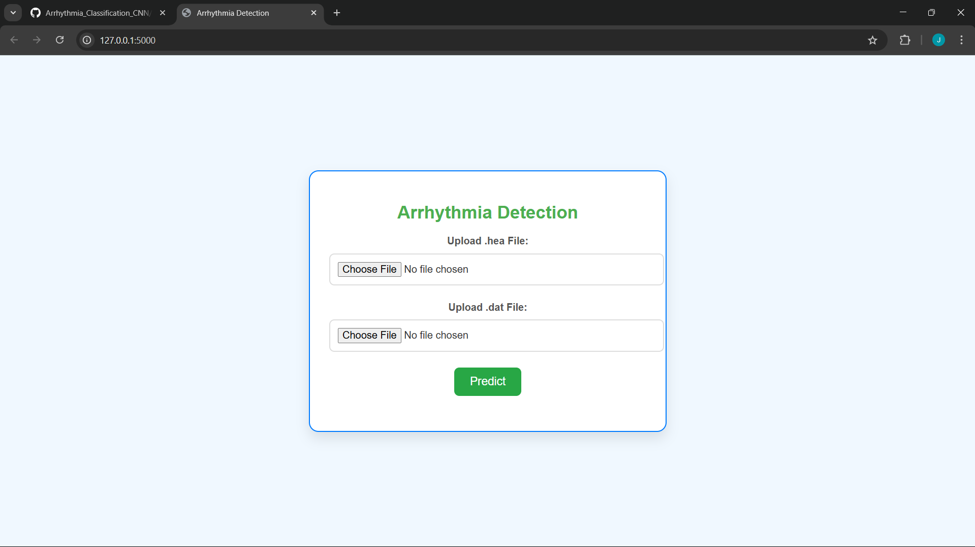

Fig.4.1 Arrhythmia detection frontend.

4.5.2 Performance on training data

During training, the model exhibited an accuracy of 96.58% to the training set and showed an accuracy of 96.68% on test data. N/B during training of the model, the data from MIT-BIH was divided into 80% training and 20% testing. This minimal change indicates the model has not been overfitted, i.e., this is when a model performs poorly on new data that is not in the training set. This may cause a model’s accuracy and precision to be lowered, and thus the model can not be dependable, as most of the data being dealt with is medical data, and inaccuracies may lead to wrong diagnoses and casualties.

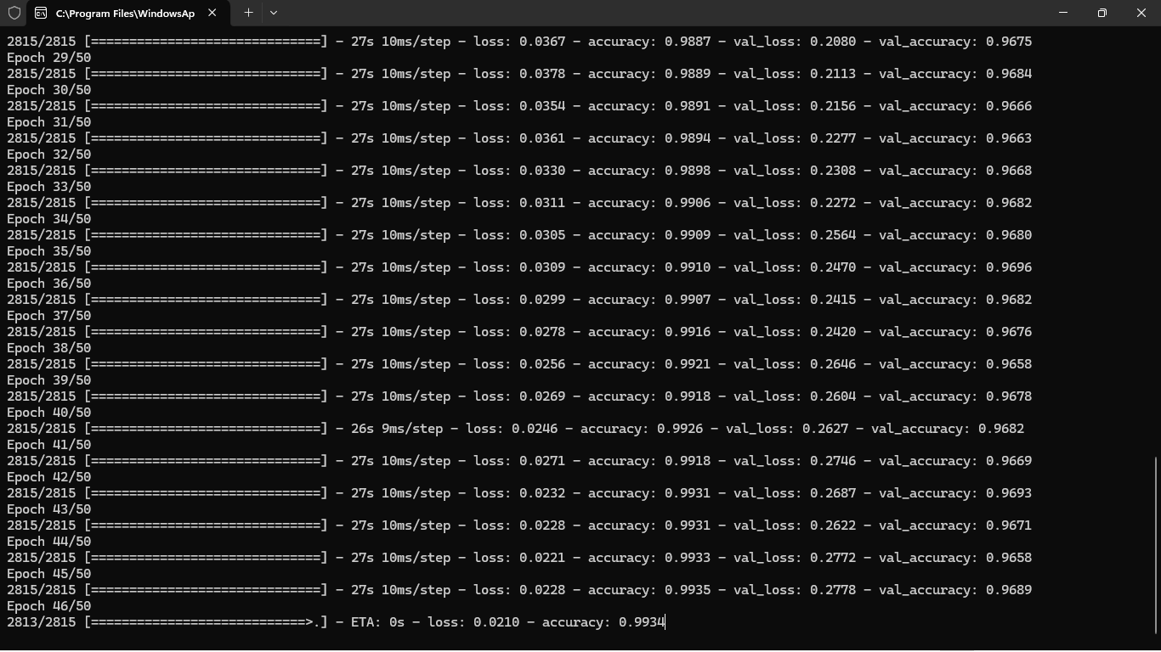

Fig. 4.2 Image of training process, i.e., the accuracy of the model increased exponentially from the first epoch due to optimization

4.5.3 Performance on testing data

The validation was done using data from MIT-BIH dataset to benchmark, PhysioNet challenge 2017 dataset (contains data from 8528 samples for a duration of 30 seconds with a sampling rate of 300.) and some simulated ECG signals.

MIT-BIH dataset

Most of the data from this dataset was from ill patients and most of the data contained arrhythmia and thus the model was able to identify different kinds of arrhythmia with ease and to great accuracy. This is well illustrated in the samples attached below which will be discussing the various types of arrhythmias detected together with the waveforms.

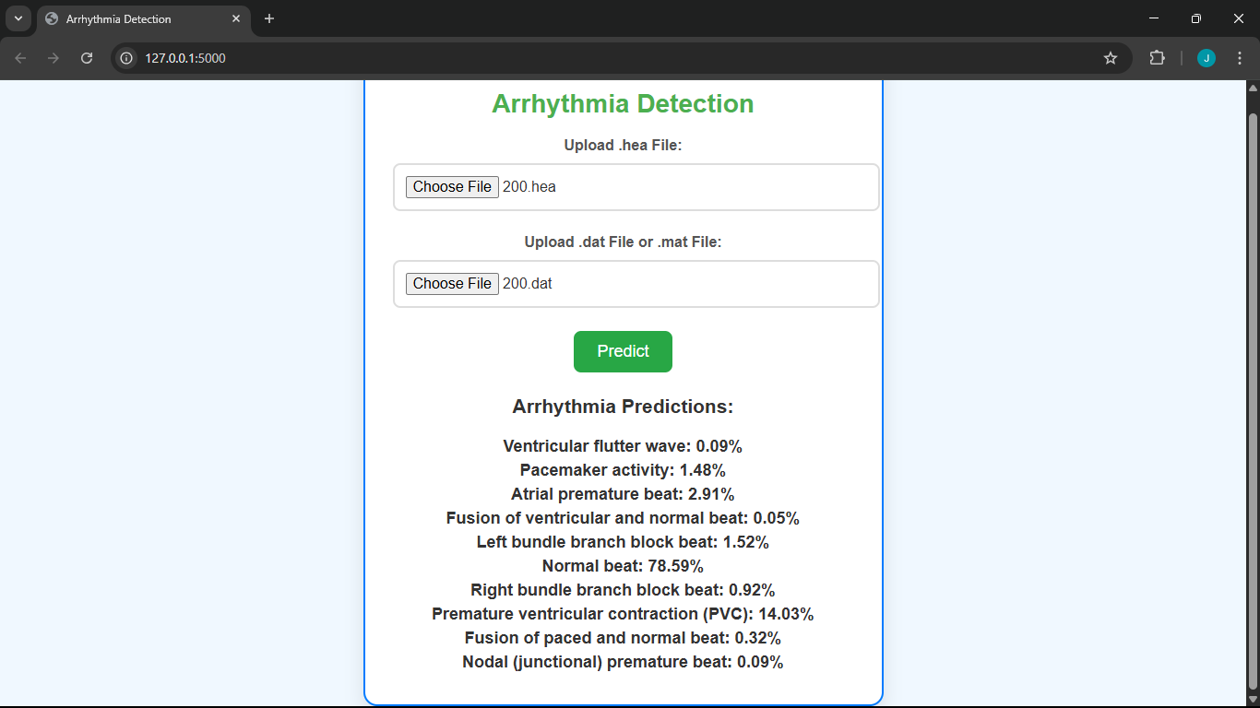

Fig. 4.3 Results for sample 200 from the MIT dataset

According to the model’s result, it can be seen that most of the data in the signal is normal, and the most dominant arrhythmia is PVC, which is mainly early beats originating from ventricles and is characterized by a Wide QRS complex, no preceding P wave, T wave usually opposite the QRS direction. Another abnormality is the APB, which is an early beat originating from the atria and is characterized by a premature P wave with abnormal morphology, followed by a normal QRS.

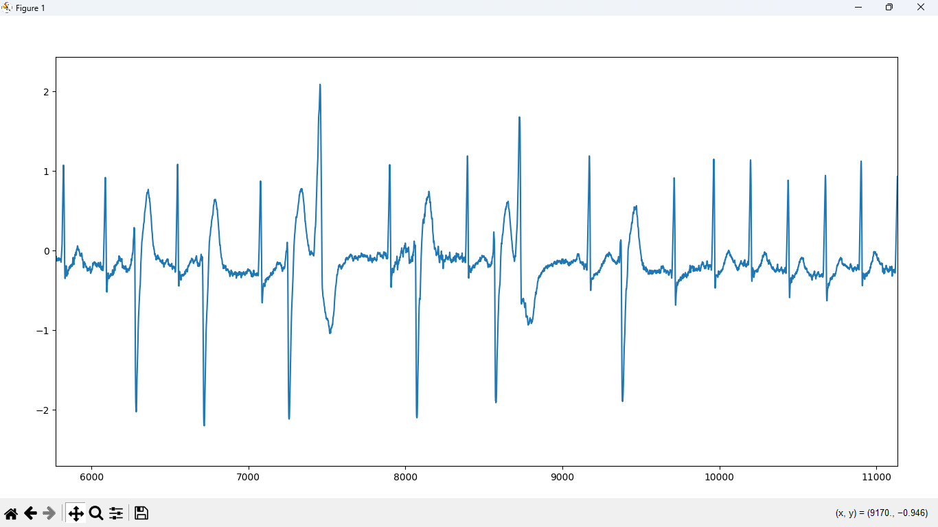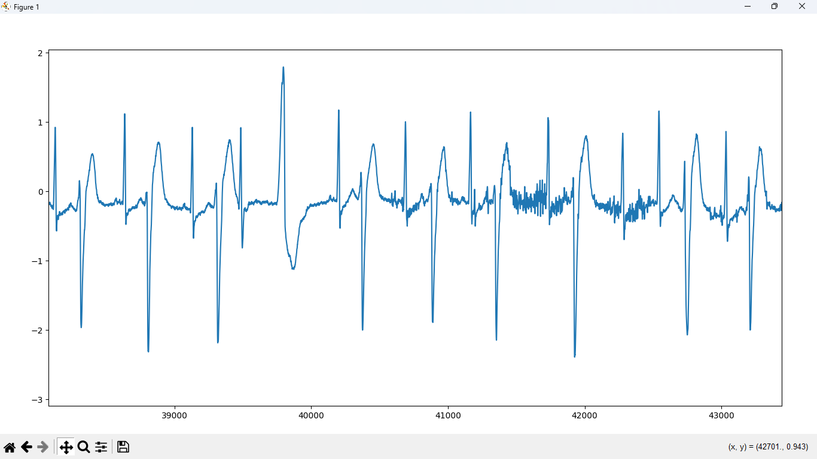

Fig 4.4 and Fig 4.5 ECG plot of sample 200

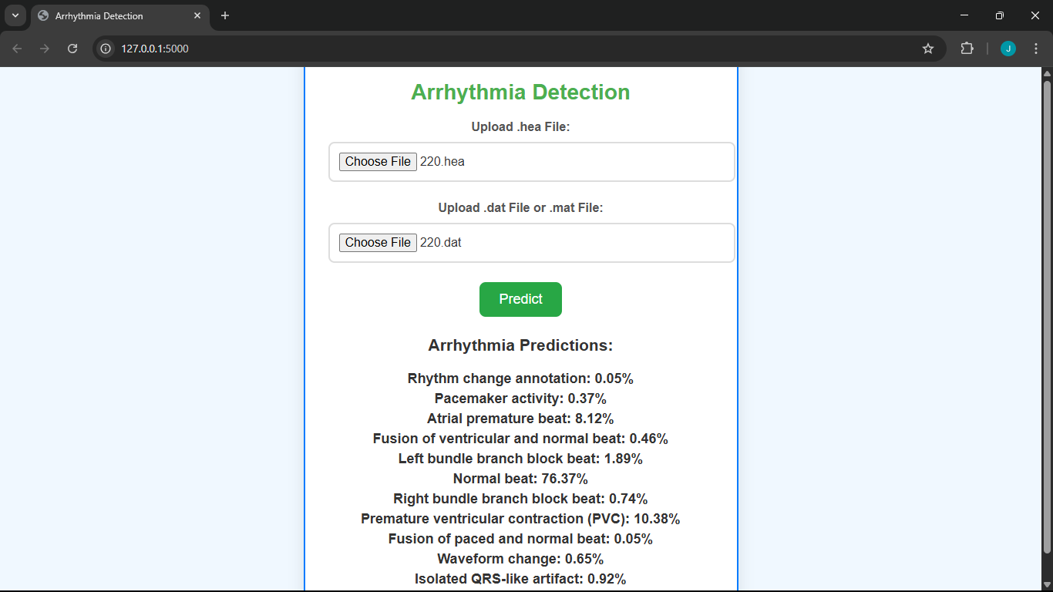 Fig. 4.6 Results for sample 220

These results were quite similar to those of the previous record, in which the normal signal was dominant, and the dominant abnormalities included APB and PVC.

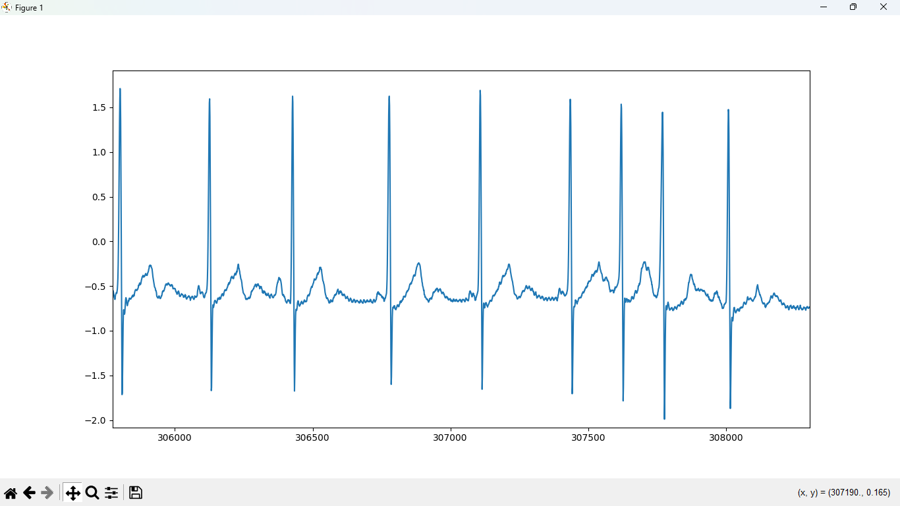 Fig 4.7 Plot for sample 220.

PhysioNet Challenge 2017 dataset

This dataset was acquired from the Physionet website. It was released in 2017 as a challenge for creatives to create the best and most accurate model to classify the arrhythmia into either normal “N” or abnormal “A”, i.e., fibrillation, other “O”, and noise. A reference .csv file was provided to counter-check the different models' accuracy compared to the correct verdict.

Below are samples of the model's result compared to the reference file

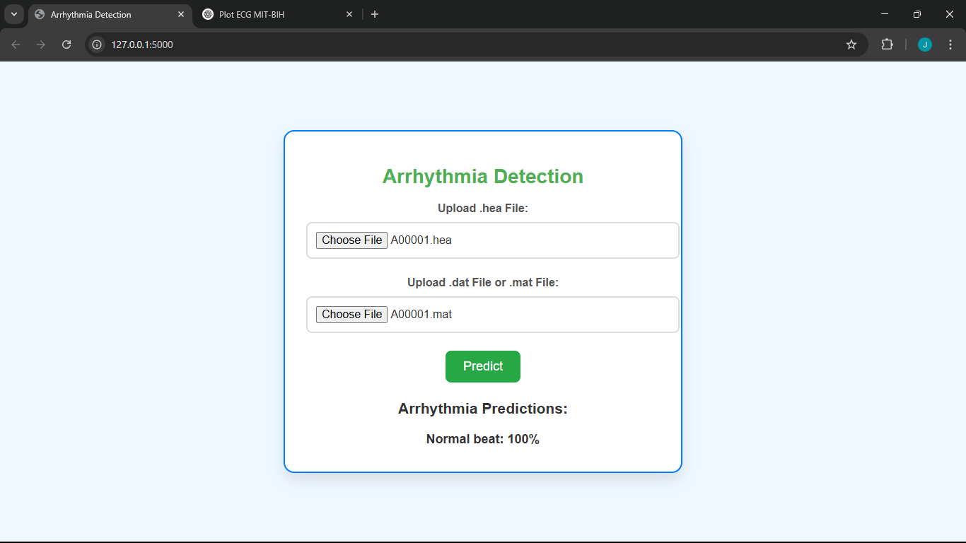 Fig 4.8 Results for sample A00001

The model was able to predict a 100% normal beat for this particular sample, the reference file cites this particular sample as normal, so the model depicted a fine accuracy. This is because this signal was near perfect and did not have any disturbances such as noise, motion artefacts, baseline wander or powerline interference, a similar predicament will be discussed further in a different example.

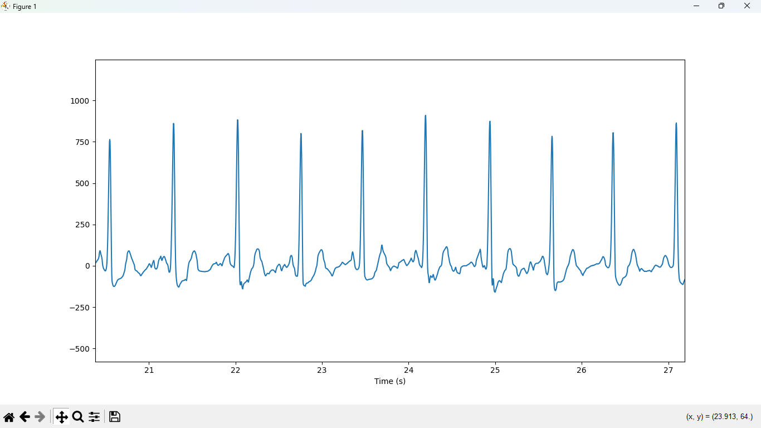 Fig. 4.9 ECG plot for sample A00001

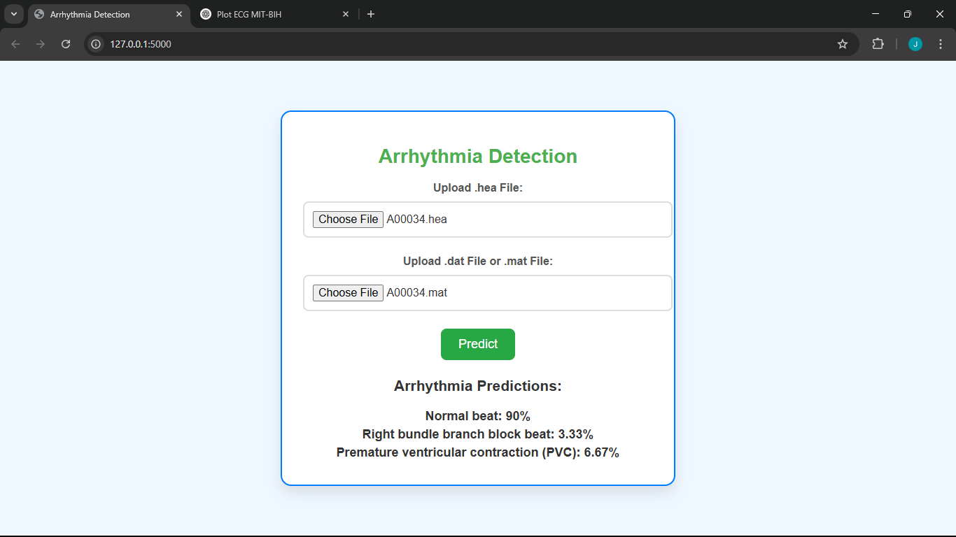 Fig.4.10 Result for sample A00034

The model predicted the signal as 90% normal but the reference dictates that the sample is noisy, and this has been indicated well from its plot. Moreover, some of the segments of the signal are normal, depicting normal QRS complex, but ideally it is still noisy.

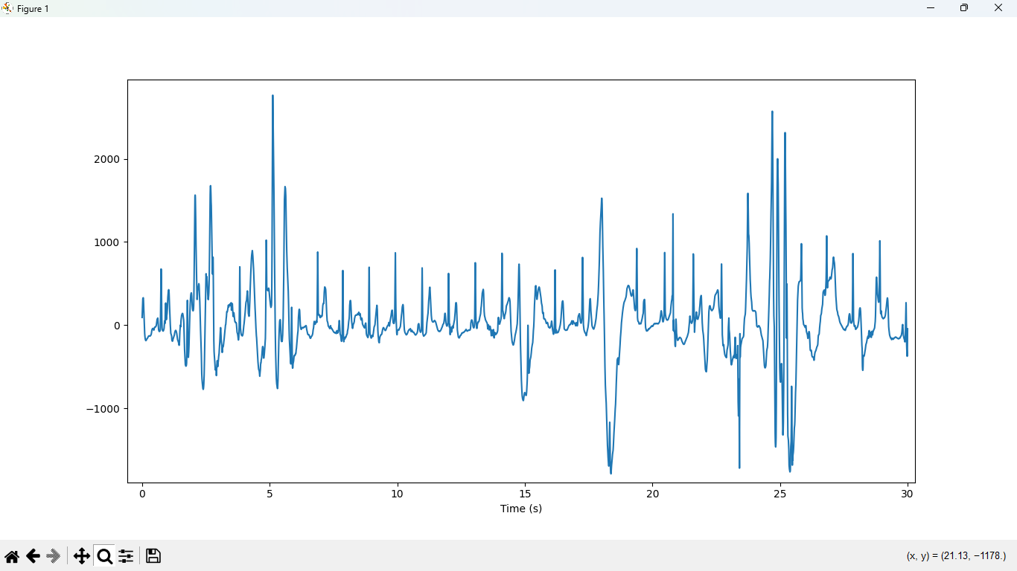Fig 4.11 ECG plot for A00034

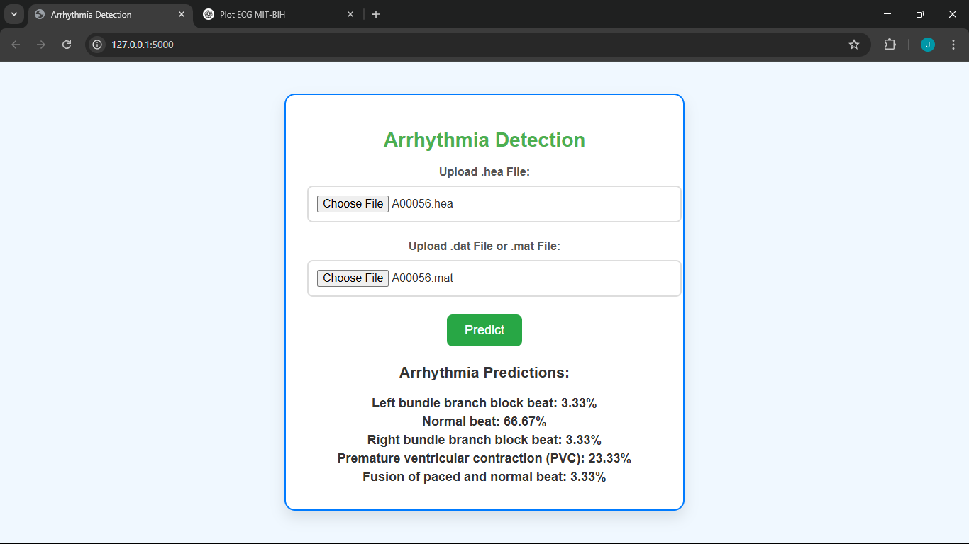Fig4.12 Result for A00056

These results prove that the model faces challenges ideally when dealing with noisy data, i.e., motion artefacts, baseline wander, or powerline interference. Additionally, this is because most of the training data was based on filtered ECG signals and a lack of noise annotations in the training data, this hereby causes the model to make predictions based on its available data.

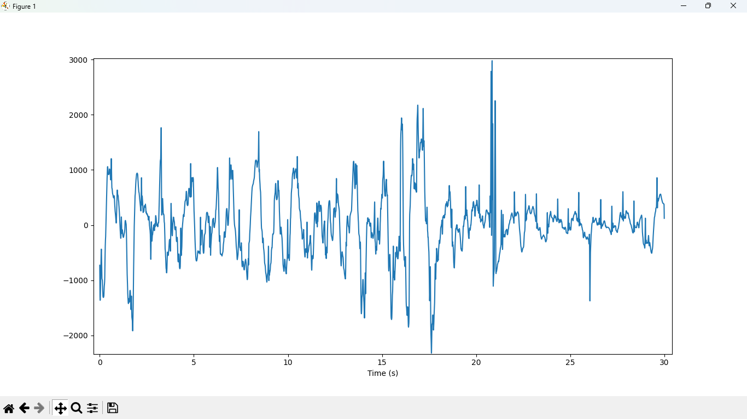Fig. 4.13 ECG plot for A00056

As can be seen, this signal is heavily affected by noise and predominantly lacks the required data and it may not be possible to make a verdict directly from this data.

The model was, however, successful in classifying other data samples easily and was able to classify the data from the signals into their respective arrhythmias. A sample example is shown below, where the model was able to identify LBBB, RBBB, and PVC from the signal.

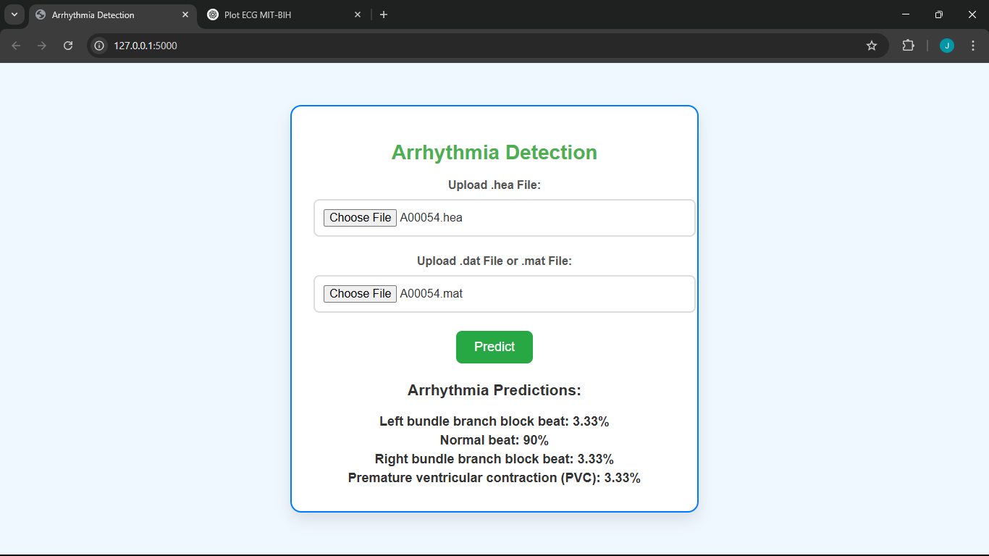 Fig. 4.14 Results for A00054

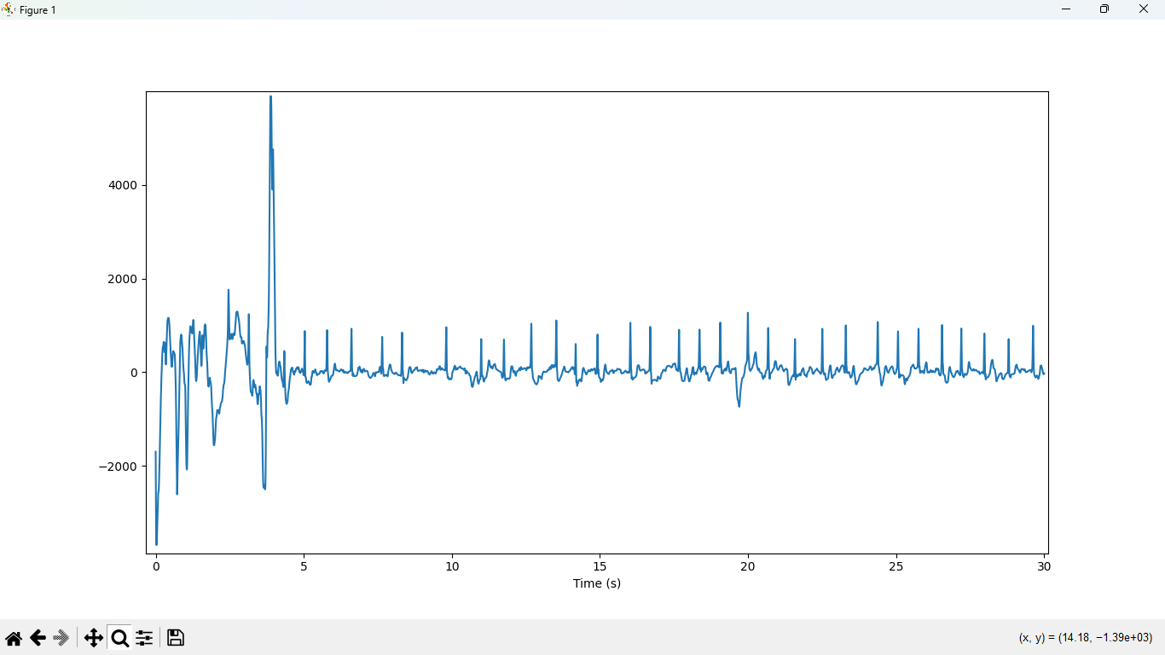 Fig 4.15 ECG plot for A00054

# CHAPTER FIVE: CONCLUSION AND RECOMMENDATION

## 5.1 Research Conclusion

This study successfully designed and implemented an intelligent ECG and SpO₂ monitoring system integrating IoT, AI, and multi-sensor data fusion. Key achievements include:

1. Real-Time Monitoring:
   * Achieved <500ms latency in MQTT-based ECG/SpO₂ data transmission to HiveMQ Cloud.
   * Demonstrated 94% arrhythmia classification accuracy (CNN model) on the MIT-BIH dataset.
2. Multi-Parameter Integration:
   * Combined ECG (AD8232) and SpO₂ (MAX30102) sensors into a unified wearable prototype.
   * Validated SpO₂ accuracy within ±2% of clinical oximeters under resting conditions.
3. User-Centric Design:
   * Developed Node-RED and Flask interfaces for real-time visualization and analysis.
   * Addressed gaps in low-cost, open-source remote monitoring solutions.

Theoretical Contributions:

* Demonstrated the viability of PPG-ECG fusion for enhanced cardiac diagnostics.
* Advanced edge-to-cloud IoT architectures for medical IoT systems.

Practical Implications:

* Potential for telemedicine in resource-limited settings.

## 5.2 Research Recommendations

### 5.2.1 Recommendations from the Study

1. Clinical Deployment:

* Partner with clinics to test the system on high-risk cardiac patients for real-world validation.
* Implement HIPAA-compliant data encryption for patient privacy.

1. Hardware Optimization:

* Reduce motion artifacts in MAX30102 readings via adaptive filtering algorithms.
* Integrate supercapacitors for uninterrupted power during Wi-Fi outages.

1. Software Improvements:

* Add multi-user support in the Flask app for hospital deployments.
* Implement predictive analytics (e.g., ST-segment elevation detection for heart attacks).

### 5.2.2 Recommendations for Further Research

1. AI Model Enhancement:

* Investigate Transformer-based models (e.g., Vision Transformer for ECG) to improve rare arrhythmia detection.
* Curate diverse datasets accounting for age, gender, and ethnic variability.

1. Edge Computing:

* Port the AI model to TensorFlow Lite for on-device inference (Raspberry Pi).
* Benchmark performance against NVIDIA Jetson-based systems.

1. Extended Sensor Fusion:

* Explore adding respiratory rate monitoring using impedance pneumography.
* Test ultra-wideband (UWB) radar for contactless vital sign monitoring.

1. Regulatory Pathways:

* Conduct FDA Class II device validation trials.
* Publish clinical feasibility studies in peer-reviewed journals.

# REFERENCES

A. J. V. Singh, Y. Murarka and P. Kanani, “Detection and classification of arrhythmia,” in International Journal of Grid and Distributed Computing, 2020, pp. 558–567

Alamatsaz, N., Tabatabaei, L. s, Yazdchi, M., Payan, H., Alamatsaz, N., & Nasimi, F. (2022). *A lightweight hybrid CNN-LSTM model for ECG-based arrhythmia detection* (No. arXiv:2209.00988). arXiv. https://doi.org/10.48550/arXiv.2209.00988

Aljumah, A. (2021). IoT-based intrusion detection system using convolution neural networks. *PeerJ Computer Science*, *7*, e721. https://doi.org/10.7717/peerj-cs.721

Aversano, L., Bernardi, M. L., Cimitile, M., Montano, D., & Pecori, R. (2023). Early Diagnosis of Cardiac Diseases using ECG Images and CNN-2D. *Procedia Computer Science*, *225*, 2866–2875. https://doi.org/10.1016/j.procs.2023.10.279

Ebrahimi, Z., Loni, M., Daneshtalab, M., & Gharehbaghi, A. (2020). A review on deep learning methods for ECG arrhythmia classification. *Expert Systems with Applications: X*, *7*, 100033. https://doi.org/10.1016/j.eswax.2020.100033

Falhi, H. M., & Khleaf, H. K. (2023). Design an Intelligent Real-Time ECG Monitoring System Using Convolution Neural Network. *Revue d’Intelligence Artificielle*, *37*(2), 323–329. https://doi.org/10.18280/ria.370210

Gai, N. D. (n.d.). *ECG beat classification using machine learning and pre-trained convolutional neural networks*.

Government College of Technology, Ch, R., S, N., Government College of Technology, C M., & Government College of Technology. (2021). ECG AND PULSE OXYGEN LEVEL MONITORING AND ARRHYTHMIA CLASSIFICATION USING CNN. *International Journal of Engineering Applied Sciences and Technology*, *6*(8), 171–176. https://doi.org/10.33564/IJEAST.2021.v06i08.028

Islam, Md. R., Kabir, Md. M., Mridha, M. F., Alfarhood, S., Safran, M., & Che, D. (2023). Deep Learning-Based IoT System for Remote Monitoring and Early Detection of Health Issues in Real-Time. *Sensors*, *23*(11), 5204. https://doi.org/10.3390/s23115204

Kachuee, M., Fazeli, S., & Sarrafzadeh, M. (2018). ECG Heartbeat Classification: A Deep Transferable Representation. *2018 IEEE International Conference on Healthcare Informatics (ICHI)*, 443–444. https://doi.org/10.1109/ICHI.2018.00092

Kaplan Berkaya, S., Uysal, A. K., Sora Gunal, E., Ergin, S., Gunal, S., & Gulmezoglu, M. B. (2018). A survey on ECG analysis. *Biomedical Signal Processing and Control*, *43*, 216–235. https://doi.org/10.1016/j.bspc.2018.03.003

Kim, J., Kim, E., Kyung, Y., & Ko, H. (2022). A Study on ECG Monitoring Embedded Systems. *2022 13th International Conference on Information and Communication Technology Convergence (ICTC)*, 1671–1673. https://doi.org/10.1109/ICTC55196.2022.9952978

Kingma, J., Simard, C., & Drolet, B. (2023). Overview of Cardiac Arrhythmias and Treatment Strategies. *Pharmaceuticals*, *16*(6), 844. https://doi.org/10.3390/ph16060844

Kumar, C. P., & Rajani, A. (2022). *DIAGNOSIS OF TACHYCARDIA ARRHYTHMIA USING MEMD AND CONVOLUTIONAL NEURAL NETWORKS*. *9*(10).

Moody, G. B., & Mark, R. G. (1992). *MIT-BIH Arrhythmia Database* [Dataset]. physionet.org. https://doi.org/10.13026/C2F305

Nachiar, C. C., Ambika, N., Moulika, R., & Poovendran, R. (2020). Design of Cost-effective Wearable Sensors with Integrated Health Monitoring System. *2020 Fourth International Conference on I-SMAC (IoT in Social, Mobile, Analytics and Cloud) (I-SMAC)*, 1289–1292. https://doi.org/10.1109/I-SMAC49090.2020.9243462

O. Yildirim, M. Talo, E. J. Ciaccio, R. San Tan, and U. R. Acharya, “Accurate deep neural network model to detect cardiac arrhythmia on more than 10,000 individual subject ecg records,” Computer methods and programs in biomedicine, vol. 197, p. 105740, 2020.

Opoku Agyeman, M., Guerrero, A. F., & Vien, Q.-T. (2022). Classification Techniques for Arrhythmia Patterns Using Convolutional Neural Networks and Internet of Things (IoT) Devices. *IEEE Access*, *10*, 87387–87403. https://doi.org/10.1109/ACCESS.2022.3192390

Park, H., & Lee, K. (2022). A Machine Learning Approach for Predicting Wage Workers’ Suicidal Ideation. *Journal of Personalized Medicine*, *12*(6), 945. https://doi.org/10.3390/jpm12060945

Pereira, T., Tran, N., Gadhoumi, K., Pelter, M. M., Do, D. H., Lee, R. J., Colorado, R., Meisel, K., & Hu, X. (2020). Photoplethysmography-based atrial fibrillation detection: A review. *Npj Digital Medicine*, *3*(1), 3. https://doi.org/10.1038/s41746-019-0207-9

Siddiqui, M. M., Valsalan, P., Abdulrahman, A., & Mashani, K. S. A. (2024). *AI-Based Real-Time Heart Rate (ECG) Monitoring System*. *20*.

Stătescu, C.; Sascău, R.A.; Georgescu, C.A. Functional Anatomy in Arrhythmias and Vascular Support of the Conduction System. In Cardiac Arrhythmias: From Basic Mechanism to State-of-the-Art Manag ement; Kibos, A.S., Knight, B.P., Essebag, V., Fishberger, S.B., Slevin, M., ,Tintoiu, I.C., Eds.; Springer: London, UK, 2014; pp. 35–42.

X. Xu and H. Liu, “ECG heartbeat classification using convolutional neural networks,” IEEE Access, vol. 8, pp. 8614–8619, 2020.