Supplementary figure 1: Assessment of AKI stage and development or progression of AKI.
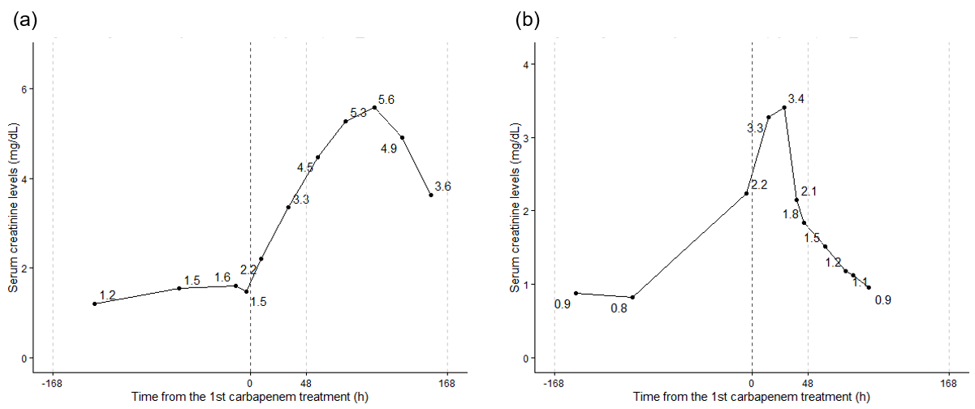
AKI stage was assessed according to the criteria by Kidney Disease Improving Global Outcomes (KDIGO) guideline. The lowest serum creatinine (sCr) level during 168 hours prior to the treatment start with carbapenems was defined as baseline sCr level. AKI stage 1 was identified when sCr levels at treatment start with carbapenems increased by at least 0.3 mg/dL from baseline sCr levels and time difference of those 2 measurements was shorter than 48 hours or when sCr levels at treatment start rose to 1.5 to 1.9 times the baseline sCr levels. Stage 2 was defined by sCr levels at treatment start increased to 2.0 to 2.9 times the baseline sCr level. Stage 3 was identified when sCr levels at treatment start increased to 3.0 times or more compared to the baseline sCr levels, when the absolute sCr levels at treatment start reached 4.0 mg/dL or higher, or when the subjects receive renal replacement therapy (RRT). Urine volume was not considered for the assessment. As examples, changes in sCr levels of 2 subjects are depicted in the figure. Both subjects did not receive RRT during the observation period. (a) Baseline sCr level, defined as the lowest sCr level prior to the treatment start, was 1.2 mg /dL. sCr level at treatment start, assessed prior to and most nearly to treatment start, was 1.5 mg/dL. Time difference in those 2 measurements was over 48 hours and sCr levels at treatment start was less than 1.5 times to baseline sCr levels. Therefore, their AKI stage at treatment start was assessed as stage 0. The highest sCr level after treatment start was 5.6 mg /dL, which is higher than 3 times to baseline sCr levels. AKI after treatment start was stage 3, and this subject was assessed as developing AKI after the treatment. (b) With baseline sCr levels as 0.8 mg /dL and sCr levels at treatment start as 2.2 mg /dL, their AKI stage at treatment start was assessed as stage 2. The highest sCr levels after treatment start was 3.4 mg /dL, which is higher than 3 times to baseline sCr levels. AKI stage after treatment start was stage 3 and this subject developed AKI progression after the treatment.

Supplementary figure 2: Distribution of propensity scores
Histograms of propensity scores for receiving I/C drugs in each dataset.
Supplementary figure 3: Difference of subject characteristics between the I/C and the NCC groups before and after propensity score-based overlap weighting
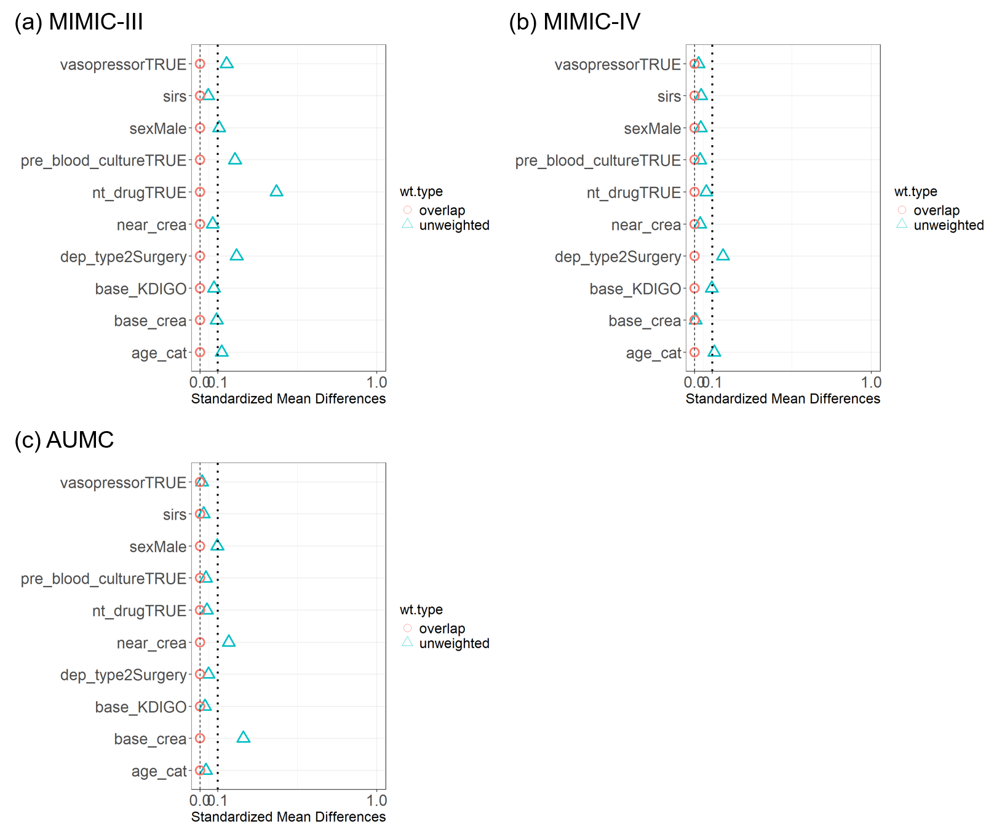
Standardized mean differences (SMD) of subject backgrounds between the I/C and the NCC groups in each dataset. The backgrounds of the subjects were adjusted with overlap weighting based on propensity scores to receive I/C drugs. SMD of propensity score-predictors are depicted as blue triangles (before overlap weighting) or red circles (after overlap weighting). The subject backgrounds were well adjusted with overlap weighting. Abbreviations; nt_drug, nephrotoxic drug usage; near_crea, sCr at treatment start; dep_type2, ICU type; base_crea, baseline sCr
Supplementary figure 4: Sensitivity analysis against competing risks of the outcomes
Forrest plot for OR of the I/C group for AKI development/progression or death. The combined outcome was assessed considering the competing risks of AKI development/progression with death. The outcome less developed in the I/C group relative to the NCC group in MIMIC-III but similarly developed between the groups in MIMIC-IV and AUMC and at overall analysis across all datasets.

Supplementary figure 5: Development of secondary outcomes among subjects without AKI at treatment start
Forrest plot for OR of the I/C group for secondary outcomes among subjects without AKI at treatment start. The outcomes similarly developed between the I/C and the NCC groups.

Supplementary figure 6: Development of secondary outcomes among subjects with AKI at treatment start
Forrest plot for OR of I/C group secondary outcomes among subjects with AKI at treatment start. The outcomes similarly developed between the I/C and the NCC groups.

Supplementary figure 7: Subgroup analysis for development or progression of AKI.
Forrest plot for OR of the I/C group for AKI development/progression among subgroups stratified based on age, sex, type of ICU, SIRS score, pre-testing for blood culture, treatment with nephrotoxic drugs, and treatment with vasopressor at treatment start. AKI development/progression similarly developed between the I/C and NCC groups except for in certain subgroups of MIMIC-III, where the outcome less commonly developed in the I/C group.
Supplementary table 1: FDA-approved treatment dose of carbapenems
 | Highest FDA-approved dose (scaled to 24 hours)
Imipenem/cilastatin
eGFR ≥ 90 | 3000 mg
90 > eGFR ≥ 60 | 2000 mg
60 > eGFR ≥ 30 | 1500 mg
30 > eGFR ≥ 15 | 1000 mg
15 > eGFR | Not recommended
Imipenem/cilastatin/relebactam
eGFR ≥ 90 | 5000 mg
90 > eGFR ≥ 60 | 4000 mg
60 > eGFR ≥ 30 | 3000 mg
30 > eGFR ≥ 15 | 2000 mg
15 > eGFR | Not recommended
Meropenem
eGFR ≥ 50 | 3000 mg
50 > eGFR ≥ 25 | 2000 mg
25 > eGFR ≥ 10 | 1000 mg
10 > eGFR | 500 mg
Ertapenem
eGFR ≥ 30 | 1000 mg
30 > eGFR | 500 mg
Doripenem
eGFR ≥ 50 | 1500 mg
50 > eGFR ≥ 30 | 750 mg
30 > eGFR | 500 mg

Highest FDA-approved dose of the carbapenems. The ratio of initial treatment dose to the highest FDA-approved dose for their kidney function was calculated on each subject to estimate “eGFR-scaled relative initial dose”. eGFR was used for the assessment of FDA-approved dose instead of creatinine clearance. If a subject with eGFR less than 15 mL/min/1.73m² received imipebem/cilastatin or imipebem/cilastatin/relebactam, “eGFR-scaled relative initial dose” was imputed with 3.

Supplementary table 2: Study characteristics
 | MIMIC-III |  |  | MIMIC-IV |  |  | AUMC
 | I/C  N = 77 | NCC  N = 332 | p-value | I/C  N = 88 | NCC  N = 2743 | p-value | I/C  N = 480 | NCC  N = 212 | p-value
Age (years) |  |  | 0.77 |  |  | 0.56 |  |  | 0.58
18-39 | 4 (5.2%) | 29 (8.7%) |  | 8 (9.1%) | 276 (10.1%) |  | 51 (10.6%) | 30 (14.2%)
40-49 | 8 (10.4%) | 32 (9.6%) |  | 10 (11.4%) | 282 (10.3%) |  | 51 (10.6%) | 22 (10.4%)
50-59 | 13 (16.9%) | 59 (17.8%) |  | 11 (12.5%) | 565 (20.6%) |  | 104 (21.7%) | 38 (17.9%)
60-69 | 17 (22.1%) | 67 (20.2%) |  | 25 (28.4%) | 713 (26.0%) |  | 152 (31.7%) | 61 (28.8%)
70-79 | 18 (23.4%) | 90 (27.1%) |  | 19 (21.6%) | 520 (19.0%) |  | 101 (21.0%) | 52 (24.5%)
80+ | 17 (22.1%) | 55 (16.6%) |  | 15 (17.0%) | 387 (14.1%) |  | 21 (4.4%) | 9 (4.2%)
Sex |  |  | 0.39 |  |  | 0.75 |  |  | 0.24
Female | 38 (49.4%) | 146 (44.0%) |  | 38 (43.2%) | 1,232 (44.9%) |  | 161 (33.5%) | 81 (38.2%)
Male | 39 (50.6%) | 186 (56.0%) |  | 50 (56.8%) | 1,511 (55.1%) |  | 319 (66.5%) | 131 (61.8%)
Body mass index | 27.5 (24.3, 30.6) | 27.7 (23.5, 33.0) | 0.86 | 27.7 (25.1, 32.6) | 27.6 (23.7, 33.6) | 0.63 | 24.5 (21.9, 27.8) | 24.5 (21.9, 27.8) | 0.61
Missing | 36 | 176 |  | 44 | 1000 |  | 28 | 5
Body weight | 75.8 (66.3, 90.0) | 76.8 (63.9, 94.6) | 0.98 | 81.2 (70.4, 98.7) | 78.8 (65.2, 95.6) | 0.25 | 75.0 (65.0, 85.0) | 75.0 (65.0, 95.0) | 0.52
Missing | 10 | 52 |  | 6 | 224 |  | 0 | 0
ICU type |  |  | 0.10 |  |  | 0.16 |  |  | 0.56
Non-surgery | 45 (58.4%) | 227 (68.4%) |  | 73 (83.0%) | 2,099 (76.5%) |  | 292 (60.8%) | 124 (58.5%)
Surgery | 32 (41.6%) | 105 (31.6%) |  | 15 (17.0%) | 644 (23.5%) |  | 188 (39.2%) | 88 (41.5%)
Type of carbapenem |  |  | <0.001 |  |  | <0.001 |  |  | <0.001
Imipenem/cilastatin | 77 (100%) | 0 (0.0%) |  | 87 (98.9%) | 0 (0.0%) |  | 480 (100%) | 0 (0.0%)
Imipenem/cilastatin/relebactam | 0 (0.0%) | 0 (0.0%) |  | 1.0 (1.1%) | 0 (0.0%) |  | 0 (0.0%) | 0 (0.0%)
Meropenem | 0 (0.0%) | 332 (100%) |  | 0 (0.0%) | 2,726 (99.4%) |  | 0 (0.0%) | 212 (100%)
Doripenem | 0 (0.0%) | 0 (0.0%) |  | 0 (0.0%) | 5 (0.2%) |  | 0 (0.0%) | 0 (0.0%)
Ertapenem | 0 (0.0%) | 0 (0.0%) |  | 0 (0.0%) | 12 (0.4%) |  | 0 (0.0%) | 0 (0.0%)
SOFA score | 5 (3, 8) | 4 (3, 7) | 0.87 | 4.5 (3, 8) | 5 (3, 8) | 0.16 | 7 (5, 10) | 7 (4, 9) | 0.36
Missing |  |  |  |  |  |  | 67 | 37
qSOFA score | 1 (0, 1) | 1 (0, 1) | 0.52 | 1 (0, 1) | 1 (0, 1) | 0.68 | 1 (0, 1) | 1 (0, 1) | 0.98
Missing | 0 | 8 |  | 0 | 8 |  | 1 | 0
SIRS score | 2 (1, 3) | 2 (1, 3) | 0.86 | 2 (1, 3) | 2 (1, 3) | 0.78 | 2 (1, 3) | 2 (1, 3) | 0.75
Blood culture | 60 (77.9%) | 284 (85.5%) | 0.10 | 68 (77.3%) | 2,154 (78.5%) | 0.78 | 67 (14.0%) | 32 (15.1%) | 0.69
Nephrotoxic drugs usage | 43 (55.8%) | 252 (75.9%) | <0.001 | 69 (78.4%) | 2223 (81.0%) | 0.54 | 283 (59.0%) | 121 (57.1%) | 0.64
Vancomycin | 37 (48.1%) | 229 (69.0%) | <0.001 | 63 (71.6%) | 2138 (77.9%) | 0.16 | 240 (50.0%) | 107 (50.5%) | 0.91
Amino  glycoside | 8 (10.4%) | 33 (9.9%) | 0.91 | 9 (10.2%) | 233 (8.5%) | 0.57 | 72 (15.0%) | 17(8.0%) | 0.01
NSAIDs | 7 (9.1%) | 48 (14.5%) | 0.21 | 6 (6.8%) | 225 (8.2%) | 0.64 | 10 (2.1%) | 15 (7.1%) | 0.001
Contrast agent | 0 (0.0%) | 0 (0.0%) |  | 1 (1.1%) | 36 (1.3%) | >0.99 | 8 (1.7%) | 0 (0.0%) | 0.11
Vasopressor usage | 30 (39.0%) | 154 (46.4%) | 0.24 | 8 (9.1%) | 233 (8.5%) | 0.84 | 303 (63.1%) | 135 (63.7%) | 0.89
Ventilation | 52 (67.5%) | 229 (69.0%) | 0.81 | 12 (13.6%) | 227 (8.3%) | 0.08 | 321 (66.9%) | 126 (59.4%) | 0.06
Baseline sCr (mg/dL) | 0.9 (0.6, 1.4) | 0.9 (0.6, 1.4) | 0.43 | 1.0 (0.6, 1.5) | 1.0 (0.6, 1.5) | 0.96 | 0.9 (0.6, 1.3) | 0.7 (0.6, 1.1) | <0.001
eGFR at treatment start (mL/min/1.73m²) | 62.5 (36.1, 92.3) | 65.8 (40.6, 100.7) | 0.30 | 64.5 (35.3, 99.5) | 64.9 (35.6, 98.2) | 0.76 | 69.1 (43.7, 99.0) | 88.1 (46.9, 108.2) | 0.004
sCr at treatment start (mg/dL) | 1.1 (0.8, 1.7) | 1.0 (0.7, 1.7) | 0.50 | 1.1 (0.7, 2.0) | 1.1 (0.7, 1.8) | 0.72 | 1.1 (0.8, 1.6) | 0.9 (0.6, 1.5) | 0.001
AKI stage at treatment start |  |  | 0.91 |  |  | 0.66 |  |  | 0.45
0 | 58 (75.3%) | 240 (72.3%) |  | 67 (76.1%) | 1,966 (71.7%) |  | 351 (73.1%) | 156 (73.6%)
1 | 17 (22.1%) | 80 (24.1%) |  | 16 (18.2%) | 587 (21.4%) |  | 105 (21.9%) | 41 (19.3%)
2 | 2 (2.6%) | 12 (3.6%) |  | 5 (5.7%) | 190 (6.9%) |  | 24 (5.0%) | 15 (7.1%)
Initial treatment dose in 24 hours (mg)
Imipenem/cilastatin | 500 (500, 750) | 0 (0.0) | NA | 500 (500, 500) | 0 (0.0) | NA | 500 (500, 500) | 0 (0.0) | NA
Meropenem | 0 (0.0) | 1000 (500, 1000) | NA | 0 (0.0) | 1000 (500, 1000) | NA | 0 (0.0) | 1000 (1000, 2000) | NA
Imipenem/cilastatin/relebactam | 0 (0.0) | 0 (0.0) | NA | 750 (750, 750) | 0 (0.0) | NA | 0 (0.0) | 0 (0.0) | NA
Ertapenem | 0 (0.0) | 0 (0.0) | NA | 0 (0.0) | 1000 (1000, 1000) | NA | 0 (0.0) | 0 (0.0) | NA
Doripenem | 0 (0.0) | 0 (0.0) | NA | 500 (500, 500) | 1000 (500, 1000) | <0.001 | 0 (0.0) | 0 (0.0) | NA
eGFR-scaled relative initial dose of carbapenems | 0.3 (0.2, 0.5) | 0.3 (0.3, 0.5) | 0.18 | 0.3 (0.2, 0.3) | 0.3 (0.3, 0.5) | <0.001 | 0.3 (0.2, 0.3) | 0.3 (0.3, 0.7) | <0.001
Treatment duration (hours) | 120.0 (48.0, 168.0) | 168.0 (72.8, 168.0) | 0.01 | 63.6 (25.0, 168.0) | 97.0 (37.0, 168.0) | 0.051 | 104.0 (37.2, 168.0) | 84.8 (32.0, 168.0) | 0.21
Cumulative drug exposure (g)
Imipenem/cilastatin | 2.5 (1.5, 3.5) | 0 (0.0) | NA | 1.8 (0.5, 3.5) | 0 (0.0) | NA | 8.0 (3.0, 16.0) | 0 (0.0) | NA
Meropenem | 0 (0.0) | 4.0 (2.4, 7.0) | NA | 0 (0.0) | 2.6 (1.2, 4.0) | NA | 0 (0.0) | 12.0 (5.5, 24.5) | NA
Imipenem/cilastatin/relebactam | 0 (0.0) | 0 (0.0) | NA | 1.4 (1.4, 1.4) | 0 (0.0) | NA | 0 (0.0) | 0 (0.0) | NA
Ertapenem | 0 (0.0) | 0 (0.0) | NA | 0 (0.0) | 1.3 (0.3, 2.4) | NA | 0 (0.0) | 0 (0.0) | NA
Doripenem | 0 (0.0) | 0 (0.0) | NA | 0 (0.0) | 3.0 (1.0, 4.0) | NA | 0 (0.0) | 0 (0.0) | NA

Supplementary table 3: Additional backgrounds of the subjects after overlap weighting
 | MIMIC-III |  |  | MIMIC-IV |  |  | AUMC
 | I/C  N = 59.6 | NCC  N = 59.6 | p-value | I/C  N = 85.1 | NCC  N = 85.1 | p-value | I/C  N = 144.1 | NCC  N = 144.1 | p-value
Body mass index | 27.5 (24.7, 30.6) | 27.8 (23.4, 33.5) | 0.98 | 28.1 (25.1, 33.6) | 27.4 (23.5, 33.1) | 0.44 | 24.5 (21.9, 27.8) | 24.5 (21.9, 27.8) | 0.41
Missing | 28 | 31 |  | 43 | 32 |  | 8 | 3
Body weight | 75.8 (66.3, 90.0) | 76.9 (62.5, 95.3) | 0.89 | 81.3 (70.4, 98.7) | 78.2 (65.0, 95.0) | 0.16 | 75.0 (65.0, 85.0) | 75.0 (65.0, 95.0) | 0.21
Missing | 8 | 10 |  | 6 | 7 |  | 6 | 3
Type of carbapenem |  |  |  |  |  | <0.001
Imipenem/cilastatin | 59.6 (100%) | 0.0 (0.0%) |  | 84.1 (98.9%) | 0.0 (0.0%) |  | 144.1 (100%) | 0.0 (0.0%)
Imipenem/cilastatin/  relebactam | 0.0 (0.0%) | 0.0 (0.0%) |  | 1.0 (1.1%) | 0.0 (0.0%) |  | 0.0 (0.0%) | 0.0 (0.0%)
Meropenem | 0.0 (0.0%) | 59.6 (100%) |  | 0.0 (0.0%) | 84.6 (99.3%) |  | 0.0 (0.0%) | 144.1 (100%)
Doripenem | 0.0 (0.0%) | 0.0 (0.0%) |  | 0.0 (0.0%) | 0.2 (0.2%) |  | 0.0 (0.0%) | 0.0 (0.0%)
Ertapenem | 0.0 (0.0%) | 0.0 (0.0%) |  | 0.0 (0.0%) | 0.4 (0.5%) |  | 0.0 (0.0%) | 0.0 (0.0%)
SOFA score | 5.0 (3.0, 8.0) | 4.0 (2.0, 7.0) | 0.31 | 4.0 (3.0, 8.0) | 5.0 (3.0, 8.0) | 0.22 | 7.0 (5.0, 9.0) | 7.0 (4.0, 9.0) | 0.67
Missing | 0 | 0 |  | 0 | 0 |  | 20 | 25
Nephrotoxic drug usage
Vancomycin | 31.2 (52.4%) | 32.6 (54.8%) | 0.71 | 61.0 (71.7%) | 64.2 (75.4%) | 0.42 | 70.0 (48.5%) | 72.9 (50.6%) | 0.62
Aminoglycoside | 6.7 (11.3%) | 4.8 (8.1%) | 0.38 | 8.7 (10.2%) | 6.9 (8.1%) | 0.48 | 21.7 (15.0%) | 11.5 (8.0%) | 0.01
NSAIDs | 5.9 (9.9%) | 6.8 (11.3%) | 0.72 | 5.8 (6.8%) | 6.9 (8.2%) | 0.65 | 3.0 (2.1%) | 11.0 (7.6%) | <0.001
Contrast agent | 0.0 (0.0%) | 0.0 (0.0%) |  | 1.0 (1.1%) | 0.9 (1.1%) | 0.99 | 2.5 (1.8%) | 0.0 (0.0%) | 0.005
eGFR at treatment start (mL/min/1.73m²) | 63.2 (36.1, 92.3) | 63.1 (38.4, 95.9) | 0.81 | 62.5 (34.1, 99.5) | 65.8 (36.4, 97.7) | 0.83 | 76.6 (48.5, 102.2) | 82.6 (46.1, 107.9) | 0.30

Supplementary table 4: Number of subjects receiving carbapenems of the other group
Before overlap weighting | I/C | NCC | p-value
MIMIC-III | 3 (3.9%) | 1 (0.3%) | 0.02
MIMIC-IV | 4 (4.5%) | 0 (0%) | <0.001
AUMC | 15 (3.1%) | 2 (0.9%) | 0.09
After overlap weighting | I/C | NCC | p-value
MIMIC-III | 2.4 (3.9%) | 0.1 (0.2%) | <0.001
MIMIC-IV | 3.9 (4.5%) | 0 (0%) | 0.04
AUMC | 4.5 (3.1%) | 1.4 (1.0%) | 0.10
The number of subjects who were censored due to receiving carbapenems of the other group during the observation period.

Supplementary table 5: Total observation time of the subjects
Before overlap weighting | I/C | NCC | p-value
MIMIC-III | 168.0 [168.0, 168.0] | 168.0 [168.0, 168.0] | 0.34
MIMIC-IV | 168.0 [125.4, 168.0] | 168.0 [159.0, 168.0] | 0.20
AUMC | 168.0 [64.6, 168.0] | 165.6 [62.1, 168.0] | 0.71
After overlap weighting | I/C | NCC | p-value
MIMIC-III | 168.0 [168.0, 168.0] | 168.0 [168.0, 168.0] | 0.46
MIMIC-IV | 168.0 [122.5, 168.0] | 168.0 [151.6, 168.0] | 0.40
AUMC | 168.0 [63.7, 168.0] | 162.0 [61.0, 168.0] | 0.75
Observation time for subjects in each group and dataset. Observation was censored when subjects receive carbapenems of the other group or die. The time (hours) was described as median value with interquartile range.

Supplementary table 6: Post-hoc analysis; odds ratio of I/C group for AKI development or progression adjusting for carbapenem dose and treatment duration.
 | MIMIC-III | MIMIC-IV | AUMC
Crude | 0.50 [0.28, 0.87] | 1.18 [0.75, 1.83] | 1.10 [0.77, 1.57]
Model 1 | 0.43 [0.22, 0.81] | 1.26 [0.78, 1.99] | 1.06 [0.72, 1.56]
Model 2 | 0.42 [0.22, 0.79] | 1.28 [0.80, 2.03] | 1.07 [0.64, 1.79]
Model 3 | 0.41 [0.21, 0.77] | 1.26 [0.78, 1.99] | 1.03 [0.70, 1.53]
Model 4 | 0.40 [0.20, 0.76] | 1.38 [0.79, 2.02] | 1.03 [0.62, 1.74]
Odds ratio and 95% confidence interval of I/C group for AKI development or progression in each dataset before and after adjustment for subject backgrounds, treatment dose of the carbapenem, and treatment duration with the carbapenem. Model 1: adjusted for baseline backgrounds including age, sex, type of ICU, baseline sCr levels, and SIRS score, treatment with nephrotoxic drugs, treatment with vasopressors, testing for blood culture, sCr levels, and AKI stage at treatment start. Model 2: adjusted for baseline backgrounds and eGFR-scaled relative initial dose of carbapenems. Model 3: adjusted for baseline backgrounds and treatment duration with the carbapenem. Model 4: adjusted for baseline backgrounds, eGFR-scaled relative initial dose of carbapenem treatment, and total treatment duration with the carbapenem.

Supplementary table 7: Backgrounds of the subjects without AKI at treatment start after overlap weighting
 | MIMIC-III |  |  | MIMIC-IV |  |  | AUMC
 | I/C  N = 44.2 | NCC  N = 44.2 | p-value | I/C  N = 64.7 | NCC  N = 64.7 | p-value | I/C  N = 104.1 | NCC  N = 104.1 | p-value
Age (years) |  |  | 0.71 |  |  | 0.88 |  |  | 0.58
18-39 | 2.5 (5.7%) | 3.6 (8.1%) |  | 7.7 (12.0%) | 6.8 (10.6%) |  | 11.6 (11.1%) | 15.4 (14.8%)
40-49 | 5.4 (12.2%) | 3.5 (7.9%) |  | 7.7 (12.0%) | 6.5 (10.1%) |  | 12.6 (12.1%) | 11.8 (11.3%)
50-59 | 8.0 (18.1%) | 7.5 (17.0%) |  | 9.7 (14.9%) | 13.5 (20.9%) |  | 24.1 (23.2%) | 19.5 (18.7%)
60-69 | 9.1 (20.5%) | 8.9 (20.1%) |  | 17.4 (26.9%) | 16.3 (25.3%) |  | 32.1 (30.9%) | 28.8 (27.7%)
70-79 | 9.1 (20.7%) | 12.8 (28.9%) |  | 11.6 (17.9%) | 11.8 (18.2%) |  | 20.0 (19.2%) | 23.1 (22.2%)
80+ | 10.1 (22.8%) | 8.0 (18.1%) |  | 10.6 (16.4%) | 9.6 (14.9%) |  | 3.7 (3.5%) | 5.6 (5.4%)
Sex |  |  | >0.99 |  |  | >0.99 |  |  | >0.99
Female | 20.2 (45.6%) | 20.2 (45.6%) |  | 28.9 (44.7%) | 28.9 (44.7%) |  | 37.5 (36.0%) | 37.5 (36.0%)
Male | 24.0 (54.4%) | 24.0 (54.4%) |  | 35.8 (55.3%) | 35.8 (55.3%) |  | 66.6 (64.0%) | 66.6 (64.0%)
ICU type |  |  | >0.99 |  |  | >0.99 |  |  | >0.99
Non-surgery | 23.7 (53.6%) | 23.7 (53.6%) |  | 54.9 (84.9%) | 54.9 (84.9%) |  | 63.2 (60.7%) | 63.2 (60.7%)
Surgery | 20.5 (46.4%) | 20.5 (46.4%) |  | 9.8 (15.1%) | 9.8 (15.1%) |  | 41.0 (39.3%) | 41.0 (39.3%)
qSOFA | 1.0 (0.0, 1.0) | 1.0 (0.0, 1.0) | 0.54 | 1.0 (0.0, 1.0) | 1.0 (0.0, 1.0) | 0.49 | 1.0 (0.0, 1.0) | 1.0 (0.0, 1.0) | 0.84
Missing | 0 | 1 |  | 0 | 0 |  | 0 | 0
SIRS | 2.0 (1.0, 3.0) | 2.0 (1.0, 3.0) | 0.94 | 2.0 (1.0, 3.0) | 2.0 (1.0, 3.0) | 0.97 | 2.0 (1.0, 3.0) | 2.0 (1.0, 3.0) | 0.95
Blood culture | 35.7 (79.2%) | 35.7 (79.2%) | >0.99 | 49.2 (76.0%) | 49.2 (76.0%) | >0.99 | 15.8 (15.2%) | 15.8 (15.2%) | >0.99
Nephrotoxic drug usage | 27.4 (61.9%) | 27.4 (61.9%) | >0.99 | 51.2 (79.2%) | 51.2 (79.2%) | >0.99 | 60.6 (58.3%) | 60.6 (58.3%) | >0.99
Vasopressor usage | 18.7 (42.4%) | 18.7 (42.4%) | >0.99 | 3.8 (5.9%) | 3.8 (5.9%) | >0.99 | 64.3 (61.7%) | 64.3 (61.7%) | >0.99
Ventilation | 29.7 (67.1%) | 30.2 (68.2%) | 0.87 | 6.7 (10.4%) | 3.7 (5.8%) | 0.12 | 68.7 (66.0%) | 62.4 (60.0%) | 0.20
Baseline sCr (mg/dL) | 1.0 (0.6, 1.4) | 0.9 (0.6, 1.5) | 0.64 | 0.9 (0.6, 1.5) | 0.9 (0.6, 1.4) | 0.92 | 0.8 (0.6, 1.1) | 0.7 (0.5, 1.1) | 0.10
sCr at treatment start (mg/dL) | 1.0 (0.8, 1.6) | 1.0 (0.7, 1.6) | 0.59 | 1.0 (0.6, 1.5) | 0.9 (0.6, 1.4) | 0.90 | 0.9 (0.6, 1.2) | 0.8 (0.6, 1.1) | 0.14

Supplementary table 8: Backgrounds of the subjects with AKI at treatment start after overlap weighting
 | MIMIC-III |  |  | MIMIC-IV |  |  | AUMC
 | I/C  n=14.2 | NCC  n=14.2 | p-value | I/C  n=20.2 | NCC  n=20.2 | p-value | I/C  n=35.9 | NCC  n=35.9 | p-value
Age (years) |  |  | >0.99 |  |  | 0.36 |  |  | 0.67
18-39 | 0.8 (5.5%) | 0.6 (3.9%) |  | 0.0 (0.0%) | 0.5 (2.5%) |  | 3.5 (9.9%) | 4.0 (11.2%)
40-49 | 0.8 (5.7%) | 1.4 (9.7%) |  | 2.0 (9.8%) | 1.0 (5.1%) |  | 2.1 (5.9%) | 2.3 (6.4%)
50-59 | 2.4 (16.6%) | 2.3 (16.1%) |  | 1.0 (4.8%) | 2.8 (13.7%) |  | 7.0 (19.6%) | 5.1 (14.1%)
60-69 | 3.7 (25.7%) | 3.3 (23.2%) |  | 6.8 (33.5%) | 5.2 (26.0%) |  | 11.6 (32.3%) | 11.3 (31.5%)
70-79 | 4.4 (31.3%) | 4.3 (30.0%) |  | 6.7 (33.4%) | 5.4 (26.9%) |  | 9.2 (25.7%) | 12.4 (34.6%)
80+ | 2.2 (15.2%) | 2.4 (17.0%) |  | 3.7 (18.5%) | 5.2 (25.9%) |  | 2.4 (6.6%) | 0.8 (2.1%)
Sex |  |  | >0.99 |  |  | >0.99 |  |  | >0.99
Female | 8.1 (56.8%) | 8.1 (56.8%) |  | 7.8 (38.4%) | 7.8 (38.4%) |  | 12.8 (35.8%) | 12.8 (35.8%)
Male | 6.1 (43.2%) | 6.1 (43.2%) |  | 12.4 (61.6%) | 12.4 (61.6%) |  | 23.0 (64.2%) | 23.0 (64.2%)
ICU type |  |  | >0.99 |  |  | >0.99 |  |  | >0.99
Non-surgery | 11.8 (83.0%) | 11.8 (83.0%) |  | 15.5 (76.5%) | 15.5 (76.5%) |  | 20.4 (56.8%) | 20.4 (56.8%)
Surgery | 2.4 (17.0%) | 2.4 (17.0%) |  | 4.8 (23.5%) | 4.8 (23.5%) |  | 15.5 (43.2%) | 15.5 (43.2%)
qSOFA | 0 | 1 |  | 0 | 0 |  | 1.0 (0.0, 1.0) | 1.0 (0.0, 1.0) | 0.91
Missing | 2.0 (2.0, 2.0) | 2.0 (1.0, 2.0) | 0.65 | 2.0 (1.0, 3.0) | 2.0 (1.0, 3.0) | 0.94 | 2.0 (2.0, 3.0) | 2.0 (2.0, 3.0) | 0.81
SIRS | 11.7 (82.7%) | 11.7 (82.7%) | >0.99 | 16.5 (81.6%) | 16.5 (81.6%) | >0.99 | 4.4 (12.2%) | 4.4 (12.2%) | >0.99
Blood culture | 8.0 (56.6%) | 8.0 (56.6%) | >0.99 | 15.5 (76.7%) | 15.5 (76.7%) | >0.99 | 20.2 (56.4%) | 20.2 (56.4%) | >0.99
Nephrotoxic drug usage | 8.0 (56.6%) | 7.1 (50.4%) | 0.64 | 14.5 (71.9%) | 15.2 (75.0%) | 0.74 | 18.3 (51.1%) | 18.3 (51.0%) | >0.99
Vasopressor usage | 9.6 (67.8%) | 8.8 (61.7%) | 0.64 | 4.9 (24.2%) | 3.8 (18.9%) | 0.55 | 23.7 (66.1%) | 20.5 (57.2%) | 0.27
Ventilation | 0.8 (0.5, 1.4) | 1.0 (0.6, 1.4) | 0.74 | 1.3 (0.9, 1.7) | 1.2 (0.8, 1.7) | 0.88 | 1.0 (0.7, 1.3) | 1.0 (0.7, 1.3) | 0.98
Baseline sCr (mg/dL) | 1.3 (1.0, 1.9) | 1.5 (1.1, 2.2) | 0.72 | 2.3 (1.5, 2.7) | 1.9 (1.4, 2.7) | 0.75 | 1.6 (1.2, 2.3) | 1.6 (1.2, 2.3) | >0.99
sCr at treatment start (mg/dL) |  |  | >0.99 |  |  | >0.99 |  |  | >0.99
AKI stage at treatment start | 12.6 (89.0%) | 12.6 (89.0%) |  | 15.4 (76.2%) | 15.4 (76.2%) |  | 27.9 (77.9%) | 27.9 (77.9%)
1 | 1.6 (11.0%) | 1.6 (11.0%) |  | 4.8 (23.8%) | 4.8 (23.8%) |  | 7.9 (22.1%) | 7.9 (22.1%)
2 | 0.8 (5.5%) | 0.6 (3.9%) |  | 0.0 (0.0%) | 0.5 (2.5%) |  | 3.5 (9.9%) | 4.0 (11.2%)

