How Stabilizing Has Fiscal Policy Been?

Louise Sheiner

Hutchins Center on Fiscal and Monetary Policy

The Brookings Institution

Michael Ng

Hutchins Center on Fiscal and Monetary Policy

The Brookings Institution

Abstract

This paper investigates the cyclicality of fiscal policy over the past 40 years, using a measure that weights the changes in the components of fiscal policy by their likely impact on the economy. Fiscal policy has been strongly countercyclical over the past four decades, with the degree of cyclicality somewhat stronger in the past 20 years than the previous 20. Automatic stabilizers, mostly through the tax system and unemployment insurance, provide roughly half the stabilization, with discretionary fiscal policy in the form of enacted tax cuts and increased spending accounting for the other half. Fiscal policy at the federal level accounts for all the stabilization. State fiscal policy has been very mildly procyclical in downturns, on average, as declines in state and local purchases have more than offset the stimulus provided by state and local tax systems.

Introduction

Government tax and spending policies naturally affect the macroeconomy. Because these policies tend to increase aggregate demand during recessions and restrain it during booms, fiscal policy is in general a stabilizing economic force. Lower taxes and larger transfer payments during recessions help cushion the blow of a lower income and help people maintain their consumption. Higher government spending during economic downturns increases aggregate demand directly, since governments either hire more people or spend more money at private businesses that, in turn, increase employment.

Economists have long debated the relative benefits of fiscal policy versus monetary policy at fighting recessions. Many economists believe that monetary policy is more effective at economic stabilization—because the Federal Reserve can act more quickly than Congress and because it is more insulated from political considerations (Elmendorf and Furman 2008). With the secular decline in interest rates observed over the past few decades, however, it seems likely that monetary policy will have more-limited firepower than in previous recessions.[1] Because interest rates are likely to be lower than they have been in the past and cannot be lowered much below zero, the need for countercyclical fiscal policy is likely to be higher in the future than it has been in the past (Rachel and Summers 2019).

As a backdrop to the debate about increasing fiscal stabilizers, it is useful to address a few questions:

1. How countercyclical has U.S. fiscal policy been over the past forty years?

2. What types of policies provide the greatest amount of stabilization?

3. What has been more important to stabilization—changes in policy that happen automatically, or changes brought about through legislation?

4. What are the contributions of federal versus state and local fiscal policies to stabilization?

5. How has fiscal stabilization changed over time?

In short, fiscal policy has been strongly countercyclical over the past five decades, with the degree of cyclicality somewhat stronger in the past 20 years than the previous 20. Almost all the stabilization is accounted for by the federal government—especially whenwe includefederal transfers to states and localities. The automatic stabilizers and discretionary fiscal policy are about equally important to macroeconomic stabilization. During economic downturns, taxes fall and transfers increase both automatically and in response to legislation, and the federal government also increases purchases. State fiscal policy is very mildly procyclical, because declines in state and local purchases more than offset stimulus provided by state automatic stabilizers.

Measuring the Direct Effects of Fiscal Policy on the Macroeconomy

While increases in government budget deficits boost aggregate demand, the composition of the deficit changes can matter for both the duration and the degree of economic stabilization arising from these policies.

The Hutchins Center on Fiscal and Monetary Policy (Hutchins Center) created its Fiscal Impact Measure (FIM) as a rough gauge of how fiscal policies of federal, state, and local governments affect near-term changes in output—measured by gross domestic product (GDP).[2] Rather than simply examining changes in government deficits over time, the FIM weights the changes in the various components of government budgets—purchases, individual and corporate taxes, and transfers—by their likely impact on the economy.[3]

Direct government purchases include spending on employee compensation and benefits, payments to contracts for defense and nondefense purposes, and other government expenditures that represent an exchange of government money for goods and services. These are counted directly in output, so have a one-for-one immediate impact on GDP.

Assessing the impact of changes in transfers (such as Social Security and Medicaid) and changes in taxes is more complicated, because these changes affect GDP only to the extent that they increase or lower consumption. Because some changes in taxes and transfers may lead to changes in saving rather than in consumption, and because people may adjust their consumption only slowly, the FIM assumes that the direct effect of changes in taxes and transfers is less than one for one and takes place slowly over time. The specific assumptions for each type of tax and transfer are detailed in online appendix A.[4]

The FIM includes only the direct effect of fiscal policy on the economy. It measures the first-order effects of government policy on GDP, but not any second-round effects whereby higher GDP in one year stimulates hiring that then boosts GDP further. Because these effects are likely to be positive, particularly during downturns, the FIM probably understates the stabilizing effects of fiscal policy on the economy. On the other hand, the FIM also excludes potential offsets from monetary policy. For example, a surge in government spending when unemployment rates are low could induce the Federal Reserve to raise interest rates, a response that might undo the effects captured by the FIM.

As explained in online appendix A, in order to calculate the effects of government policy on the economy it is necessary to specify a counterfactual; in other words, we need to know what the effects of a particular set of policies are compared to some alternative. The counterfactual assumed by the FIM is that taxes and spending rise with potential GDP—the gross domestic output that would be obtained if the economy were at full employment. When the FIM is positive, fiscal policy is stimulative, in the sense that it is a force that is pushing GDP growth above potential growth. When the FIM is negative, policy is contractionary, in the sense that it is lowering real GDP growth relative to potential growth.

To get a better sense of the FIM, consider the effects of a temporary tax cut enacted to spur growth in a recession. When the tax cut goes into effect, the FIM would increase. But once consumers had adjusted their consumption to reflect the lower taxes, the FIM would fall—even though the tax cut was still supporting the new level of consumption. Finally, when the temporary tax cut expires, the FIM would become negative, because changes in fiscal policy would be curtailing consumption growth.

The FIM is closely related to a measure of fiscal stance developed by Federal Reserve Board staff (see Cashin et al. 2018). Their measure is somewhat more detailed, and more carefully tracks specific changes in federal fiscal policy, but the overall measure looks quite similar to the FIM.

Data

Most of the data are from the Bureau of Economic Analysis’s (BEA’s) National Income and Product Accounts (NIPA). In the NIPA, government spending is attributed to the level of government that spends the money rather than to the level of government that finances the spending. For example, total expenditures on Medicaid, a program that is jointly financed by states and the federal government (with the federal government paying roughly 60 percent) are labeled by BEA as state and local government transfers, whereas the federal Medicaid expenditures are recorded as grants to state and local governments.

To better attribute spending to the entity that made the policy decision, we reallocate to the federal government state and local spending that is financed by the federal government. In particular, we use data on the federal share of Medicaid spending to split Medicaid expenditures into federal and state expenditures and to categorize the remainder of federal grants to states (i.e., for purposes other than Medicaid) as federal purchases.[5]

Apart from the NIPA data, we use the Congressional Budget Office’s (CBO’s) estimates of potential GDP and the natural rate of unemployment to calculate output gaps and unemployment gaps. We also use their estimate of the automatic stabilization associated with federal revenues. We calculate our own automatic stabilizers for state and local taxes, and federal and state spending.

The Cyclicality of Fiscal Policy

Figure 1 plots the four-quarter moving average of the FIM and the four-quarter change in the unemployment gap (defined as the difference between the actual unemployment rate and CBO’s estimate of the natural rate of unemployment). Fiscal policy is clearly countercyclical, with the FIM rising when the unemployment rate increases, and falling when it decreases, though sometimes the fiscal policy shifts lag the unemployment rate changes slightly. (Other measures of the business cycle, like the output gap, also fit, but not quite as well.) Fiscal policy responded quite strongly to changes in the unemployment gap in the Great Recession, boosting GDP growth over four quarters by almost 3 percentage points at its peak, but turned sharply contractionary from 2011 to 2014. Indeed, fiscal policy was more contractionary in those years than it was in any of the preceding 40 years, even though the unemployment gap remained substantial, as can be seen in figure 2. As we show below, had policy followed the pattern of previous business cycles, fiscal policy would have been closer to neutral from 2011 to 2014.

Figure 1.

Fiscal Impact Measure and Change in the Unemployment Rate Gap, 1980–2018

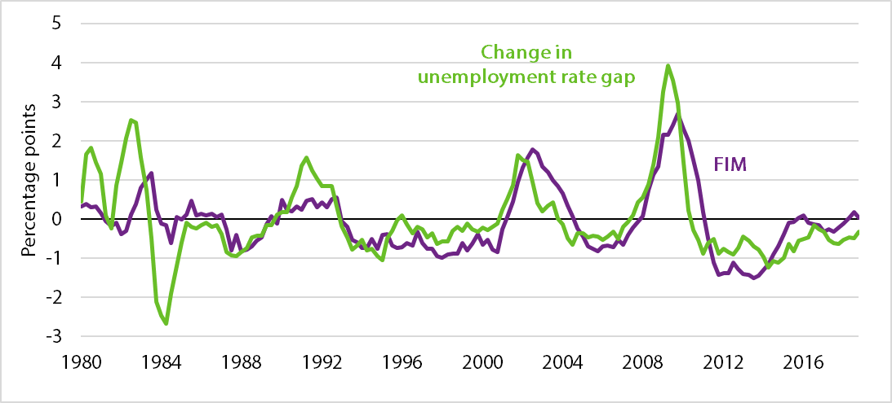

*Source:* Bureau of Labor Statistics [BLS] 1980–2018; Congressional Budget Office [CBO] 1980–2018; authors' calculations; see online appendix A for more details on FIM.

*Note:* The Hutchins Center Fiscal Impact Measure (FIM) is a gauge of how the fiscal policies of federal, state, and local governments affect near-term changes in GDP. The unemployment rate gap is the actual unemployment rate minus the CBO’s estimate of the natural rate of unemployment. Both series are four-quarter moving averages.

One question is whether following the fiscal stance of previous business cycles would still have been too contractionary. Because fiscal stimulus responds to changes in the unemployment rate, it diminishes when the economy starts to improve, even if unemployment remains high. While this might seem counterintuitive, it is analogous to how monetary policy responds to a decline in the unemployment gap under a Taylor-type rule and should be interpreted similarly: when the FIM is falling but is still above zero, fiscal policy remains stimulative, but to a lessening degree. Thus, the cyclicality of fiscal policy seems reasonable overall (Taylor 2000). In the recovery from the Great Recession, however, with monetary policy still constrained by the zero lower bound, keeping fiscal policy stimulative for longer might have been warranted. Certainly the move to contractionary fiscal policy in 2011–14 impeded the pace of the recovery and was far from optimal.[6]

Components of Stabilization

Figure 3 decomposes the FIM into its three main components: purchases, taxes, and transfers. Of the three, taxes and transfers are about equally countercyclical, but purchases also appear to be important stabilizers.

Figure 2.

Fiscal Impact Measure and the Unemployment Rate Gap, 1980–2018

*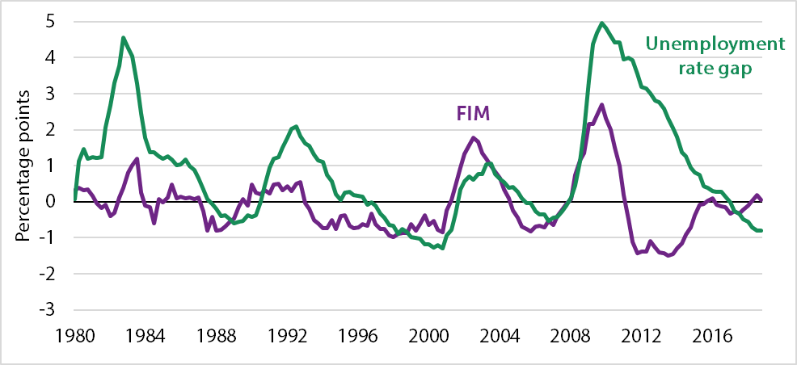Source:* BLS 1980–2018; CBO 1980–2018; authors' calculations; see online appendix A for more details on FIM.

*Note:* The Hutchins Center Fiscal Impact Measure (FIM) is a gauge of how the fiscal policies of federal, state, and local governments affect near-term changes in GDP. It is shown as a four-quarter moving average. The unemployment rate gap is the actual unemployment rate minus the CBO’s estimate of the natural rate of unemployment.

To be more precise about the relationships between FIM components and the business cycle, we run a regression that relates the FIM to the size of the change in the unemployment gap. (The regression results are reported in online appendix table A-2.) We run the regression for the years 1980 through 2018, and then also split the sample into four periods, using the labor market cycles defined by Aaronson et al. (2019). The FIM is defined as the contribution of fiscal policy to GDP growth, so if taxes decline when the unemployment rate rises, thereby boosting consumption, the FIM will show up as positive. Thus, a positive coefficient on the unemployment gap is countercyclical and stabilizing, whereas a negative coefficient is procyclical and destabilizing.

Figure 4 plots the responsiveness of each components of the FIM to a 1-percentage-point increase in the four-quarter change in the unemployment gap over different time horizons. Over the entire 1980–2018 period, a 1-percentage-point increase in the unemployment gap over the previous four quarters raises the FIM by 0.6 percentage point, meaning that quarterly real GDP growth is 0.6 percentage point higher, at an annual rate, than it would otherwise be.

Figure 3.

Fiscal Impact Measure: Contributions of Purchases, Taxes, and Transfers, 1980–2018

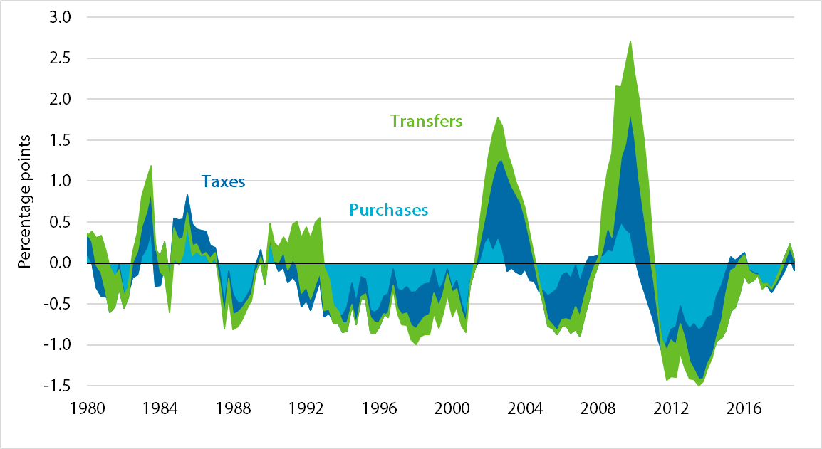

*Source:* Authors’ calculations; see online appendix A for more details on FIM.

*Note:* Data show the four-quarter moving average of each FIM component. Data are for all levels of government.

As expected, taxes are the most important fiscal stabilizer, but transfers (like unemployment insurance and Medicaid) and even purchases are quite responsive as well.

Figure 4.

Fiscal Impact Measure Response to a Higher Unemployment Rate Gap, 1980–2018

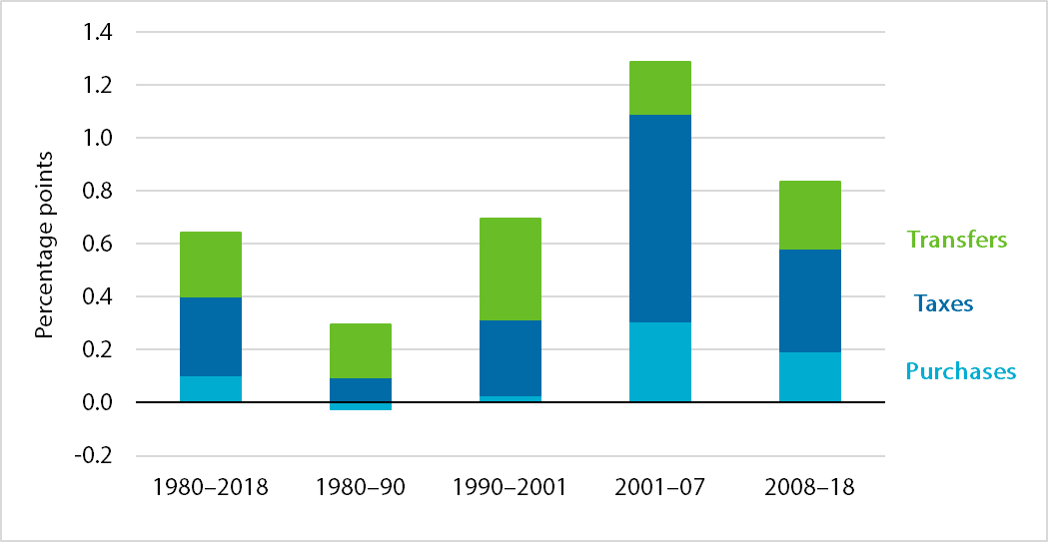

*Source:* Authors’ calculations; see online appendix A for more details on FIM.

*Note:* Data show the regression coefficients of each FIM component regressed on the four-quarter change in the unemployment gap from 1980 to 2018. Coefficients are for a one-percentage-point change in the unemployment rate gap.

One way to put these coefficients into context is to consider the rule of thumb coined by Arthur Okun known as Okun’s law. Okun’s law suggests that lowering the unemployment rate 1 percentage point requires GDP growth 2 percentage points above trend. Thus, these fiscal coefficients, ranging from 0.3 to 1.3, suggest policy was providing between 15 percent and 65 percent of the GDP growth needed to offset the increases in unemployment.

The relatively small effect of fiscal policy during the 1980 to 1990 period may be surprising, given the 1981 tax cuts and Reagan-era defense buildup, which seemed to fortuitously coincide with the 1981/1982 recession. Indeed, Follette and Lutz (2013) find that enacted legislation around the time of the 1981 recession did have sizable positive effects on aggregate demand. But, high inflation during the early 1980s pushed taxpayers into higher tax brackets (the tax system was not indexed for inflation until 1985), effectively raising tax rates during the 1980 recession, and partially offsetting the effects of the 1981 tax cuts during the 1981/1982 recession (CBO 1986). Furthermore, many of the effects of the 1981 tax cuts appeared in later years, when the economy was already recovering.

Fiscal Policy in the Recovery from the Great Recession

As noted above, fiscal policy became unusually contractionary in the 2011–14 period, a development that was widely viewed as holding back the recovery. Had the policies reflected in the FIM been as responsive to unemployment in that period as they had been through 2010, fiscal policy would have been much less contractionary. Figure 5 compares the actual FIM (blue line) with the FIM that would be predicted using a regression of the FIM on the change of the unemployment rate through 2010. Had policy reacted after 2010 as it did before, the FIM would have hovered near zero in the 2011–14 period.

Figure 5.

Actual and Predicted Fiscal Impact Measure, 1980–2018 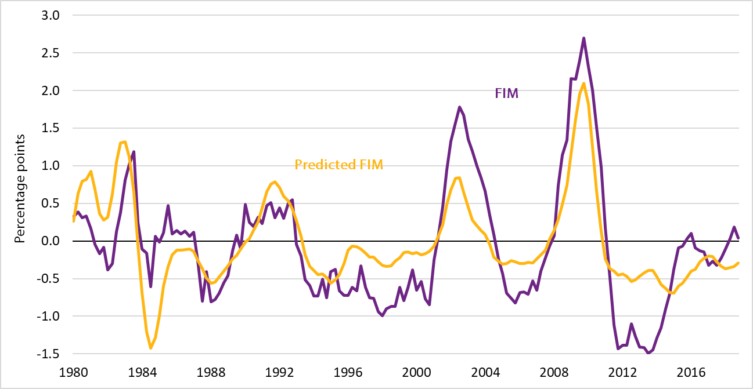

*Source:* Authors’ calculations; see online appendix A for more details on FIM.

*Note:* This graph shows the four-quarter moving average of the FIM and the four-quarter moving average of the predicted FIM, using a regression of the FIM on the four-quarter change in the unemployment gap from 1980 through 2010 to predict the FIM from 2011 to 2018.

Discretionary or Automatic?

Another way to split these data is according to whether the policy changes are automatic or discretionary. Automatic stabilizers are those that occur without legislative changes. The tax system is an automatic stabilizer because taxes fall when income falls—both because taxes are calculated as a share of income and because the tax system—particularly the federal tax system—is progressive, meaning that when people’s incomes fall, they fall into a lower tax bracket and thus face a lower tax rate.

We use CBO’s estimates of the automatic stabilizers for federal taxes, which CBO defines as the difference between actual taxes and the taxes that would have been collected had the economy been operating at its potential given the existing tax system.[7] For state and local taxes, we calculate the automatic stabilizers as the difference between actual and potential multiplied by the state and local tax rate, which we assume is equal to the ratio of tax collections to GDP in the previous quarter.[8]

Some transfers also move automatically with the business cycle. In particular, when the unemployment rate increases, more people are unemployed and so UI benefits increase. Similarly, when income declines, more people become eligible for Medicaid, boosting Medicaid expenditures (unless those expenditures are offset by changes to Medicaid rules). To calculate the automatic stabilizers for transfers, we follow a version of the method in CBO (2015).[9]

Other cyclical changes in taxes and transfers are discretionary. For example, Congress sometimes enacts tax cuts to counter recessions, as it did during the Great Recession, whereas states and localities might boost certain taxes to help balance their budgets. Basic unemployment benefits are automatic, but most extended benefits provided in recent years (benefits that allow people to stay on UI for longer than the standard 26 weeks) require legislation.[10] Stimulus packages enacted by the federal government may include increased infrastructure spending, either directly or via increases in transfers to state governments. At the same time, and due to their balanced budget requirements, state and local governments often cut purchases during downturns to reduce their deficits.[11]

Many changes in tax and spending are acyclical or at least are not intended to be cyclical. Examples are changes in Social Security and Medicare that occur over time because of increases in health spending and population aging, boosts in taxes that are the result of a stock market boom, and defense buildups in response to increased threats to national security.[12] These types of spending increases are unlikely to be responsive to changes in the unemployment gap, and can reduce the measured countercyclicality of fiscal policy. Note that, in this paper, we call all these changes discretionary, even though some of them—like changes in tax revenues fueled by increases in the stock market—occur without any legislative changes.[13]

Figure 6 decomposes the FIM into its automatic and discretionary portions, where the term discretionary encompasses all changes in the FIM other than the automatic stabilizers. Figure 7 presents the results from the regression of each component on the four-quarter change in the unemployment gap. Automatic stabilizers (the green shaded portions of the bars in figure 7) account for about one-half of the total stabilization over the entire period—with automatic changes in taxes being somewhat more important than automatic changes in transfers. But about one-half of the stabilization provided by fiscal policy has come from discretionary changes, with discretionary changes in purchases, taxes, and transfers all contributing. These discretionary changes have been particularly large since 2001, and account for most of the difference between the responsiveness of fiscal policy over time. Thus, even while some economists might have dismissed the value of countercyclical discretionary fiscal policy, governments continued enacting it.

Figure 6.

Fiscal Impact Measure: Contributions of Automatic and Discretionary Policy, 1980–2018

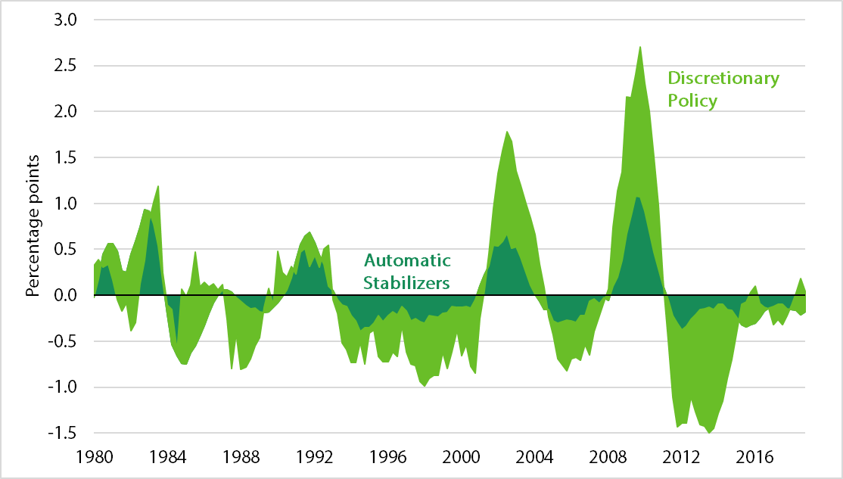

*Source:* Authors’ calculations; see online appendix A for more details on FIM.

*Note:* Data show the four-quarter moving average of each FIM component.

Figure 7.

Automatic and Discretionary Policy Responses to a Higher Unemployment Rate Gap, 1980–2018

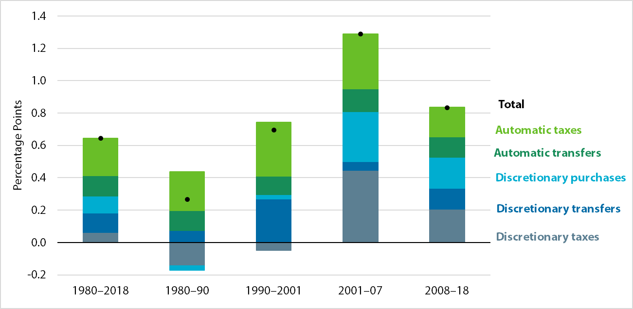

*Source:* Authors’ calculations; see online appendix A for more details on FIM.

*Note:* Data show the regression coefficients of each FIM component regressed on the four-quarter change in the unemployment gap using data from 1980 to 2018. Automatic policies are shown in blue and discretionary policies are shown in green.

Federal or State and Local?

Figure 8 shows that most of the impact of fiscal policy on the macroeconomy reflect federal policy. This is unsurprising, for several reasons. First, as shown in figure 9, the federal government represents a larger share of the economy. Federal tax collections are about double those of state and local governments, and most transfers are federal (recall that we have reallocated the federal portion of Medicaid to the federal government), although Social Security and Medicare—the two largest transfers—are not countercyclical. Federal and state and local governments represent roughly equal share of purchases. Thus, the scope for stabilization for policy is larger at the federal level than at the state and local levels.

Figure 8.

Fiscal Impact Measure: Contributions of Federal and State and Local Governments, 1980–2018

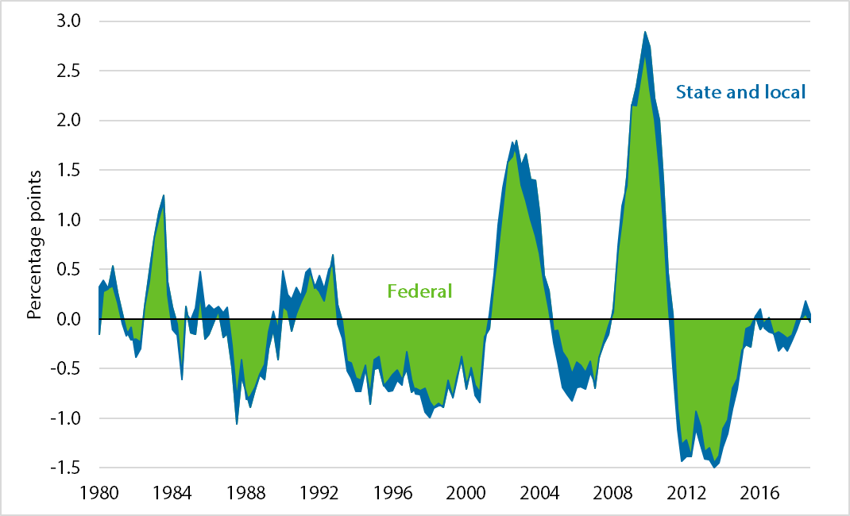

*Source:* Authors’ calculations; see online appendix A for more details on FIM.

*Note:* Data show the four-quarter moving average of each FIM component.

Figure 9.

Components of Fiscal Policy, by Level of Government, 1980–2018

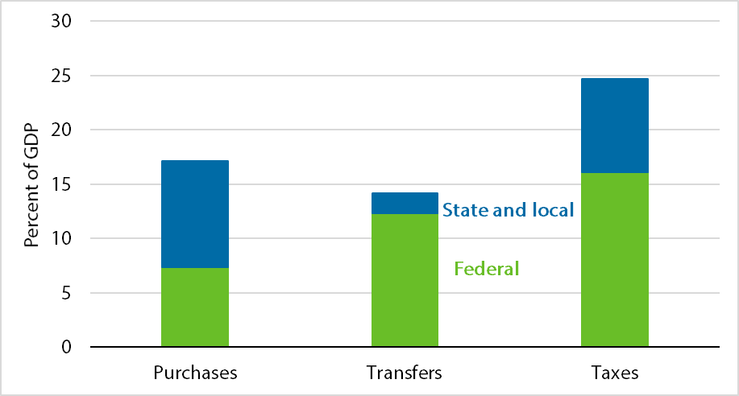

*Source:* Bureau of Economic Advisers (BEA) 2018; authors’ calculations.

*Note:* Data show the different components of fiscal policy, broken out by level of government, as a share of GDP.

Second, states and localities generally operate under balanced budget requirements, meaning that any reductions in taxes (that stabilize the economy) are generally offset by reductions in spending (that destabilize the economy). Because changes in purchases affect the economy one for one, whereas changes in taxes and transfers have smaller and more-gradual effects on consumption, spending cuts that perfectly balanced tax revenue shortfalls would have a net negative effect on economic growth. But balanced budget requirements do not preclude all stabilization because they do not apply to capital investments, and because states have ways to meet them other than through cutting spending, such as by depleting rainy-day funds or cutting back on contributions to employee pension funds.

Figure 10 reports the results of the regression of various federal, state, and local components of the FIM on the four-quarter change in the unemployment gap for the whole 1980–2018 period. These regressions indicate that not only is the federal government a more important player in the macroeconomy, but it is also a more stabilizing force. The automatic stabilizers make both federal, and state and local, taxes and transfers countercyclical, but the federal government reinforces these effects by also enacting legislation that reduces taxes, increases transfers, and increases purchases during downturns. In contrast, state and local governments, reflecting their need to balance their budgets, offset the automatic declines in revenues by cutting spending.

Figure 10.

Responsiveness of Fiscal Policies to a Higher Unemployment Rate Gap, by Level of Government, 1980–2018 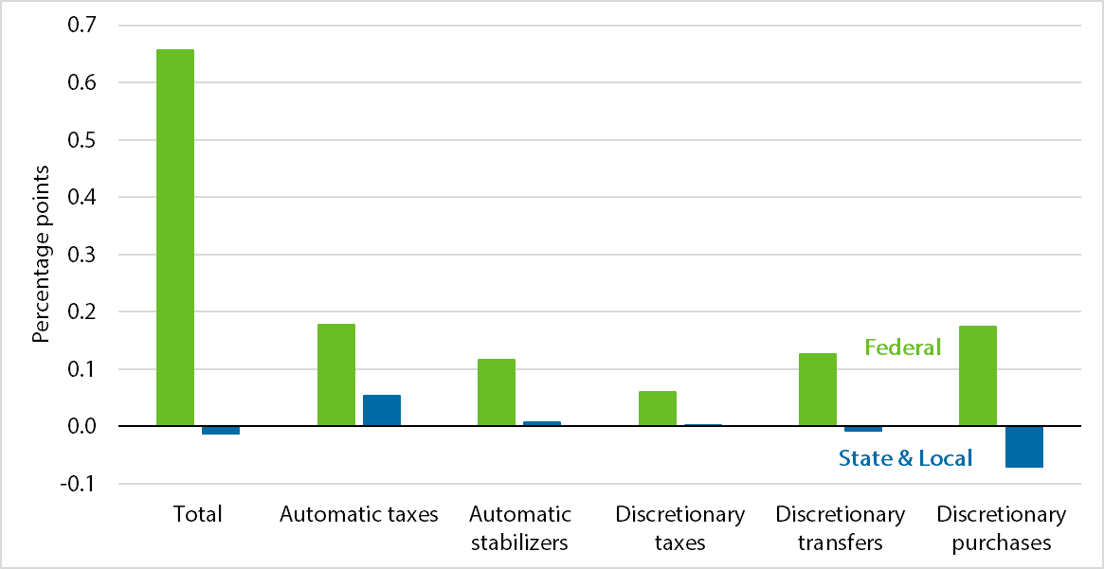

*Source:* Authors’ calculations; see online appendix A for more details on FIM.

*Note:* Data show the regression coefficients of each FIM component regressed on the four-quarter change in the unemployment gap from 1980 to 2018.

As shown in figures 11 and 12, these patterns are relatively consistent over the various periods. The conclusion that state and local tax policy is only mildly procyclical might appear at odds with the conventional wisdom that state and local government policy was meaningfully holding back the recovery during the Great Recession (Furman, forthcoming). One reason may be that the combined state and local policy was more procyclical in 2008 than in any other business cycle. It may also be that observers generally focus on the purchasing behavior of state and local governments, rather than on the combination of tax and spending policy, which, as detailed above, is less procyclical. Finally, it could be that the state cutbacks were large in 2011–16 when the unemployment rate was falling (and hence do not look procyclical by the measure used) but the economy was still weak.[14] If state and local governments did not cut spending or raise taxes during recessions, fiscal policy would be more powerful in combatting recessions, but, as shown in figure 9, the effect would not be particularly large.

Figure 11.

Responsiveness of Federal Fiscal Policies to a Higher Unemployment Rate Gap, 1980–2018

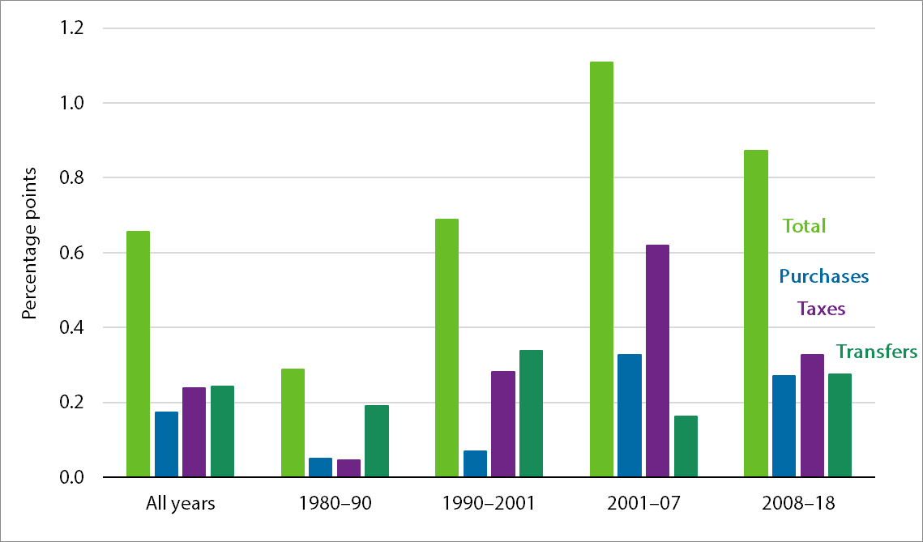

*Source:* Authors’ calculations; see online appendix A for more details on FIM.

*Note:* Data show the regression coefficients of each FIM component regressed on the four-quarter change in the unemployment gap from 1980 to 2018.

Figure 12.

State and Local Responsiveness to a Higher Unemployment Rate Gap, 1980–2018

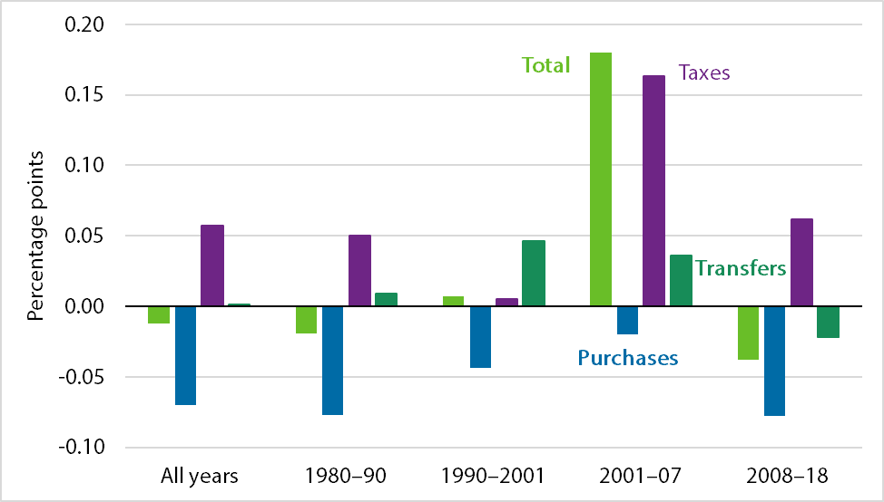

*Source:* Authors’ calculations; see online appendix A for more details on FIM.

*Note:* Data show the regression coefficients of each FIM component regressed on the four-quarter change in the unemployment gap from 1980 to 2018.

Online appendix B explores the timing of the fiscal responses of federal and state and local governments. It shows that for a given unemployment gap shock, cuts to state and local spending offsets about 25 percent of the total stimulus provided by the federal government during a recession. Moreover, although federal stimulus reaches its peak after about two years, state and local spending cuts continue over the course of almost five years after an unemployment gap shock.

Conclusion

Fiscal policy has been strongly countercyclical over the past five decades, with the degree of cyclicality somewhat stronger in the past 20 years than the previous 20. Almost all the stabilization is accounted for by the federal government—especially when spending financed by the federal government but implemented by states and localities is counted as federal. The automatic stabilizers and discretionary fiscal policy are about equally important to macroeconomic stabilization. During economic downturns, taxes fall and transfers increase both automatically and in response to legislation, and the federal government also increases purchases. State fiscal policy is very mildly procyclical, and declines in state and local purchases more than offset stimulus provided by state automatic stabilizers.

Acknowledgments

We thank Glenn Follette, Byron Lutz, Ryan Nunn, Jay Shambaugh, and David Wessel for helpful comments. All errors are, of course, our own.

References

Aaronson, Stephanie R., Mary C. Daly, William Wascher, and David W. Wilcox. 2019. “Okun Revisited: Who Benefits Most from a Strong Economy?” *Brookings Papers on Economic Activity,* Conference Draft, Brookings Institution, Washington, DC.

Belz, Sage, and Louise Sheiner. 2019, April 5. “Hutchins Center Fiscal Impact Measure.” The Brookings Institution, Washington, DC.

Blinder, Alan S. 2016. “Fiscal Policy Reconsidered.” Policy Proposal 2016-05, The Hamilton Project, Brookings Institution, Washington, DC.

Bureau of Economic Analysis (BEA). 2018. “National Income and Product Accounts (NIPA) Tables.” Bureau of Economic Analysis, U.S. Department of Commerce, Suitland, MD.

Bureau of Labor Statistics (BLS). 1980–2018. “Unemployment Level (Seas).” Bureau of Labor Statistics, U.S. Department of Labor, Washington, DC.

Cashin, David, Jamie Lenney, Byron Lutz, and William Peterman. 2018. “Fiscal Policy and Aggregate Demand in the USA Before, During, and Following the Great Recession.” *International Tax and Public Finance* 25 (6).

Congressional Budget Office (CBO). 1980–2018. “Natural Rate of Unemployment.” Congressional Budget Office, Washington, DC.

———. 1986. “Effects of the 1981 Tax Act on the Distribution of Income and Taxes Paid.” Staff Working Paper, Congressional Budget Office, Washington, DC.

———. 2015. “How CBO Estimates Automatic Stabilizers.” Working Paper 2015-07, Congressional Budget Office, Washington, DC.

———. 2019. “Data that Supplement CBO’s January 2019 Report.” Congressional Budget Office, Washington, DC.

Elmendorf, Douglas, and Jason Furman. 2008. “If, When, How: A Primer on Fiscal Stimulus.” Strategy Paper, The Hamilton Project, Brookings Institution, Washington, DC.

Follette and Lutz. 2013. Fiscal Multipliers: How Much Bang for the Buck?” Fiscal Policy and Growth, Banca d’Italia, Rome, Italy.

Furman, Jason. 2016, October 5. “The New View of Fiscal Policy and Its Application.” Remarks prepared for delivery, Global Implications of Europe’s Redesign, New York, NY.

———Forthcoming. “The Fiscal Response to the Great Recession: Steps Taken, Paths Rejected, and Lessons for Next Time.” In *Responding to the Global Financial Crisis, What We Did and Why We Did It,* edited by Nellie Liang*.* Yale University Press and the Hutchins Center on Fiscal & Monetary Policy at Brookings, Washington, DC.

Rachel, Łukasz, and Lawrence H. Summers. 2019. “On Falling Neutral Real Rates, Fiscal Policy, and the Risk of Secular Stagnation.” *Brookings Papers on Economic Activity,* Conference Draft, Brookings Institution, Washington, DC.

Russek, Frank, and Kim Kowalewski. 2015. “How CBO Estimates Automatic Stabilizers.” Working Paper 2015-07, Congressional Budget Office, Washington, DC.

Sheiner, Louise. 2019. “Effects of Low Productivity Growth on Fiscal Sustainability in the United States.” In *Facing up to Low Productivity Growth,* edited by Ada Posen and Jeromin Zettelmeyer, 87-115. Washington, DC: Peterson Institute for International Economics.

Stock, James H., and Mark W. Watson. 2001. “Vector Autoregressions.” *Journal of Economic Perspectives* 15 (4): 101–15.

Taylor, John. 2000. “Reassessing Discretionary Fiscal Policy.” *Journal of Economic Perspectives* 14 (3): 21–36.

Appendix A. Deriving the Fiscal Impact Measure

The FIM is defined as the actual contributions of real government purchases and real consumption to GDP less the contributions that would have prevailed if real purchases, real taxes, and real transfers were growing with potential GDP.

Define G as nominal government purchases, πG as the inflation rate for government purchases, C as nominal consumption, T as nominal taxes, TR as nominal transfers, πC as the inflation rate for personal consumption expenditures (PCE), Y as nominal GDP, and µ as real potential output growth. Then the FIM is calculated as follows:

Purchases

The contribution of real purchases to GDP is just the growth rate of real government purchases times the share of government in GDP:

$$\left(\frac{G_{t}}{G_{t-1}}-(1+π_{G})\right)\frac{G_{t-1}}{Y_{t-1}}= \frac{G_{t}-(1+π_{G})G_{t-1}}{Y_{t-1}}$$

The counterfactual contribution of real government purchases under the assumption that real government spending rises with potential GDP is just

$$μ\frac{G_{t-1}}{Y_{t-1}}$$

Thus, the FIM for purchases is defined as

$$\frac{G_{t}-(1+π_{G}+μ)G_{t-1}}{Y_{t-1}}$$

Taxes and Transfers

The contribution of real consumption to GDP is just the growth rate of real consumption times the share of consumption in GDP:

$$\left(\frac{C_{t}}{C_{t-1}}-(1+π_{C})\right)\frac{C_{t-1}}{Y_{t-1}}= \frac{C_{t}-(1+π_{C})C_{t-1}}{Y_{t-1}}$$

Under the counterfactual, net taxes (taxes less transfers) would be rising with potential GDP: With ${\tilde{T}}_{t}$ denoting the counterfactual net taxes, $$\left(\frac{{\tilde{T}}_{t}}{T_{t-1}}-(1+π_{C})\right)= μ$$

So

$${\tilde{T}}_{t}=T_{t-1}(1+π_{C}+ μ)$$

The fiscal impact of changes in taxes and transfers is measured as the change in the contribution of consumption to real GDP growth given actual net taxes less the contribution that would have occurred had net taxes been rising with potential GDP.

$$\left(\frac{C_{t}}{C_{t-1}}-\left(1+π_{C}\right)\right)\frac{C_{t-1}}{Y_{t-1}} -\left(\frac{C_{t} +\sum_{i=t-n}^{t}{{MPC}_{i}}\left({T_{t}-\tilde{T}}_{t}\right)}{C_{t-1}}-\left(1+π_{C}\right)\right)\frac{C_{t-1}}{Y_{t-1}}$$

$$\frac{\sum_{i=t-n}^{t}{{MPC}_{i}}({T_{t}-\tilde{T}}_{t})}{Y_{t-1}}= \frac{\sum_{i=t-n}^{t}{{MPC}_{i}}(T_{t}-T_{t-1}( 1+π_{C}+μ))}{Y_{t-1}}$$

Putting the two pieces together, the FIM is defined as

$$FIM= \frac{G_{t}-\left(1+π_{G}+μ\right)G_{t-1}+ \sum_{i=t-n}^{t}{{MPC}_{i}}({T_{t}-T}_{t-1}( 1+π_{C}+ μ))}{Y_{t-1}}$$

Assumed Marginal Propensities to Consume

Cashin et al. (2018) summarize the long literature on marginal propensities to consume (MPCs), and assign an MPC of 0.5 to temporary changes in individual taxes and transfers, and an MPC of 0.7 to permanent changes. Because we do not track temporary versus permanent, we take a simple average and use 0.6 as our MPC. For transfers, we assume that the MPC is 0.9, reflecting the fact that some transfers—like Medicare and Medicaid—are likely to increase spending one for one, and others, like temporary changes in unemployment benefits, are received by liquidity-constrained households that are likely to spend most of their benefits. The MPC out of a corporate tax cut is much smaller, since most corporate equity is held by high-income individuals and pension plans, who are less likely to be liquidity constrained. Part of the effect may also be viewed as a responsiveness of investment to corporate tax changes. Cashin et al. (2018) note that changes in MPC do not have a large effect on their fiscal stance measure. Our assumptions are in table A-1.

Table A-1.

Assumed Marginal Propensities to Consume

|  |  |  |  |  |  |
| --- | --- | --- | --- | --- | --- |
| Assumed MPCs | | | | | |
|  | Total MPC | Q1–Q2 | Q3–Q4 | Q5–Q8 | Q9–Q12 |
| Government Purchases | 1.0 | 1.0 | 0 | 0 | 0 |
| Transfers | 0.9 | 0.225 | 0.225 | 0 | 0 |
| Individual Taxes | 0.6 | 0.12 | 0.06 | 0.06 | 0 |
| Corporate Taxes | 0.4 | 0.033 | 0.033 | 0.033 | 0.033 |

Table A-2.

Regression Results: Fiscal Impact Measure and Its Components on the Four-quarter Change in the Unemployment Gap

|  |  |  |  |  |  |
| --- | --- | --- | --- | --- | --- |
|  | 1980–2018 | 1980–90 | 1990–2001 | 2001–7 | 2008–18 |
| Total | 0.644*** | 0.268** | 0.696*** | 1.288*** | 0.834*** |
| Purchases | 0.105** | –0.026 | 0.027 | 0.307*** | 0.192*** |
| Taxes | 0.296*** | 0.095** | 0.286*** | 0.783*** | 0.389*** |
| Transfers | 0.243*** | 0.199*** | 0.382*** | 0.198*** | 0.253*** |
| *Federal* | 0.656*** | 0.287** | 0.688*** | 1.108*** | 0.872*** |
| Fed Purchases | 0.174*** | 0.051 | 0.07 | 0.327** | 0.270*** |
| Federal Taxes | 0.239*** | 0.045 | 0.281*** | 0.620*** | 0.327*** |
| Federal Transfers | 0.242*** | 0.190*** | 0.337*** | 0.162*** | 0.275*** |
| *State* | –0.012 | –0.019 | 0.007 | 0.18 | –0.038 |
| State Purchases | –0.070** | –0.077 | –0.044 | –0.02 | –0.078* |
| State Taxes | 0.057*** | 0.050*** | 0.005 | 0.163*** | 0.062*** |
| State Transfers | 0.001 | 0.009* | 0.046*** | 0.036** | –0.022*** |
| Automatic | 0.356*** | 0.363*** | 0.449*** | 0.481*** | 0.309*** |
| Discretionary | 0.288*** | –0.095 | 0.247* | 0.807*** | 0.525*** |
| Automatic: |  |  |  |  |  |
| Taxes | 0.232*** | 0.239*** | 0.335*** | 0.338*** | 0.183*** |
| Transfers | 0.125*** | 0.124*** | 0.113*** | 0.142*** | 0.126*** |
| *Federal* |  |  |  |  |  |
| Federal Taxes | 0.178*** | 0.185*** | 0.264*** | 0.268*** | 0.136*** |
| Federal Transfers | 0.116*** | 0.116*** | 0.109*** | 0.124*** | 0.118*** |
| *State* |  |  |  |  |  |
| State Taxes | 0.054*** | 0.054*** | 0.072*** | 0.070*** | 0.047*** |
| State Transfers | 0.008*** | 0.008*** | 0.005 | 0.018 | 0.008** |
| Discretionary: |  |  |  |  |  |
| Taxes | 0.064** | –0.144*** | –0.049 | 0.445*** | 0.206*** |
| Transfers | 0.119*** | 0.075*** | 0.269*** | 0.056 | 0.128** |
| *Federal* |  |  |  |  |  |
| Federal Taxes | 0.061** | –0.140*** | 0.017 | 0.352** | 0.190*** |
| Federal Transfers | 0.126*** | 0.075*** | 0.228*** | 0.038 | 0.158*** |
| Federal Purchases | 0.174*** | 0.051 | 0.07 | 0.327** |  |
| *State* |  |  |  |  |  |
| State Taxes | 0.003 | –0.004 | –0.066*** | 0.093*** | 0.016 |
| State Transfers | –0.007* | 0.001 | 0.041*** | 0.018 | –0.030*** |
| State Purchases | –0.070** | –0.077 | –0.044 | –0.02 | –0.078* |

*Source:* Authors’ calculations.

*Note:* This table reports the results of regressions of various components of the quarterly FIM on the four-quarter change in the unemployment gap. Standard errors are Newey-West, and *p<0.1; **p<0.05; ***p<0.01.

Appendix B. Vector Autoregressions and Impulse Response Functions

Vector autoregressions (VARs) can be used to analyze the timing and ultimate magnitude of the response of fiscal policy to an unemployment shock. We show here the impulse response functions (IRFs) from some simple VARs, where the FIM is regressed on lagged values of itself and the unemployment gap. We provide the details below. Examining the VAR for the total FIM, we see that the fiscal policy response takes time—reaching its largest magnitude about seven quarters after an initial change in unemployment. Furthermore, examining the VAR for the state and local fiscal response, we see that it is quite negative—subtracting about 25 percent off the federal response, but that it takes a particularly long time to reach its full effect—close to four years.

Appendix B Figure 1A.

FIM Cumulative Response to a 1 Percentage Point Increase in the Unemployment Gap

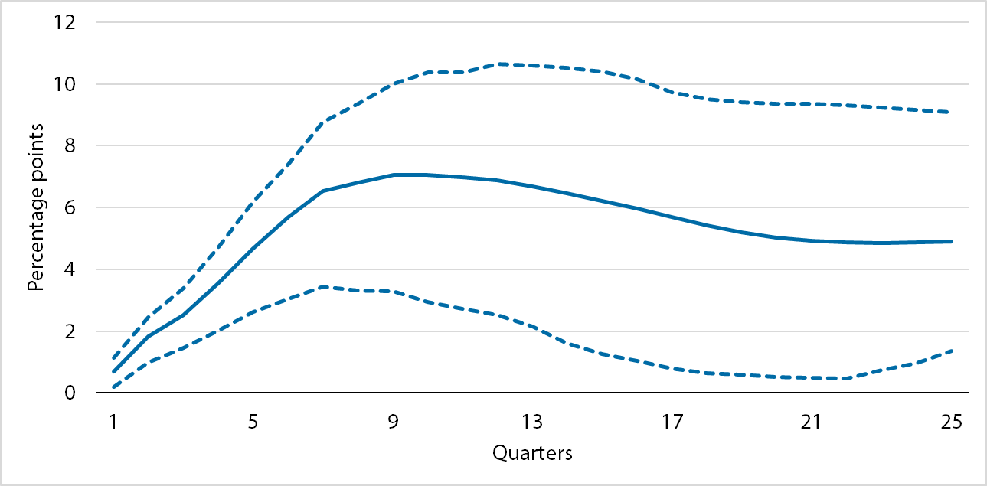

Appendix B Figure 1B.

Automatic Stabilizers Cumulative Response to a 1 Percentage Point Increase in the Unemployment Gap

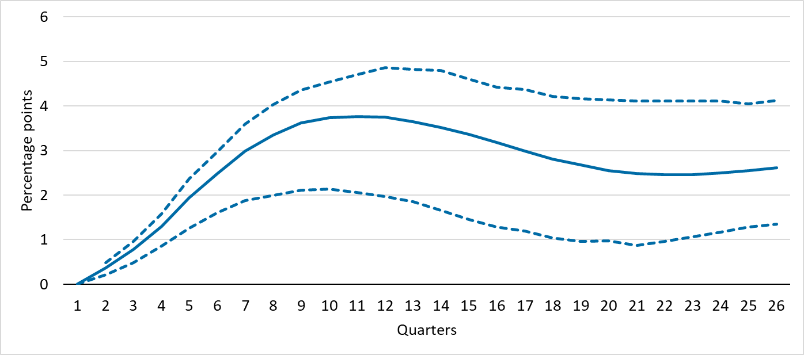

Appendix B Figure 1C.

Discretionary Policy Cumulative Response to a 1 Percentage Point Increase in the Unemployment Gap

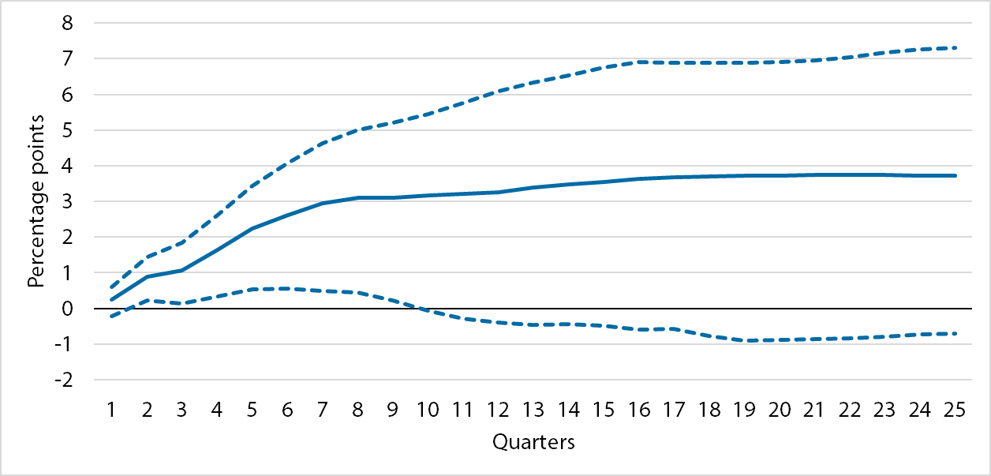

Appendix B Figure 1D.

Federal FIM Cumulative Response to a 1 Percentage Point Increase in the Unemployment Gap

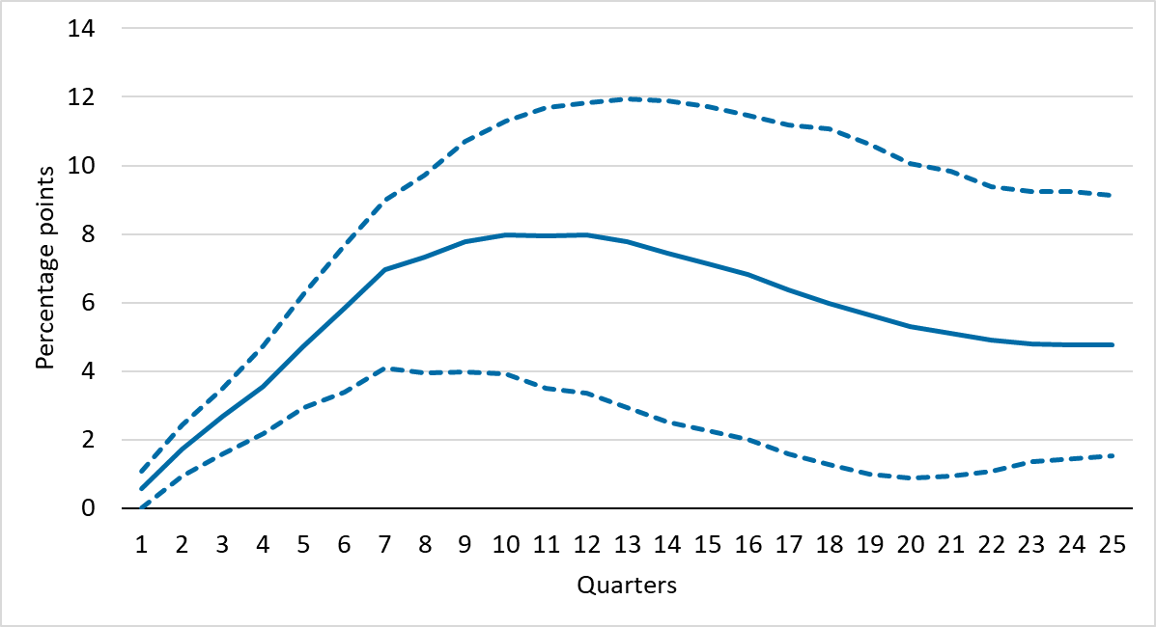

Appendix B Figure 1E.

State and Local FIM Cumulative Response to a 1 Percentage Point Increase in the Unemployment Gap

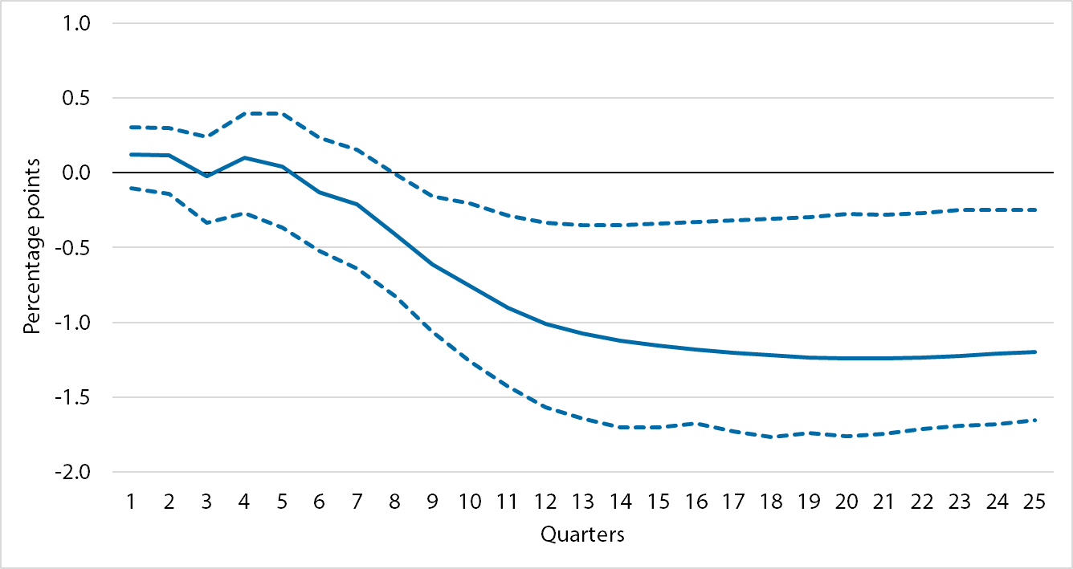

Source: Author’s calculations.

Note: Technical details: Figure B-1 show the results of several orthogonalized IRFs obtained through estimations of several recursive VARs. The VARs regress each FIM component on lags of itself and lags of the four-quarter change in the unemployment gap, with the number of lags in each VAR chosen by Aikake Information Criteria. In the case of the discretionary FIM and the state and local FIM, the automatic stabilizer component of the FIM and the federal component of the FIM are each included as the second variable in each respective VAR, ordered after the change in the unemployment gap.

The VARs are recursive and the IRFs orthogonal such that the contemporaneous relationships between the variables are limited based on the order in which they appear in order to better identify contemporaneous shocks. In other words, variables ordered earlier contemporaneously affect variables ordered later, but not vice versa. For the orthogonal IRFs, this is achieved through the Cholesky decompositions of the model residuals. All IRFs are cumulative over a 24-quarter window after the shock. Dotted lines show the 95 percent confidence intervals of each estimate. The IRFs can be interpreted as the cumulative FIM response to a 1-percentage-point exogenous increase in the unemployment gap not predicted by the model. For more on VARs, see Stock and Watson (2001) or reference the vars package in the R programming language.

The VARs are specified as

Total ~ Δ4Ugap + ε

Automatic Stabilizers FIM ~ Δ4Ugap + ε

Discretionary FIM ~ Δ4Ugap + Automatic Stabilizers FIM + ε

Federal FIM ~ Δ4Ugap + ε

State and Local FIM ~ Δ4Ugap + Federal FIM + ε

where each variable represents a vector of current and lagged values chosen by Aikake Information Criteria. The model is estimated as a system with the impulse response coming as a shock to the error term playing through the system.

1. See Blinder (2016) for discussion of the history of thought on the use of fiscal policy.
2. The Hutchins Center publishes its latest reading of the FIM with every GDP release (see Belz and Sheiner 2019).
3. The assumed total fiscal multipliers are 1.0 for government purchases, 0.9 for government transfers, 0.6 for individual taxes, and 0.4 for corporate taxes. See online appendix A for more details.
4. Appendices can be found at the end of the online version of this chapter.
5. The rest of federal grants are mainly for education and transportation, so are likely to be purchases rather than transfers. Data on the federal share of Medicaid are from the National Health Expenditure Accounts released by the Center for Medicare & Medicaid Services.
6. See Furman (2016) for a discussion of the need for sustained fiscal policy following large recessions. Cashin et al. (2018) also discuss the unusual degree of contraction in these years.
7. CBO uses cross-sectional data to estimate how much taxes would increase were everyone’s income to rise by 1 percentage point, which allows CBO to isolate the automatic part of revenue changes from changes that occur because of legislation (Russek and Kowalewski 2015). CBO’s most recent estimates can be found at CBO (2019).
8. As noted by Sheiner (2019), state income taxes are not very progressive, and most state and local sales and property taxes are also subject to a flat rate, so the assumption of a flat tax rate seems fine. But if the tax base does not move one for one with GDP—for example, if property values do not fall much during recessions—this calculation will overstate the effect of state automatic stabilizers.
9. CBO appears to regress federal Medicaid spending against measures of the business cycle, without accounting for the fact that Congress has in the past increased the federal share of Medicaid spending during recessions, which will make Medicaid appear more countercyclical than it is. We regress total Medicaid spending, including both state and federal, to avoid this problem.
10. Both BEA and CBO count all UI benefits as federal, although the UI program is really a joint federal-state program, with the states having discretion to set the rules and financing most of the regular benefit payments, either through tax proceeds or through loans from the federal government. We follow their lead in assigning all benefits to the federal government; assigning some benefits to state governments would reduce the procyclicality of state and local fiscal policy.
11. Furman (2018) has a comprehensive discussion of the changes in fiscal policy that occurred during the Great Recession.
12. Follette and Lutz (2013) decompose discretionary policies into those intended to stimulate the economy and those enacted for other reasons.
13. The fiscal stance measured in Cashin et al. (2018) is decomposed into three pieces: discretionary policy (policy that requires legislation), automatic stabilizers, and a residual (everything else). Cashin et al. find that their residual category is slightly countercyclical, which could mean that including it with discretionary, as we do, implies that we are overstating the countercyclicality of fiscal policy a bit. But even that is not clear. It may be that Congress is more likely to allow increases in spending or reductions in taxes to show through to the deficit when the economy is weak, but not when the economy is strong, meaning that residual cyclicality is viewed appropriately as countercyclical fiscal policy.
14. It is worth noting that, while the one-year change in the unemployment gap fits most of the data well, adding an additional lag (the one-year change lagged four quarters) to the equations involving state FIM improves the fit and increases the procyclicality of state and local policy. This suggests that the chain of events between an increase in the unemployment rate and a reduction in state and local spending takes longer. When recessions are short and the economy bounces back quickly, this lag makes state and local fiscal policy less destabilizing. When recessions are long, though, the lag acts to impede the recovery.