

PROJECT: Makeup
GROUP NO: 01 BATCH: T5.2309.E0

A. SYSTEM REQUIREMENTS:
Sr. | Item | Description
1. | Operating system | Windows 7, 8, or higher
2. | Hardware | Pentium 166 or better with 64 Megabytes of RAM or better
3. | Web Browser | Version in later of: Edge 44, Firefox 40, Chrome 55, etc…
4. | Fonts | Standard font Unicode: Arial, Tahoma, Lucida Console, Times New Roman, etc…
5. | Other requirement | A working internet connection.
Notes: Do not install IDEs (Integrated Development Environment) on the system such as MS Visual Studio, Jbuilder, Dreamweaver, etc.

B. Program Instrallation
Step 1. Visit the Github repository at “https://github.com/Hutee-Le/Makeup_Group01” to access the Makeup_Group01project.
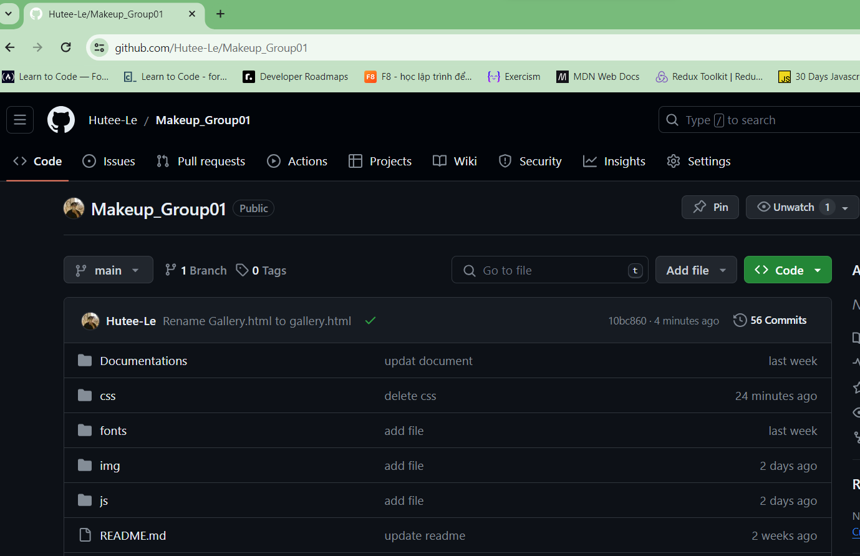
Step 2. In the repository, scroll down to the README section and click
on the link Published website. “https://hutee-le.github.io/Makeup_Group01/homepage.html”.
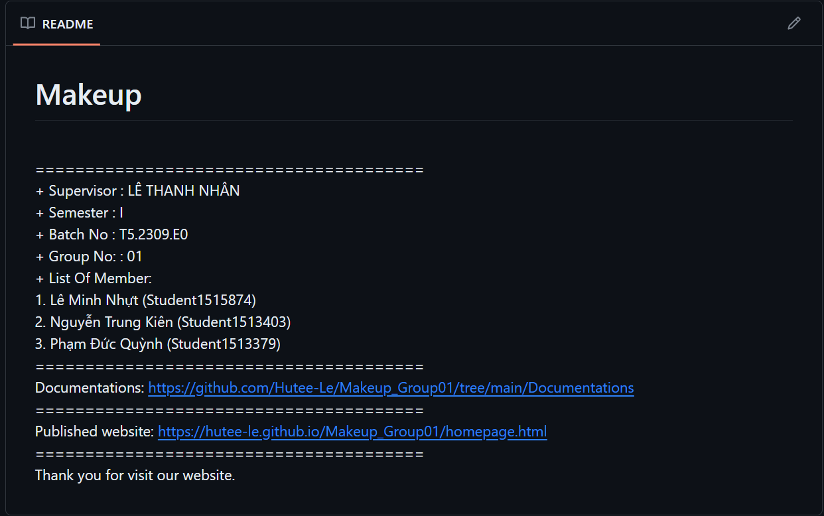
Step 3. After clicking the link, you will be redirected to the live website. If you wish to run the project locally, find the 'Download Zip' ( or
Clone) section in the repository to download the project files to your computer.
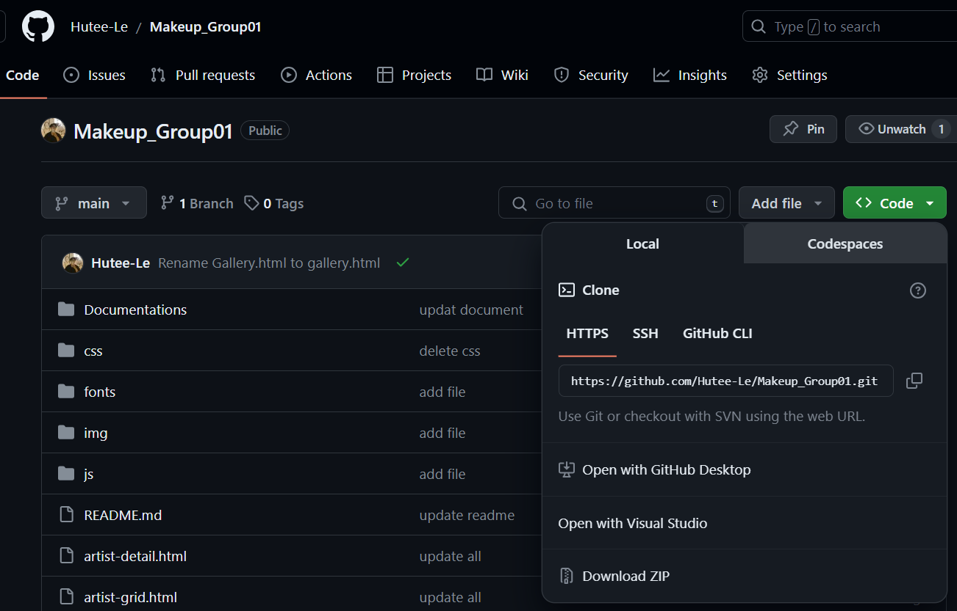
Step 4. Copy Makeup_Group01-main.zip from download folder to your website directory (for example Drive E:\eProject_Makeup)
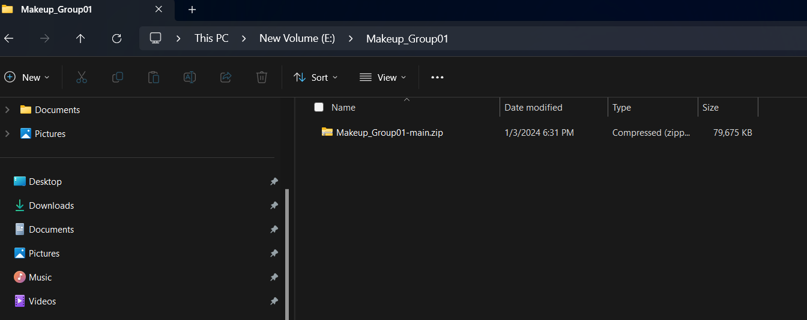
Step 5. Extract Here .zip file into the eProject_Makeup folder
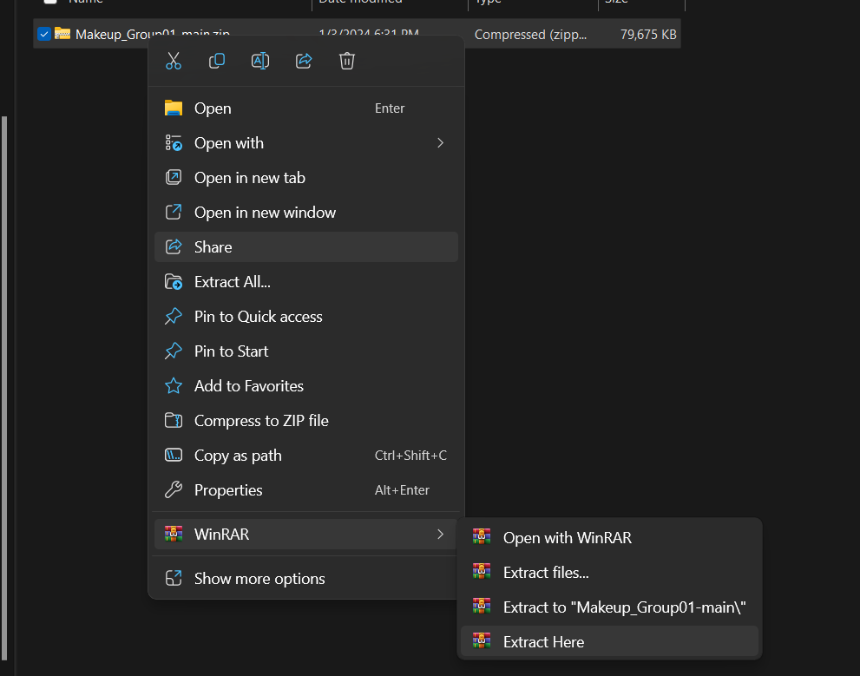
Step 6. Open folder Makeup_Group01-main
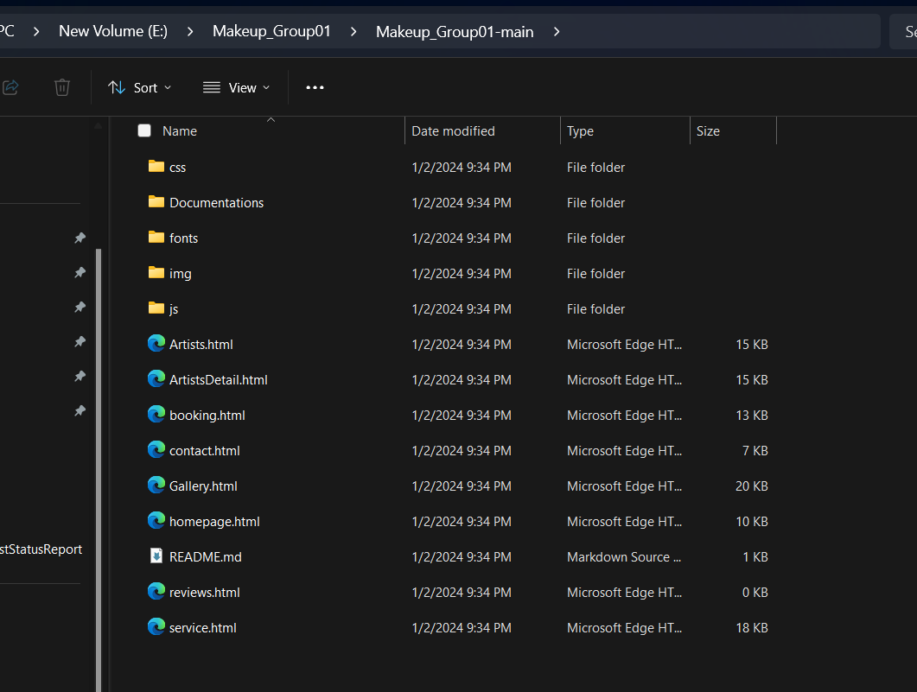
Step 7. Run homepage.html in eProject_Makeup folder. (please use Chrome or Firefox browser for website for best experience.)

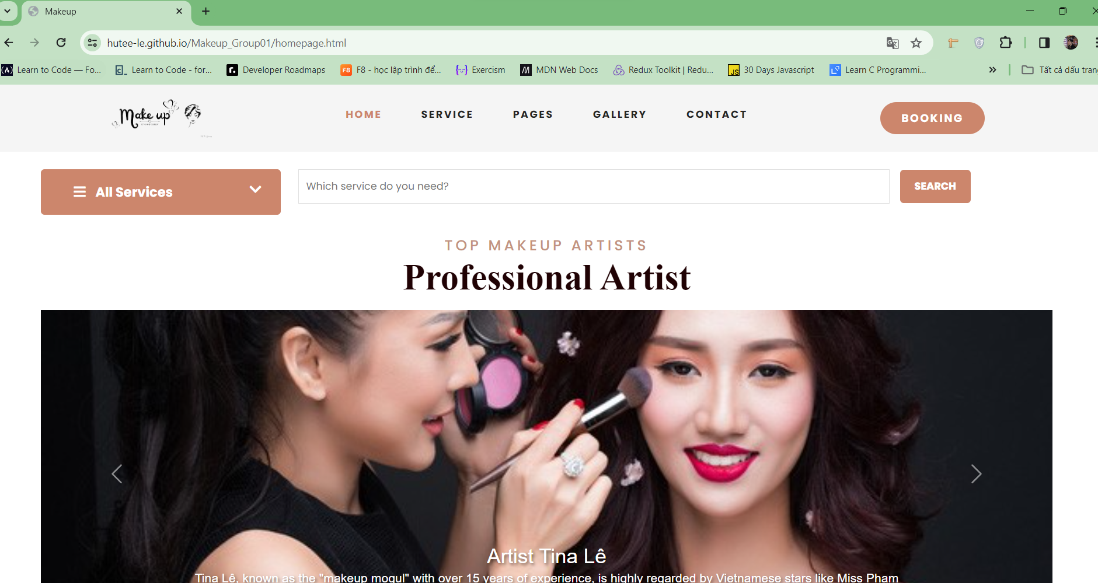

C. Successful test
- The file is loaded successfully
- Homepage should be displayed as described in the documentation.


