Web Technology and Standards

Assignment 4

Fall 2018

Assigned: 11/15/2018

Due: 11/26/2018 (I will accept all assignments until Friday 11/30).

Option 1:

* Use Nodejs, Express, MongoDB, Angularjs to create a small REST API.
  + You can modify the API we did in the class which has one route for all http request.
    - Create different routes for different requests for example: In your app.js or server.js you will define different routes. For adding new product by ID: router.route('/products/:product_id').put(function (req, res) ->this route is for updating a product by ID
  + Your app should
    - Add authentication. (optional)
    - Route for finding product by ID
    - Route to update specific record by ID
    - Route to delete by ID
    - Route to add new product by ID
  + You can follow [this tutorial](https://medium.com/@debug_mode/step-by-step-building-node-js-based-rest-api-to-perform-crud-operations-on-mongodb-ab18835111d7)
  + You can use this as part of your final project so you can create the rest API for your final project but you need to work on it individually.
  + You can install any packages in Nodejs if it is helpful to you.

Submission:

Github: <https://github.com/Hutsh/MEANApp>

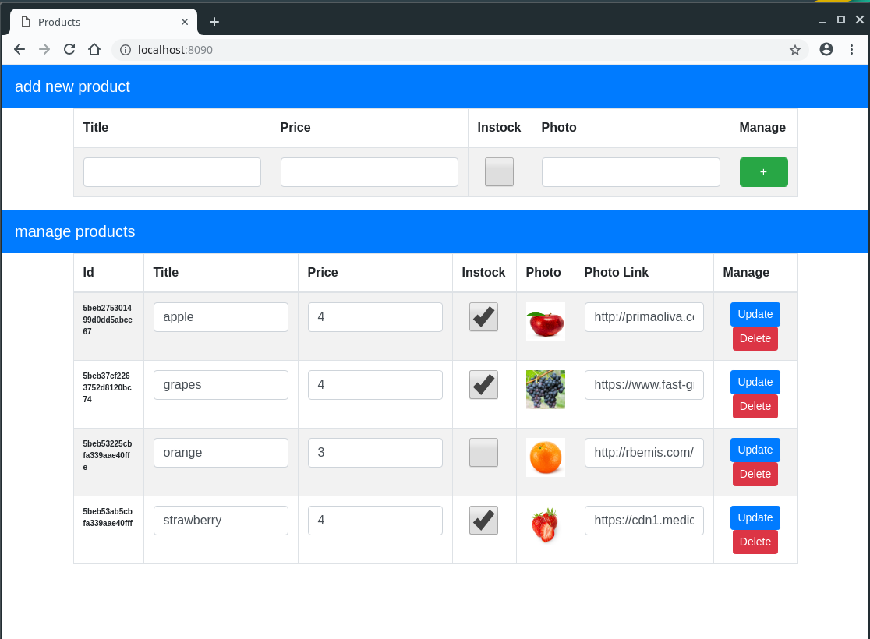

Route for finding product by ID:

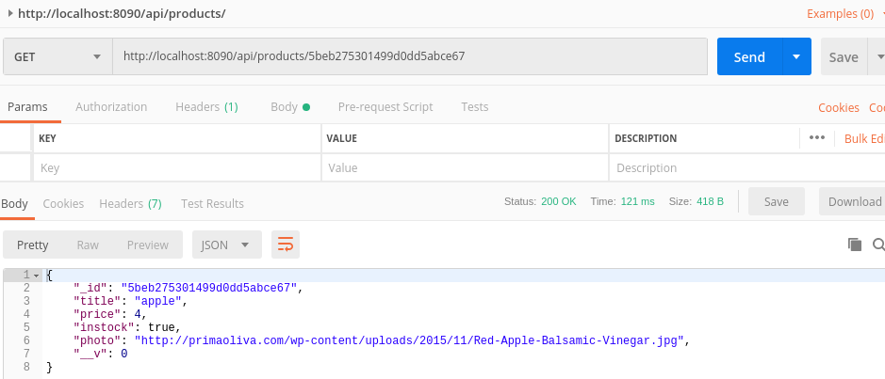

Route to update specific record by ID：

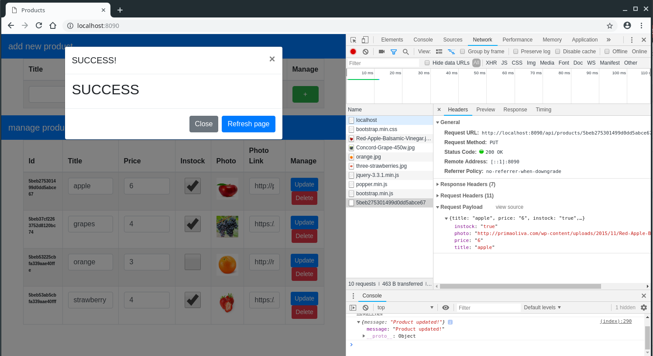

Route to delete by ID：

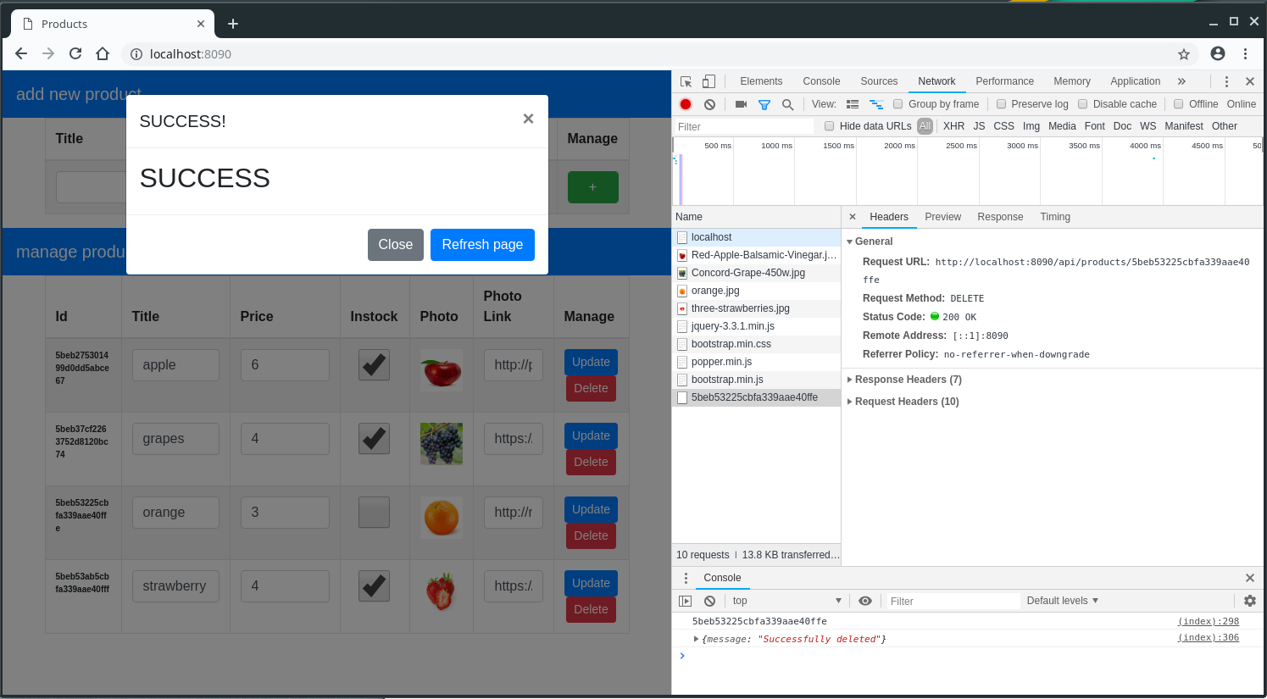

Route to add new product by ID：

