Cachalot DB - version 1.0.8



Quick Start and Administration Guide

Index

What is Cachalot DB? 3

Show me some code first 3

Other types of indexes and how to use them 6

1) Index Data Type 6

2) Index type 6

3) Ordered index 6

More code. Adding indexes to the real estate property 7

Indexing collection properties 9

Other methods of the API 10

Deleting items from the database 10

Inserting or updating many objects 10

Compressing object data 11

Storing polymorphic collections in the database 11

Conditional operations and “optimistic synchronization” 13

Two Stage Transactions 15

More on client configuration 19

The connection-pool 19

In-process server 21

What is Cachalot DB good at? 21

Administration 22

Connecting to the database 23

Visualizing data 24

Updating data 26

Backup and Restore 27

Change cluster configuration 29

Other commands 29

# What is Cachalot DB?

A very fast, open source, no-sql, fully transactional database for .NET applications.

It is distributed, it scales linearly with the number of nodes. On a single node you can durably insert fifty thousand objects per second on a modest system.

A powerful LINQ provider is available. As well as an administration console.

It can also be used as a very powerful, transactional, distributed cache with unique features.

Much more detail in the next sections but…

# Show me some code first

Let’s prepare our business objects for database storage.

We start with a toy web site which allows to rent homes between individuals.

A simple description of a real estate property would be.

**public** class Home

**{**

**public** string CountryCode **{** **get;** **set;** **}**

**public** string Town **{** **get;** **set;** **}**

**public** string Adress **{** **get;** **set;** **}**

**public** string Owner **{** **get;** **set;** **}**

**public** string OwnerEmail **{** **get;** **set;** **}**

**public** string OwnerPhone **{** **get;** **set;** **}**

**public** int Rooms **{** **get;** **set;** **}**

**public** int Bathrooms **{** **get;** **set;** **}**

**public** int PriceInEuros **{** **get;** **set;** **}**

**}**

The first requirement for a business object is to have a primary key. As there is no “natural” one in this case, we will add a numeric Id.

**public** class Home

**{**

**[**PrimaryKey**(**KeyDataType**.**IntKey**)]**

**public** int Id **{** **get;** **set;** **}**

°°°

**}**

Now the object can be stored in the database.

First step is to instantiate a **Connector** which needs a client configuration. More on the configuration later but, for now, it needs to contain the list of servers in the cluster. To start, only one run locally.

The configuration is usually read from an external file. For the moment, let’s build it manually

var config **=** **new** ClientConfig

**{**

Servers **=** **{new** ServerConfig **{**Host **=** "localhost"**,** Port **=** 4848**}}**

**};**

**using** **(**var connector **=** **new** Cachalot**.**Linq**.**Connector**(**config**))**

**{**

var homes **=** connector**.**DataSource**<**Home**>();**

// the rest of the code goes here

**}**

One last step before storing an object in the database. We need to generate a unique value for the primary key. Multiple unique values can be generated with a single call.

Unlike other databases, you do not need to explicitly create a unique value generator. First call with an unknown generator name will automatically create it.

var ids **=** connector**.**GenerateUniqueIds**(**"home_id"**,** 1**);**

var home **=** **new** Home

**{**

Id **=** ids**[**0**],**

Adress **=** "14 rue du chien qui fume"**,**

Bathrooms **=** 1**,**

CountryCode **=** "FR"**,**

PriceInEuros **=** 125**,**

Rooms **=** 2**,**

Town **=** "Paris"

**};**

homes**.**Put**(**home**);**

Now your first object is safely stored in the database.

For the moment, you can only retrieve it by primary key. That can be done in two equivalent ways.

var reloaded = homes[property.Id];

Or with a LINQ expression.

var reloaded = homes.First(p => p.Id == property.Id);

The first one is faster as there is no need to parse the expression tree.

In most relational databases we use two distinct operations: INSERT and UPDATE. In Cachalot Db only one operation is exposed: PUT

It will insert new items (new primary key) and will update existing items.

You probably have higher expectation from a modern database than simply storing and retrieving objects by primary key. And you are right.

# Other types of indexes and how to use them

Three characteristics of an index need to be understood

## Index Data Type

To be indexable in Cachalot DB, a .NET property needs to be convertible either to Int64 or string.

Using integer type makes the search slightly faster.

Automatic conversion to Int64 is provided for

* All numeric types
* DateTime and DateTimeOffset
* Enumerated types
* Boolean

Conversion to string is done by calling **ToString**() on the property value

## Index type

Three types of indexed properties are available

* Primary key (the only mandatory one)
* Unique key: zero or more can be defined on type
* Index key: zero or more can be defined on type

## Ordered index

On any index we can apply the equality operator.

If an index is declared as “ordered”, all the comparisons operators can equally be applied: <, <=, >, >=

This type of index is essential for most modern systems but be aware that it has a cost because the ordered indexes must always be sorted.

Massive insert/update operations (**DataStore.PutMany** method) are well optimized. After a threshold is reached (50 items by default) the operation is treated like a “bulk insert”. Ordered indexes are sorted only once, at the end.

# More code. Adding indexes to the real estate property

**public** class Home

**{**

**[**PrimaryKey**(**KeyDataType**.**IntKey**)]**

**public** int Id **{** **get;** **set;** **}**

**[**Index**(**KeyDataType**.**StringKey**)]**

**public** string CountryCode **{** **get;** **set;** **}**

**[**Index**(**KeyDataType**.**StringKey**)]**

**public** string Town **{** **get;** **set;** **}**

**public** string Adress **{** **get;** **set;** **}**

**public** string Owner **{** **get;** **set;** **}**

**public** string OwnerEmail **{** **get;** **set;** **}**

**public** string OwnerPhone **{** **get;** **set;** **}**

**[**Index**(**KeyDataType**.**IntKey**,** or dered**:true)]**

**public** int Rooms **{** **get;** **set;** **}**

**[**Index**(**KeyDataType**.**IntKey**)]**

**public** int Bathrooms **{** **get;** **set;** **}**

**[**Index**(**KeyDataType**.**IntKey**,** ordered**:true)]**

**public** decimal PriceInEuros **{** **get;** **set;** **}**

**}**

With an object indexed like this you can now do some useful queries

var results **=** homes**.**Where**(**p **=>** p**.**PriceInEuros **<=** 200 **&&**

p**.**Rooms **>** 1 **&&**

p**.**Town **==** "Paris"**).**Take**(10);**

The query is, of course, executed server-side including the **take** operator. At most ten objects are sent to the client through the network

The “Contains” extension method is also supported

var towns **=** **new[]** **{**"Paris"**,** "Nice"**};**

var one **=** homes**.**First**(**p **=>** p**.**PriceInEuros **<** 150 **&&** towns**.**Contains**(**p**.**Town**));**

This is equivalent to the SQL:

SELECT * from HOME where PriceInEuros < 150 and Town IN (“Paris”, “Nice”)

Another use of the “Contains” extension, which does not have any equivalent in traditional SQL, is explained in the next section.

# Indexing collection properties

Let’s enrich our business object. It would be useful to have the list of available dates on each home.

Adding this new property enables some interesting features.

This is a collection property and it can be indexed the same way as the scalar properties

**[**Index**(**KeyDataType**.**IntKey**)]**

**public** List**<**DateTime**>** AvailableDates **{** **get;** **set;** **}** **=** **new** List**<**DateTime**>();**

We would like to be able search for homes available at a specific date

var availableNextWeek **=** homes**.**Where**(**

p **=>** p**.**Town **==** "Paris" **&&**

p**.**AvailableDates**.**Contains**(**DateTime**.**Today**.**AddDays**(**7**))**

**).**ToList**();**

This has no direct equivalent in the classical SQL databases. It conveniently replaces most of the uses for the classical JOIN operator.

You may need to dynamically create a query. For example, in a search screen, you add criteria to restrict you results. This can be done by chaining **Where** methods.

var query **=** homes**.**Where**(**p **=>** p**.**Town **==** "Paris"**);**

query **=** query**.**Where**(**p **=>** p**.**PriceInEuros **<** 200**);**

query **=** query**.**Where**(**p **=>** p**.**Rooms **>** 1**);**

query **=** query**.**Where**(**p **=>** p**.**AvailableDates**.**Contains**(**DateTime**.**Today**));**

var result **=** query**.**ToList**();**

This is equivalent to a single query where all criteria are joined with the && (AND) operator.

# Other methods of the API

In addition to querying and putting single items, other methods are exposed by the **DataSource** object

## Deleting items from the database

home.Delete(home);

homes**.**DeleteMany**(**p **=>** p**.**Town **==** "Paris"**);**

## Inserting or updating many objects

homes**.**PutMany**(**collection**);**

This method is very optimized for huge collections of objects

* Packets of objects are sent together in the network
* For massive collections, the ordered indexes are sorted only after the insertion of the last object. It is similar to a BULK INSERT in classical SQL databases

The parameter is an **IEnumerable**. This allows to dynamically generate data that will be inserted in the database. The full collection does not need to be present in client memory.

# Compressing object data

The business objects are stored internally in a type-agnostic format. Index fields are stored as **Int64** or **string**, and all the object data is stored as UTF-8 encoded JSON. The process of transforming a .NET object in the internal format is called “packing”. Packing is done client-side, the server only uses the indexes and manipulates the object as row data. It has no dependency on the concrete .NET datatype.

In our example, adding availability dates to our business object has an impact on its size. By default, the object data is not compressed but for objects that take more than a few kilobytes, compression may be very useful. For an object that takes 10 KB in JSON, compression ratio is around 1:10.

In order to enable compression, add a single attribute on the business data type.

**[**Storage**(**compressed**:true)]**

**public** class Home

**{**

°°°

Using compressed objects is transparent for the client code. However, it has an impact on the packing time which is done on the client. When objects are retrieved they are unpacked (which may imply decompression)

As a conclusion, compression may be very useful starting with medium size objects if you are ready to pay a small price, client-side only, for data insertion and retrieval.

# Storing polymorphic collections in the database

Polymorphic collections are natively managed. Type information is stored internally in the JSON and it is used to deserialize the proper concrete type.

A small example from a trading system

Product Event

Negotiated Product Event

Fixing Event

Increase Decrease

Creation

In order to store a collection of events we must expose all required indexes on the base type.

If this is not natural for your business-object hierarchy, an alternate solution is possible. Create a new data type that aggregates a base type and exposes all the required index fields.

Null values are perfectly acceptable for index fields which allows to expose indexed properties which make sense only for a specific child type.

Code example for the first solution:

**public** **abstract** class ProductEvent

**{**

**[**PrimaryKey**(**KeyDataType**.**IntKey**)]**

**public** int Id **{** **get;** **set;** **}**

**[**Index**(**KeyDataType**.**StringKey**)]**

**public** **abstract** string EventType **{** **get;** **}**

**[**Index**(**KeyDataType**.**IntKey**,** ordered**:true)]**

**public** DateTime EventDate **{** **get;** **set;** **}**

**[**Index**(**KeyDataType**.**IntKey**,** ordered**:** **true)]**

**public** DateTime ValueDate **{** **get;** **set;** **}**

**°°°**

**}**

**public** **abstract** class NegotiatedProductEvent**:** ProductEvent

**{**

°°°

**}**

**public** class IncreaseDecrease **:** NegotiatedProductEvent

**{**

**°°°**

**public** **override** string EventType **=>** "IncreaseDecrease"**;**

**}**

This is an example of code which retrieves a collection of concrete events from a DataStore typed with an abstract base class.

var events **=** connector**.**DataSource**<**ProductEvent**>();**

var increaseEvents **=** events**.**Where**(**

evt **=>** evt**.**EventType **==** "IncreaseDecrease" **&&**

evt**.**EventDate **==** DateTime**.**Today

**).**Cast**<**IncreaseDecrease**>();**

# Conditional operations and “optimistic synchronization”

A normal “put” operation adds an object or updates an existent one using the primary key as object identity.

More advanced use cases are implemented:

1. **Add an object only if it is not already there and tell me if it was really added**
2. **Update an existent object only if the current version in the database satisfies a condition”**

The first one is available through the **TryAdd** operation on the **DataStore** object. If the object was already there it is not modified, and it returns false. The test on the object existence and the insertion are executed as an atomic operation. The object cannot be updated or deleted by another client in-between.

That ca be useful for data initialization, creating singleton objects, distributed locks etc.

The second use case is especially useful for, but not limited to, the implementation of “optimistic synchronization”.

If we need to be sure that nobody else modified an object while we were editing it (manually or algorithmically), there are two possibilities

* Lock the object during the edit operation. This is not the best option for a modern distributed system. A distributed lock is not suitable for massively parallel processing and if it is not released automatically (due to client or network failure) manual intervention by an administrator is required
* Use “optimistic synchronization”: do not lock but require that, when saving the modified object, the one in the database did not change since it was loaded. Otherwise the operation fails, and we must retry (load + edit + save) This can be achieved in different ways:
  + Having a version on an object. When we save version n+1 we require that the object in the database is still at version n. In Cachalot DB the syntax is datastore.UpdateIf(item, i=> i.Version == n-1)
  + Having a timestamp on an object. When we save a modified object, we require that the timestamp of the version in the database is identical to the one of the object before our update.

var oldTimestamp = item.Timestamp;

item.Timestamp = DateTime.Now;

datastore.UpdateIf(item, i=> i.Timestamp == oldTimestamp);

This can be even more useful when committing multiple object modifications in a transaction. If a condition is not satisfied on one object, rollback the whole transaction. See next section…

# Two Stage Transactions

The most important thing to understand about two stage transactions is when you really need them.

Most of the time you don’t.

An operation that involves one single object (Put, TryAdd, UpdateIf, Delete) is always transactional.

It is durable (operations are synchronously written to an append-only transaction log), and it is atomic. An object will be visible to the rest of the world only fully updated or fully inserted.

On a single-node cluster, operations on multiple objects (PutMany, DeleteMany) are also transactional.

You need two stage transactions only if you must transactionally manipulate multiple objects on a multi-node cluster.

As usual, let’s build a small example: a toy banking system that allows money to be transferred between accounts. There are two types of business objects: **Account** and **AccountOperation**

**public** class Account

**{**

**[**PrimaryKey**(**KeyDataType**.**IntKey**)]**

**public** int Id **{** **get;** **set;** **}**

[Index(KeyDataType.IntKey, true)]

**public** decimal Balance **{** **get;** **set;** **}**

**}**

**public** class AccountOperation

**{**

**[**PrimaryKey**(**KeyDataType**.**IntKey**)]**

**public** int Id **{** **get;** **set;** **}**

**[**Index**(**KeyDataType**.**IntKey**)]**

**public** int SourceAccount **{** **get;** **set;** **}**

**[**Index**(**KeyDataType**.**IntKey**)]**

**public** int TargetAccount **{** **get;** **set;** **}**

**[**Index**(**KeyDataType**.**IntKey**,** ordered**:true)]**

**public** DateTime Timestamp **{** **get;** **set;** **}**

**public** decimal TransferedAmount **{** **get;** **set;** **}**

**}**

Let’s create two accounts. No need for transactions at this stage.

var accountIds **=** connector**.**GenerateUniqueIds**(**"account_id"**,** 2**);**

var accounts **=** connector**.**DataSource**<**Account**>();**

var account1 **=** **new** Account **{**Id **=** accountIds**[**0**],** Balance **=** 100**};**

var account2 **=** **new** Account **{**Id **=** accountIds**[**1**],** Balance **=** 100**};**

accounts**.**Put**(**account1**);**

accounts**.**Put**(**account2**);**

When we transfer money between the accounts we would like to simultaneously (atomically) update the balance of both accounts and to create a new instance of **AccountOperation**.

This is how the business logic could be implemented

**private** static void MoneyTransfer**(**Connector connector**,** Account sourceAccount**,** Account targetAccount**,** decimal amount**)**

**{**

sourceAccount**.**Balance **-=** amount**;**

targetAccount**.**Balance **+=** amount**;**

var tids **=** connector**.**GenerateUniqueIds**(**"transaction_id"**,** 1**);**

var transfer **=** **new** AccountOperation

**{**

Id **=** tids**[**0**],**

SourceAccount **=** sourceAccount**.**Id**,**

TargetAccount **=** targetAccount**.**Id**,**

TransferedAmount **=** amount

**};**

var transaction **=** connector**.**BeginTransaction**();**

transaction**.**Put**(**sourceAccount**);**

transaction**.**Put**(**targetAccount**);**

transaction**.**Put**(**transfer**);**

// this is where the two stage transaction happens

transaction**.**Commit**();**

**}**

The operations allowed inside a transaction are:

* Put
* Delete
* UpdateIf

If a conditional update (**UpdateIf**) is used and the condition is not satisfied by one object, the whole transaction is rolled back.

In the previous example we could, to prevent “monetary creation”, allow the transaction to be committed only if the balance of the source account did not change since the account object was loaded.

**private** static void MoneyTransfer**(**Connector connector**,** Account sourceAccount**,** Account targetAccount**,** decimal amount**)**

**{**

// store the old balance before updating it

var oldBalance = sourceAccount**.**Balance;

sourceAccount**.**Balance **-=** amount**;**

targetAccount**.**Balance **+=** amount**;**

var tids **=** connector**.**GenerateUniqueIds**(**"transaction_id"**,** 1**);**

var transfer **=** **new** AccountOperation

**{**

Id **=** tids**[**0**],**

SourceAccount **=** sourceAccount**.**Id**,**

TargetAccount **=** targetAccount**.**Id**,**

TransferedAmount **=** amount

**};**

var transaction **=** connector**.**BeginTransaction**();**

// if another operation changed the balance, the transaction is // rolled-back and an exception is thrown

transaction**.**PutIf**(**sourceAccount, acc=>acc.Balance == oldBalance**);**

transaction**.**Put**(**targetAccount**);**

transaction**.**Put**(**transfer**);**

transaction**.**Commit**();**

**}**

A full example-application be found in the release package: “DemoClients/Accounts”.

# More on client configuration

At this point it is important to stress an important design choice: the nodes of a cluster do not know each other. Only the client has a view of the whole cluster.

In the previous sections we mentioned the **ClientConfig** class which is the one and only parameter required to instantiate a **Connector**.

You already know it contains the list of servers in the cluster and in the previous example we filled it manually. It can do much more and usually it is loaded from an XML file.

var cfg **=** **new** ClientConfig**();**

cfg**.**LoadFromFile**(**"two_nodes_cluster.xml"**);**

In all the previous examples the index fields where described by using attributes on .NET properties.

Alternatively, indexes can be described in the configuration file. Both ways are perfectly acceptable, but you need to choose one of them. If you use tagged properties on your objects they will override the parameters from the configuration file.

On the next page, an example of configuration file that contains an equivalent description for the Home type.

## The connection-pool

Cachalot DB is usually used in server environments (REST backends for example).

Lots of clients can make requests in the same time. Without a connection pool, their requests would be either queued or a new connection would be required for each client.

A high-performance connection pool is used transparently by the client code. It allows for simultaneous connections from multiple clients but ensures that a reasonable quantity of TCP connections is used.

Two parameters of the connection pool can be set in the configuration file

**Capacity**: the maximum number of connections in the pool; it is also the maximum number of client requests that are actually processed in parallel. If this limit is reached, requests are queued. Given the average request time which is in the low milliseconds (mostly network latency) the number of clients that can effectively be connected to the backend without any visible latency is much more than the capacity of the connection pool. For example, if you have one thousand connected clients, ten simultaneous connections to the database are probably enough. It depends, of course, of the kind of request and on their frequency.

**Preloaded**: by default, the pool is empty, and it is dynamically filled to scale up with the client activity. This parameter allows connections to be preloaded in the pool thus improving the response time for the very first requests.

The connection pool allows also for the transparent recreation of connections if one or more nodes restart. The client does not need to reconnect explicitly.

<?xml version=**"1.0"** encoding=**"utf-8"** ?>

<clientConfig>

<servers>

<server>

<host>**SRVPRD100**</host>

<port>**4848**</port>

</server>

<server>

<host>**SRVPRD200**</host>

<port>**4568**</port>

</server>

</servers>

<typeDescriptions>

<type fullName=**"BookingMarketplace.Home"** assembly=**"BookingMarketplace"**>

<property name=**"Id"** dataType=**"int"** keyType=**"primary"** ordered=**"false"**/>

<property name=**"CountryCode"** dataType=**"string"** keyType=**"index"** ordered=**"false"**/>

<property name=**"Town"** dataType=**"string"** keyType=**"index"** ordered=**"false"**/>

<property name=**"Rooms"** dataType=**"int"** keyType=**"index"** ordered=**"true"**/>

<property name=**"Bathrooms"** dataType=**"int"** keyType=**"index"** ordered=**"true"**/>

<property name=**"ValueDate"** dataType=**"int"** keyType=**"index"** ordered=**"true"**/>

<property name=**"PriceInEuros"** dataType=**"int"** keyType=**"index"** ordered=**"true"**/>

<property name=**"AvailableDates"** dataType=**"int"** keyType=**"list"** ordered=**"false"**/>

</type>

</typeDescriptions>

<connectionPool capacity=**"10"** preloaded=**"2"**/>

</clientConfig>

# In-process server

In some cases, especially if the quantity of data is bounded and it can be stored on a single node, you can instantiate a Cachalot server directly inside your server process. This will give blazing fast responses as there is no more network latency involved.

To do this, pass an empty client configuration to the **Connector** constructor. A database server will be instantiated inside the connector object and communications will be done by simple in-process calls, not a TCP channel.

var connector **=** **new** Connector**(new** ClientConfig**());**

Connector implements **IDisposable**. Disposing the **Connector** will graciously stop the server. You need to instantiate the Connector once when the server process starts and dispose it once when the server process stops.

# What is Cachalot DB good at?

Cachalot DB is designed to be blazing fast and transactional. As always, there is a trade-off in terms of what it is not designed for.

The infamous [CAP Theorem](https://en.wikipedia.org/wiki/CAP_theorem) proves that a distributed system cannot be in the same time fault tolerant and transactionally consistent. We made the choice of full transactional consistency.

To be as fast as possible, Cachalot is fully memory cached. It means you need enough memory to store all your data. Each node loads everything in memory when it starts (Cachalot is a contraction of “Cache a lot” 😊)

Tests have been done up to 200 GB of data and one hundred million, medium size, objects. It can scale even more but, if you need to store more than 1 TB of data, it is probably not the right technology to choose.

It is designed to manipulate objects, as complex as you want. But it will always retrieve full objects. So, if you need to extract fragments of big data structures or if your data can not be naturally represented as collections of typed objects it is probably not the right technology to choose.

# Administration

In this section we introduce a new member of the Cachalot ecosystem. The “Administration Console”. It is the **AdminConsole.exe** in your distribution

It can be used to:

* visualize data
* create backup
* restore from backup
* change cluster configuration
  + schema modification: add or delete indexes on an object
  + add nodes to a cluster
* extract data to json files
* import data from json files
* switch database to read-only/read-write mode
* delete data
  + drop a whole database
  + delete a whole table
  + delete items that match a condition

The first command to know is “help” which will display a list of available commands. “help” + “command name” will display a detailed explanation and examples.

A very powerful autocompletion feature is also available. Use TAB to activate it in almost every context

## Connecting to the database

If you double-click the AdminConsole you will see this

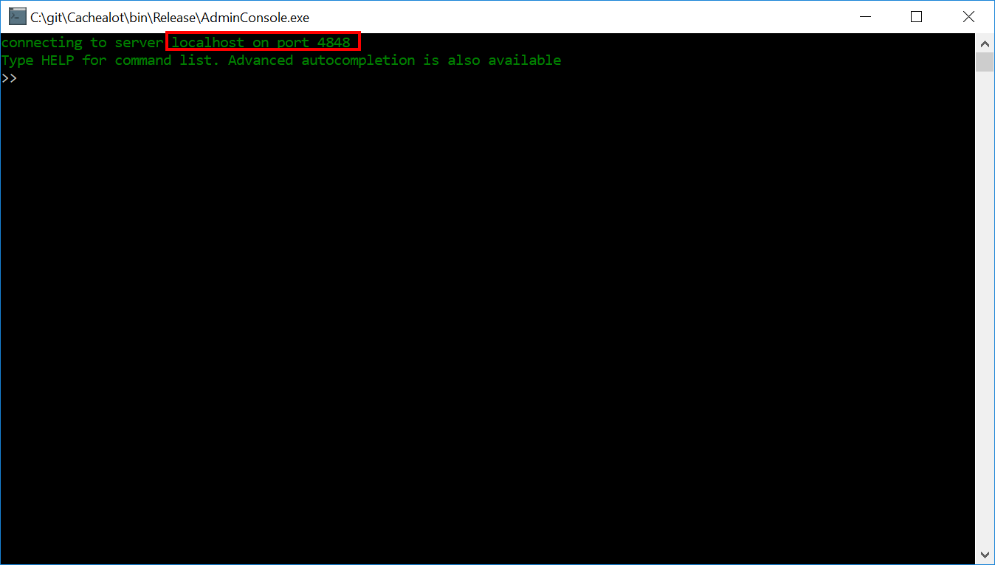

By default, it will try to connect to a single node on the current machine using the port 4848.

You can use **connect <hostname or IP adress > <port>** to connect to a single node or **connect <client config.xml>** to connect to a cluster

Type h + TAB; this will be autocompleted to “help” and will display this

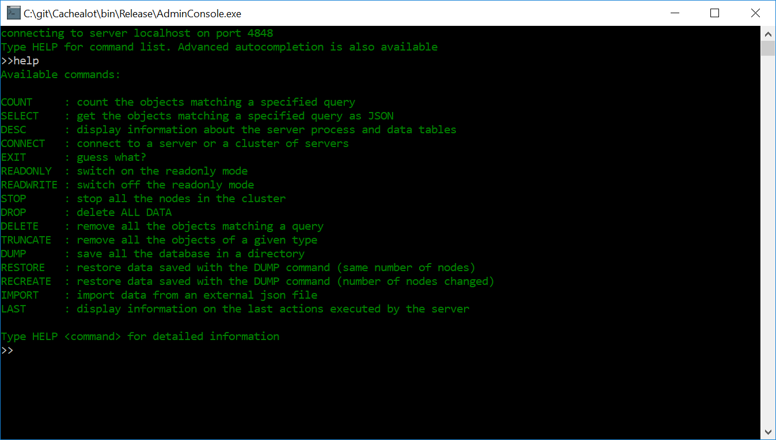

Typing “help connect” will display this

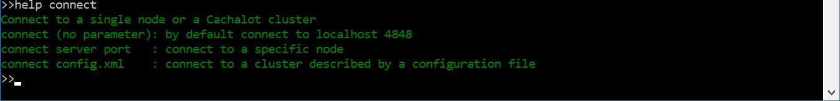

## Visualizing data

The **desc** command will display all the data types that are known by the server/cluster and some information about each server process:

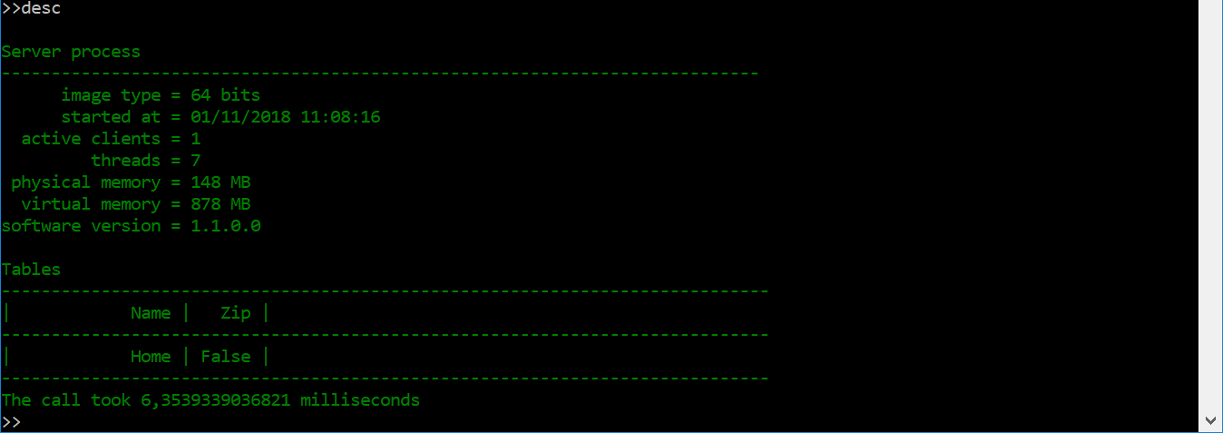

**desc <type name>** displays all the indexes on a data type.

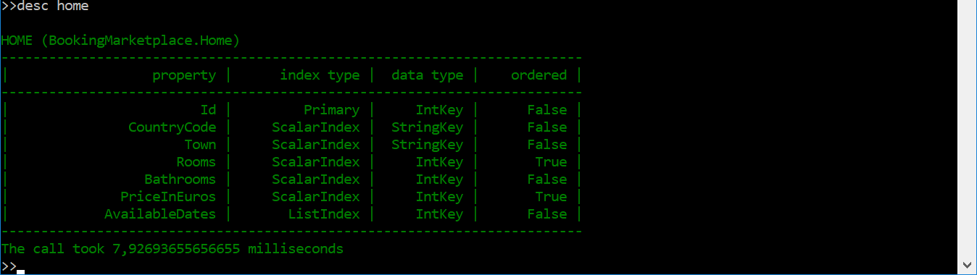

A SQL-like query language is available in the admin console. It is a subset of the commands available through the LINQ provider. Only AND logical operator is supported and the CONTAINS operator is not supported.

“help select” will display a pretty good description of the query language:

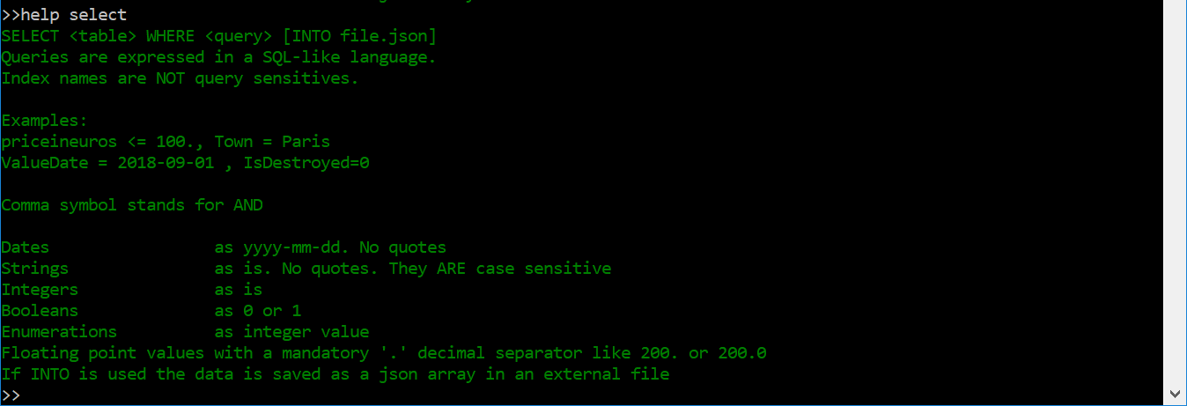

As explained in the output of the help command, be aware of some pitfalls: no quotes are required for strings and dates, and the decimal point “.” is mandatory for float values. Dates are always formatted as **yyyy-mm-dd**.

The query language can be used with the **count**, **select**, **delete** commands. For example, count the apartments of at least three rooms in Paris France



Select will display a well formatted JSON array containing the result of your query

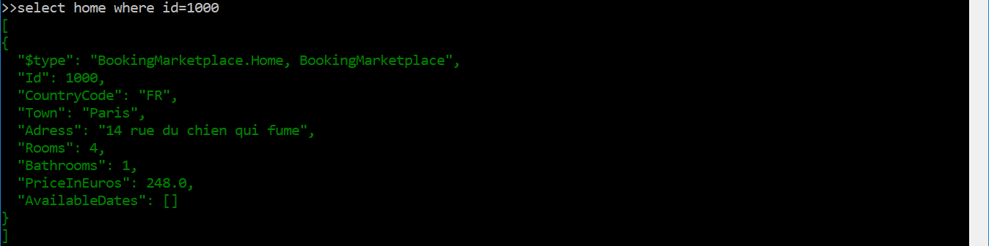

## Updating data

The most radical of the data modification commands is **drop**. It will completely delete all data from the database, including the schema (type definitions).

To completely delete all items of a type: **truncate <table name>**

To delete all the items matching a query: **delete <query>**

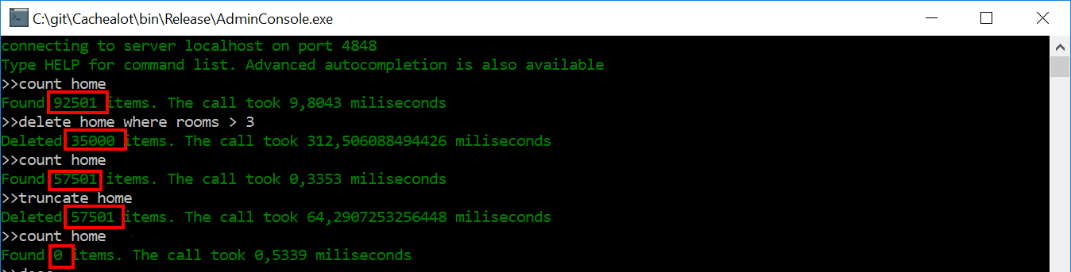

After the execution of **truncate** command, the table does not contain data any more but the schema (type definition) is still present.

The **drop** command deletes all data from all tables and the type definitions

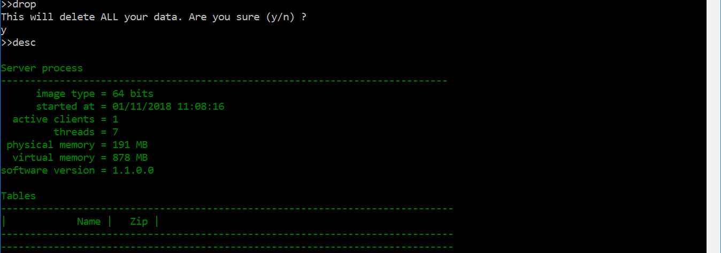

Data update has three steps:

* use a variant of **select** that allows to specify an external JSON file; the query result will be stored in this file instead of being displayed in the console
* update the json file with an external application (text editor or script for example)
* **import** the data from the external file into the database

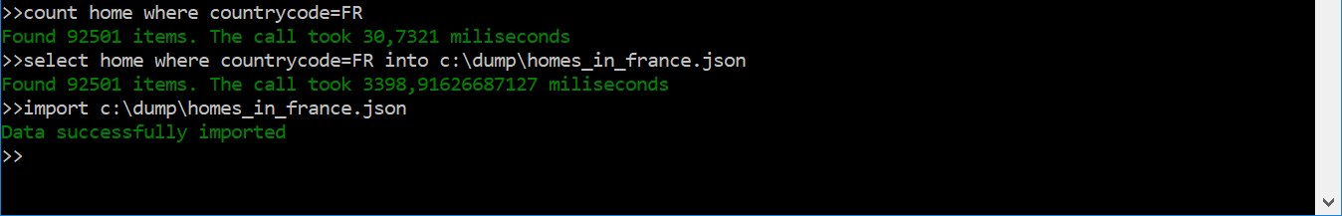

## Backup and Restore

The backup/restore functions allow to

* save and recovered a complete database
* transfer data to another database cluster
* change the type definitions (schema)

The **restore** command is designed to be very fast: data is restored in parallel by all the servers. But to be as fast as possible it does not allow data to be restored to a cluster which has a different number of nodes than the one who saved the backup.

A specific command is available to import data into a cluster with a different number of nodes. See next section.

The syntax of dump is **dump <existent root directory>.** The directory is usually a network drive as it needs to be accessible by al the servers in the cluster. Each dump will be saved in a subdirectory whose name is the current date in yyyy-mm-dd format. This subdirectory is created automatically if it does not exist.

Restoring data:

* restore <root directory> will restore the most recent dump available
* restore <root directory>/yyyy-mm-dd will restore a specific dump

The type definitions may be changed by editing a special file in the dump: **schema.json**. This is the only file from a dump who can be manually edited without compromising the dump integrity.

Editing it allows to:

* add indexes
* remove indexes
* change index definition (ordered or not)
* activate or deactivate compression.

{

"TypeDescriptions": [

{

**…**

"IndexFields": [

{

"KeyDataType": "StringKey",

"KeyType": "ScalarIndex",

"Name": "CountryCode",

"IsOrdered": false

},

**…**

],

"ListFields": [

{

"KeyDataType": "IntKey",

"KeyType": "ListIndex",

"Name": "AvailableDates",

"IsOrdered": false

}

],

"FullTypeName": "BookingMarketplace.Home",

"TypeName": "Home",

"UseCompression": false

}

]

}

## Change cluster configuration

To transfer complete databases between clusters with different numbers of nodes (or add nodes to an existing cluster) we use the usual dump command (from the previous section) but we restore data with a specific function: **recreate** with the same syntax as **restore**.

This function is significantly slower than **restore**. Instead of having each server restoring its data in parallel is reads the dump file on the client and feed the data to all nodes in the new cluster. The target database needs to be empty (new on or after drop) before executing this command.

## Other commands

* readonly 🡪 switch data to read-only mode
* readwrite 🡪 switch off the read-only mode
* stop 🡪 stops all the servers in a cluster
* last <n> 🡪 display information on the last n commands executed on the server: server-side execution time, items affected, execution plan (primary index used). The execution plan may be used to optimize your queries and detect inefficient indexes