**ASSIGNMENT 2 FRONT SHEET**

|  |  |  |  |
| --- | --- | --- | --- |
| **Qualification** | **TEC Level 5 HND Diploma in Computing** | | |
| **Unit number and title** | **Unit 43: Internet of Things** | | |
| **Submission date** |  | **Date Received 1st submission** |  |
| **Re-submission Date** |  | **Date Received 2nd submission** |  |
| **Student Name** | Do Huu Tu | **Student ID** | GCH18565 |
| **Class** | GCH0902 | **Assessor name** | Le Anh Ngoc |
| **Student declaration**  I certify that the assignment submission is entirely my own work and I fully understand the consequences of plagiarism. I understand that making a false declaration is a form of malpractice. | | | |
|  |  | **Student’s signature** |  |

**Grading grid**

|  |  |  |  |  |  |  |
| --- | --- | --- | --- | --- | --- | --- |
| P5 | P6 | P7 | M5 | M6 | D3 | D4 |
|  |  |  |  |  |  |  |

|  |  |  |
| --- | --- | --- |
| **❒ Summative Feedback: ❒ Resubmission Feedback:** | | |
| **Grade:** | **Assessor Signature:** | **Date:** |
| **Internal Verifier’s Comments:** | | |
| **Signature & Date:** | | |

I. Introduction 4

II. Employ an appropriate set of tools to develop your plan into an IoT application. 4

III. Run end user experiments and examines feedback. 14

IV. Project Evaluation 14

V. Conclusion 15

VI. Reference 15

# I. Introduction

This report will demonstrate a specific IoT project that solves a problem includes the process of build the hardware, developing the software as well as gather user’s feedback to give a final evaluation about the project.

# II. Employ an appropriate set of tools to develop your plan into an IoT application.

Here it’s what we choose for this system:

* Hardware: DHT22, micro motor servo, resistors, USB cables, Module HC-SR04 Ultrasonic Sensor, and an ESP8266 nodemcu modules
* Software: For this system I choose Arduino IDE with its own programming language (built on top of C++), the library required are DHT sensor library, BlynkEdgent library, and servo library.

The demonstration of the hardware in the end will look like this:

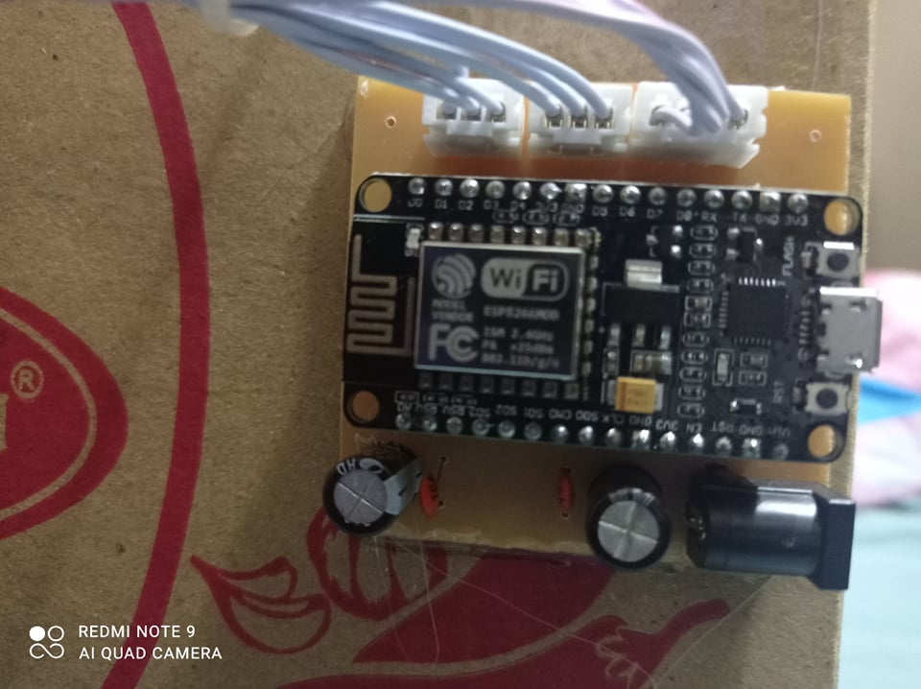

This is esp8266 nodemcu. This has the most important use in arduino. It provides power, runs code, and connects to blynk to control the device

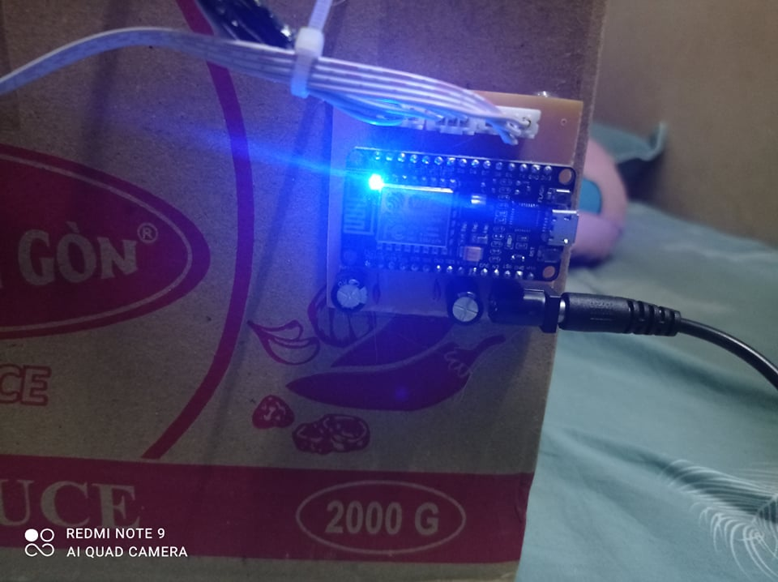

When I plug in the power cord and the light comes on, it's powered on. It is then capable of operating the device. In addition, when the blynk connection is successful, the light will blink continuously for about 1 minute and then turn off if the light does not blink continuously, indicating that you have not successfully connected blynk.

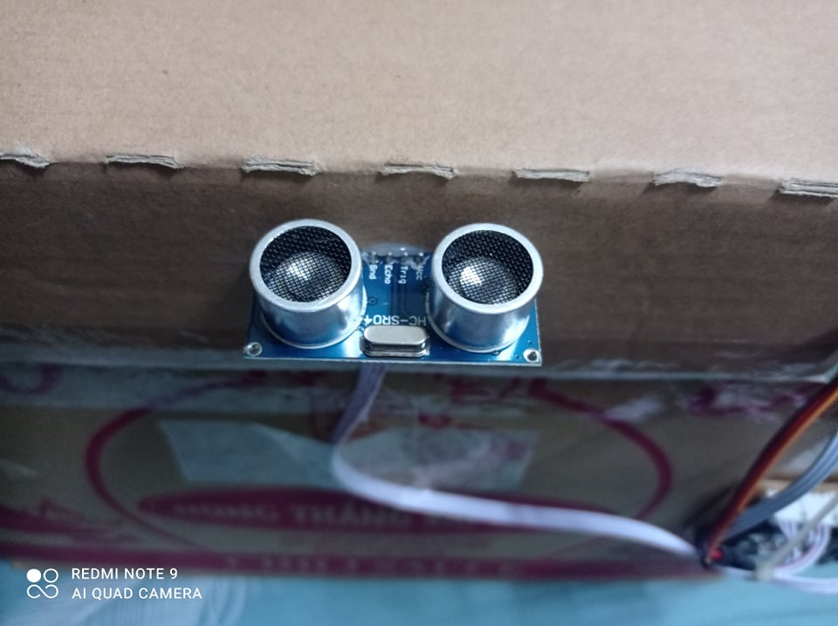

This is the HC-SR04 Ultrasonic Sensor Module. It has the role of transceiver to measure the distance from it to the object from which it sends a signal to Nodemcu and Nodemcu will send a signal to the servo motor. The way it works is very simple. It will emit an ultrasonic wave, this wave, if it comes into contact with an object, it will reflect back to obtain the distance from the device to the object.

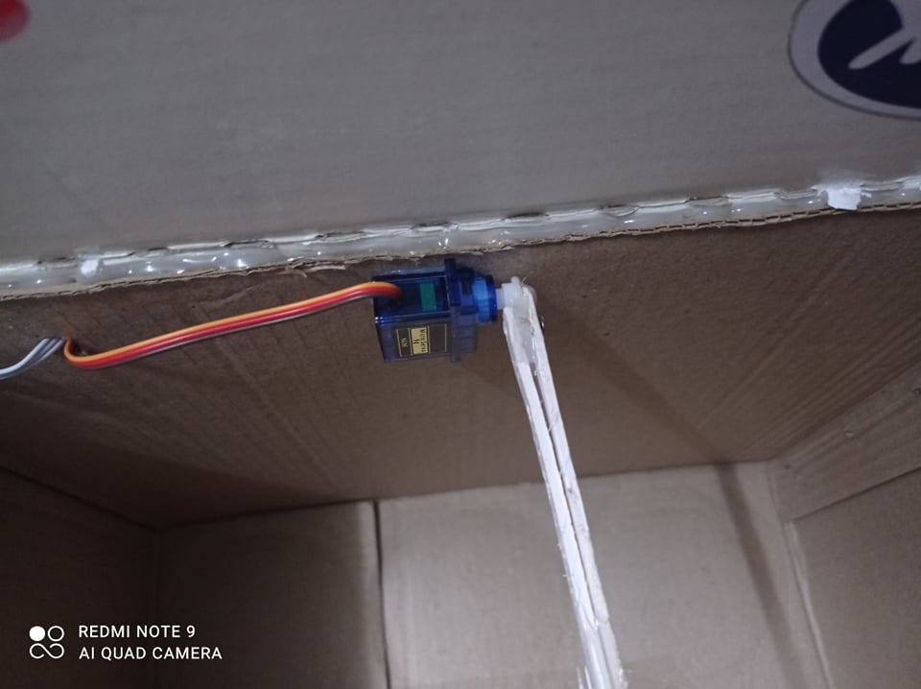

This is a servo motor that has the role of opening and closing the trash can. When Nodemcu receives a signal from the HC-SR04, it will send a signal to the servo motor and the servo motor will have the function of opening and closing the box.

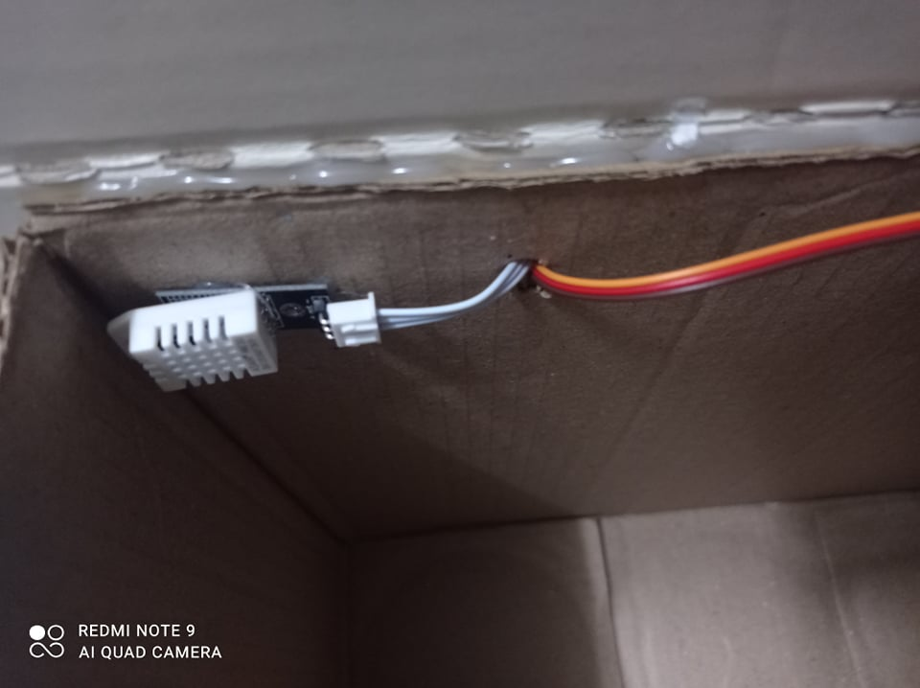

This temperature and humidity sensor DHT22. They have the role of measuring the temperature and humidity in the trash, from which it will be sent to the phone with a blynk connection.

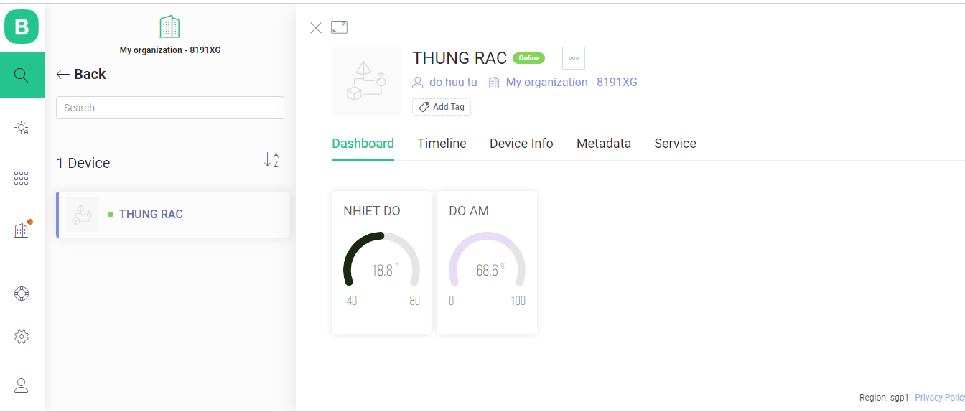

Humidity temperature will be displayed on the computer screen.

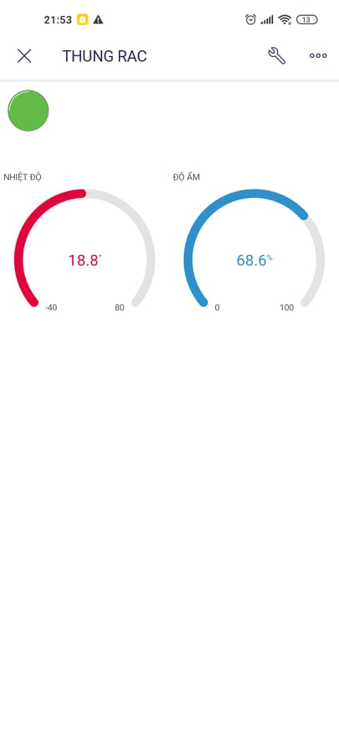

Humidity temperature will be displayed on the phone screen.

Next is the coding process, to make the system work. First we have to install the library. Here are some libraries and definitions

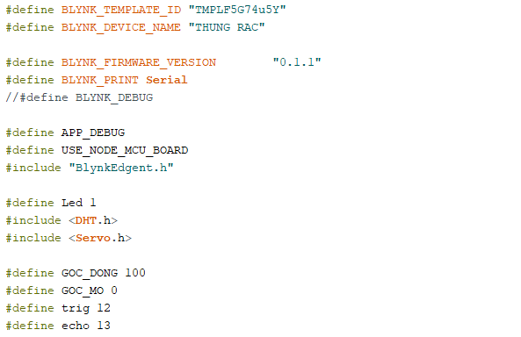

This is the function to know if the connection to Blynk was successful. If successful, the light will come on, if not, the light will not come on.

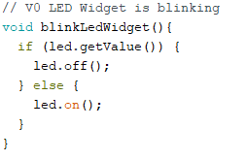

This function is used to declare the statement on the first run.

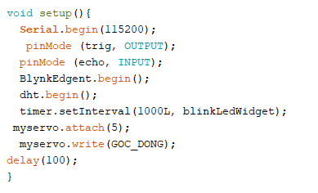

This function plays the most important role in the program. It is an iterative function, the function it will repeat continuously until the end of the program.

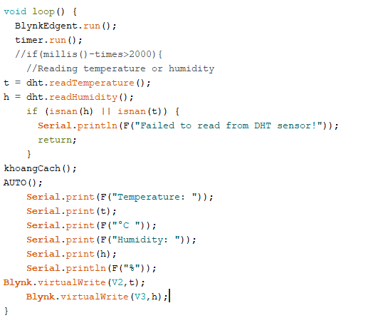

This function is to calculate the distance from the starting point position to the object.

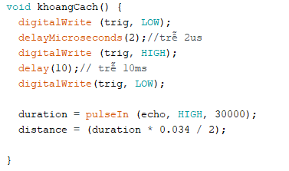

This function is used to calculate the opening and closing distance of the box and it will close the box after 2s.

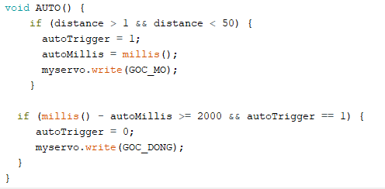

Compete video shot of coding process:

Demo video: <https://drive.google.com/file/d/1XoIS5PeRrDdBPhY-5j9du_jIZ8to5qg-/view?usp=sharing>

# III. Run end user experiments and examines feedback.

# IV. Project Evaluation

After conducting the survey and giving the results, this will be the evaluation of the project. Basically, all the most basic features of the product have been completed. For example, opening and closing feature, temperature and humidity sensor, led light feature and successful blynk connection. Since the project is still in the process of being completed, so it will still have some bad points. First, sometimes the HC - SR04 sensor doesn't get the gas signal for project completion, I think the problem is with the device, so I'll have to buy a new one to fix it. trouble. Second, the problem of connecting Blynk is a bit difficult, basically I am already connected but I can't change the WIFI account and password but I can't connect. It's because of the version I've downloaded, so it will take a while to see if the version is up to date. I will fix it then.

Overall the project is almost complete. Now it can make some contribution to people's lives. But we will still need some new sensors in the future. In the future, we want to design automatic control feature for smart trash bin. It will automatically move if it sees humans approaching. In addition, we will also have some improvements on how to connect to Blynk as I wrote above. Right now we still don't know how to change the account password for the device and we will wait for the next update to change. We will try our hardest to make sure the system are bug-free as well with daily update to the software.

# V. Conclusion

# VI. Reference