

**CLOTHING SHOP Project Report**

**Software Requirement Specification**

– Hanoi,May 2022–

Contents

1. Introduction 3

1.1 Purpose 3

1.2 Document Conventions 3

1.3 Project Scope 3

1.4 References 3

2. Overall Description 3

2.1 Product Perspective 3

2.2 User Classes and Their Use Cases 4

2.2.1 Visitor 4

2.2.2 Customer 4

2.2.3 Seller 4

2.2.4 Administrator 4

2.3 Operating Environment 5

2.4 Dependencies 5

Dependencies: 5

2.5 Business rules (Updating…) 5

3. Functional Requirements 5

3.1 System Functional Overview 5

**3.4****View Product Detail** 13

**3.5****Change Amount** 14

**3.6****Delete Product** 15

**3.7****Register** 16

4. Data Requirements 17

4.1 Logical Data Model (Updating…) 17

4.2 Data Dictionary (Updating…) 17

4.4 Data Integrity and Retention 17

5. External Interface Requirements 17

5.1 User Interfaces 17

The Clothing Shop Ordering System screen displays shall conform to the User Interface Design and User Experience Design 17

5.2 Software Interfaces (Updating…) 17

5.3 Hardware Interfaces 17

5.4 Communications Interfaces 17

6. Nonfunctional Requirements 18

6.1 Performance Requirements 18

6.2 Security 18

7. Other Requirements 18

Appendix A: Analysis models 19

Context Diagram 19

State Transition Diagram for Order 19

# **1.** **Introduction**

**1.1 Purpose**

This document describes the requirements for the Online Clothing Shopping.com website, which provides information about clothing products such as prices, product information, sizes...

**1.2 Document Conventions**

The functional requirements for this project are organized by use case within the user class.

**1.3**  **Project Vision and Product Scope**

**1.3.1 Vision Statement**

For each customer who wants to order local clothing products and more without leaving home, Online Clothing Shopping will be an Internet-based and smartphone-enabled application that will accept receive orders. Customers order clothing products in multiple product groups or just a single product, process payments, and trigger delivery of available products in stock to locations entered by the customer in the system. purchasing system. Thanks to that, customers who place an order will not need to go to the store to buy, but now just sitting at home can easily order the products they need with just simple steps such as entering the shop. online, select products, add to cart, go to cart and click place order, then the system will automatically calculate the total amount you need to pay and the shop owner will pack the goods and send them to the shipping units. transfer. In order to have the item you need delivered to you at the address you previously gave, you only need to make one payment at the end to complete the purchase.

**1.3.2 Product Scope**

Online Clothing Shopping is a website that will provide all available information about products such as brand information, product quantity, details and other related products.

**2. User Classes and Their Use Cases**

**2.1 Customer**

A customer is someone who orders a product from the website. Use cases:

1: Login

2: View all products

3: Search for a product

4: View product’s detail

5: Add product to cart

6: Checkout

7: Check order status

8: Cancel order

9: Rate product

10: Give feedback

11: Read blog

### **2.2 Seller**

A seller is someone who has the responsibilities to manage the website’s products and the business important data

1: Create a product

2: Modify a product

3: Delete a product

4: Add promotion detail

5: View dashboard

### **2.3 Administrator**

An administrator is the person who has the responsibility to manage users of website. Use cases:

1: Change users’ information

2: Block an user

**3. Functional Requirements (Updating…)**

### **3.1 System Functional Overview**

#### ***a. Screen Flow***

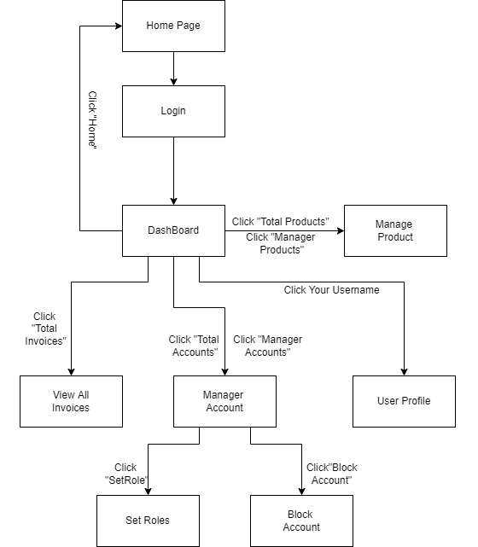

|  |
| --- |
| **Figure 1-1: Screen Flow for Admin** |

#### Customer

|  |
| --- |
| **Figure 1-2: Screen Flow for User** |

#### Seller

|  |
| --- |
| **Figure 1-3: Screen Flow for Seller** |

#### ***b. Screen Details***

|  |  |  |  |
| --- | --- | --- | --- |
| **#** | **Feature** | **Screen** | **Description** |
| 1 | Search & Filter Product | Home Page | Search product by name,price or filter it by category |
| 2 | Sort Product | Home Page | Sort product by price, name, ... |
| 3 | User Login | Login | User login by username and password |
| 4 | Register | Register | User register a new account by input the following information: full name, gender, email, phone number… and verify by gmail |
| 5 | View Product Detail | Product Details | Show information of product |
| 6 | Change Password | Change password | Users change their old password with new password |
| 7 | User Profile | User Profile | Show information about their account |
| 8 | Add To Cart | Home Page, Product Details | Users can add product they want to buy by click “Add to cart” |
| 9 | View Cart | Cart Details | Users can view all products they add to cart |
| 10 | Change Amount | Cart Details | Plus or minus the amount product in cart |
| 11 | Delete Product | Cart Details | Delete a product in cart |
| 12 | Check out | Check out | Users can check their all product before payment |
| 13 | View User List | Users List [Admin] | Admin can view the list of all Accounts in the System |
| 14 | Block User | Users List [Admin] | Admin can block accounts and accounts are blocked can’t login to website |
| 15 | Set Role User | Users List [Admin] | Admin can set role customer to seller or seller to customer |
| 16 | Order History | Order History | Users can view the history of all orders they bought |
| 17 | View Manager Products | Manager Product  [Seller] | Seller can view their products by id |
| 18 | CRUD Products | Manager Product  [Seller] | Seller can add, delete, update their products |
| 19 | Send Feedback | Product Details | Customer can write and send a Feedback about a product |
| 20 | View Feedback | Product Details | Customer can view all the Feedbacks about a Product |
| 21 | Blogs List | Blogs List | Customer views the list of all Blogs |
| 22 | Blog Details | Blog Details | Customer views the Detail information of 1 Blog |
| 24 | View Dashboard | Dashboard [Seller] | Seller can see total orders are sold, most sellest product, …. |
| 25 | Order Management | Order Management | Seller can see all of order and status |

#### ***c. Screen Authorization***

|  |  |  |  |
| --- | --- | --- | --- |
| **Screen** | **User** | **Seller** | **Admin** |
| Home Page | x | x | x |
| Product Details | x | x | x |
| Cart Details | x |  |  |
| Login | x | x | x |
| Register | x |  |  |
| Users List [Admin] |  |  | x |
| Change Password | x | x | x |
| Check out | x | x |  |
| User Profile | x | x | x |
| Order History | x |  |  |
| Dashboard [Sale] |  | x |  |
| Manager Product [Seller] |  | x |  |
| Order Management |  | x |  |
| Feedback | x |  |  |
| Blogs List | x |  |  |
| Blog Details | x |  |  |

In which:

* User: Customer who has an account an has logged in
* Seller: People who sell products in the shop
* Admin: People who manage the shop

#### ***d. Non-Screen Functions***

|  |  |  |  |
| --- | --- | --- | --- |
| **#** | **Feature** | **System Function** | **Description** |
| 1 | Remember Me | Login | System store user’s login account and password in cookies for future re-login |

#### e. Entity Relationship Diagram (Updating…)

#### The database is just enumerating entities and data for each entity. Details of the data can be viewed in the attached 'QuanaoDatabase' folder.

**Entities List (Updating…)**

|  |  |  |
| --- | --- | --- |
| **#** | **Entity** | **Description** |
| 01 | TypeOfProduct | Loại sản phẩm |
| 02 | NameOfProduct | Tên sản phẩm |
| 03 | CodeOfProduct | Mã sản phẩm |
| 04 | Price | Giá thành của sản phẩm |
| 05 | Quatity | Số lượng sản phẩm hiện có ở shop |
| 06 |  |  |
| 07 |  |  |
| 08 |  |  |
| 09 |  |  |
| 10 |  |  |
| 11 |  |  |
| 12 |  |  |
| 13 |  |  |
| 14 |  |  |
| 15 |  |  |
| 16 |  |  |
| 17 |  |  |
| 18 |  |  |

* 1. **View Product Detail**
* Function description:
  + Role: Guest, User
  + Purpose: User can view all the detail information of a Product
* Screen layout:

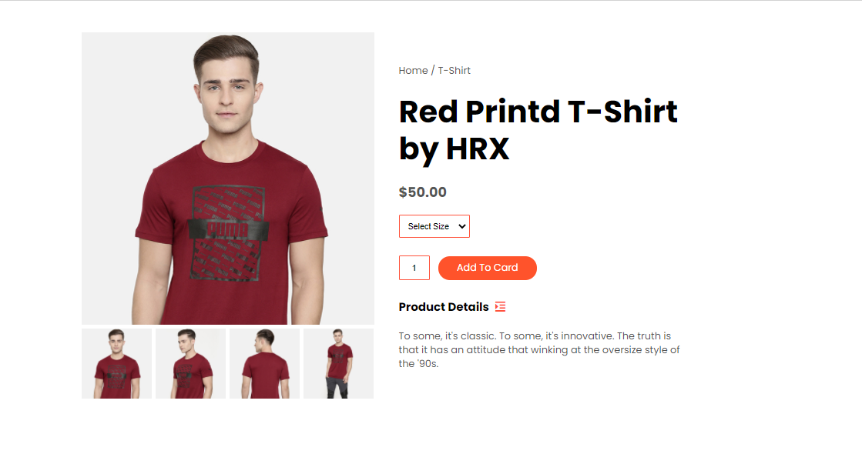

* 1. **Change Amount**
* Function description:
  + Role: User
  + Purpose: User can change the amount of the Product they want to buy
* Screen layout:

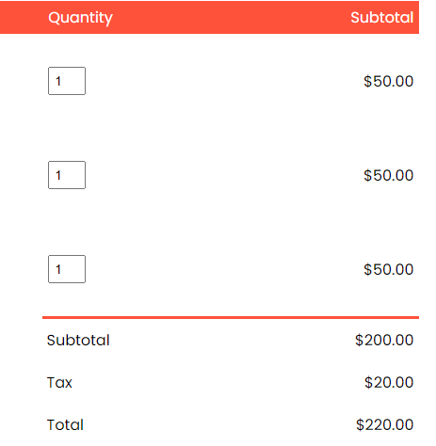

* 1. **Delete Product**
* Function description:
  + Role: Guest
  + Purpose: User can Delete a Product from their Cart
* Screen layout:

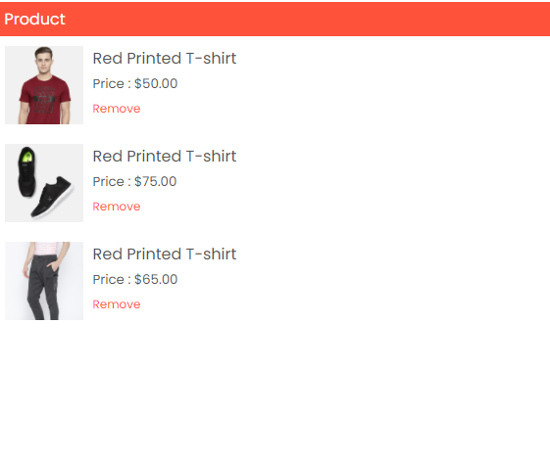

* 1. **Register**
* Function description:
  + Role: Guest.
  + Purpose: Provide a form for customer to register an account.
* Screen layout:

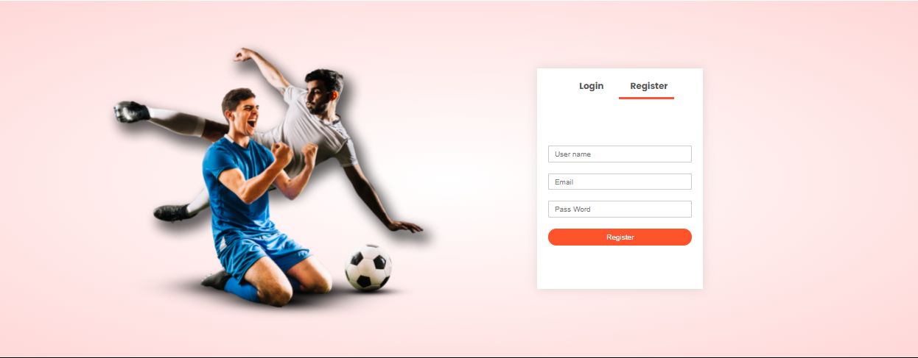

# 4. Data Requirements

## 4.1 Logical Data Model (Updating…)

## 4.2 Data Dictionary (Updating…)

## 4.4 Data Integrity and Retention

## Clothing Shop system will store customer orders so that when customers want to see what they bought last time.

## 5. External Interface Requirements

## 5.1 User Interfaces

## The Clothing Shop Ordering System screen displays shall conform to the User Interface Design and User Experience Design

## 5.2 Software Interfaces (Updating…)

+ Clothing Shop Account Checking system

+ Upload existing user data in the system through a programming interface

+ The system automatically checks what state the account is in in the UserStatus. If you belong to Locked, you will not be able to log in and have to create a new account, and if you belong to Unverified, you must go to gmail to verify your account.

+ Clothing System will transmit the quantities of product items ordered through a programmatic interface.

+ The Clothing system will display the quantity left in stock for the buyer. If there is no stock in stock, the user will not be able to place an order for this product.

## 5.3 Hardware Interfaces

No hardware interfaces have been identified.

## 5.4 Communications Interfaces

Clothing Shop shall send an email to the Customer to report any problems with the product order or delivery.

# Nonfunctional Requirements

## Performance Requirements

+ The system will provide continuous service, which means the shop will work 24/7, with an estimated average session duration of 30 minutes.

## Security

+ The website will use standard Web security protocols when transferring any private information regarding a Guest, Customer, or Seller.

+ Users will be required to log on to the Clothing Shop website for all operations except viewing home page, blog, product list and viewing a specific product.

+ Only the Admin will be permitted to confirm an order, only the Customer will be permitted to confirm an order has been delivered.

+ The system will permit Customer to view only orders that they placed and give a feedback on each products in those orders.

# Other Requirements

+ If the connection between the user and the Clothing Shop is broken prior to a new order being either confirmed or terminated, the Clothing Shop will enable the user to recover an incomplete order and continue working on it.

+ All confirmation code and order information will be send via user’s email.

+ The users email and user name cannot be changed.

# Appendix A: Analysis models

## Context Diagram

*GMAIL*

User email address, mail content

**ONLINE SHOP**

## State Transition Diagram for Order

