

**CLOTHING SHOP PROJECT REPORT**

**Software Requirement Specification**

– Hanoi, Summer 2022 –

Contents

I. Overview 3

1. Introduction 3

2. System Functions 3

a. Screen Flow 3

b. Screen Details 6

c. Screen Authorization 9

d. Non-Screen Functions 10

3. Common Requirements 10

II. Functional Requirements 10

# Overview

## Introduction

This document describes the requirements for website, which provides services and supplies clothes for purchaser. Types of reader this document is intended for: developers, project managers, testers, customers, etc...

## System Functions

#### a. Screen Flow

User

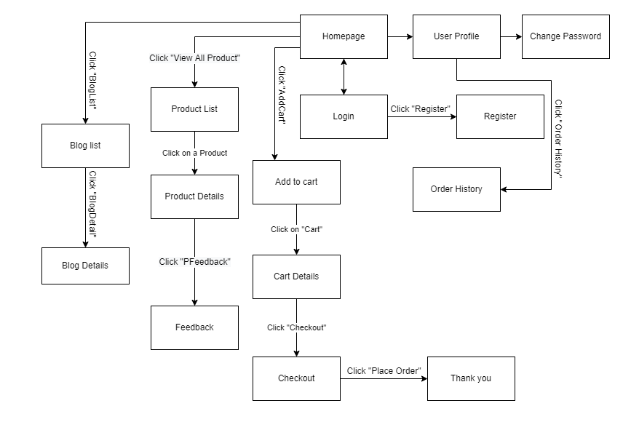

Figure 1-1: Screen Flow for User

Admin

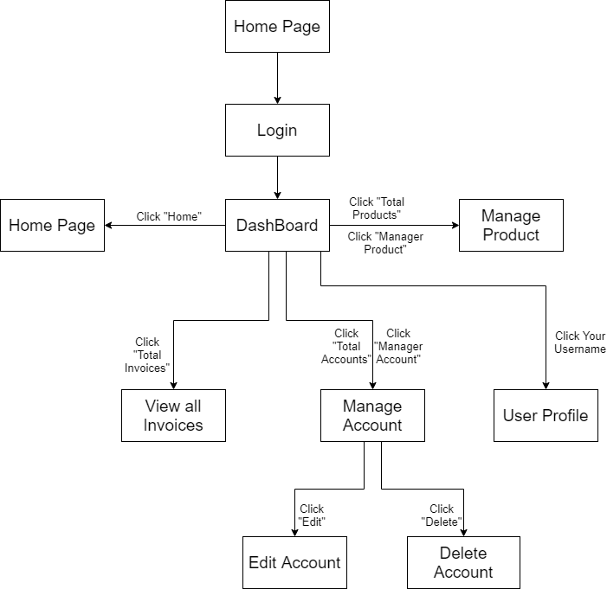

Figure 1-2: Screen Flow for Admin

Seller

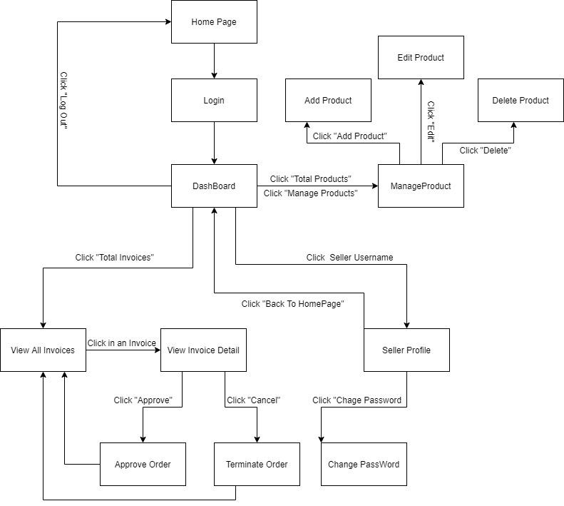

Figure 1-3: Screen Flow for Seller

#### b. Screen Details

|  |  |  |  |
| --- | --- | --- | --- |
| **#** | **Feature** | **Screen** | **Description** |
| 1 | Search & Filter Product | Home Page | Search product by name,price or filter it by category |
| 2 | Sort Product | Home Page | Sort product by price, name, ... |
| 3 | User Login | Login | User login by username and password |
| 4 | Register | Register | User register a new account by input the following information: full name, gender, email, phone number… and verify by gmail |
| 5 | View Product Detail | Product Details | Show information of product |
| 6 | Change Password | Change password | Users change their old password with new password |
| 7 | User Profile | User Profile | Show information about their account |
| 8 | Add To Cart | Home Page, Product Details | Users can add product they want to buy by click “Add to cart” |
| 9 | View Cart | Cart Details | Users can view all products they add to cart |
| 10 | Change Amount | Cart Details | Plus or minus the amount product in cart |
| 11 | Delete Product | Cart Details | Delete a product in cart |
| 12 | Check out | Check out | Users can check their all product before payment |
| 13 | View User List | Users List [Admin] | Admin can view the list of all Accounts in the System |
| 14 | Block User | Users List [Admin] | Admin can block accounts and accounts are blocked can’t login to website |
| 15 | Set Role User | Users List [Admin] | Admin can set role customer to seller or seller to customer |
| 16 | Order History | Order History | Users can view the history of all orders they bought |
| 17 | View Manager Products | Manager Product  [Seller] | Seller can view their products by id |
| 18 | CRUD Products | Manager Product  [Seller] | Seller can add, delete, update their products |
| 19 | Send Feedback | Product Details | Customer can write and send a Feedback about a product |
| 20 | View Feedback | Product Details | Customer can view all the Feedbacks about a Product |
| 21 | Blogs List | Blogs List | Customer views the list of all Blogs |
| 22 | Blog Details | Blog Details | Customer views the Detail information of 1 Blog |
| 24 | View Dashboard | Dashboard [Seller] | Seller can see total orders are sold, most sellest product, …. |
| 25 | Order Management | Order Management | Seller can see all of order and status |

Table 1-1: Screen Details

#### c. Screen Authorization

|  |  |  |  |
| --- | --- | --- | --- |
| **Screen** | **User** | **Seller** | **Admin** |
| Home Page | x | x | x |
| Product Details | x | x | x |
| Cart Details | x |  |  |
| Login | x | x | x |
| Register | x |  |  |
| Users List [Admin] |  |  | x |
| Change Password | x | x | x |
| Check out | x | x |  |
| User Profile | x | x | x |
| Order History | x |  |  |
| Dashboard [Sale] |  | x |  |
| Manager Product [Seller] |  | x |  |
| Order Management |  | x |  |
| Feedback | x |  |  |
| Blogs List | x |  |  |
| Blog Details | x |  |  |

In which:

* Guest: Customer who has not yet logged in to the site
* User: Customer who has an account an has logged in
* Seller: People who sell products in the shop
* Admin: People who manage the shop

#### d. Non-Screen Functions

|  |  |  |  |
| --- | --- | --- | --- |
| **#** | **Feature** | **System Function** | **Description** |
| 1 | Remember Me | Login | System store user’s login account and password in cookies for future re-login |
| 2 | Performance  Requirements | Response | The server shall respond to the client within 2  seconds each time requesting |

## Common Requirements

# Functional Requirements

**z Search & Filter Product**

* Function trigger: User accesses the website
* Function description:
  + Role: Guest, User
  + Purpose: Users Search for the Product they want
* Screen layout:

**3.3 View Product Detail**

* Function trigger: User Click on a Product in Home Page
* Function description:
  + Role: Guest, User
  + Purpose: User can view all the detail information of a Product
* Screen layout:

**3.3 View Product List**

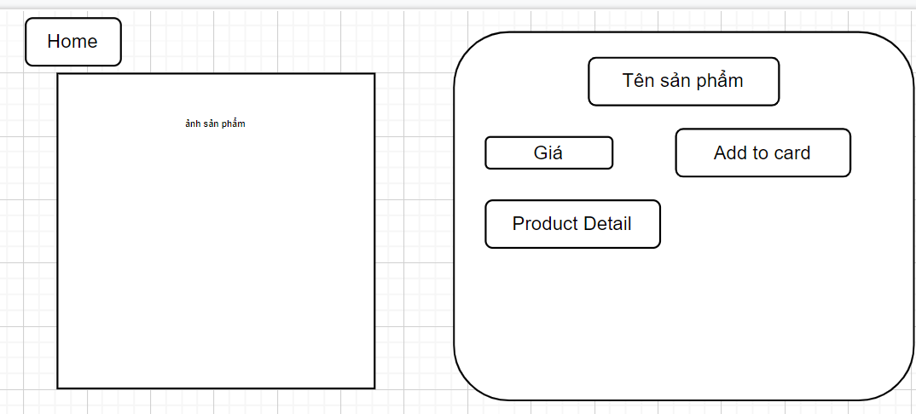

* Function trigger: User Click on a customer list in Dashboard Page
* Function description:
  + Role: Admin
  + Purpose: Show list of all customer
* Screen layout:

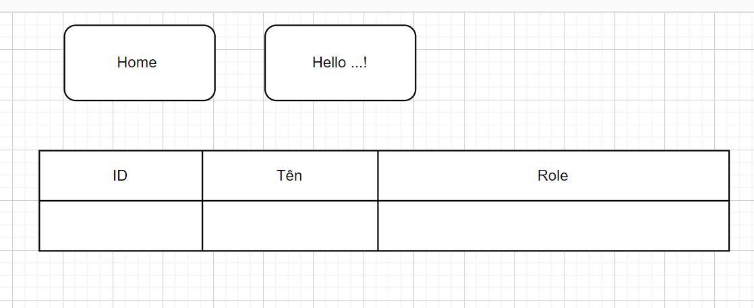

* Function trigger: User Click on a Product list in Home Page
* Function description:
  + Role: Sell
  + Purpose: seller views and manages all products
* Screen layout:

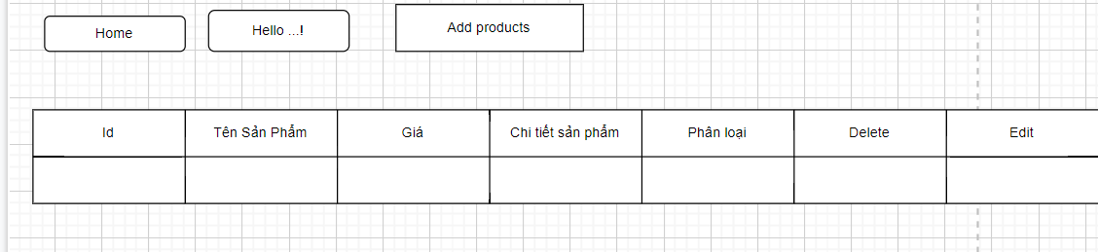

**3.5 Change Amount**

* Function trigger: User Click on “Cart” in Menu bar
* Function description:
  + Role: User
  + Purpose: User can change the amount of the Product they want to buy
* Screen layout: 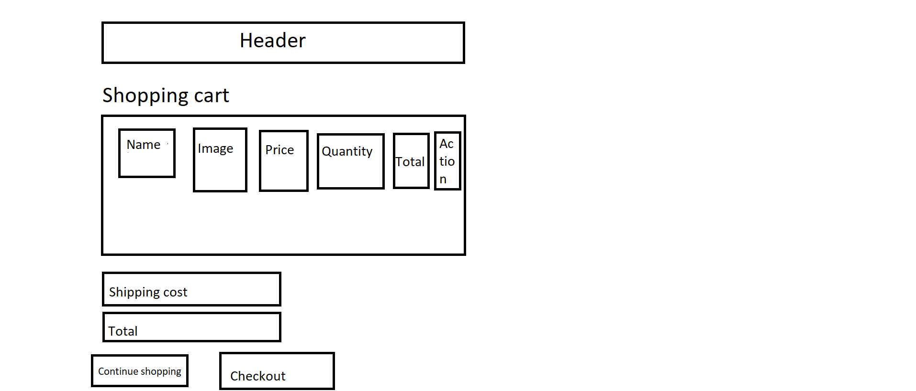

**3.6 Delete Product**

* Function trigger: User Click on the Delete icon in a Product in Cart
* Function description:
  + Role: User
  + Purpose: User can Delete a Product from their Cart
* Screen layout:



**3.7 Cart Detail**

* Function trigger: User Click on “Cart” in Menu bar and click on green button they want to increase in amount
* Function description:
  + Role: User
  + Purpose: User can change the amount of the Product they want to buy
* Screen layout:



**3.8 Checkout**

* Function trigger: User Click on “Checkout” button to view information of Cart
* Function description:
  + Role: User
  + Purpose: User can view information of order before deciding Order.
* Screen layout:

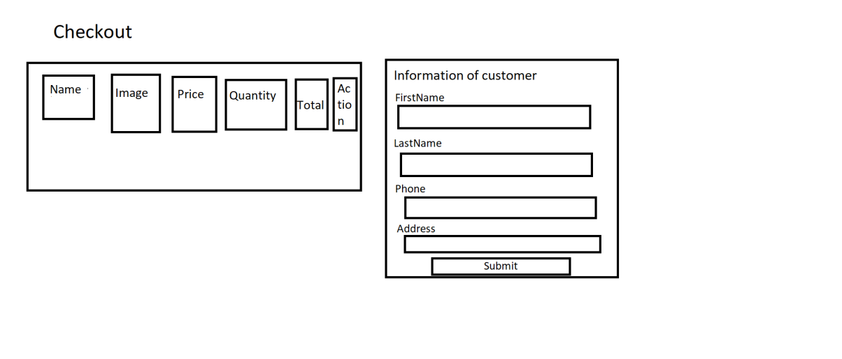

**3.9 Delete Cart**

* Function trigger: User Click on “Delete Cart” button in Cart
* Function description:
  + Role: User
  + Purpose: User can delete all the Product in their Cart
* Screen layout:

**3.10 Login**

* Function trigger: User Click on “Login” link in the Menu bar
* Function description:
  + Role: Guest
  + Purpose: For people to log in to the system for access to more functions
* Screen layout:

**3.11 Register**

* Function trigger: Guest click “Sign up” button from Login screen.
* Function description:
  + Role: Guest.
  + Purpose: Provide a form for customers to register an account.
* Screen layout:

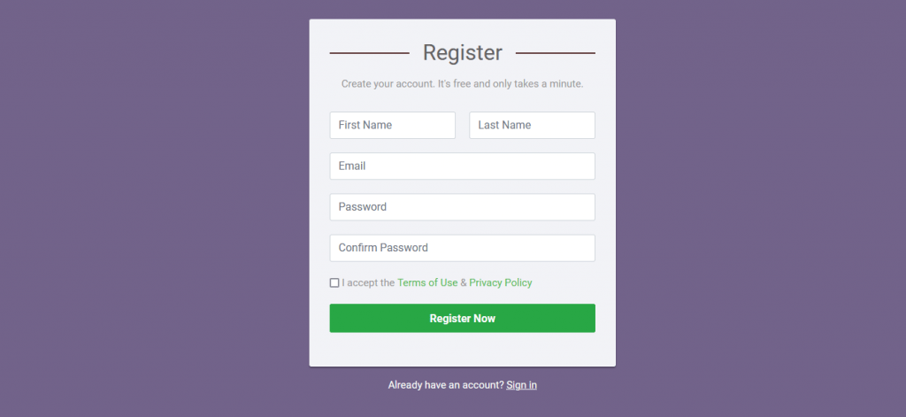

**3.13 Set Role User**

* Function trigger: Admin click “Set role” button next to an entry from user list.
* Function description:
  + Role: Admin.
  + Purpose: Set role as an account.
* Screen layout:

**3.14 Block User**

* Function trigger: Admin click the “Block” button next to an entry from the user list.
* Function description:
  + Role: Admin.
  + Purpose: Block an account from the system.
* Screen layout:

**3.15 Reset Password**

* Function trigger: Users access the website and click on Reset Password button
* Function description:
  + Role: Buyer, Seller, Admin
  + Purpose: Users can change their passwords when they forget their old one
* Screen Layout:

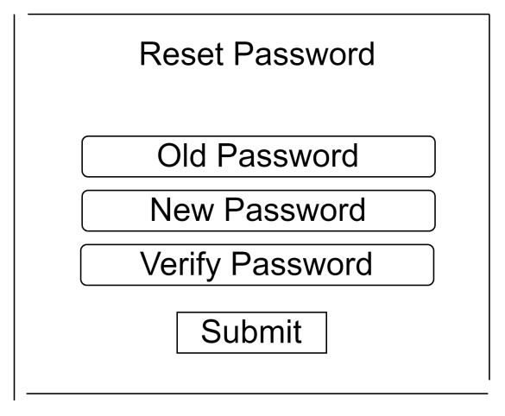

**3.16 Change Password**

* Function trigger: Users login the website and access the profile page and click on Change Password button
* Function description:
  + Role: Buyer, Seller, Admin
  + Purpose: Users can change their passwords
* Screen Layout:

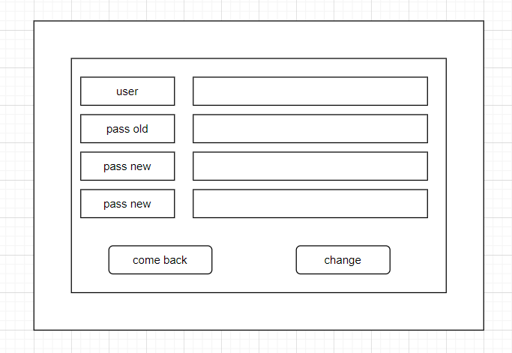

**3.17 User Profile**

* Function trigger: User log-in the website and click on the profile icon on the top-right corner
* Function description:
  + Role: Buyers, Seller, Admin
  + Purpose: Users can see their account’s detailed information
* Screen layout:

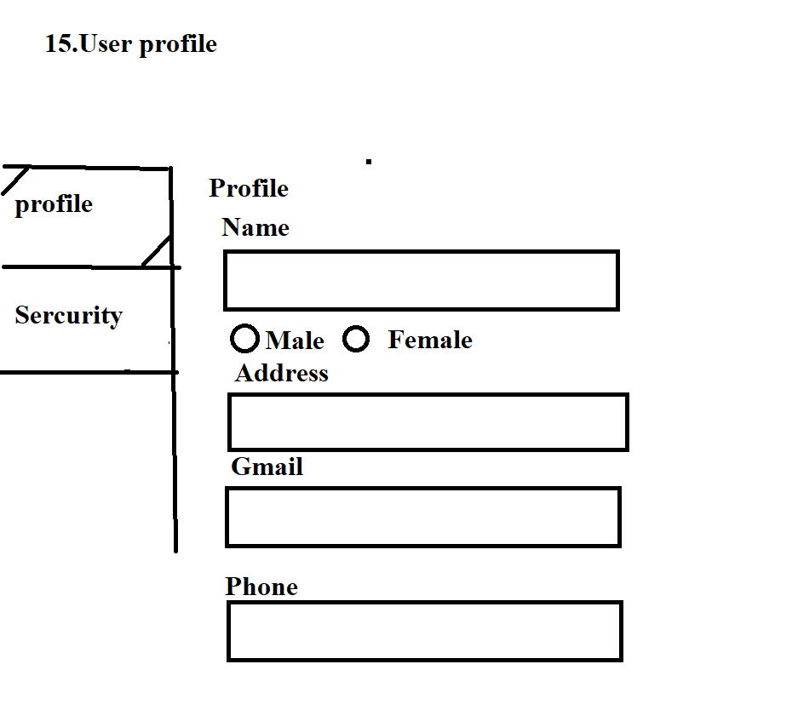

**3.18 My Orders**

* Function trigger: Users log-in the website, access the profile page and click on My Orders button
* Function description:
  + Role: Buyers
  + Purpose: Users can see their shopping history
* Screen layout:

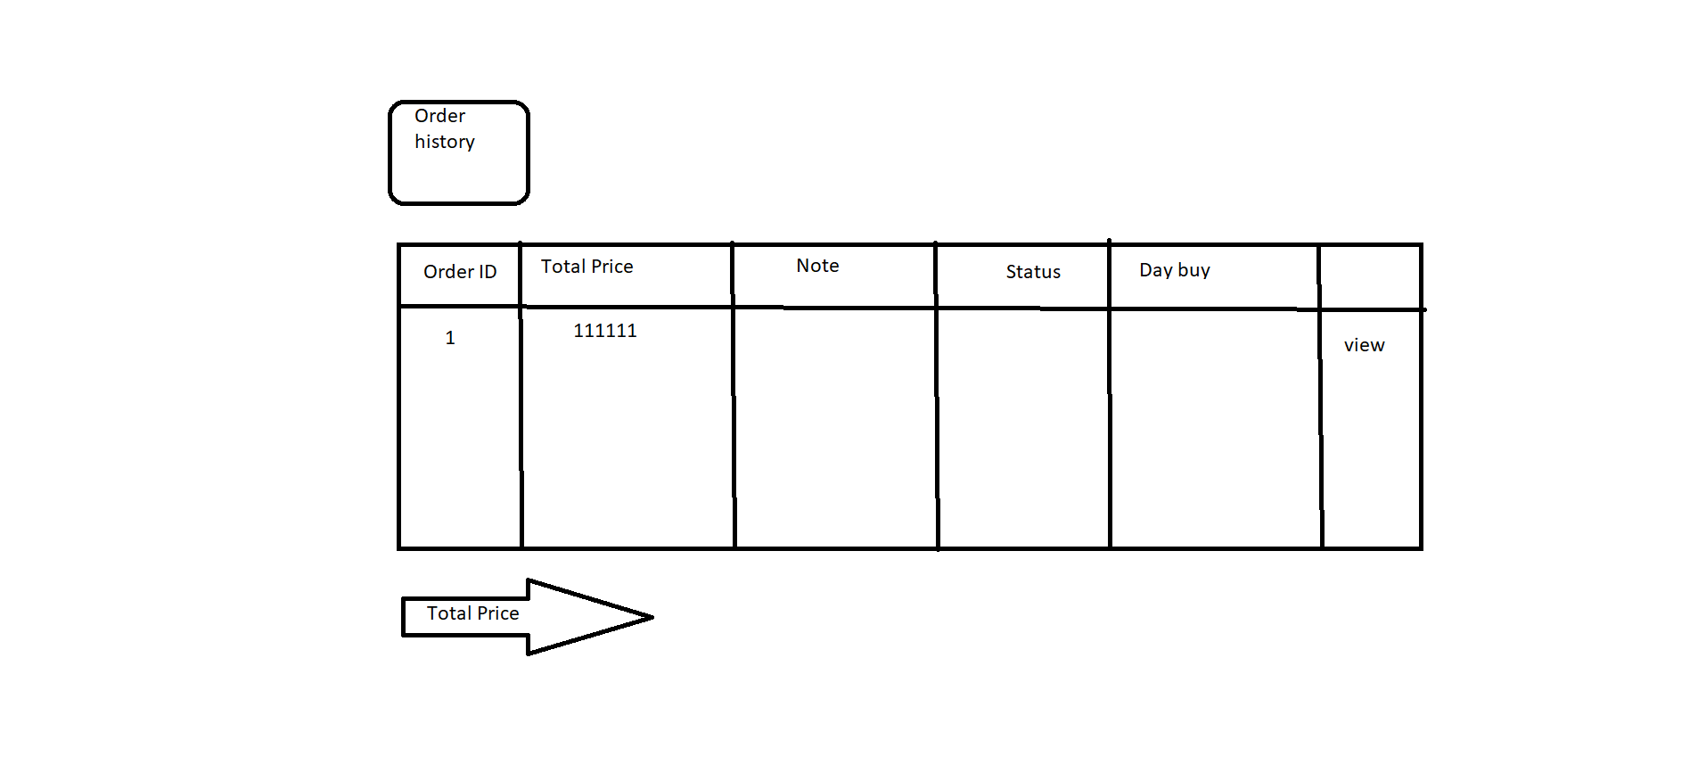

**3.19 Order Information**

* Function trigger: Users log-in to the website, access My Orders page and click View button
* Function description:
  + Role: Buyers
  + Purpose: See the order detailed information
* Screen layout:

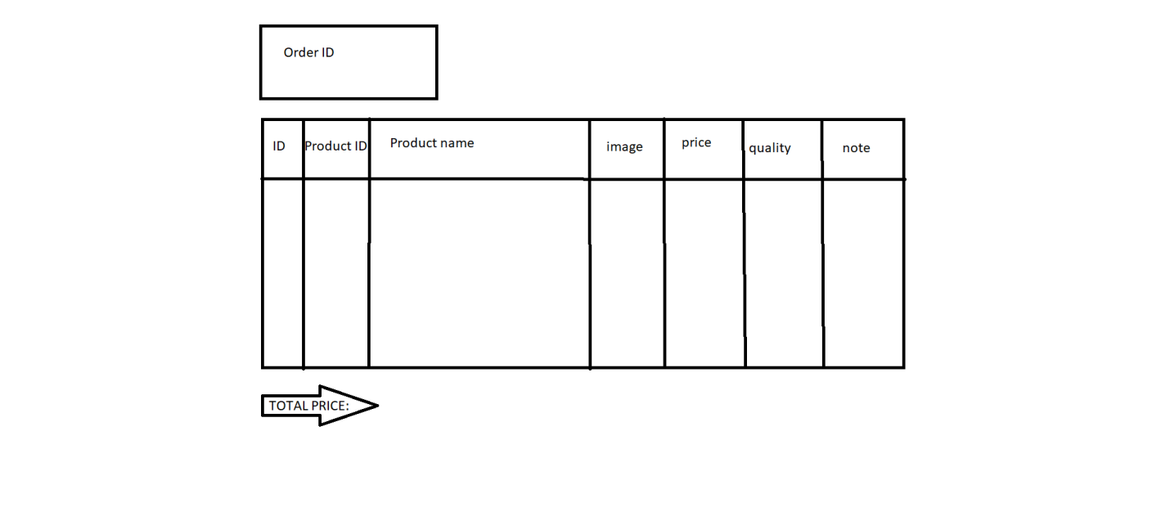

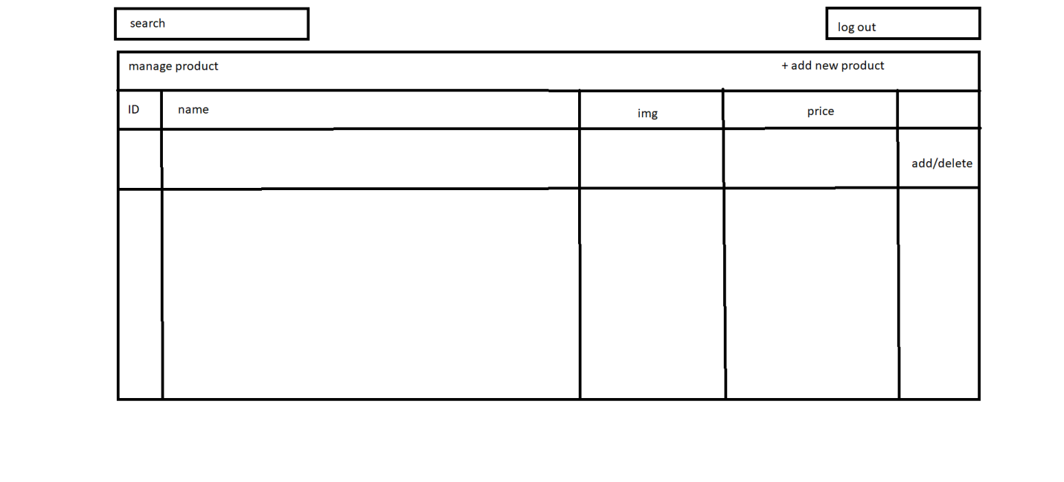

**3.20 Order List**

Function trigger: Admin Login and click Total Invoices

Function description:

• Role: Admin

• Purpose: Admin views list of all of 2orders

Screen layout:

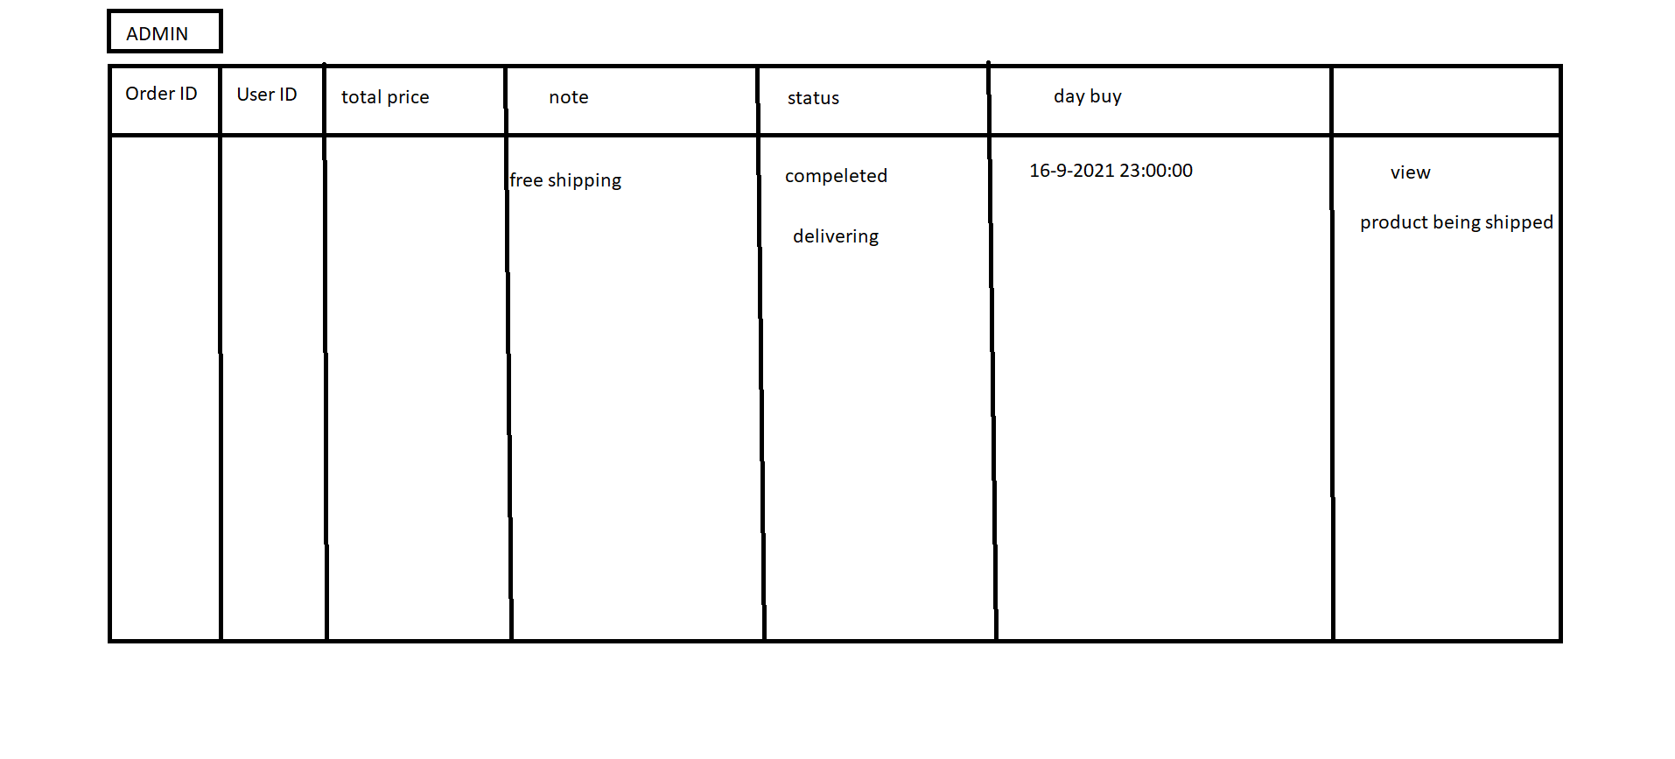

**3.21 Order Details**

Function trigger: Seller Login and click Total Invoices

Function description:

• Role: Seller

• Purpose: Seller views the detail of 1 of his orders

Screen layout:

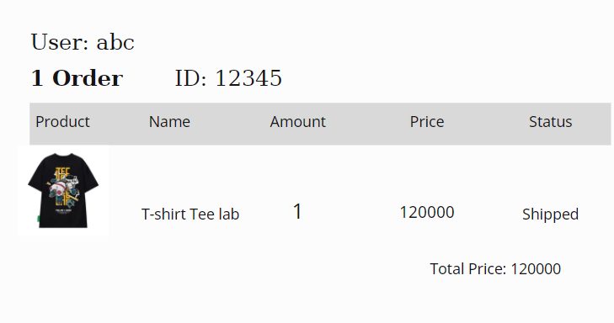

**3.22 View Feedback**

Function trigger: Customers click on the product they want to see, scroll down to see the feedback

Function description:

* Role: Guest, User
* Purpose: Customer views all the Feedbacks about a Product

Screen layout:

**3.23 Send Feedback**

Function trigger: When the user receives the goods, click on My order and then click on Add feedback and evaluate

Function description:

* Role: Guest, User
* Purpose: Customer writes and send a Feedback about a Product

Screen layout:

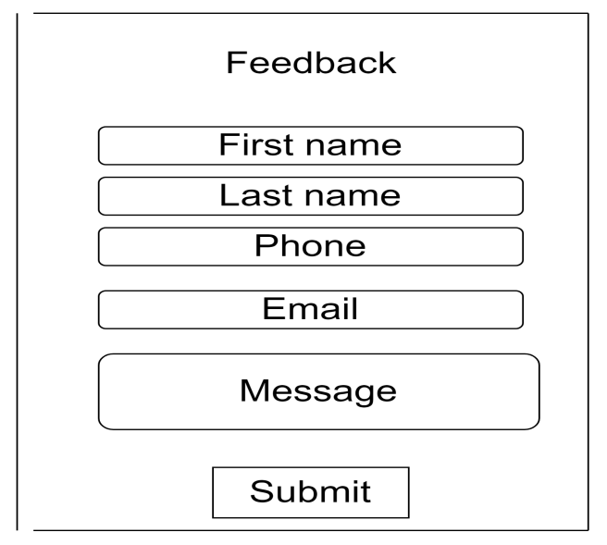

**3.24 Blogs List**

Function trigger: User Click Blog in menu bar

Function description:

* Role: Guest, User
* Purpose: Customer views the list of all Blogs

Screen layout: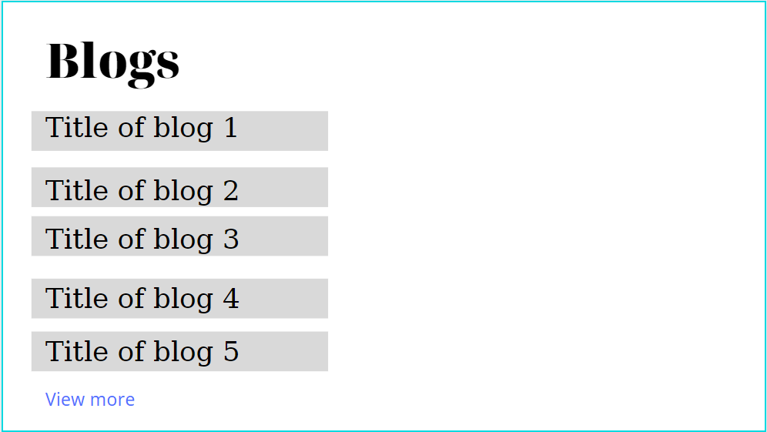

**3.25 Blog Details**

Function trigger: User Click Blog in menu bar. Next, click Blog want to see detail

Function description:

Role: Guest, User

Purpose: Customer views the Detail information of 1 Blog

Screen layout:

