

**CLOTHING SHOP PROJECT REPORT**

**Software Requirement Specification**

– Hanoi, Summer 2022 –

Contents

1. Introduction 4

1.1 Purpose 3

1.2 Document Conventions 3

1.3 Project Scope 3

1.4 References 3

2. Overall Description 4

2.1 Product Perspective 4

2.2 User Classes and Their Use Cases 4

2.2.1 Guest 4

2.2.2 Customer 4

2.2.3 Seller 5

2.2.4 Administrator 5

2.3 Operating Environment 5

2.4 Dependencies 6

Dependencies: 6

2.5 Business rules 6

3. Functional Requirements 6

3.1 System Functional Overview 6

a. Screen Flow 6

b. Screen Details 10

c. Screen Authorization 13

d. Non-Screen Functions 14

e. Entity Relationship Diagram 15

4. Data Requirements 31

4.1 Logical Data Model (Updating…) 31

4.2 Data Dictionary (Updating…) 31

4.4 Data Integrity and Retention 31

Clothing Shop system will store customer orders so that when customers want to see what they bought last time. 31

5. External Interface Requirements 32

5.1 User Interfaces 32

The Clothing Shop Ordering System screen displays shall conform to the User Interface Design and User Experience Design 32

5.2 Software Interfaces 32

5.3 Hardware Interfaces 32

5.4 Communications Interfaces 32

6. Nonfunctional Requirements 33

6.1 Performance Requirements 33

6.2 Security 33

7. Other Requirements 33

Appendix A: Analysis models 34

Context Diagram 34

State Transition Diagram for Order 34

# Introduction

## Purpose

This document describes the requirements for website, which provides services and supplies clothes for purchaser. Types of reader this document is intended for: developers, project managers, testers, customers, etc...

## Document Conventions

The functional requirements for this project are organized by users.

## Project Scope

The website will provides common information clothes for the customers. This website also will permit purchasers to pick up clothes from the company online to be delivered to specified locations.

## References

Existing web sites used as models for ideas regarding the functionality documented and user interface style here include:

* https://www.zanado.com
* http://www.viviane.vn
* http://www.yes24.vn
* http://www.penda.vn

# Overall Description

## Product Perspective

The 4.0 revolution is approaching, that's why information technology has been playing a huge role today , and it will be a challenge when an organization or any area of life lacks a computer system. Online shopping is a trend that provides all the details about customers, products, orders, etc… Specifically, this Online Shopping System is a kind of online shop where a seller can sell his/her products or services and customers can buy. Selling online has been easier, faster, or more convenient than with traditional selling.. We have developed this mini project Online Shopping System on Java, JSP, and SQL, all HTML code will conform to the HTML 5.0 standard and the project will runs over the Glassfish 4.1.1 Server. In case something bad happens, including system failure or negative feedback,… the administrator will be able to maintain and modify the site. This system supports the below types of user… (see more in section 2.2)

## User Classes and Their Use Cases

### Guest

A visitor is someone who visit the website to learn more information about clothes sold on this website. Use cases:

1: View all products

2: Search for a product

3: View product’s detail

4: Read blog

### Customer

A customer is someone who orders a product from the website. Use cases:

1: Login

2: View all products

3: Search for a product

4: View product’s detail

5: Add product to cart

6: Checkout

7: Check order status

8: Cancel order

9: Rate product

10: Give feedback

11: Read blog

### Seller

A seller is someone who has the responsibilities to manage the website’s products and the business important data

1: Create a product

2: Modify a product

3: Delete a product

4: Add promotion detail

5: View dashboard

### Administrator

An administrator is the person who has the responsibility to manage users of website. Use cases:

1: Change users’ information

2: Delete an user

## Operating Environment

The website will be compatible with standard web browsers on Computer and Smart Phone platforms.

## Dependencies

## Dependencies:

* User’s environment (Browser)
* User’s devices (Computer, Smart phone,…)
* External libraries

## Business rules

|  |  |  |  |  |
| --- | --- | --- | --- | --- |
| ID | Rule definition | Type of rule | Static or dynamic | Source |
| BR-1 | Deliveries must be completed in 1 week after the order approved | Constraint | Dynamic | Shop policy |
| BR-2 | All goods in a single order must be paid for by using the same payment method. | Constraint | Static | Shop manager |
| BR-3 | Only sellers can create, modify, or delete products. | Constraint | Static | Shop manager |
| BR-4 | Only administrators can modify, or block users. | Constraint | Static | Shop manager |
| BR-5 | Order price is calculated as the sum of each order item price times the quantity of that order item ordered, plus shipping fee | Computation | Dynamic | Shop manager |

## 3. Functional Requirements

### 3.1 System Functional Overview

#### a. Screen Flow

User

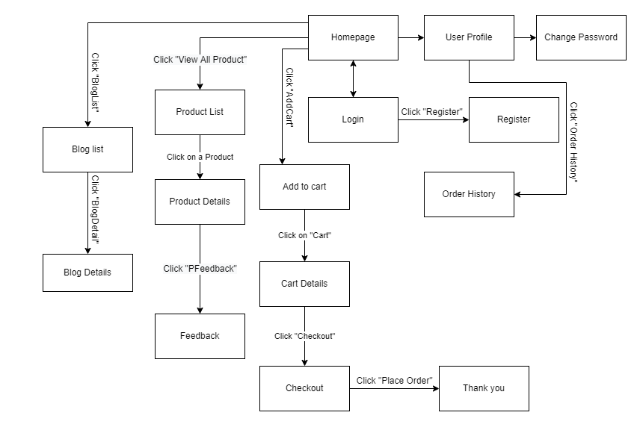

Figure 1-1: Screen Flow for User

Admin

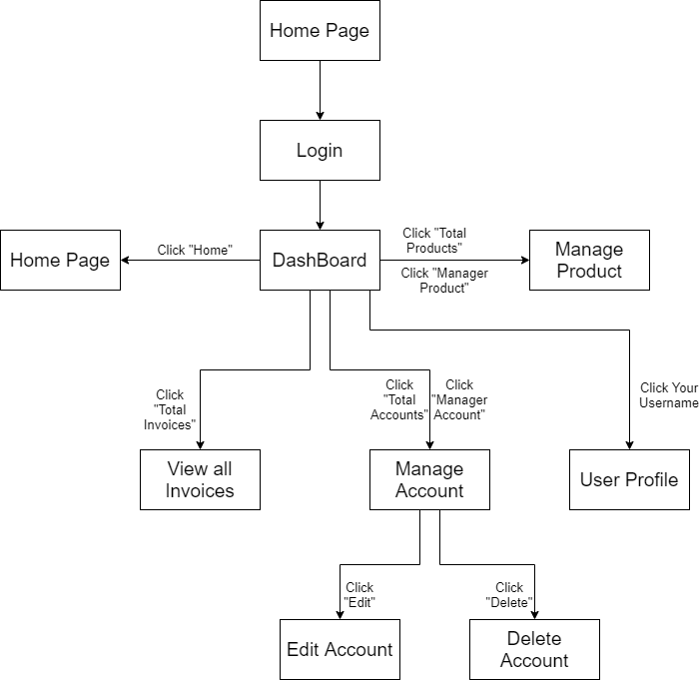

Figure 1-2: Screen Flow for Admin

Seller

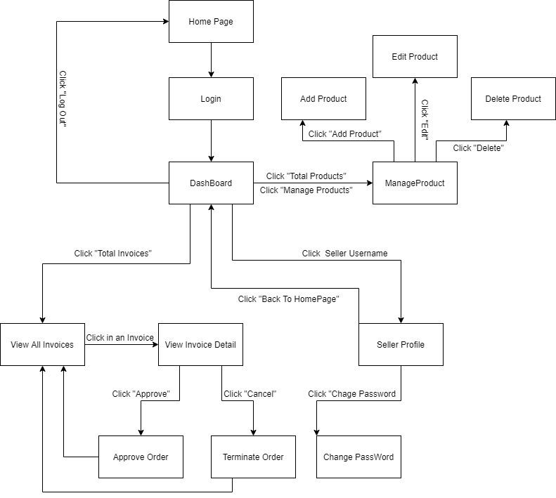

Figure 1-3: Screen Flow for Seller

#### b. Screen Details

|  |  |  |  |
| --- | --- | --- | --- |
| **#** | **Feature** | **Screen** | **Description** |
| 1 | Search & Filter Product | Home Page | Search product by name,price or filter it by category |
| 2 | Sort Product | Home Page | Sort product by price, name, ... |
| 3 | User Login | Login | User login by username and password |
| 4 | Register | Register | User register a new account by input the following information: full name, gender, email, phone number… and verify by gmail |
| 5 | View Product Detail | Product Details | Show information of product |
| 6 | Change Password | Change password | Users change their old password with new password |
| 7 | User Profile | User Profile | Show information about their account |
| 8 | Add To Cart | Home Page, Product Details | Users can add product they want to buy by click “Add to cart” |
| 9 | View Cart | Cart Details | Users can view all products they add to cart |
| 10 | Change Amount | Cart Details | Plus or minus the amount product in cart |
| 11 | Delete Product | Cart Details | Delete a product in cart |
| 12 | Check out | Check out | Users can check their all product before payment |
| 13 | View User List | Users List [Admin] | Admin can view the list of all Accounts in the System |
| 14 | Block User | Users List [Admin] | Admin can block accounts and accounts are blocked can’t login to website |
| 15 | Set Role User | Users List [Admin] | Admin can set role customer to seller or seller to customer |
| 16 | Order History | Order History | Users can view the history of all orders they bought |
| 17 | View Manager Products | Manager Product  [Seller] | Seller can view their products by id |
| 18 | CRUD Products | Manager Product  [Seller] | Seller can add, delete, update their products |
| 19 | Send Feedback | Product Details | Customer can write and send a Feedback about a product |
| 20 | View Feedback | Product Details | Customer can view all the Feedbacks about a Product |
| 21 | Blogs List | Blogs List | Customer views the list of all Blogs |
| 22 | Blog Details | Blog Details | Customer views the Detail information of 1 Blog |
| 24 | View Dashboard | Dashboard [Seller] | Seller can see total orders are sold, most sellest product, …. |
| 25 | Order Management | Order Management | Seller can see all of order and status |

Table 1-1: Screen Details

#### c. Screen Authorization

|  |  |  |  |
| --- | --- | --- | --- |
| **Screen** | **User** | **Seller** | **Admin** |
| Home Page | x | x | x |
| Product Details | x | x | x |
| Cart Details | x |  |  |
| Login | x | x | x |
| Register | x |  |  |
| Users List [Admin] |  |  | x |
| Change Password | x | x | x |
| Check out | x | x |  |
| User Profile | x | x | x |
| Order History | x |  |  |
| Dashboard [Sale] |  | x |  |
| Manager Product [Seller] |  | x |  |
| Order Management |  | x |  |
| Feedback | x |  |  |
| Blogs List | x |  |  |
| Blog Details | x |  |  |

In which:

* Guest: Customer who has not yet logged in to the site
* User: Customer who has an account an has logged in
* Seller: People who sell products in the shop
* Admin: People who manage the shop

#### d. Non-Screen Functions

|  |  |  |  |
| --- | --- | --- | --- |
| **#** | **Feature** | **System Function** | **Description** |
| 1 | Remember Me | Login | System store user’s login account and password in cookies for future re-login |
| 2 | |  | | --- | | Performance  Requirements | | |  | | --- | | Response | | |  | | --- | | The server shall respond to the client within 2  seconds each time requesting | |

#### e. Entity Relationship Diagram

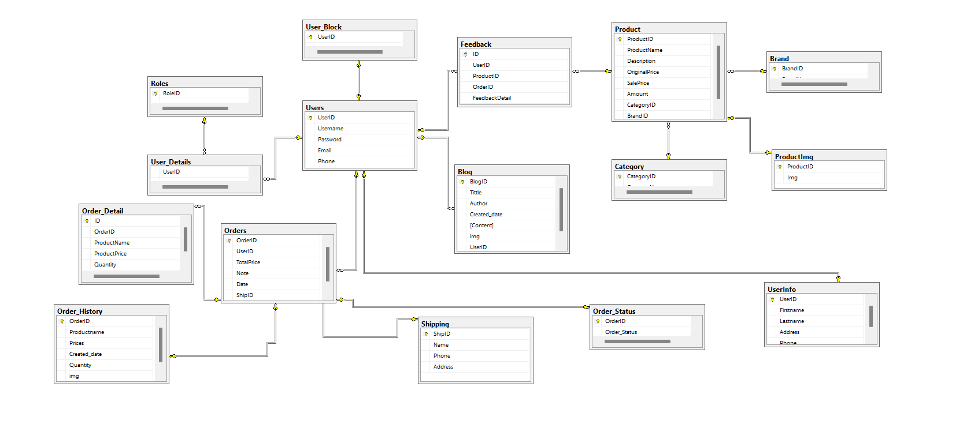

**Entities List**

|  |  |  |
| --- | --- | --- |
| **#** | **Entity** | **Description** |
| 01 | Blog | Store the blogs |
| 02 | Role | Customers or Sellers or Admin |
| 03 | Users | Store the information of all users (including customers, sellers and admin) |
| 04 | User_Block | Store users who are blocked |
| 05 | Cart | Store information of the Cart (a list of product) of each Customer |
| 06 | Ship | Store the price of ship for each City |
| 07 | Order_Status | Store the status value of the order |
| 08 | Orders | Store the information about orders |
| 09 | Feedback | Store the rating of every product from the customer after buying |
| 10 | ShipInfo | Store the information of the order (including shipping address, shipping price, phone number of customer…) |
| 11 | Order_Detail | Store information about detailed shopping in every order. |
| 12 | Product | Store the information of all products |
| 13 | Brand | Store the manufacturer name of the product |
| 14 | ProductImg | Store the image of product |
| 15 | Category | Store the information of Categories of products |

**3.2 Search & Filter Product**

* Function trigger: User accesses the website
* Function description:
  + Role: Guest, User
  + Purpose: Users Search for the Product they want
* Screen layout:

**3.3 View Product Detail**

* Function trigger: User Click on a Product in Home Page
* Function description:
  + Role: Guest, User
  + Purpose: User can view all the detail information of a Product
* Screen layout:

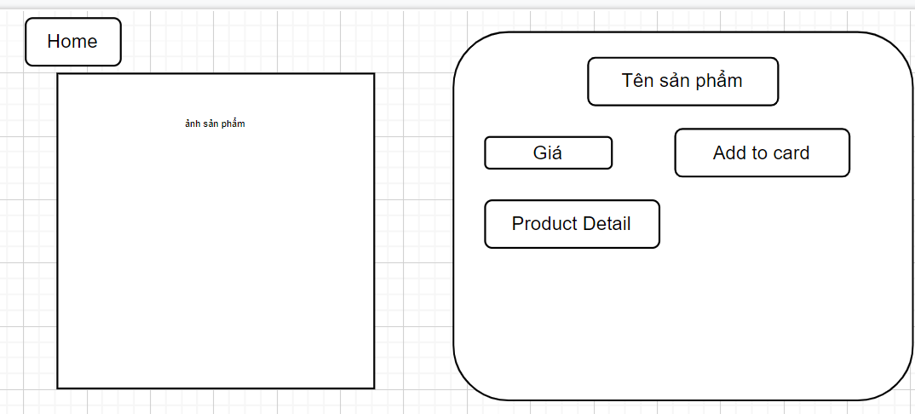

**3.4 Customers List**

* Function trigger: User Click on a customer list in Dashboard Page
* Function description:
  + Role: Admin
  + Purpose: Show list of all customer
* Screen layout:

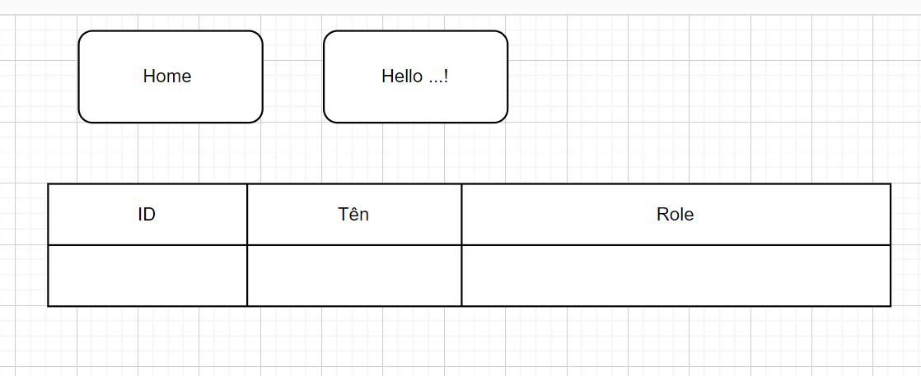

**3.5 Products List**

* Function trigger: User Click on a Product list in Home Page
* Function description:
  + Role: Sell
  + Purpose: seller views and manages all products
* Screen layout:

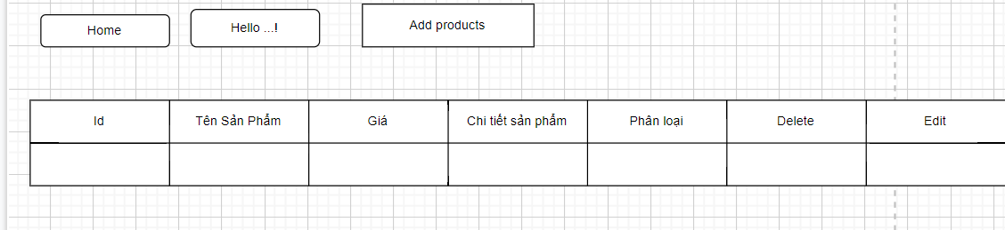

**3.5 Change Amount**

* Function trigger: User Click on “Cart” in Menu bar
* Function description:
  + Role: User
  + Purpose: User can change the amount of the Product they want to buy
* Screen layout: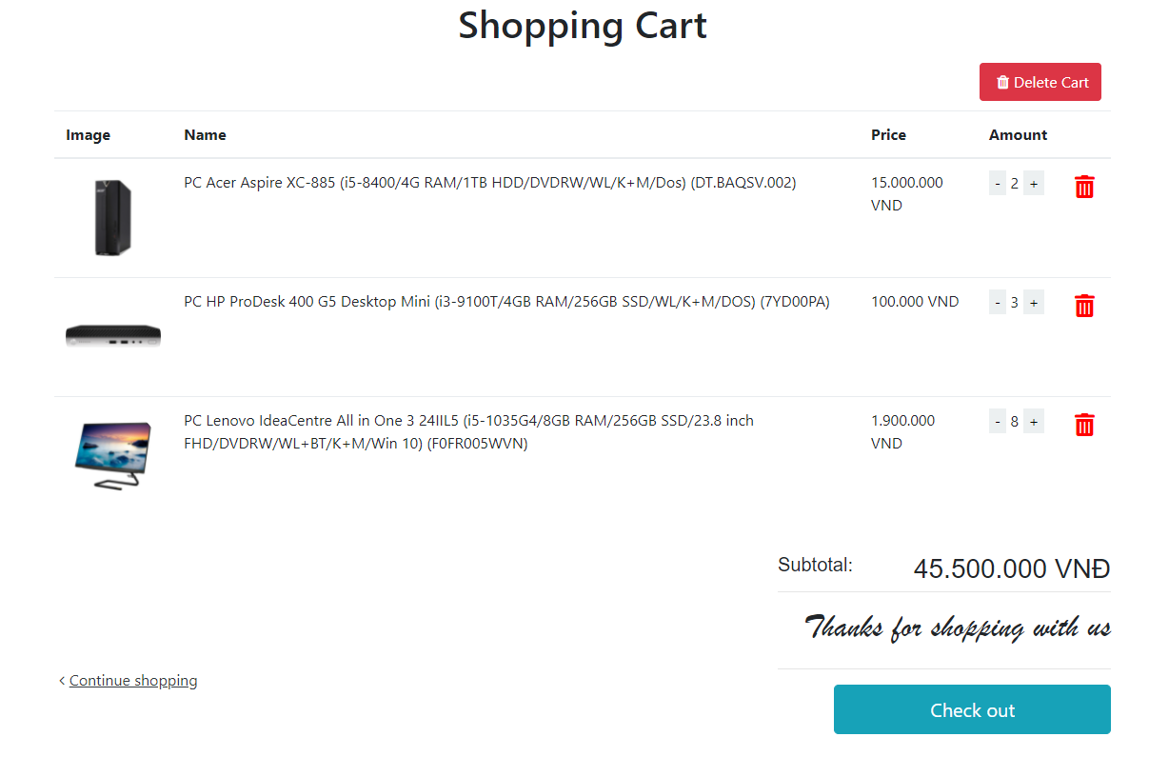

**3.6 Delete Product**

* Function trigger: User Click on the Delete icon in a Product in Cart
* Function description:
  + Role: User
  + Purpose: User can Delete a Product from their Cart
* Screen layout:

**

**3.7 Cart Detail**

* Function trigger: User Click on “Cart” in Menu bar and click on green button they want to increase in amount
* Function description:
  + Role: User
  + Purpose: User can change the amount of the Product they want to buy
* Screen layout:

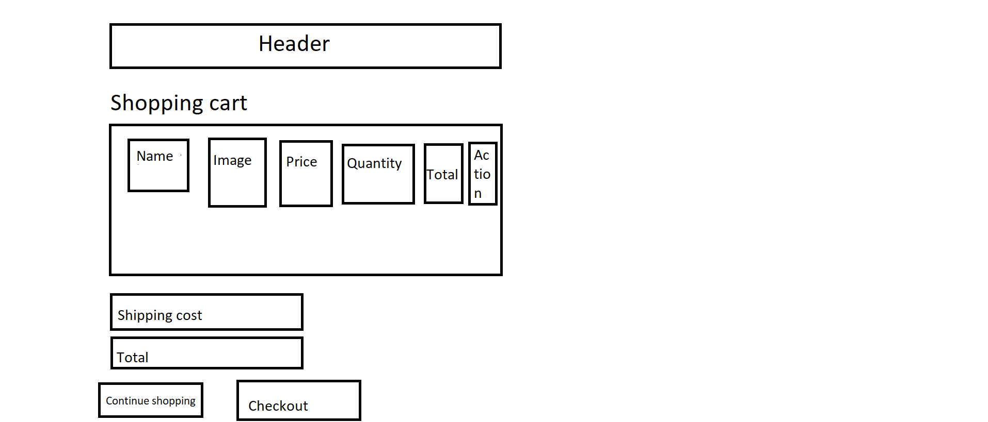

**3.8 Checkout**

* Function trigger: User Click on “Checkout” button to view information of Cart
* Function description:
  + Role: User
  + Purpose: User can view information of order before deciding Order.
* Screen layout:

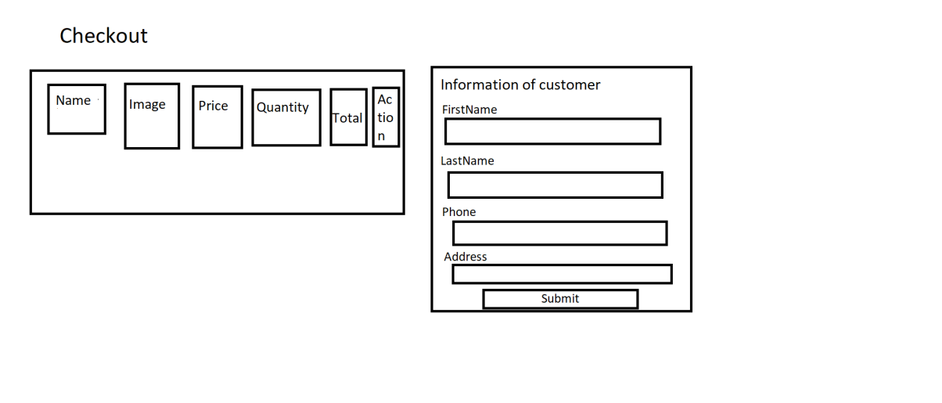

**3.9 Delete Cart**

* Function trigger: User Click on “Delete Cart” button in Cart
* Function description:
  + Role: User
  + Purpose: User can delete all the Product in their Cart
* Screen layout:

**3.10 Login**

* Function trigger: User Click on “Login” link in the Menu bar
* Function description:
  + Role: Guest
  + Purpose: For people to log in to the system for access to more functions
* Screen layout:

**3.11 Register**

* Function trigger: Guest click “Sign up” button from Login screen.
* Function description:
  + Role: Guest.
  + Purpose: Provide a form for customers to register an account.
* Screen layout:

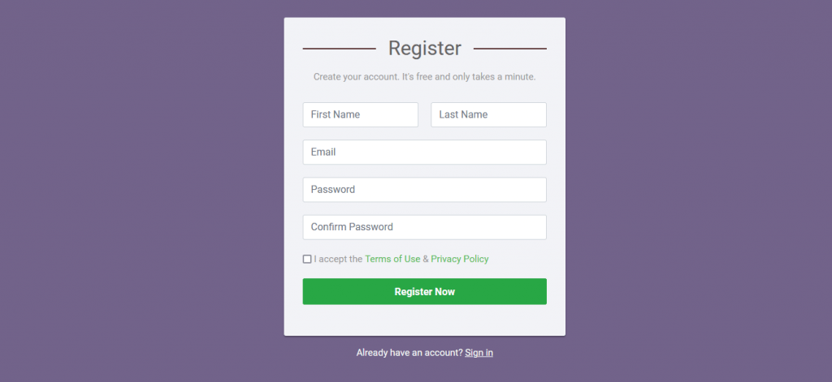

**3.13 Set Role User**

* Function trigger: Admin click “Set role” button next to an entry from user list.
* Function description:
  + Role: Admin.
  + Purpose: Set role as an account.
* Screen layout:

**3.14 Block User**

* Function trigger: Admin click the “Block” button next to an entry from the user list.
* Function description:
  + Role: Admin.
  + Purpose: Block an account from the system.
* Screen layout:

**3.15 Reset Password**

* Function trigger: Users access the website and click on Reset Password button
* Function description:
  + Role: Buyer, Seller, Admin
  + Purpose: Users can change their passwords when they forget their old one
* Screen Layout:

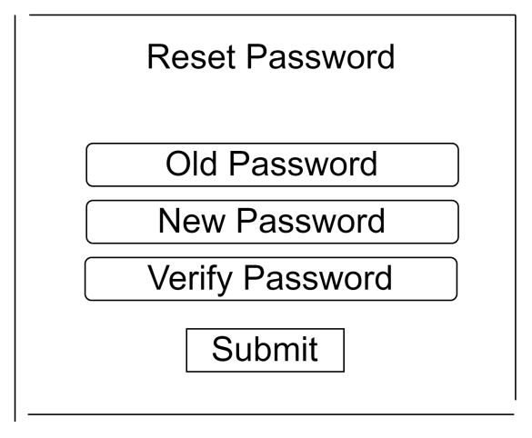

**3.16 Change Password**

* Function trigger: Users login the website and access the profile page and click on Change Password button
* Function description:
  + Role: Buyer, Seller, Admin
  + Purpose: Users can change their passwords
* Screen Layout:

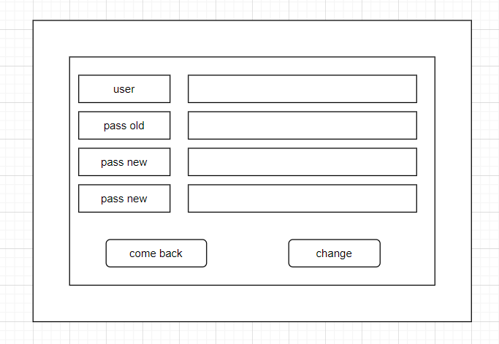

**3.17 User Profile**

* Function trigger: User log-in the website and click on the profile icon on the top-right corner
* Function description:
  + Role: Buyers, Seller, Admin
  + Purpose: Users can see their account’s detailed information
* Screen layout:

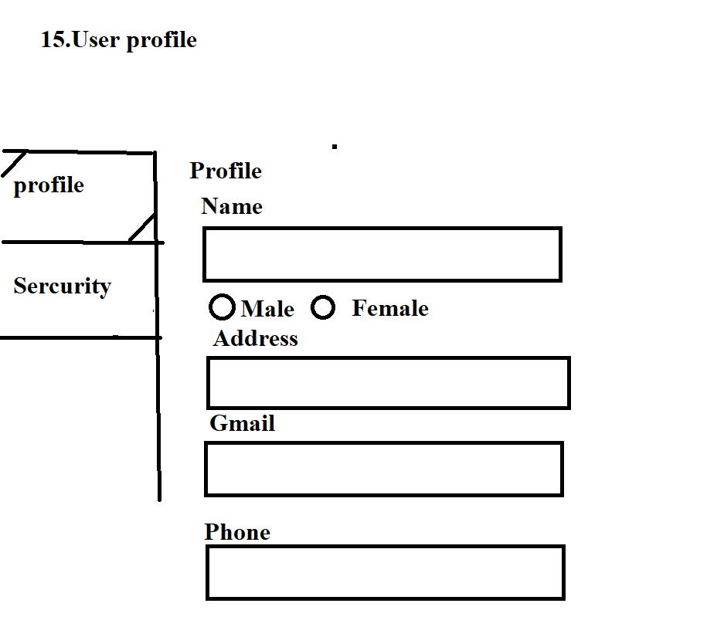

**3.18 My Orders**

* Function trigger: Users log-in the website, access the profile page and click on My Orders button
* Function description:
  + Role: Buyers
  + Purpose: Users can see their shopping history
* Screen layout:

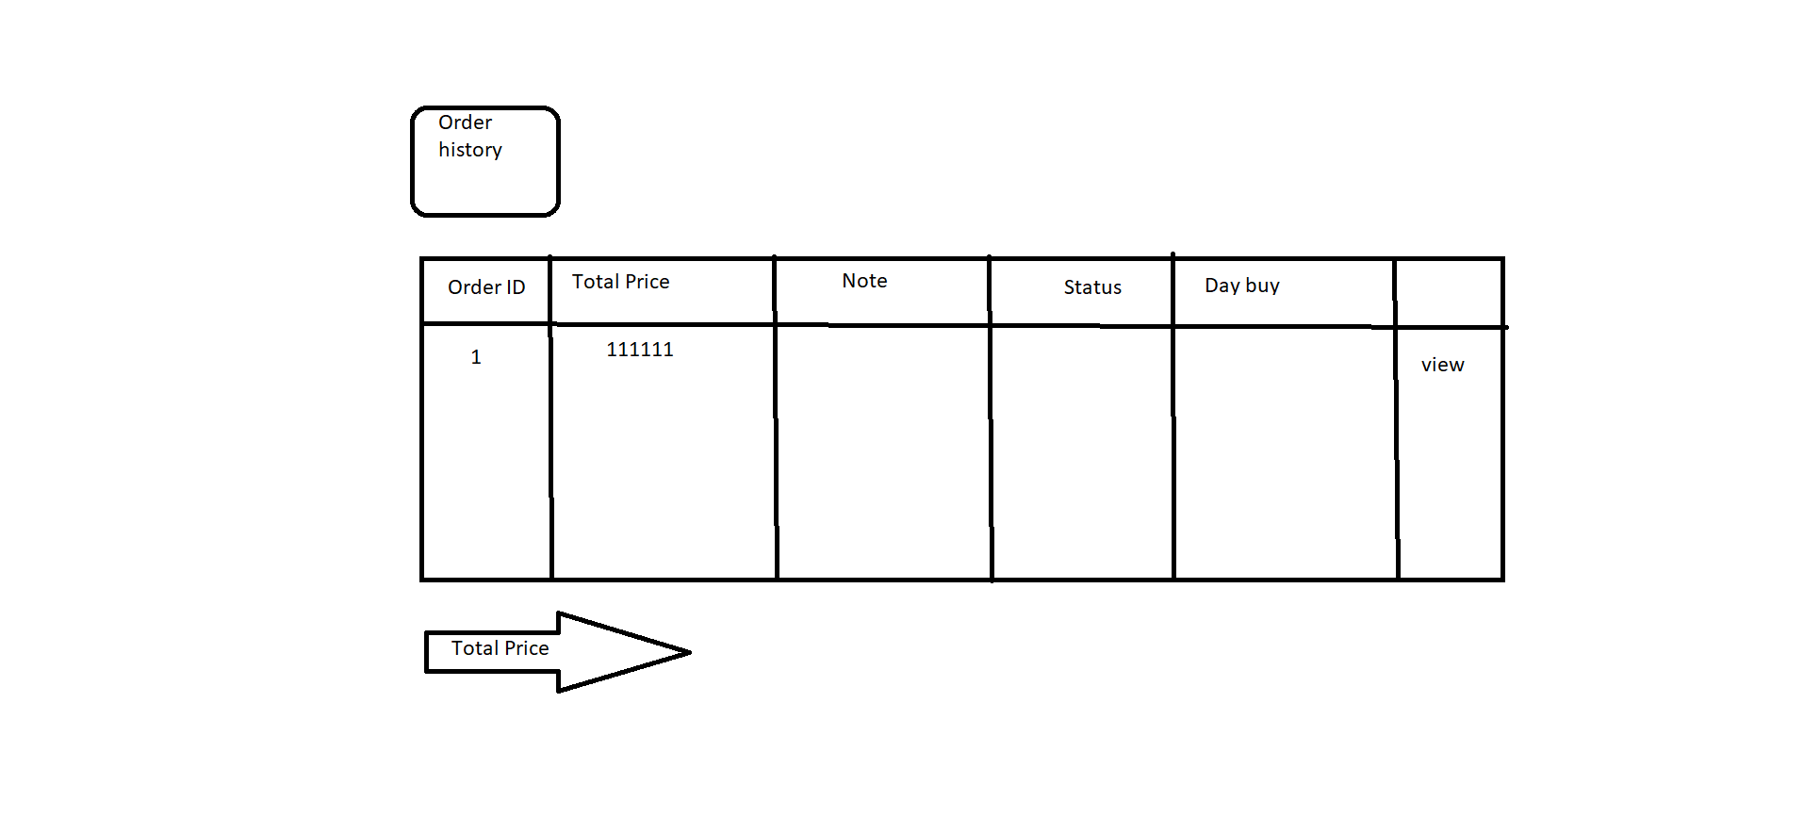

**3.19 Order Information**

* Function trigger: Users log-in to the website, access My Orders page and click View button
* Function description:
  + Role: Buyers
  + Purpose: See the order detailed information
* Screen layout:

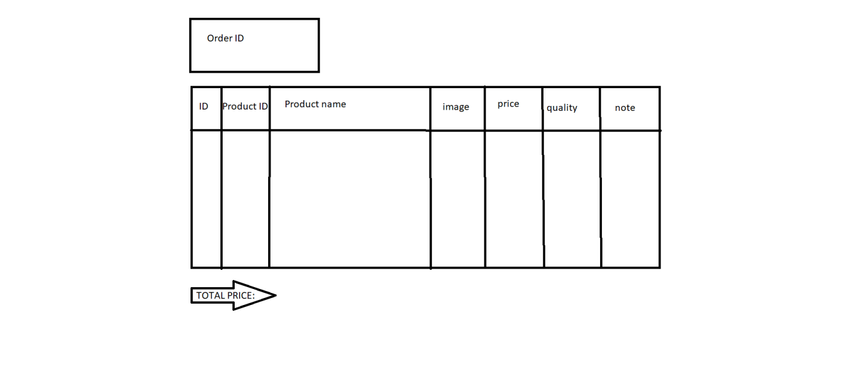

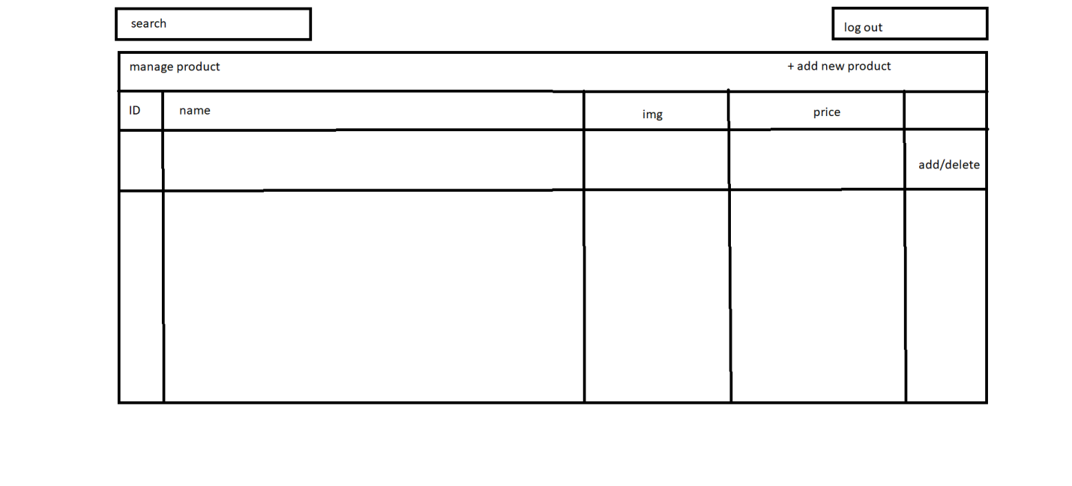

**3.20 Order List**

Function trigger: Admin Login and click Total Invoices

Function description:

• Role: Admin

• Purpose: Admin views list of all of 2orders

Screen layout:

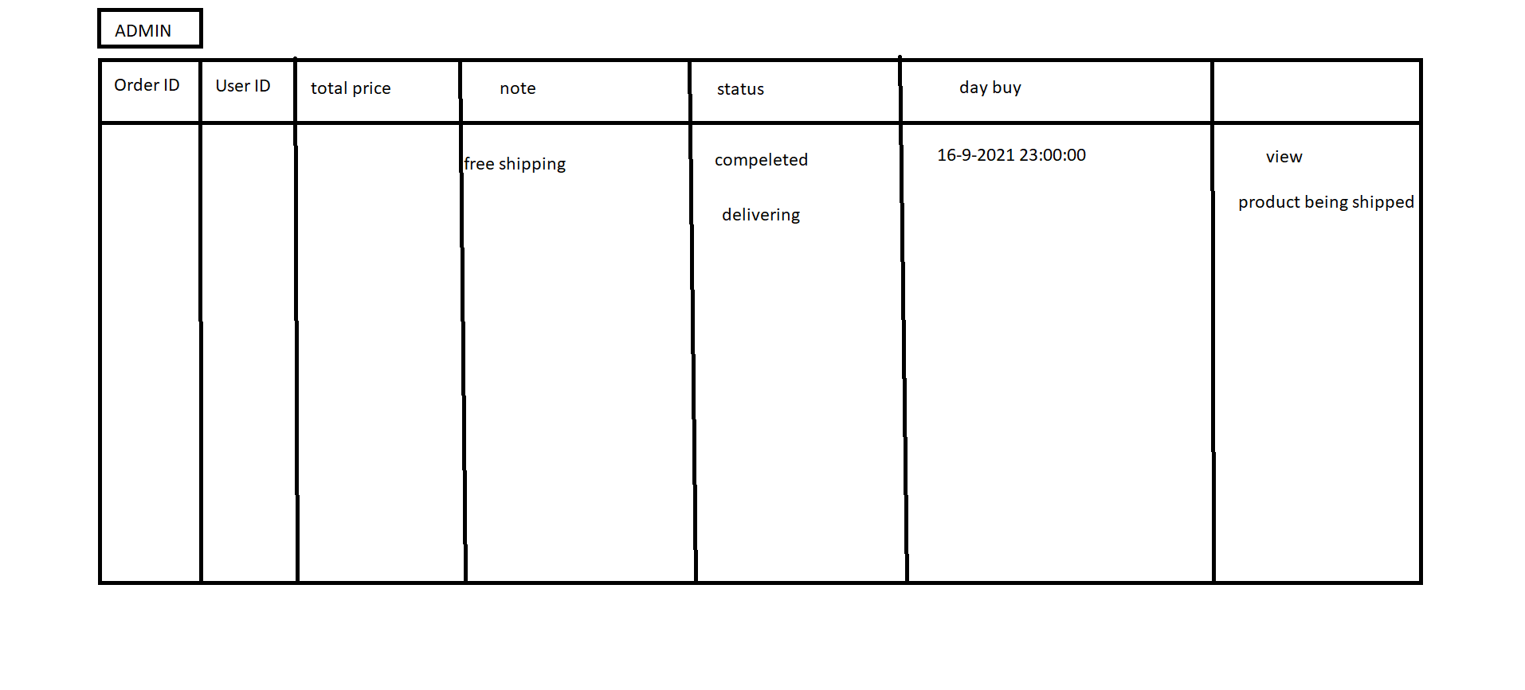

**3.21 Order Details**

Function trigger: Seller Login and click Total Invoices

Function description:

• Role: Seller

• Purpose: Seller views the detail of 1 of his orders

Screen layout:

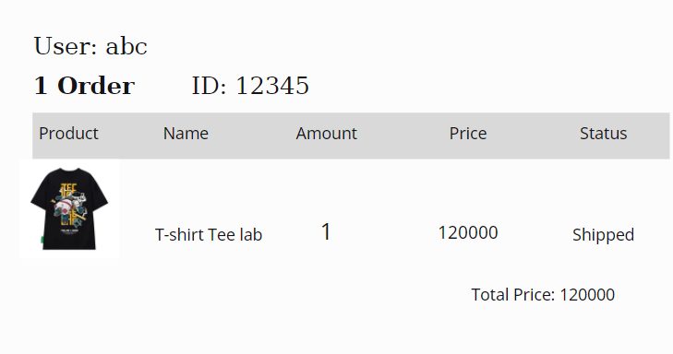

**3.22 View Feedback**

Function trigger: Customers click on the product they want to see, scroll down to see the feedback

Function description:

* Role: Guest, User
* Purpose: Customer views all the Feedbacks about a Product

Screen layout:

**3.23 Send Feedback**

Function trigger: When the user receives the goods, click on My order and then click on Add feedback and evaluate

Function description:

* Role: Guest, User
* Purpose: Customer writes and send a Feedback about a Product

Screen layout:

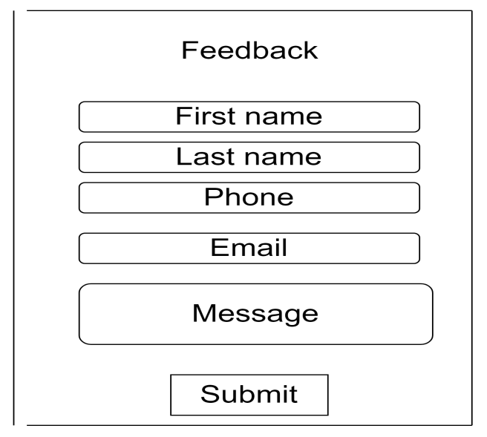

**3.24 Blogs List**

Function trigger: User Click Blog in menu bar

Function description:

* Role: Guest, User
* Purpose: Customer views the list of all Blogs

Screen layout: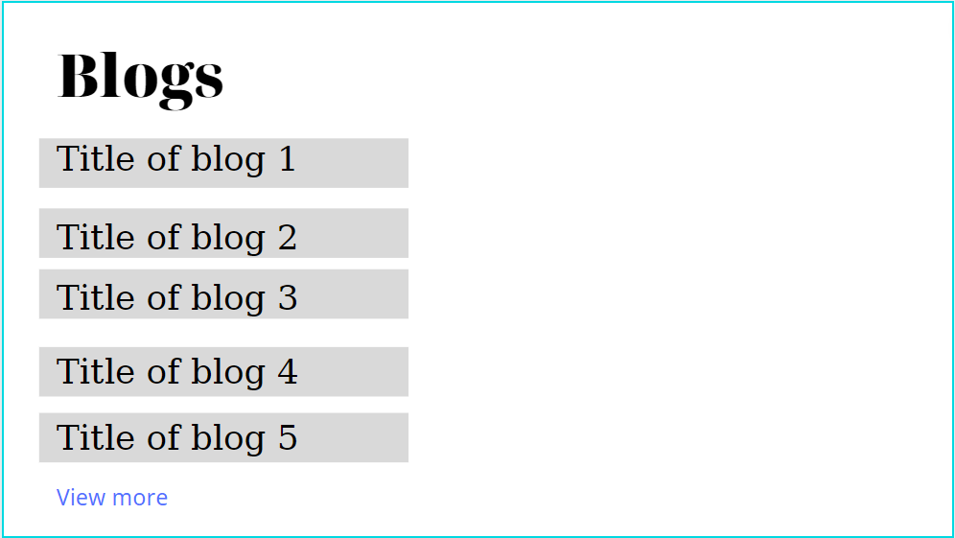

**3.25 Blog Details**

Function trigger: User Click Blog in menu bar. Next, click Blog want to see detail

Function description:

Role: Guest, User

Purpose: Customer views the Detail information of 1 Blog

Screen layout:

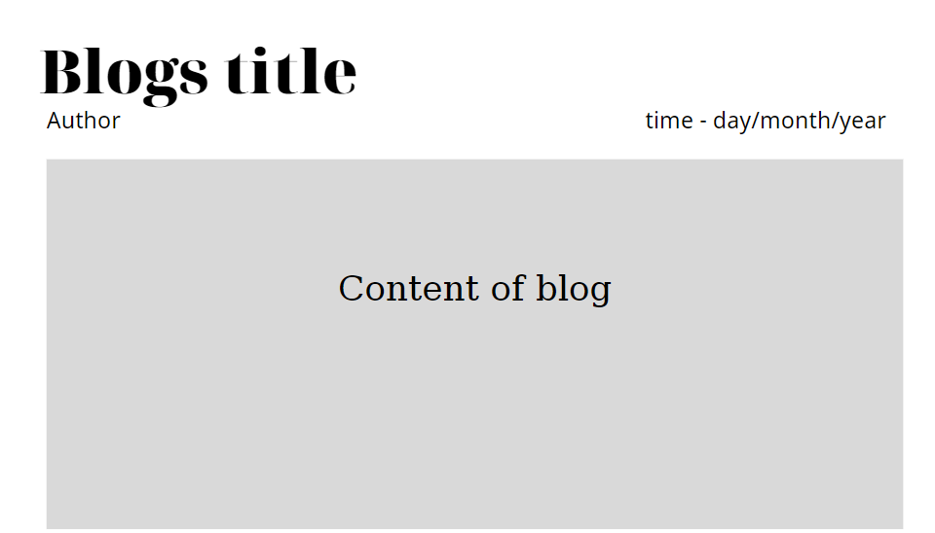

**3.26**

Function trigger: Admin Login and click user list

Function description:

• Role: Admin

• Purpose: Admin views list of all of user

Screen layout:

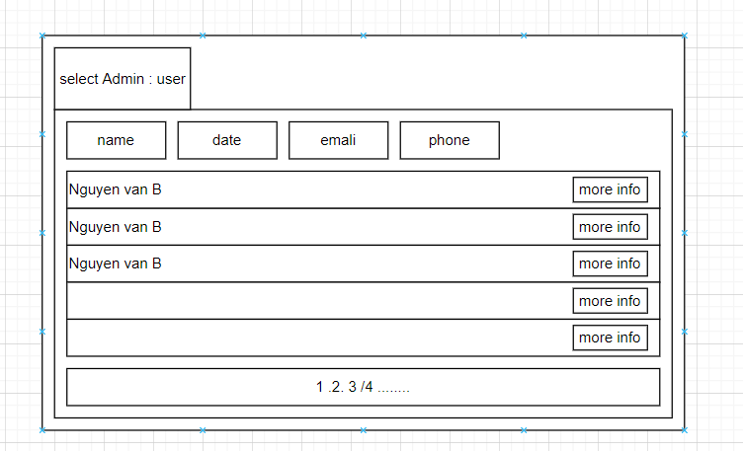

# 4. Data Requirements

## 4.1 Logical Data Model (Updating…)

## 4.2 Data Dictionary (Updating…)

## 4.4 Data Integrity and Retention

## Clothing Shop system will store customer orders so that when customers want to see what they bought last time.

## 5. External Interface Requirements

## 5.1 User Interfaces

## The Clothing Shop Ordering System screen displays shall conform to the User Interface Design and User Experience Design

## 5.2 Software Interfaces

+ Clothing Shop Account Checking system

+ Upload existing user data in the system through a programming interface

+ The system automatically checks what state the account is in in the UserStatus. If you belong to Locked, you will not be able to log in and have to create a new account, and if you belong to Unverified, you must go to gmail to verify your account.

+ Clothing System will transmit the quantities of product items ordered through a programmatic interface.

+ The Clothing system will display the quantity left in stock for the buyer. If there is no stock in stock, the user will not be able to place an order for this product.

## 5.3 Hardware Interfaces

No hardware interfaces have been identified.

## 5.4 Communications Interfaces

Clothing Shop shall send an email to the Customer to report any problems with the product order or delivery.

# Nonfunctional Requirements

## Performance Requirements

+ The system will provide continuous service, which means the shop will work 24/7, with an estimated average session duration of 30 minutes.

## Security

+ The website will use standard Web security protocols when transferring any private information regarding a Guest, Customer, or Seller.

+ Users will be required to log on to the Clothing Shop website for all operations except viewing home page, blog, product list and viewing a specific product.

+ Only the Admin will be permitted to confirm an order, only the Customer will be permitted to confirm an order has been delivered.

+ The system will permit Customer to view only orders that they placed and give a feedback on each products in those orders.

# Other Requirements

+ If the connection between the user and the Clothing Shop is broken prior to a new order being either confirmed or terminated, the Clothing Shop will enable the user to recover an incomplete order and continue working on it.

+ All confirmation code and order information will be send via user’s email.

+ The users email and user name cannot be changed.

# Appendix A: Analysis models

## Context Diagram

*GMAIL*

User email address, mail content

**ONLINE SHOP**

## State Transition Diagram for Order

