

**CLOTHING SHOP PROJECT REPORT**

**Software Design Document**

– Hanoi, Summer 2022 –

**Table of Contents**

I. Overview 7

1. Code Packages/Namespaces 7

2. Coding Conventions 8

II. Code Designs 8

1. Home Page 8

2. Login 9

a. Class Diagram 9

b. Class Specifications 9

c. Sequence Diagram(s) 10

d. Database queries 10

4. Product detail 11

a. Class Diagram 11

b. Class Specifications 12

c. Sequence Diagram(s) 13

d. Database queries 13

5. Register 14

a. Class Diagram 14

b. Class Specifications 14

c. Sequence Diagram(s) 15

d. Database queries 16

6. Add to cart 17

a. Class Diagram 17

b. Class Specifications 17

c. Sequence Diagram(s) 18

d. Database queries 18

7. Blog List 19

a. Class Diagram 19

b. Class Specifications 19

c. Sequence Diagram(s) 20

d. Database queries 20

8. Blog Detail 21

a. Class Diagram 21

b. Class Specifications 21

c. Sequence Diagram(s) 22

d. Database queries 22

9. Logout 23

a. Class Diagram 23

b.Class Specifications 23

c. Sequence Diagram(s) 23

d. Database queries 24

10. Add Product 25

a. Class Diagram 25

b. Class Specifications 25

c. Sequence Diagram(s) 26

11. Change amount 27

a. Class Diagram 27

b. Class Specifications 27

c. Sequence Diagram(s) 27

12. Delete cart 28

a. Class Diagram 28

b. Class Specifications 28

c. Sequence Diagram(s) 29

d. Database queries 30

13. View List User 30

a. Class Diagram 30

b. Class Specifications 30

c. Sequence Diagram(s) 31

d. Database queries 31

14. Edit Information User 32

a. Class Diagram 32

b. Class Specifications 32

c. Sequence Diagram(s) 32

d. Database queries 33

15.Set Role User 33

a. Class Diagram 33

b. Class Specifications 33

c. Sequence Diagram(s) 33

d. Database queries 34

16. Block User 35

a. Class Diagram 35

b. Class Specifications 35

c. Sequence Diagram(s) 36

d. Database queries 36

17. Reset Password 37

a. Class Diagram 37

b. Class Specifications 37

c. Sequence Diagram(s) 38

d. Database queries 39

18. Change Password 39

a. Class Diagram 39

b. Class Specifications 39

c. Sequence Diagram(s) 40

d. Database queries 41

19. User profile 41

a. Class Diagram 41

b. Class Specifications 41

c. Sequence Diagram(s) 42

d. Database queries 43

20. Order History 43

a. Class Diagram 43

b. Class Specifications 43

c. Sequence Diagram(s) 44

d. Database queries 45

21. Delete Product 46

a. Class Diagram 46

b. Class Specifications 46

c. Sequence Diagram(s) 47

d. Database queries 47

22. Edit Product 48

a. Class Diagram 48

b. Class Specifications 48

c. Sequence Diagram(s) 49

d. Database queries 49

23. Checkout 49

a. Class Diagram 49

b. Class Specifications 49

c. Sequence Diagram(s) 50

d. Database queries 50

24.Manager Product 51

a. Class diagram 51

b. Class specifications 51

c. Sequence Diagram(s) 52

d. Database queries 52

25.HomePage 52

a. Class Diagram 52

b. Class Specifications 52

c. Sequence Diagram 53

d. Database queries 54

26. List Customer 54

a. Class Diagram 54

b. Class Specification 55

c. Sequence Diagram(s) 55

d. Database queries 55

26. Product list 55

a.Class diagram 55

b.Class specifications 55

c. Sequence Diagram(s) 56

d. Database queries 56

III. Database Design 57

1. Database Schema 57

2. Table Description 58

# I. Overview

## 1. Code Packages/Namespaces

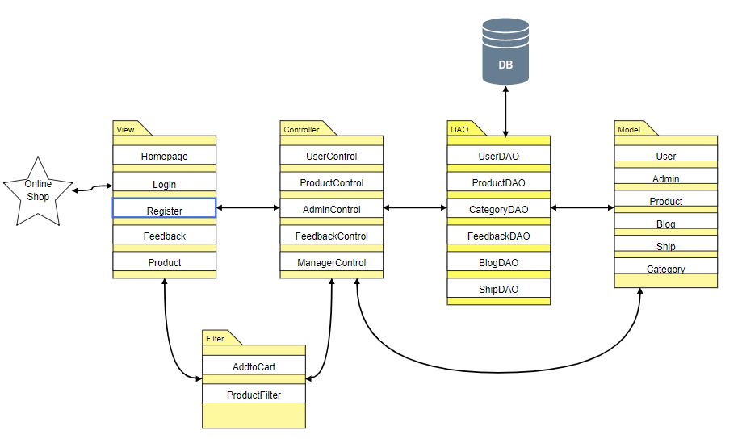

***Package descriptions & package class naming conventions***

|  |  |  |
| --- | --- | --- |
| **No** | **Package** | **Description** |
| *01* | *Controllers* | This package contains all controllers for this MVC2 project and authentication or dispatcher filters  Servlet Naming convention: Starting with a verb.  Ex: LoginController, SignUpController,... |
| *02* | *Views* | This package contains all views (HTML,CSS,JS,JSP file) for this project  HTML/CSS/JS/JSP file naming convention: first letter is a lowercase letter, using camelCase naming |
| *03* | *Model* | This package provide the connection to the Database, Extract data for the system  Naming convention: first letter is a lowercase letter, the name is using camelCase naming  This package .java files which allow developers to skip writing DAOs for their persistence objects when they usingJDBC. |
| *04* | *Utils* | This package contains DBcontext.java file which is a bridge connection between database and programming and contains sendEmail.java allows users to send email  Naming convention: first letter is a lowercase letter, the name is using camelCase naming |
| *05* | *Filter* | This package handles the Authentication that helps avoid duplicate in controller  Naming convention: first letter is a lowercase letter, the name is using camelCase naming |

## 2. Coding Conventions

# II. Code Designs

## 1. Feature Product

### a. Class Diagram

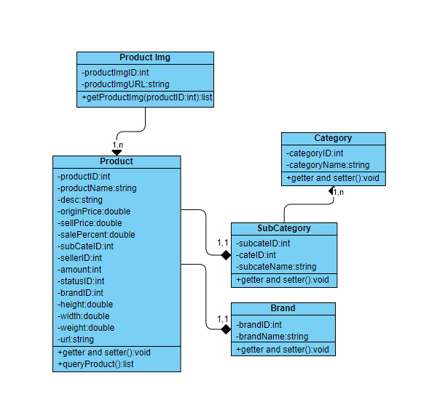

### b. Class Specifications

|  |  |  |
| --- | --- | --- |
| **No** | **Method** | **Description** |
| *01* | *getAllProduct()* | *Query will get all product from database* |

### c. Sequence Diagram(s)

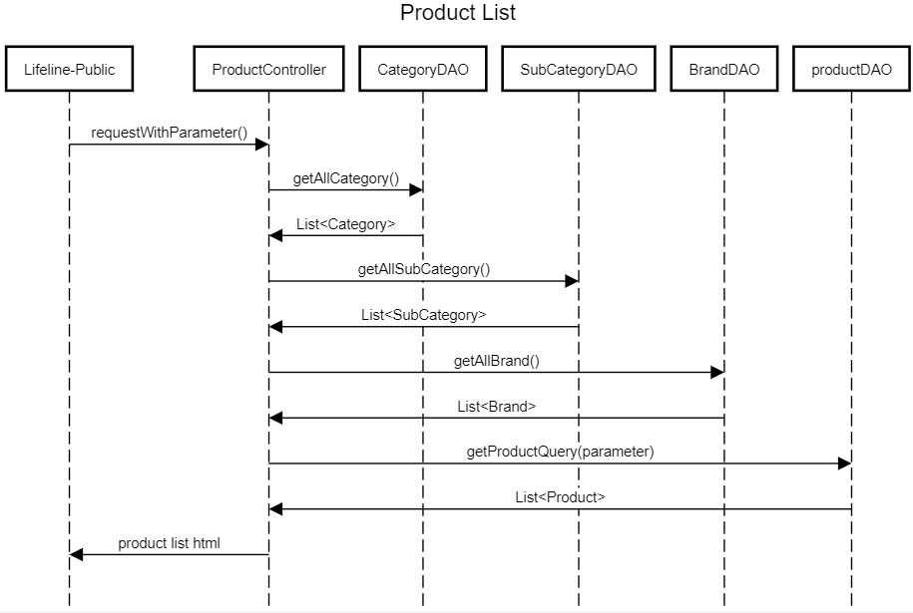

### d. Database queries

select p.ProductID , ProductName , Description , OriginalPrice , SellPrice , SalePercent ,SubCategoryID , SellerID , Amount , StatusID , StatusID ,BrandID , height , width ,weight , s.ProductImgURL from Product p join ProductImg s on p.ProductID = s.ProductID

## 2. Login

### Class Diagram

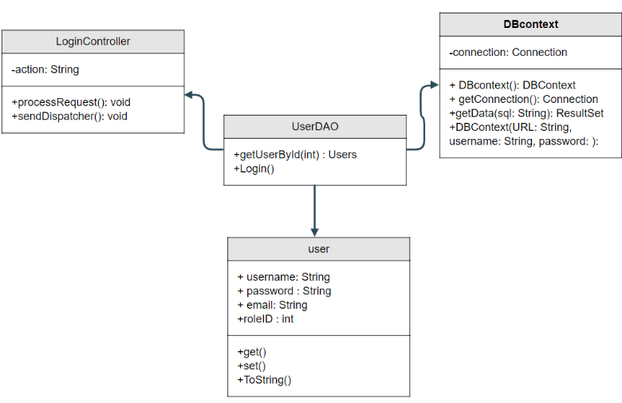

### Class Specifications

UserController

|  |  |  |
| --- | --- | --- |
| No | Method | Description |
| 01 | processRequest() | get all new information from user Form and update the database |

UserDAO

[Provide the detailed description for the class methods]

|  |  |  |
| --- | --- | --- |
| No | Method | Description |
| 01 | getUserList() | get the list of user |
| 02 | getUserById(int uId) | get the user where the user id is |

### Sequence Diagram(s)

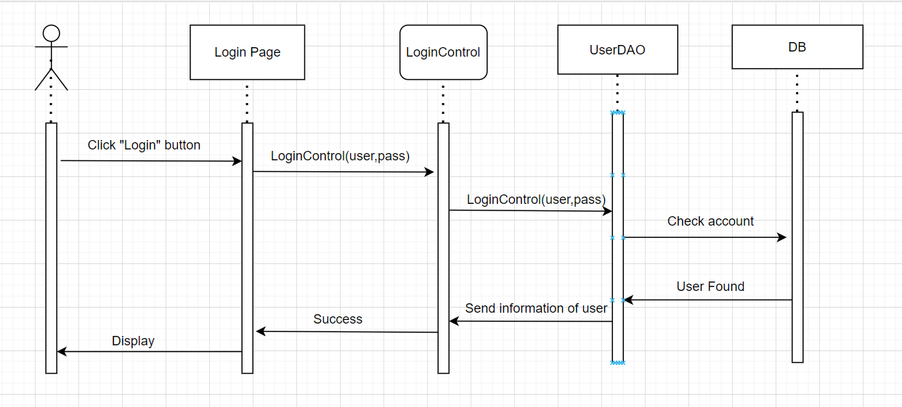

### Database queries

**"select * from [User] where username=? and password=?"**

**3.Cart Detail**

1. **Class Diagram**

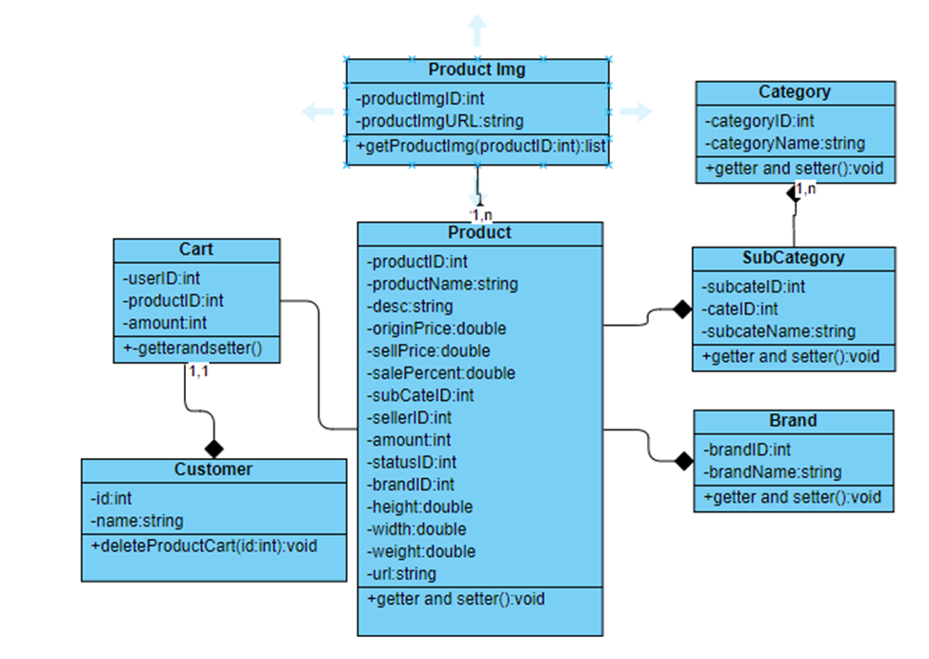

### 

## 4. Product detail

### Class Diagram

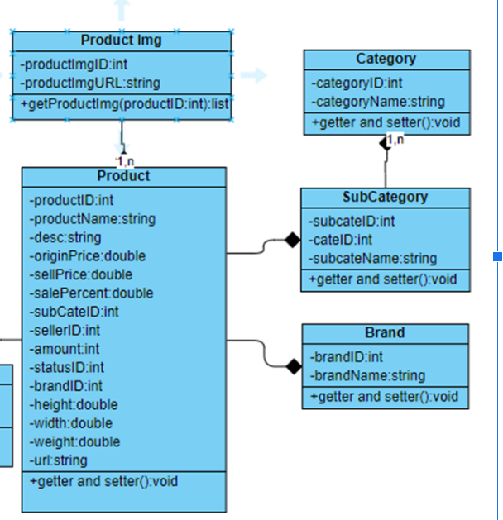

### Class Specifications

|  |  |  |
| --- | --- | --- |
| No | Method | Description |
| 01 | processRequest() |  |

ProductDAO

|  |  |  |
| --- | --- | --- |
| No | Method | Description |
| 01 | getProductByID(int id) | get Product by ID |

### 

### c. Sequence Diagram(s)

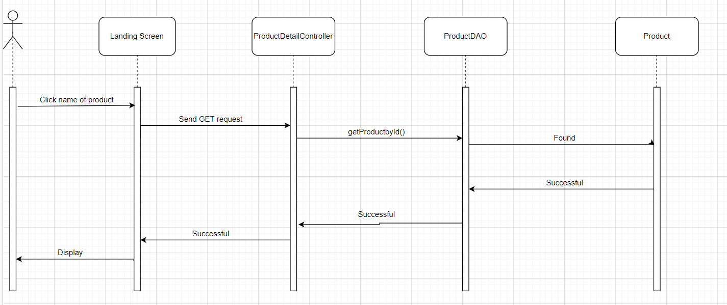

### d. Database queries

"select p.*,s.SubCategoryName,c.*,b.BrandName from Product p join SubCategory s \n"

+ "on p.SubCategoryID = s.SubCategoryID\n"

+ "join Brand b on b.BrandID = p.BrandID\n"

+ "join Category c on c.CategoryID = s.CategoryID"

## 5. Register

### **a. Class Diagram**

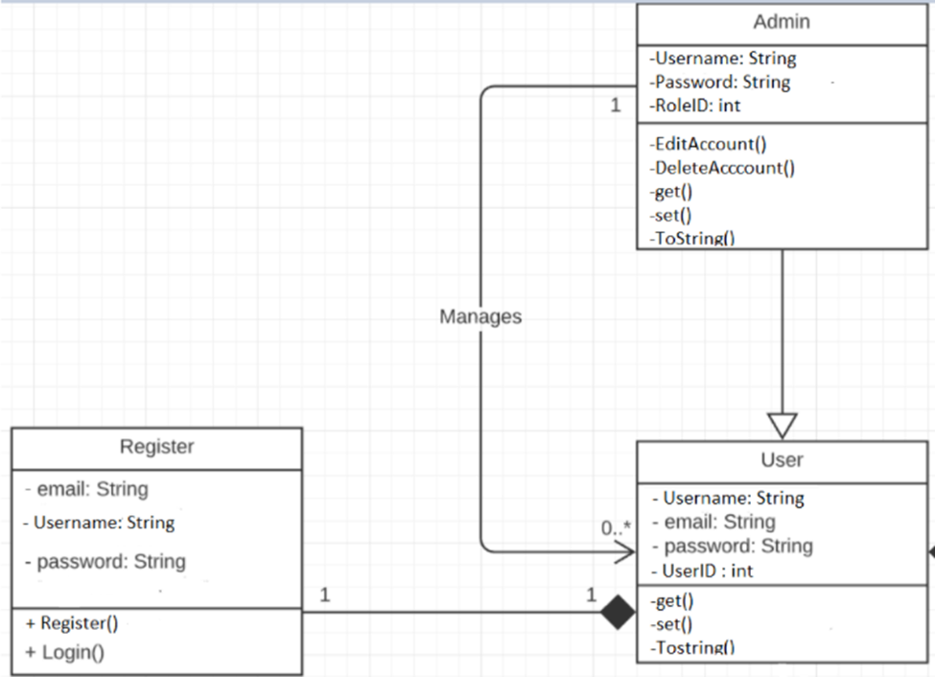

### b. Class Specifications

UserController

|  |  |  |
| --- | --- | --- |
| No | Method | Description |
| 01 | processRequest() |  |

UserDAO

[Provide the detailed description for the class methods]

|  |  |  |
| --- | --- | --- |
| No | Method | Description |
| 01 | Register( String username,String password, String mai) | insert a new user with Name , Pass, Mail) |
| 02 | checkExistAccount(String xName) | - check if the username is already exist  - return null |

### 

### c. Sequence Diagram(s)

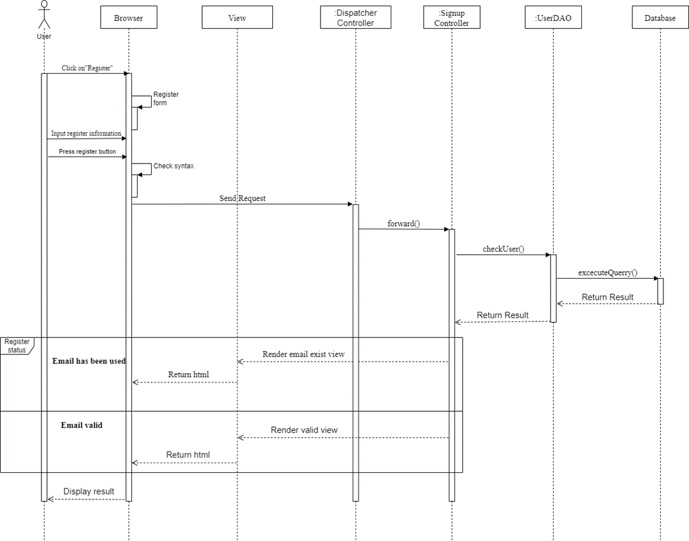

### d. Database queries

**"**INSERT INTO [dbo].[Users]

([Username

,[Password]

,[email]

,[RoleID]

,[isBlock])

VALUES (?,?,?,?,?)"**"**

## 6. Add to cart

### Class Diagram



### Class Specifications

CartDetailController

|  |  |  |
| --- | --- | --- |
| No | Method | Description |
| 01 | processRequest() |  |

CartDAO

[Provide the detailed description for the class methods]

|  |  |  |
| --- | --- | --- |
| No | Method | Description |
| *01* | *deleteProductCart()* | *Remove a product() from cart* |

### 

### c. Sequence Diagram(s)

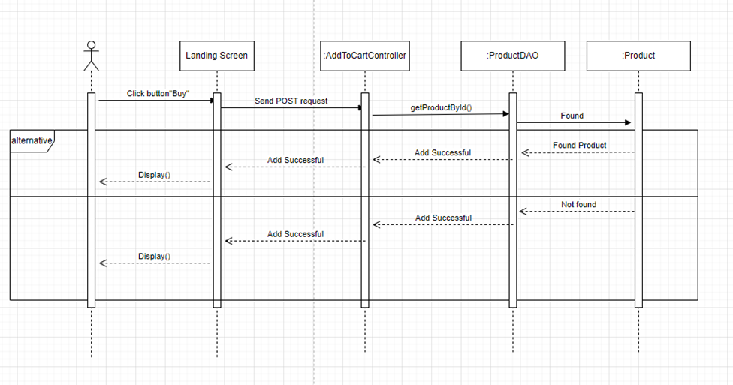

### d. Database queries

## Blog List

### Class Diagram

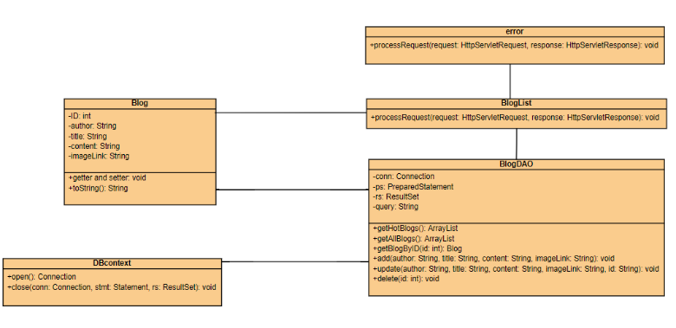

### Class Specifications

- BlogList class

|  |  |  |
| --- | --- | --- |
| **No** | **Method** | **Description** |
| 01 | processRequest() | get blog list from the database to display on BlogList.jsp |

- BlogDAO class

|  |  |  |
| --- | --- | --- |
| **No** | **Method** | **Description** |
| 01 | getBlogByID(int id) | Return: Blog Detail where blog id contain parameter  Input: ID of blog |
| 02 | getHotBlogs() | Return: top 3 newest blog from database |
| 03 | getAllBlog() | Return: All blog in database |
| 04 | add(String author, String title, String content, String imageLink) | Add blog with detail entered in addBlog.jsp page  Return: null  Input: author, title, content, imageLink |
| 05 | update(String author, String title, String content, String imageLink, String id) | Update blog with detail entered in updateBlog.jsp page  Return: null  Input: author, title, content, imageLink, id |
| 06 | delete(int id) | Update blog with id entered in blogManage.jsp  Return: null  Input: id |

### 

### c. Sequence Diagram(s)

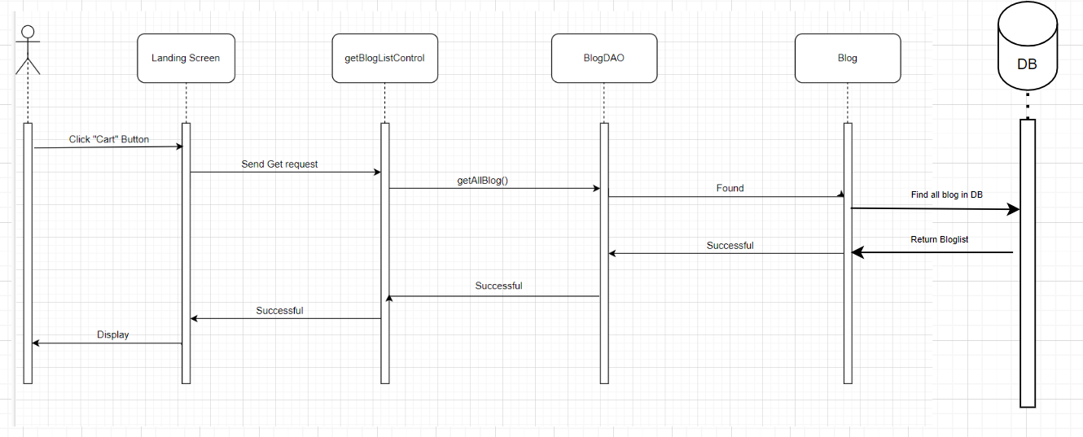

### 

### d. Database queries

**Select * from Blog desc**

## 8. Blog Detail

### Class Diagram

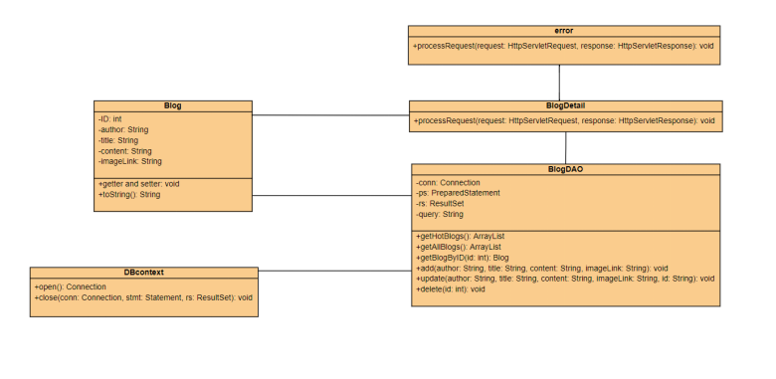

### Class Specifications

- BlogDetail class

|  |  |  |
| --- | --- | --- |
| **No** | **Method** | **Description** |
| 01 | processRequest() | get blog detail from the database to display on BlogDetail.jsp |

- BlogDAO class

|  |  |  |
| --- | --- | --- |
| **No** | **Method** | **Description** |
| 01 | getBlogByID(int id) | Return: Blog Detail where blog id contain parameter  Input: ID of blog |
| 02 | getHotBlogs() | Return: top 3 newest blog from database |
| 03 | getAllBlog() | Return: All blog in database |
| 04 | add(String author, String title, String content, String imageLink) | Add blog with detail entered in addBlog.jsp page  Return: null  Input: author, title, content, imageLink |
| 05 | update(String author, String title, String content, String imageLink, String id) | Update blog with detail entered in updateBlog.jsp page  Return: null  Input: author, title, content, imageLink, id |
| 06 | delete(int id) | Update blog with id entered in blogManage.jsp  Return: null  Input: id |

### 

### c. Sequence Diagram(s)

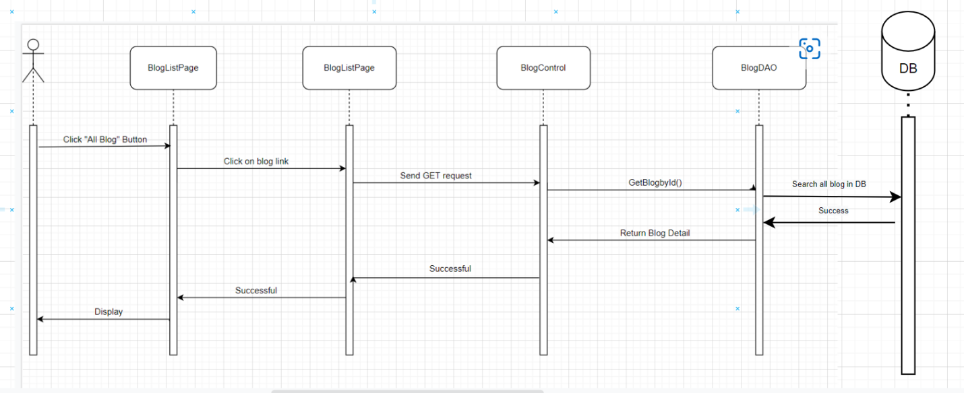

### 

### d. Database queries

SELECT * FROM Blog WHERE ID = ?

## 9. Logout

### a. Class Diagram

### b.Class Specifications

LogoutController

|  |  |  |
| --- | --- | --- |
| No | Method | Description |
| 01 | processRequest() | Remove attribute from session |

### 

### c. Sequence Diagram(s)

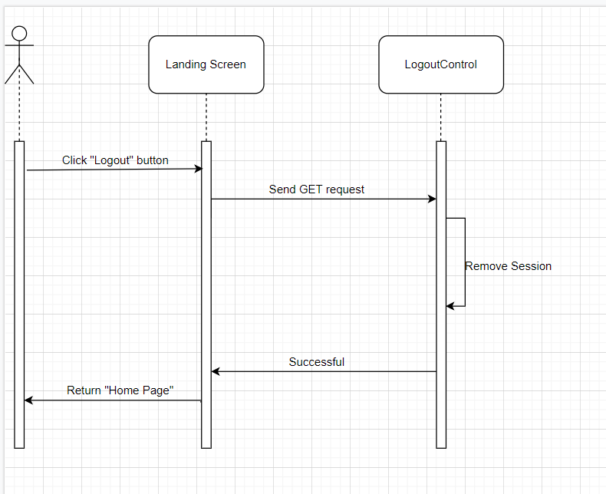

### 

### d. Database queries

## 10. Add Product

### a. Class Diagram

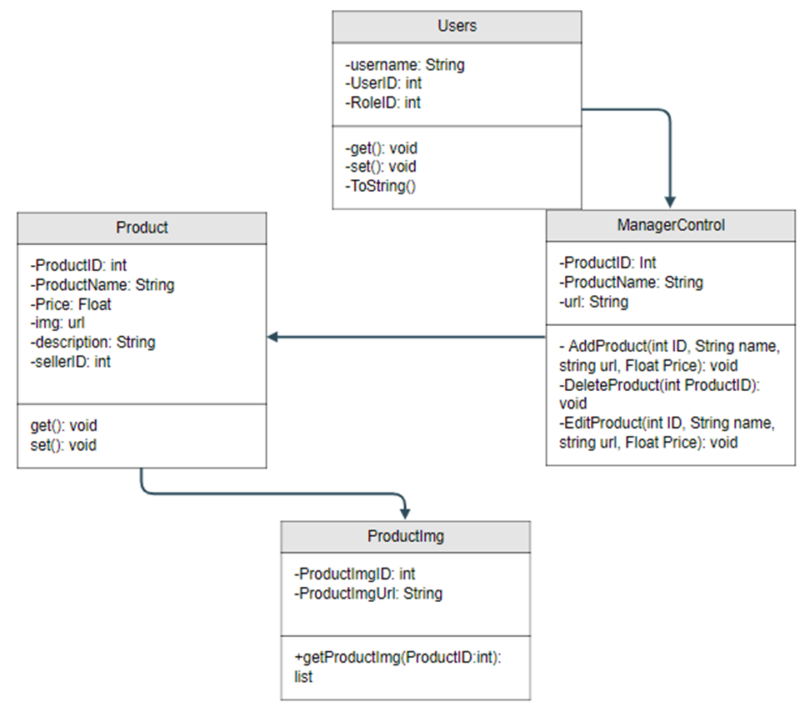

### b. Class Specifications

|  |  |  |
| --- | --- | --- |
| No | Method | Description |
| 01 | addProduct() | AddProduct from the database to display on ManageProduct.jsp |

### 

### c. Sequence Diagram(s)

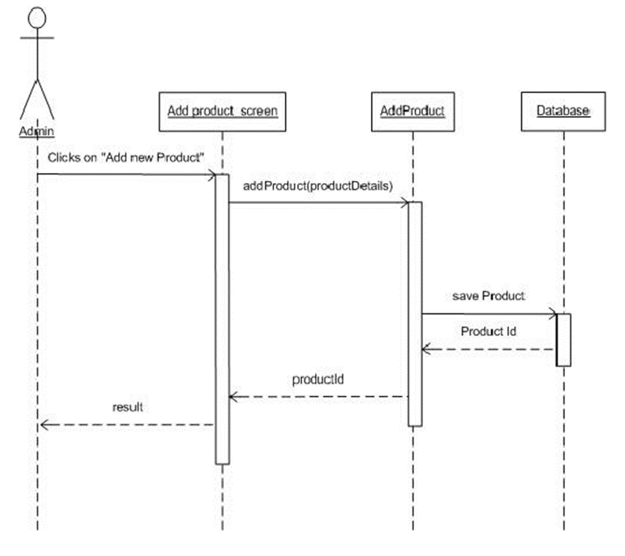 d. Database queries

## 11. Change amount

### a. Class Diagram

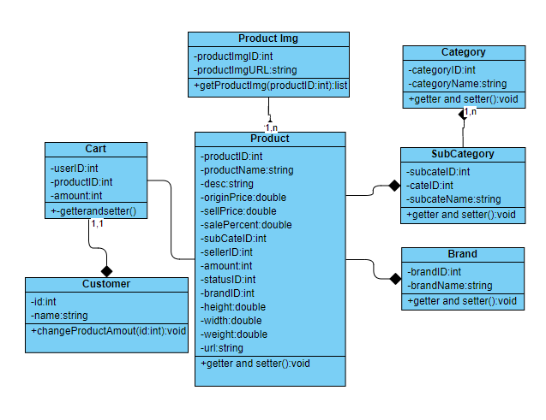

### b. Class Specifications

Customer

|  |  |  |
| --- | --- | --- |
| **No** | **Method** | **Description** |
| *01* | *changeProductAmount()* | *Add or reduce amount of a product from cart* |

### c. Sequence Diagram(s)

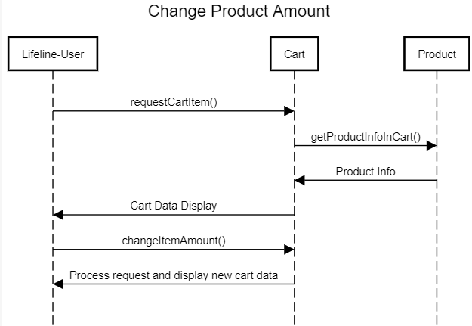

### d. Database queries

UPDATE dbo.cart

SET amount = ?

WHERE userID = ? and productID = ?

## 12. Delete cart

### a. Class Diagram

### b. Class Specifications

UserController

|  |  |  |
| --- | --- | --- |
| No | Method | Description |
| 01 | processRequest() | Delete Cart by ProductID through HashMap |

### 

### c. Sequence Diagram(s)

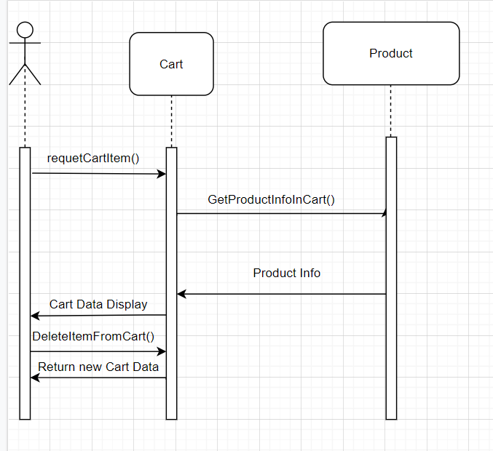

### **d. Database queries**

## 13. View List User

### a. Class Diagram

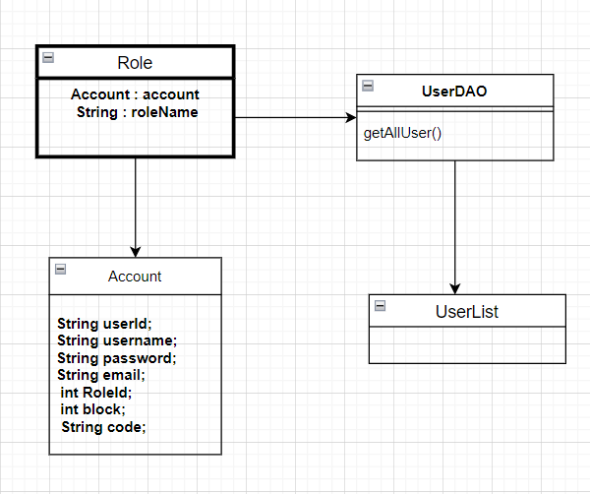

### b. Class Specifications

UserDAO

|  |  |  |
| --- | --- | --- |
| No | Method | Description |
| 01 | GetAllUser() | Get All User from Database |

### 

### c. Sequence Diagram(s)

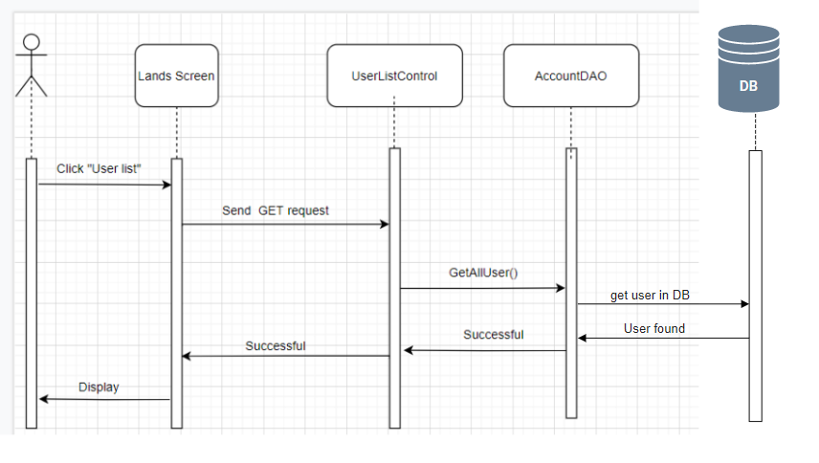

### 

### d. Database queries

select u.*,r.RoleName from Users u inner join role r on u.RoleID = r.RoleID

## 14. Edit Information User

### a. Class Diagram

### b. Class Specifications

UserDAO

|  |  |  |
| --- | --- | --- |
| No | Method | Description |
| 01 | Create User | Insert new user to database |
| 02 | Validate user | Check user if exists |

### 

### c. Sequence Diagram(s)

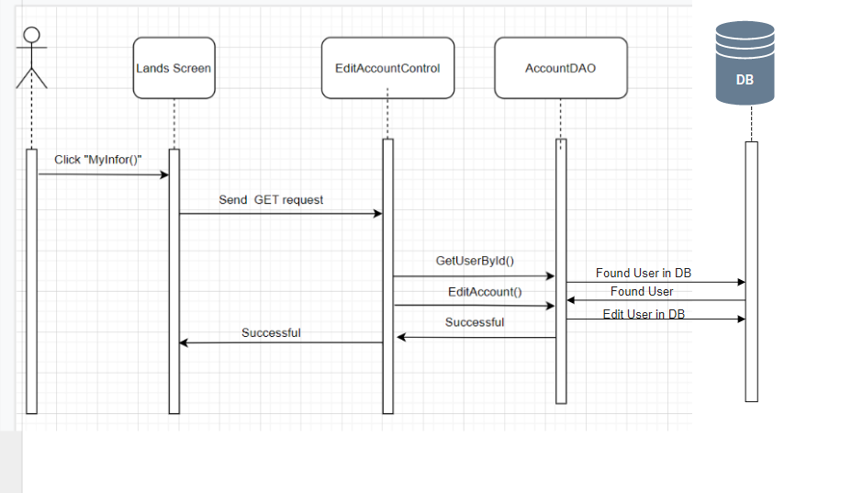

### d. Database queries

Select * from Users

## 15.Set Role User

### a. Class Diagram

### b. Class Specifications

UserController

|  |  |  |
| --- | --- | --- |
| No | Method | Description |
| 01 | processRequest() |  |

BlogDAO

[Provide the detailed description for the class methods]

|  |  |  |
| --- | --- | --- |
| No | Method | Description |
| 01 | Create User | Insert new user to database |
| 02 | Validate user | Check user if exists |

### 

### c. Sequence Diagram(s)

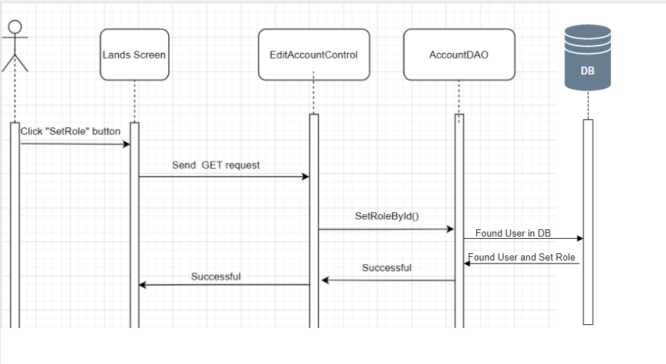

### 

### d. Database queries

Select * from Users

## 16. Block User

### a. Class Diagram

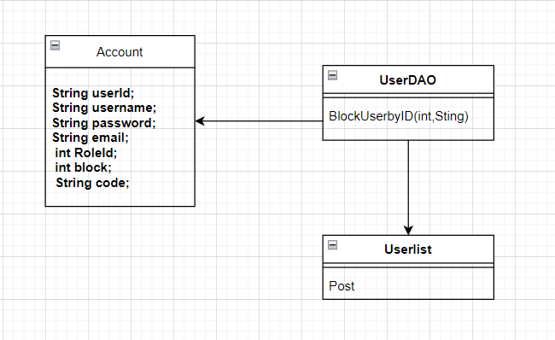

### b. Class Specifications

Userlist

|  |  |  |
| --- | --- | --- |
| No | Method | Description |
| 01 | Post() | get UserID and change isBlock on Users |

UserDAO

[Provide the detailed description for the class methods]

|  |  |  |
| --- | --- | --- |
| No | Method | Description |
| 01 | BlockUserbyID | Change isBlock user on database |

### 

### c. Sequence Diagram(s)

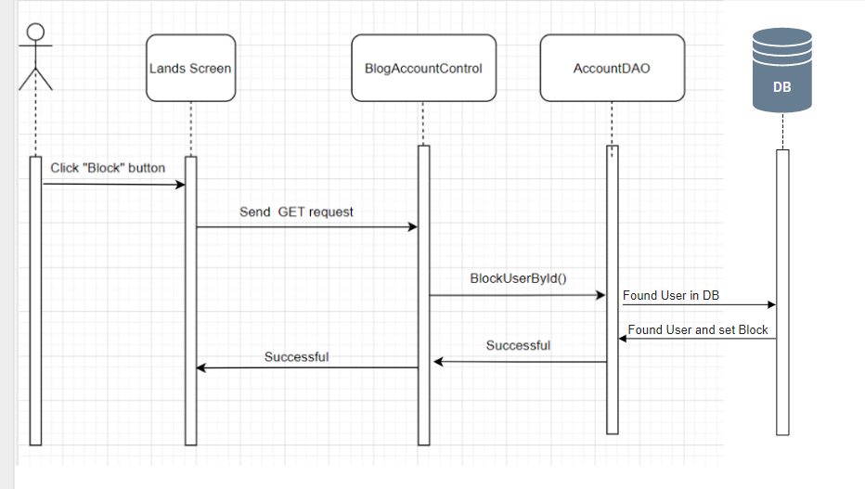

### 

### d. Database queries

Update users

set isBlock = ?

where UserID = ?

## 17. Reset Password

### Class Diagram

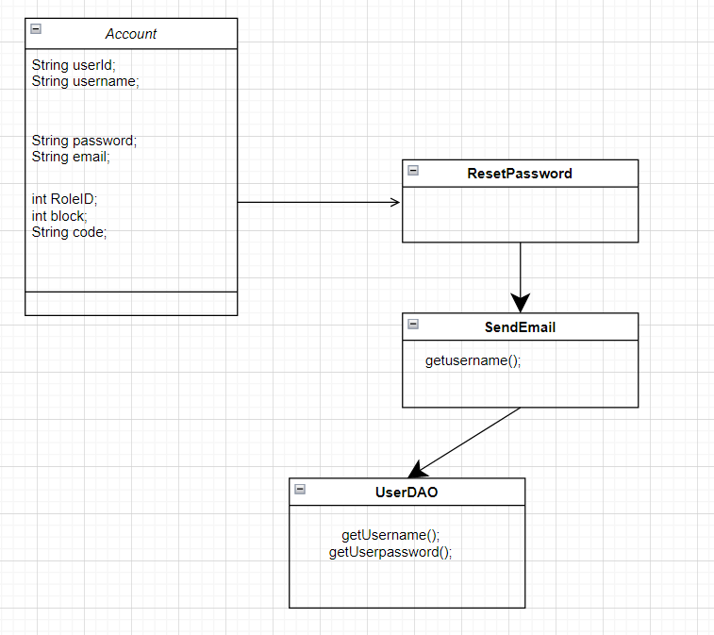

### Class Specifications

### 

UserController

|  |  |  |
| --- | --- | --- |
| No | Method | Description |
| 01 | processRequest() |  |

BlogDAO

[Provide the detailed description for the class methods]

|  |  |  |
| --- | --- | --- |
| No | Method | Description |
| 01 | Create User | Insert new user to database |
| 02 | Validate user | Check user if exists |

### 

### c. Sequence Diagram(s)

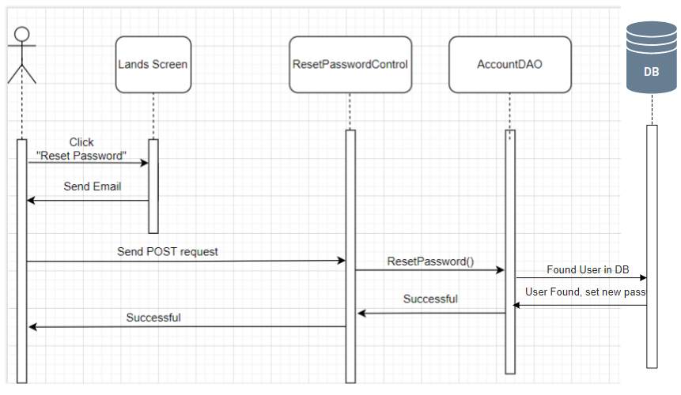

### 

### d. Database queries

Select * from Users

## 18. Change Password

### a. Class Diagram

### b. Class Specifications

UserDAO

|  |  |  |
| --- | --- | --- |
| No | Method | Description |
| 01 | processRequest() |  |

|  |  |  |
| --- | --- | --- |
| No | Method | Description |
| 01 | Create User | Insert new user to database |
| 02 | Validate user | Check user if exists |

### 

### c. Sequence Diagram(s)

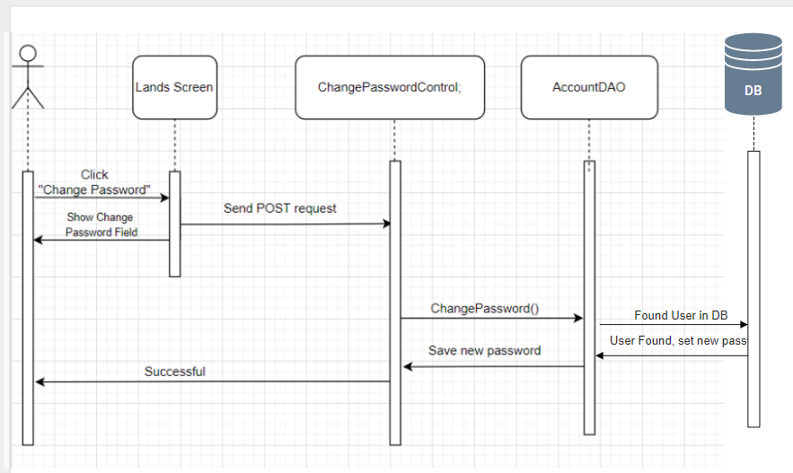

### 

### d. Database queries

## 19. User profile

### a. Class Diagram

### b. Class Specifications

UserController

|  |  |  |
| --- | --- | --- |
| No | Method | Description |
| 01 | processRequest() |  |

|  |  |  |
| --- | --- | --- |
| No | Method | Description |
| 01 | Create User | Insert new user to database |
| 02 | Validate user | Check user if exists |

### 

### c. Sequence Diagram(s)

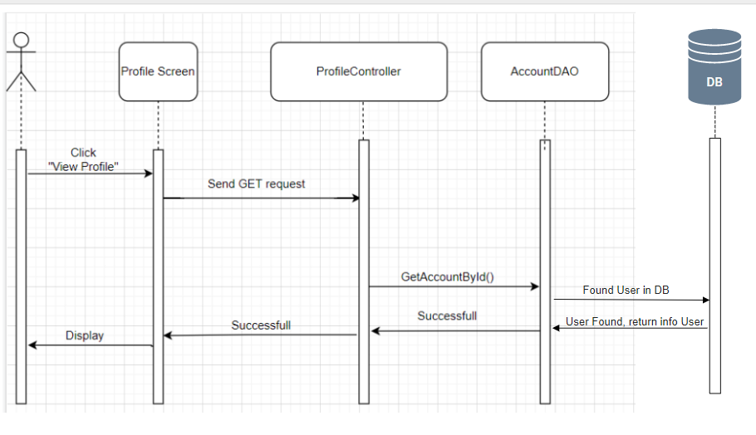

### 

### d. Database queries

Select * from Users

## 20. Order History

### a. Class Diagram

### b. Class Specifications

UserController

|  |  |  |
| --- | --- | --- |
| No | Method | Description |
| 01 | processRequest() |  |

OrderDAO

|  |  |  |
| --- | --- | --- |
| No | Method | Description |
| 01 | viewOrderWait(String userId) | See the product that userId ordered is in the waiting state |
| 02 |  | Check user if exists |
|  |  |  |

### 

### c. Sequence Diagram(s)

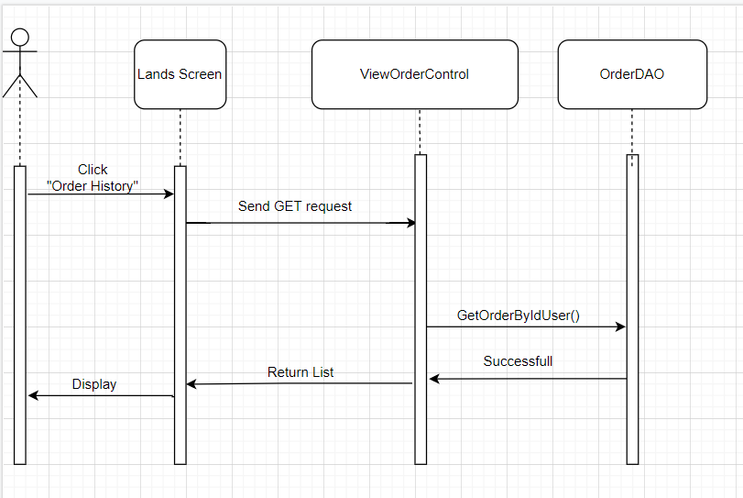

### 

### d. Database queries

Select * from Users

,

## 21. Delete Product

### a. Class Diagram



### b. Class Specifications

ProductDAO

|  |  |  |
| --- | --- | --- |
| No | Method | Description |
| 01 | deleteProduct() | *DeleteProduct from the database to display on ManageProduct.jsp* |

### 

### c. Sequence Diagram(s)

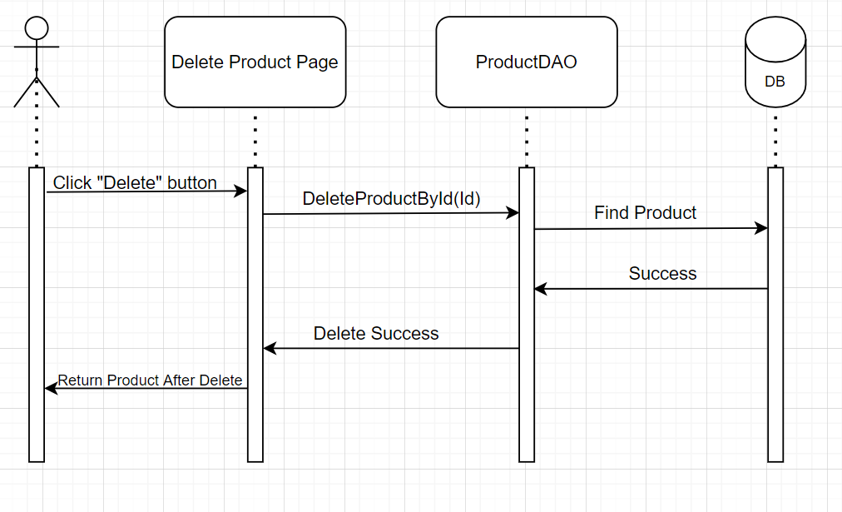

### d. Database queries

delete from Product where ProductID = ?

## 22. Edit Product

### a. Class Diagram



### b. Class Specifications

ProductDAO

|  |  |  |
| --- | --- | --- |
| No | Method | Description |
| 01 | editProduct() | *Update from the database to display on ManageProduct.jsp* |

### 

### c. Sequence Diagram(s)

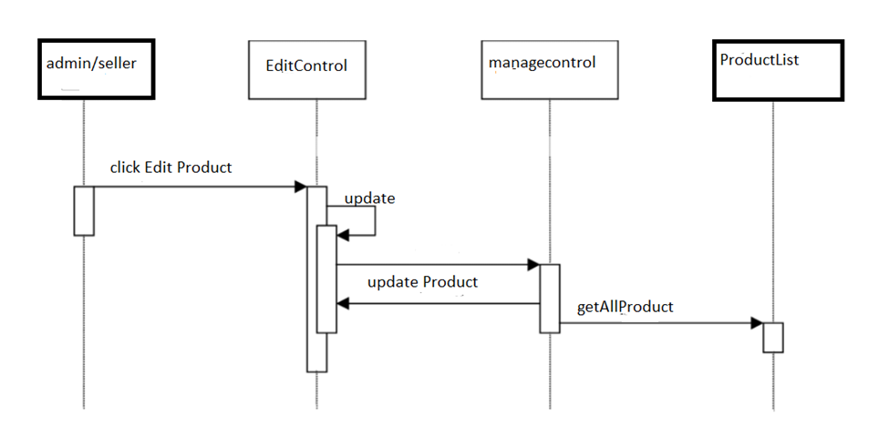

### 

### d. Database queries

UPDATE datatable

SET ... = ?

WHERE …... = ?

## 23. Checkout

### a. Class Diagram

### b. Class Specifications

|  |  |  |
| --- | --- | --- |
| No | Method | Description |
| 01 | getProductById() | *Get Product which confirm to buy* |
| 02 | saveOrder() | *Insert information in Order table* |
| 03 | SaveOderDetail() | *Insert information in OrderDetail table* |
| 04 | SaveShipping() | *Insert information in Shipping table* |

### 

### c. Sequence Diagram(s)

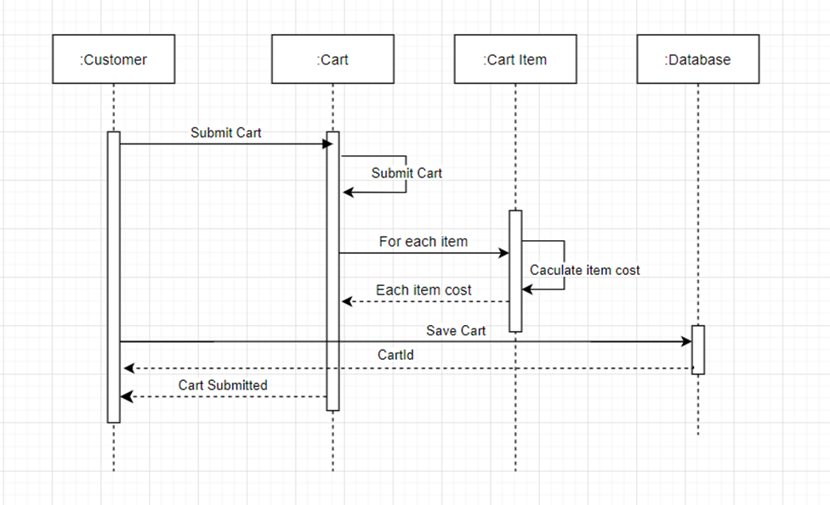

### d. Database queries

INSERT INTO [dbo].[Orders]

([UserID]

,[TotalPrice]

,[Note]

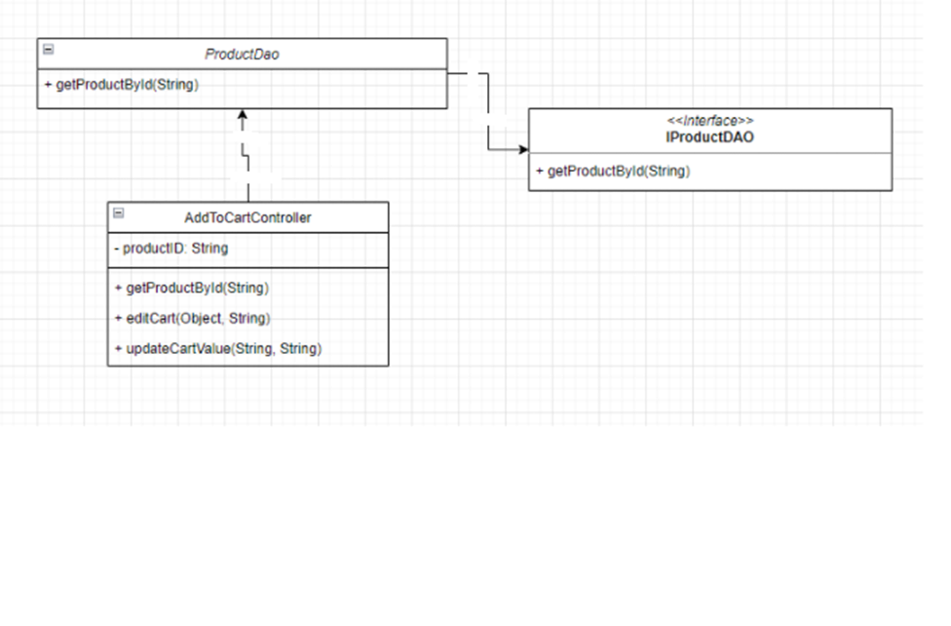 ,[Status]

,[Date]

,[ShippingID])

VALUES

(?,?,?,?,GETDATE(),?)

## 24.Manager Product

### Class diagram

### 

### Class specifications

|  |  |  |
| --- | --- | --- |
| No | Method | Description |
| 01 | processRequest() | View and manage products |

### Sequence Diagram(s)

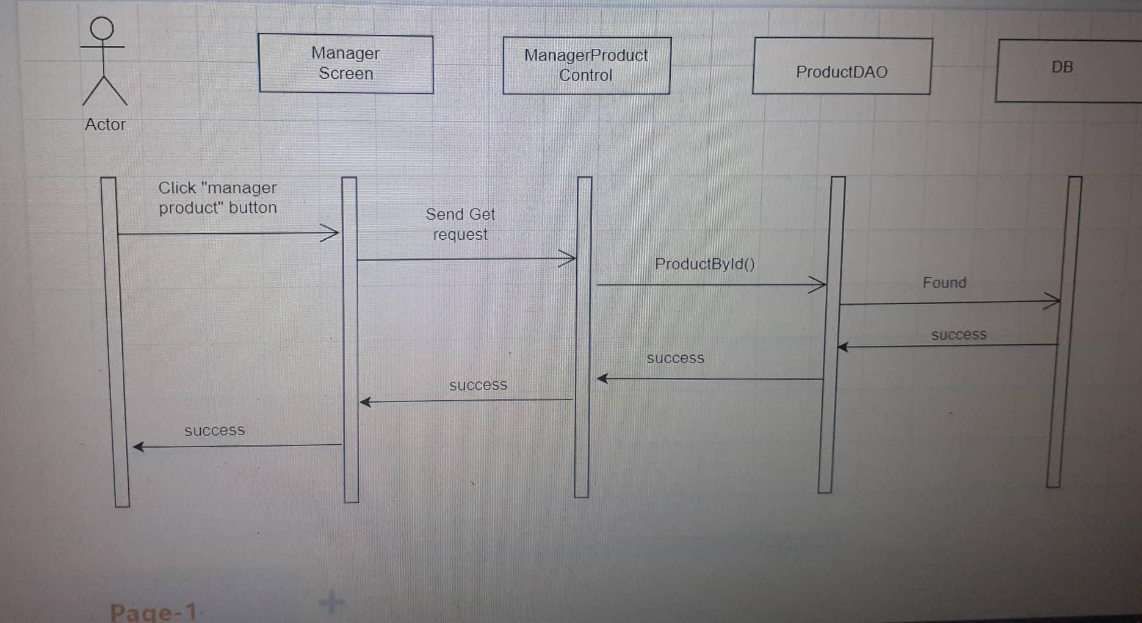

### Database queries

select p.*,pr.ProductImgURL from Product p join ProductImg pr

+ "on p.ProductID = pr.ProductID

## 25.HomePage

### Class Diagram

### 

### 

### Class Specifications

ProductDAO

|  |  |  |
| --- | --- | --- |
| No | Method | Description |
| 01  02 | getAll  pagingProductBy6 | *Get all product*  *product pagination 6 products 1 page* |

SubCategoryDAO

|  |  |  |
| --- | --- | --- |
| No | Method | Description |
| 01 | getAllSubCategory | *Get all SubCategory* |

CategoryDAO

|  |  |  |
| --- | --- | --- |
| No | Method | Description |
| 01 | getAllCategory | *Get all Category* |

BrandDAO

|  |  |  |
| --- | --- | --- |
| No | Method | Description |
| 01 | getAllBrand | *Get all brand* |

### Sequence Diagram



1. Database queries

### d. Database queries

select p.*,pr.ProductImgURL from Product p join ProductImg pr

+ "on p.ProductID = pr.ProductID

## 26. List Customer

### Class Diagram

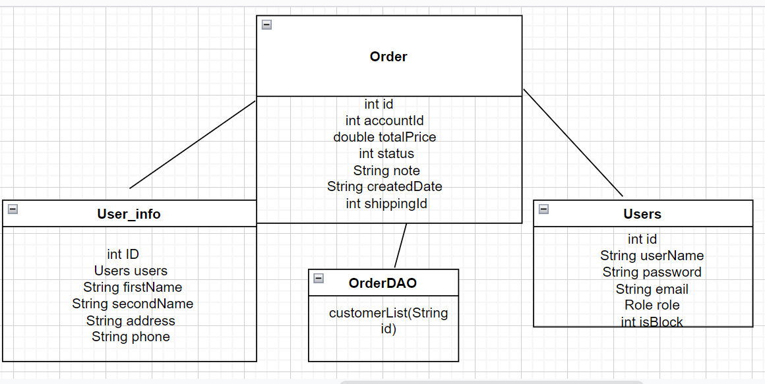

### Class Specification

|  |  |  |
| --- | --- | --- |
| No | Method | Description |
| 01 | processRequest() | Review a list of past customers. |

### Sequence Diagram(s)

### 

### Database queries

select * from Orders join Users

on Orders.UserID = Users.UserID

join User_info as c

on Users.UserID = c.UserID

## 26. Product list

### a.Class diagram

### 

### 

### 

### b.Class specifications

### 

UserDAO

|  |  |  |
| --- | --- | --- |
| No | Method | Description |
| 01 | login | *Input correct username and password to login in to web* |

ProductDAO

|  |  |  |
| --- | --- | --- |
| **No** | **Method** | **Description** |
| *01* | *View Product* | *View detail of one specific post* |
| *02* | *Productlist* | *View list all post* |
| *03* | *addtoCart* | *Add product to cart* |

### c. Sequence Diagram(s)

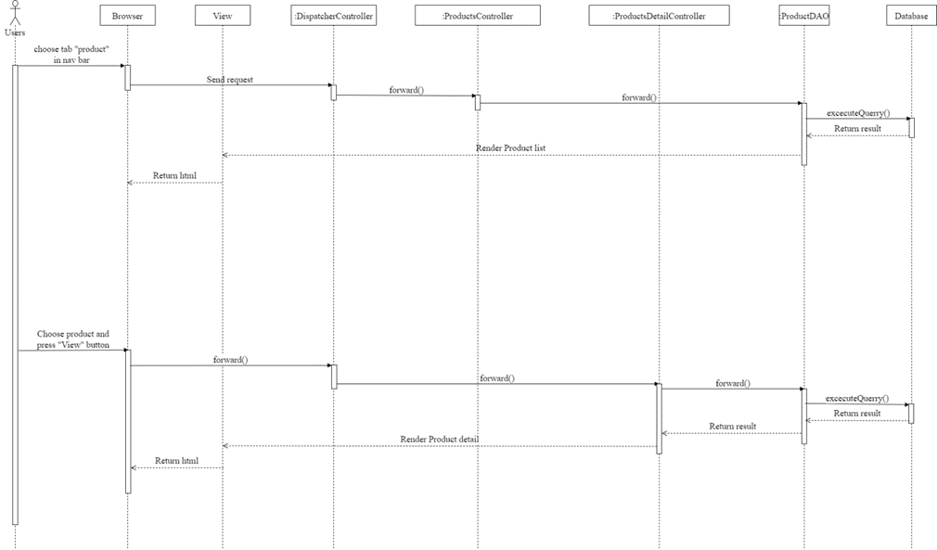

### d. Database queries

## 27. Delete Product From Cart

### a. Class Diagram

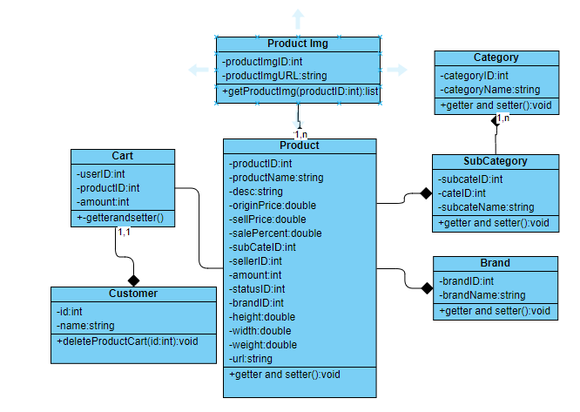

### b. Class Specifications

Customer

|  |  |  |
| --- | --- | --- |
| **No** | **Method** | **Description** |
| *01* | *deleteProductCart()* | *Remove a product() from cart* |

### c. Sequence Diagram(s)

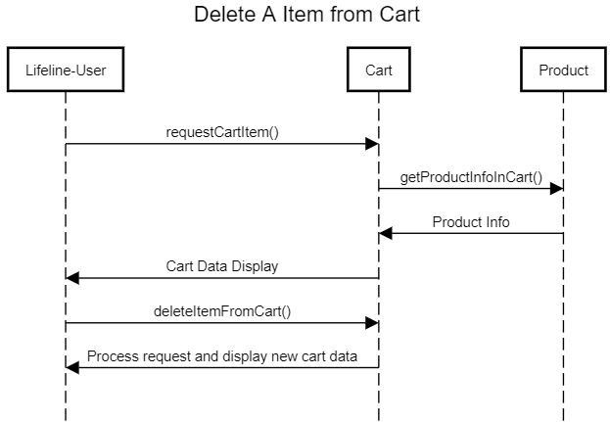

### d. Database queries

DELETE FROM *dbo.cart* WHERE *userID= ? and* productID = ?

# III. Database Design

## 1. Database Schema

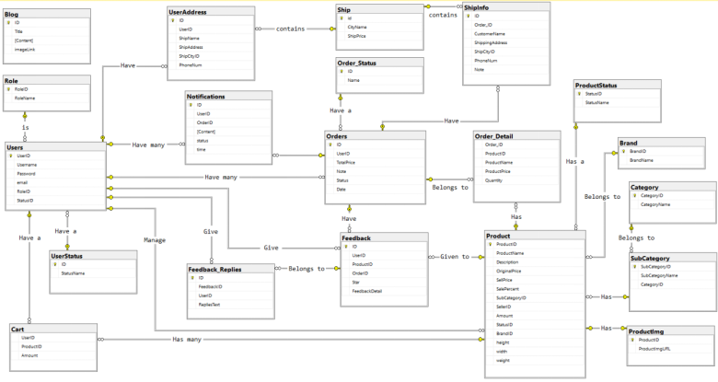

## 2. Table Description

|  |  |  |
| --- | --- | --- |
| **No** | **Table** | **Description** |
| *01* | *Blog* | *Blog content + image*  *- Primary keys: ID*  *- Foreign keys:* |
| *02* | *Role* | *Role of a user ( Admin,Marketing,Sale,Customer )*  *- Primary keys: RoleID*  *- Foreign keys:* |
| *03* | *UserStatus* | *Account activation status*  *- Primary keys: ID*  *- Foreign keys:* |
| *04* | *Ship* | *Shipping price for each city*  *- Primary keys: id*  *- Foreign keys:* |
| *05* | *Order_Detail* | *Detail of each product in order*  *- Primary keys:*  *- Foreign keys: OrderID, ProductID* |
| *06* | *UserAddress* | *Address for each user*  *- Primary keys:ID*  *- Foreign keys: UserID, ShipCityID* |
| *07* | *Users* | *Users*  *- Primary keys: UserID*  *- Foreign keys: RoleID,StatusID* |
| *08* | *Notification* | *Notification data*  *- Primary keys: ID*  *- Foreign keys: OrderID, UserID* |
| *09* | *ShipInfo* | *Shipping info for each order*  *- Primary keys: ID*  *- Foreign keys: Order_ID, ShipCityID* |
| *10* | *Order* | *Order data*  *- Primary keys: ID*  *- Foreign keys: UserID,Status* |
| *11* | *Feedback* | *Feedback of a product order*  *- Primary keys: ID*  *- Foreign keys: UserID,ProductID, OrderID* |
| *12* | *Feedback_Replies* | *Replies of feedbacks*  *- Primary keys: id*  *- Foreign keys: FeedbackID,UserID* |
| *13* | *Order_Status* | *Status of a order*  *- Primary keys: ID*  *- Foreign keys:* |
| *14* | *Product* | *Product Data*  *- Primary keys: ProductID*  *- Foreign keys: SubCategoryID,SellerID,StatusID,BrandID* |
| *15* | *Category* | *Category Data*  *- Primary keys: CategoryID*  *- Foreign keys:* |
| *16* | *SubCategory* | *Sub Category ID*  *- Primary keys: SubCategoryID*  *- Foreign keys: CategoryID* |
| *17* | *Productimg* | *Image of products*  *- Primary keys:*  *- Foreign keys: ProductID* |
| *18* | *ProductStatus* | *Status of a product*  *- Primary keys: StatusID*  *- Foreign keys: StatusName* |
| *19* | *Brand* | *Brand data*  *- Primary keys: BrandID*  *- Foreign keys:* |
| *20* | *Cart* | *Cart info for each user*  *- Primary keys: UserID*  *- Foreign keys: ProductID* |