

**CLOTHING SHOP PROJECT REPORT**

**Software Requirement Specification**

– Hanoi, Summer 2022 –

Contents

I. Overview 4

1. Introduction 4

2. System Functions 4

a. Screen Flow 4

b. Screen Details 9

c. Screen Authorization 12

d. Non-Screen Functions 14

3. Common Requirements 14

II. Functional Requirements 14

1. Search & Filter Product 14

2. View Product Detail 15

3. View Customer List 16

4. View Product List 17

5. Change Amount 18

6. Delete Product 20

7. Cart Detail 21

8. Checkout 22

9. Delete Cart 22

10. Login 23

11. Register 24

12. Set Role User 25

13. Block User 26

14. Reset Password 27

15. Change Password 28

16. User Profile 29

17. My Orders 30

18. Order Information 31

19. Order List 32

20. Order Details 33

21. View Feedback 33

22 Send Feedback 34

23. Blogs List 35

24. Blog Details 36

25. Blog management 37

26. Notification 37

27. Error Page 38

28. Homepage 39

29. Delete all Cart Item 40

30. Add Ship Information 41

a. Class Diagram 41

b. Class Specifications 42

c. Sequence Diagram(s) 42

# Overview

## Introduction

This document describes the requirements for the website, which provides services and supplies clothes for purchasers. Types of reader this document is intended for: developers, project managers, testers, customers, etc…

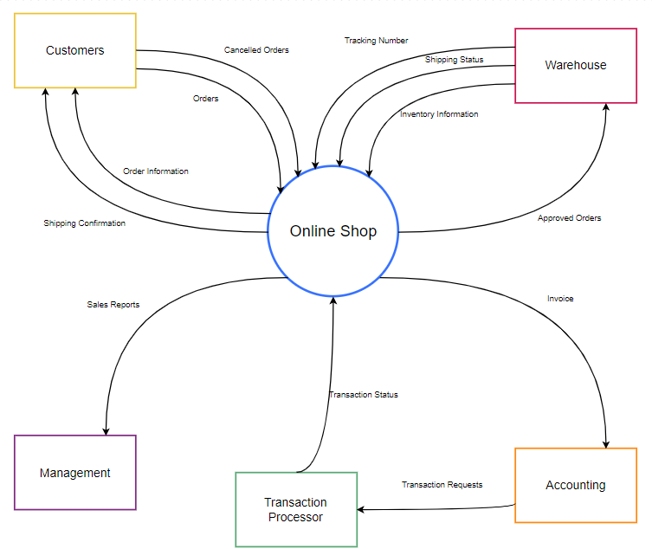

## System Functions

#### a. Screen Flow

User

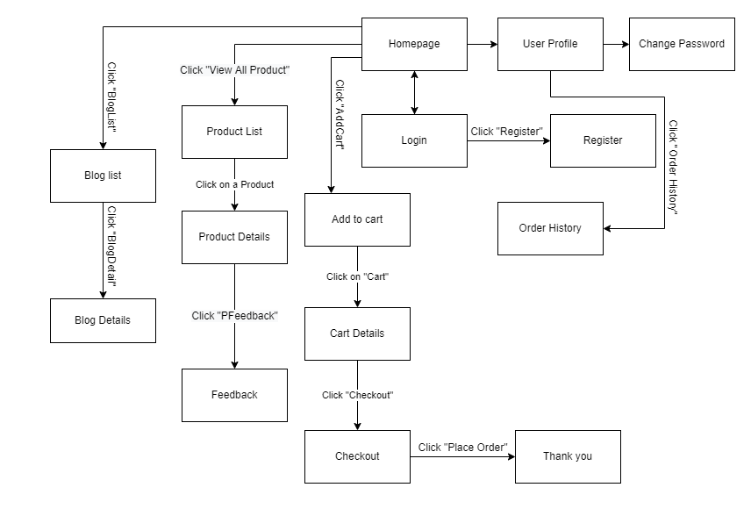

Figure 1-1: Screen Flow for User

Admin

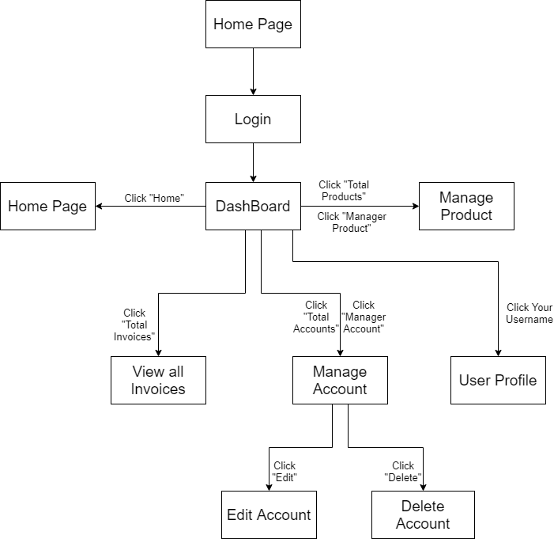

Figure 1-2: Screen Flow for Admin

Seller

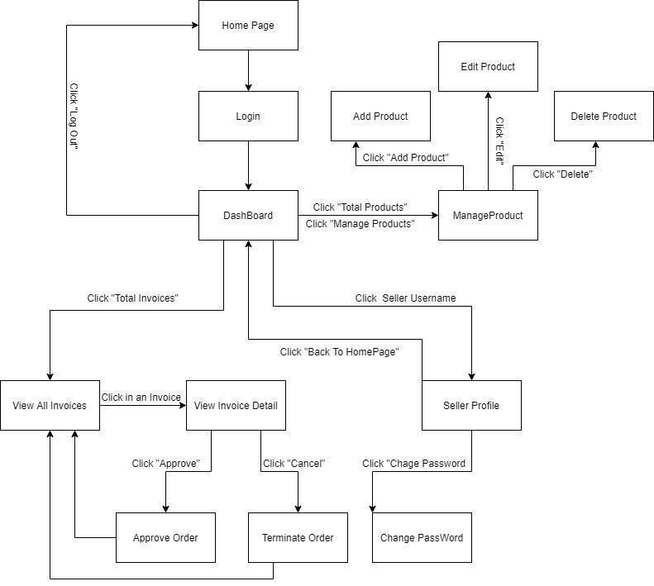

Figure 1-3: Screen Flow for Seller

#### b. Screen Details

|  |  |  |  |
| --- | --- | --- | --- |
| **#** | **Feature** | **Screen** | **Description** |
| 1 | Search & Filter Product | Home Page | Search product by name,price or filter it by category |
| 2 | Sort Product | Home Page | Sort product by price, name, ... |
| 3 | User Login | Login | User login by username and password |
| 4 | Register | Register | User register a new account by input the following information: full name, gender, email, phone number… and verify by gmail |
| 5 | View Product Detail | Product Details | Show information of product |
| 6 | Change Password | Change password | Users change their old password with new password |
| 7 | User Profile | User Profile | Show information about their account |
| 8 | Add To Cart | Home Page, Product Details | Users can add product they want to buy by click “Add to cart” |
| 9 | View Cart | Cart Details | Users can view all products they add to cart |
| 10 | Change Amount | Cart Details | Plus or minus the amount product in cart |
| 11 | Delete Product | Cart Details | Delete a product in cart |
| 12 | Check out | Check out | Users can check their all product before payment |
| 13 | View User List | Users List [Admin] | Admin can view the list of all Accounts in the System |
| 14 | Block User | Users List [Admin] | Admin can block accounts and accounts are blocked can’t login to website |
| 15 | Set Role User | Users List [Admin] | Admin can set role customer to seller or seller to customer |
| 16 | Order History | Order History | Users can view the history of all orders they bought |
| 17 | View Manager Products | Manager Product  [Seller] | Seller can view their products by id |
| 18 | CRUD Products | Manager Product  [Seller] | Seller can add, delete, update their products |
| 19 | Send Feedback | Product Details | Customer can write and send a Feedback about a product |
| 20 | View Feedback | Product Details | Customer can view all the Feedbacks about a Product |
| 21 | Blogs List | Blogs List | Customer views the list of all Blogs |
| 22 | Blog Details | Blog Details | Customer views the Detail information of 1 Blog |
| 24 | View Dashboard | Dashboard [Seller] | Seller can see total orders are sold, most sellest product, …. |
| 25 | Order Management | Order Management | Seller can see all of order and status |
| 26 | View Order | View Order | Seller can sell detail product which is ordered |
| 27 | Error | Error | Error page |
| 28 | Add Product | Product Management | Seller can add product |
| 29 | Update Product | Update Product | Seller can update product |
| 30 | Add Blog | Blog Management | User or Seller can add blog |
| 31 | Update Blog | Update Blog | User can update sell price |
| 32 | Update Sales | Update Sales | User can update sell price |
| 33 |  |  |  |

Table 1-1: Screen Details

#### c. Screen Authorization

|  |  |  |  |  |  |
| --- | --- | --- | --- | --- | --- |
| **Screen** | **User** | **Seller** | **Admin** | **Shipper** | **Marketing** |
| Home Page | x | x | x | x | x |
| Product Details | x | x | x | x | x |
| Update Product |  | x |  |  |  |
| Cart Details | x |  |  |  |  |
| Login | x | x | x | x | x |
| Register | x |  |  |  |  |
| Users List [Admin] |  |  | x |  |  |
| Search User [Admin] |  |  | x |  |  |
| Change Password | x | x | x | x | x |
| Check out | x |  |  |  |  |
| User Profile | x | x | x | x | x |
| Order History | x |  |  |  |  |
| Dashboard [Sellers] |  | x |  |  |  |
| Dashboard [Admin] |  |  | x |  |  |
| Dashboard [Shipper] |  |  |  | x |  |
| Dashboard [Marketing] |  |  |  |  | x |
| Manager Product [Seller] |  | x |  |  |  |
| Order Management |  | x |  |  |  |
| Feedback | x |  |  |  |  |
| Feedback Replies |  | x |  |  |  |
| Blogs List | x |  |  |  |  |
| Blog Details | x |  |  |  |  |
| Update Blog | x |  |  |  |  |
| View Order |  | x |  |  |  |
| Blog Management |  |  | x |  |  |
| Thanks | x |  |  |  |  |
| Product List | x | x | x |  |  |
| Verify Email | x |  |  |  |  |
| Error | x | x | x | x | x |
| Edit user Info | x | x | x | x | x |
| Manage Sale |  | x |  |  |  |
| Update Sales |  | x |  |  |  |
| List Complete Order |  | x |  | x |  |
| View Order |  | x |  |  |  |
| Recruitment |  | x |  |  |  |
| About Shop | x | x | x | x | x |
| Delivery Dashboard | x |  |  |  |  |
|  |  |  |  |  |  |

In which:

* Guest: Customer who has not yet logged in to the site
* User: Customer who has an account an has logged in
* Seller: People who sell products in the shop
* Admin: People who manage the shop
* Shipper: People who shipping order
* Marketing : People who make an advertisement

#### d. Non-Screen Functions

|  |  |  |  |
| --- | --- | --- | --- |
| **#** | **Feature** | **System Function** | **Description** |
| 1 | Remember Me | Login | System store user’s login account and password in cookies for future re-login |
| 2 | Performance  Requirements | Response | The server shall respond to the client within 2  seconds each time requesting |

## Common Requirements

# Functional Requirements

## **1. Search & Filter Product**

* Function trigger: User accesses the website
* Function description:
  + Role: Guest, User
  + Purpose: Users Search for the Product they want
* Screen layout:

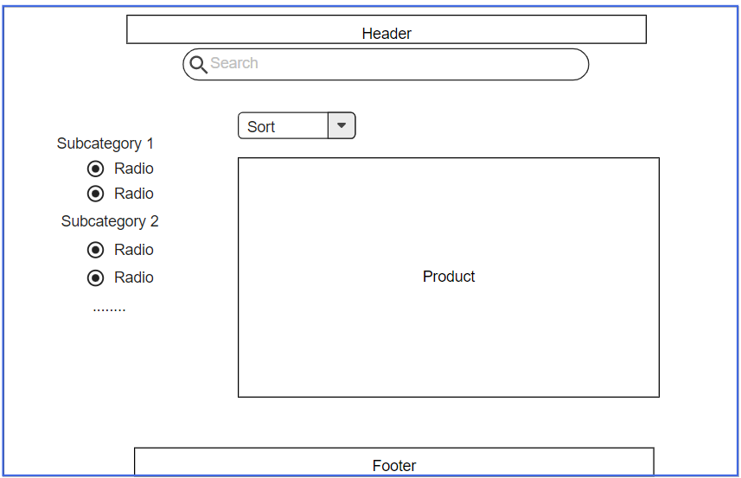

## 2. View Product Detail

* Function trigger: User Click on a Product in Home Page
* Function description:
  + Role: Guest, User
  + Purpose: User can view all the detail information of a Product
* Screen layout:

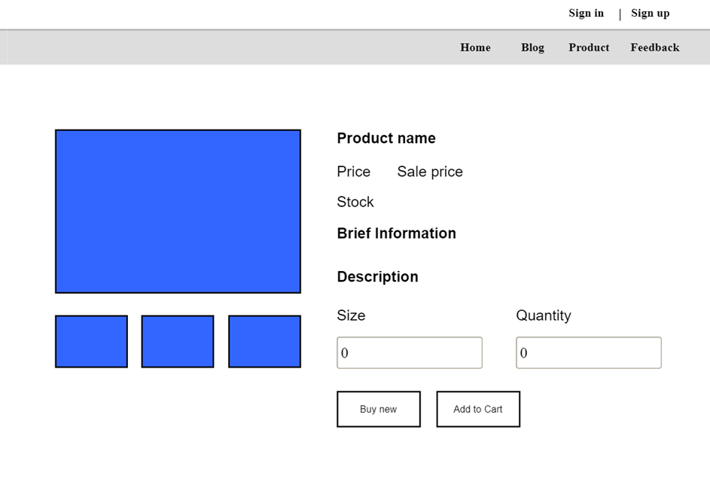

## 3. View Customer List

* Function trigger: User Click on a customer list in Dashboard Page
* Function description:
  + Role: Admin
  + Purpose: Show list of all customer
* Screen layout:

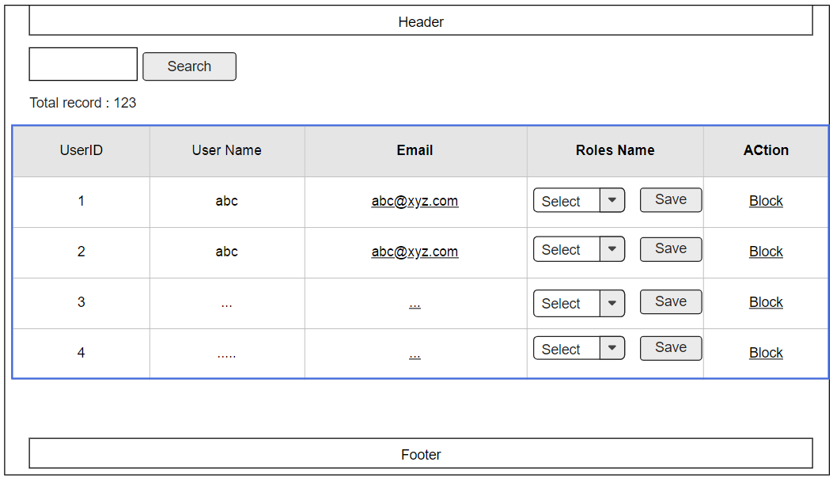

## 4. View Product List

* Function trigger: User Click on a Product list in Home Page
* Function description:
  + Role: Sell
  + Purpose: seller views and manages all products
* Screen layout:

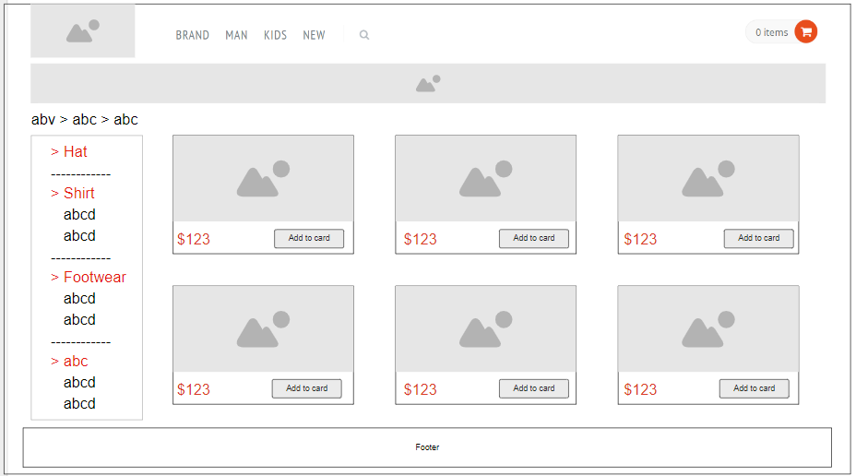

## **5. Change Amount**

* Function trigger: User Click on “Cart” in Menu bar
* Function description:
  + Role: User
  + Purpose: User can change the amount of the Product they want to buy
* Screen layout: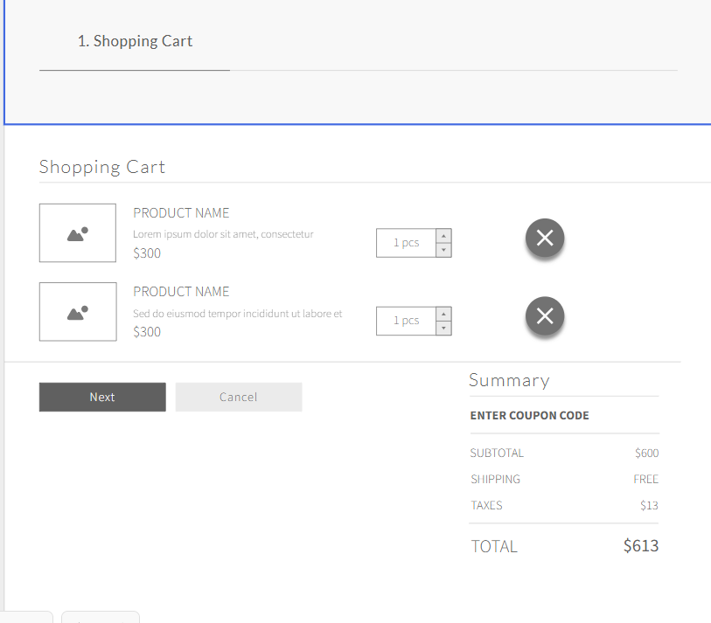

## 6. Delete Product

* Function trigger: User Click on the Delete icon in a Product in Cart
* Function description:
  + Role: User
  + Purpose: User can Delete a Product from their Cart
* Screen layout:



## 7. Cart Detail

* Function trigger: User Click on “Cart” in Menu bar and click on green button they want to increase in amount
* Function description:
  + Role: User
  + Purpose: User can change the amount of the Product they want to buy
* Screen layout:



## 8. Checkout

* Function trigger: User Click on “Checkout” button to view information of Cart
* Function description:
  + Role: User
  + Purpose: User can view information of order before deciding Order.
* Screen layout:

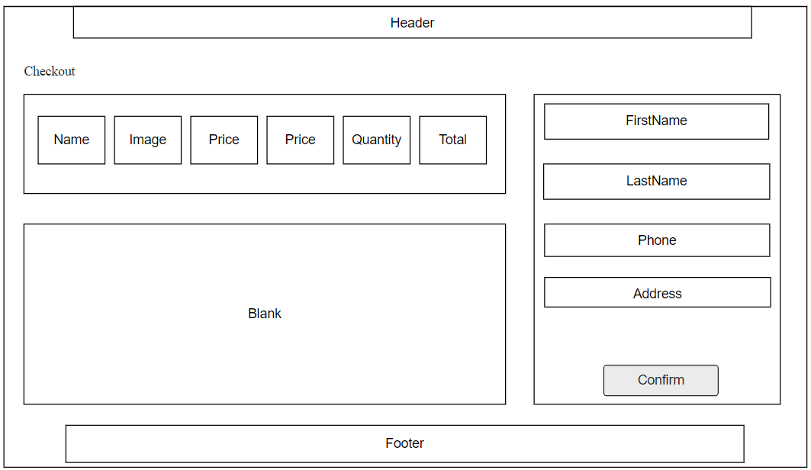

## 9. Delete Cart

* Function trigger: User Click on “Delete Cart” button in Cart
* Function description:
  + Role: User
  + Purpose: User can delete all the Product in their Cart
* Screen layout:



## 10. Login

* Function trigger: User Click on “Login” link in the Menu bar
* Function description:
  + Role: Guest
  + Purpose: For people to log in to the system for access to more functions
* Screen layout:

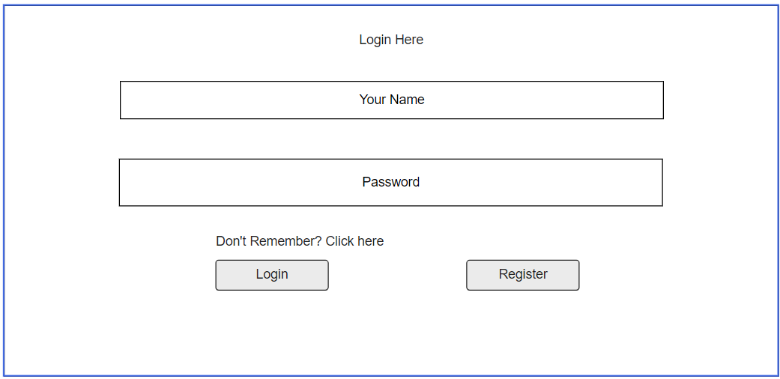

## 11. Register

* Function trigger: Guest click “Sign up” button from Login screen.
* Function description:
  + Role: Guest.
  + Purpose: Provide a form for customers to register an account.
* Screen layout:

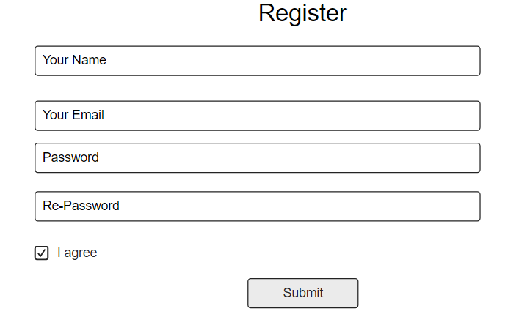

## 12. Set Role User

* Function trigger: Admin click “Set role” button next to an entry from user list.
* Function description:
  + Role: Admin.
  + Purpose: Set role as an account.
* Screen layout:

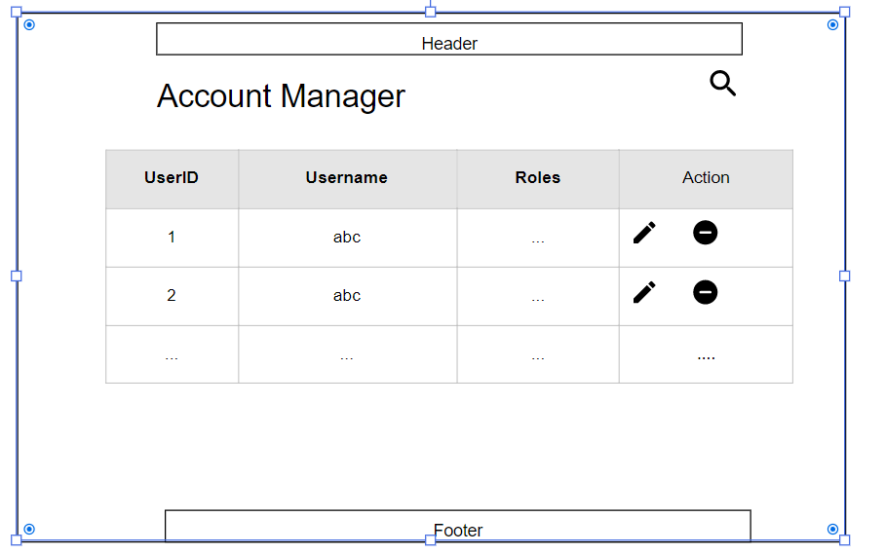

## 13. Block User

* Function trigger: Admin click the “Block” button next to an entry from the user list.
* Function description:
  + Role: Admin.
  + Purpose: Block an account from the system.
* Screen layout:



## **14. Reset Password**

* Function trigger: Users access the website and click on Reset Password button
* Function description:
  + Role: Buyer, Seller, Admin
  + Purpose: Users can change their passwords when they forget their old one
* Screen Layout:

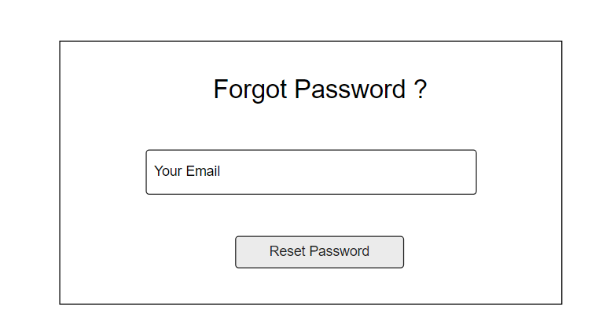

## **15. Change Password**

* Function trigger: Users login the website and access the profile page and click on Change Password button
* Function description:
  + Role: Buyer, Seller, Admin
  + Purpose: Users can change their passwords
* Screen Layout:

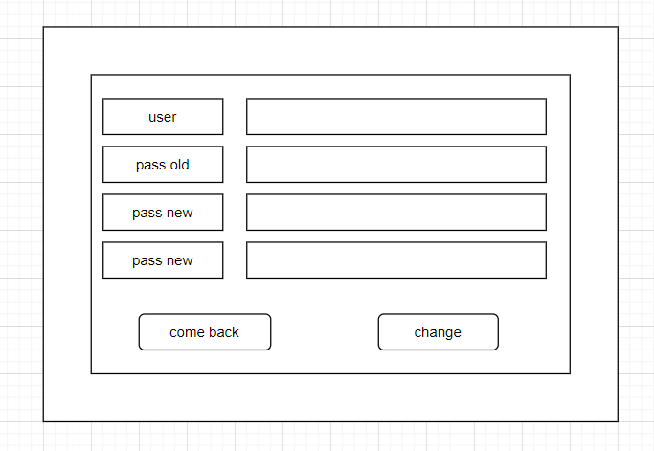

## 16. User Profile

* Function trigger: User log-in the website and click on the profile icon on the top-right corner
* Function description:
  + Role: Buyers, Seller, Admin
  + Purpose: Users can see their account’s detailed information
* Screen layout:

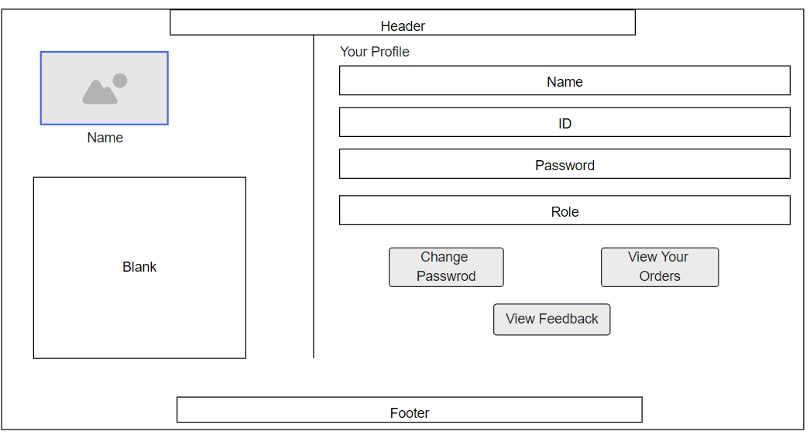

## 17. My Orders

* Function trigger: Users log-in the website, access the profile page and click on My Orders button
* Function description:
  + Role: Buyers
  + Purpose: Users can see their shopping history
* Screen layout:

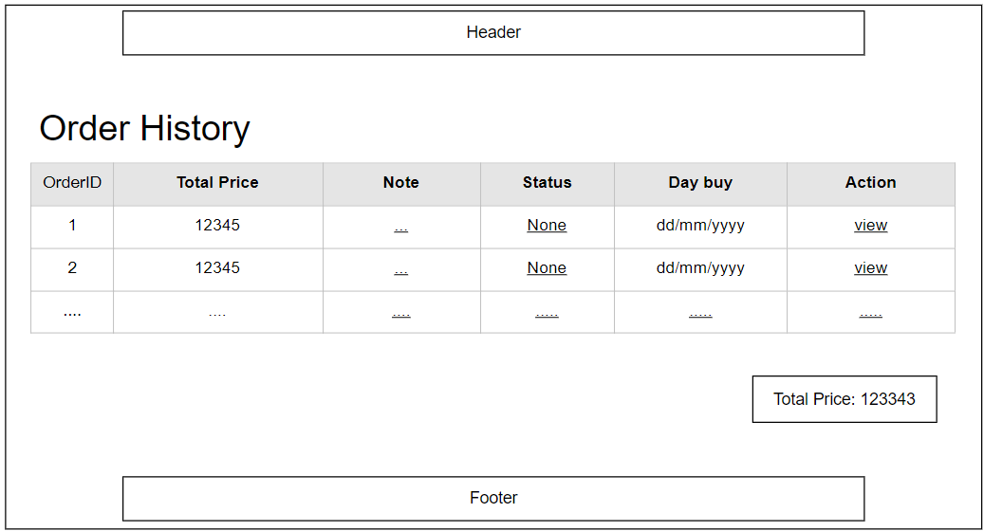

## 18. Order Information

* Function trigger: Users log-in to the website, access My Orders page and click View button
* Function description:
  + Role: Buyers
  + Purpose: See the order detailed information
* Screen layout:

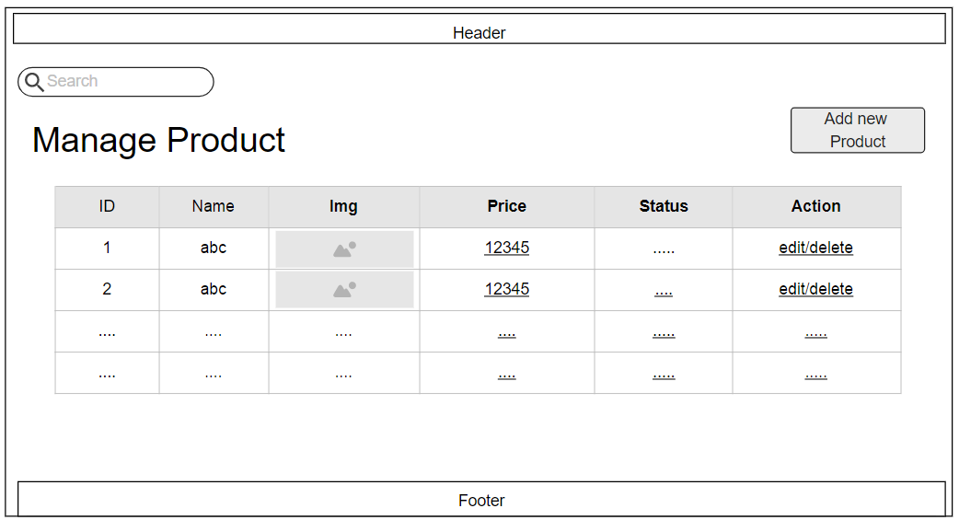

## 19. Order List

Function trigger: Admin Login and click Total Invoices

Function description:

• Role: Admin

• Purpose: Admin views list of all of 2 orders

Screen layout:

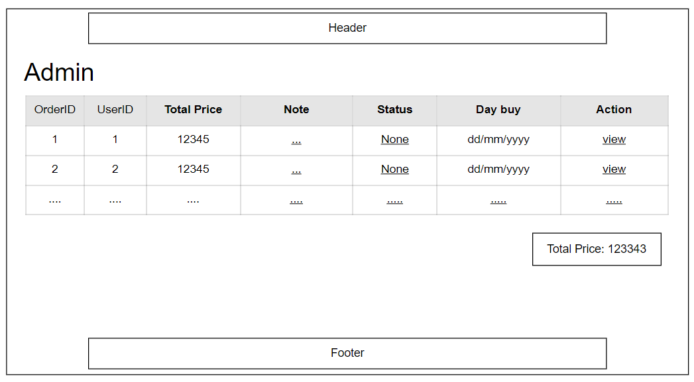

## 20. Order Details

Function trigger: Seller Login and click Total Invoices

Function description:

• Role: Seller

• Purpose: Seller views the detail of 1 of his orders

Screen layout:

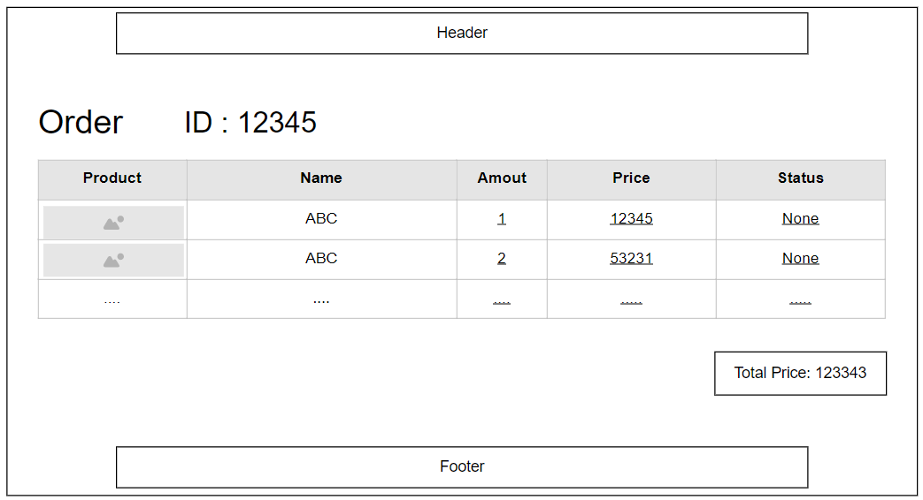

## 21. View Feedback

Function trigger: Customers click on the product they want to see, scroll down to see the feedback

Function description:

* Role: Guest, User
* Purpose: Customer views all the Feedback about a Product

Screen layout:

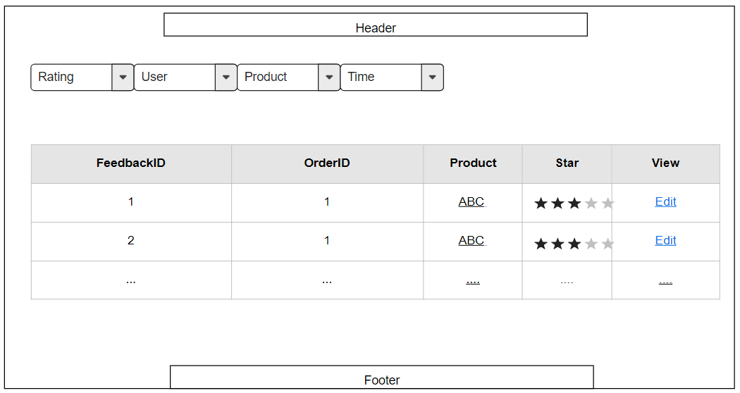

## 22 Send Feedback

Function trigger: When the user receives the goods, click on My order and then click on Add feedback and evaluate

Function description:

* Role: Guest, User
* Purpose: Customer writes and send a Feedback about a Product

Screen layout:

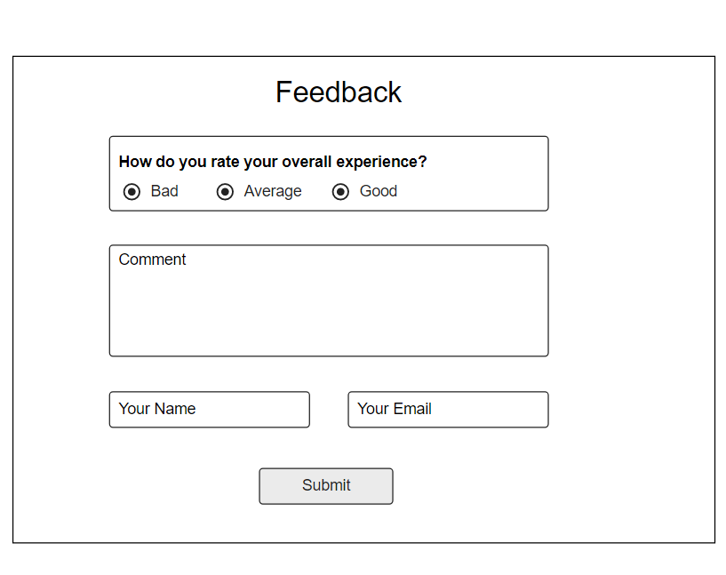

## 23. Blogs List

Function trigger: User Click Blog in menu bar

Function description:

* Role: Guest, User
* Purpose: Customer views the list of all Blog

Screen layout: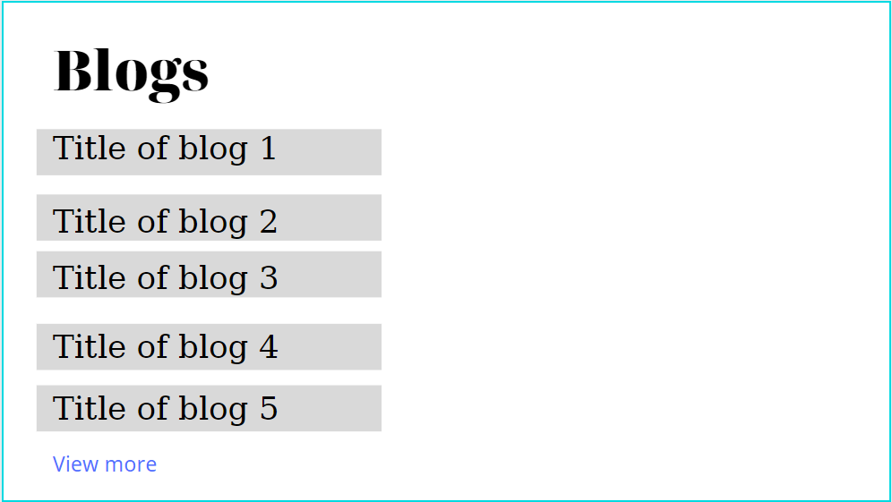

## 24. Blog Details

Function trigger: User Click Blog in menu bar. Next, click Blog want to see detail

Function description:

Role: Guest, User

Purpose: Customer views the Detail information of 1 Blog

Screen layout:

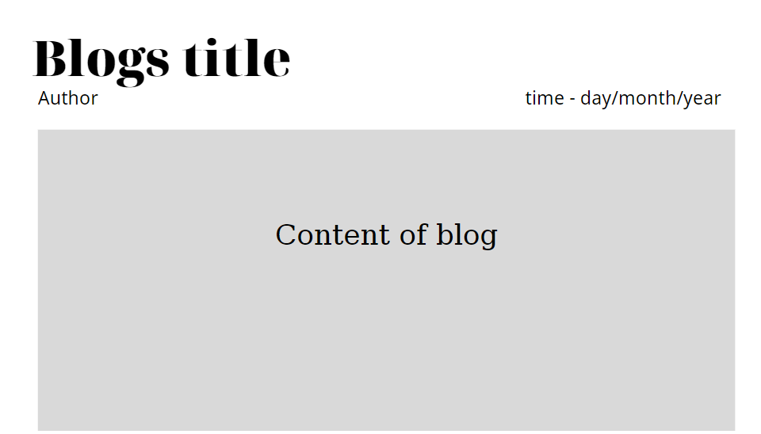

## Blog management

Function trigger: Admin click Manage Blog in menu bar, view, add, update, delete blog

Function description:

Role: Admin

Purpose: Admin views, add, update, delete blog

Screen layout:

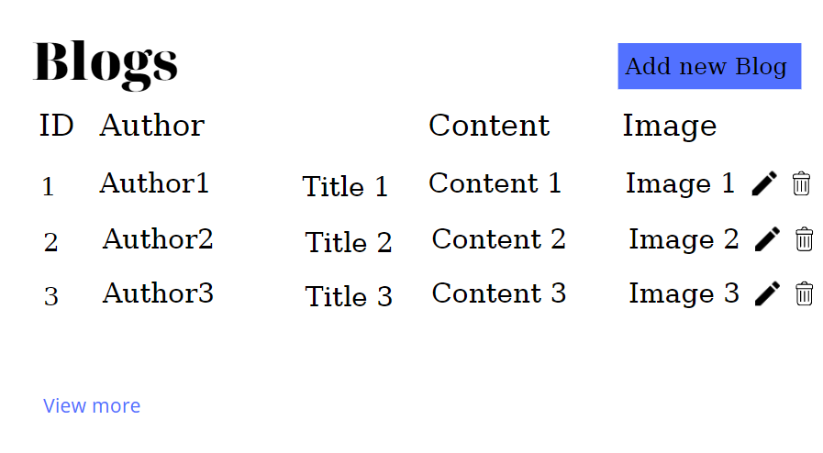

## Notification

Function trigger: User click notification icon ( ) to view notification

Function description:

Role: User

Purpose: View notification about your order

Screen layout:

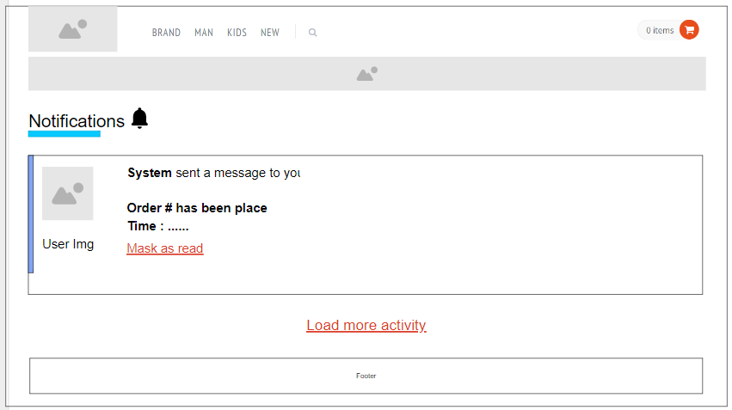

## Error Page

* Function trigger: User accesses the website, the website got an error when progressing user request
* Function description:
  + Role: Guest, User, Seller, Admin
  + Purpose: Show in case there’s an Error occurs
  + Screen layout:

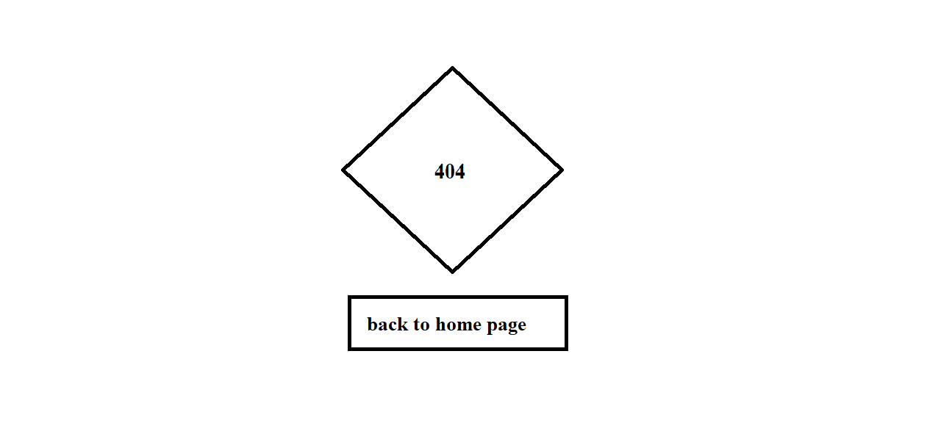

## Homepage

* Function trigger: User accesses the website
* Function description:
  + Role: Guest, User
  + Purpose: Showcase feature product to visitors
* Screen layout:

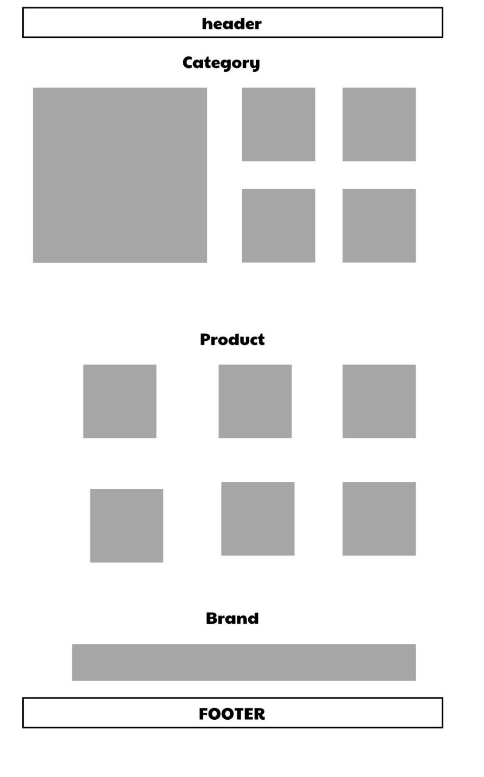

## Delete all Cart Item

* Function trigger: User Click on the Delete icon ( red button ) in a Product in Cart
* Function description:
  + Role: Guest
  + Purpose: User can Delete a Product from their Cart
* Screen layout:

