

**CLOTHING SHOP PROJECT REPORT**

**Software Requirement Specification**

– Hanoi, Summer 2022 –

Contents

Overview **4**

Introduction 4

System Functions 5

a. Screen Flow 5

b. Screen Details 9

c. Screen Authorization 13

d. Non-Screen Functions 16

Common Requirements 16

Functional Requirements **16**

1. Search & Filter Product 16

2. View Product Detail 17

3. View Customer List 18

4. View Product List 19

5. Change Amount 20

6. Delete Product 22

7. Cart Detail 23

8. Checkout 23

9. Delete Cart 24

10. Login 25

11. Register 26

12. Set Role User 27

13. Block User 28

14. Reset Password 29

15. Change Password 30

16. User Profile 31

17. My Orders 32

18. Order Information 33

19. Order List 34

20. Order Details 34

21. View Comment 35

22. Send Feedback 36

23. Blog List 37

24. Blog Detail 38

25.Add Blog 39

26.Update Blog 39

27.Blog management 40

28.Replies Feedback 41

29.Notification 41

30.Error Page 42

31.Homepage 43

32.Order Management 45

33.Chart Manager 45

34.Admin Dashboard 46

35.View brand 47

36.Add brand 49

37.Edit brand 49

38.Category View 49

39.Add Category 50

40.Edit Category 51

41.Delivery DashBoard[Shipper] 51

42.Delivering Product[Shipper] 52

43.Completed Product[Shipper] 53

44. Manager Product 54

45.Add Product 54

46. Edit Product 54

# Overview

## Introduction

This document describes the requirements for the website, which provides services and supplies clothes for purchasers. Types of reader this document is intended for: developers, project managers, testers, customers, etc…

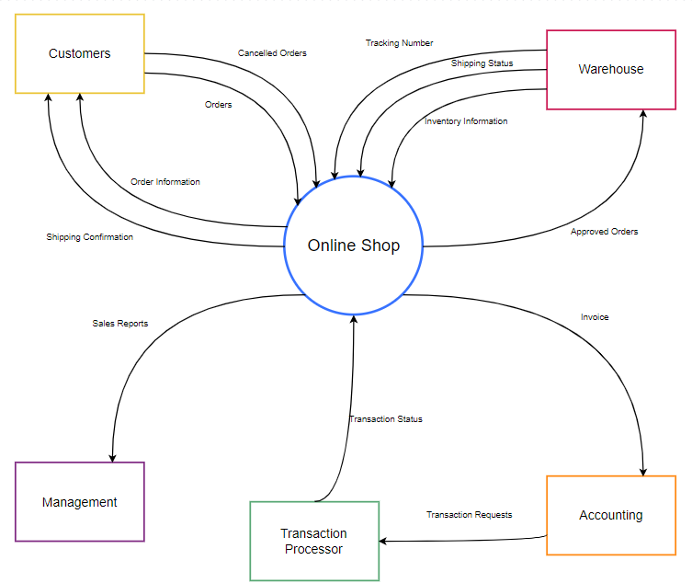

## System Functions

#### a. Screen Flow

User

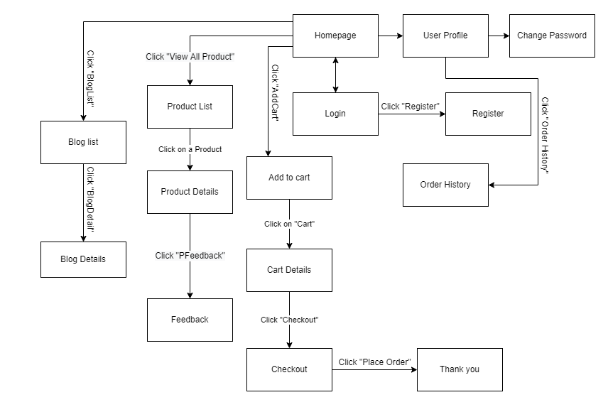

Figure 1-1: Screen Flow for User

Admin

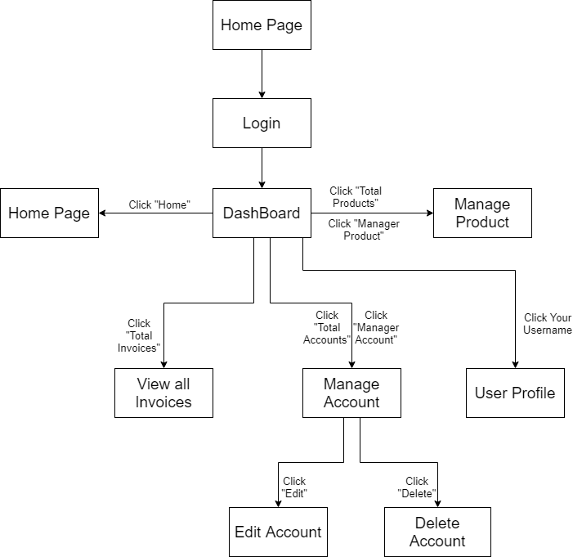

Figure 1-2: Screen Flow for Admin

Seller

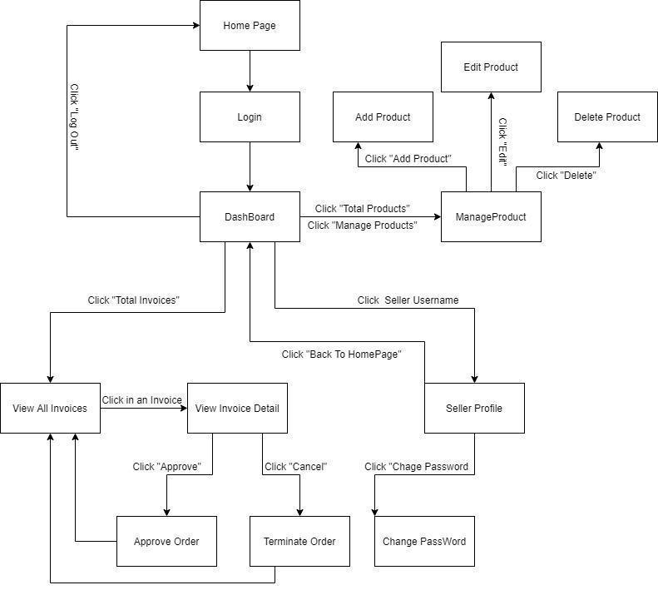

Figure 1-3: Screen Flow for Seller

#### b. Screen Details

| **#** | **Feature** | **Screen** | **Description** |
| --- | --- | --- | --- |
| 1 | Search & Filter Product | Home Page | Search product by name,price or filter it by category |
| 2 | Sort Product | Home Page | Sort product by price, name, ... |
| 3 | User Login | Login | User login by username and password |
| 4 | Register | Register | User register a new account by input the following information: full name, gender, email, phone number… and verify by gmail |
| 5 | View Product Detail | Product Details | Show information of product |
| 6 | Change Password | Change password | Users change their old password with new password |
| 7 | User Profile | User Profile | Show information about their account |
| 8 | Add To Cart | Home Page, Product Details | Users can add product they want to buy by click “Add to cart” |
| 9 | View Cart | Cart Details | Users can view all products they add to cart |
| 10 | Change Amount | Cart Details | Plus or minus the amount product in cart |
| 11 | Delete Product | Cart Details | Delete a product in cart |
| 12 | Check out | Check out | Users can check their all product before payment |
| 13 | View User List | Users List [Admin] | Admin can view the list of all Accounts in the System |
| 14 | Block User | Users List [Admin] | Admin can block accounts and accounts are blocked can’t login to website |
| 15 | Set Role User | Users List [Admin] | Admin can set role customer to seller or seller to customer |
| 16 | Order History | Order History | Users can view the history of all orders they bought |
| 17 | View Manager Products | Manager Product  [Seller] | Seller can view their products by id |
| 18 | CRUD Products | Manager Product  [Seller] | Seller can add, delete, update their products |
| 19 | Write Comment | Product Details | Customer can write and send a Feedback about a product |
| 20 | View Comment | Product Details | Customer can view all the Feedbacks about a Product |
| 21 | Blogs List | Blogs List | Customer views the list of all Blogs |
| 22 | Blog Details | Blog Details | Customer views the Detail information of 1 Blog |
| 24 | View Dashboard | Dashboard [Seller] | Seller can see total orders are sold, most sellest product, …. |
| 25 | Order Management | Order Management | Seller can see all of order and status |
| 26 | View Order | View Order | Seller can sell detail product which is ordered |
| 27 | Error | Error | Error page |
| 28 | Add Product | Product Management | Seller can add product |
| 29 | Update Product | Update Product | Seller can update product |
| 30 | Add Blog | Blog Management | User or Seller can add blog |
| 31 | Update Blog | Update Blog | User can update sell price |
| 32 | Update Sales | Update Sales | User can update sell price |
| 33 | View Category | Category Details | Sellers can view all off list detail |
| 34 | Edit Category | Category Details | Sellers can add new category |
| 35 | Edit Category | Category Details | Sellers can edit category and add new Subcategory |
| 36 | Add brand | Add brand | Sellers can add new brand |
| 37 | Edit brand | Edit brand | Sellers can update new brand |
| 38 | View brand | Brand manager | Seller can view all off list brand |
| 39 | Send Feedback | Send FeedBack | Customer can send feedback to Seller |
| 40 | Feedback Replies | Seller DashBoard | Seller Can replies Feedback to customer |
| 41 | Notification | Notification | User can view notification about their order |

Table 1-1: Screen Details

#### c. Screen Authorization

| **Screen** | **User** | **Seller** | **Admin** | **Shipper** | **Marketing** |
| --- | --- | --- | --- | --- | --- |
| Home Page | x | x | x | x | x |
| Product Details | x | x | x | x | x |
| Update Product |  | x |  |  |  |
| Cart Details | x |  |  |  |  |
| Login | x | x | x | x | x |
| Register | x |  |  |  |  |
| Users List [Admin] |  |  | x |  |  |
| Search User [Admin] |  |  | x |  |  |
| Change Password | x | x | x | x | x |
| Check out | x |  |  |  |  |
| User Profile | x | x | x | x | x |
| Order History | x |  |  |  |  |
| Dashboard [Sellers] |  | x |  |  |  |
| Dashboard [Admin] |  |  | x |  |  |
| Dashboard [Shipper] |  |  |  | x |  |
| Dashboard [Marketing] |  |  |  |  | x |
| Manager Product [Seller] |  | x |  |  |  |
| Order Management |  | x |  |  |  |
| Feedback | x |  |  |  |  |
| Feedback Replies |  | x |  |  |  |
| Blogs List | x |  |  |  |  |
| Blog Details | x |  |  |  |  |
| Update Blog | x |  |  |  |  |
| View Order |  | x |  |  |  |
| Blog Management |  |  | x |  |  |
| Thanks | x |  |  |  |  |
| Product List | x | x | x |  |  |
| Verify Email | x |  |  |  |  |
| Error | x | x | x | x | x |
| Edit user Info | x | x | x | x | x |
| Manage Sale |  | x |  |  |  |
| Update Sales |  | x |  |  |  |
| List Complete Order |  | x |  | x |  |
| View Order |  | x |  |  |  |
| Recruitment |  | x |  |  |  |
| About Shop | x | x | x | x | x |
| Delivery Dashboard | x |  |  |  |  |
| Category Details |  | x |  |  |  |

In which:

* Guest: Customer who has not yet logged in to the site
* User: Customer who has an account an has logged in
* Seller: People who sell products in the shop
* Admin: People who manage the shop
* Shipper: People who shipping order
* Marketing : People who make an advertisement

#### d. Non-Screen Functions

| **#** | **Feature** | **System Function** | **Description** |
| --- | --- | --- | --- |
| 1 | Remember Me | Login | System store user’s login account and password in cookies for future re-login |
| 2 | Performance  Requirements | Response | The server shall respond to the client within 2  seconds each time requesting |

## Common Requirements

# Functional Requirements

## 1. Search & Filter Product

* Function trigger: User accesses the website
* Function description:
  + Role: Guest, User
  + Purpose: Users Search for the Product they want
* Screen layout:

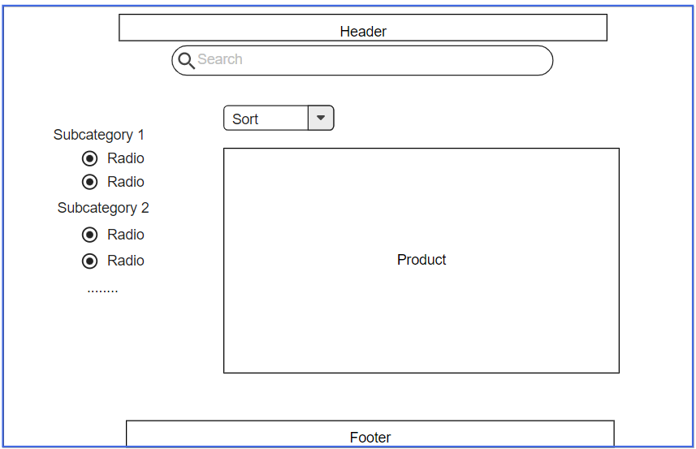

## 2. View Product Detail

* Function trigger: User Click on a Product in Home Page
* Function description:
  + Role: Guest, User
  + Purpose: User can view all the detail information of a Product
* Screen layout:

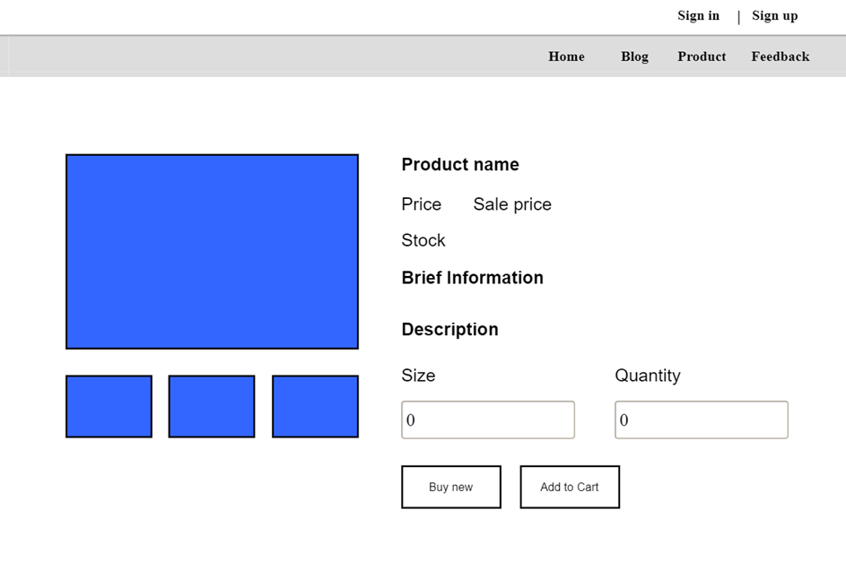

## 3. View Customer List

* Function trigger: User Click on a customer list in Dashboard Page
* Function description:
  + Role: Admin
  + Purpose: Show list of all customer
* Screen layout:

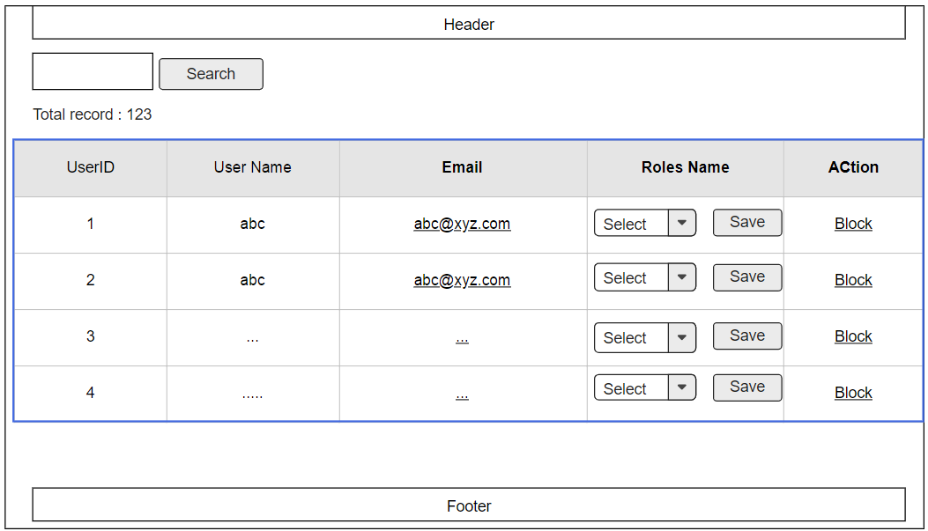

## 4. View Product List

* Function trigger: User Click on a Product list in Home Page
* Function description:
  + Role: Sell
  + Purpose: seller views and manages all products
* Screen layout:

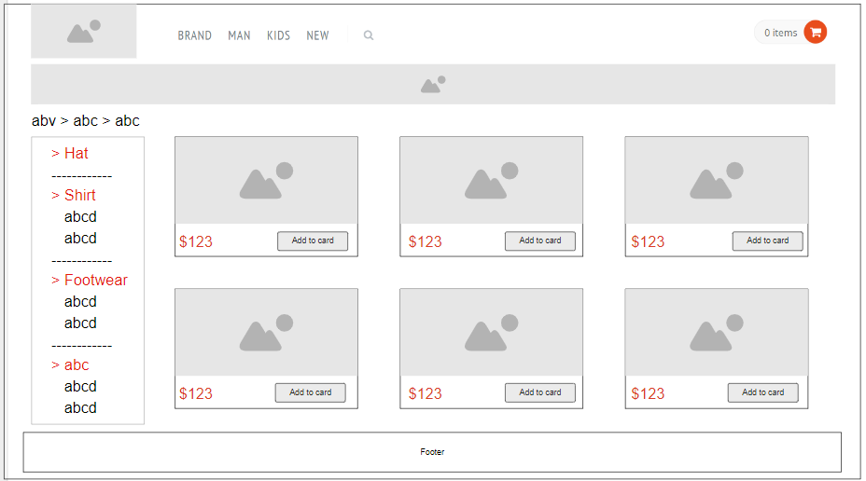

## 5. Change Amount

* Function trigger: User Click on “Cart” in Menu bar
* Function description:
  + Role: User
  + Purpose: User can change the amount of the Product they want to buy
* Screen layout: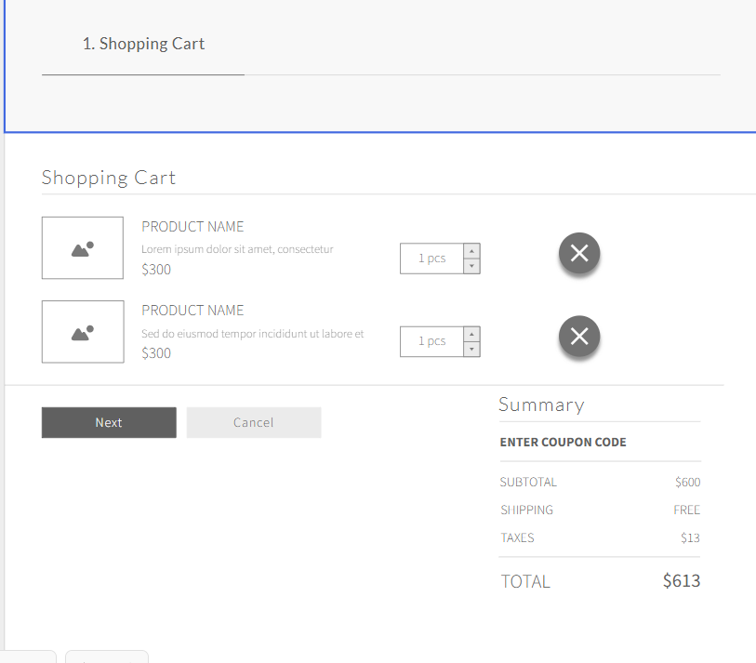

## 6. Delete Product

* Function trigger: User Click on the Delete icon in a Product in Cart
* Function description:
  + Role: User
  + Purpose: User can Delete a Product from their Cart
* Screen layout:



## 7. Cart Detail

* Function trigger: User Click on “Cart” in Menu bar and click on green button they want to increase in amount
* Function description:
  + Role: User
  + Purpose: User can change the amount of the Product they want to buy
* Screen layout:



## 8. Checkout

* Function trigger: User Click on “Checkout” button to view information of Cart
* Function description:
  + Role: User
  + Purpose: User can view information of order before deciding Order.
* Screen layout:

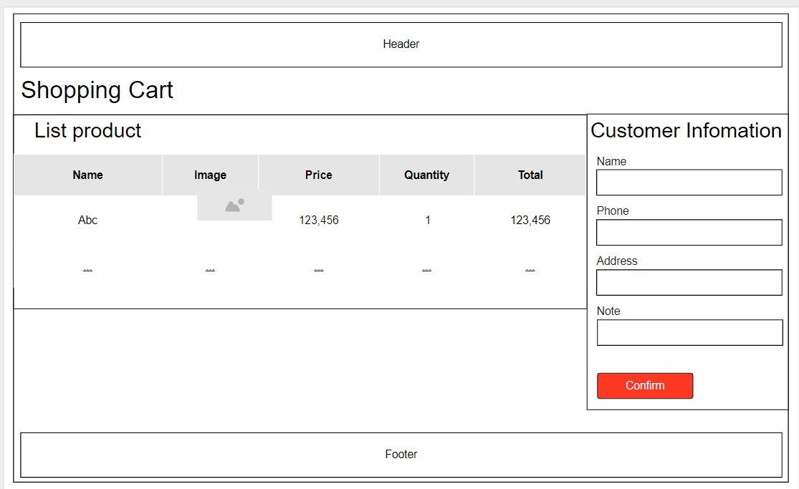

## 9. Delete Cart

* Function trigger: User Click on “Delete Cart” button in Cart
* Function description:
  + Role: User
  + Purpose: User can delete all the Product in their Cart
* Screen layout:



## 10. Login

* Function trigger: User Click on “Login” link in the Menu bar
* Function description:
  + Role: Guest
  + Purpose: For people to log in to the system for access to more functions
* Screen layout:

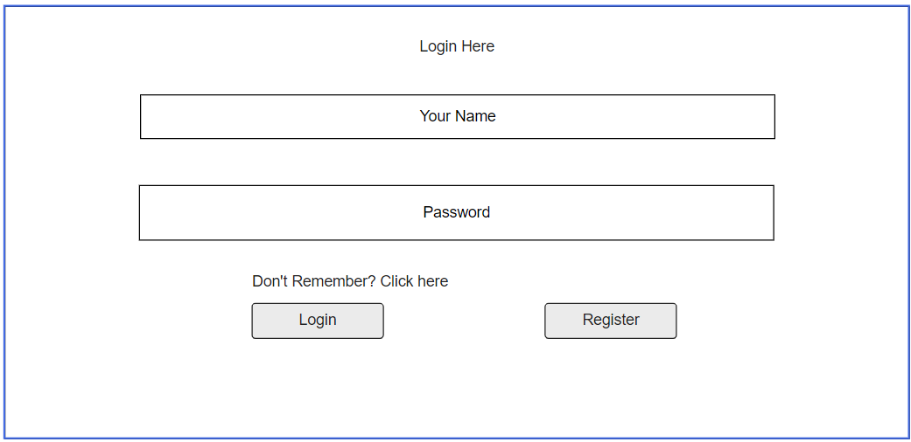

## 11. Register

* Function trigger: Guest click “Sign up” button from Login screen.
* Function description:
  + Role: Guest.
  + Purpose: Provide a form for customers to register an account.
* Screen layout:

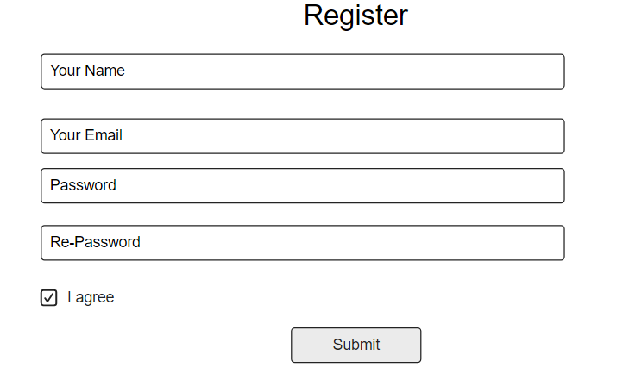

## 12. Set Role User

* Function trigger: Admin click “Set role” button next to an entry from user list.
* Function description:
  + Role: Admin.
  + Purpose: Set role as an account.
* Screen layout:

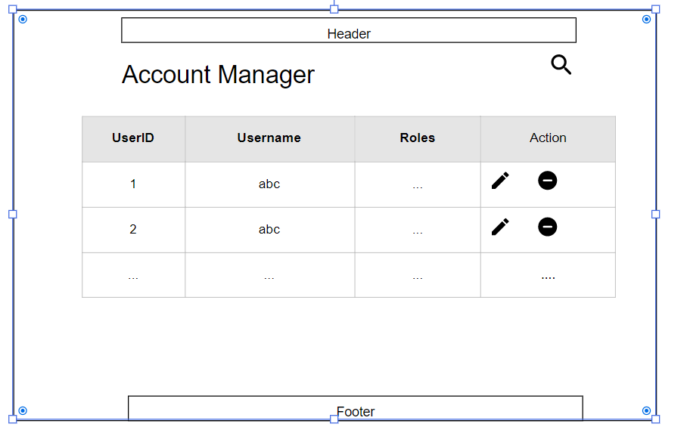

## 13. Block User

* Function trigger: Admin click the “Block” button next to an entry from the user list.
* Function description:
  + Role: Admin.
  + Purpose: Block an account from the system.
* Screen layout:



## 14. Reset Password

* Function trigger: Users access the website and click on Reset Password button
* Function description:
  + Role: Buyer, Seller, Admin
  + Purpose: Users can change their passwords when they forget their old one
* Screen Layout:

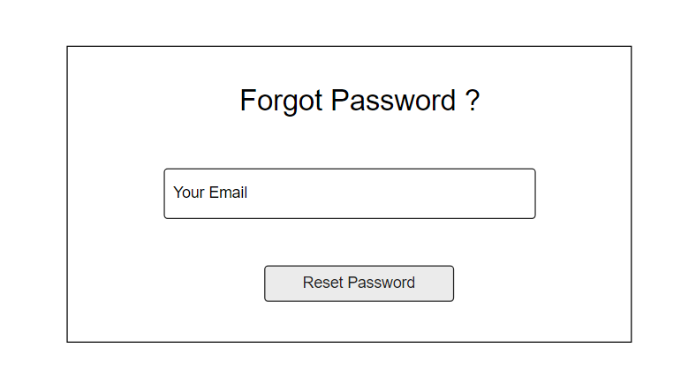

## 15. Change Password

* Function trigger: Users login the website and access the profile page and click on Change Password button
* Function description:
  + Role: Buyer, Seller, Admin
  + Purpose: Users can change their passwords
* Screen Layout:

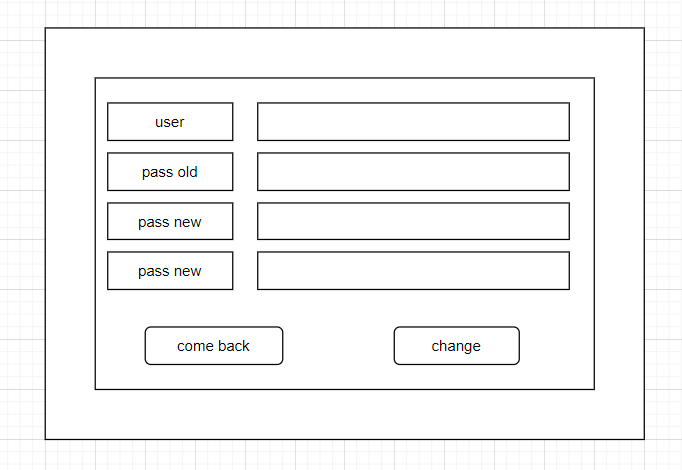

## 16. User Profile

* Function trigger: User log-in the website and click on the profile icon on the top-right corner
* Function description:
  + Role: Buyers, Seller, Admin
  + Purpose: Users can see their account’s detailed information
* Screen layout:

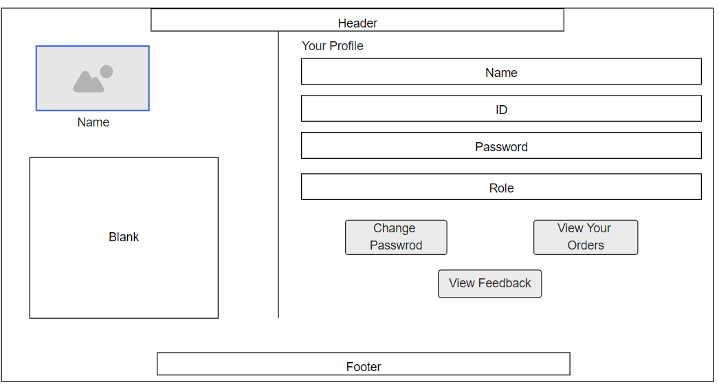

## 17. My Orders

* Function trigger: Users log-in the website, access the profile page and click on My Orders button
* Function description:
  + Role: Buyers
  + Purpose: Users can see their shopping history
* Screen layout:

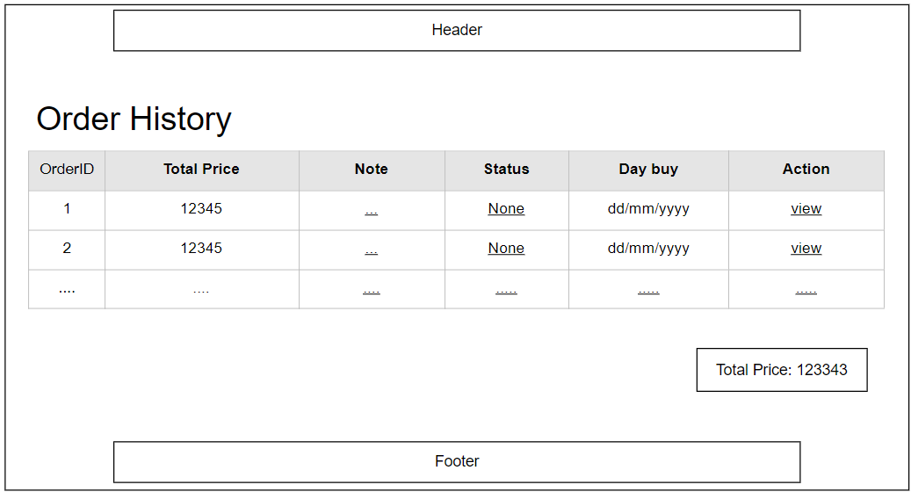

## 18. Order Information

* Function trigger: Users log-in to the website, access My Orders page and click View button
* Function description:
  + Role: Buyers
  + Purpose: See the order detailed information
* Screen layout:

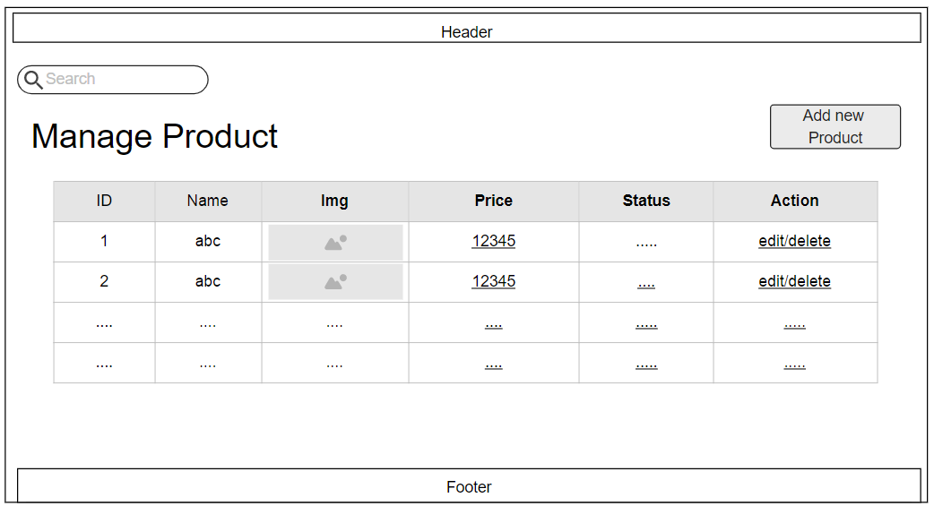

## 19. Order List

Function trigger: Admin Login and click Total Invoices

Function description:

• Role: Admin

• Purpose: Admin views list of all of 2 orders

Screen layout:

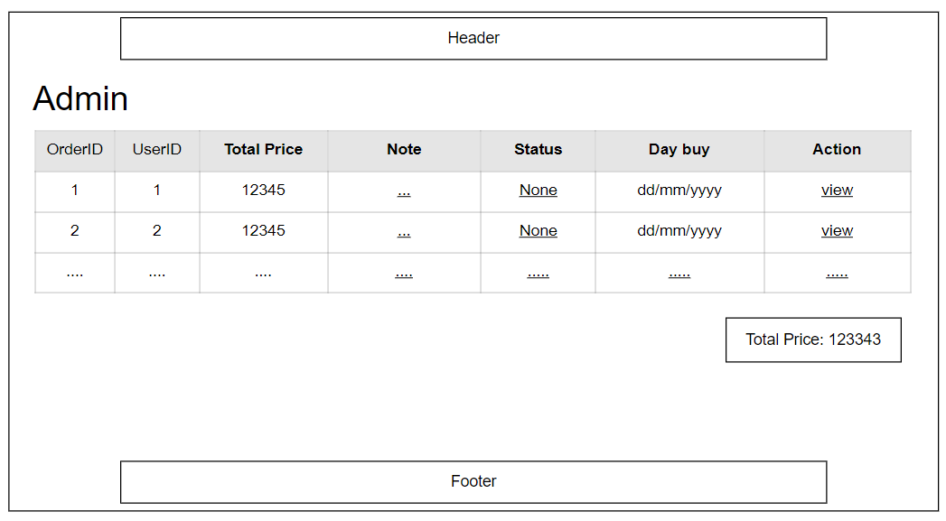

## 20. Order Details

Function trigger: Seller Login and click Total Invoices

Function description:

• Role: Seller

• Purpose: Seller views the detail of 1 of his orders

Screen layout:

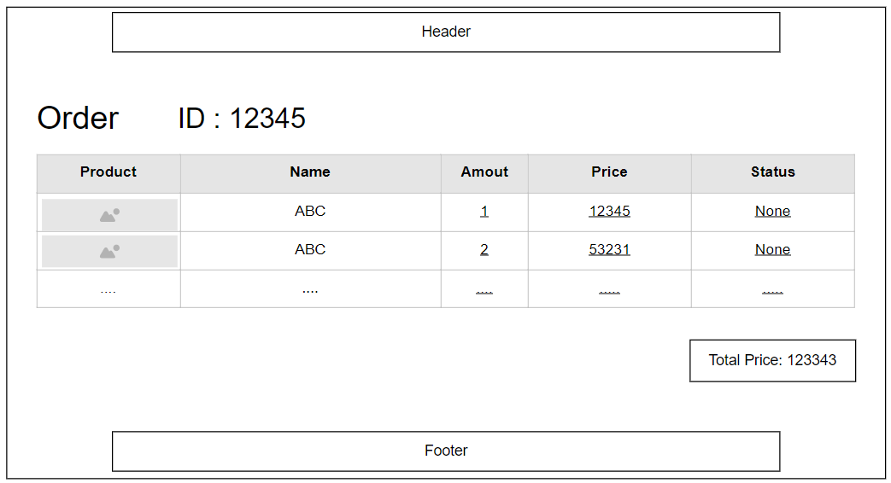

## 21. View Comment

Function trigger: Customers click on the product they want to see, scroll down to see the feedback

Function description:

* Role: Guest, User
* Purpose: Customer views all the Feedback about a Product

Screen layout:

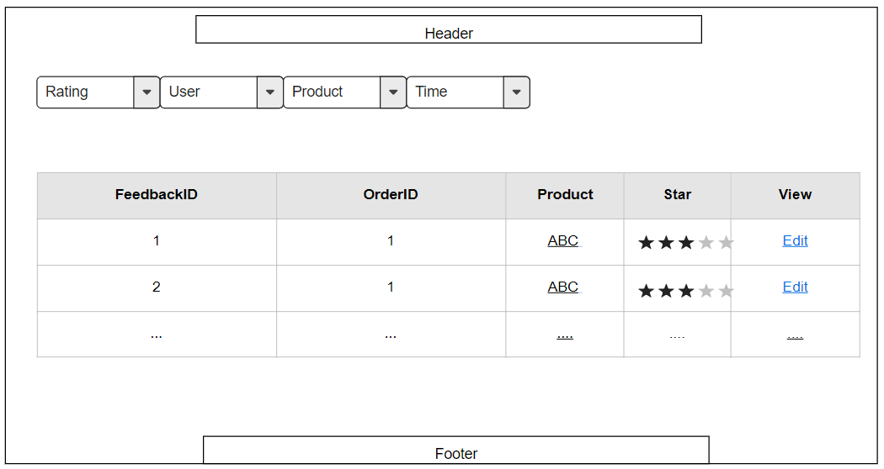

## 

## 22. Send Feedback

Function trigger: When the user want to contact with seller about product

Function description:

Role: User

Purpose: Customer writes and send a Feedback about a Product

Screen layout:

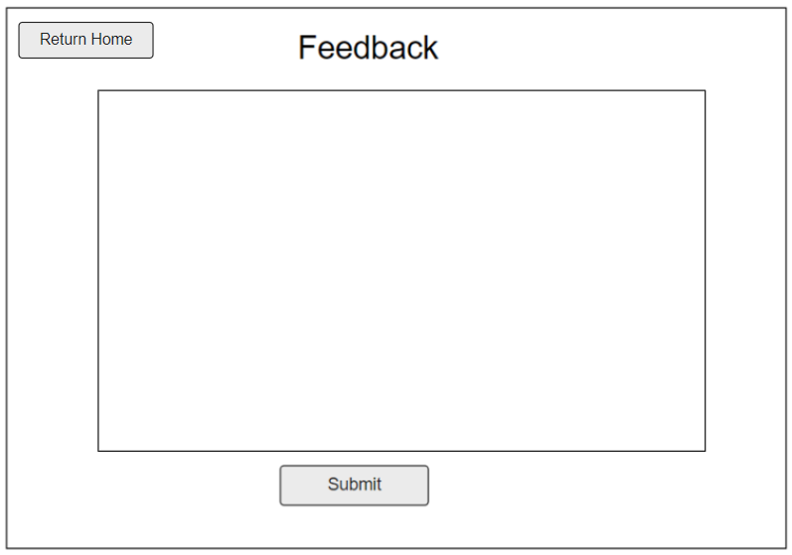

## 23. Blog List

Function trigger: User Click Blog in menu bar

Function description:

Role: Guest, User

Purpose: Customer views the list of all Blog

Screen layout:

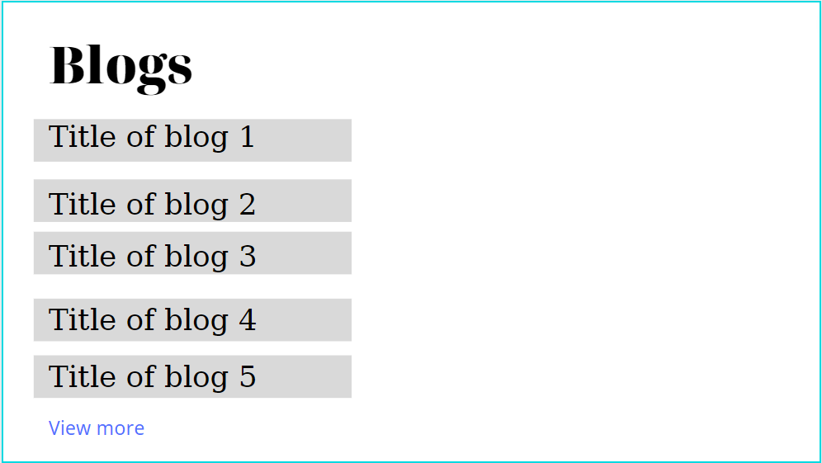

## 24. Blog Detail

Function trigger: User Click Blog in menu bar. Next, click Blog want to see detail

Function description:

Role: Guest, User

Purpose: Customer views the Detail information of 1 Blog

Screen layout:

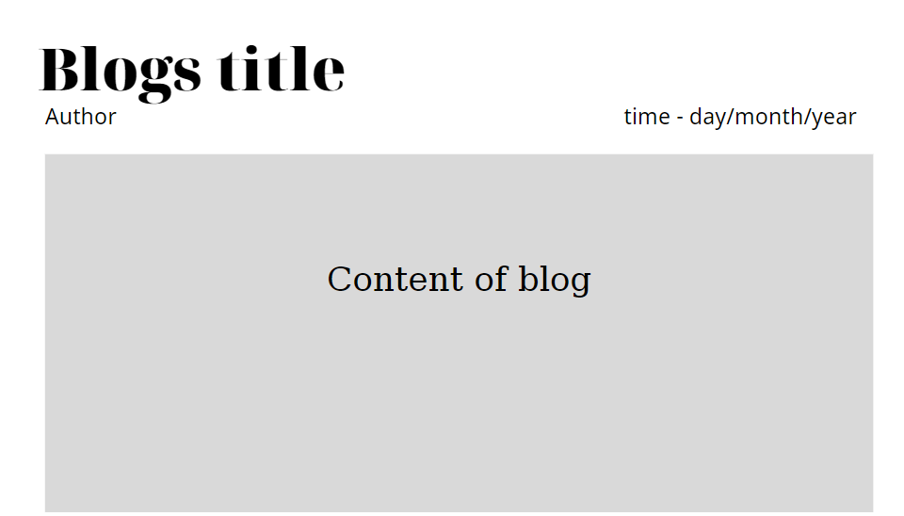

## 25.Add Blog

Function trigger: User click Add Blog button

Function description:

Role: User

Purpose: Users can add blogs.

Screen layout:

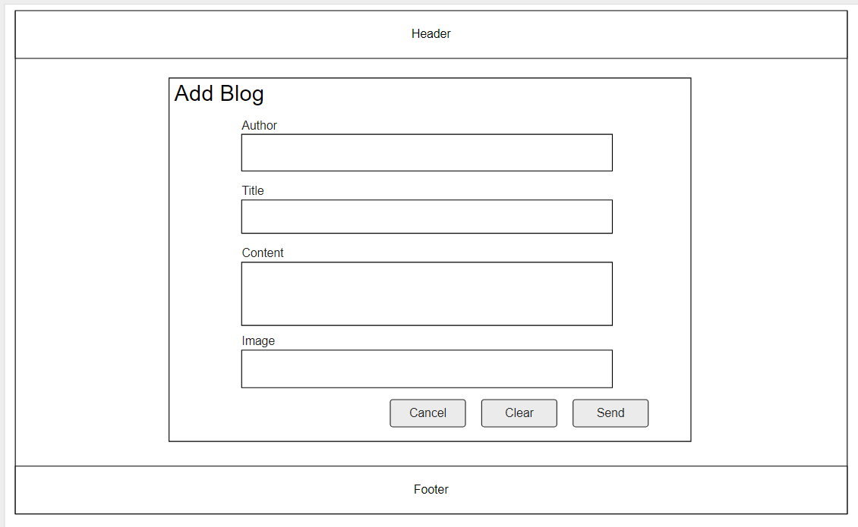

## 26.Update Blog

Function trigger: User click Update Blog button

Function description:

Role: User

Purpose: Users can update blogs.

Screen layout:

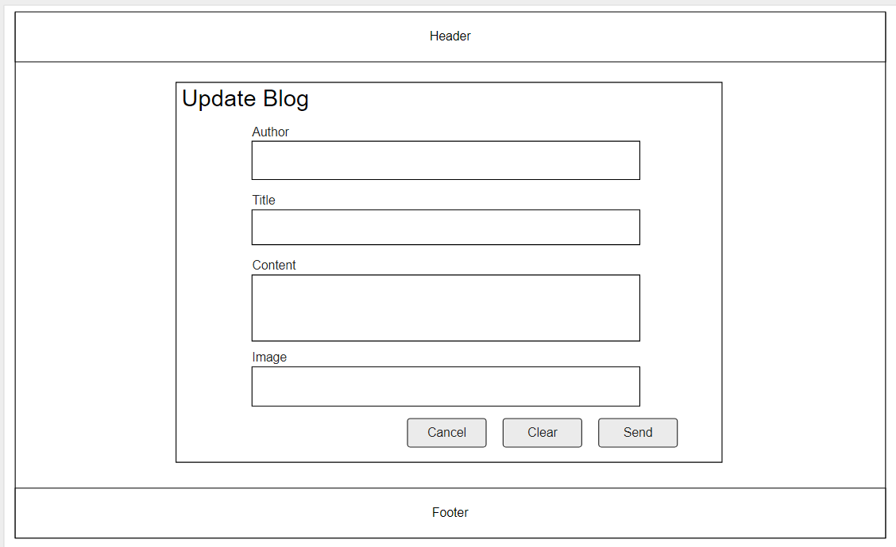

## 27.Blog management

Function trigger: Marketting click Manage Blog in menu bar,delete blog

Function description:

Role: Marketing

Purpose: Marketing can delete blogs.

Screen layout:

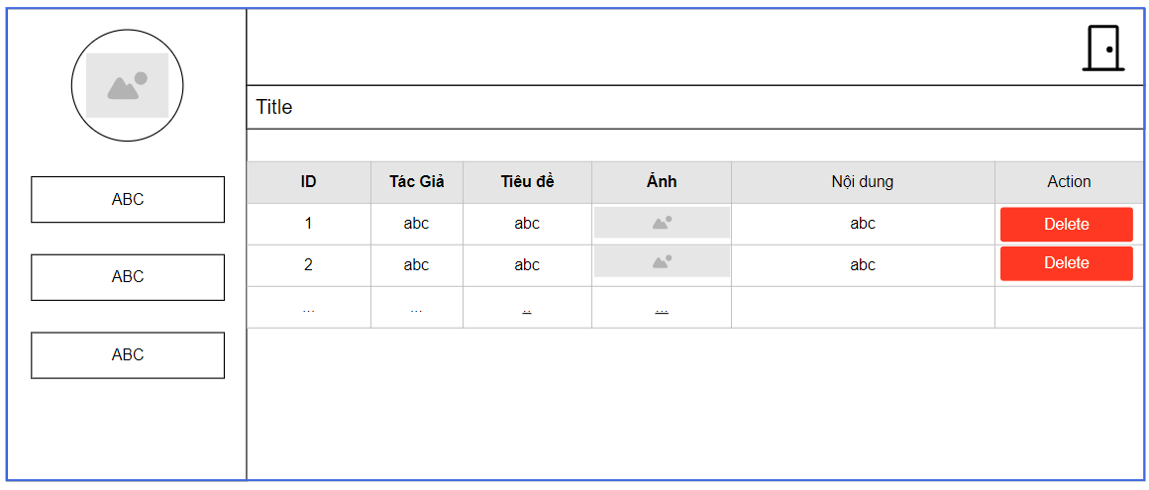

## 28.Replies Feedback

Function trigger: When the Seller clicks on the replies icon.

Function description:

Role: User

Purpose: Seller replies Customer feedback

Screen layout:

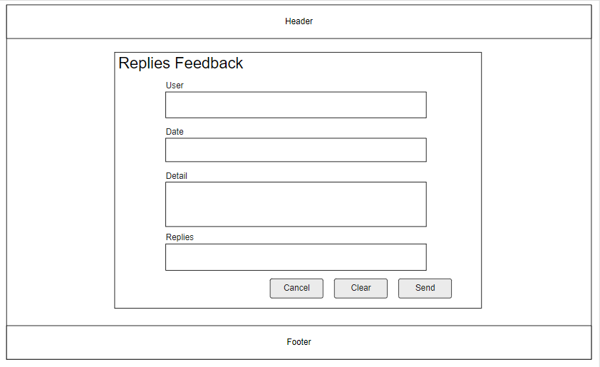

## 29.Notification

Function trigger: User click notification icon ( ) to view notification

Function description:

Role: User

Purpose: View notification about your order

Screen layout:

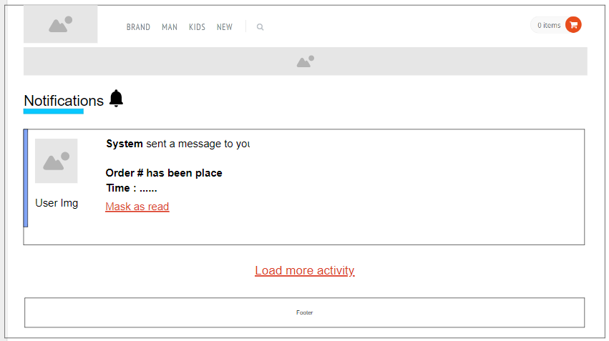

## 30.Error Page

* Function trigger: User accesses the website, the website got an error when progressing user request
* Function description:
  + Role: Guest, User, Seller, Admin
  + Purpose: Show in case there’s an Error occurs
  + Screen layout:

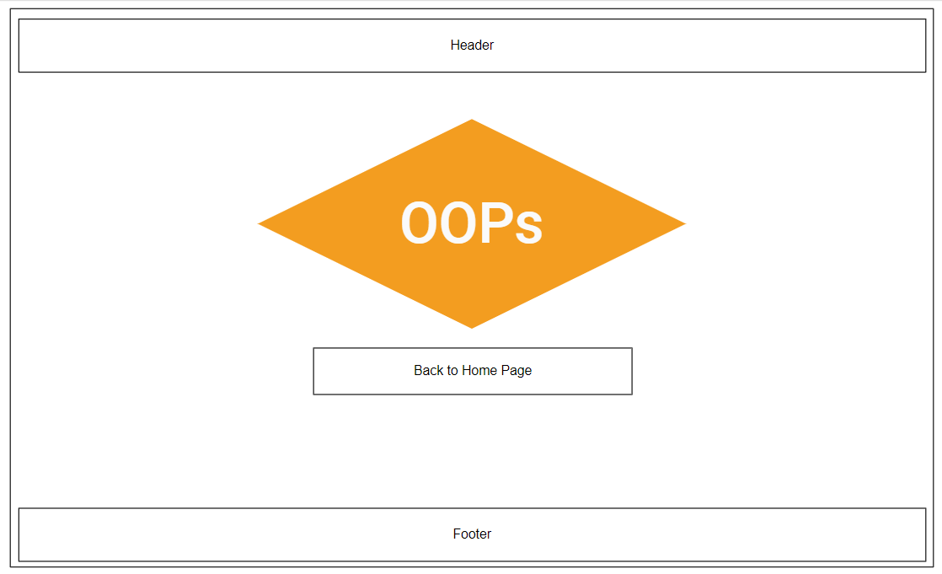

## 31.Homepage

Function trigger: User accesses the website

Function description:

Role: Guest, User

Purpose: Showcase feature product to visitors

Screen layout:

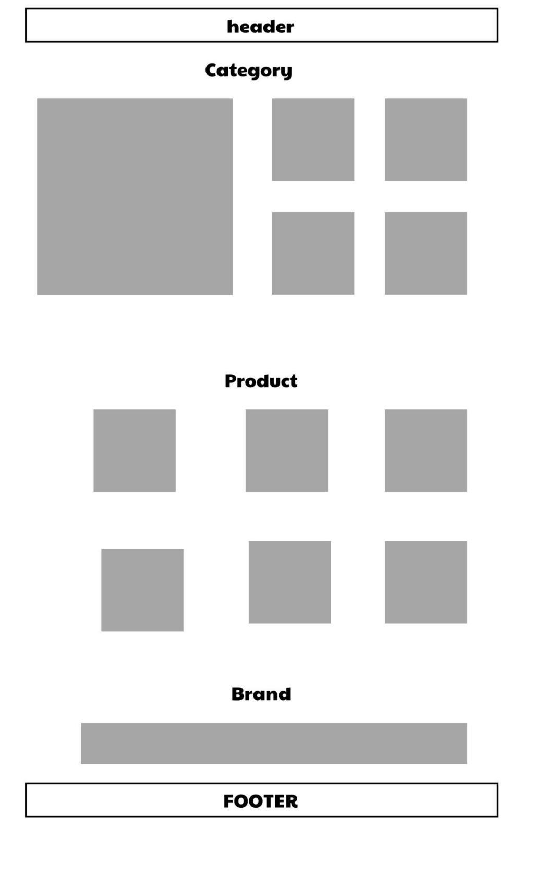

## 32.Order Management

Function trigger: Marketting click Manage Blog in menu bar,delete blog

Function description:

Role: Marketing

Purpose: Marketing can delete blogs.

Screen layout:

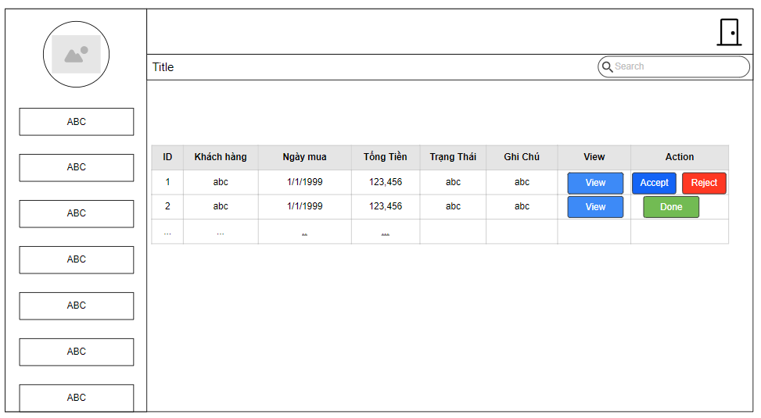

## 33.Chart Manager

Function trigger: Seller click on Chart Manager on SellDashBoard

Function description:

Role: Seller

Purpose: Seller can view total revenue and total category sold

Screen layout:

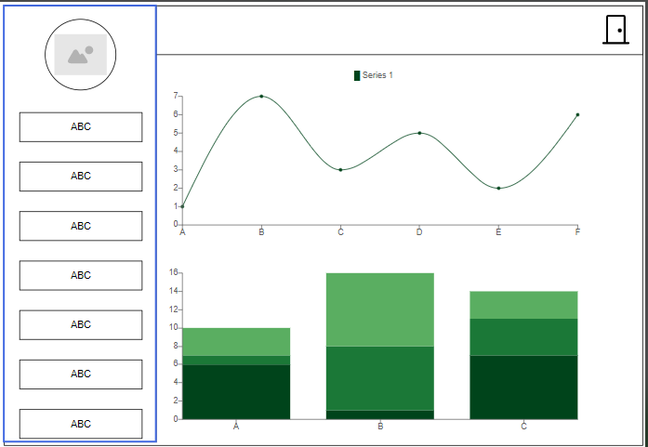

## 34.Admin Dashboard

Function trigger: Admin click on DashBoard

Function description:

Role: Admin

Purpose: Admin can view total accounts and manage accounts.

Screen layout:

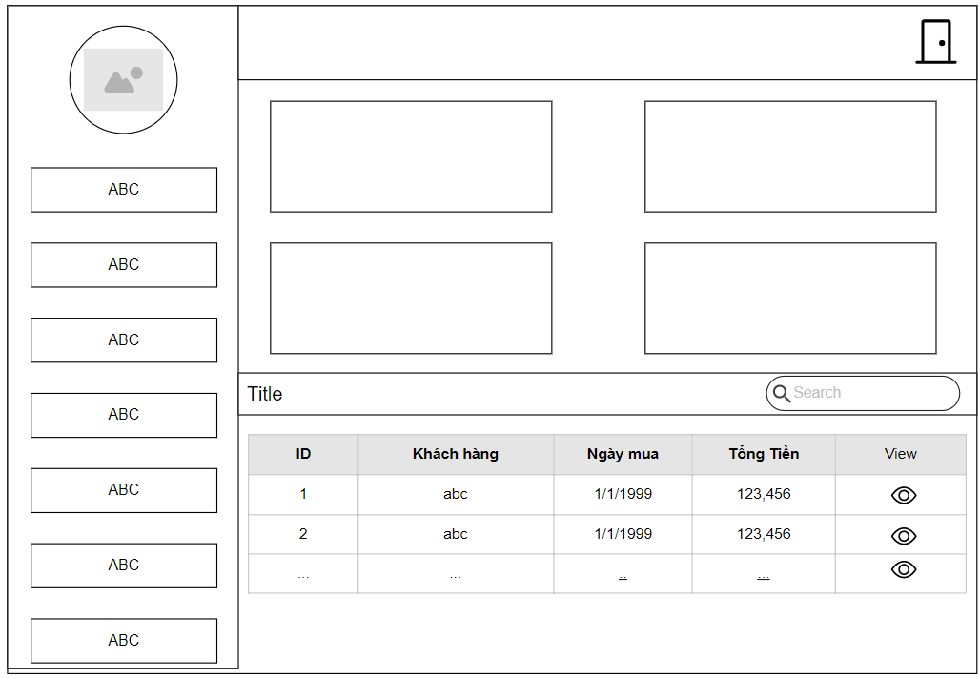

## 35.View brand

Function trigger: Sell click on DashBoard

Function description:

Role: sell

Purpose: Sell can view list of brand

Screen layout:

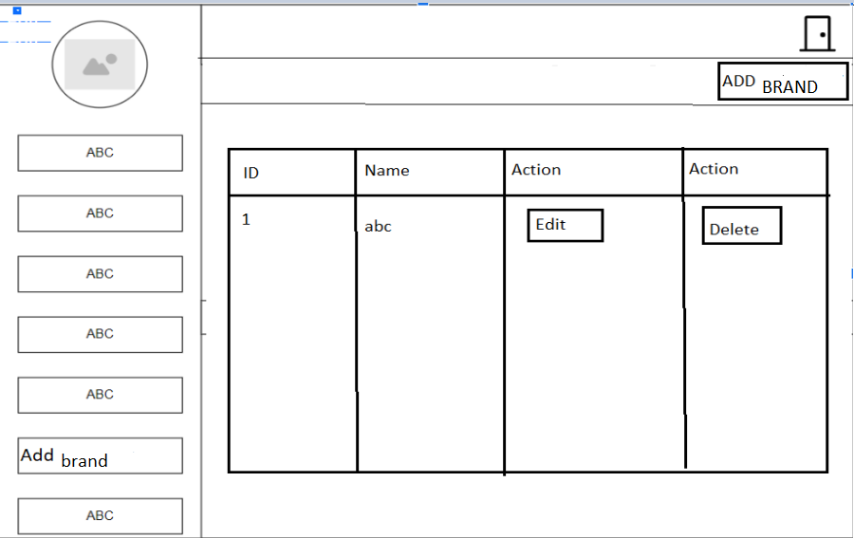

## 36.Add brand

Function trigger: Sell click on DashBoard

Function description:

Role: sell

Purpose: Sell can update brand

Screen layout:

## 37.Edit brand

Function trigger: Sell click on DashBoard

Function description:

Role: sell

Purpose: Sell can edit brand

Screen layout:

## 38.Category View

Function trigger: sellers go to the Dashboard and click to Add Category

Function description:

Role: Sellers

Purpose: Sellers can view list all of Category

Screen layout: 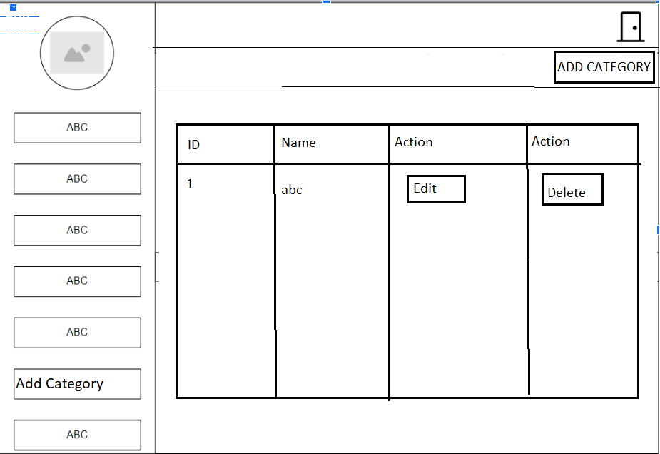

## 39.Add Category

Function trigger: sellers go to the Add Category on the Category View screen.

Function description:

Role: Sellers

Purpose: Sellers can add new Category

Screen layout:

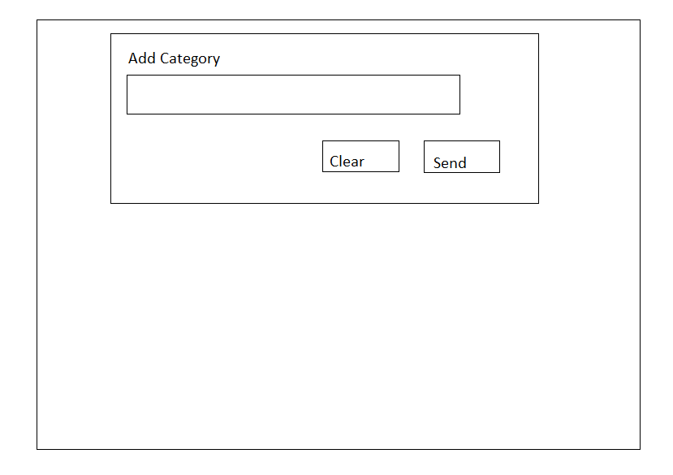

## 40.Edit Category

Function trigger: sellers go to the Edit Category on the Category View screen.

Function description:

Role: Sellers

Purpose: Sellers can edit Category and add, delete SubCategory

Screen layout:

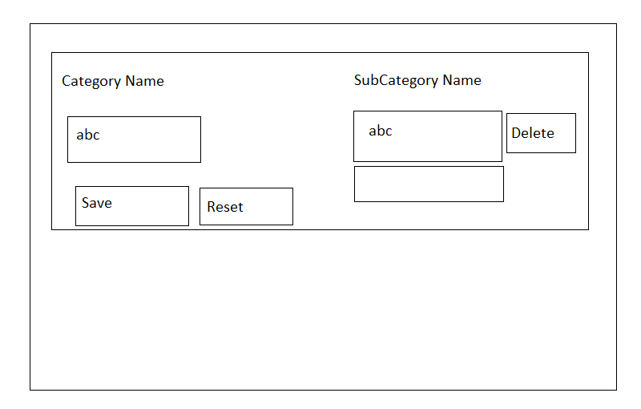

## 41.Delivery DashBoard[Shipper]

Function trigger: Shippers choose Delivery DashBoard on the HomeControl

Function description:

Role: Shipper

Purpose: Shipper can view total the product need to deliver and delivered

Screen layout:

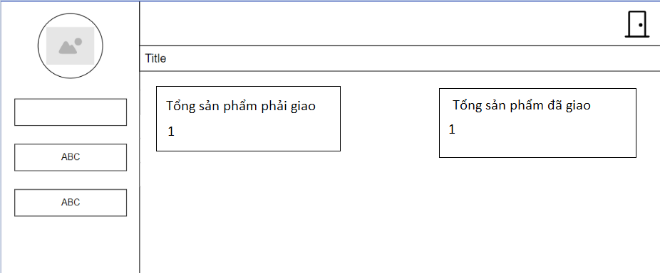

## 42.Delivering Product[Shipper]

Function trigger: Shippers choose Delivering on the Delivery DashBoard

Function description:

Role: Shipper

Purpose: Shipper can view total the product need to deliver

Screen layout:

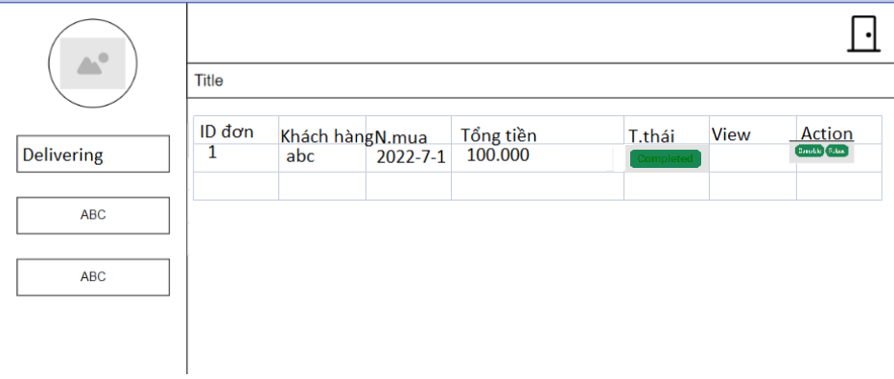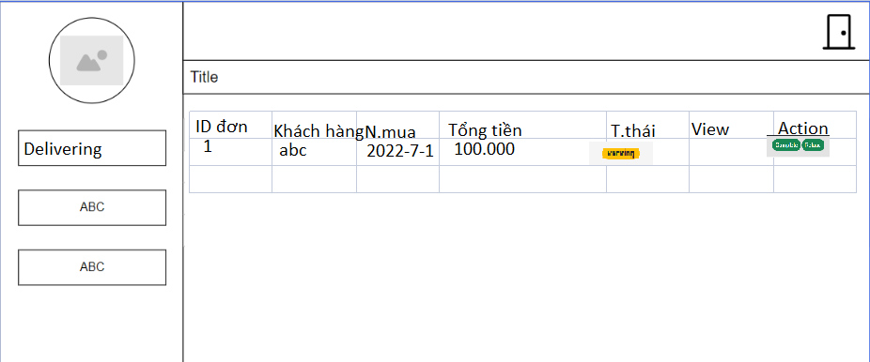

## 43.Completed Product[Shipper]

Function trigger: Shippers choose Completed on the Delivery DashBoard

Function description:

Role: Shipper

Purpose: Shipper can view the product are completed deliver.

Screen layout:

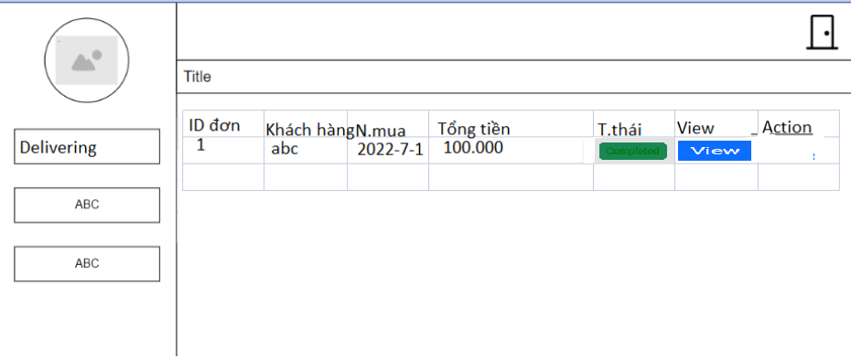

## 44.Canceled Product[Shipper]

Function trigger: Shippers choose Completed on the Delivery DashBoard

Function description:

Role: Shipper

Purpose: Shipper can view the product are completed deliver.

Screen layout:

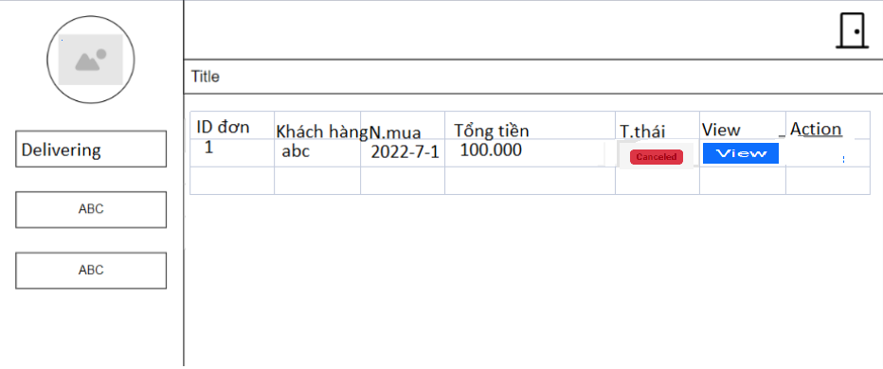

## 45.View Order History

Function trigger: Choose Order History in the menu bar

Function description:

Role: Customers

Purpose: Everyone can view the product which bought

Screen layout:

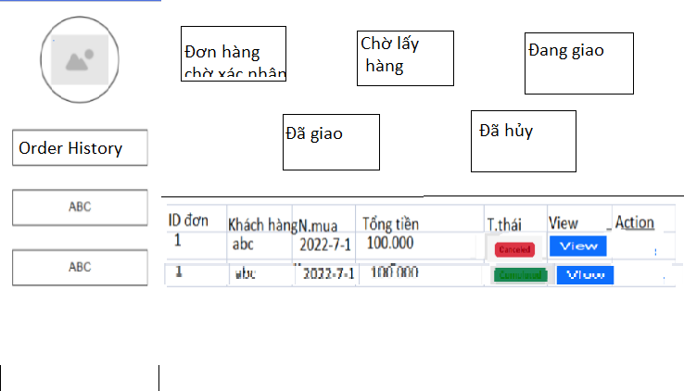

## 46.View the product are waiting confirmation

Function trigger: Choose Waiting confirmation in the Order History

Function description:

Role: Customers

Purpose: Everyone can view the product are waiting confirmation

Screen layout:

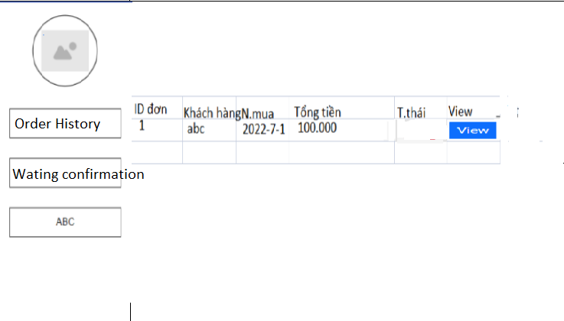

## 47.View the product are packing

Function trigger: Choose Packing in the Order History

Function description:

Role: Customers

Purpose: Everyone can view the product are packing

Screen layout:

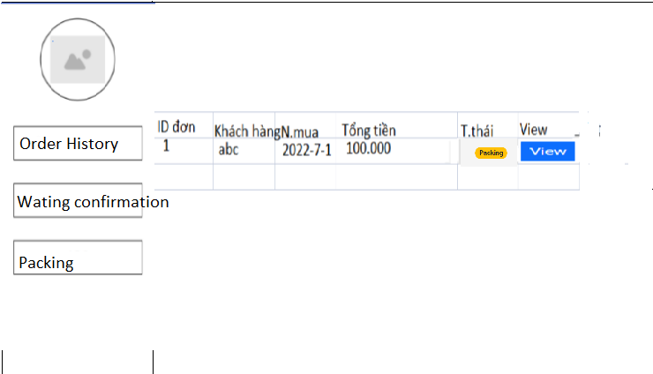

## 48.View the product are Delivering

Function trigger: Choose Delivering in the Order History

Function description:

Role: Customers

Purpose: Everyone can view the product are delivering

Screen layout:

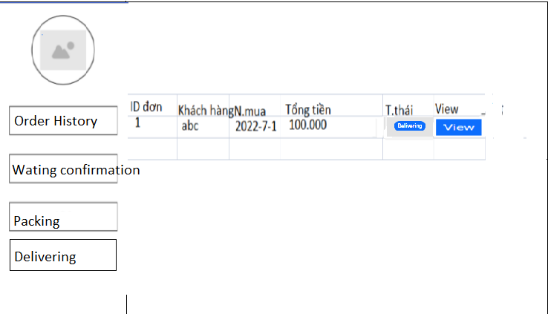

## 49.View the product are Completed

Function trigger: Choose Completed in the Order History

Function description:

Role: Customers

Purpose: Everyone can view the product are completed

Screen layout:

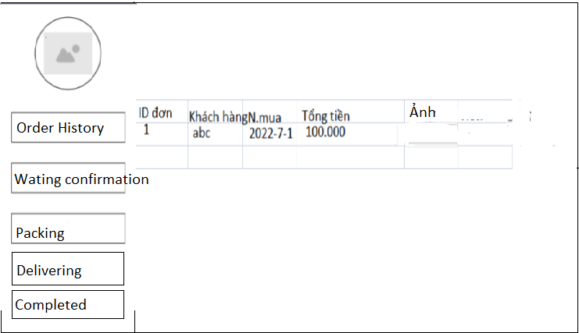

## 50.View the product are Cancelled

Function trigger: Choose Cancelled in the Order History

Function description:

Role: Customers

Purpose: Everyone can view the product are Cancelled

Screen layout:

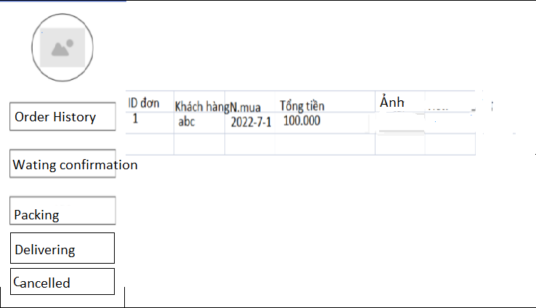

## 44. Manager Product

Function trigger: sellers go to the view product

Function description:

Role: Sellers

Purpose: Sellers can view Product

Screen layout:

## 45.Add Product

Function trigger: sellers go to the Add Category Function description:

Role: Sellers

Purpose: Sellers can add Product

Screen layout:

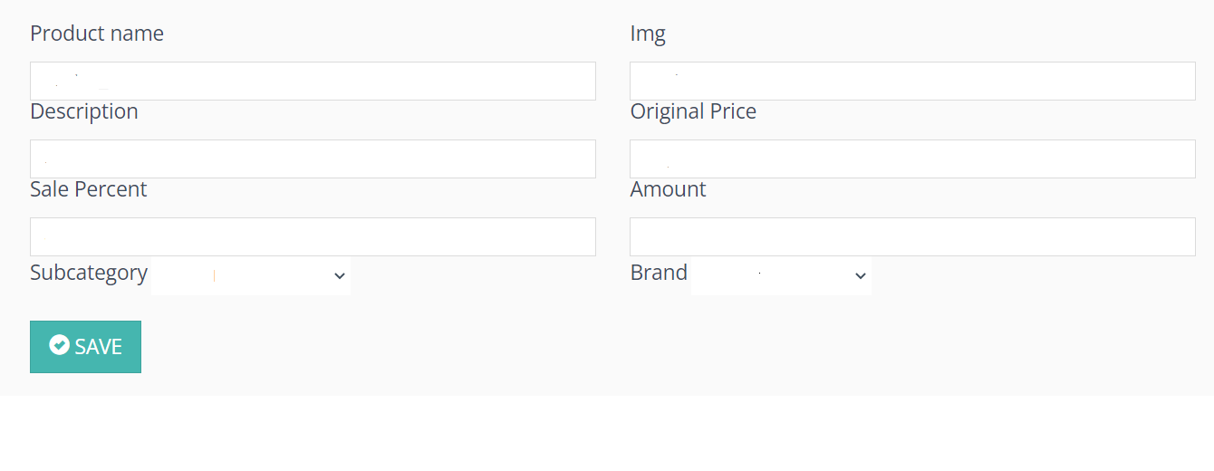

## 46. Edit Product

Function trigger: sellers go to the Edit Product

Function description:

Role: Sellers

Purpose: Sellers can edit product

Screen layout:

