|  |  |
| --- | --- |
| Function name | Description |
| Add | Add new OC insert to OC table in database |
| Add lower level | Add Sub OC insert to OC table in database |
| Edit | Edit OC name: double click record update to OC table in database |
| Cancel | Hủy bỏ thao tác thêm mới hoặc chỉnh sửa dòng dữ liệu trên grid table |
| Add Sub item | Add Sub OC: right click |
| Delete | Delete data record from OC table |

1. OC

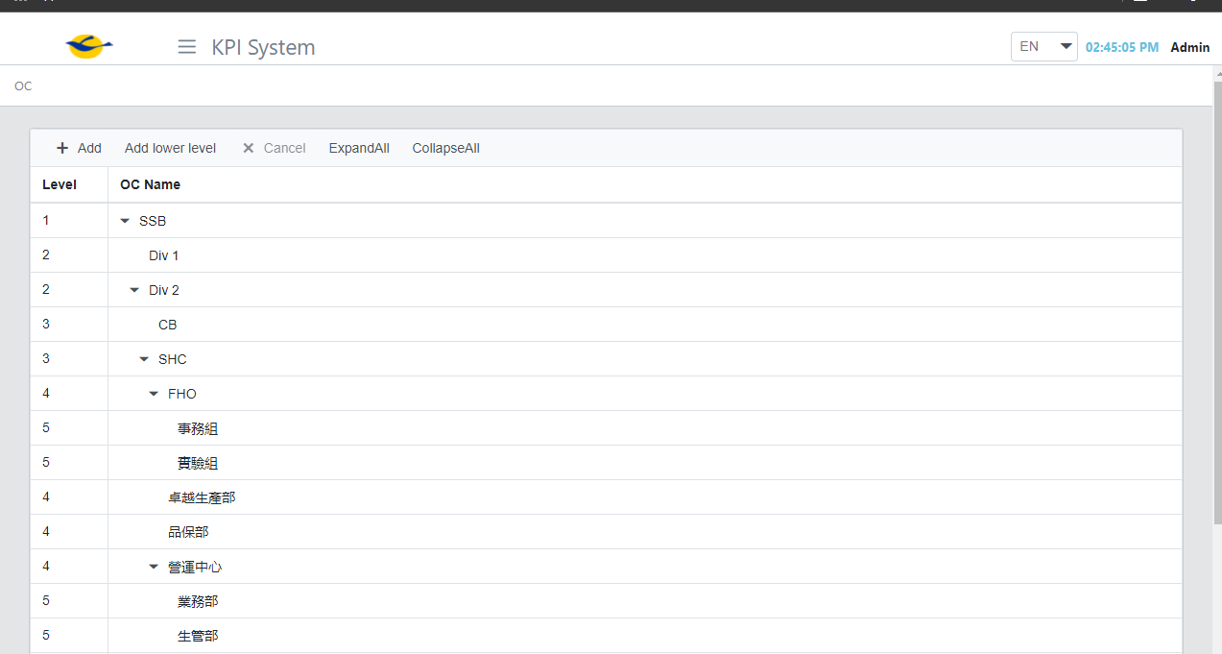

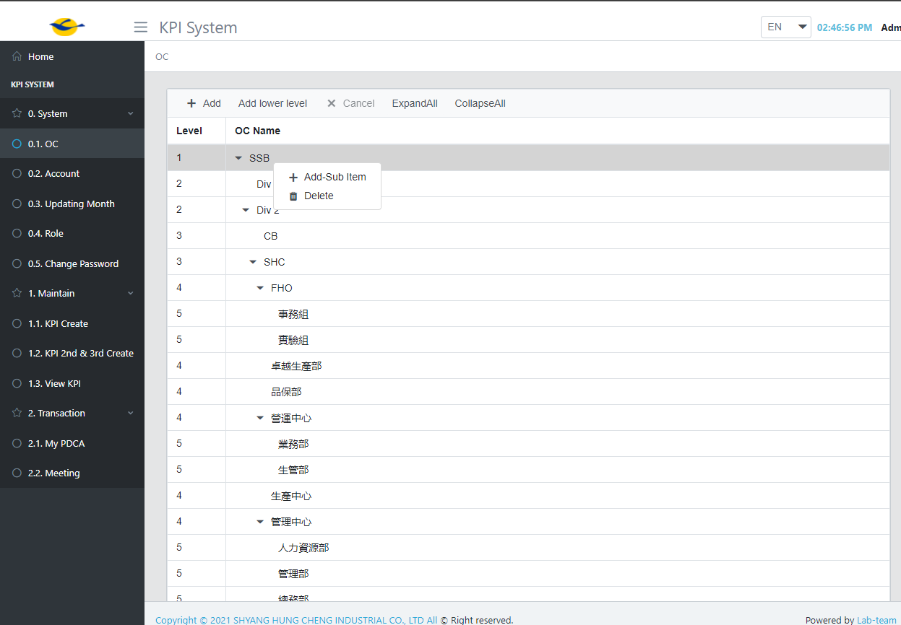

1. Account

|  |  |
| --- | --- |
| Function name | Description |
| Add | Insert new account to Accounts table in database |
| Update | Save data when edit account to Accounts table |
| Edit |  |
| Delete | Delete account from Accounts table |
| Cancel | Hủy bỏ thao tác thêm mới hoặc chỉnh sửa dòng dữ liệu trên grid table |
|  |  |
|  |  |

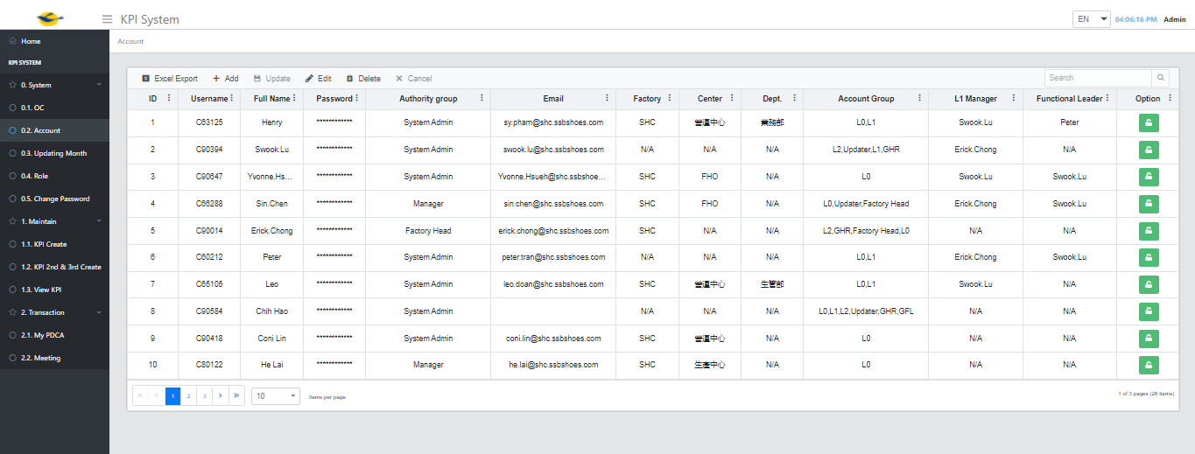

Setting Monthly

|  |  |
| --- | --- |
| Function name | description |
| Add | Insert date time to SettingMonthly table in database |
| Update | Save data when edit record |
| Edit | Edit record |
| Delete | Delete record from SettingMonthly table in database |
| Cancel | Hủy bỏ thao tác thêm mới hoặc chỉnh sửa trên grid table |

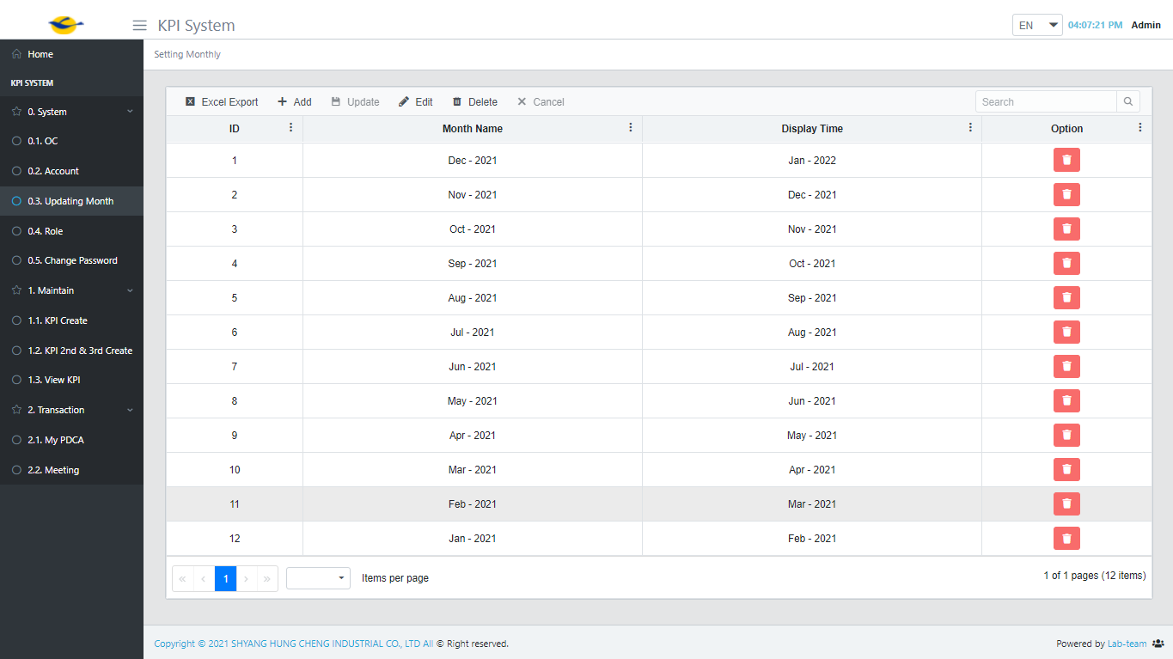

|  |  |
| --- | --- |
| Function name | Description |
| Add | Add new Role Group for user to Roles table in database |
| Update | Save role when edit |
| Edit | Update role name: Double click record |
| Delete | Delete role from Roles table |
| Cancel | Hủy bỏ thao tác thêm mới hoặc chỉnh sửa trên grid table |
| Privilege | Go to set role for user of group |
|  |  |

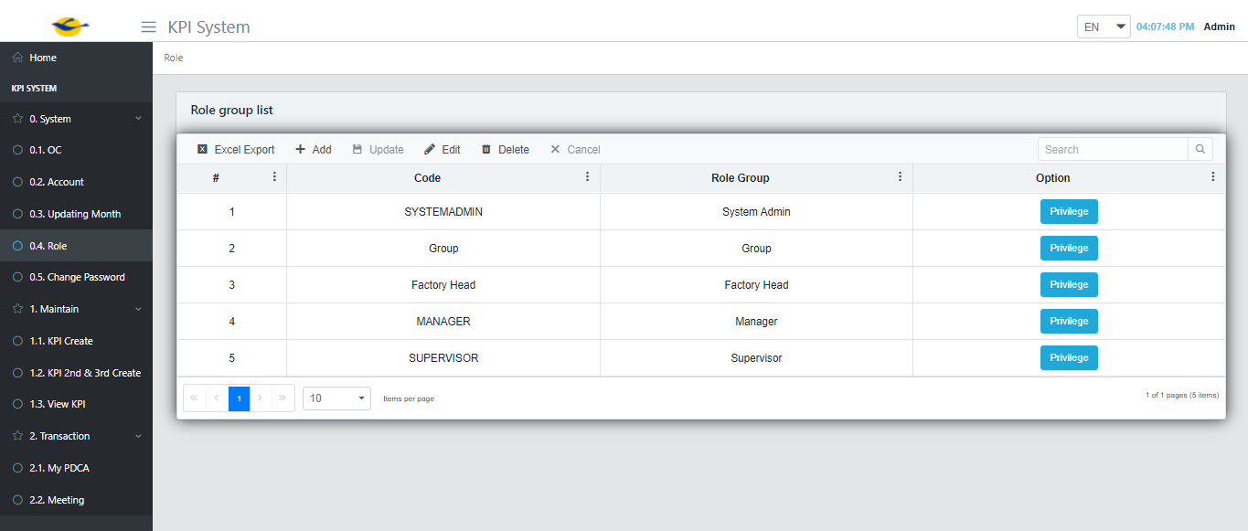

Set role

* select the permission you want to assign to the user group and press save button => save data to Permission table in database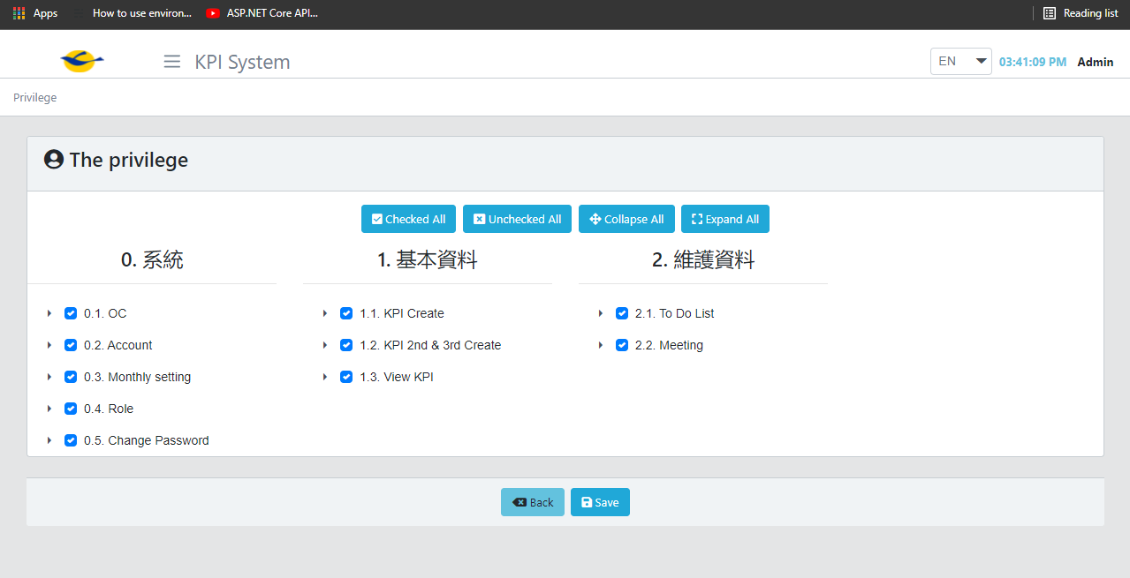

Change Password

Key in a new password and confirm pass word => press submit button => update a new password to Account table in database

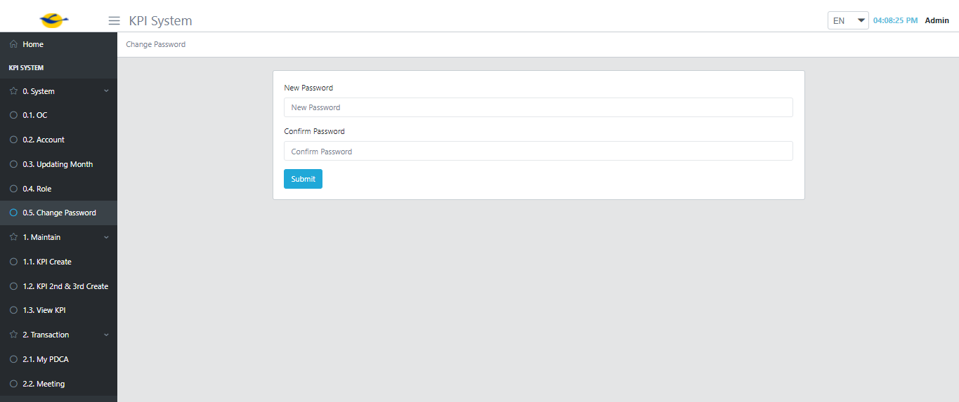

KPI Create

|  |  |
| --- | --- |
| Function name | Description |
| Add | Add new KPI level 1 insert to KPINew , KPIAccount table |
| Update | Save data when edit |
| Cancel | Hủy bỏ thao tác thêm mới hoặc chỉnh sửa trên grid table |
|  |  |
|  |  |
|  |  |
|  |  |

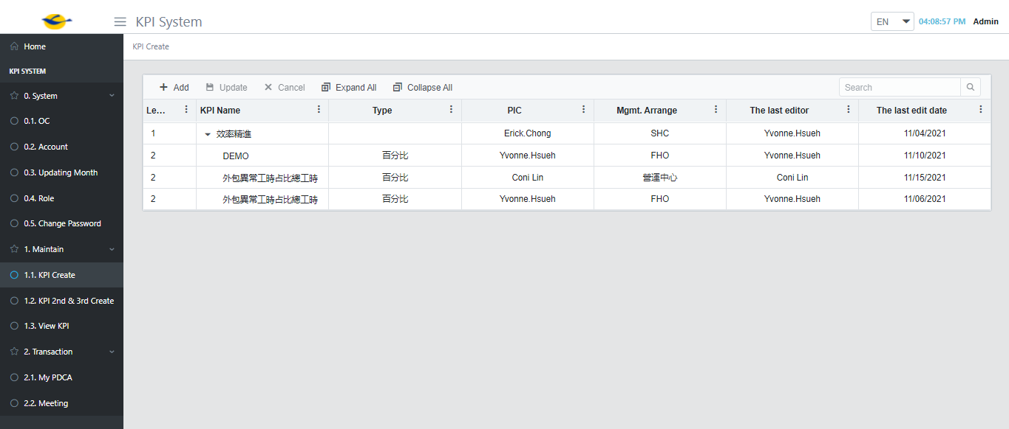

KPI 2nd & 3rd

|  |  |
| --- | --- |
| Function name | Description |
| Add LL KPI | Add KPI level 2 and level 3 insert to KPINew, KPIAccount table |
| Update | Save data when edit record update to KPINew, KPIAccount table |
| Cancel | Hủy bỏ thao tác thêm mới hoặc chỉnh sửa trên grid table |

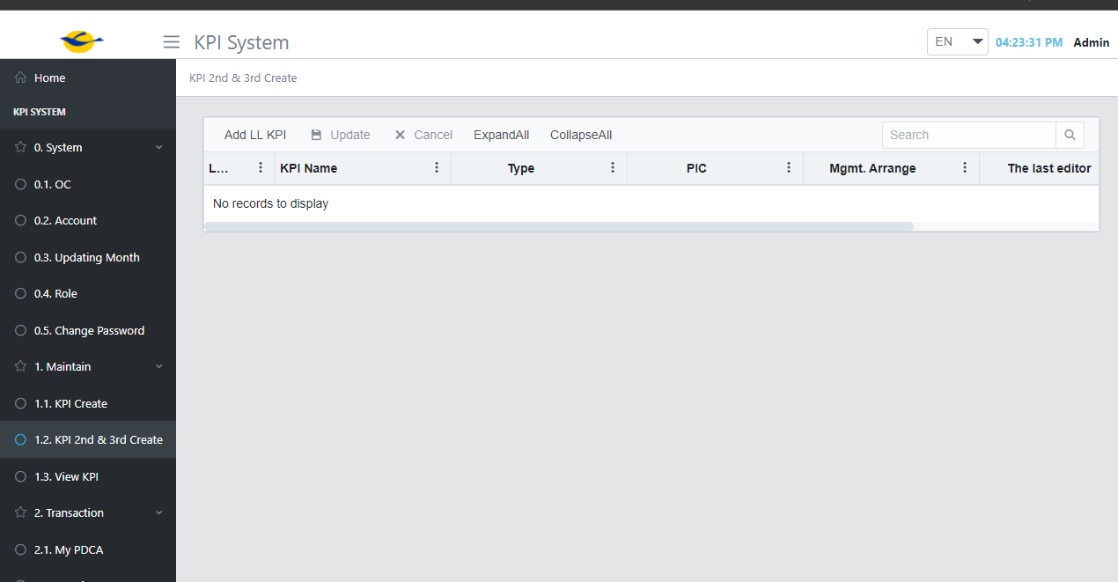

KPI View => View All KPI

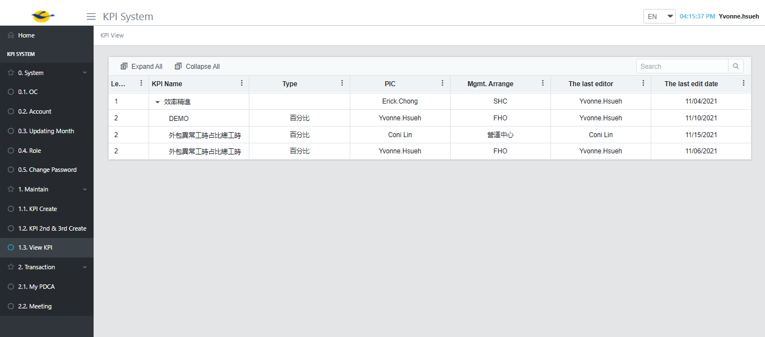

Page: My PDCA

Function: Action & Update PDCA

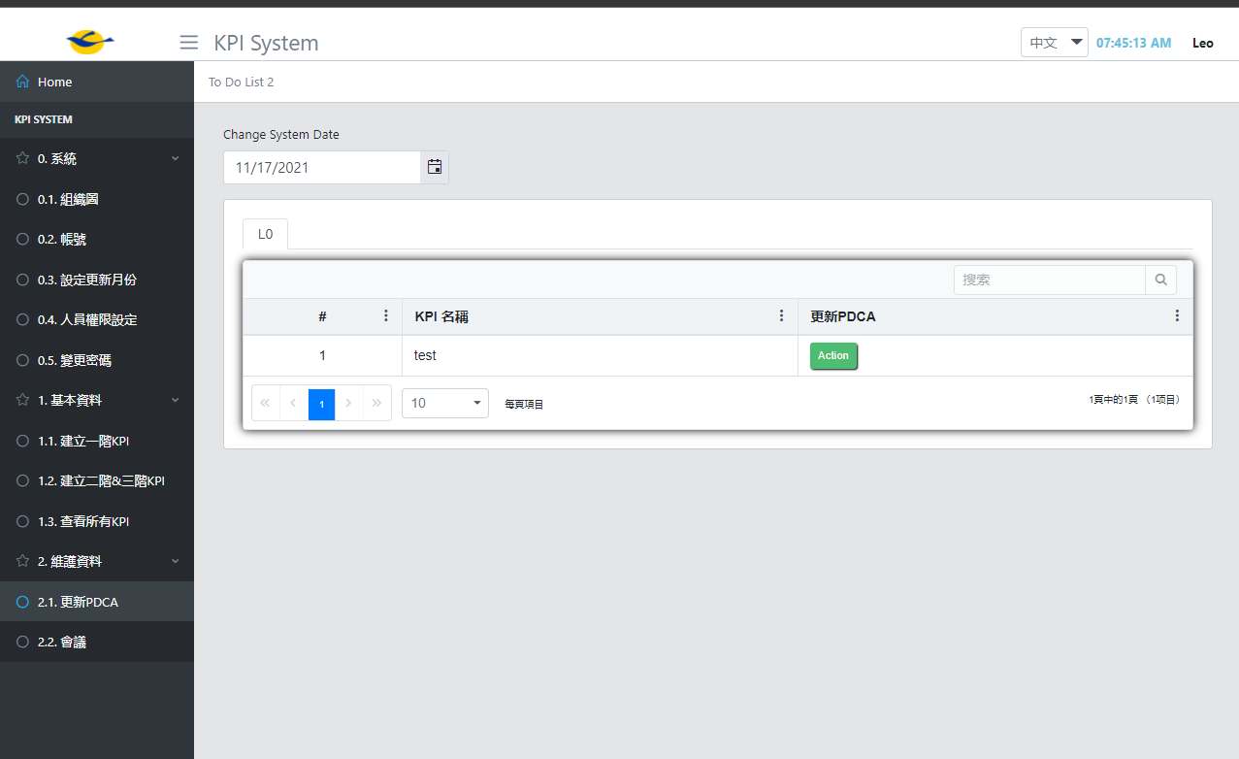

|  |  |
| --- | --- |
| Function name | Description |
| Action button | Click action button show Plan modal |
| Next month Target | Key in the number value |
| Target YTD | Key in the number value |
| Add | Add a new Plan |
| Delete | Delete Plan |
| Plan | Key in : string |
| Target | Key in : string |
| Deadline | Date time |
| Save | Save all current content to Actions, Targets, TargetYTD table and keep action button |
| Submit | Save all content to Actions, KPIAccount, Targets, TargetPIC , TargetYTD table and disappear action button |

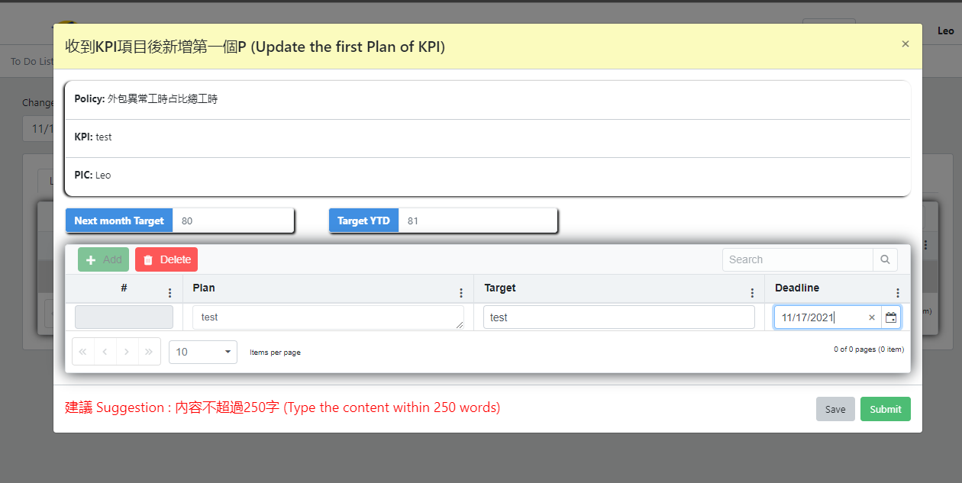

#### Update PDCA => update PDCA previous monthly

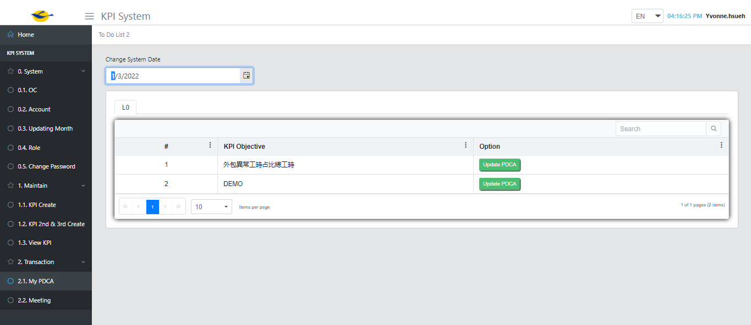

|  |  |
| --- | --- |
| Function name | Description |
| Update PDCA button | Click PDCA button show PDCA modal |
| This month performance | Key in the number value |
| This month YTD | Key in the number value |
| This month target | Data from previous monthly |
| Target YTD | Data from previous monthly |
| Next month target | Key in the number value |
| Add | Create new plan for current month |
| Delete | Delete plan |
| Save | Save all content to Targets, TargetYTD, Actions , Do table , close modal but keep PDCA button |
| Submit | Save all content to KPIAccount, Target, TargetYTD, Actions, ActionStatus, Do table and submit data to server , hidden PDCA button |
| D (Do) | Type text |
| Achievement | Type text |
| Status | Select status : update status for last month’s plan insert or update status to ActionStatus table |
| C (Content) | Type text |

