|  |  |
| --- | --- |
| Function name | Description |
| Add | Store data into tbl.OC in database |
| Add lower level | Store data into tbl.OC in database |
| Edit | Update data on tbl.OC |
| Cancel | Hủy bỏ thao tác thêm mới hoặc chỉnh sửa dòng dữ liệu trên grid table |
| Add Sub item | Store data into tbl.OC in database |
| Delete | Delete data r from tbl.OC |

1. OC

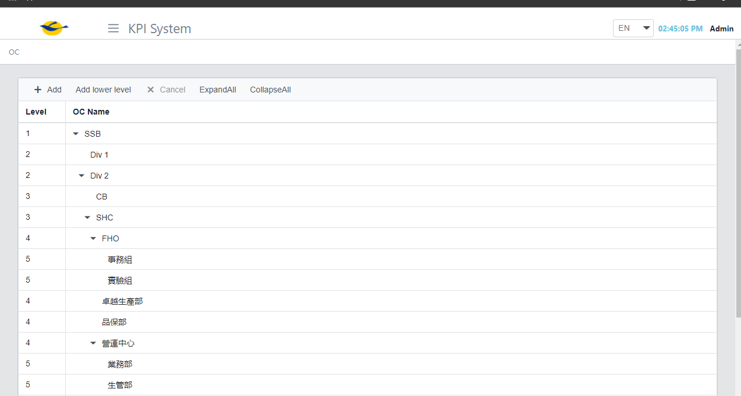

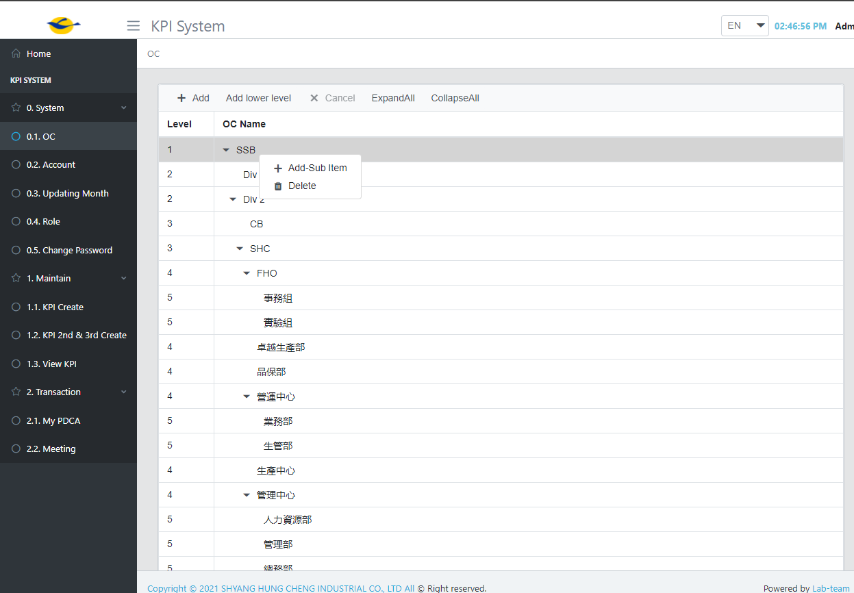

1. Account

|  |  |
| --- | --- |
| Function name | Description |
| Add | Store data into tbl.Accounts in database |
| Update | Update data on tbl.Account |
| Edit |  |
| Delete | Delete account from tbl.Account |
| Cancel | Hủy bỏ thao tác thêm mới hoặc chỉnh sửa dòng dữ liệu trên grid table |
|  |  |
|  |  |

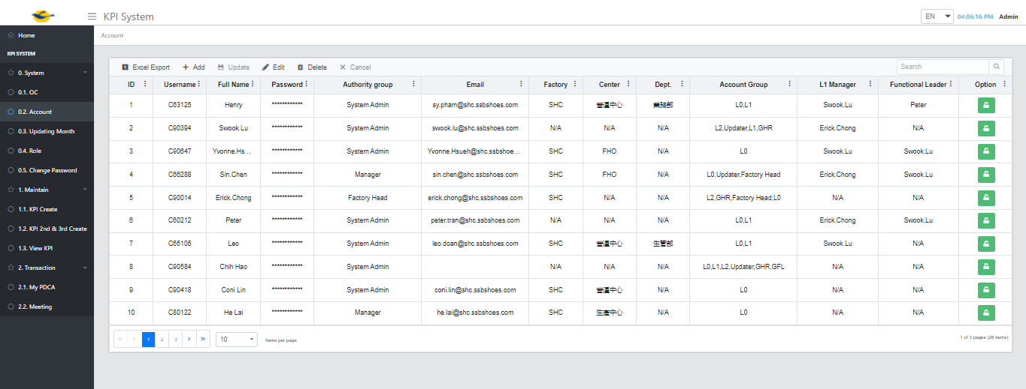

Setting Monthly

|  |  |
| --- | --- |
| Function name | description |
| Add | Store data into tbl.SettingMonthly in database |
| Update | Update data on tbl.SettingMonthly |
| Edit | Edit record |
| Delete | Delete record from tbl.SettingMonthly |
| Cancel | Hủy bỏ thao tác thêm mới hoặc chỉnh sửa trên grid table |

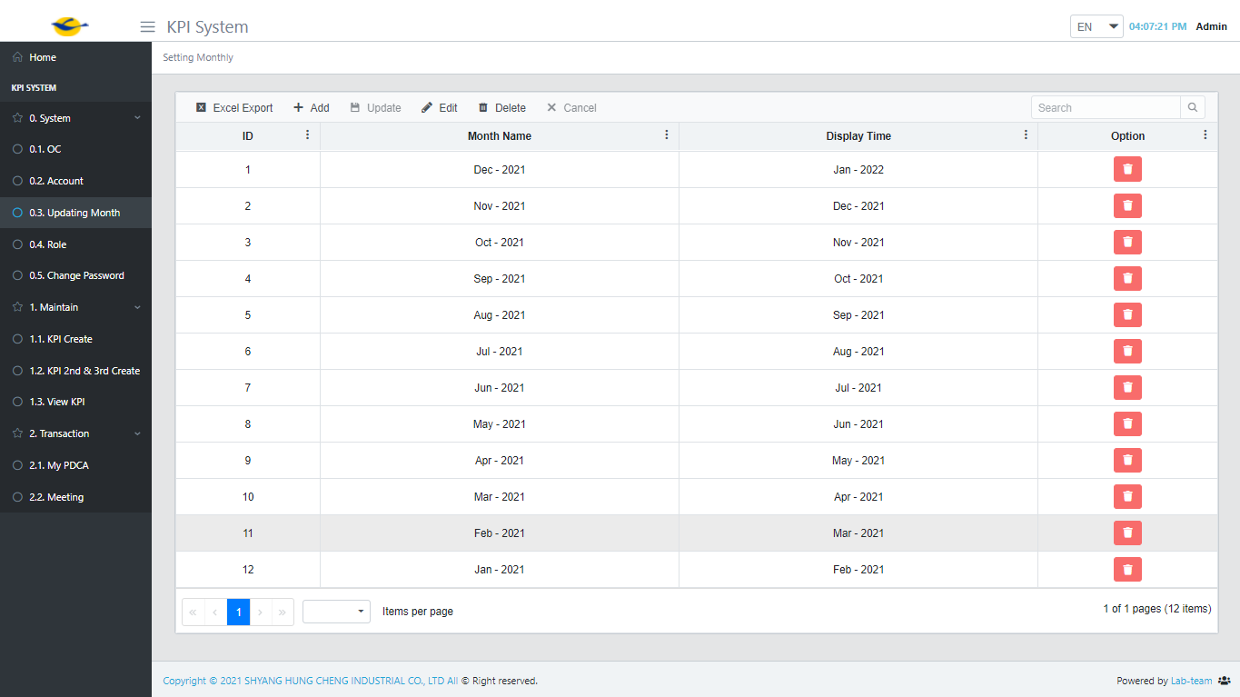

|  |  |
| --- | --- |
| Function name | Description |
| Add | Store data into tbl.Roles in database |
| Update | Update data on tbl.Roles |
| Edit |  |
| Delete | Delete role from tbl.Roles |
| Cancel | Hủy bỏ thao tác thêm mới hoặc chỉnh sửa trên grid table |
| Privilege | Go to set role for user of group |
|  |  |

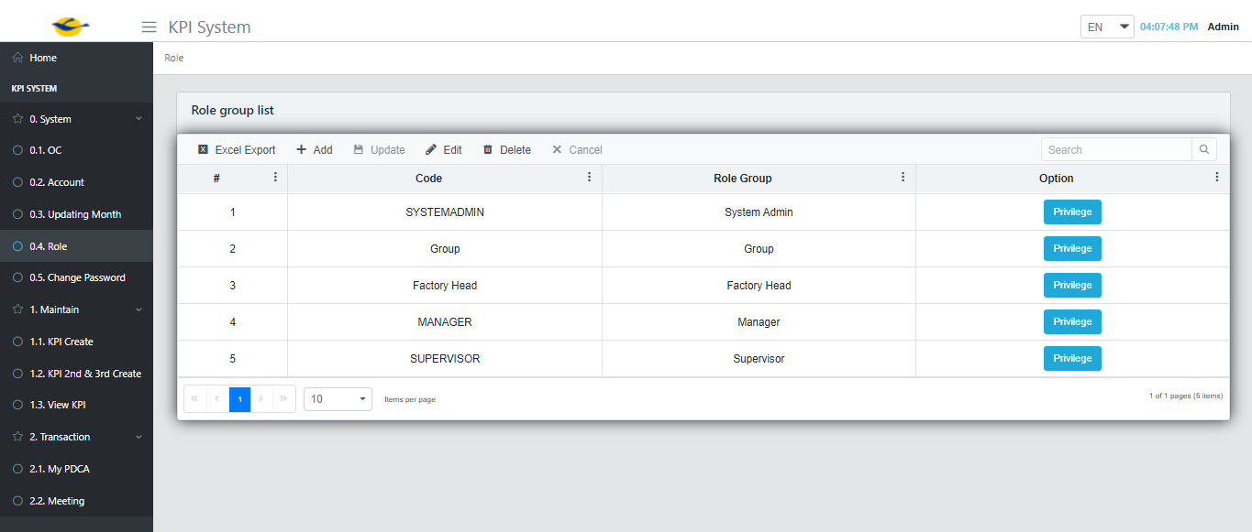

Set role

* select the permission you want to assign to the user group and press save button => save data to tbl.Permission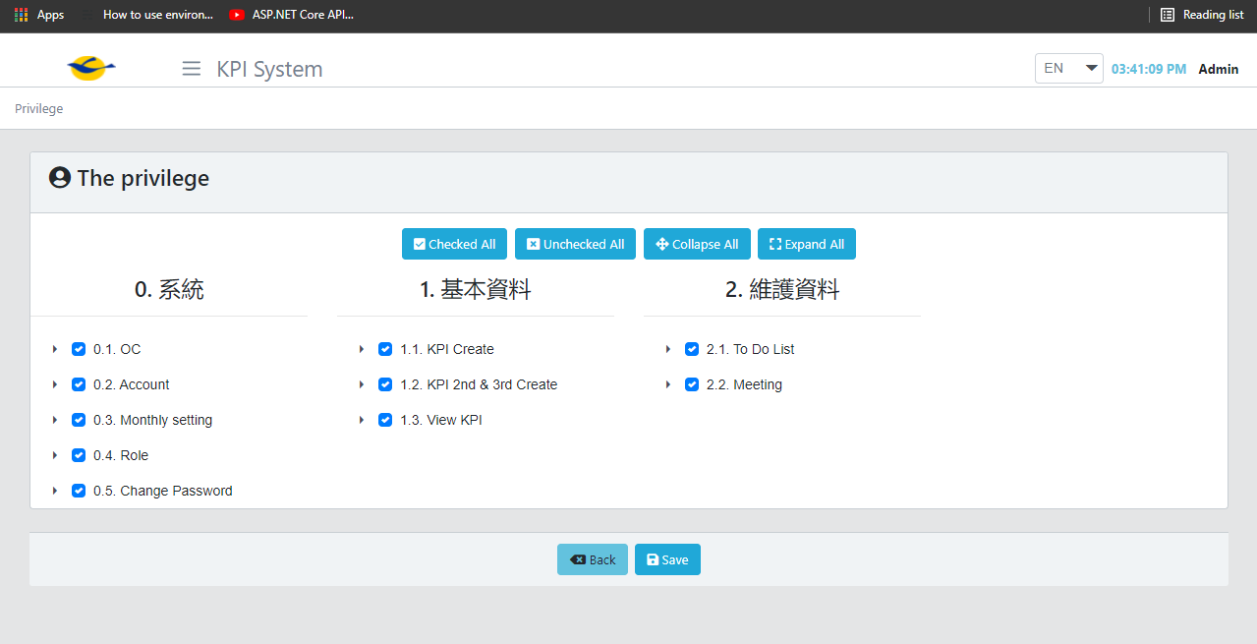

Change Password

Key in a new password and confirm pass word => update a new password to tbl.Account table in database

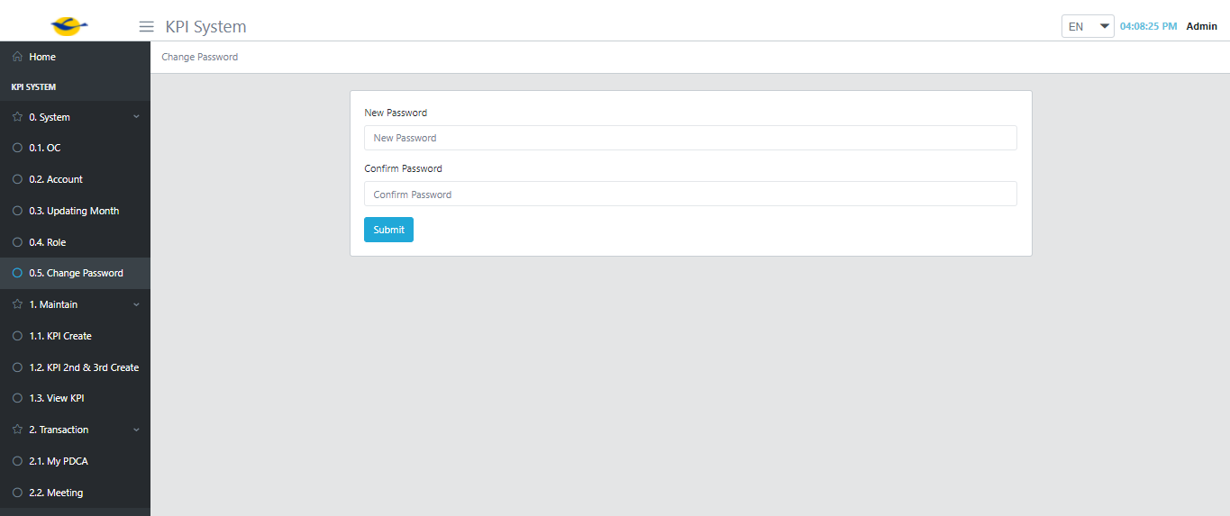

KPI Create

|  |  |
| --- | --- |
| Function name | Description |
| Add | Store data into tbl.KPINew , tbl.KPIAccount in database |
| Update | Update data on tbl.KPINew , tbl.KPIAccount |
| Cancel | Hủy bỏ thao tác thêm mới hoặc chỉnh sửa trên grid table |
|  |  |
|  |  |
|  |  |
|  |  |

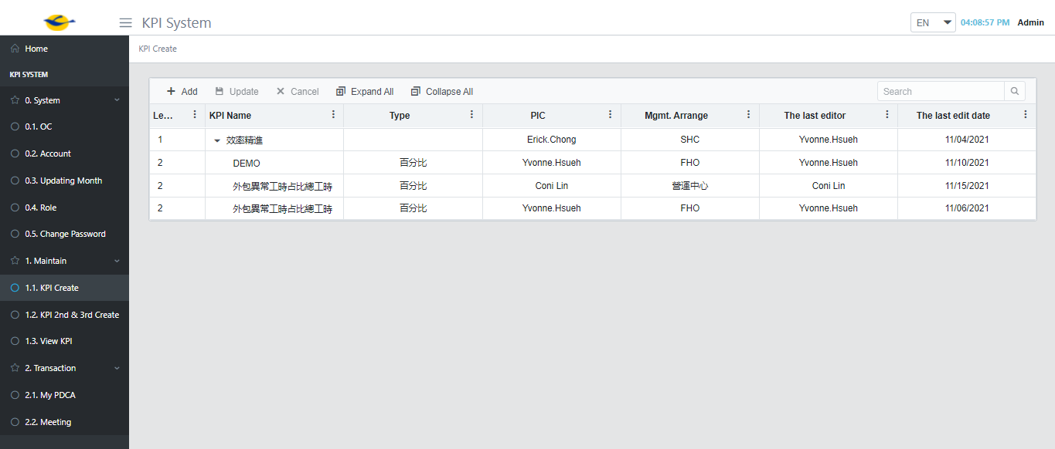

KPI 2nd & 3rd

|  |  |
| --- | --- |
| Function name | Description |
| Add LL KPI | Store data into tbl.KPINew , tbl.KPIAccount in database |
| Update | Update data on tbl.KPINew , tbl.KPIAccount |
| Cancel | Hủy bỏ thao tác thêm mới hoặc chỉnh sửa trên grid table |

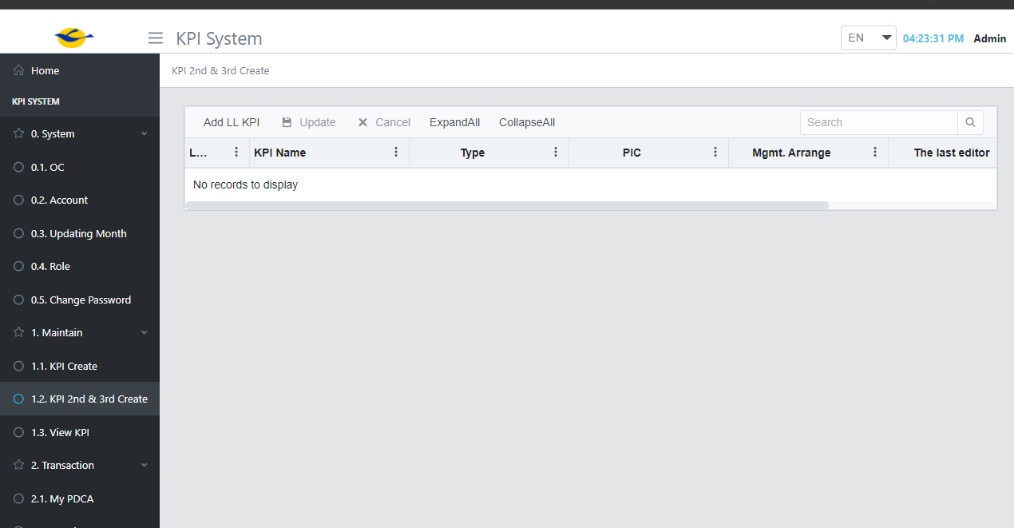

KPI View => View All KPI

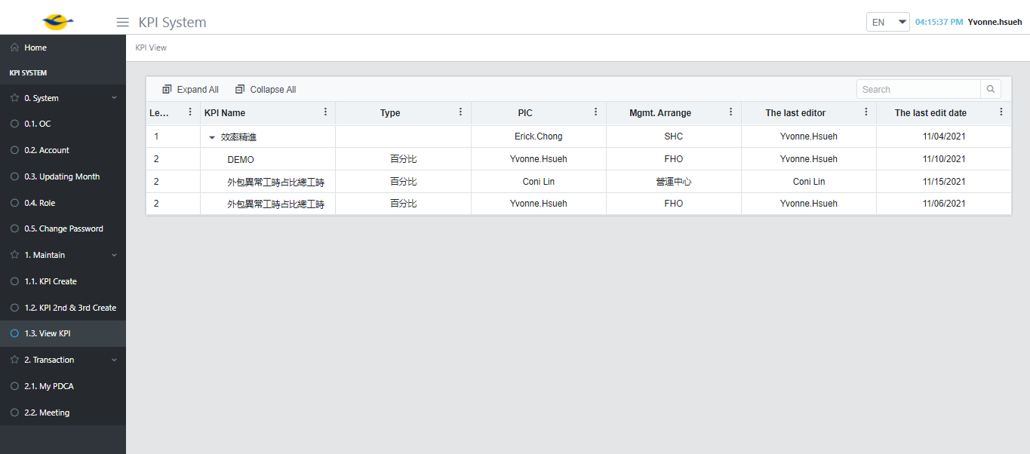

Page: My PDCA

Function: Action & Update PDCA

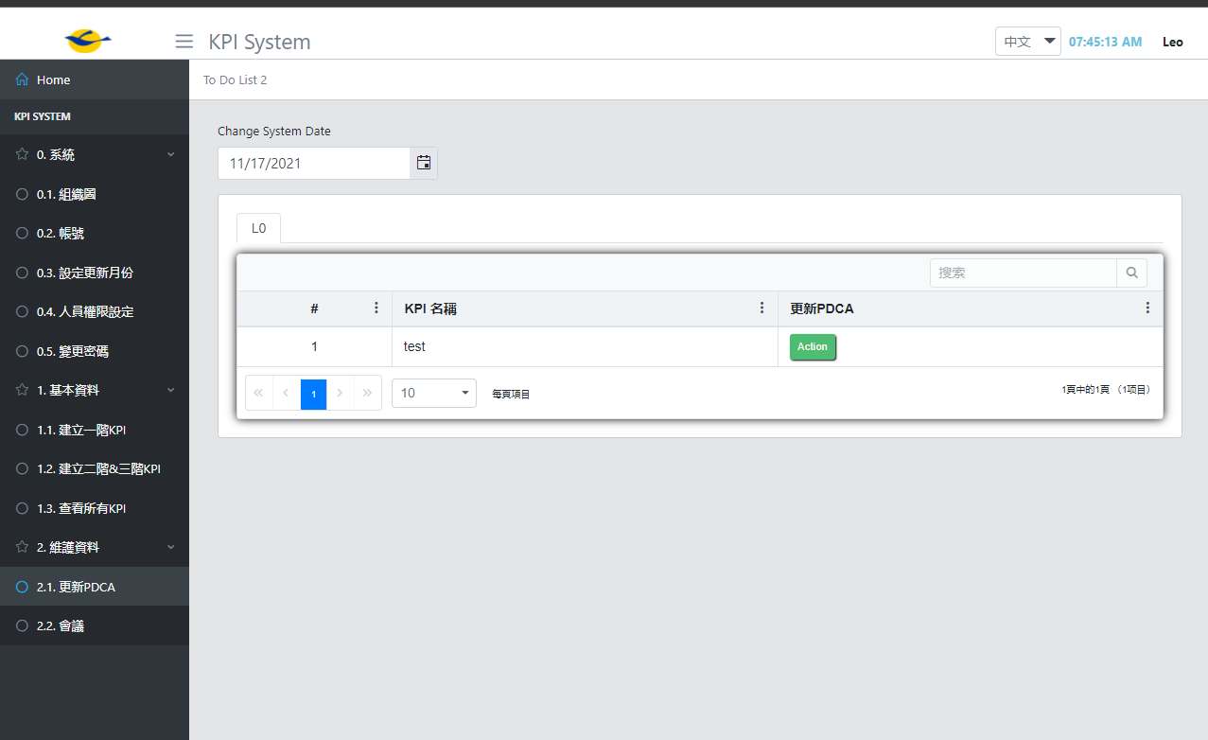

|  |  |
| --- | --- |
| Function name | Description |
| Action button | Click action button show Plan modal |
| Next month Target | Input field |
| Target YTD | Input field |
| Add |  |
| Delete | Delete data from tbl.Actions |
| Plan | Input field |
| Target | Input field |
| Deadline | Date time |
| Save | - Store data (Next month Target , Target YTD) into tbl.Targets , tbl.TargetYTD  - Store Plan data into tbl.Actions |
| Submit | - Store data (Next month Target , Target YTD) into tbl.Targets , tbl.TargetYTD  - Store targetId into tbl.TargetPIC  - Store Plan data into tbl.Actions  - Update tbl.KPIAccount set [IsActionSubmit] = true |

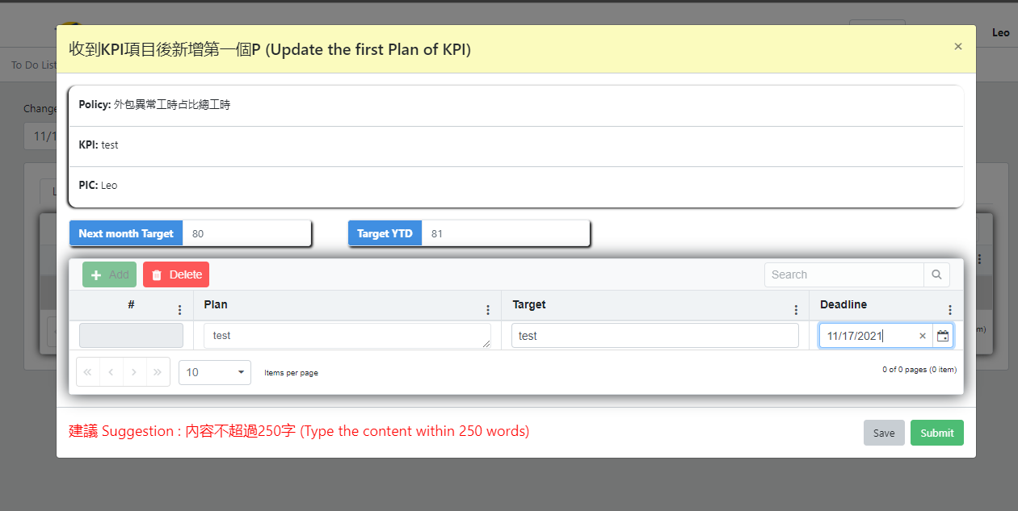

#### Update PDCA => update PDCA previous monthly

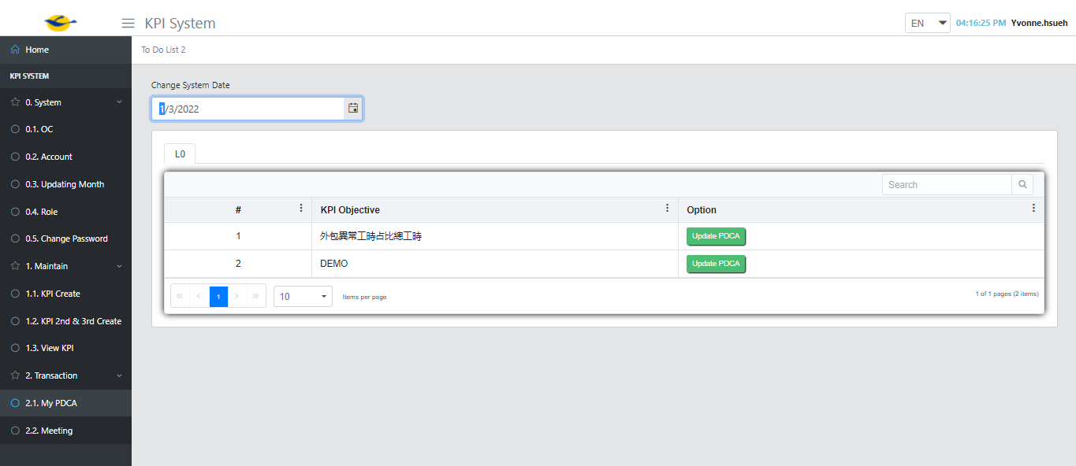

|  |  |
| --- | --- |
| Function name | Description |
| Update PDCA button | Click PDCA button show PDCA modal |
| This month performance | Input field |
| This month YTD | Input field |
| This month target |  |
| Target YTD |  |
| Next month target | Input field |
| Add | Display input field for Plan data table on website |
| Delete | Delete data from tbl.Actions |
| Save | - Store data (This month performance, This month YTD, Next month target ), into tbl.Target  - Update data (This month target , Target YTD ) into tbl.TargetYTD,  - Store Plan data into tbl.Actions,  - Update data (D (Do) ,Achievement , C (Content)) into tbl.Do and tbl.ActionStatus, |
| Submit | - Store data (This month performance, This month YTD, Next month target ), into tbl.Target  - Update data (This month target , Target YTD ) into tbl.TargetYTD,  - Store Plan data into tbl.Actions,  - Update data (D (Do) ,Achievement , C (Content) , Status) into tbl.Do and tbl.ActionStatus,  - Store targetId data into tbl.TargetPIC  - Update tbl.KPIAccount set [isPDCASubmit] = true |
| D (Do) | Input field |
| Achievement | Input field |
| Status | Select StatusId |
| C (Content) | Input field |

