Implement & Test it for the “SJF_Scheduling_Notes” in the attachment.

FCFS Scheduling Algorithms

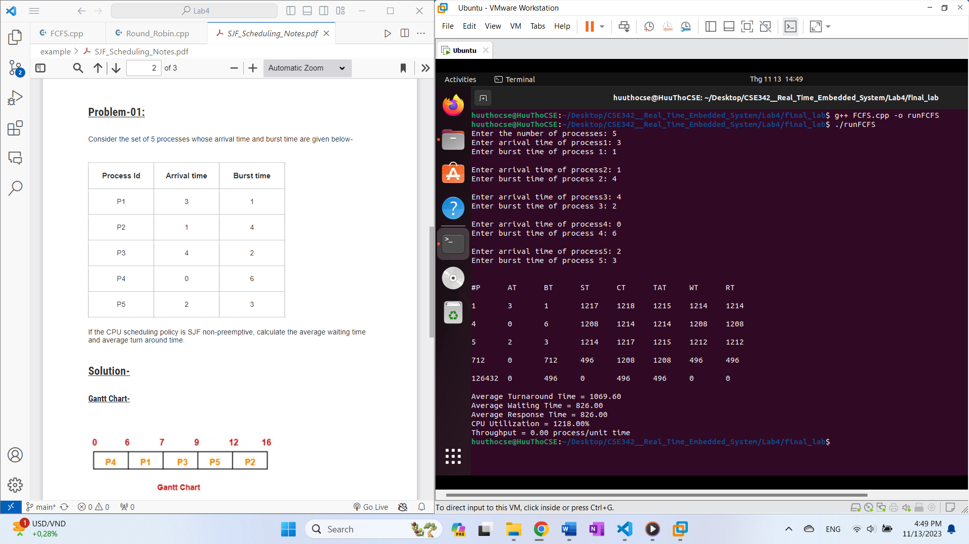

Round Robin Scheduling Algorithms

