**SJF Scheduling-**

In SJF Scheduling,

* Out of all the available processes, CPU is assigned to the process having smallest burst time.
* In case of a tie, it is broken by [**FCFS Scheduling**.](https://www.gatevidyalay.com/first-come-first-serve-cpu-scheduling/)

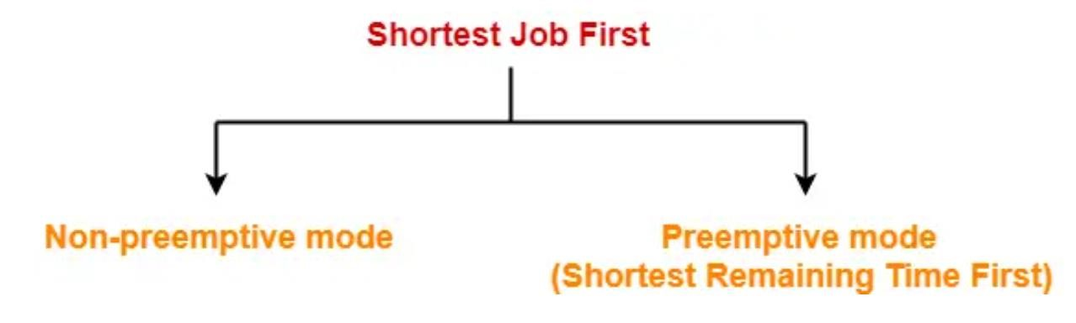

* SJF Scheduling can be used in both preemptive and non-preemptive mode.
* Preemptive mode of Shortest Job First is called as **Shortest Remaining Time First (SRTF)**.

**Advantages-**

* SRTF is optimal and guarantees the minimum average waiting time.
* It provides a standard for other algorithms since no other algorithm performs better than it.

**Disadvantages-**

* It can not be implemented practically since burst time of the processes can not be known in advance.
* It leads to starvation for processes with larger burst time.
* Priorities can not be set for the processes.
* Processes with larger burst time have poor response time.

1. **Problem 1 has example of the solution.**
2. **Add Gantt Charts for the problems 2 ~ 5.**

**Problem-01:**

Consider the set of 5 processes whose arrival time and burst time are given below-

**Process Id**

**Arrival time**

**Burst time**

P1

3

1

P2

1

4

P3

4

2

P4

0

6

P5

2

3

If the CPU scheduling policy is SJF non-preemptive, calculate the average waiting time and average turn around time.

**Solution-**

**Gantt Chart-**

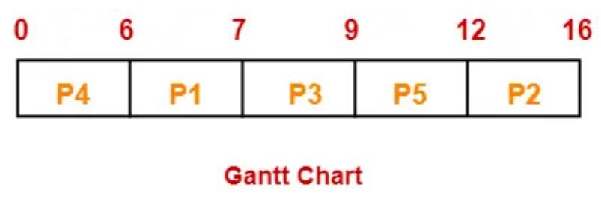

Now, we know-

* Turn Around time = Exit time – Arrival time
* Waiting time = Turn Around time – Burst time

**Also read-** [**Various Times of Process**](https://www.gatevidyalay.com/turn-around-time-response-time-waiting-time/)

|  |  |  |  |  |
| --- | --- | --- | --- | --- |
| **Process**  **Id** | **Exit time** | **Turn Around time** | **Waiting time** |  |
| P1 | 7 | 7 – 3 = 4 | 4 – 1 = 3 |
| P2 | 16 | 16 – 1 = 15 | 15 – 4 = 11 |
| P3 | 9 | 9 – 4 = 5 | 5 – 2 = 3 |
| P4 | 6 | 6 – 0 = 6 | 6 – 6 = 0 |
| P5 | 12 | 12 – 2 = 10 | 10 – 3 = 7 |
|  |  |  |  | |

Now,

* Average Turn Around time = (4 + 15 + 5 + 6 + 10) / 5 = 40 / 5 = 8 unit
* Average waiting time = (3 + 11 + 3 + 0 + 7) / 5 = 24 / 5 = 4.8 unit

**Problem-02:**

Consider the set of 5 processes whose arrival time and burst time are given below

*(Hãy xét tập hợp 5 tiến trình có thời gian đến và thời gian chạy được cho như sau)*

|  |  |  |
| --- | --- | --- |
| **Process Id** | **Arrival time** | **Burst time** |
| P1 | 3 | 1 |
| P2 | 1 | 4 |
| P3 | 4 | 2 |
| P4 | 0 | 6 |
| P5 | 2 | 3 |

If the CPU scheduling policy is SJF preemptive, calculate the average waiting time and average turn around time.

*(Nếu chính sách lập lịch CPU là SJF có ngắt (SJF preemptive), hãy tính thời gian chờ trung bình và thời gian xoay vòng trung bình.)*

Process Id Arrival time Burst time

P1 3 1

P2 1 4

P3 4 2

P4 0 6

P5 2 3

|  |  |  |  |
| --- | --- | --- | --- |
| **Process Id** | **Exit time** | **Turn Around time** | **Waiting time** |
| P1 |  | 3 | 1 |
| P2 |  | 1 | 4 |
| P3 |  | 4 | 2 |
| P4 |  | 0 | 6 |
| P5 |  | 2 | 3 |

**Problem-03:**

Consider the set of 6 processes whose arrival time and burst time are given below

*(Hãy xét tập hợp 6 tiến trình có thời gian đến và thời gian chạy được cho như sau)*

|  |  |  |
| --- | --- | --- |
| **Process Id** | **Arrival time** | **Burst time** |
| P1 | 0 | 7 |
| P2 | 1 | 5 |
| P3 | 2 | 3 |
| P4 | 3 | 1 |
| P5 | 4 | 2 |
| P6 | 5 | 1 |

If the CPU scheduling policy is shortest remaining time first, calculate the average waiting time and average turn around time.

*(Nếu chính sách lập lịch CPU là thời gian còn lại ngắn nhất được ưu tiên (shortest remaining time first), hãy tính thời gian chờ trung bình và thời gian xoay vòng trung bình.)*

---

**Problem-04:**

Consider the set of 3 processes whose arrival time and burst time are given below

*(Hãy xét tập hợp 3 tiến trình có thời gian đến và thời gian chạy được cho như sau)*

|  |  |  |
| --- | --- | --- |
| **Process Id** | **Arrival time** | **Burst time** |
| P1 | 0 | 9 |
| P2 | 1 | 4 |
| P3 | 2 | 9 |

If the CPU scheduling policy is SRTF, calculate the average waiting time and average turn around time.

*(Nếu chính sách lập lịch CPU là SRTF (Shortest Remaining Time First), hãy tính thời gian chờ trung bình và thời gian xoay vòng trung bình.)*

----

**Problem-05:**

Consider the set of 4 processes whose arrival time and burst time are given below

|  |  |  |
| --- | --- | --- |
| **Process Id** | **Arrival time** | **Burst time** |
| P1 | 0 | 20 |
| P2 | 15 | 25 |
| P3 | 30 | 10 |
| P4 | 45 | 15 |

If the CPU scheduling policy is SRTF, calculate the waiting time of process P2.