**SJF_Scheduling_Notes**

Proglem 1

SJF => Ok

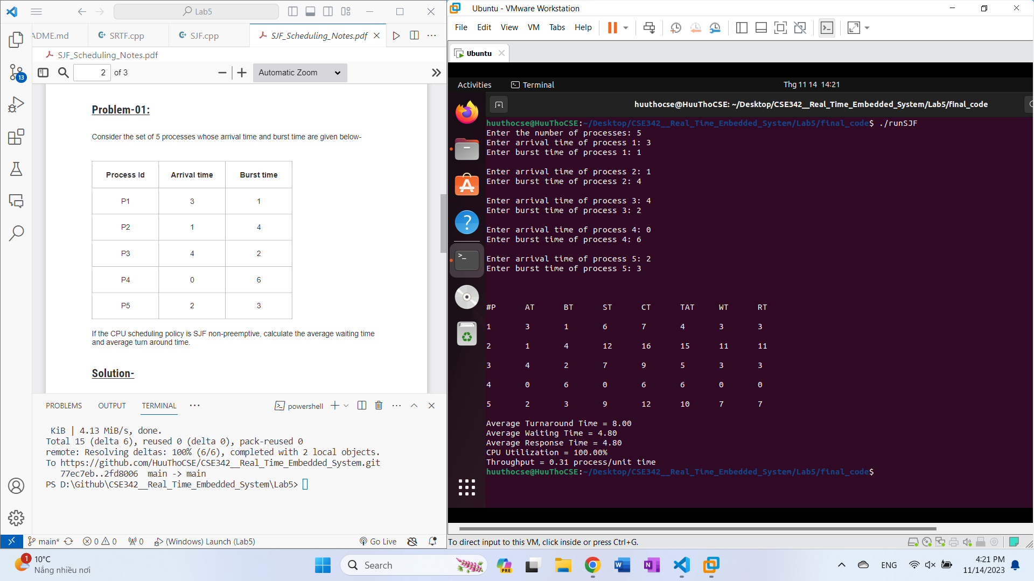

---

SRTF => Ok

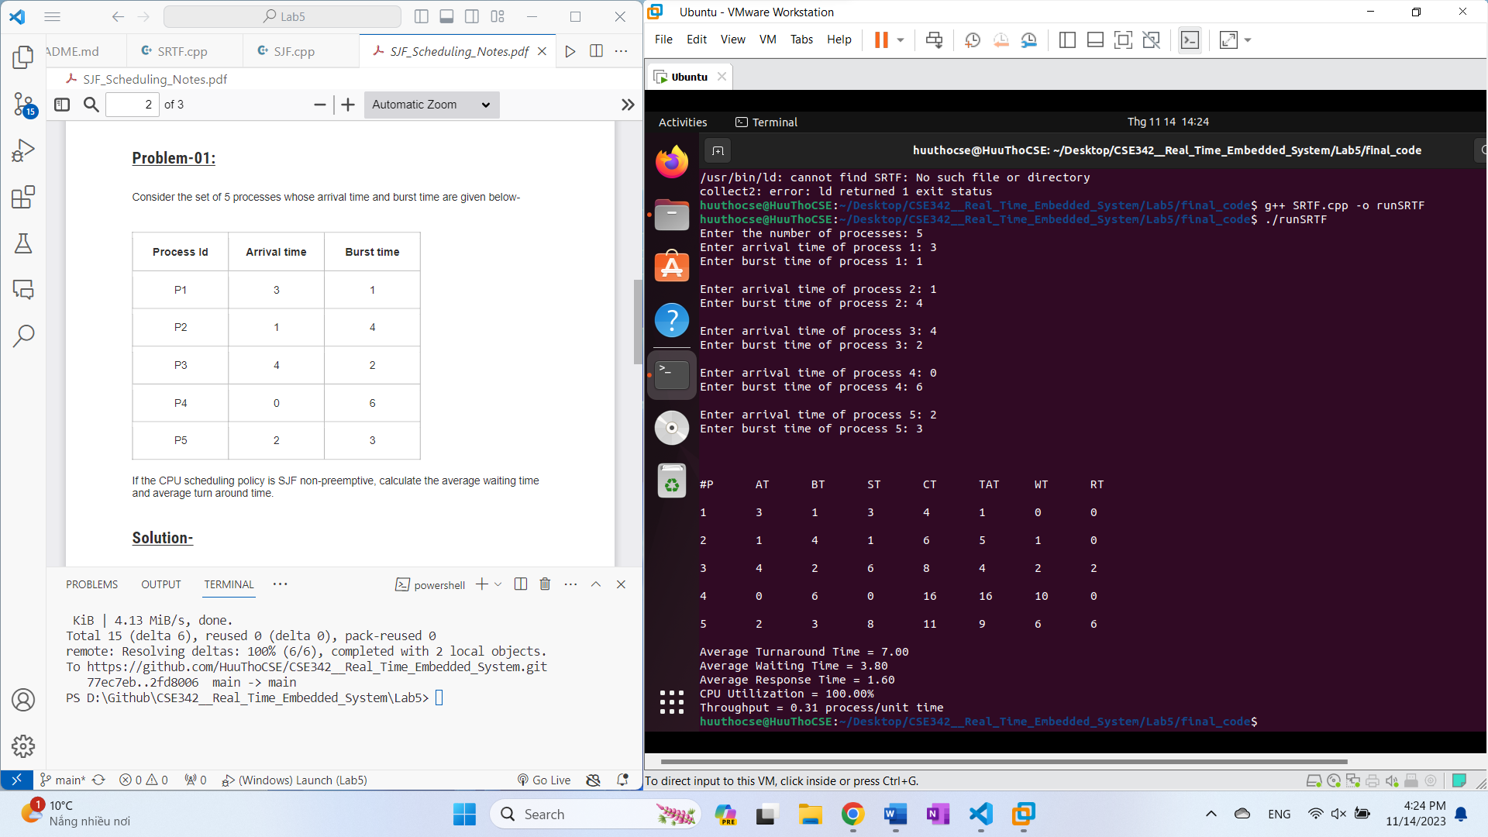



|  |  |  |  |  |  |
| --- | --- | --- | --- | --- | --- |
| Process ID | Arrival time | Burst time | Exit time | Turn Around time | Waiting time |
| P1 | 3 | 1 | 4 | 4 – 3 = 1 | 1 – 1 = 0 |
| P2 | 1 | 4 | 6 | 6 – 1 = 5 | 5 – 4 = 1 |
| P3 | 4 | 2 | 8 | 8 – 4 = 4 | 4 – 2 = 2 |
| P4 | 0 | 6 | 16 | 16 – 0 = 16 | 16 – 6 = 10 |
| P5 | 2 | 3 | 11 | 11 – 2 = 9 | 9 – 3 = 6 |

Average Turn Around time = ( 1 + 5 + 4 + 16 + 9 ) / 5 = 35 / 5 = 7 unit

Average Waiting time = ( 0 + 1 + 2 + 10 + 6) / 5 = 19 / 5 = 3.8 unit

Assignment_SJF_SRTF_Scheduling.pdf

**Problem-02-(Preemptive SJF):**

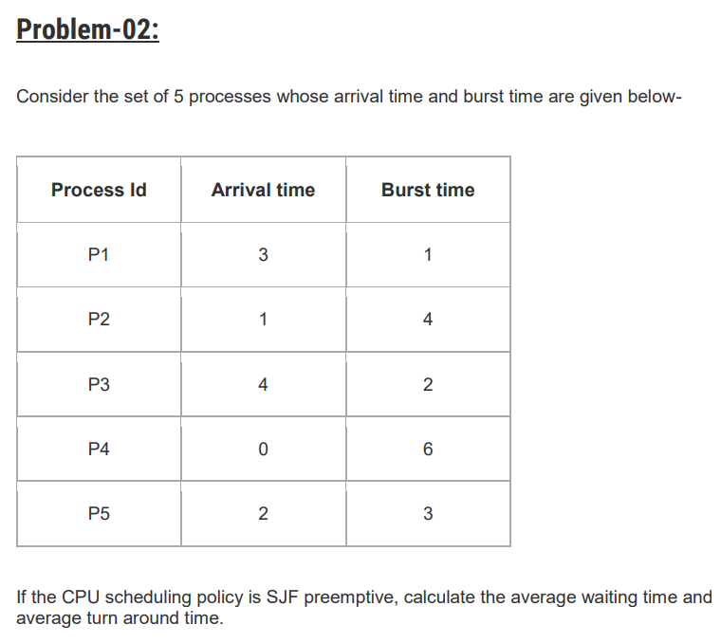



|  |  |  |  |  |  |
| --- | --- | --- | --- | --- | --- |
| Process ID | Arrival time | Burst time | Exit time | Turn Around time | Waiting time |
| P1 | 3 | 1 | 4 | 4 – 3 = 1 | 1 – 1 = 0 |
| P2 | 1 | 4 | 6 | 6 – 1 = 5 | 5 – 4 = 1 |
| P3 | 4 | 2 | 8 | 8 – 4 = 4 | 4 – 2 = 2 |
| P4 | 0 | 6 | 16 | 16 – 0 = 16 | 16 – 6 = 10 |
| P5 | 2 | 3 | 11 | 11 – 2 = 9 | 9 – 3 = 6 |

Average Turn Around time = ( 1 + 5 + 4 + 16 + 9 ) / 5 = 35 / 5 = 7 unit

Average Waiting time = ( 0 + 1 + 2 + 10 + 6) / 5 = 19 / 5 = 3.8 unit

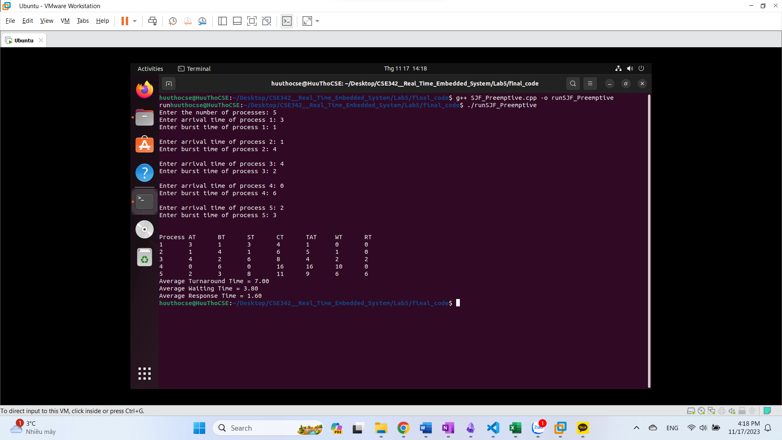

----

Problem-03-(SRTF):

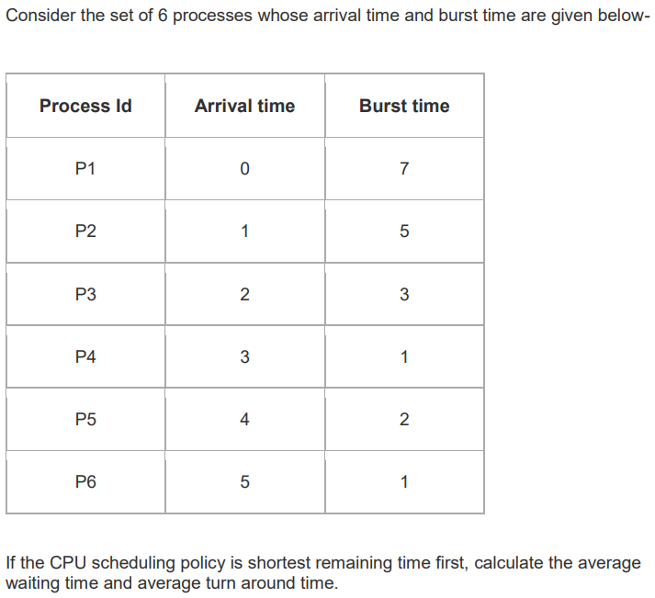



|  |  |  |  |  |  |
| --- | --- | --- | --- | --- | --- |
| Process ID | Arrival time | Burst time | Exit time | Turn Around time | Waiting time |
| P1 | 0 | 7 | 19 | 19 – 0 = 19 | 19 – 7 = 12 |
| P2 | 1 | 5 | 13 | 13 – 1 = 12 | 12 – 5 = 7 |
| P3 | 2 | 3 | 6 | 6 – 2 = 4 | 4 – 3 = 1 |
| P4 | 3 | 1 | 4 | 4 – 3 = 1 | 1 – 1 = 0 |
| P5 | 4 | 2 | 9 | 9 – 4 = 5 | 5 – 2 = 3 |
| P6 | 5 | 1 | 7 | 7 – 5 = 2 | 2 – 1 = 1 |

Average Turn Around time = ( 19 + 12 + 4 + 1 + 5 + 2 ) / 6 = 43 / 5 = 7.1667 unit

Average Waiting time = ( 12 + 7 + 1 + 0 + 3 + 1) / 6 = 24 / 6 = 4 unit

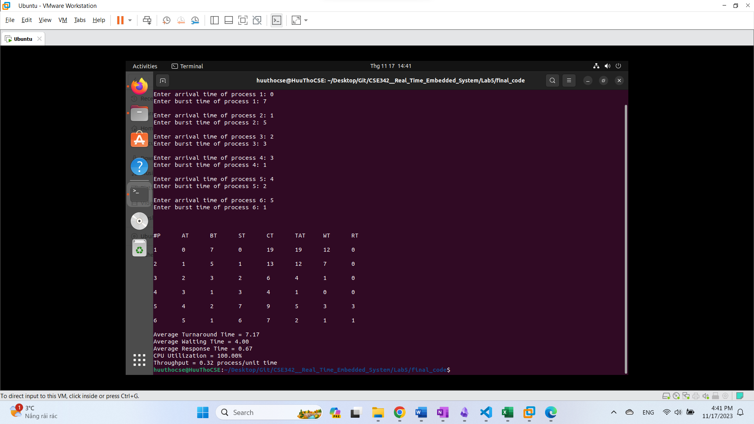

---

Problem-04-(SRTF):

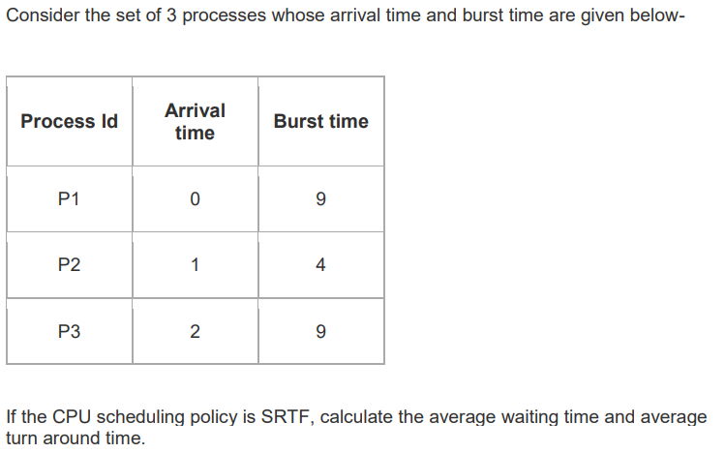



|  |  |  |  |  |  |
| --- | --- | --- | --- | --- | --- |
| Process ID | Arrival time | Burst time | Exit time | Turn Around time | Waiting time |
| P1 | 0 | 9 | 13 | 13 – 0 = 13 | 13 – 9 = 4 |
| P2 | 1 | 4 | 5 | 5 – 1 = 4 | 4 – 4 = 0 |
| P3 | 2 | 9 | 22 | 22 – 2 = 20 | 20 – 9 = 11 |

Average Turn Around time = ( 13 + 4 + 20 ) / 3 = 37 / 3 = 12.3333 unit

Average Waiting time = ( 4 + 0 + 11 ) / 3 = 15 / 3 = 5 unit

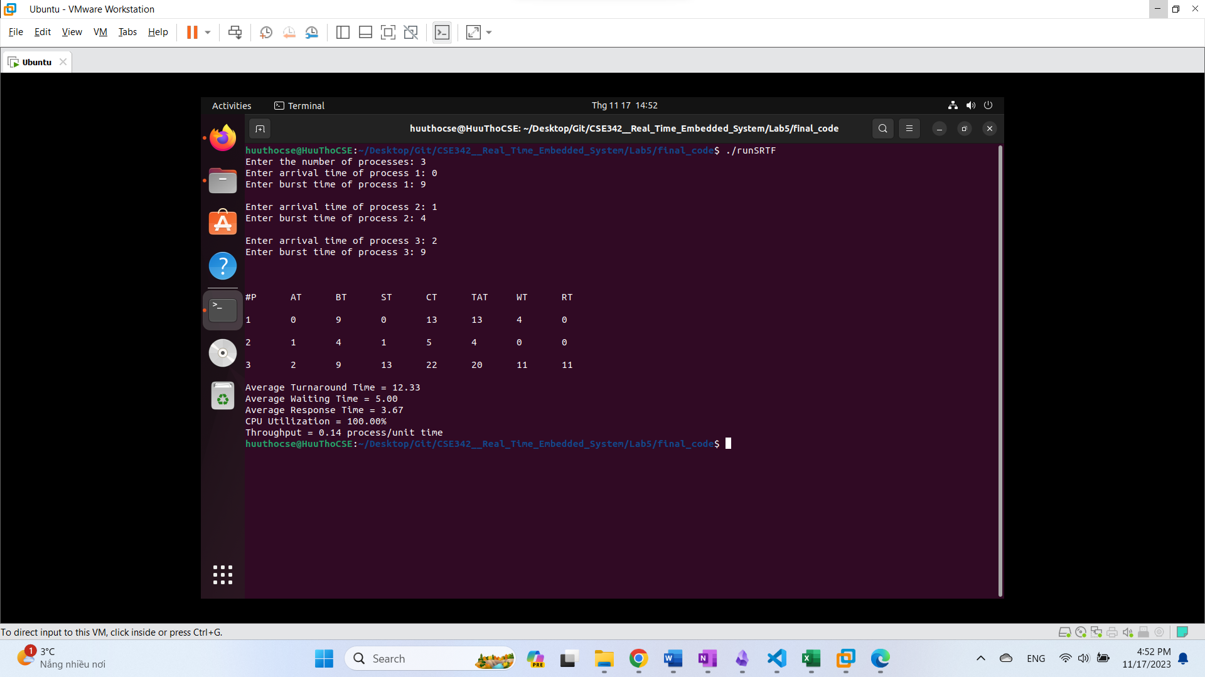

---

Problem-06-(SRTF):

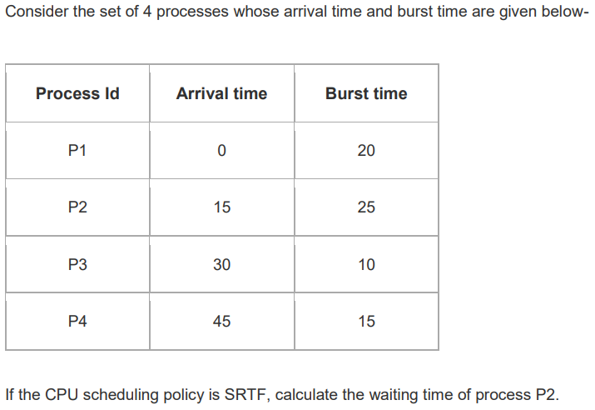



|  |  |  |  |  |  |
| --- | --- | --- | --- | --- | --- |
| Process ID | Arrival time | Burst time | Exit time | Turn Around time | Waiting time |
| P1 | 0 | 20 | 20 | 20 – 0 = 20 | 20 – 20 = 0 |
| **P2** | **15** | **25** | **55** | **55 – 15 = 40** | **40 – 25 = 15** |
| P3 | 30 | 10 | 40 | 40 – 30 = 10 | 10 – 10 = 0 |
| P4 | 45 | 15 | 70 | 70 – 45 = 25 | 25 – 15 = 10 |

