[MobileNet](https://keras.io/api/applications/mobilenet)

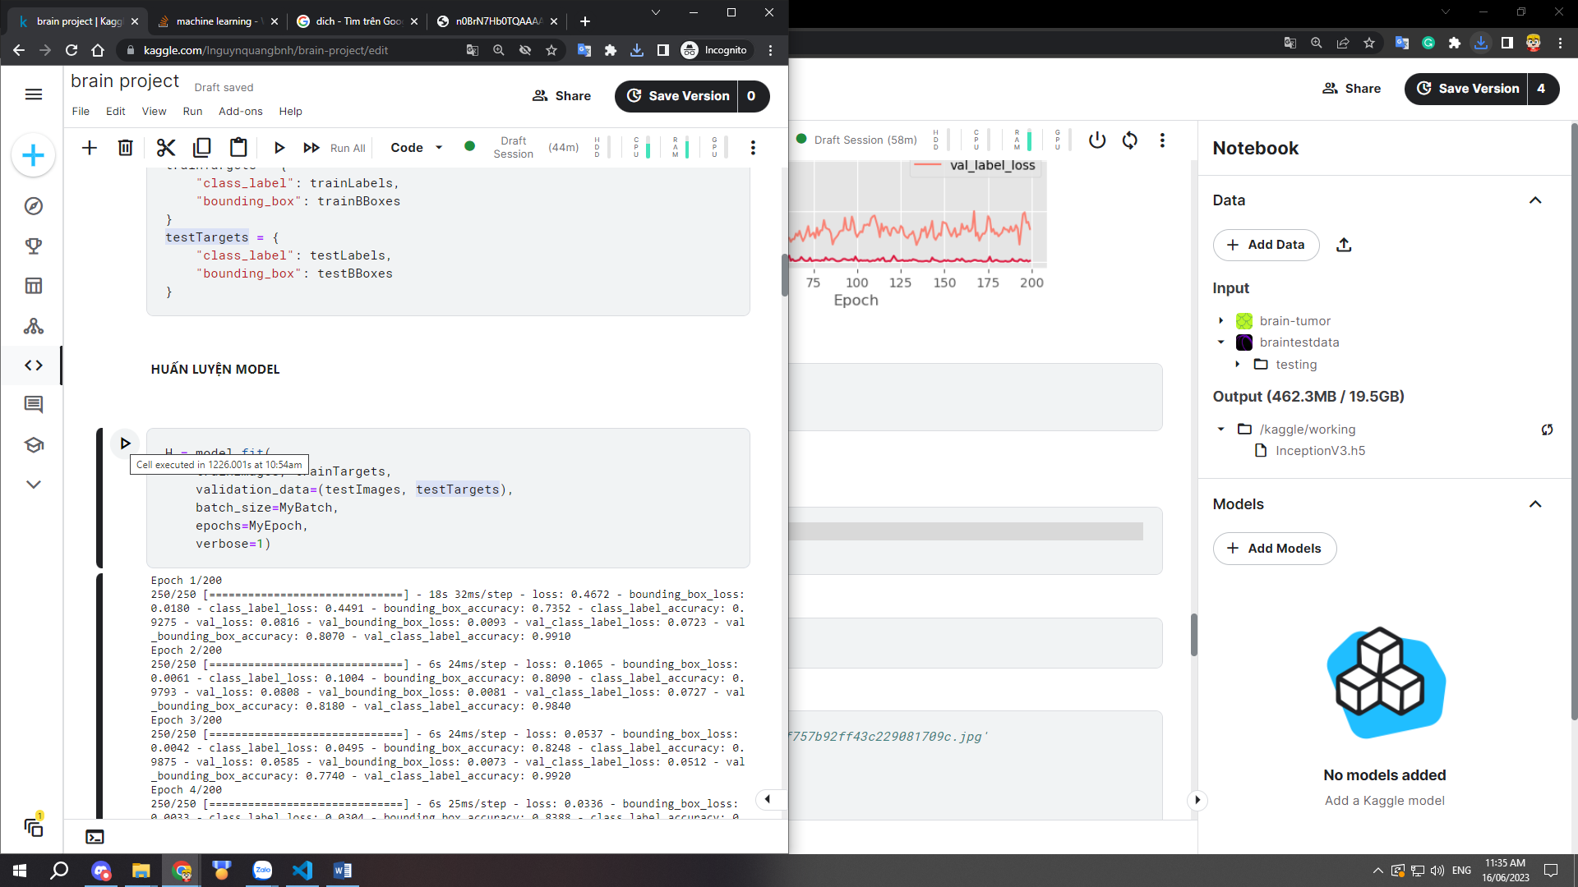

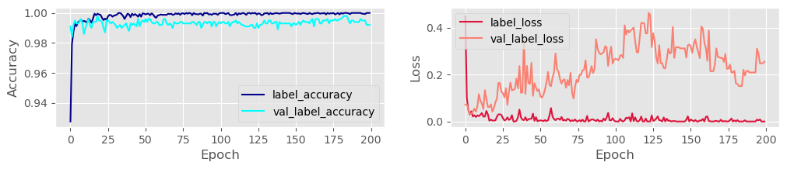

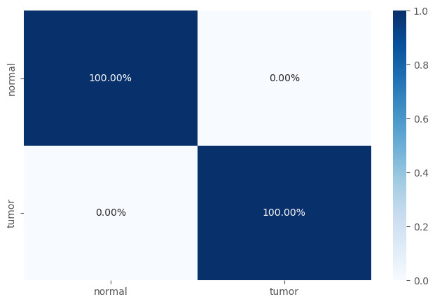

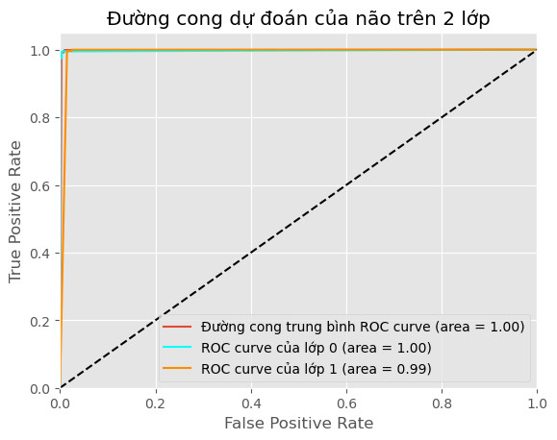

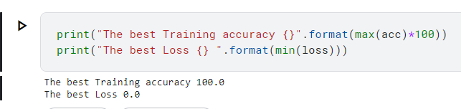

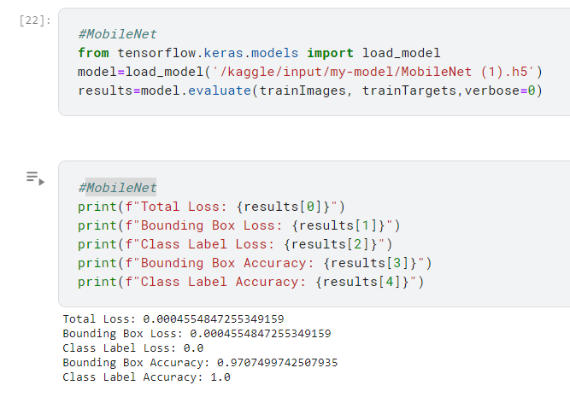

Total Loss: 0.0004554847255349159

Bounding Box Loss: 0.0004554847255349159

Class Label Loss: 0.0

Bounding Box Accuracy: 0.9707499742507935

Class Label Accuracy: 1.0

**InceptionV3**

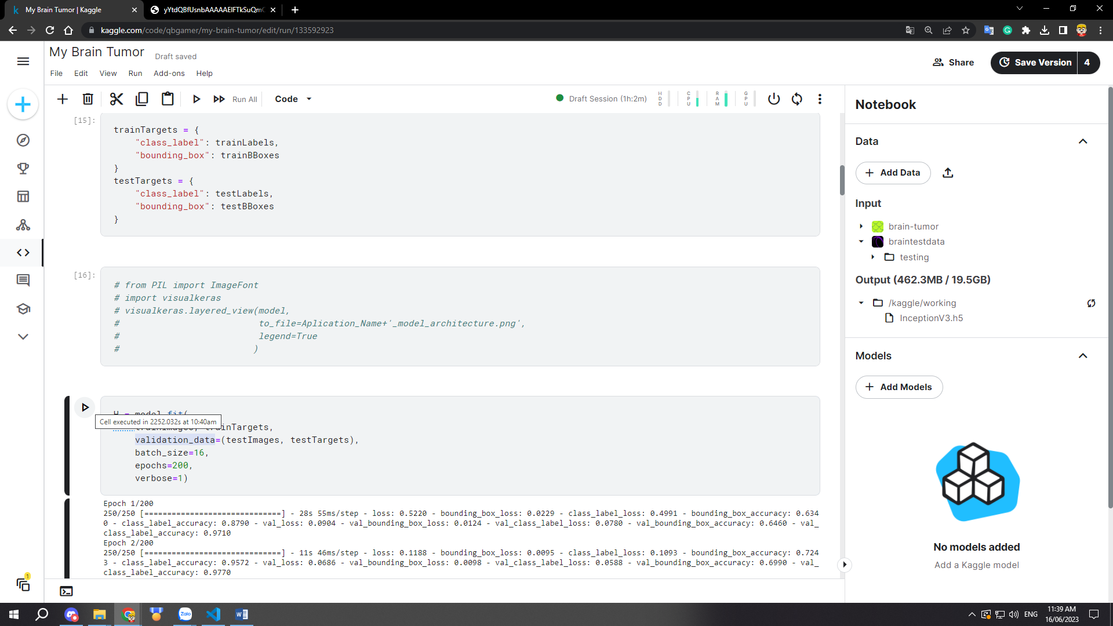

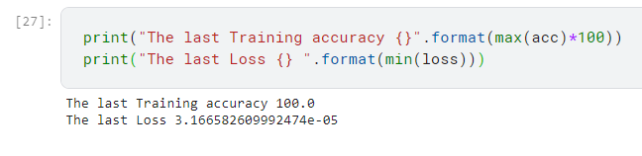

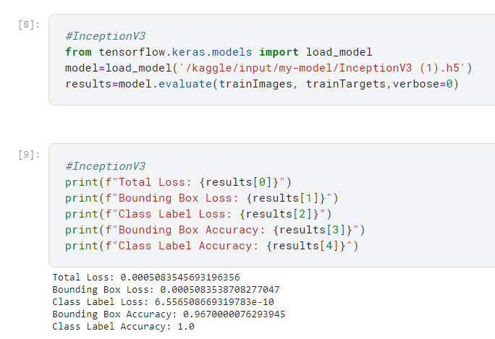

Total Loss: 0.0005083545693196356

Bounding Box Loss: 0.0005083538708277047

Class Label Loss: 6.556508669319783e-10

Bounding Box Accuracy: 0.9670000076293945

Class Label Accuracy: 1.0

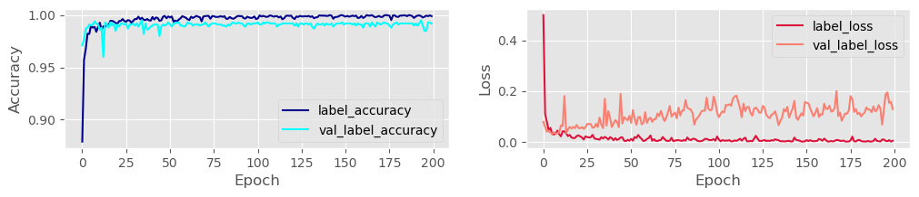

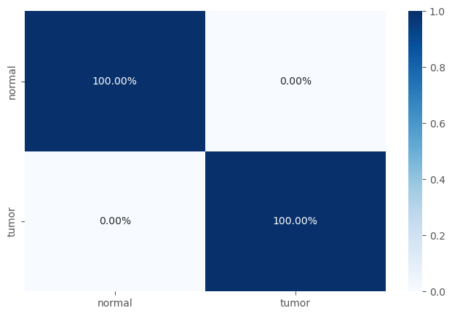

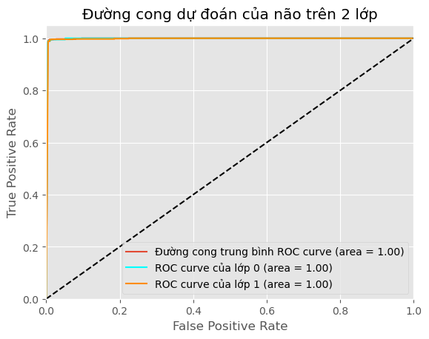

**DenseNet121**

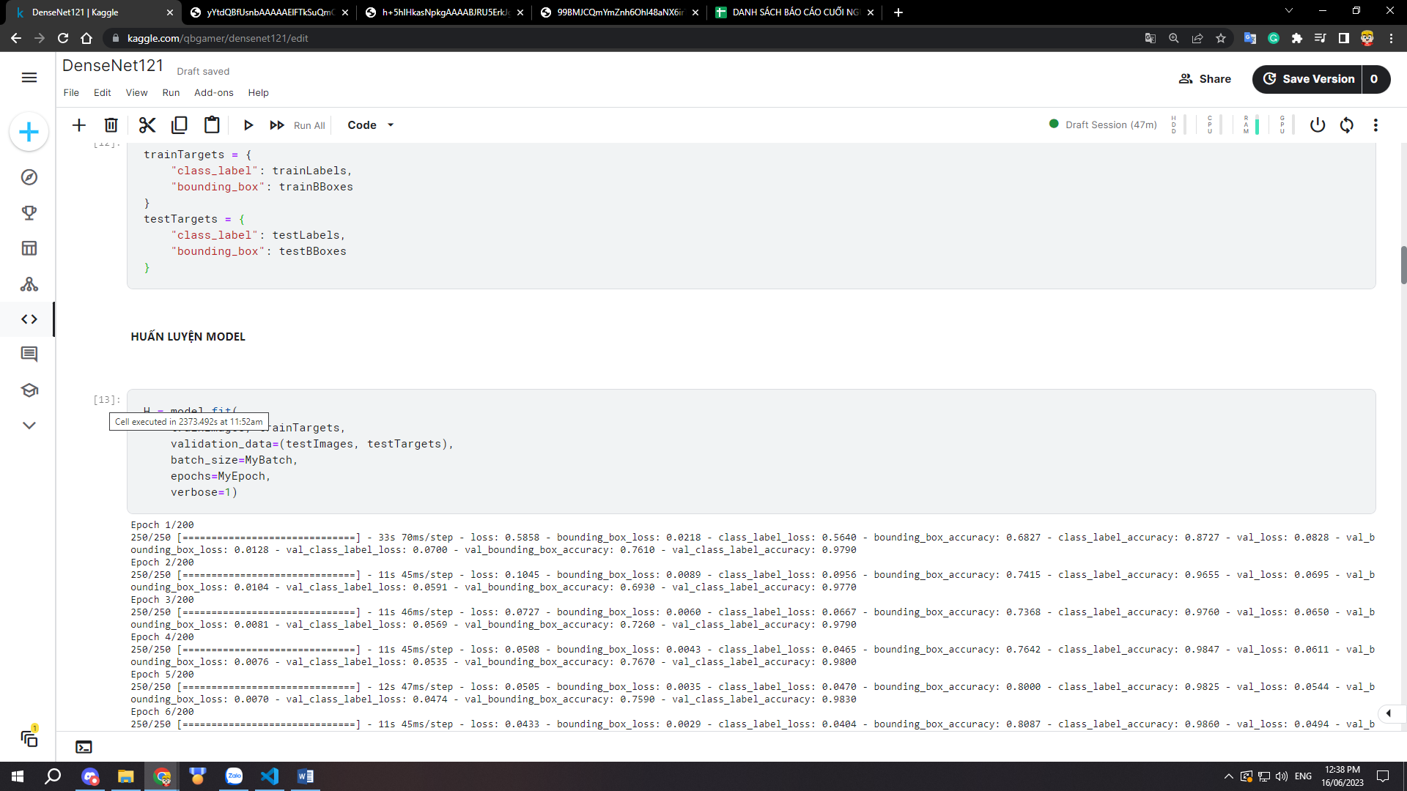

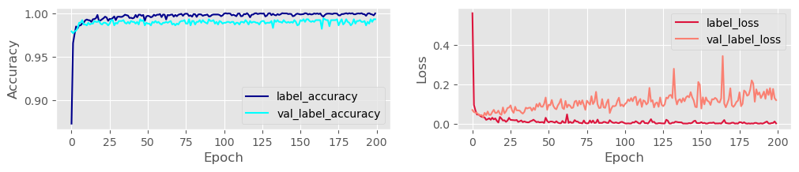

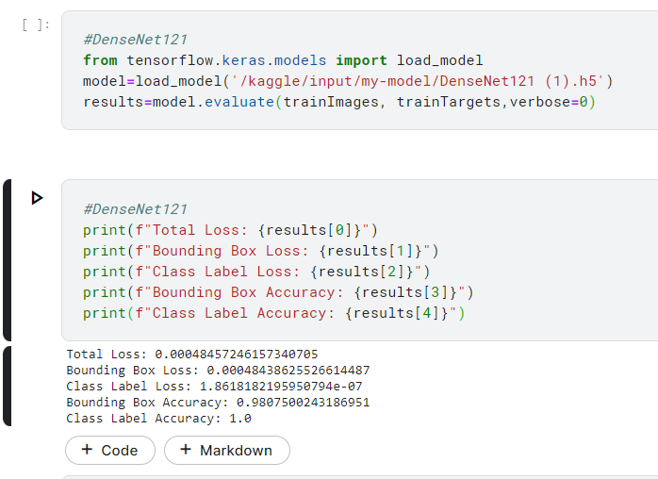

Total Loss: 0.00048457246157340705

Bounding Box Loss: 0.00048438625526614487

Class Label Loss: 1.8618182195950794e-07

Bounding Box Accuracy: 0.9807500243186951

Class Label Accuracy: 1.0



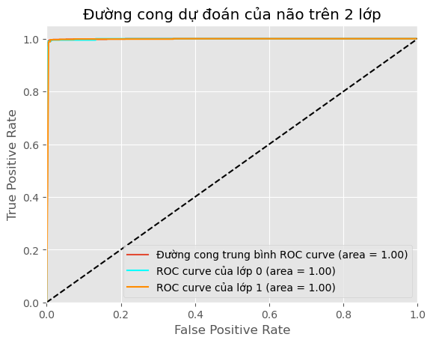

**ResNet101**

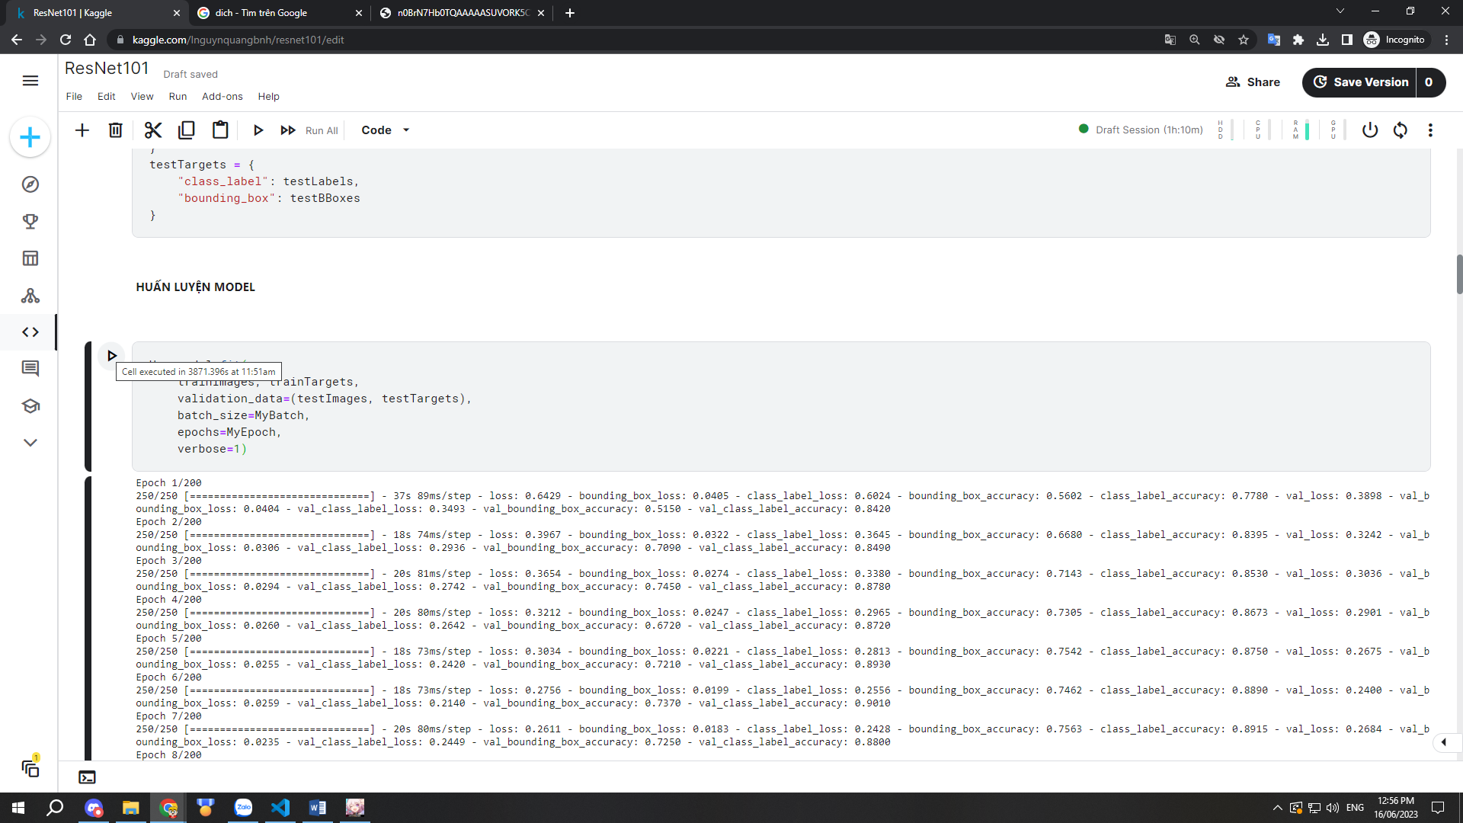

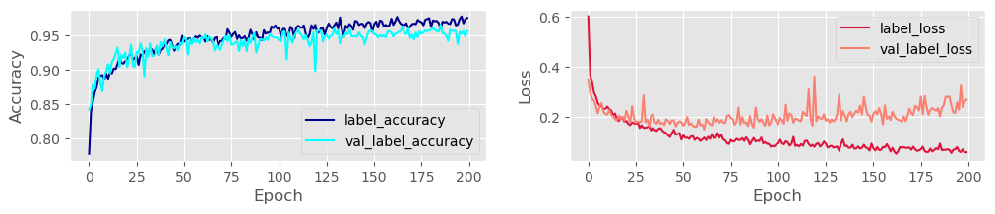

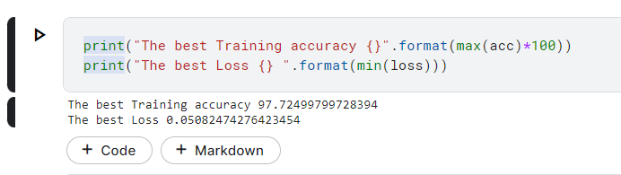

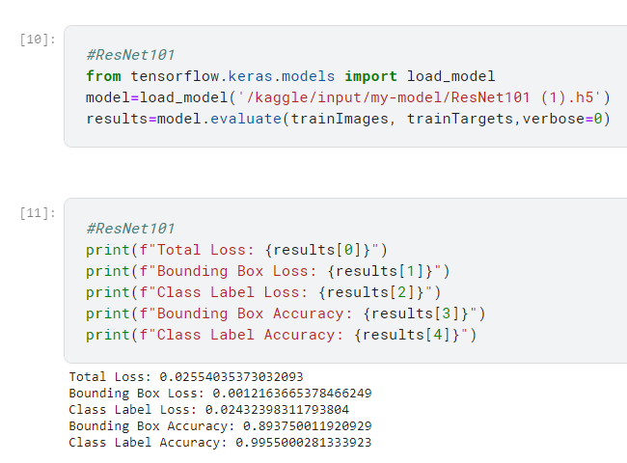

Total Loss: 0.02554035373032093

Bounding Box Loss: 0.0012163665378466249

Class Label Loss: 0.02432398311793804

Bounding Box Accuracy: 0.893750011920929

Class Label Accuracy: 0.9955000281333923

