**Bai tap1:**

img=imread('B2_images\cameraman.tif');

subplot(121);

imshow(img);

subplot(122);

imhist(img);

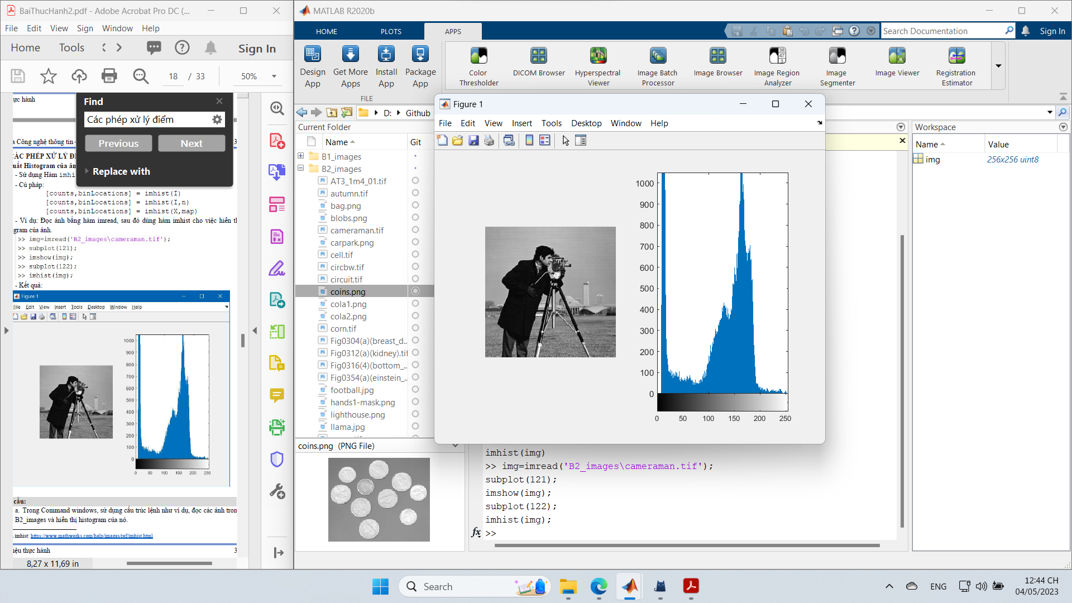

**Bai tap 2:**

[filename,path]=uigetfile({'*.png';'*.jpg';'*.tif'},"chọn ảnh");

if isequal(filename,0)||isequal(path,0)

uialert(app.UIFigure,"Chưa đọc ảnh","Lỗi đọc ảnh");

cla(app.UIAnhGoc);

else

file=strcat(path,filename);

app.img=imread(file);

imshow(app.img,'Parent',app.AxesAnhGoc);

end

--

[pixels, graylevels] = imhist(app.img);

bar(app.AxesHistogram,graylevels, pixels, 0.2, "stacked", "black");

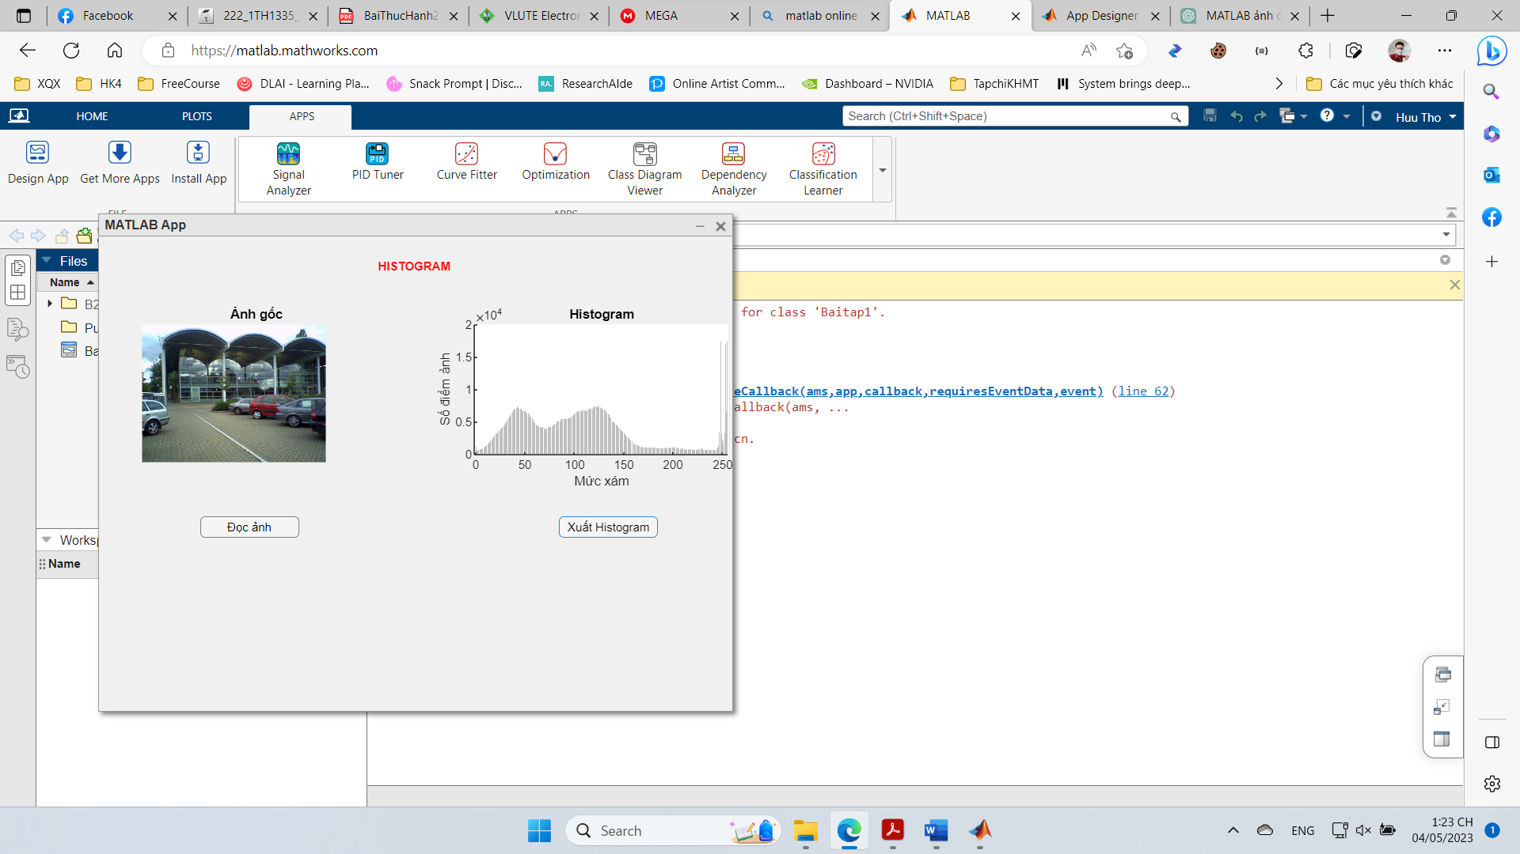

**Bai tap 3:**

img = imread("B2_images/carpark.png");

gray=rgb2gray(img);

com=imcomplement(gray);

subplot(131);

imshow(img);

subplot(132);

imshow(gray);

subplot(133);

imshow(com);

**Bai tap 3:**

function [com, omap]=layanhamban(file)

% Hàm tr? v? ?nh âm b?n c?a m?t ?nh * Ð?c ?nh t? file, chuy?n ?nh sang ?nh ða c?p xâm

% Tính ?nh âm b?n c?a ?nh ða c?p xám

% Tr? k?t qu? ?nh ð?u ra cho com,

%và colormap c?a ?nh ð?u vào cho omap cho vi?c hi?n th? ?nh

[img, map]=imread(file);

info=imfinfo(file);

if length (info)>1

info=info(1);

end

bitdepth=info.BitDepth;

if info.ColorType=="truecolor"

gray=rgb2gray (img);

bitdepth=bitdepth/3;

elseif info.ColorType=="indexed"

gray=ind2gray(img, map);

else

gray=img;

end

Lmax=2^bitdepth-1;

[yl, x1]=size (gray);

com=zeros (yl, x1);

omap=map;

for i=1:yl

for j=1:x1

com(i,j)=Lmax-gray (i, j);

end

end

--

img = imread("B2_images\yellowlily.jpg");

subplot(131);

imshow(img);

gray=rgb2gray(img);

subplot(132);

imshow(gray);

amban=layanhamban("B2_images\yellowlily.jpg");

subplot(133);

imshow(amban,[]);

