21022008_NguyenHuuTho

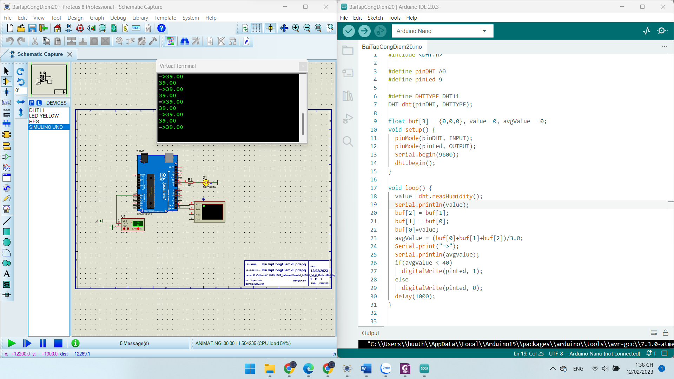

#include <DHT.h>

#define pinDHT A0

#define pinLed 9

#define DHTTYPE DHT11

DHT dht(pinDHT, DHTTYPE);

float buf[3] = {0,0,0}, value =0, avgValue = 0;

void setup() {

  pinMode(pinDHT, INPUT);

  pinMode(pinLed, OUTPUT);

  Serial.begin(9600);

  dht.begin();

}

void loop() {

  value= dht.readHumidity();

  Serial.println(value);

  buf[2] = buf[1];

  buf[1] = buf[0];

  buf[0]=value;

  avgValue = (buf[0]+buf[1]+buf[2])/3.0;

  Serial.print("=>");

  Serial.println(avgValue);

  if(avgValue < 40)

    digitalWrite(pinLed, 1);

  else

    digitalWrite(pinLed, 0);

  delay(1000);

}