20004249-NguyenTienVang

BAI TH9

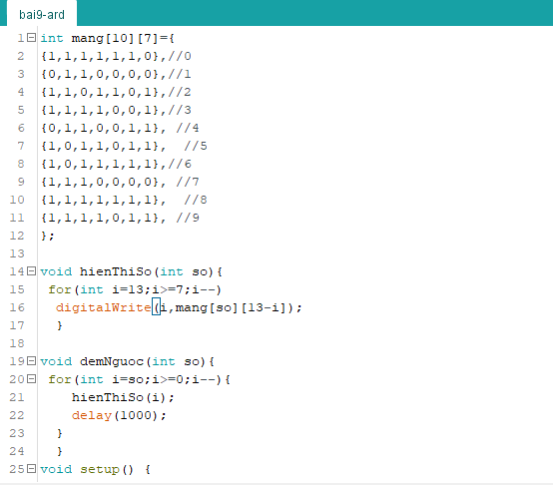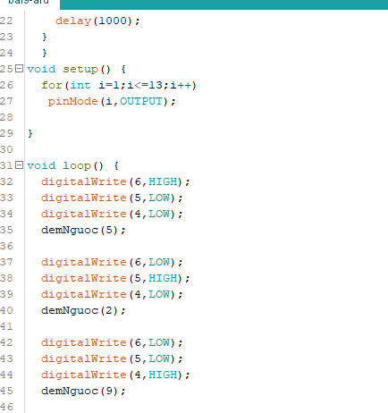int mang[10][7]={

{1,1,1,1,1,1,0},//0

{0,1,1,0,0,0,0},//1

{1,1,0,1,1,0,1},//2

{1,1,1,1,0,0,1},//3

{0,1,1,0,0,1,1}, //4

{1,0,1,1,0,1,1}, //5

{1,0,1,1,1,1,1},//6

{1,1,1,0,0,0,0}, //7

{1,1,1,1,1,1,1}, //8

{1,1,1,1,0,1,1}, //9

};

void hienThiSo(int so){

for(int i=13;i>=7;i--)

digitalWrite(i,mang[so][13-i]);

}

void demNguoc(int so){

for(int i=so;i>=0;i--){

hienThiSo(i);

delay(1000);

}

}

void setup() {

for(int i=1;i<=13;i++)

pinMode(i,OUTPUT);

}

void loop() {

digitalWrite(6,HIGH);

digitalWrite(5,LOW);

digitalWrite(4,LOW);

demNguoc(5);

digitalWrite(6,LOW);

digitalWrite(5,HIGH);

digitalWrite(4,LOW);

demNguoc(2);

digitalWrite(6,LOW);

digitalWrite(5,LOW);

digitalWrite(4,HIGH);

demNguoc(9);

}

