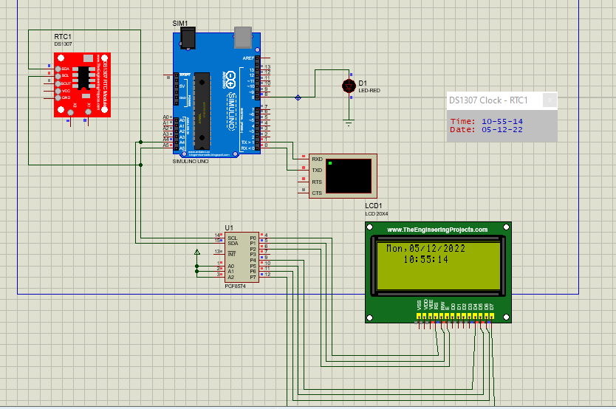#include <Wire.h>

#include <LiquidCrystal_I2C.h>

#include "RTClib.h"

RTC_DS1307 rtc;

LiquidCrystal_I2C lcd(0x27,20,4);

char daysOfTheWeek[7][12] = {"Sun", "Mon", "Tue", "Wed", "Thu", "Fri", "Sat"};

void setup ()

{

Serial.begin(9600);

lcd.init();

lcd.backlight();

if (! rtc.begin())

{

lcd.print("Couldn't find RTC");

while (1);

}

if (! rtc.isrunning())

{

lcd.print("RTC is NOT running!");

}

rtc.adjust(DateTime(F(__DATE__), F(__TIME__)));//auto update from computer time

//rtc.adjust(DateTime(2014, 1, 21, 3, 0, 0));// to set the time manualy

}

void loop ()

{

DateTime now = rtc.now();

lcd.setCursor(4, 1);

if(now.hour()<=9)

{

lcd.print("0");

lcd.print(now.hour());

}

else {

lcd.print(now.hour());

}

lcd.print(':');

if(now.minute()<=9)

{

lcd.print("0");

lcd.print(now.minute());

}

else {

lcd.print(now.minute());

}

lcd.print(':');

if(now.second()<=9)

{

lcd.print("0");

lcd.print(now.second());

}

else {

lcd.print(now.second());

}

lcd.print(" ");

lcd.setCursor(1, 0);

lcd.print(daysOfTheWeek[now.dayOfTheWeek()]);

lcd.print(",");

if(now.day()<=9)

{

lcd.print("0");

lcd.print(now.day());

}

else {

lcd.print(now.day());

}

lcd.print('/');

if(now.month()<=9)

{

lcd.print("0");

lcd.print(now.month());

}

else {

lcd.print(now.month());

}

lcd.print('/');

if(now.year()<=9)

{

lcd.print("0");

lcd.print(now.year());

}

else {

lcd.print(now.year());

}

}