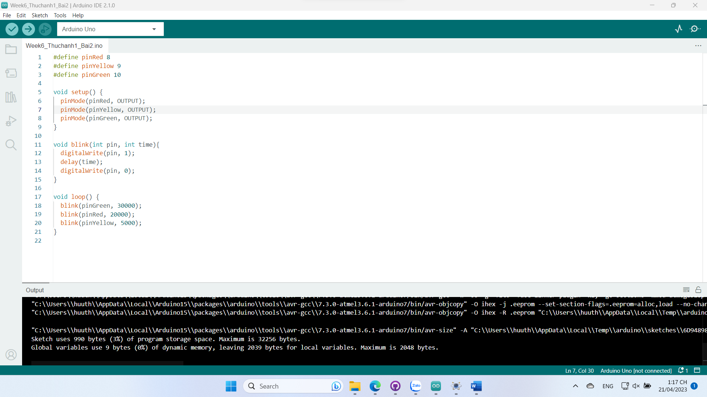

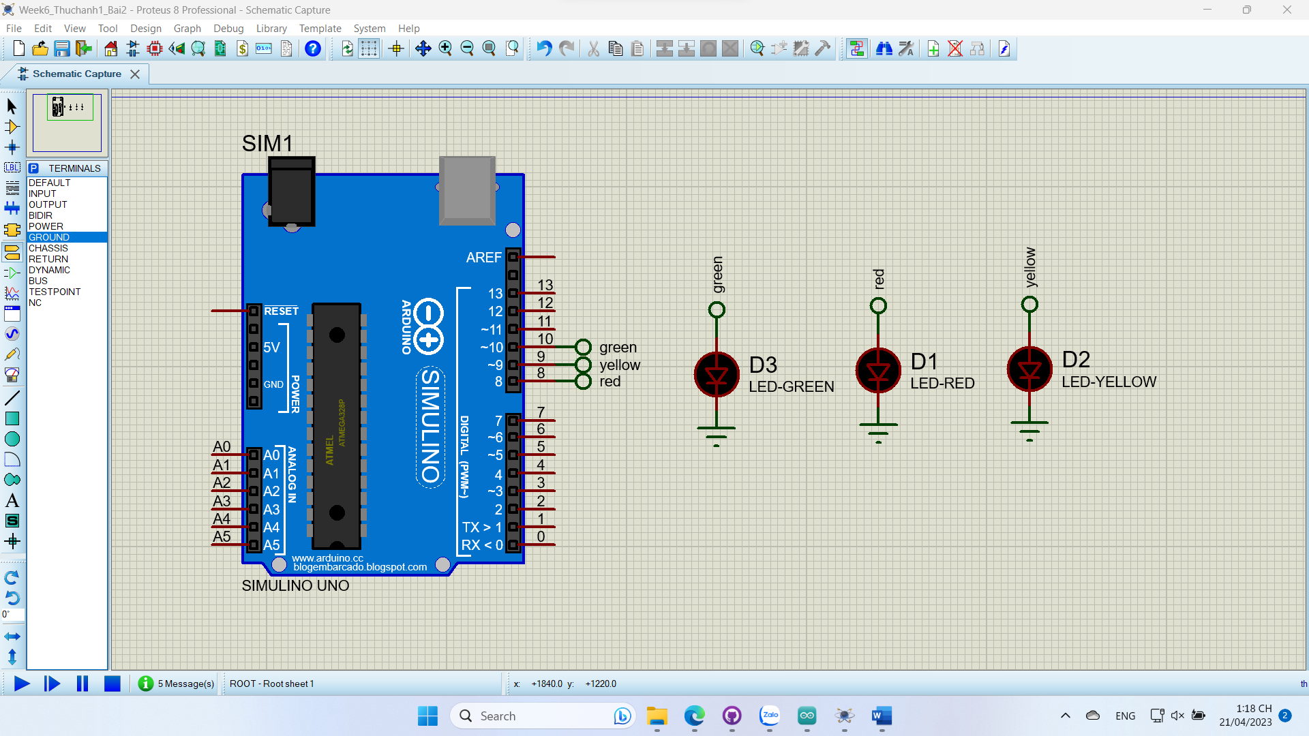

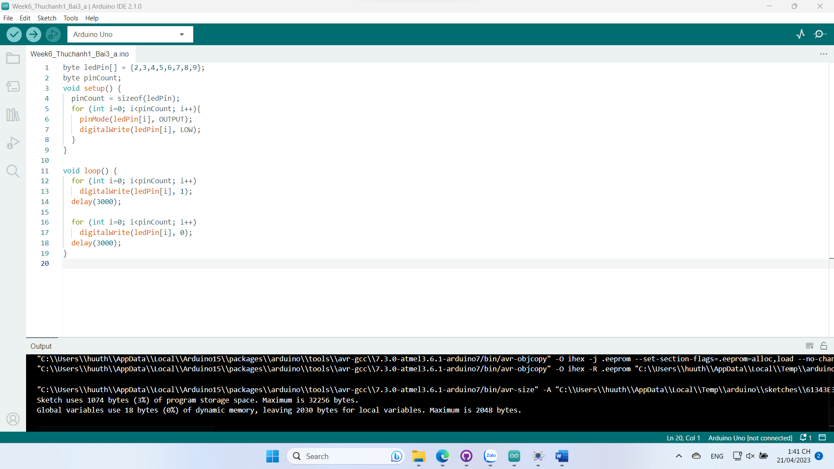

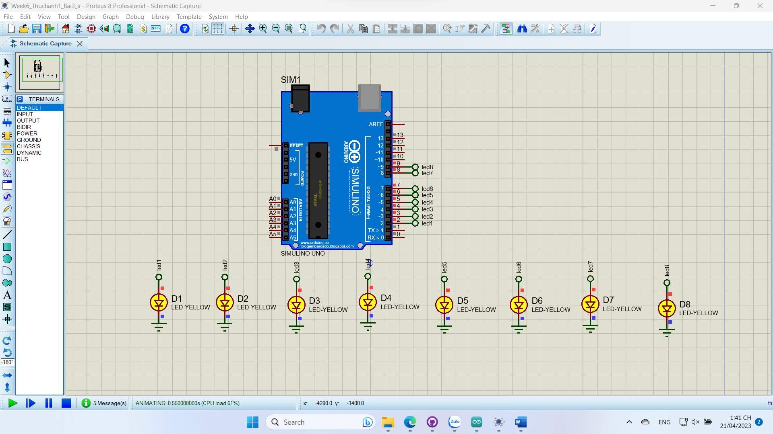

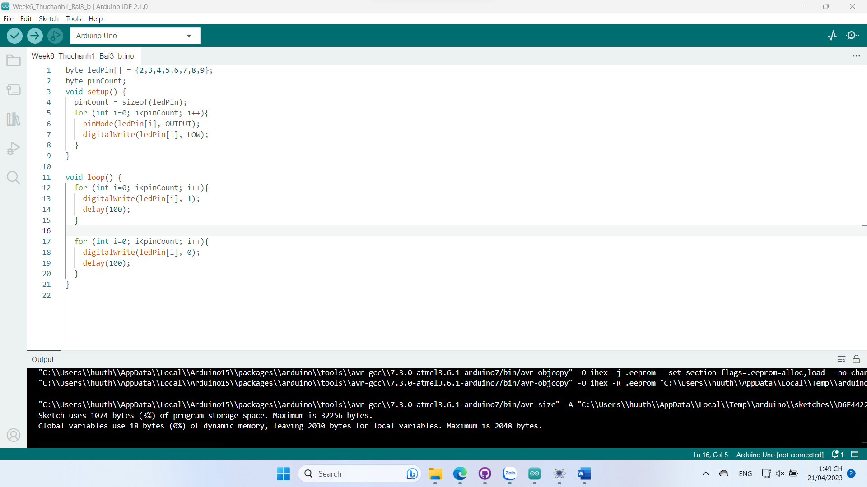

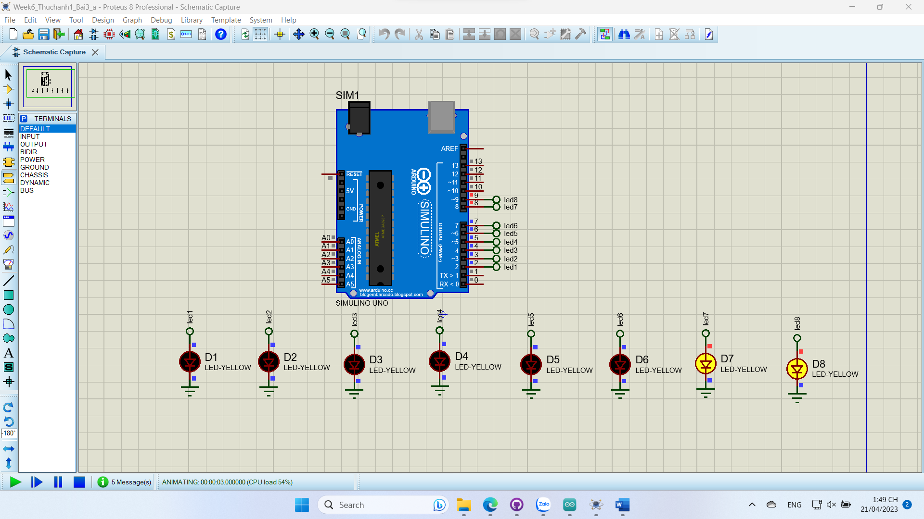

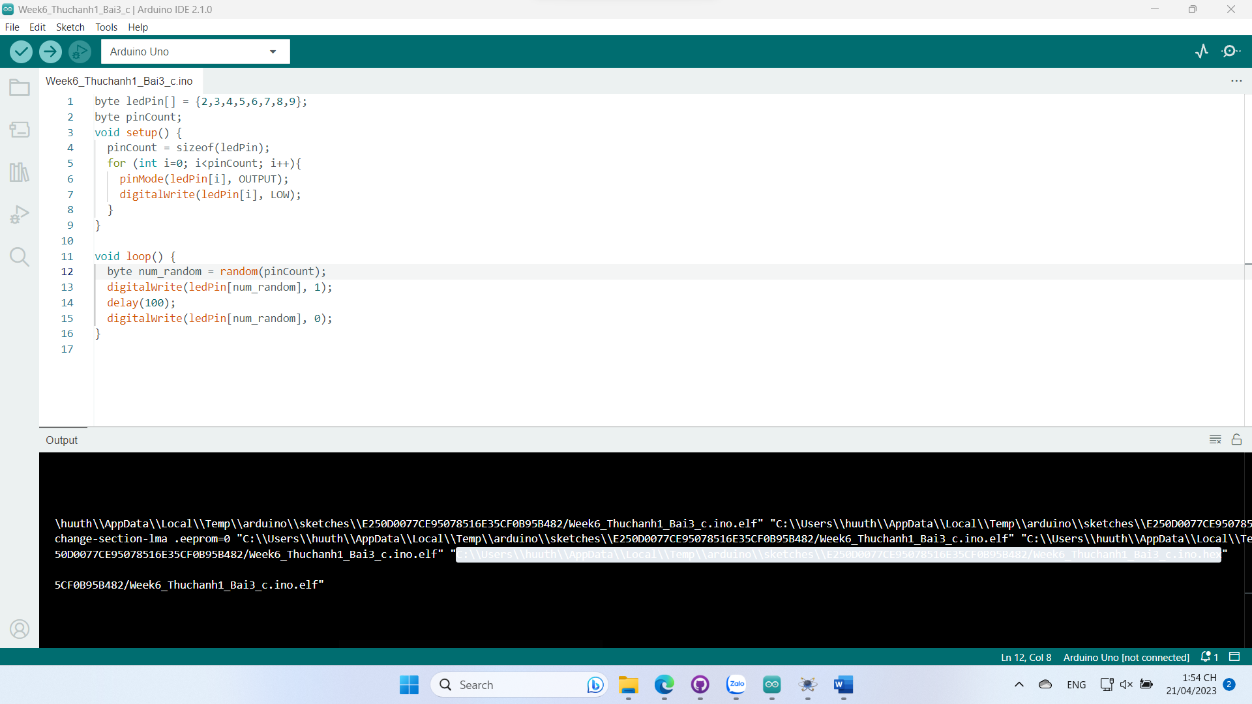

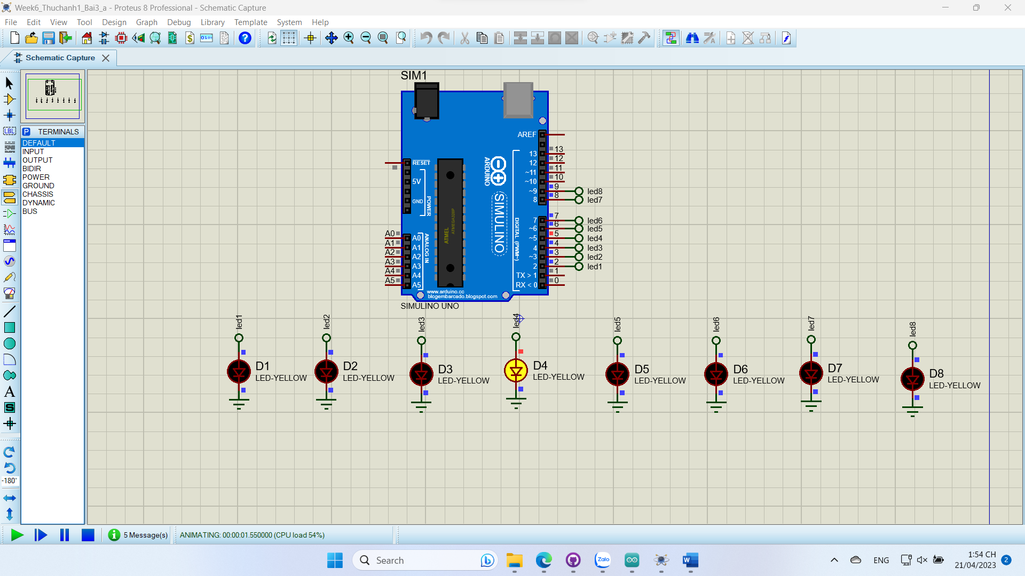

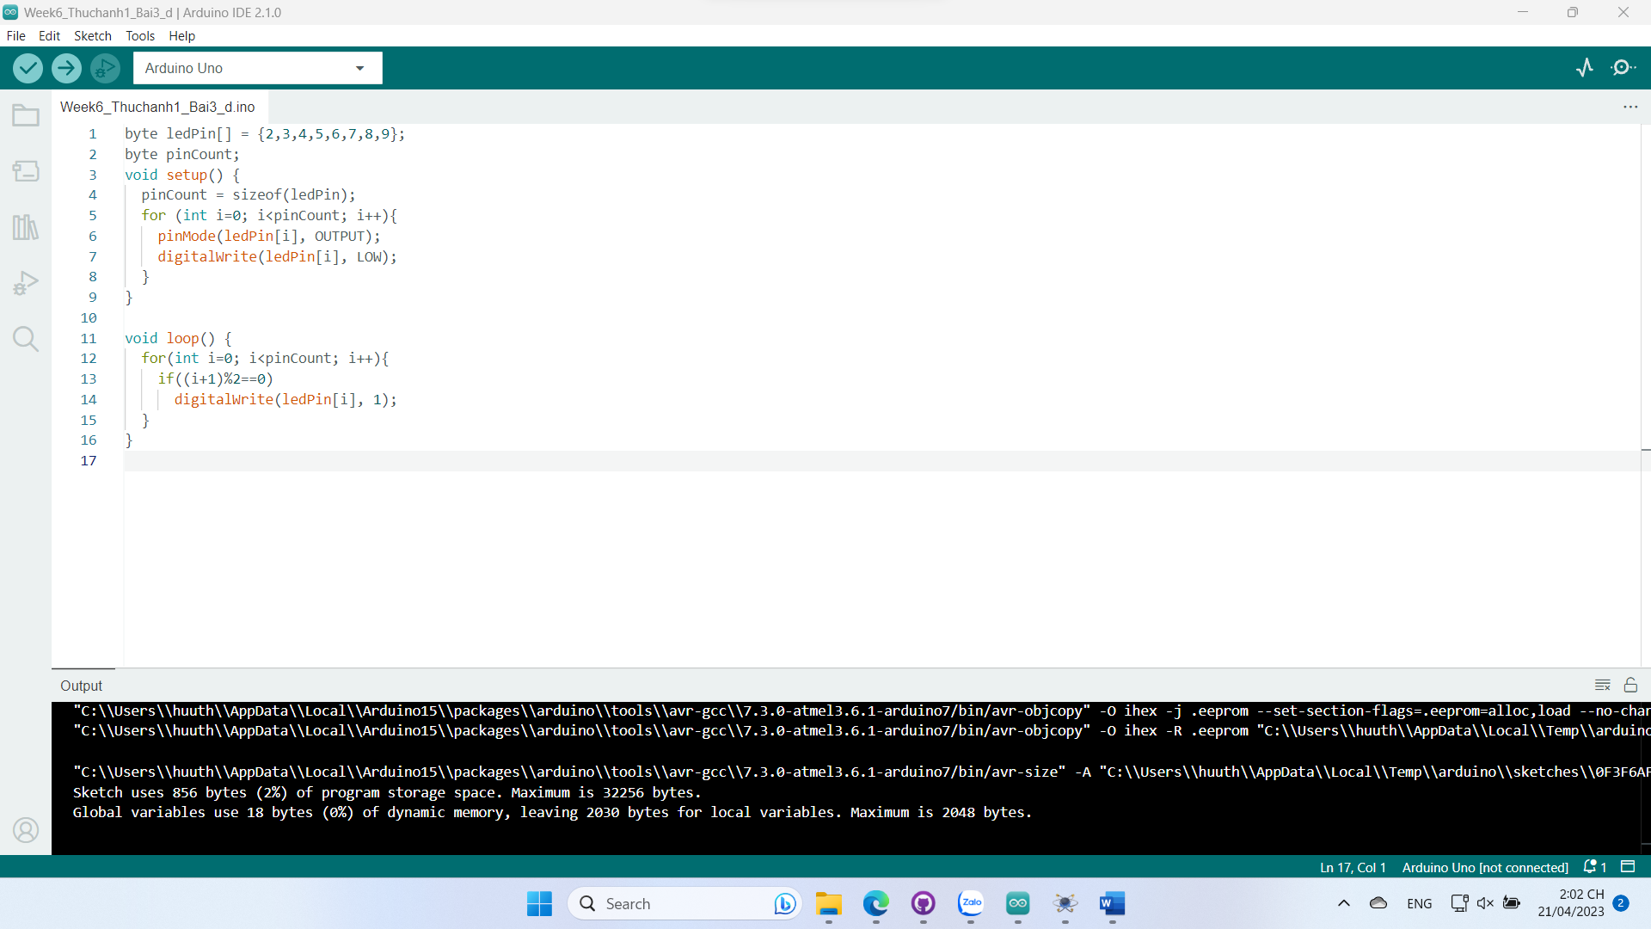

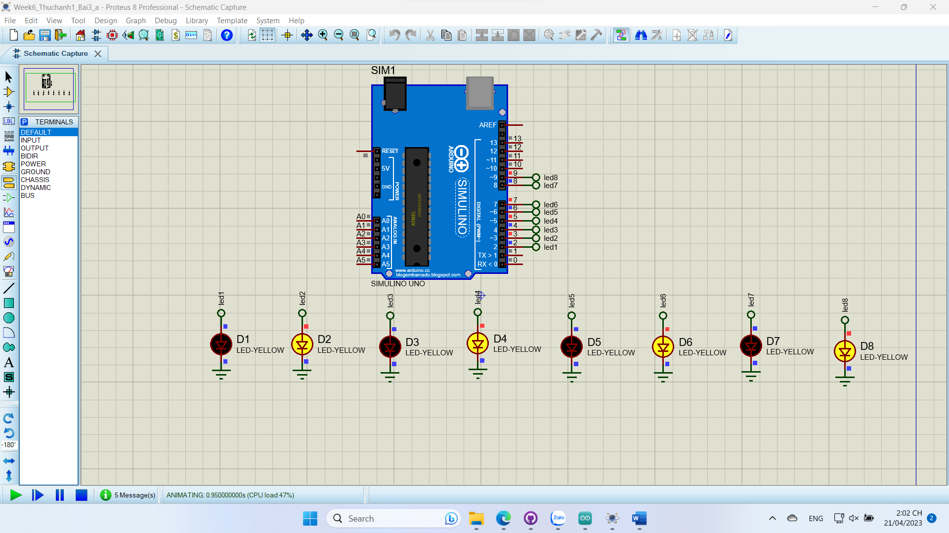

#define pinBtn 2

#define pinLed 8

unsigned long buttonPressTime = 0;

bool isButtonPressed = false;

bool ledState = false;

void setup() {

  pinMode(pinLed, OUTPUT);

  pinMode(pinBtn, INPUT);

}

void loop() {

  int buttonState = digitalRead(pinBtn);

  if (buttonState == LOW && !isButtonPressed) {

    buttonPressTime = millis();

    isButtonPressed = true;

  }

  if (isButtonPressed && buttonState == HIGH) {

    unsigned long duration = millis() - buttonPressTime;

    if (duration >= 500) {

      ledState = !ledState;

      digitalWrite(pinLed, ledState);

      delay(5000);

      digitalWrite(pinLed, LOW);

    }

    isButtonPressed = false;

  }

}

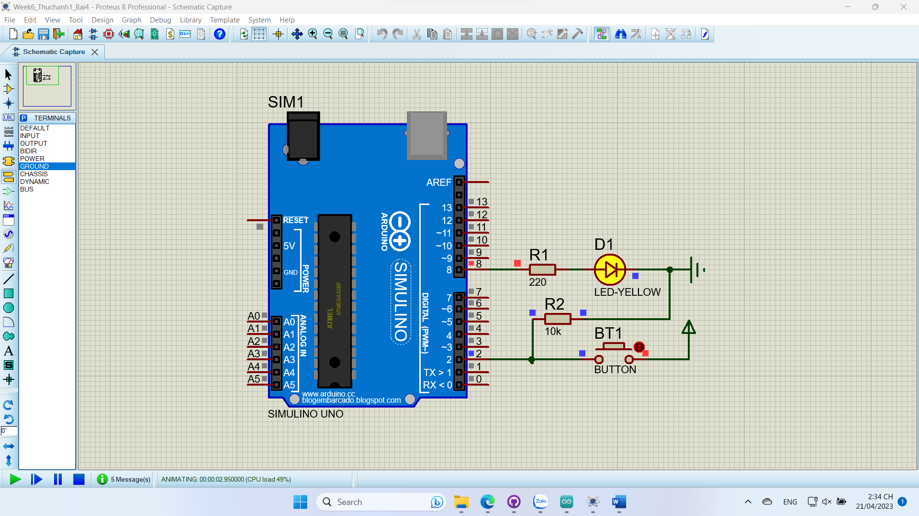

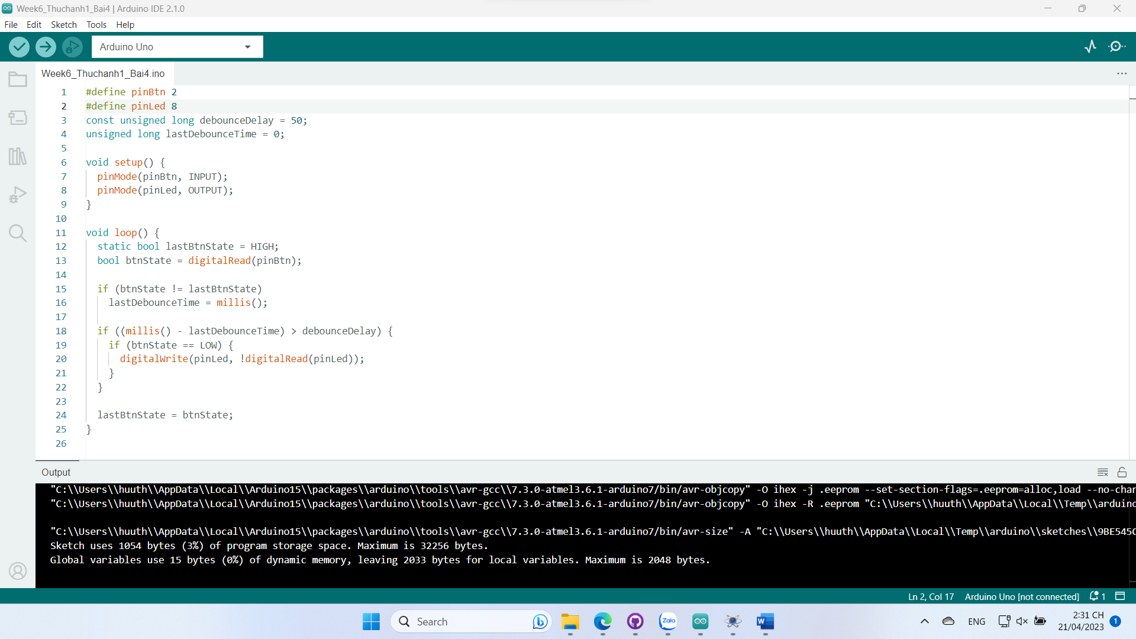



int mang[10][7] = {

  {1, 1, 1, 1, 1, 1, 0}, //0

  {0, 1, 1, 0, 0, 0, 0}, //1

  {1, 1, 0, 1, 1, 0, 1}, //2

  {1, 1, 1, 1, 0, 0, 1}, //3

  {0, 1, 1, 0, 0, 1, 1}, //4

  {1, 0, 1, 1, 0, 1, 1}, //5

  {1, 0, 1, 1, 1, 1, 1}, //6

  {1, 1, 1, 0, 0, 0, 0}, //7

  {1, 1, 1, 1, 1, 1, 1}, //8

  {1, 1, 1, 1, 0, 1, 1}, //9

};

void hienThiSo(int so) {

  for (int i = 13; i >= 7; i--)

    digitalWrite(i, mang[so][13 - i]);

}

void setup() {

  for (int i = 1; i <= 13; i++)

    pinMode(i, OUTPUT);

}

void loop() {

  hienThiSo(3);

}

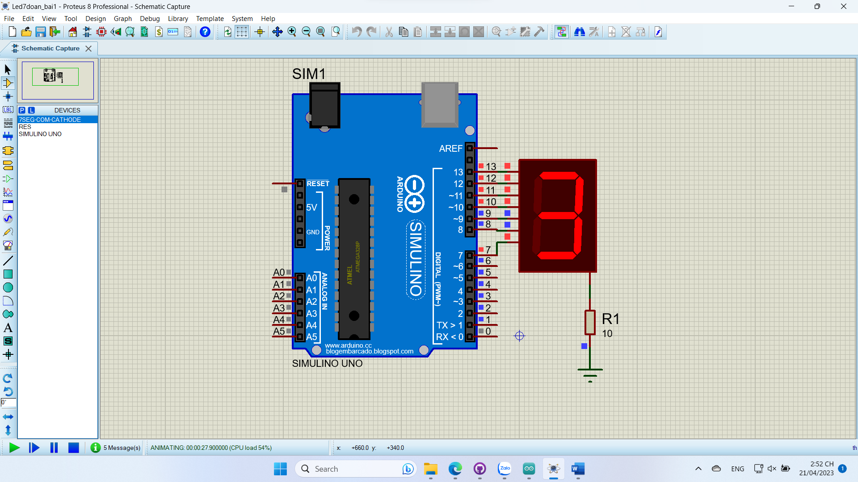

int mang[10][7] = {

  {1, 1, 1, 1, 1, 1, 0}, //0

  {0, 1, 1, 0, 0, 0, 0}, //1

  {1, 1, 0, 1, 1, 0, 1}, //2

  {1, 1, 1, 1, 0, 0, 1}, //3

  {0, 1, 1, 0, 0, 1, 1}, //4

  {1, 0, 1, 1, 0, 1, 1}, //5

  {1, 0, 1, 1, 1, 1, 1}, //6

  {1, 1, 1, 0, 0, 0, 0}, //7

  {1, 1, 1, 1, 1, 1, 1}, //8

  {1, 1, 1, 1, 0, 1, 1}, //9

};

void hienThiSo(int so) {

  for (int i = 13; i >= 7; i--)

    digitalWrite(i, mang[so][13 - i]);

}

void setup() {

  for (int i = 1; i <= 13; i++)

    pinMode(i, OUTPUT);

}

void loop() {

  for(int i=0; i<=9; i++){

    hienThiSo(i);

    delay(500);

  }

}

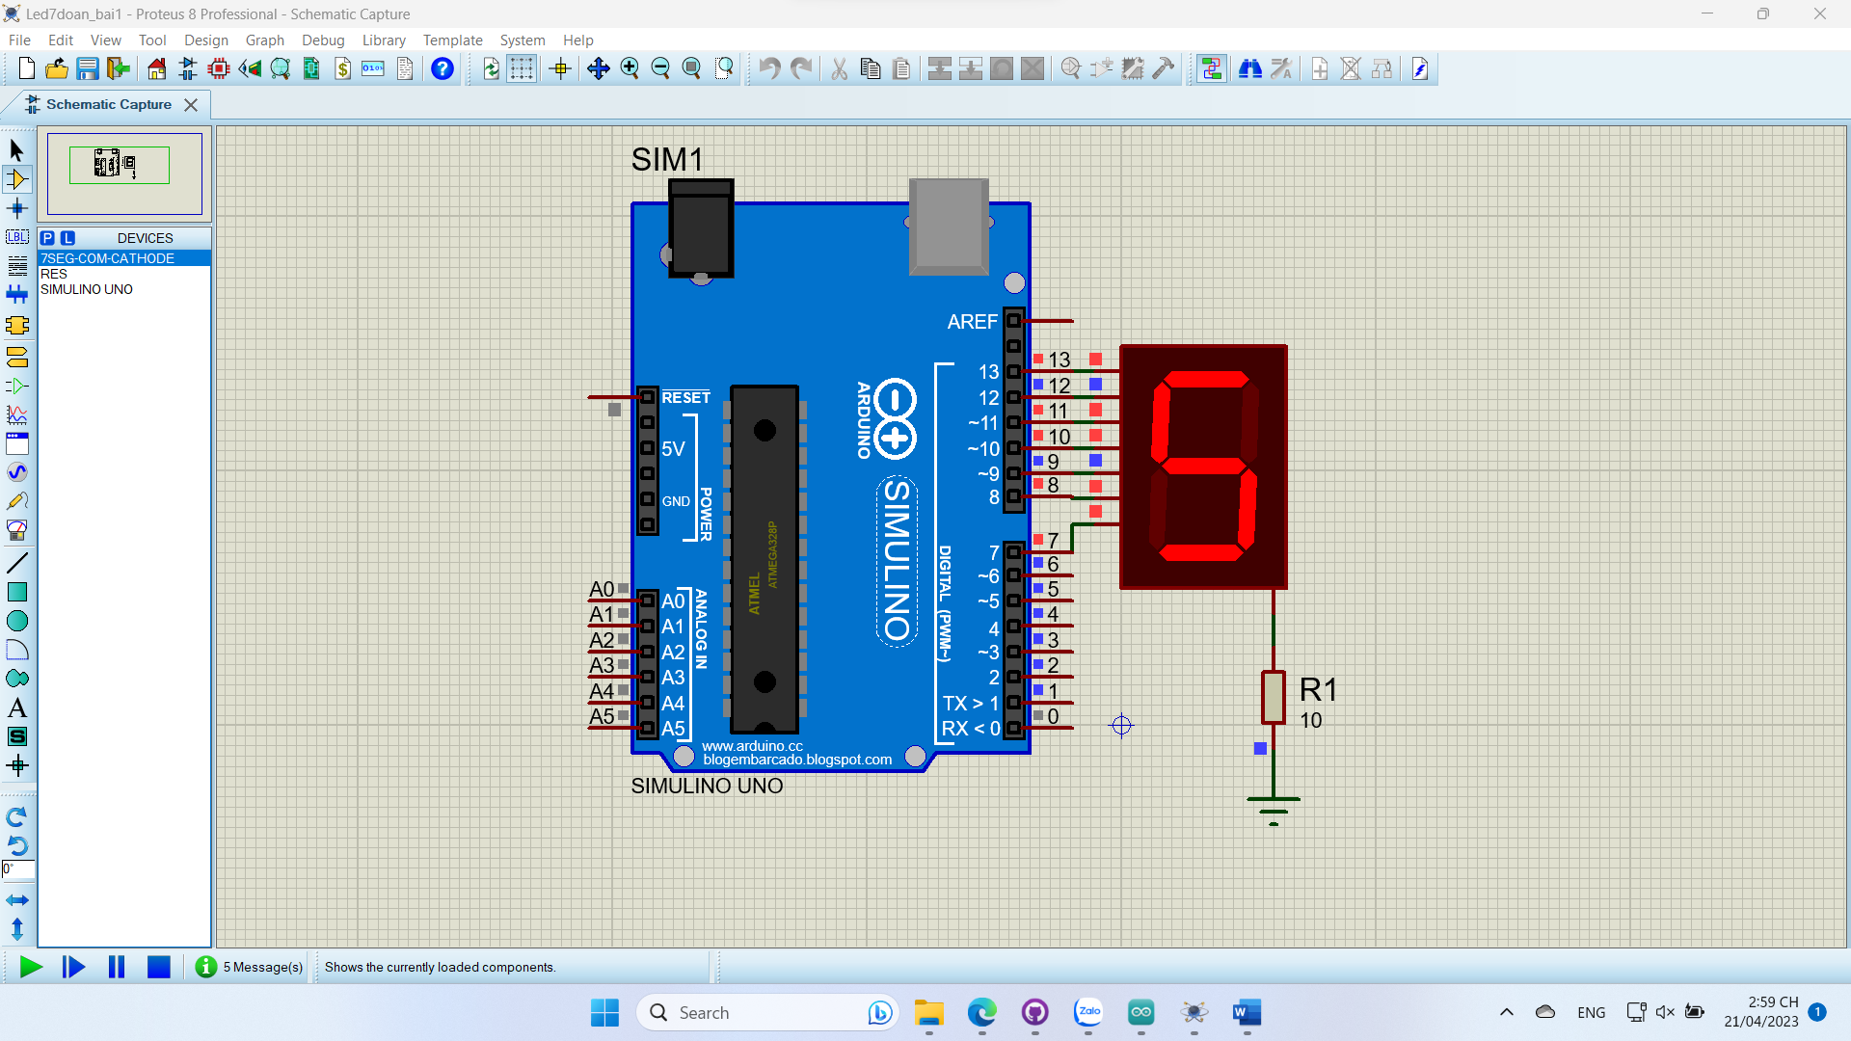

#define ledRed 2

#define ledYellow 3

#define ledGreen 4

int mang[10][7] = {

  {1, 1, 1, 1, 1, 1, 0}, //0

  {0, 1, 1, 0, 0, 0, 0}, //1

  {1, 1, 0, 1, 1, 0, 1}, //2

  {1, 1, 1, 1, 0, 0, 1}, //3

  {0, 1, 1, 0, 0, 1, 1}, //4

  {1, 0, 1, 1, 0, 1, 1}, //5

  {1, 0, 1, 1, 1, 1, 1}, //6

  {1, 1, 1, 0, 0, 0, 0}, //7

  {1, 1, 1, 1, 1, 1, 1}, //8

  {1, 1, 1, 1, 0, 1, 1}, //9

};

void hienThiSo(int so) {

  for (int i = 13; i >= 7; i--)

    digitalWrite(i, mang[so][13 - i]);

}

void setup() {

  pinMode(ledRed, OUTPUT);

  pinMode(ledYellow, OUTPUT);

  pinMode(ledGreen, OUTPUT);

  for (int i = 1; i <= 13; i++)

    pinMode(i, OUTPUT);

}

void blink(int pin, int time){

  int numSeconds = time / 1000;

  digitalWrite(pin, 1);

  for(int i=numSeconds; i>=0; i--){

    hienThiSo(i);

    delay(1000);

  }

  digitalWrite(pin, 0);

}

void loop() {

  blink(ledRed, 9000);

  blink(ledYellow, 9000);

  blink(ledGreen, 9000);

}

