1. RESTORE Cơ sở dữ liệu đã đươc backup QLDuAn_backup.bak vào cơ sở dữ liệu QLDuAn trên Server1.

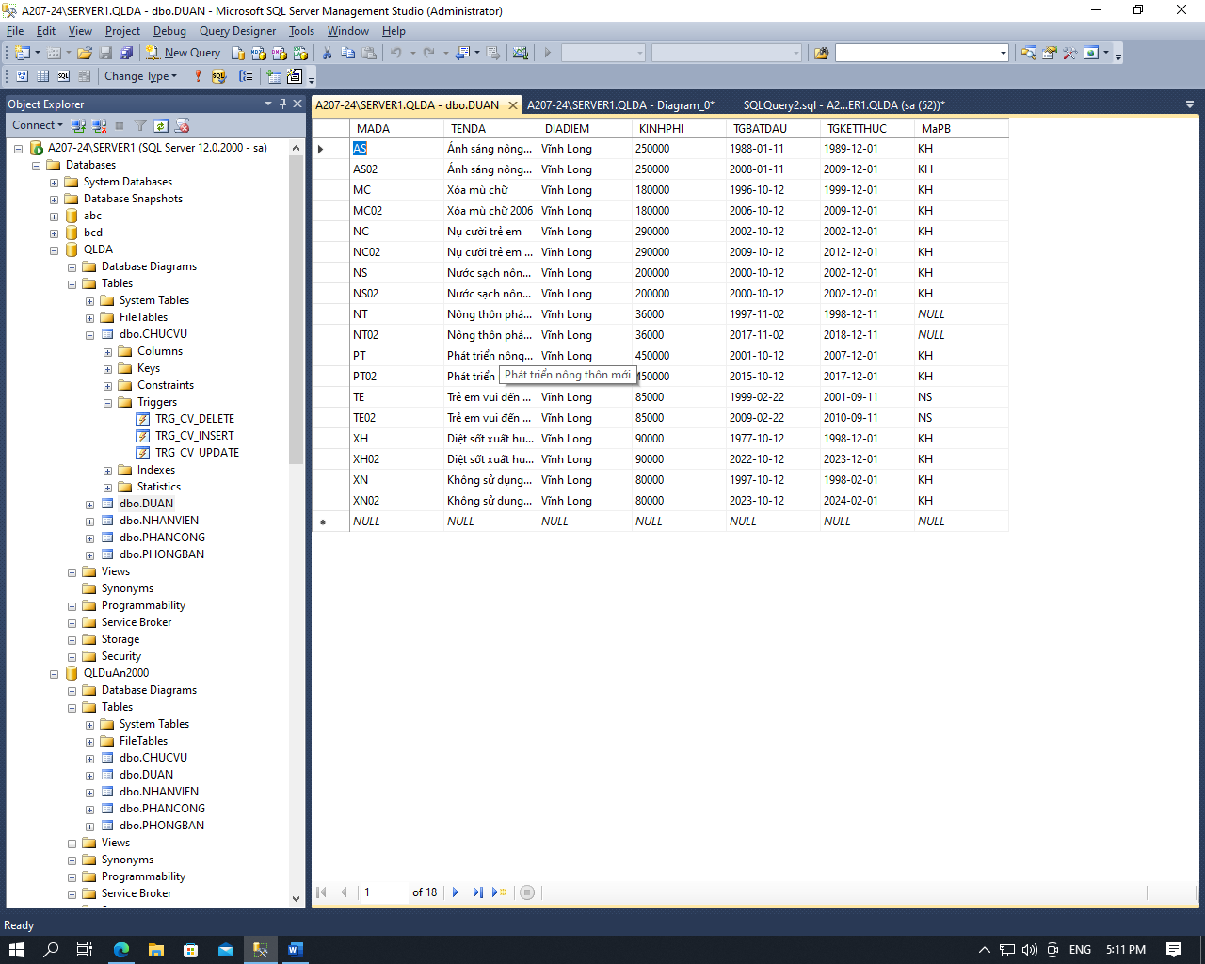

2. Thiết lập các ràng buộc toàn vẹn giữa các table

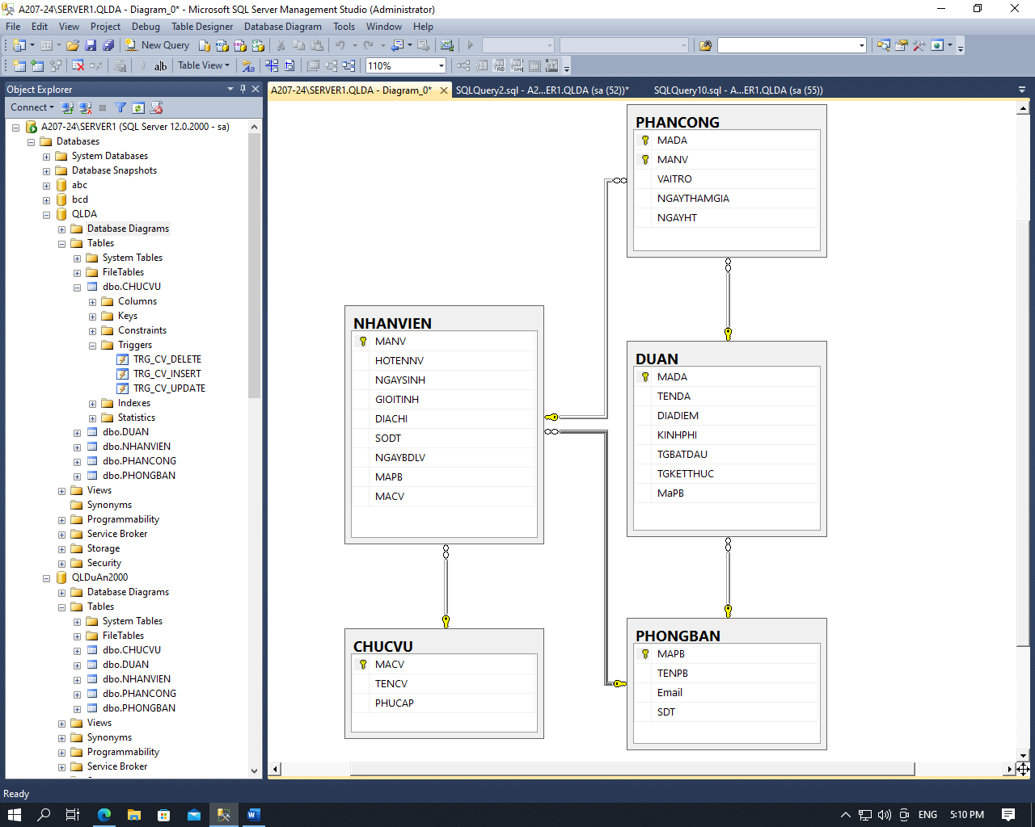

update DUAN set MaPB=NULL where MaPB not in (select MaPB from PHONGBAN)

alter table DUAN alter

column MaPB varchar(5)

alter table PHANCONG drop

constraint PK_PHANCONG

alter table PHANCONG alter

column MADA varchar(25) not null

alter table PHANCONG alter

column MANV varchar(15) not null

alter table PHANCONG add

constraint FK_PHANCONG primary key(MADA,MANV)

alter table DUAN add

constraint FK_DA_PB foreign key(MaPB)

references PHONGBAN(MAPB)

alter table NHANVIEN add

constraint FK_NV_PB foreign key(MAPB)

references PHONGBAN(MAPB),

constraint FK_NV_CV foreign key(MACV)

references CHUCVU(MACV)

alter table PHANCONG add

constraint FK_PC_DA foreign key(MADA)

references DUAN(MADA),

constraint FK_PC_NV foreign key(MANV)

references NHANVIEN(MANV)

alter table PHANCONG drop

constraint FK_PC_DA

alter table PHANCONG drop

constraint FK_PC_NV

alter table PHANCONG add

constraint FK_PC_DA foreign key(MADA)

references DUAN(MADA) on delete cascade on update cascade,

constraint FK_PC_NV foreign key(MANV)

references NHANVIEN(MANV) on delete cascade on update cascade

4. Thực hiện phân tán cơ sở dữ liệu:

- m1: dự án có địa điểm tại 'Vĩnh Long' có kinh phía trên 200000; phân tán đến CSDL QLDuAn2000

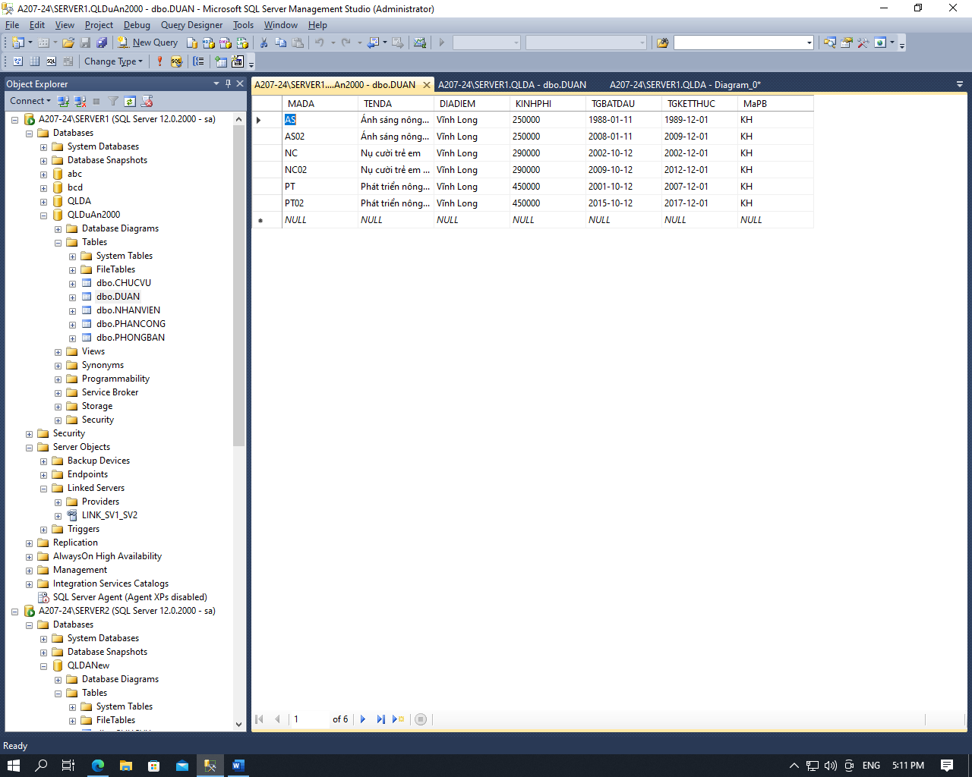

/*create database QLDuAn2000

go

use QLDuAn2000

go

--select * into DUAN from QLDA.[dbo].DUAN where DIADIEM=N'Vĩnh Long' and KINHPHI>200000

--select PHANCONG.* into PHANCONG from QLDA.[dbo].PHANCONG,DUAN where PHANCONG.MADA=DUAN.MADA

--select distinct NHANVIEN.* into NHANVIEN from QLDA.[dbo].NHANVIEN,PHANCONG where PHANCONG.MANV=NHANVIEN.MANV

select * into PHONGBAN from QLDA.[dbo].PHONGBAN

select * into CHUCVU from QLDA.[dbo].CHUCVU

alter table DUAN add

constraint PK_DUAN primary key(MADA)

alter table NHANVIEN add

constraint PK_NHANVIEN primary key(MANV)

alter table PHONGBAN add

constraint PK_PHONGBAN primary key(MAPB)

alter table CHUCVU add

constraint PK_CHUCVU primary key(MACV)

alter table PHANCONG add

constraint FK_PHANCONG primary key(MADA,MANV)

alter table DUAN add

constraint FK_DA_PB foreign key(MaPB)

references PHONGBAN(MAPB)

alter table NHANVIEN add

constraint FK_NV_PB foreign key(MAPB)

references PHONGBAN(MAPB),

constraint FK_NV_CV foreign key(MACV)

references CHUCVU(MACV)

alter table PHANCONG add

constraint FK_PC_DA foreign key(MADA)

references DUAN(MADA),

constraint FK_PC_NV foreign key(MANV)

references NHANVIEN(MANV)*/

--select * from DUAN

--insert into DUAN values ('AS1','ASD',N'Vĩnh Long',2000001,'1988-01-11','1989-12-01','KH')

--update DUAN set TENDA='QWE' where MADA='AS1'

--delete DUAN where MADA='AS1'

alter table PHANCONG drop

constraint FK_PC_DA

alter table PHANCONG drop

constraint FK_PC_NV

alter table PHANCONG add

constraint FK_PC_DA foreign key(MADA)

references DUAN(MADA) on delete cascade on update cascade,

constraint FK_PC_NV foreign key(MANV)

references NHANVIEN(MANV) on delete cascade on update cascade

- m2: các dự án do phòng Nhân sự thực hiện trước năm 2000 phân tán đến Server 2



/*create database QLDANew

go

use QLDANew

go*/

select * into PHONGBAN from QLDA.[dbo].PHONGBAN

go

select * into CHUCVU from QLDA.[dbo].CHUCVU

go

select DUAN.* into DUAN from QLDA.[dbo].DUAN,PHONGBAN

where DUAN.MAPB=PHONGBAN.MAPB and TENPB=N'Nhân sự' and year(TGBATDAU)<2000 and (DIADIEM<>N'Vĩnh Long' or KINHPHI<=200000)

go

select PHANCONG.* into PHANCONG from QLDA.[dbo].PHANCONG,DUAN where PHANCONG.MADA=DUAN.MADA

go

select distinct NHANVIEN.* into NHANVIEN from QLDA.[dbo].NHANVIEN,PHANCONG where PHANCONG.MANV=NHANVIEN.MANV

alter table DUAN add

constraint PK_DUAN primary key(MADA)

alter table NHANVIEN add

constraint PK_NHANVIEN primary key(MANV)

alter table PHONGBAN add

constraint PK_PHONGBAN primary key(MAPB)

alter table CHUCVU add

constraint PK_CHUCVU primary key(MACV)

alter table PHANCONG add

constraint FK_PHANCONG primary key(MADA,MANV)

alter table DUAN add

constraint FK_DA_PB foreign key(MaPB)

references PHONGBAN(MAPB)

alter table NHANVIEN add

constraint FK_NV_PB foreign key(MAPB)

references PHONGBAN(MAPB),

constraint FK_NV_CV foreign key(MACV)

references CHUCVU(MACV)

alter table PHANCONG add

constraint FK_PC_DA foreign key(MADA)

references DUAN(MADA),

constraint FK_PC_NV foreign key(MANV)

references NHANVIEN(MANV)

alter table PHANCONG drop

constraint FK_PC_DA

alter table PHANCONG drop

constraint FK_PC_NV

alter table PHANCONG add

constraint FK_PC_DA foreign key(MADA)

references DUAN(MADA) on delete cascade on update cascade,

constraint FK_PC_NV foreign key(MANV)

references NHANVIEN(MANV) on delete cascade on update cascade

5. Đồng bộ dữ liệu từ các Site lên Server

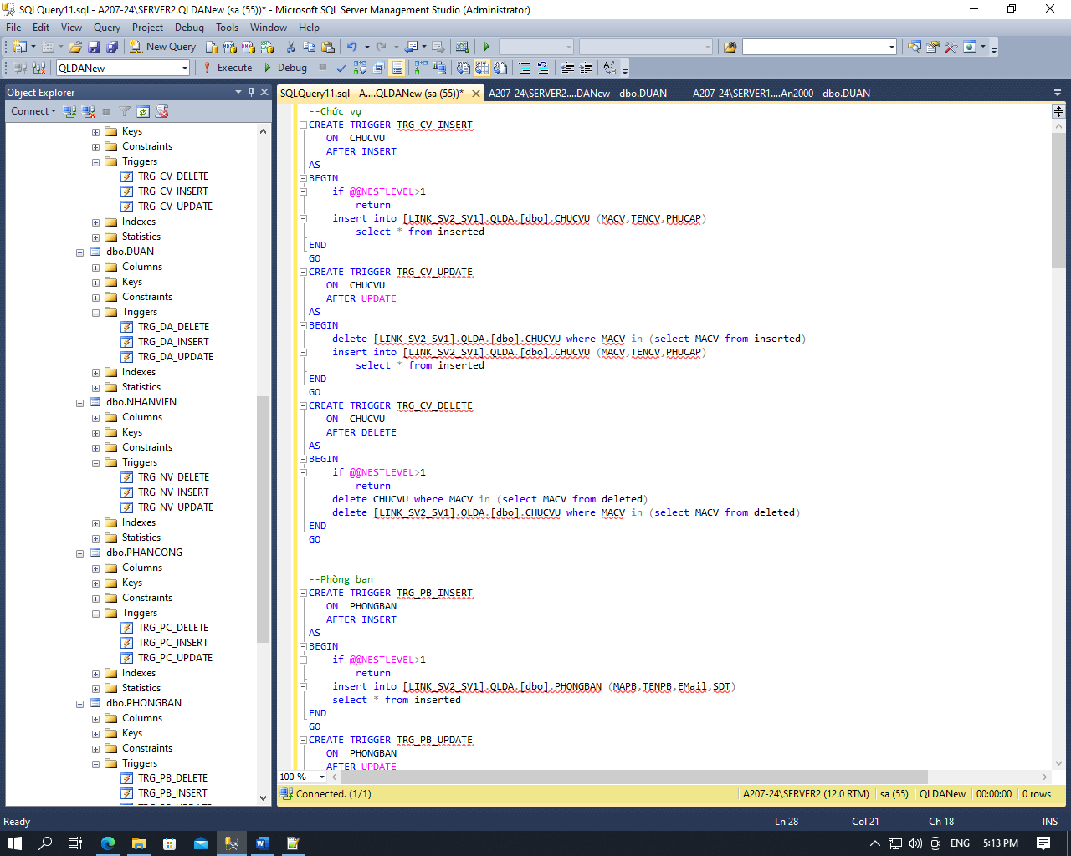

--Chức vụ

CREATE TRIGGER TRG_CV_INSERT

ON CHUCVU

AFTER INSERT

AS

BEGIN

if @@NESTLEVEL>1

return

insert into [LINK_SV2_SV1].QLDA.[dbo].CHUCVU (MACV,TENCV,PHUCAP)

select * from inserted

END

GO

CREATE TRIGGER TRG_CV_UPDATE

ON CHUCVU

AFTER UPDATE

AS

BEGIN

delete [LINK_SV2_SV1].QLDA.[dbo].CHUCVU where MACV in (select MACV from inserted)

insert into [LINK_SV2_SV1].QLDA.[dbo].CHUCVU (MACV,TENCV,PHUCAP)

select * from inserted

END

GO

CREATE TRIGGER TRG_CV_DELETE

ON CHUCVU

AFTER DELETE

AS

BEGIN

if @@NESTLEVEL>1

return

delete CHUCVU where MACV in (select MACV from deleted)

delete [LINK_SV2_SV1].QLDA.[dbo].CHUCVU where MACV in (select MACV from deleted)

END

GO

--Phòng ban

CREATE TRIGGER TRG_PB_INSERT

ON PHONGBAN

AFTER INSERT

AS

BEGIN

if @@NESTLEVEL>1

return

insert into [LINK_SV2_SV1].QLDA.[dbo].PHONGBAN (MAPB,TENPB,EMail,SDT)

select * from inserted

END

GO

CREATE TRIGGER TRG_PB_UPDATE

ON PHONGBAN

AFTER UPDATE

AS

BEGIN

delete [LINK_SV2_SV1].QLDA.[dbo].PHONGBAN where MAPB in (select MAPB from inserted)

insert into [LINK_SV2_SV1].QLDA.[dbo].PHONGBAN (MAPB,TENPB,EMail,SDT)

select * from inserted

END

GO

CREATE TRIGGER TRG_PB_DELETE

ON PHONGBAN

AFTER DELETE

AS

BEGIN

if @@NESTLEVEL>1

return

delete PHONGBAN where MAPB in (select MAPB from deleted)

delete [LINK_SV2_SV1].QLDA.[dbo].PHONGBAN where MAPB in (select MAPB from deleted)

END

GO

--Nhân viên

CREATE TRIGGER TRG_NV_INSERT

ON NHANVIEN

AFTER INSERT

AS

BEGIN

if @@NESTLEVEL>1

return

insert into [LINK_SV2_SV1].QLDA.[dbo].NHANVIEN (MANV,HOTENNV,NGAYSINH,GIOITINH,DIACHI,SODT,NGAYBDLV,MAPB,MACV)

select * from inserted

END

GO

CREATE TRIGGER TRG_NV_UPDATE

ON NHANVIEN

AFTER UPDATE

AS

BEGIN

delete [LINK_SV2_SV1].QLDA.[dbo].NHANVIEN where MANV in (select MANV from inserted)

insert into [LINK_SV2_SV1].QLDA.[dbo].NHANVIEN (MANV,HOTENNV,NGAYSINH,GIOITINH,DIACHI,SODT,NGAYBDLV,MAPB,MACV)

select * from inserted

END

GO

CREATE TRIGGER TRG_NV_DELETE

ON NHANVIEN

AFTER DELETE

AS

BEGIN

if @@NESTLEVEL>1

return

delete NHANVIEN where MANV in (select MANV from deleted)

delete [LINK_SV2_SV1].QLDA.[dbo].NHANVIEN where MANV in (select MANV from deleted)

END

GO

--Dự án

CREATE TRIGGER TRG_DA_INSERT

ON DUAN

AFTER INSERT

AS

BEGIN

if @@NESTLEVEL>1

return

if (exists(select * from inserted where MaPB<>'NS' or year(TGBATDAU)>=2000))

begin

return

end

insert into [LINK_SV2_SV1].QLDA.[dbo].DUAN (MADA,TENDA,DIADIEM,KINHPHI,TGBATDAU,TGKETTHUC,MAPB)

select * from inserted

END

GO

CREATE TRIGGER TRG_DA_UPDATE

ON DUAN

AFTER UPDATE

AS

BEGIN

if (exists(select * from inserted where MaPB<>'NS' or year(TGBATDAU)>=2000))

begin

return

end

delete [LINK_SV2_SV1].QLDA.[dbo].DUAN where MADA in (select MADA from inserted)

insert into [LINK_SV2_SV1].QLDA.[dbo].DUAN (MADA,TENDA,DIADIEM,KINHPHI,TGBATDAU,TGKETTHUC,MAPB)

select * from inserted

END

GO

CREATE TRIGGER TRG_DA_DELETE

ON DUAN

AFTER DELETE

AS

BEGIN

if @@NESTLEVEL>1

return

delete DUAN where MADA in (select MADA from deleted)

delete [LINK_SV2_SV1].QLDA.[dbo].DUAN where MADA in (select MADA from deleted)

END

GO

--Phân công

CREATE TRIGGER TRG_PC_INSERT

ON PHANCONG

AFTER INSERT

AS

BEGIN

if @@NESTLEVEL>1

return

insert into [LINK_SV2_SV1].QLDA.[dbo].PHANCONG (MADA,MANV,VAITRO,NGAYTHAMGIA,NGAYHT)

select * from inserted

END

GO

CREATE TRIGGER TRG_PC_UPDATE

ON PHANCONG

AFTER UPDATE

AS

BEGIN

delete [LINK_SV2_SV1].QLDA.[dbo].PHANCONG where MADA=(select MADA from inserted) and MANV=(select MANV from inserted)

insert into [LINK_SV2_SV1].QLDA.[dbo].PHANCONG (MADA,MANV,VAITRO,NGAYTHAMGIA,NGAYHT)

select * from inserted

END

GO

CREATE TRIGGER TRG_PC_DELETE

ON PHANCONG

AFTER DELETE

AS

BEGIN

if @@NESTLEVEL>1

return

delete PHANCONG where MADA=(select MADA from deleted) and MANV=(select MANV from deleted)

delete [LINK_SV2_SV1].QLDA.[dbo].PHANCONG where MADA=(select MADA from deleted) and MANV=(select MANV from deleted)

END

GO

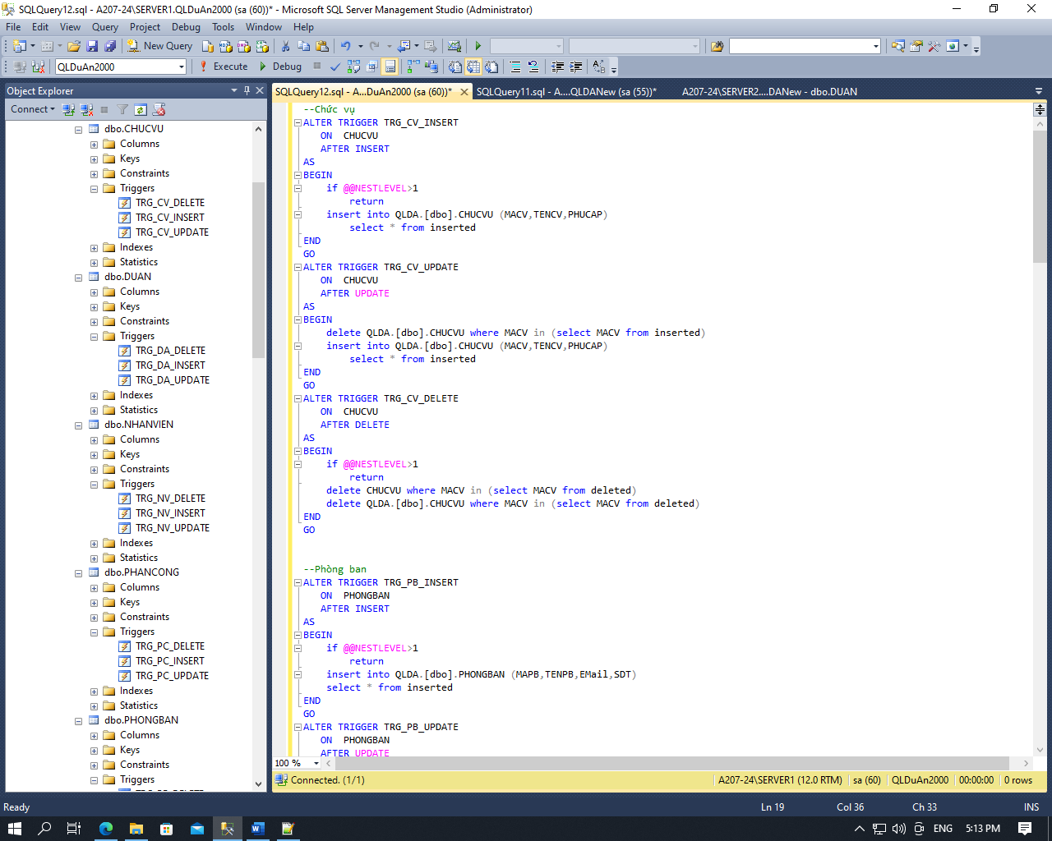

--Chức vụ

ALTER TRIGGER TRG_CV_INSERT

ON CHUCVU

AFTER INSERT

AS

BEGIN

if @@NESTLEVEL>1

return

insert into QLDA.[dbo].CHUCVU (MACV,TENCV,PHUCAP)

select * from inserted

END

GO

ALTER TRIGGER TRG_CV_UPDATE

ON CHUCVU

AFTER UPDATE

AS

BEGIN

delete QLDA.[dbo].CHUCVU where MACV in (select MACV from inserted)

insert into QLDA.[dbo].CHUCVU (MACV,TENCV,PHUCAP)

select * from inserted

END

GO

ALTER TRIGGER TRG_CV_DELETE

ON CHUCVU

AFTER DELETE

AS

BEGIN

if @@NESTLEVEL>1

return

delete CHUCVU where MACV in (select MACV from deleted)

delete QLDA.[dbo].CHUCVU where MACV in (select MACV from deleted)

END

GO

--Phòng ban

ALTER TRIGGER TRG_PB_INSERT

ON PHONGBAN

AFTER INSERT

AS

BEGIN

if @@NESTLEVEL>1

return

insert into QLDA.[dbo].PHONGBAN (MAPB,TENPB,EMail,SDT)

select * from inserted

END

GO

ALTER TRIGGER TRG_PB_UPDATE

ON PHONGBAN

AFTER UPDATE

AS

BEGIN

delete QLDA.[dbo].PHONGBAN where MAPB in (select MAPB from inserted)

insert into QLDA.[dbo].PHONGBAN (MAPB,TENPB,EMail,SDT)

select * from inserted

END

GO

ALTER TRIGGER TRG_PB_DELETE

ON PHONGBAN

AFTER DELETE

AS

BEGIN

if @@NESTLEVEL>1

return

delete PHONGBAN where MAPB in (select MAPB from deleted)

delete QLDA.[dbo].PHONGBAN where MAPB in (select MAPB from deleted)

END

GO

--Nhân viên

ALTER TRIGGER TRG_NV_INSERT

ON NHANVIEN

AFTER INSERT

AS

BEGIN

if @@NESTLEVEL>1

return

insert into QLDA.[dbo].NHANVIEN (MANV,HOTENNV,NGAYSINH,GIOITINH,DIACHI,SODT,NGAYBDLV,MAPB,MACV)

select * from inserted

END

GO

ALTER TRIGGER TRG_NV_UPDATE

ON NHANVIEN

AFTER UPDATE

AS

BEGIN

delete QLDA.[dbo].NHANVIEN where MANV in (select MANV from inserted)

insert into QLDA.[dbo].NHANVIEN (MANV,HOTENNV,NGAYSINH,GIOITINH,DIACHI,SODT,NGAYBDLV,MAPB,MACV)

select * from inserted

END

GO

ALTER TRIGGER TRG_NV_DELETE

ON NHANVIEN

AFTER DELETE

AS

BEGIN

if @@NESTLEVEL>1

return

delete NHANVIEN where MANV in (select MANV from deleted)

delete QLDA.[dbo].NHANVIEN where MANV in (select MANV from deleted)

END

GO

--Dự án

ALTER TRIGGER TRG_DA_INSERT

ON DUAN

AFTER INSERT

AS

BEGIN

if @@NESTLEVEL>1

return

if (exists(select * from inserted where MaPB<>'NS' or year(TGBATDAU)>=2000))

begin

return

end

insert into QLDA.[dbo].DUAN (MADA,TENDA,DIADIEM,KINHPHI,TGBATDAU,TGKETTHUC,MAPB)

select * from inserted

END

GO

ALTER TRIGGER TRG_DA_UPDATE

ON DUAN

AFTER UPDATE

AS

BEGIN

if (exists(select * from inserted where MaPB<>'NS' or year(TGBATDAU)>=2000))

begin

return

end

delete QLDA.[dbo].DUAN where MADA in (select MADA from inserted)

insert into QLDA.[dbo].DUAN (MADA,TENDA,DIADIEM,KINHPHI,TGBATDAU,TGKETTHUC,MAPB)

select * from inserted

END

GO

ALTER TRIGGER TRG_DA_DELETE

ON DUAN

AFTER DELETE

AS

BEGIN

if @@NESTLEVEL>1

return

delete DUAN where MADA in (select MADA from deleted)

delete QLDA.[dbo].DUAN where MADA in (select MADA from deleted)

END

GO

--Phân công

ALTER TRIGGER TRG_PC_INSERT

ON PHANCONG

AFTER INSERT

AS

BEGIN

if @@NESTLEVEL>1

return

insert into QLDA.[dbo].PHANCONG (MADA,MANV,VAITRO,NGAYTHAMGIA,NGAYHT)

select * from inserted

END

GO

ALTER TRIGGER TRG_PC_UPDATE

ON PHANCONG

AFTER UPDATE

AS

BEGIN

delete QLDA.[dbo].PHANCONG where MADA=(select MADA from inserted) and MANV=(select MANV from inserted)

insert into QLDA.[dbo].PHANCONG (MADA,MANV,VAITRO,NGAYTHAMGIA,NGAYHT)

select * from inserted

END

GO

ALTER TRIGGER TRG_PC_DELETE

ON PHANCONG

AFTER DELETE

AS

BEGIN

if @@NESTLEVEL>1

return

delete PHANCONG where MADA=(select MADA from deleted) and MANV=(select MANV from deleted)

delete QLDA.[dbo].PHANCONG where MADA=(select MADA from deleted) and MANV=(select MANV from deleted)

END

GO

6. Đồng bộ dữ liệu từ Server đến các Site

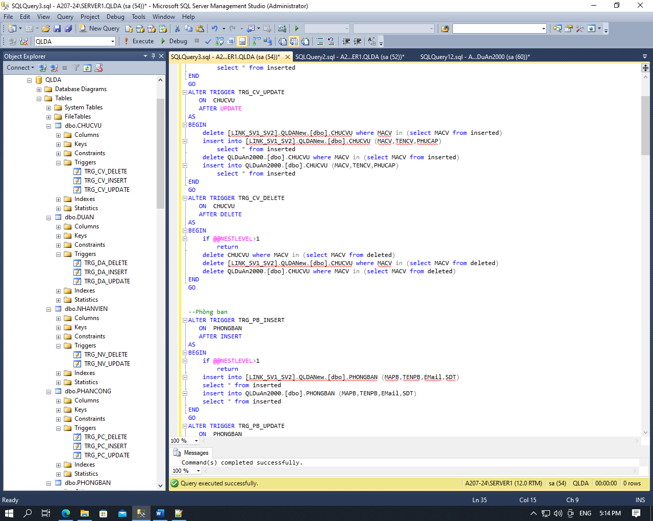

--Chức vụ

ALTER TRIGGER TRG_CV_INSERT

ON CHUCVU

AFTER INSERT

AS

BEGIN

if @@NESTLEVEL>1

return

print('run')

insert into [LINK_SV1_SV2].QLDANew.[dbo].CHUCVU (MACV,TENCV,PHUCAP)

select * from inserted

insert into QLDuAn2000.[dbo].CHUCVU (MACV,TENCV,PHUCAP)

select * from inserted

END

GO

ALTER TRIGGER TRG_CV_UPDATE

ON CHUCVU

AFTER UPDATE

AS

BEGIN

delete [LINK_SV1_SV2].QLDANew.[dbo].CHUCVU where MACV in (select MACV from inserted)

insert into [LINK_SV1_SV2].QLDANew.[dbo].CHUCVU (MACV,TENCV,PHUCAP)

select * from inserted

delete QLDuAn2000.[dbo].CHUCVU where MACV in (select MACV from inserted)

insert into QLDuAn2000.[dbo].CHUCVU (MACV,TENCV,PHUCAP)

select * from inserted

END

GO

ALTER TRIGGER TRG_CV_DELETE

ON CHUCVU

AFTER DELETE

AS

BEGIN

if @@NESTLEVEL>1

return

delete CHUCVU where MACV in (select MACV from deleted)

delete [LINK_SV1_SV2].QLDANew.[dbo].CHUCVU where MACV in (select MACV from deleted)

delete QLDuAn2000.[dbo].CHUCVU where MACV in (select MACV from deleted)

END

GO

--Phòng ban

ALTER TRIGGER TRG_PB_INSERT

ON PHONGBAN

AFTER INSERT

AS

BEGIN

if @@NESTLEVEL>1

return

insert into [LINK_SV1_SV2].QLDANew.[dbo].PHONGBAN (MAPB,TENPB,EMail,SDT)

select * from inserted

insert into QLDuAn2000.[dbo].PHONGBAN (MAPB,TENPB,EMail,SDT)

select * from inserted

END

GO

ALTER TRIGGER TRG_PB_UPDATE

ON PHONGBAN

AFTER UPDATE

AS

BEGIN

delete [LINK_SV1_SV2].QLDANew.[dbo].PHONGBAN where MAPB in (select MAPB from inserted)

insert into [LINK_SV1_SV2].QLDANew.[dbo].PHONGBAN (MAPB,TENPB,EMail,SDT)

select * from inserted

delete QLDuAn2000.[dbo].PHONGBAN where MAPB in (select MAPB from inserted)

insert into QLDuAn2000.[dbo].PHONGBAN (MAPB,TENPB,EMail,SDT)

select * from inserted

END

GO

ALTER TRIGGER TRG_PB_DELETE

ON PHONGBAN

AFTER DELETE

AS

BEGIN

if @@NESTLEVEL>1

return

delete PHONGBAN where MAPB in (select MAPB from deleted)

delete [LINK_SV1_SV2].QLDANew.[dbo].PHONGBAN where MAPB in (select MAPB from deleted)

delete QLDuAn2000.[dbo].PHONGBAN where MAPB in (select MAPB from deleted)

END

GO

--Nhân viên

ALTER TRIGGER TRG_NV_UPDATE

ON NHANVIEN

AFTER UPDATE

AS

BEGIN

if(exists(select * from [LINK_SV1_SV2].QLDANew.[dbo].NHANVIEN where MANV in (select MANV from inserted)))

begin

delete [LINK_SV1_SV2].QLDANew.[dbo].NHANVIEN where MANV in (select MANV from inserted)

insert into [LINK_SV1_SV2].QLDANew.[dbo].NHANVIEN (MANV,HOTENNV,NGAYSINH,GIOITINH,DIACHI,SODT,NGAYBDLV,MAPB,MACV)

select * from inserted

end

if(exists(select * from QLDuAn2000.[dbo].NHANVIEN where MANV in (select MACV from inserted)))

begin

delete QLDuAn2000.[dbo].NHANVIEN where MANV in (select MANV from inserted)

insert into QLDuAn2000.[dbo].NHANVIEN (MANV,HOTENNV,NGAYSINH,GIOITINH,DIACHI,SODT,NGAYBDLV,MAPB,MACV)

select * from inserted

end

END

GO

ALTER TRIGGER TRG_NV_DELETE

ON NHANVIEN

AFTER DELETE

AS

BEGIN

if @@NESTLEVEL>1

return

delete NHANVIEN where MANV in (select MANV from deleted)

if(exists(select * from [LINK_SV1_SV2].QLDANew.[dbo].NHANVIEN where MANV in (select MANV from inserted)))

begin

delete [LINK_SV1_SV2].QLDANew.[dbo].NHANVIEN where MANV in (select MANV from inserted)

end

if(exists(select * from QLDuAn2000.[dbo].NHANVIEN where MANV in (select MACV from inserted)))

begin

delete QLDuAn2000.[dbo].NHANVIEN where MANV in (select MANV from inserted)

end

END

GO

--Dự án

ALTER TRIGGER TRG_DA_INSERT

ON DUAN

AFTER INSERT

AS

BEGIN

if @@NESTLEVEL>1

return

insert into [LINK_SV1_SV2].QLDANew.[dbo].DUAN (MADA,TENDA,DIADIEM,KINHPHI,TGBATDAU,TGKETTHUC,MAPB)

select * from inserted where MAPB='NS' and year(TGBATDAU)<2000 and (DIADIEM<>N'Vĩnh Long' or KINHPHI<=200000)

insert into QLDuAn2000.[dbo].DUAN (MADA,TENDA,DIADIEM,KINHPHI,TGBATDAU,TGKETTHUC,MAPB)

select * from inserted where DIADIEM=N'Vĩnh Long' and KINHPHI>200000

END

GO

ALTER TRIGGER TRG_DA_UPDATE

ON DUAN

AFTER UPDATE

AS

BEGIN

delete [LINK_SV1_SV2].QLDANew.[dbo].DUAN where MADA in (select MADA from inserted where MAPB='NS' and year(TGBATDAU)<2000 and (DIADIEM<>N'Vĩnh Long' or KINHPHI<=200000))

insert into [LINK_SV1_SV2].QLDANew.[dbo].DUAN (MADA,TENDA,DIADIEM,KINHPHI,TGBATDAU,TGKETTHUC,MAPB)

select * from inserted where MAPB='NS' and year(TGBATDAU)<2000 and (DIADIEM<>N'Vĩnh Long' or KINHPHI<=200000)

delete QLDuAn2000.[dbo].DUAN where MADA in (select MADA from inserted where DIADIEM=N'Vĩnh Long' and KINHPHI>200000)

insert into QLDuAn2000.[dbo].DUAN (MADA,TENDA,DIADIEM,KINHPHI,TGBATDAU,TGKETTHUC,MAPB)

select * from inserted where DIADIEM=N'Vĩnh Long' and KINHPHI>200000

END

GO

ALTER TRIGGER TRG_DA_DELETE

ON DUAN

AFTER DELETE

AS

BEGIN

if @@NESTLEVEL>1

return

delete DUAN where MADA in (select MADA from deleted)

delete [LINK_SV1_SV2].QLDANew.[dbo].DUAN where MADA in (select MADA from deleted where MAPB='NS' and year(TGBATDAU)<2000 and (DIADIEM<>N'Vĩnh Long' or KINHPHI<=200000))

delete QLDuAn2000.[dbo].DUAN where MADA in (select MADA from deleted where DIADIEM=N'Vĩnh Long' and KINHPHI>200000)

END

GO

--Phân công

ALTER TRIGGER TRG_PC_INSERT

ON PHANCONG

AFTER INSERT

AS

BEGIN

if @@NESTLEVEL>1

return

if(exists(select inserted.* from inserted,DUAN where inserted.MADA=DUAN.MADA and DIADIEM=N'Vĩnh Long' and KINHPHI>200000))

begin

insert into QLDuAn2000.[dbo].NHANVIEN

select NHANVIEN.* from NHANVIEN,inserted where NHANVIEN.MANV=inserted.MANV

insert into QLDuAn2000.[dbo].PHANCONG

select * from inserted

end

if(exists(select inserted.* from inserted,DUAN where MAPB='NS' and year(TGBATDAU)<2000 and (DIADIEM<>N'Vĩnh Long' or KINHPHI<=200000)))

begin

insert into [LINK_SV1_SV2].QLDANew.[dbo].NHANVIEN

select NHANVIEN.* from NHANVIEN,inserted where NHANVIEN.MANV=inserted.MANV

insert into [LINK_SV1_SV2].QLDANew.[dbo].PHANCONG

select * from inserted

end

END

GO

ALTER TRIGGER TRG_PC_UPDATE

ON PHANCONG

AFTER UPDATE

AS

BEGIN

if(exists(select inserted.* from inserted,DUAN where inserted.MADA=DUAN.MADA and DIADIEM=N'Vĩnh Long' and KINHPHI>200000))

begin

delete QLDuAn2000.[dbo].PHANCONG where MADA=(select MADA from inserted) and MANV=(select MANV from inserted)

insert into QLDuAn2000.[dbo].PHANCONG (MADA,MANV,VAITRO,NGAYTHAMGIA,NGAYHT)

select * from inserted

end

if(exists(select inserted.* from inserted,DUAN where MAPB='NS' and year(TGBATDAU)<2000 and (DIADIEM<>N'Vĩnh Long' or KINHPHI<=200000)))

begin

delete [LINK_SV1_SV2].QLDANew.[dbo].PHANCONG where MADA=(select MADA from inserted) and MANV=(select MANV from inserted)

insert into [LINK_SV1_SV2].QLDANew.[dbo].PHANCONG (MADA,MANV,VAITRO,NGAYTHAMGIA,NGAYHT)

select * from inserted

end

END

GO

ALTER TRIGGER TRG_PC_DELETE

ON PHANCONG

AFTER DELETE

AS

BEGIN

if @@NESTLEVEL>1

return

delete PHANCONG where MADA=(select MADA from deleted) and MANV=(select MANV from deleted)

if(exists(select inserted.* from inserted,DUAN where inserted.MADA=DUAN.MADA and DIADIEM=N'Vĩnh Long' and KINHPHI>200000))

begin

delete QLDuAn2000.[dbo].PHANCONG where MADA=(select MADA from deleted) and MANV=(select MANV from deleted)

end

if(exists(select inserted.* from inserted,DUAN where MAPB='NS' and year(TGBATDAU)<2000 and (DIADIEM<>N'Vĩnh Long' or KINHPHI<=200000)))

begin

delete [LINK_SV1_SV2].QLDANew.[dbo].PHANCONG where MADA=(select MADA from deleted) and MANV=(select MANV from deleted)

end

END

GO