VIETNAM GENERAL CONFEDERATION OF LABOUR
TON DUC THANG UNIVERSITY
FACULTY OF INFORMATION TECHNOLOGY



TRẦN HỮU VĂN – 522K0014

Final Report

Service-Oriented Architecture

HO CHI MINH CITY, YEAR 2025

VIETNAM GENERAL CONFEDERATION OF LABOUR
TON DUC THANG UNIVERSITY
FACULTY OF INFORMATION TECHNOLOGY

TRẦN HỮU VĂN – 522K0014

Final Report

Service-Oriented Architecture

Advised by
Prof., Dr. Dương Hữu Phúc

ABSTRACT
This report details the development of a comprehensive e-commerce and content management platform built using modern software architecture principles. The project implements a sophisticated online shopping experience combined with content marketing capabilities, all powered by a custom microservices infrastructure.
This platform exemplifies Service-Oriented Architecture (SOA) principles through a sophisticated ecosystem of Python-based microservices interconnected via RESTful APIs. Each service maintains clear boundaries aligned with business domains—customer management, cart operations, order processing, payment handling, product catalog, promotions, and content publication—while communicating through well-defined REST endpoints with standardized JSON payloads.
At its core lies a custom-built database service leveraging Flask and SQLite, which provides abstracted data persistence capabilities through a standardized API interface. This service allows other microservices to perform schema management, CRUD operations, and complex queries without direct database interaction. The database service implements connection pooling, transaction support, and a consistent data access pattern while maintaining referential integrity across service boundaries.
The architecture delivers a comprehensive e-commerce experience with product catalog management, dynamic cart functionality, a flexible promotion engine, secure payment processing, and order fulfillment tracking. This is complemented by a robust content management system featuring article publication, media handling, and content categorization with tagging capabilities.
The entire system is containerized using Docker, enabling consistent deployment across development, staging, and production environments. Each microservice is packaged as a separate container with its own dependencies and configuration, allowing for isolated scaling and resource allocation. Docker Compose orchestrates the multi-container application, managing networking, volume mounting, and service dependencies during local development.
External access and testing are facilitated through ngrok, providing secure tunnels to localhost and enabling public URLs for local web servers. This approach allows for webhook testing, mobile app integration, and third-party API testing without deploying to production environments, significantly accelerating the development and integration process.
This Python-powered platform demonstrates how methodically designed SOA principles with a custom database abstraction layer can create a scalable, maintainable system. It seamlessly integrates shopping experiences with content-driven marketing while providing operational flexibility through independent service deployment and scaling capabilities.
TABLE OF CONTENTS
ABSTRACT 3
TABLE OF FIGURES 6
1. Introduction 6
1.1 Project Background 6
1.2 Objectives 7
2. System Architecture 7
2.1 Microservice Overview 7
2.2 Data Models 8
3. Use Case Diagram 12
4. Entity Relationship Diagram 14
5. Frontend-service 14
Overview 14
Key Responsibilities 14
Frontend Implementation 14
Backend Implementation 17
API Endpoints 18
6. Storage-service 19
Overview 19
Key Responsibilities 19
Backend Implementation 19
Frontend Implementation 19
API Endpoints 20
7. Promotion-service 22
Overview 22
Key Responsibilities 22
Backend Implementation 22
Frontend Implementation 23
API Endpoints 23
8. Payment-service 24
Overview 24
Key Responsibilities 24
Backend Implementation 24
API Endpoints 25
9. Order-service 26
Overview 26
Key Responsibilities 26
Frontend Implementation 27
Backend Implementation 28
API Endpoints 29
10. Media-service 30
Overview 30
Key Responsibilities 30
Frontend Implementation 30
Backend Implementation 31
API Endpoints 32
11. Customer-Service 33
Overview 33
Key Responsibilities 33
Frontend Implementation 34
Backend Implementation 35
API Endpoints 35
12. Database-service 37
Overview 37
Key Responsibilities 37
Backend Implementation 37
API Endpoints 38
13. Email-Service 41
Overview 41
Key Responsibilities 41
Backend Implementation 42
API Endpoints 42
14. Public Website 43
15. Conclusion 44

TABLE OF FIGURES

Figure 1Use Case Diagram 7
Figure 2: ERD 8
Figure 3:Get_menu_items 11
Figure 4:Create Order 11
Figure 5:Get_order 12
Figure 6:User 1 13
Figure 7:User 2 13
Figure 8:Waiter 14
Figure 9:Kitchen 14
Figure 10:Manager 1 15
Figure 11:Manager 2 15
Figure 12:Manager 3 16
Figure 13:Admin 1 16
Figure 14:Admin 2 17

Introduction

1.1 Project Background
This project emerged in response to the growing disconnect between e-commerce functionality and content marketing in existing retail platforms. Traditional systems typically treat these as separate concerns, creating data silos, inconsistent user experiences, and operational inefficiencies. Many retailers struggle with legacy monolithic architectures that resist modification, perform poorly during high-traffic periods, and slow development cycles. The strategic vision addresses these challenges through an integrated platform that seamlessly blends robust e-commerce capabilities with sophisticated content management, delivered via a microservices architecture. Built with Python and Flask, employing a custom database service for unified data access, and leveraging Docker for deployment consistency, the system enables independent development across components while providing a unified customer journey where content and commerce reinforce each other. This modern architectural approach supports rapid innovation, targeted scaling, and simplified integration of new features as business needs evolve.

1.2 Objectives
The primary objectives of this project are:
- Develop an integrated e-commerce and content management platform that eliminates the traditional separation between online shopping and content marketing, creating a unified customer experience.
- Implement a microservices architecture following Service-Oriented Architecture (SOA) principles to enable scalability, maintainability, and independent service development across distinct business domains.
- Create a custom database service that provides abstracted data persistence capabilities through a standardized REST API interface, maintaining data integrity while isolating services from direct database dependencies.
- Design a comprehensive entity-relationship model supporting all aspects of e-commerce operations and content management, including customer data, product information, order processing, payment handling, and content publishing.
- Establish standardized communication patterns between services to ensure reliable data exchange, process coordination, and consistent API design across the entire platform.

System Architecture

2.1 Microservice Overview
- Cart Service
- Create and update shopping carts with product selections
- Apply promotional discounts to cart items
- Customer Service
- Maintain customer profiles and account information
- Process account verification and manage customer preferences
- Database Service
- Provide abstracted data persistence through REST API
- Manage table schema creation and modifications
- Email Service
- Send transactional emails for order confirmation
- Deliver account-related notifications and marketing communications
- Frontend Service
- Serve web interface for customer interaction
- Handle user interface rendering and client-side logic
- Media Service
- Publish and manage articles and news content
- Organize content with tagging and media attachments
- Order Service
- Process order creation from shopping carts
- Track order status through fulfillment lifecycle
- Payment Service
- Store customer payment methods securely
- Process payment transactions through various gateways
- Promotion Service
- Define and manage time-limited promotional offers
- Apply discount rules to eligible products
- Storage Service
- Manage product catalog including details and inventory
- Handle product images and asset management

Data Models
Cart-service data model
cart_schema = {
"cart_id": "TEXT PRIMARY KEY",
"customer_id": "TEXT NOT NULL",
"created_at": "TIMESTAMP DEFAULT CURRENT_TIMESTAMP",
"updated_at": "TIMESTAMP DEFAULT CURRENT_TIMESTAMP"
}
cart_items_schema = {
"item_id": "TEXT PRIMARY KEY",
"cart_id": "TEXT NOT NULL",
"product_id": "TEXT NOT NULL",
"product_name": "TEXT",
"quantity": "INTEGER NOT NULL DEFAULT 1",
"original_price": "REAL",
"has_promotion": "INTEGER DEFAULT 0",
"promotion_id": "TEXT",
"promotion_name": "TEXT",
"discount_type": "TEXT",
"discount_value": "REAL",
"discounted_price": "REAL",
"added_at": "TIMESTAMP DEFAULT CURRENT_TIMESTAMP",
"FOREIGN KEY (cart_id)": "REFERENCES carts(cart_id)"
}
Customer-service data model
customer_schema = {
"customer_id": "TEXT PRIMARY KEY",
"email": "TEXT UNIQUE NOT NULL",
"password_hash": "TEXT NOT NULL",
"first_name": "TEXT",
"last_name": "TEXT",
"phone": "TEXT",
"address": "TEXT",
"email_verified": "BOOLEAN DEFAULT 0", # Add verification status
"created_at": "TIMESTAMP DEFAULT CURRENT_TIMESTAMP",
"updated_at": "TIMESTAMP DEFAULT CURRENT_TIMESTAMP",
"last_login": "TIMESTAMP"
}

session_schema = {
"session_id": "TEXT PRIMARY KEY",
"customer_id": "TEXT NOT NULL",
"token": "TEXT NOT NULL",
"created_at": "TIMESTAMP DEFAULT CURRENT_TIMESTAMP",
"expires_at": "TIMESTAMP NOT NULL",
"FOREIGN KEY (customer_id)": "REFERENCES customers(customer_id)"
}
Email-service data model
email_logs_schema = {
"email_id": "TEXT PRIMARY KEY",
"recipient": "TEXT NOT NULL",
"subject": "TEXT NOT NULL",
"email_type": "TEXT NOT NULL",
"status": "TEXT NOT NULL",
"sent_at": "TIMESTAMP DEFAULT CURRENT_TIMESTAMP",
"error_message": "TEXT"
}
verification_codes_schema = {
"email": "TEXT NOT NULL",
"code": "TEXT NOT NULL",
"code_type": "TEXT NOT NULL",
"created_at": "TIMESTAMP DEFAULT CURRENT_TIMESTAMP",
"expires_at": "TIMESTAMP NOT NULL",
"PRIMARY KEY": "(email, code_type)"
}
Media-service data model
article_schema={
"article_id": "TEXT PRIMARY KEY",
"title": "TEXT NOT NULL",
"content": "TEXT NOT NULL",
"summary": "TEXT",
"type": "TEXT NOT NULL", # 'article' or 'news'
"author": "TEXT",
"published_date": "TEXT",
"status": "TEXT DEFAULT 'draft'", # draft, published, archived
"featured": "INTEGER DEFAULT 0",
"featured_image_id": "TEXT",
"view_count": "INTEGER DEFAULT 0",
"created_at": "TEXT",
"updated_at": "TEXT"
}
image_schema= {
"image_id": "TEXT PRIMARY KEY",
"article_id": "TEXT",
"filename": "TEXT NOT NULL",
"path": "TEXT NOT NULL",
"alt_text": "TEXT",
"caption": "TEXT",
"width": "INTEGER",
"height": "INTEGER",
"size_kb": "INTEGER",
"mime_type": "TEXT",
"order_index": "INTEGER DEFAULT 0",
"created_at": "TEXT",
"FOREIGN KEY (article_id)": "REFERENCES articles(article_id) ON DELETE CASCADE"
}
tag_schema= {
"tag_id": "TEXT PRIMARY KEY",
"name": "TEXT NOT NULL UNIQUE",
"slug": "TEXT NOT NULL UNIQUE",
"description": "TEXT",
"created_at": "TEXT"
}
article_tags= {
"tag_id": "TEXT PRIMARY KEY",
"name": "TEXT NOT NULL UNIQUE",
"slug": "TEXT NOT NULL UNIQUE",
"description": "TEXT",
"created_at": "TEXT"
}
Order-service data model
orders_schema = {
"order_id": "TEXT PRIMARY KEY",
"customer_id": "TEXT NOT NULL",
"transaction_id": "TEXT NOT NULL",
"payment_method_id": "TEXT NOT NULL",
"address_id": "TEXT NOT NULL",
"total_amount": "REAL NOT NULL",
"status": "TEXT NOT NULL", # 'pending', 'processing', 'shipped', 'delivered', 'cancelled'
"tracking_number": "TEXT",
"carrier": "TEXT",
"notes": "TEXT",
"created_at": "TIMESTAMP DEFAULT CURRENT_TIMESTAMP",
"updated_at": "TIMESTAMP DEFAULT CURRENT_TIMESTAMP",
"estimated_delivery": "TIMESTAMP"
}

order_items_schema = {
"order_item_id": "TEXT PRIMARY KEY",
"order_id": "TEXT NOT NULL",
"product_id": "TEXT NOT NULL",
"product_name": "TEXT NOT NULL",
"product_image": "TEXT",
"quantity": "INTEGER NOT NULL",
"price": "REAL NOT NULL",
"discount": "REAL DEFAULT 0",
"original_price": "REAL",
"has_promotion": "INTEGER DEFAULT 0",
"promotion_id": "TEXT",
"FOREIGN KEY (order_id)": "REFERENCES orders(order_id)"
}
status_history_schema = {
"history_id": "TEXT PRIMARY KEY",
"order_id": "TEXT NOT NULL",
"status": "TEXT NOT NULL",
"notes": "TEXT",
"created_at": "TIMESTAMP DEFAULT CURRENT_TIMESTAMP",
"FOREIGN KEY (order_id)": "REFERENCES orders(order_id)"
}
Payment-service data model
payment_methods_schema = {
"payment_method_id": "TEXT PRIMARY KEY",
"customer_id": "TEXT NOT NULL",
"method_type": "TEXT NOT NULL", # 'credit_card', 'paypal', etc.
"card_number": "TEXT", # Last 4 digits stored for reference
"card_type": "TEXT", # Visa, Mastercard, etc.
"card_holder_name": "TEXT",
"expiry_date": "TEXT",
"billing_address": "TEXT",
"is_default": "BOOLEAN DEFAULT 0",
"created_at": "TIMESTAMP DEFAULT CURRENT_TIMESTAMP",
"updated_at": "TIMESTAMP DEFAULT CURRENT_TIMESTAMP"
}
addresses_schema = {
"address_id": "TEXT PRIMARY KEY",
"customer_id": "TEXT NOT NULL",
"name": "TEXT NOT NULL",
"address_line1": "TEXT NOT NULL",
"address_line2": "TEXT",
"city": "TEXT NOT NULL",
"state": "TEXT NOT NULL",
"country": "TEXT NOT NULL",
"postal_code": "TEXT NOT NULL",
"phone_number": "TEXT",
"is_default": "BOOLEAN DEFAULT 0",
"created_at": "TIMESTAMP DEFAULT CURRENT_TIMESTAMP",
"updated_at": "TIMESTAMP DEFAULT CURRENT_TIMESTAMP"
}
transactions_schema = {
"transaction_id": "TEXT PRIMARY KEY",
"order_id": "TEXT NOT NULL",
"amount": "REAL NOT NULL",
"payment_gateway": "TEXT NOT NULL", # 'stripe', 'paypal', etc.
"status": "TEXT NOT NULL", # 'pending', 'completed', 'failed'
"gateway_transaction_id": "TEXT",
"gateway_response": "TEXT",
"created_at": "TIMESTAMP DEFAULT CURRENT_TIMESTAMP"
}
Promotion-service data model
columns = {
"promotion_id": "TEXT PRIMARY KEY",
"product_id": "TEXT NOT NULL",
"name": "TEXT NOT NULL",
"description": "TEXT",
"discount_type": "TEXT NOT NULL", # 'percentage' or 'fixed_amount'
"discount_value": "REAL NOT NULL",
"start_date": "TEXT",
"end_date": "TEXT",
"is_active": "INTEGER DEFAULT 1", # 1 = true, 0 = false
"created_at": "TEXT",
"updated_at": "TEXT"
}
Storage-service data model
if 'products' not in tables:
# Create products table
create_table_url = f"{self.db_service_url}/tables"
columns = {
"product_id": "TEXT PRIMARY KEY",
"name": "TEXT NOT NULL",
"price": "REAL NOT NULL",
"description": "TEXT",
"category": "TEXT",
"manufacturer": "TEXT",
"stock_quantity": "INTEGER DEFAULT 0",
"image_url": "TEXT",
"created_at": "TEXT",
"updated_at": "TEXT"
}
if 'product_images' not in tables:
# Create product_images table
create_table_url = f"{self.db_service_url}/tables"
columns = {
"image_id": "TEXT PRIMARY KEY",
"product_id": "TEXT NOT NULL",
"filename": "TEXT NOT NULL",
"path": "TEXT NOT NULL",
"alt_text": "TEXT",
"is_primary": "INTEGER DEFAULT 0",
"width": "INTEGER",
"height": "INTEGER",
"size_kb": "INTEGER",
"mime_type": "TEXT",
"sort_order": "INTEGER DEFAULT 0",
"created_at": "TEXT",
"FOREIGN KEY (product_id)": "REFERENCES products(product_id) ON DELETE CASCADE"
}

Use Case Diagram
The Use Case diagram provides a comprehensive view of how different actors interact with the restaurant microservices system. It illustrates the system’s functionality from the users’ perspective and clarifies the roles and responsibilities of each actor.
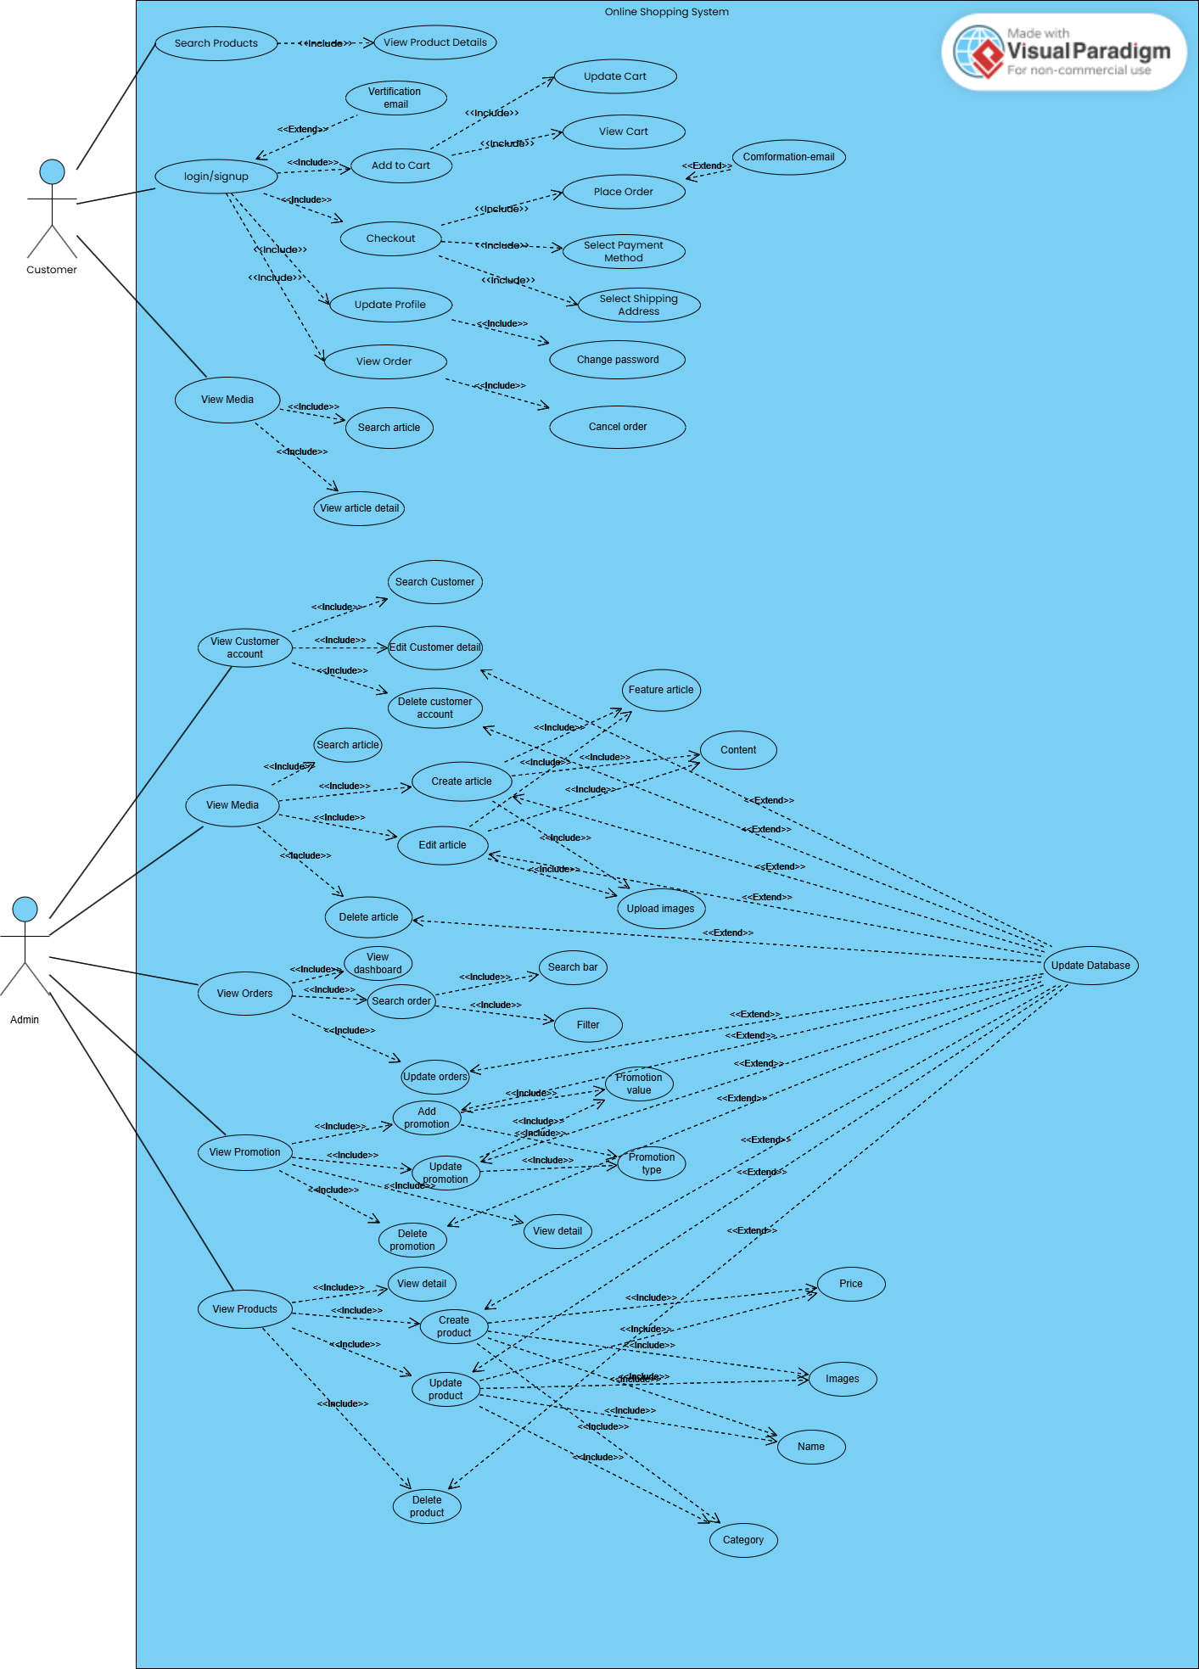
Figure 1 Use-case diagram
The diagram demonstrates how these use cases extend and include one another, creating a network of functionality that spans across the microservices architecture. This representation helps visualize the complete system while highlighting the specific responsibilities of each actor.

Entity Relationship Diagram
The Entity Relationship Diagram (ERD) provides a comprehensive view of the data model across all microservices. It illustrates how entities are structured within each service and how they relate to entities in other services.
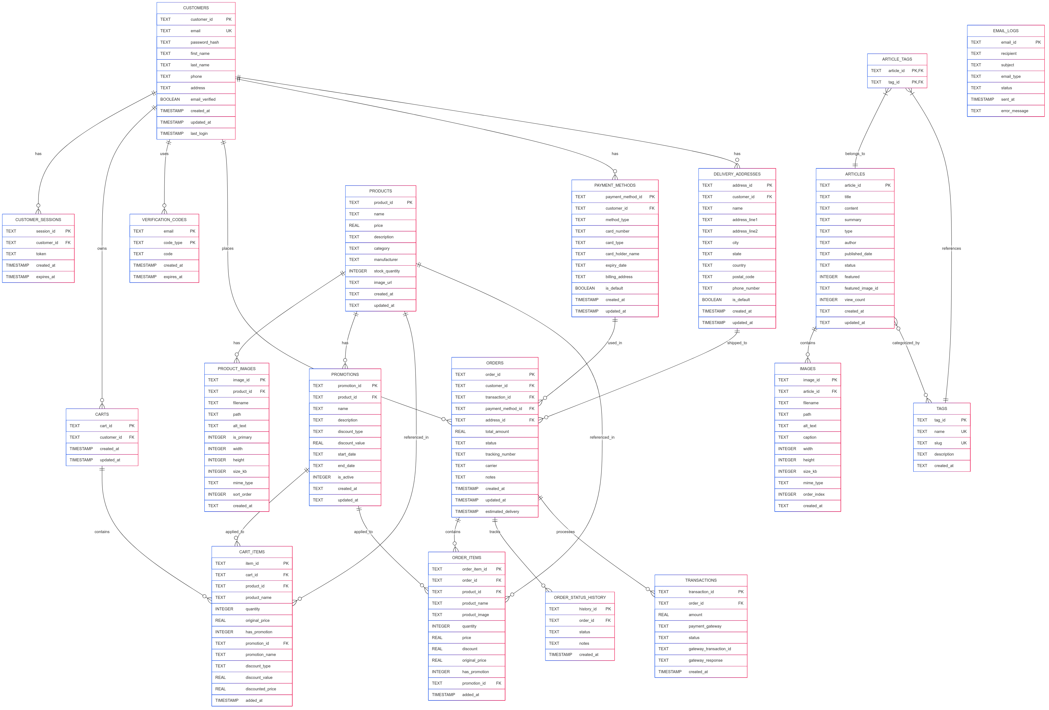
Figure 2 Entity Relationship Diagram

Frontend-service

Overview
The Frontend Service functions as the primary interface between users and the e-commerce platform's microservices architecture. It serves as both a web server delivering HTML templates and a reverse proxy that routes API requests to the appropriate backend services. This dual role unifies the user experience by presenting a cohesive interface while abstracting away the complexity of the underlying microservices architecture.

Key Responsibilities
- Web Page Rendering: Serves HTML templates for various pages including homepage, product listings, product details, cart, checkout, account management, and content pages.
- API Gateway: Acts as a reverse proxy, routing client requests to appropriate backend microservices and returning responses to the client.
- Service Composition: Aggregates data from multiple services (e.g., combining product data with promotion information) to provide enriched responses.
- Static Asset Management: Handles static resources including test images, placeholders, and client-side scripts.
- Cross-Cutting Concerns: Implements shared functionality such as error handling, logging, and request tracing.

Frontend Implementation
- Template-Based Views: Uses Flask's templating system to render HTML pages that structure the user interface.
- Client-Side JavaScript:
  - Modular JavaScript files organized by functionality:
    - media.js: Handles article and news content loading and display
    - auth.js: Manages user authentication, registration, and profile management
    - home.js: Implements homepage-specific UI elements like category grids and featured content
    - Product-related scripts for browsing, searching, and cart interactions
- UI Components:
  - Dynamic content loading with fetch API
  - Product cards with image carousels and hover effects
  - Shopping cart management
  - Authentication modals
  - Category navigation
  - Toast notifications for user feedback
- Responsive Design: Implementation of responsive layouts to support various device sizes using Bootstrap classes.
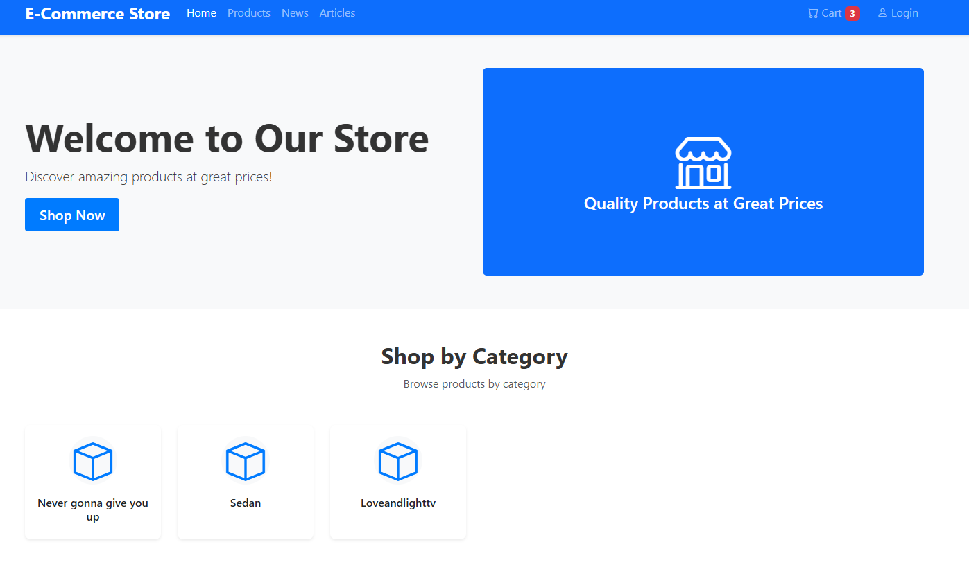
Figure 3 Home page
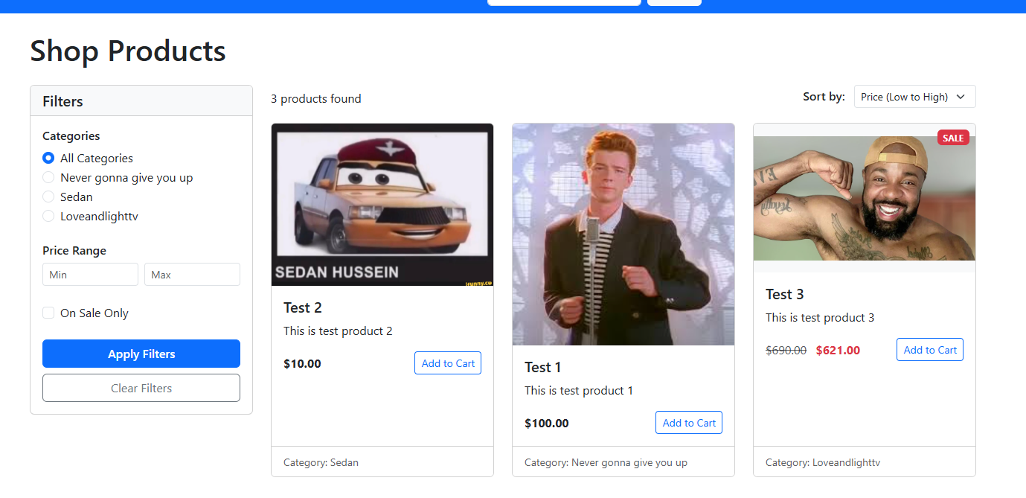
Figure 4 Product page
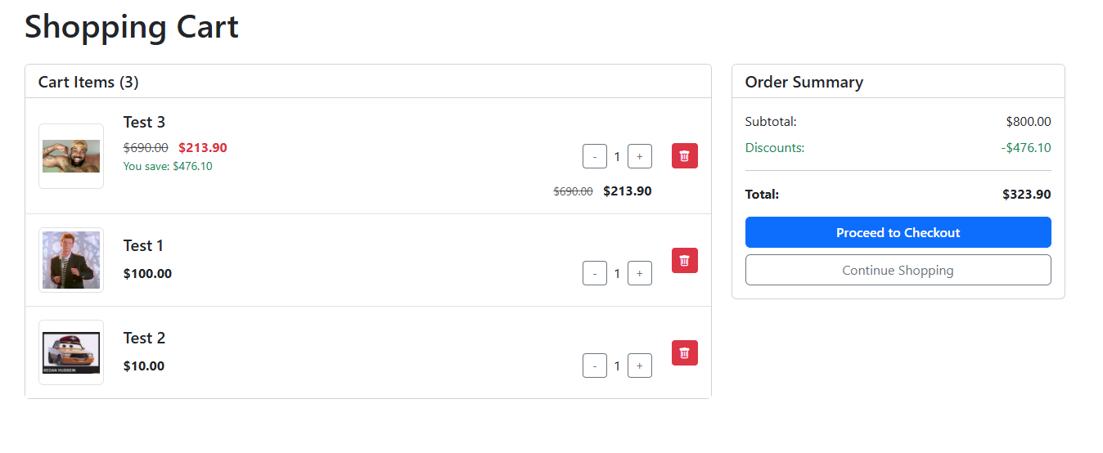
Figure 5 Cart page
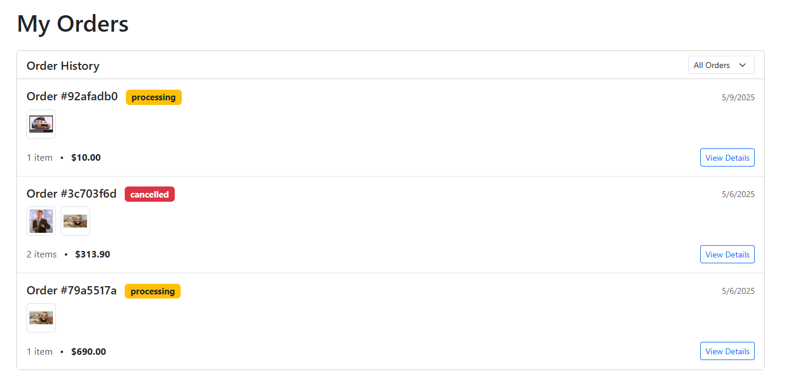
Figure 6 Orders page

Figure 7 Media page
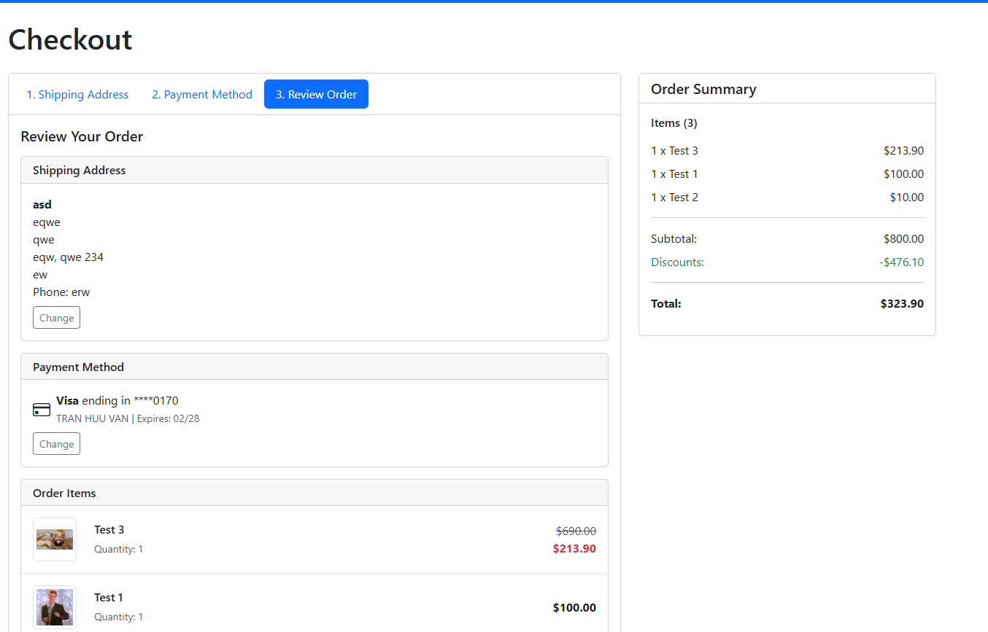
Figure 8 Payment
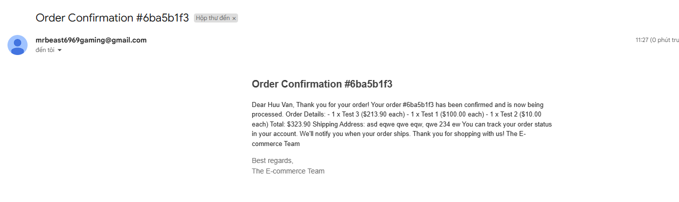
Figure 9 Email

Backend Implementation
- Flask Application Structure:
  - Route handlers for both HTML page rendering and API proxying
  - Environment variable configuration for service URLs
  - CORS support for cross-origin requests
- Proxy Functionality:
  - Forwards client requests to appropriate microservices
  - Preserves headers, request body, and query parameters
  - Handles response processing and error management
- Data Aggregation:
  - Enriches product data with active promotions
  - Combines multiple API responses into unified views
  - Generates placeholder images when content is unavailable
- Error Handling:
  - Graceful fallbacks for service failures
  - Comprehensive logging for troubleshooting
  - User-friendly error messages

API Endpoints
Function | Method | Endpoint | Input | Output
Health Check | GET | /api/health | N/A | JSON status of all microservices
Product Related APIs
Get All Products | GET | /api/frontend/products | N/A | List of products with promotion data
Get Featured Products | GET | /api/frontend/featured-products | Query param: limit (optional) | List of featured products
Get Product Categories | GET | /api/frontend/categories | N/A | List of product categories
Get Product Details | GET | /api/frontend/product/{product_id} | URL param: product_id | Detailed product information with promotions
Get Related Products | GET | /api/frontend/related-products | Query params: category, product_id (optional), limit (optional) | List of related products
Search Products | GET | /api/frontend/search | Query param: q (search query) | Search results with promotion data
Serve Product Image | GET | /api/storage/serve/{filepath} | URL param: filepath | Product image file
Generate Placeholder | GET | /api/placeholder/{width}/{height} | URL params: width, height  Query param: text (optional) | SVG placeholder image
Media Related APIs
Get Featured Articles | GET | /api/frontend/featured-articles | Query param: limit (optional) | List of featured articles
Get Latest News | GET | /api/frontend/latest-news | Query param: limit (optional) | List of latest news articles
Serve Media File | GET | /api/media/serve/{filepath} | URL param: filepath | Media file
Proxy Routes (passes requests to microservices)
Customer API Proxy | ANY | /api/customers/* | Varies by endpoint | Proxied response from Customer Service
Cart API Proxy | ANY | /api/cart/* | Varies by endpoint | Proxied response from Cart Service
Payment Methods Proxy | ANY | /api/payment-methods/* | Varies by endpoint | Proxied response from Payment Service
Addresses Proxy | ANY | /api/addresses/* | Varies by endpoint | Proxied response from Payment Service
Checkout Proxy | POST | /api/checkout | Checkout request data | Proxied response from Payment Service
Orders Proxy | ANY | /api/orders/* | Varies by endpoint | Proxied response from Order Service
Media Proxy | ANY | /api/media/* | Varies by endpoint | Proxied response from Media Service

Storage-service

Overview
The Storage Service functions as the product catalog management system within the e-commerce platform's microservices architecture. It manages product data, images, and metadata while providing a comprehensive API for create, read, update, and delete (CRUD) operations. This service interacts directly with the Database Service for data persistence and handles file storage for product images, implementing a structured directory hierarchy for organized asset management.

Key Responsibilities
- Product Data Management: Maintains comprehensive product information including name, description, price, inventory levels, categorization, and manufacturer details.
- Image Handling: Processes image uploads for products, handles image metadata, and manages primary/secondary image relationships.
- File Storage: Organizes uploaded product images in a structured directory system with year/month partitioning for scalability.
- Data Validation: Ensures data integrity through validation of product information and image file types.
- Search and Filtering: Provides functionality to search products by name, description, or metadata and filter products by category or manufacturer.

Backend Implementation
- Flask Application Structure:
  - RESTful API endpoints for product and image management
  - Integration with the Database Service for data persistence
  - Secure file handling with path sanitization
- Product Management Class:
  - ProductStorage class encapsulating product operations
  - Database connectivity and schema management
  - Product CRUD operations with error handling
  - Image metadata and file management
- File System Architecture:
  - Organized directory structure: /products/{product_id}/{year}/{month}/
  - Unique filename generation with UUID
  - Mime type detection and file size tracking
  - Cleanup routines for removing orphaned files
- Error Handling and Logging:
  - Comprehensive exception handling throughout the API
  - Detailed logging for troubleshooting
  - Graceful failure responses with informative messages

Frontend Implementation
- Product Management Interface:
  - The API JavaScript module encapsulates all AJAX calls to the backend
  - Product listing, creation, editing, and deletion flows
  - Image upload and management functionality
- Component Architecture:
  - Products module for product listing and detail views
  - ProductForm module for product creation and editing forms
  - Utils module for shared utility functions
- User Interface Features:
  - Product grid with card-based display
  - Product detail view with image gallery
  - Form validation and error handling
  - Loading indicators and notifications
  - Confirmation dialogs for destructive actions
- Image Management:
  - Multi-image upload with preview
  - Primary image selection
  - Image gallery with navigation
  - Placeholder system for missing images
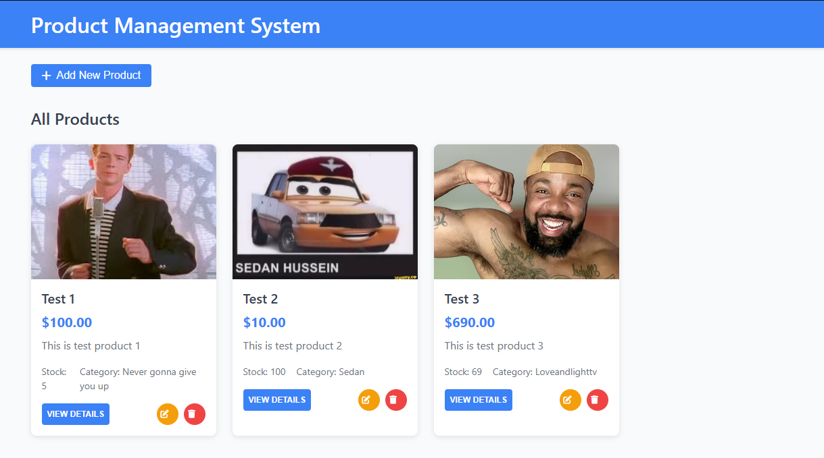
Figure 10 Product Management

API Endpoints
Function | Method | Endpoint | Input | Output
Health Check | GET | /api/health | N/A | JSON status of service and database connection
Product Management APIs
Get All Products | GET | /api/products | N/A | List of all products
Get Product | GET | /api/products/{product_id} | URL param: product_id | Details of a specific product with images
Create Product | POST | /api/products | JSON body with product data:  { "name": string, "price": number, "description": string, "stock": number, ... } | Created product details
Update Product | PUT | /api/products/{product_id} | URL param: product_id  JSON body with updated fields | Updated product details
Delete Product | DELETE | /api/products/{product_id} | URL param: product_id | Confirmation of deletion
Search Products | GET | /api/products/search | Query param: q (search query) | List of products matching search criteria
Product Image APIs
Get Product Images | GET | /api/products/{product_id}/images | URL param: product_id | List of images for a product
Upload Product Image | POST | /api/products/{product_id}/images/upload | URL param: product_id  Form data: file, alt_text (optional), is_primary (optional), sort_order (optional) | Uploaded image details
Upload Multiple Images | POST | /api/products/{product_id}/images/upload/multiple | URL param: product_id  Form data: files[] (array of files) | Details of all uploaded images
Get Image | GET | /api/images/{image_id} | URL param: image_id | Details of a specific image
Update Image | PUT | /api/images/{image_id} | URL param: image_id  JSON body with updated fields | Updated image details
Delete Image | DELETE | /api/images/{image_id} | URL param: image_id | Confirmation of deletion
Set Primary Image | PUT | /api/images/{image_id}/set-primary | URL param: image_id | Updated image details with primary flag set
Serve File | GET | /api/storage/serve/{filepath} | URL param: filepath | File content
Category and Manufacturer APIs
Get Products by Category | GET | /api/products/category/{category} | URL param: category | List of products in the category
Get Products by Manufacturer | GET | /api/products/manufacturer/{manufacturer} | URL param: manufacturer | List of products from the manufacturer
Get All Categories | GET | /api/categories | N/A | List of all unique product categories
Get All Manufacturers | GET | /api/manufacturers | N/A | List of all unique product manufacturers
Debug API
Debug Storage | GET | /api/storage/debug | Query param: product_id (optional) | Information about storage directory contents

Promotion-service

Overview
The Promotion Service manages special offers and discounts on products within the e-commerce platform. It creates a bridge between the product catalog (managed by the Storage Service) and dynamic pricing strategies. This service enables merchants to create time-limited promotions, percentage or fixed-amount discounts, and track active promotional campaigns, providing a flexible framework for implementing marketing and sales strategies.

Key Responsibilities
- Promotion Management: Creates, reads, updates, and deletes promotional campaigns for products in the catalog.
- Discount Calculation: Computes discounted prices based on promotion rules (percentage or fixed-amount discounts).
- Time-Based Promotion Handling: Manages the lifecycle of promotions with defined start and end dates.
- Product Integration: Connects with the Storage Service to access product details and apply promotions to specific items.
- Active Promotion Filtering: Filters and returns currently active promotions based on date ranges and activation status.

Backend Implementation
- Flask Application Structure:
  - RESTful API endpoints for promotion management
  - Integration with the Database Service for data persistence
  - Communication with the Storage Service for product information
- Promotion Service Class:
  - PromotionService class encapsulating promotion operations
  - Database connectivity and schema management
  - Promotion CRUD operations with error handling
  - Cross-service communication with Storage Service
- Discount Logic:
  - Support for percentage-based discounts (e.g., 20% off)
  - Support for fixed-amount discounts (e.g., $10 off)
  - Validation to prevent negative pricing
  - Precise calculation with decimal rounding
- Promotion Status Management:
  - Date-based activation/deactivation
  - Manual override for promotion status
  - Automatic filtering of active promotions

Frontend Implementation
- Promotion Dashboard Interface:
  - Tabbed interface for viewing all promotions or only active ones
  - Promotion creation and editing forms
  - Real-time health status monitoring
- Product Selection Interface:
  - Product search and selection for applying promotions
  - Product preview with key details (price, category, stock)
  - Validation to ensure promotions are linked to valid products
- Discount Visualization:
  - Display of original and discounted prices
  - Formatting of discount types (percentage vs. fixed amount)
  - Visual indicators for promotion status (active/inactive)
- User Interaction Features:
  - Form validation for required fields
  - Confirmation dialogs for destructive actions
  - Status alerts for operation results
  - Modal interfaces for focused tasks
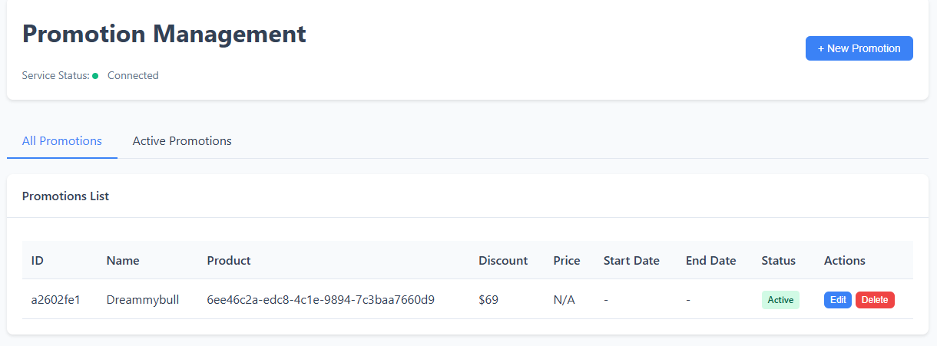
Figure 11 Promotion Front end

API Endpoints
Function | Method | Endpoint | Input | Output
Health Check | GET | /api/health | N/A | JSON status of service and database connections
Product Access APIs
Get All Products | GET | /api/products | N/A | List of all products from storage service
Promotion Management APIs
Get All Promotions | GET | /api/promotions | N/A | List of all promotions
Get Promotion | GET | /api/promotions/{promotion_id} | URL param: promotion_id | Details of a specific promotion with product info
Create Promotion | POST | /api/promotions | JSON body with promotion data:  { "product_id": string, "name": string, "discount_type": string, "discount_value": number, ... } | Created promotion details
Update Promotion | PUT | /api/promotions/{promotion_id} | URL param: promotion_id  JSON body with updated fields | Updated promotion details
Delete Promotion | DELETE | /api/promotions/{promotion_id} | URL param: promotion_id | Confirmation of deletion
Query APIs
Get Product Promotions | GET | /api/products/{product_id}/promotions | URL param: product_id | List of promotions for a specific product
Get Active Promotions | GET | /api/promotions/active | N/A | List of currently active promotions

Payment-service

Overview
The Payment Service handles all financial transactions and customer payment-related data within the e-commerce platform's microservices architecture. It manages payment methods, delivery addresses, and processes transactions during checkout. The service integrates with external payment gateways while maintaining secure records of payment details and transaction history, serving as the critical financial backbone of the e-commerce system.

Key Responsibilities
- Payment Method Management: Stores and manages customer payment methods (credit cards, PayPal, etc.) with appropriate security measures like tokenization and masking of sensitive data.
- Delivery Address Management: Maintains customer shipping addresses with full CRUD capabilities and default address designation.
- Transaction Processing: Handles the checkout flow by validating payment methods, communicating with payment gateways, and recording transaction results.
- Service Integration: Communicates with multiple services (Cart, Customer, Order) to orchestrate the complete purchase flow.
- Data Security: Implements appropriate security measures for handling sensitive financial data, including masking card numbers and using secure transmission protocols.
- Order Creation: Triggers order creation after successful payment by communicating with the Order Service.

Backend Implementation
- Flask Application Structure:
  - RESTful API endpoints with authentication via token validation
  - Integration with the Database Service for data persistence
  - Service-to-service communication with Cart, Customer, and Order services
- Payment Management Classes:
  - PaymentMethodManager: Handles payment method operations with security protocols
  - AddressManager: Manages delivery address operations
  - PaymentProcessor: Orchestrates checkout flow and payment gateway integration
- Database Schema:
  - payment_methods: Stores customer payment information with sensitive data masked
  - delivery_addresses: Maintains customer shipping addresses
  - transactions: Records payment transaction history and status
- Payment Gateway Integration:
  - Simulated payment gateway interface for processing transactions
  - Transaction status tracking and error handling
  - Webhook notification system for order creation after successful payment
- Security Measures:
  - Token-based authentication for all endpoints
  - Card number masking (storing only last 4 digits)
  - Authorization checks to ensure users can only access their own data
- Error Handling and Logging:
  - Comprehensive exception management throughout the payment flow
  - Detailed logging for transaction auditing
  - Graceful failure responses with informative error messages

API Endpoints
Function | Method | Endpoint | Input | Output
Health Check | GET | /api/health | N/A | JSON status of service and dependencies
Payment Methods APIs
Get All Payment Methods | GET | /api/payment-methods | Authorization header with Bearer token | List of payment methods for the authenticated customer
Get Payment Method | GET | /api/payment-methods/{payment_method_id} | Authorization header with Bearer token  URL param: payment_method_id | Details of specific payment method
Add Payment Method | POST | /api/payment-methods | Authorization header with Bearer token  Body: Payment method details including method_type, card information | Confirmation with payment method ID
Update Payment Method | PUT | /api/payment-methods/{payment_method_id} | Authorization header with Bearer token  URL param: payment_method_id  Body: Updated payment method fields | Confirmation of update
Delete Payment Method | DELETE | /api/payment-methods/{payment_method_id} | Authorization header with Bearer token  URL param: payment_method_id | Confirmation of deletion
Set Default Payment Method | PUT | /api/payment-methods/{payment_method_id}/set-default | Authorization header with Bearer token  URL param: payment_method_id | Confirmation of default update
Delivery Addresses APIs
Get All Addresses | GET | /api/addresses | Authorization header with Bearer token | List of delivery addresses for the authenticated customer
Get Address | GET | /api/addresses/{address_id} | Authorization header with Bearer token  URL param: address_id | Details of specific address
Add Address | POST | /api/addresses | Authorization header with Bearer token  Body: Address details including name, address_line1, city, etc. | Confirmation with address ID
Update Address | PUT | /api/addresses/{address_id} | Authorization header with Bearer token  URL param: address_id  Body: Updated address fields | Confirmation of update
Delete Address | DELETE | /api/addresses/{address_id} | Authorization header with Bearer token  URL param: address_id | Confirmation of deletion
Set Default Address | PUT | /api/addresses/{address_id}/set-default | Authorization header with Bearer token  URL param: address_id | Confirmation of default update
Checkout API
Process Checkout | POST | /api/checkout | Authorization header with Bearer token  Body: { "payment_method_id": string, "address_id": string } | Payment confirmation and order ID

Order-service

Overview
The Order Service is the central management system for tracking and processing customer orders in the e-commerce platform. It forms a crucial bridge between successful payment transactions and order fulfillment, providing comprehensive visibility into each stage of the order lifecycle. The service maintains detailed records of orders, their items, and status history while facilitating administrative management and customer notifications. It also generates analytics and reports that provide valuable business insights on order volumes, revenues, and trends.

Key Responsibilities
- Order Processing: Creates orders from successful payment transactions, records order details, line items, and maintains the entire order lifecycle from creation to completion.
- Status Management: Handles order status transitions with validation rules, maintains a historical log of status changes, and enforces business rules for allowable state changes (e.g., processing → shipped → delivered).
- Customer Communication: Sends notifications via email when orders are created and when status changes occur, ensuring customers are informed throughout the fulfillment process.
- Order History: Maintains detailed records of all customer orders with complete line item details, pricing information, and promotional data.
- Shipping and Delivery: Tracks shipping information including carrier details and tracking numbers, and calculates estimated delivery dates.
- Administrative Controls: Provides comprehensive tools for order management, including filtering, searching, status updates, and order analytics for business reporting.
- Service Integration: Coordinates with multiple services including Payment, Product, Customer, and Email services to provide a cohesive order management solution.

Frontend Implementation
- Order Dashboard Interface:
  - Administrative dashboard with key metrics (total orders, revenue, average order value)
  - Visual representations of order status distribution and daily order trends
  - Comprehensive order filtering and search capabilities
  - Responsive layout for all device sizes
- Order Management Views:
  - Detailed order cards showing customer, order, and shipping information
  - Order status indicators with color-coding for quick visual recognition
  - Action buttons for common administrative tasks (view details, update status)
  - Pagination controls for handling large volumes of orders
- Order Detail Modal:
  - Comprehensive order information display with customer and shipping details
  - Complete order line items with product information, quantities, and pricing
  - Status history timeline showing the progression of the order through the fulfillment process
  - Tracking information display for shipped orders
- Status Management Interface:
  - Status update modal with appropriate status transition options
  - Shipping information fields for orders marked as shipped
  - Notes capability for adding context to status changes
  - Validation to prevent invalid status transitions
- Visualization Components:
  - Status distribution bar chart showing counts by order status
  - Order trend line chart displaying daily order volumes
  - Stat cards with key performance indicators
  - Status history timeline with chronological progression
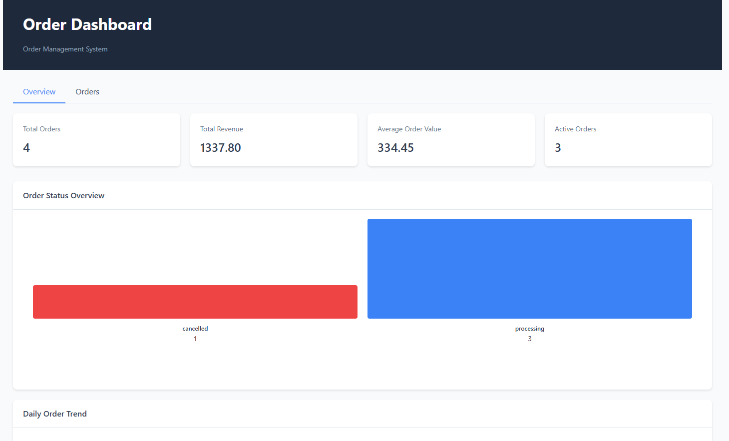
Figure 12 Order Dashboard
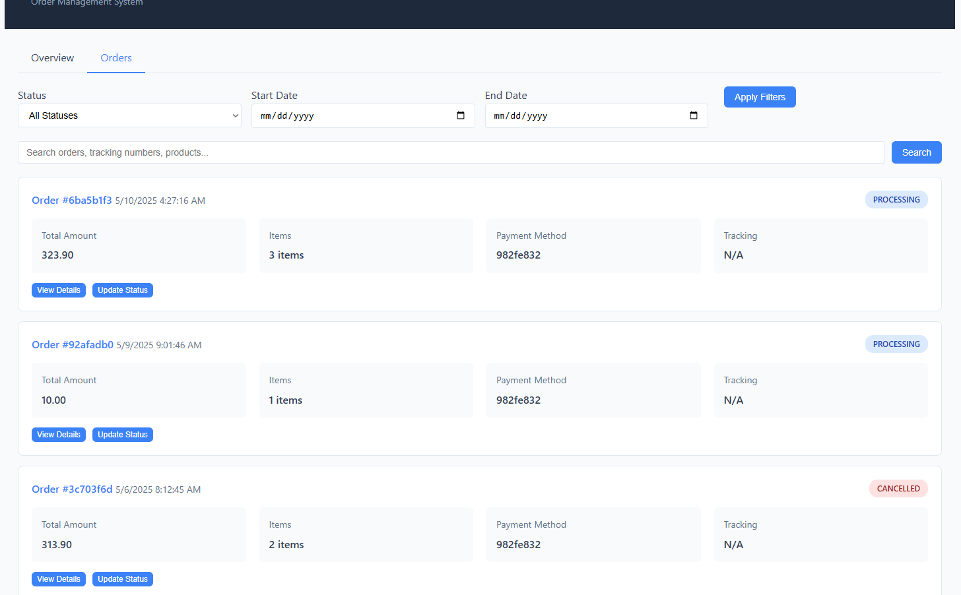
Figure 13 Order tracking and status

Backend Implementation
- Flask Application Structure:
  - RESTful API endpoints with clean separation between customer and administrative routes
  - JWT-based authentication for securing customer-specific endpoints
  - Database schema initialization and migration handling
  - Cross-service communication with comprehensive error handling
- OrderManager Class:
  - Core business logic for order creation, retrieval, and updates
  - Status transition validation and enforcement
  - Status history tracking and notification dispatch
  - Data enrichment by integrating information from multiple services
- Database Schema:
  - orders: Main order data including customer reference, payment details, shipping information
  - order_items: Line items with product details, quantities, prices, and promotional information
  - order_status_history: Chronological record of status changes with timestamps and notes
- Email Notification System:
  - Order confirmation emails with complete order details
  - Status update notifications with relevant shipping information
  - Formatted templates for consistent customer communication
- Reporting and Analytics:
  - Aggregated order statistics by status, time period, and other dimensions
  - Daily trend analysis for order volumes and revenue
  - Average order value calculations and active order tracking
  - CSV report generation for export and further analysis
- Error Handling and Logging:
  - Comprehensive exception handling with informative error messages
  - Detailed logging for troubleshooting and audit purposes
  - Graceful degradation when dependent services are unavailable

API Endpoints
Function | Method | Endpoint | Input | Output
Health Check | GET | /api/health | N/A | JSON status of service and dependencies
Customer-Facing APIs
Get Customer Orders | GET | /api/orders | Authorization header with Bearer token | List of all orders for the authenticated customer
Get Order Details | GET | /api/orders/{order_id} | Authorization header with Bearer token  URL param: order_id | Detailed information about a specific order
Cancel Order | POST | /api/orders/{order_id}/cancel | Authorization header with Bearer token  URL param: order_id  Body: { "reason": string } | Confirmation of order cancellation
Payment Service Integration
Payment Webhook | POST | /api/orders/payment-webhook | JSON body with payment data | Confirmation of order creation
Admin APIs
Get All Orders | GET | /api/admin/orders | Query params: status, start_date, end_date, page, per_page (all optional) | List of orders with pagination and filtering
Get Order Details (Admin) | GET | /api/admin/orders/{order_id} | URL param: order_id | Detailed information about a specific order
Update Order Status | PUT | /api/admin/orders/{order_id}/status | URL param: order_id  Body: { "status": string, "notes": string (optional), "tracking_number": string (optional), "carrier": string (optional) } | Confirmation of status update
Update Order Notes | PUT | /api/admin/orders/{order_id}/notes | URL param: order_id  Body: { "notes": string } | Confirmation of notes update
Get Order Statistics | GET | /api/admin/orders/stats | Query params: start_date, end_date (optional) | Order statistics including status breakdown, trends, and totals
Generate Order Report | GET | /api/admin/orders/reports | Query params: type (summary/detailed), start_date, end_date, format (json/csv) | Order report in the specified format
Search APIs
Search Orders | GET | /api/orders/search | Query params: q (search term), status, date_from, date_to (all optional) | Orders matching the search criteria

Media-service

Overview
The Media Service is a comprehensive content management system for the e-commerce platform that handles the creation, storage, and retrieval of articles, news items, and associated images. It serves as the platform's publishing system, managing all content-related operations from drafting and editing to publishing and archiving. The service supports rich media content with image uploads, tagging capabilities, and full-text search to provide an extensive content management solution for the platform's informational and marketing needs.

Key Responsibilities
- Content Management: Handles the complete lifecycle of articles and news items, including creation, editing, publishing, archiving, and deletion.
- Media Storage: Manages the secure storage and retrieval of images and other media files with appropriate directory organization and metadata tracking.
- Tagging System: Provides a flexible categorization system through tagging that allows content to be organized, filtered, and discovered by related topics.
- Content Discovery: Supports search functionality across article titles, content, and summaries to help users find relevant information.
- Featured Content: Enables highlighting important articles through a featured flag, allowing priority promotion of specific content.
- Content Analytics: Tracks basic engagement metrics such as view counts to measure content performance.
- Image Association: Manages relationships between articles and their associated images, including featured image designation.

Frontend Implementation
- Content Management Dashboard:
  - Comprehensive dashboard for content creators and managers
  - Tabbed interface for filtering content by type (article/news) and status (draft/published/archived)
  - Card-based content displays with featured image thumbnails
  - Status badges indicating publication state and featured status
- Article Creation and Editing:
  - Rich form interface for article creation and editing
  - Support for article metadata including title, summary, content, author, and status
  - Tag management interface with add/remove capabilities
  - Featured flag toggle for promoting important content
- Image Management:
  - Drag-and-drop file upload functionality
  - Multi-file upload support with progress indicators
  - File type validation and size display
  - Association of images with specific articles
- Content Organization:
  - Tag-based content filtering
  - Search functionality across all content fields
  - Featured content highlighting for important articles
  - Status-based content filtering (draft/published/archived)
- Content Preview:
  - Detailed article view with all metadata displayed
  - Image gallery for associated media
  - Tag display and linking
  - View count display for engagement tracking
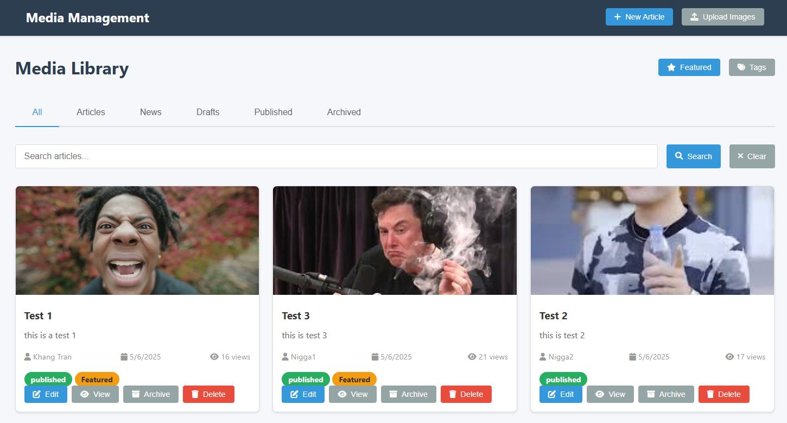
Figure 14 Media management

Backend Implementation
- Flask Application Structure:
  - RESTful API endpoints for content and media management
  - Integration with the Database Service for data persistence
  - Secure file handling with path sanitization and type validation
- MediaService Class:
  - Core functionality encapsulated in service class
  - Database connectivity and table initialization
  - CRUD operations for articles, images, and tags
  - Search and filtering capabilities
- Content Management:
  - Support for article states (draft, published, archived)
  - Versioning through updated timestamps
  - View counting for engagement tracking
  - Featured article designation
- File Storage System:
  - Structured directory organization by article ID and date
  - Unique filename generation with UUIDs
  - File type validation and security checks
  - Image metadata tracking (size, type, dimensions)
- Tagging Implementation:
  - Many-to-many relationship between articles and tags
  - Slug generation for URL-friendly tag references
  - Tag creation, association, and retrieval
  - Support for finding articles by tag
- Image Handling:
  - Image uploads with metadata extraction
  - Association with parent articles
  - Featured image designation
  - Image deletion with file system cleanup

API Endpoints
Function | Method | Endpoint | Input | Output
Health Check | GET | /api/health | N/A | JSON status of service and DB connection
Article Related APIs
Get All Articles | GET | /api/articles | Query params: type, status, limit, offset (all optional) | List of articles with pagination
Get Article | GET | /api/articles/{article_id} | URL param: article_id | Article details with images and tags
Create Article | POST | /api/articles | JSON body with article data | Created article details
Update Article | PUT | /api/articles/{article_id} | URL param: article_id  JSON body with update data | Updated article details
Delete Article | DELETE | /api/articles/{article_id} | URL param: article_id | Success confirmation
Publish Article | PUT | /api/articles/{article_id}/publish | URL param: article_id | Published article details
Archive Article | PUT | /api/articles/{article_id}/archive | URL param: article_id | Archived article details
Search Articles | GET | /api/articles/search | Query params: q (required), limit, offset (optional) | Search results with pagination
Get Featured Articles | GET | /api/articles/featured | Query param: limit (optional) | List of featured articles
Image Related APIs
Get Article Images | GET | /api/articles/{article_id}/images | URL param: article_id | List of images for the article
Get Image | GET | /api/images/{image_id} | URL param: image_id | Image details
Upload Image | POST | /api/articles/{article_id}/images/upload | URL param: article_id  Form data with file | Uploaded image details
Upload Multiple Images | POST | /api/articles/{article_id}/images/upload/multiple | URL param: article_id  Form data with files[] | Uploaded images details
Serve Media File | GET | /api/media/serve/{filepath} | URL param: filepath | Media file
Add Image | POST | /api/images | JSON body with image data | Added image details
Update Image | PUT | /api/images/{image_id} | URL param: image_id  JSON body with update data | Updated image details
Delete Image | DELETE | /api/images/{image_id} | URL param: image_id | Success confirmation
Tag Related APIs
Get All Tags | GET | /api/tags | N/A | List of all tags
Get Articles By Tag | GET | /api/tags/{tag_slug}/articles | URL param: tag_slug  Query params: limit, offset (optional) | List of articles with the specified tag
Get Article Tags | GET | /api/articles/{article_id}/tags | URL param: article_id | List of tags for the article

Customer-Service

Overview
The Customer Service Microservice is a comprehensive solution for managing customer accounts, authentication, and profile information within the e-commerce platform. It provides a RESTful API built with Flask that handles customer registration, authentication, profile management, and administrative functions. The service includes both backend functionality for customer data processing and a frontend admin dashboard for customer management.

Key Responsibilities
- Customer Account Management
- User registration with email verification flow
- Secure password handling and authentication
- Profile creation and management
- Account status tracking (verified vs. unverified)
- Authentication and Authorization
- JWT-based token generation and validation
- Session management with expiration tracking
- Access control through token verification
- Security middleware for protected endpoints
- Email Communication
- Verification emails for new accounts
- Welcome emails for newly verified users
- Account-related notifications
- Verification code validation
- Profile Management
- Customer profile data storage and retrieval
- Profile updating with validation
- Password changing with security measures
- Order history access
- Administration Functions
- Customer record browsing and filtering
- Customer data editing
- Account verification status management
- Customer account deletion
- Security Implementation
- Password hashing using SHA-256
- Email format validation
- Protection against unauthorized access
- Session invalidation on password change

Frontend Implementation
- Admin Dashboard Interface
- Responsive design with mobile support
- Clean, modern UI with card and table-based layouts
- Visual status indicators for verification status
- Intuitive navigation and data presentation
- Customer Management Tools
- Comprehensive customer list with sortable columns
- Customer data display with verification status badges
- Search functionality across multiple fields (email, name, phone)
- Customer count and filtering statistics
- Interactive Features
- Modal-based customer editing interface
- Confirmation dialogs for destructive actions
- Real-time search filtering
- Status notifications for operation feedback
- UI Components
- Data tables with action buttons
- Edit forms with validation
- Loading spinners for asynchronous operations
- Status badges for verification state
- Toast notifications for user feedback
- JavaScript Functionality
- Asynchronous data loading with fetch API
- Dynamic DOM manipulation
- Event handling for user interactions
- Authorization header injection for API requests
- Error handling with user notifications

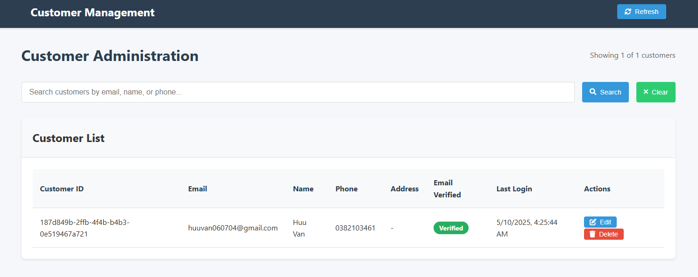
Figure 15 Customer management

Backend Implementation
- Flask Application Structure
- RESTful API design pattern
- Organized route handlers for different customer operations
- Error handling with appropriate HTTP status codes
- CORS support for cross-origin requests
- Database Integration
- Table initialization for customers and sessions
- CRUD operations through database service
- Relational data management between customers and sessions
- Query parameter handling for data filtering
- Authentication System
- JWT token generation and validation
- Customer session tracking
- Token-based middleware for protected routes
- Email verification requirement enforcement
- Security Measures
- Password hashing implementation
- Input validation and sanitization
- Protection against unauthorized profile access
- Session management to prevent token misuse
- Service Integration
- Email service connectivity for customer communications
- Database service integration for data persistence
- Health checks for dependent services
- Error handling for service failures
- Logging and Monitoring
- Comprehensive logging throughout the application
- Error tracking with detailed information
- Health endpoint for system monitoring
- Service status reporting

API Endpoints
Function | Method | Endpoint | Input | Output
Health Check | GET | /api/health | N/A | JSON status response
Register | POST | /api/customers/register | JSON with email, password, name | Success with customer data and token
Login | POST | /api/customers/login | JSON with email, password | Success with customer data and token
Logout | POST | /api/customers/logout | Bearer token | Success message
Verify Email | POST | /api/customers/verify-email | JSON with email, code | Success with token
Resend Verification | POST | /api/customers/resend-verification | JSON with email | Success message
Get Profile | GET | /api/customers/profile | Bearer token | Customer profile data
Update Profile | PUT | /api/customers/profile | Bearer token, profile data | Updated profile data
Change Password | PUT | /api/customers/password | Bearer token, old/new passwords | Success with new token
Check Email Exists | GET | /api/customers/{email}/exists | Email in URL | Boolean exists flag
Validate Token | POST | /api/customers/validate-token | JSON with token | Validation result with customer data
Get Customer Orders | GET | /api/customers/orders | Bearer token | Customer orders data
Get All Customers | GET | /api/customers/all | N/A | List of all customers
Admin Update Customer | PUT | /api/customers/{customer_id}/update | Customer ID in URL, customer data | Updated customer data
Admin Delete Customer | DELETE | /api/customers/{customer_id}/delete | Customer ID in URL | Success message

Database-service

Overview
The Database Service Microservice provides a centralized data management solution for the e-commerce platform, enabling other microservices to interact with databases through a RESTful API. It offers a comprehensive set of operations for database management, table operations, and data manipulation. This service abstracts the complexity of direct database interactions, providing a consistent interface for all data operations across the platform.

Key Responsibilities
- Database Connection Management
  - Establish and maintain connections to multiple SQLite databases
  - Support concurrent connections to different databases
  - Provide secure connection handling and error management
  - Track connection states across service instances
- Table Management
  - Create, modify, and delete database tables
  - Define and enforce schema structures
  - Retrieve table metadata and schema information
  - List all available tables in a database
- Data Operations
  - Execute CRUD operations (Create, Read, Update, Delete) on database records
  - Support complex query execution with parameterized statements
  - Handle data transactions with proper commit and rollback mechanisms
  - Manage referential integrity between related tables
- Query Processing
  - Execute custom SQL queries with parameter binding
  - Perform data filtering, sorting, and pagination
  - Support condition-based data retrieval
  - Ensure query security through parameterization
- Database Administration
  - Create database backups with timestamped filenames
  - Monitor database health and connection status
  - Provide diagnostic information about database state
  - Maintain database integrity during operations
- E-Commerce Specific Functions
  - Manage product catalog data and inventory
  - Handle customer orders and transaction records
  - Support product review and rating systems
  - Provide statistical analysis of business data

Backend Implementation
- DatabaseManager Class
  - Core class encapsulating all database functionality
  - Connection handling with error management
  - Method-based approach to database operations
  - Transaction support for multi-step operations
- Connection Pool Architecture
  - Support for multiple simultaneous database connections
  - Dynamic management of connection instances
  - Connection tracking via dictionary-based registry
  - Database-specific connection parameters
- Query Execution Framework
  - Parameterized query execution to prevent SQL injection
  - Result formatting to standardized JSON responses
  - Support for direct and complex SQL execution
  - Error handling and logging for failed queries
- Data Transformation Layer
  - Conversion between SQLite row objects and JSON
  - Standardized response formatting across all endpoints
  - Consistent error message structure
  - Support for nested data structures in responses
- Transaction Management
  - BEGIN/COMMIT/ROLLBACK transaction support
  - Atomic operations for data integrity
  - Error handling during transaction execution
  - Automatic rollback on operation failure
- Logging System
  - Comprehensive logging of database operations
  - Error tracking with detailed context information
  - Activity logging for audit purposes
  - Configurable logging levels
- Security Implementation
  - Parameter binding to prevent SQL injection
  - Input validation and sanitization
  - Database-specific headers for isolation
  - Error handling that avoids information leakage

API Endpoints
Function | Method | Endpoint | Input | Output
Health Check | GET | /api/health | N/A | JSON status of service and database connections
Connection Management APIs
Connect to Database | POST | /api/connect | JSON body: {"db_name": string} | Connection status
Table Management APIs
List Tables | GET | /api/tables | Optional header: X-Database-Name | List of tables in the database
Create Table | POST | /api/tables | JSON body: {"table_name": string, "columns": object}  Optional header: X-Database-Name | Table creation status
Drop Table | DELETE | /api/tables/{table_name} | URL param: table_name  Optional header: X-Database-Name | Table deletion status
Get Table Schema | GET | /api/tables/{table_name}/schema | URL param: table_name  Optional header: X-Database-Name | Table schema information
Data Management APIs
Select Data | GET | /api/tables/{table_name}/data | URL param: table_name  Query params: columns, condition, params (all optional)  Optional header: X-Database-Name | Query results
Insert Data | POST | /api/tables/{table_name}/data | URL param: table_name  JSON body: Data to insert  Optional header: X-Database-Name | Insert status and row ID
Update Data | PUT | /api/tables/{table_name}/data | URL param: table_name  JSON body: {"values": object, "condition": string, "params": array}  Optional header: X-Database-Name | Update status and affected rows
Delete Data | DELETE | /api/tables/{table_name}/data | URL param: table_name  JSON body: {"condition": string, "params": array}  Optional header: X-Database-Name | Delete status and affected rows
Count Records | GET | /api/tables/{table_name}/count_records | URL param: table_name  Query params: condition, params (both optional)  Optional header: X-Database-Name | Record count
Raw SQL Execution
Execute SQL Query | POST | /api/execute | JSON body: {"query": string, "params": array}  Optional header: X-Database-Name | Query results or execution status
Database Utilities
Backup Database | POST | /api/backup | JSON body: {"backup_dir": string} (optional)  Optional header: X-Database-Name | Backup status and file path

Email-Service

Overview
The Email Service Microservice is a dedicated component of the e-commerce platform that handles all email communications with users. It provides a robust, secure, and reliable system for sending transactional emails, managing verification codes, and tracking email delivery status. The service is designed with rate limiting, security measures, and comprehensive logging to ensure reliable email delivery while preventing abuse.

Key Responsibilities
- Email Delivery Management
  - Handles sending of all transactional and notification emails
  - Manages SMTP connections to email service providers
  - Implements retry and failure handling mechanisms
  - Ensures reliable delivery of critical communications
- Verification Workflow Support
  - Generates and manages email verification codes
  - Stores and validates verification codes securely
  - Implements expiration logic for time-sensitive codes
  - Supports user onboarding with email verification
- Password Reset Functionality
  - Generates secure password reset codes
  - Manages the lifecycle of reset tokens
  - Enforces time-limited availability of reset codes
  - Provides secure verification of submitted codes
- Transactional Notifications
  - Sends welcome emails to new users
  - Delivers order confirmations and updates
  - Provides account status notifications
  - Supports custom notification templates
- Email Logging and Analytics
  - Tracks all email sending attempts and outcomes
  - Records delivery status and failure reasons
  - Provides statistical data on email performance
  - Supports troubleshooting and service monitoring
- Security and Rate Limiting
  - Implements API key authentication for all endpoints
  - Enforces rate limits to prevent abuse
  - Protects against email flooding attacks
  - Ensures compliance with email sending best practices

Backend Implementation
- Flask Application Structure
  - RESTful API design with endpoint-specific functionality
  - Structured organization with clear separation of concerns
  - Comprehensive error handling and logging
  - Environment variable configuration for security and flexibility
- Email Template System
  - Template functions for different email types
  - Both plain text and HTML content generation
  - Standardized formatting and branding
  - Support for dynamic content insertion
- SMTP Integration
  - Secure connection to SMTP servers using TLS/SSL
  - Authentication with email service provider
  - Proper MIME message formatting
  - Error handling for delivery failures
- Database Integration
  - Connection to the Database Service for persistent storage
  - Automatic creation of required database tables
  - Storage of email logs and verification codes
  - Query optimization for high-volume operations
- Verification Code Management
  - Secure random code generation
  - Database storage with expiration timestamps
  - Code validation and verification logic
  - Automatic purging of expired codes
- Security Implementation
  - API key validation middleware
  - Rate limiting based on API key, IP, or global scope
  - Prevention of email verification abuse
  - Secure handling of sensitive information
- Logging and Monitoring
  - Detailed logging of all email operations
  - Status tracking for analytics and troubleshooting
  - Performance monitoring for SMTP operations
  - Error tracking with contextual information

API Endpoints
Function | Method | Endpoint | Input | Output
Health Check | GET | /api/health | N/A | JSON status with service information
Send Verification Email | POST | /send/verification | X-API-Key header  Body: { "email": string, "code_length": number (optional) } | Confirmation of sent verification email
Verify Code | POST | /verify/code | X-API-Key header  Body: { "email": string, "code": string } | Verification result (verified: true/false)
Send Password Reset | POST | /send/password-reset | X-API-Key header  Body: { "email": string, "code_length": number (optional) } | Confirmation of sent password reset email
Send Welcome Email | POST | /send/welcome | X-API-Key header  Body: { "email": string, "name": string } | Confirmation of sent welcome email
Send Notification | POST | /api/send/notification | X-API-Key header  Body: { "email": string, "subject": string, "message": string } | Confirmation of sent notification email
Send Custom Email | POST | /send/custom | X-API-Key header  Body: { "email": string, "subject": string, "text_content": string, "html_content": string } | Confirmation of sent custom email
Get Email Logs | GET | /emails/logs | X-API-Key header  Query params: email, status, type, from, to (all optional) | List of email logs matching criteria
Get Email Stats | GET | /stats | X-API-Key header | Email sending statistics summary

Public Website
The E-Commerce Platform integrates microservices architecture (Customer, Database, and Email services) with Ngrok tunneling technology to provide instant public access without complicated hosting requirements. Using an authenticated Ngrok container targeting the frontend service on port 5012, the platform enables secure, encrypted access to the complete retail system from anywhere on the internet. This approach facilitates real-world testing, stakeholder demonstrations, and streamlined development while maintaining robust customer management, secure database operations, and reliable email communications—all accessible through a dynamically generated public URL that can be monitored through Ngrok's web interface on port 4040.

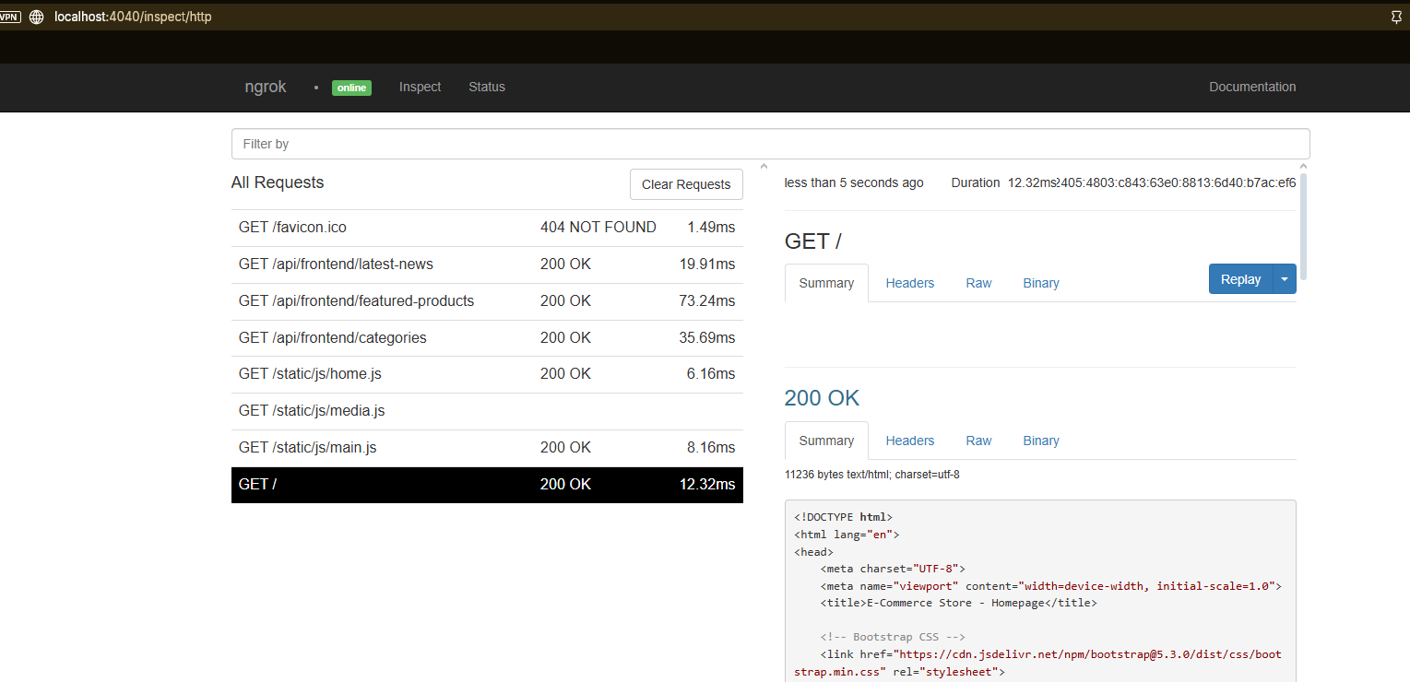
Figure 16 Ngrok 1
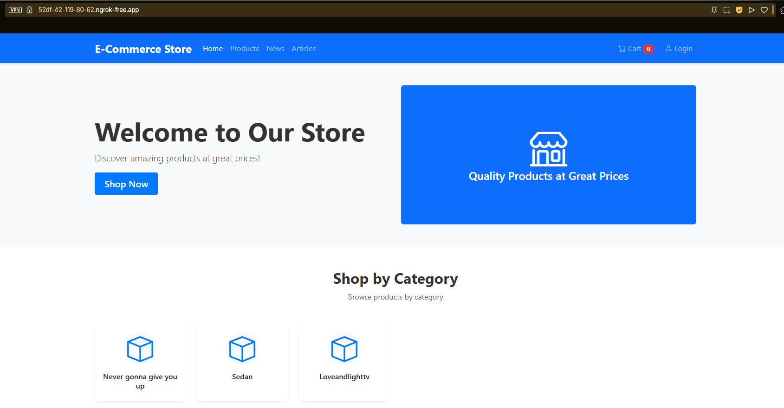
Figure 17 Web with public URL

Conclusion
This report demonstrated the effectiveness of a microservice architecture for e-commerce applications through the implementation of eleven distinct services (cart, customer, data, database, email, frontend, media, order, payment, promotion, and storage). Python proved suitable for both development efficiency and performance requirements across all services.
The custom database implementation for each microservice optimized data operations while adhering to database-per-service patterns. Deployment via ngrok tunneling facilitated secure external access without excessive infrastructure complexity.
Results confirm established benefits of microservice architectures: enhanced system resilience through service isolation, independent scalability, and increased development velocity through decoupled teams. Future research should address cross-service authentication, containerization strategies, and observability frameworks to manage distributed system complexity.
References
- Chen, L. (2018). Microservices: Architecting for Continuous Delivery and DevOps. IEEE International Conference on Software Architecture, 39-46.
- Fowler, M., & Lewis, J. (2014). Microservices: a definition of this new architectural term. Martin Fowler's Blog, 25.
- Newman, S. (2021). Building Microservices: Designing Fine-Grained Systems (2nd ed.). O'Reilly Media.
- Richardson, C. (2022). Microservices Patterns: With Examples in Java. Manning Publications.
- Taibi, D., Lenarduzzi, V., & Pahl, C. (2020). Architectural Patterns for Microservices: A Systematic Mapping Study. International Conference on Cloud Computing and Services Science, 221-232.
- Villamizar, M., Garcés, O., Castro, H., Verano, M., Salamanca, L., Casallas, R., & Gil, S. (2023). Evaluating the Monolithic and the Microservice Architecture Pattern to Deploy Web Applications in the Cloud. Computing Conference, 583-590.

