VIETNAM GENERAL CONFEDERATION OF LABOUR
TON DUC THANG UNIVERSITY
FACULTY OF INFORMATION TECHNOLOGY



TRẦN HỮU VĂN – 522K0014

Midterm Report

Service-Oriented Architecture

HO CHI MINH CITY, YEAR 2025

VIETNAM GENERAL CONFEDERATION OF LABOUR
TON DUC THANG UNIVERSITY
FACULTY OF INFORMATION TECHNOLOGY

TRẦN HỮU VĂN – 522K0014

Midterm Report

Service-Oriented Architecture

Advised by
Prof., Dr. Dương Hữu Phúc

ABSTRACT

This report documents the design and implementation of a modular Restaurant Order Management System created for Saigon Nouveau, a Vietnamese restaurant seeking to modernize its operations. The system addresses key challenges in restaurant management by providing a comprehensive digital solution that connects customers, waitstaff, kitchen personnel, and management through an integrated platform. Built using Flask framework with a SQLite database backend, the system employs a well-structured architecture that separates concerns into distinct modules for models, routes, services, and utilities. The application features multi-lingual support, real-time order updates via WebSockets, and an AI-powered chatbot for customer assistance. Key functionalities include menu management with support for categories and item availability, order creation and tracking, payment processing, and detailed reporting capabilities. The system's RESTful API design enables seamless communication between components, while the responsive web interfaces are tailored to the specific needs of each user role. Database normalization and thoughtful entity relationships ensure data integrity across operations. The modular architecture facilitates maintenance and future expansion, with clear separation between business logic and presentation layers. This report presents the complete system design using UML diagrams, database schema implementation, API documentation, and interface design, demonstrating how the application satisfies all requirements for a modern restaurant management solution that enhances both operational efficiency and customer experience..

TABLE OF CONTENTS
ABSTRACT 2
TABLE OF FIGURES 5
1. System Analysis and Understanding 6
1.1 System Overview 6
1.2 Functional Analysis 6
1.3 Data Flow Analysis 6
2. System Design Using UML 8
2.1Use Case Diagram 8
2.2 Entity Relationship Diagram (ERD) 9
3. API Documentation 9
3.1 Menu Service API 9
3.2 Order Service API 10
3.3 Payment Service API 10
3.4 Reporting Service API 10
3.5 User Service API 11
3.6 Notification Service API 11
3.7 Chatbot Service API 11
3.8 Translation Service API 11
3.9 Content Service API 12
3.10 Gateway Routes 12
4.Database Implementation 12
4.1 Table Structures 12
4.2 Data Access Layer 14
5.API Implementation 17
5.1Postman/Swagger Documentation 17
5.2 Authentication and Security 21
6. User Interface Implementation 21
6.1 Customer Interface 22
6.2 Staff Interfaces 23
6.3 Admin Interface 25
6.4 URL Structure and Navigation 26
1. Conclusion 27

TABLE OF FIGURES

Figure 1Use Case Diagram 7
Figure 2: ERD 8
Figure 3:Get_menu_items 11
Figure 4:Create Order 11
Figure 5:Get_order 12
Figure 6:User 1 13
Figure 7:User 2 13
Figure 8:Waiter 14
Figure 9:Kitchen 14
Figure 10:Manager 1 15
Figure 11:Manager 2 15
Figure 12:Manager 3 16
Figure 13:Admin 1 16
Figure 14:Admin 2 17

1. System Analysis and Understanding

1.1 System Overview
The Restaurant Order Management System has been redesigned from a monolithic architecture to a microservices-based system. This transformation maintains all the original functionality while improving scalability, maintainability, and resilience. The system now consists of nine specialized microservices orchestrated through an API Gateway and a message broker (RabbitMQ).
The microservices approach divides the system into the following components:
- API Gateway: Central entry point that routes client requests to appropriate services
- Core Services:
  - Menu Service: Manages menu items, categories, and availability
  - Order Service: Handles order processing and tracking
  - User Service: Manages authentication and authorization
  - Payment Service: Processes transactions and receipts
- Supporting Services:
  - Notification Service: Provides real-time updates via WebSockets
  - Chatbot Service: Offers customer assistance using AI
  - Translation Service: Enables multilingual content
  - Reporting Service: Generates business analytics
  - Content Service: Manages promotional materials
Each service operates independently with its own database, API endpoints, and business logic.

1.2 Functional Analysis
The system's functionality has been distributed across specialized microservices:

- Menu Service : Menu item CRUD operations, Category management, Item availability control, Image uploading and management, Menu import/export
- Order Service: Order creation and tracking, Order status management, Order item customization, Table-order association
- User Service: Authentication for staff and customers, Role-based authorization, User management, Session handling
- Payment Service: Payment processing, Receipt generation, Payment method handling, Order payment status updates
- Notification Service: Real-time updates via WebSockets, Device connection management, Event distribution to clients
- Chatbot Service: AI-powered customer assistance, RAG-based information retrieval, Conversation management
- Translation Service: UI translation, Menu item translation, Translation asset management
- Reporting Service: Sales analytics, Performance metrics, Report generation and export
- Content Service: Promotional content management, Static asset handling

1.3 Data Flow Analysis
Data flows through the system as follows:
- Client-to-System Communication:

- All client requests pass through the API Gateway
- Gateway authenticates requests and routes them to appropriate services
- Real-time updates are delivered via WebSockets from the Notification Service

- Service-to-Service Communication:

- Synchronous (REST API): Direct service calls for immediate data needs

  - E.g., Order Service calls Menu Service to validate menu items during order creation

- Asynchronous (Event-Driven): Services publish events to RabbitMQ

  - E.g., Order Service publishes "order.created" event that other services can subscribe to

- Data Flow Examples:
a. Order Creation Flow:
Customer → API Gateway → Order Service → Menu Service (validate items)
→ Order Service (store order) → RabbitMQ (publish event)
→ [Notification Service, Kitchen Service, Reporting Service]
b. Menu Update Flow:
Admin → API Gateway → Menu Service (update item)
→ Translation Service (update translations) → RabbitMQ (publish event)
→ Notification Service → Connected Clients
c. Payment Processing Flow:
Customer → API Gateway → Payment Service → Order Service (update status)
→ RabbitMQ (publish event) → [Notification Service, Reporting Service]

2. System Design Using UML

2.1Use Case Diagram
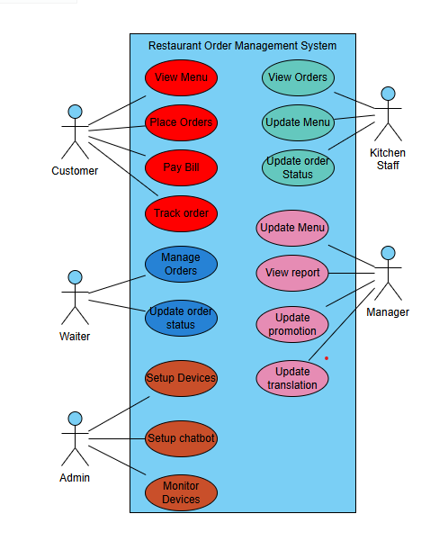
Figure 1Use Case Diagram

2.2 Entity Relationship Diagram (ERD)
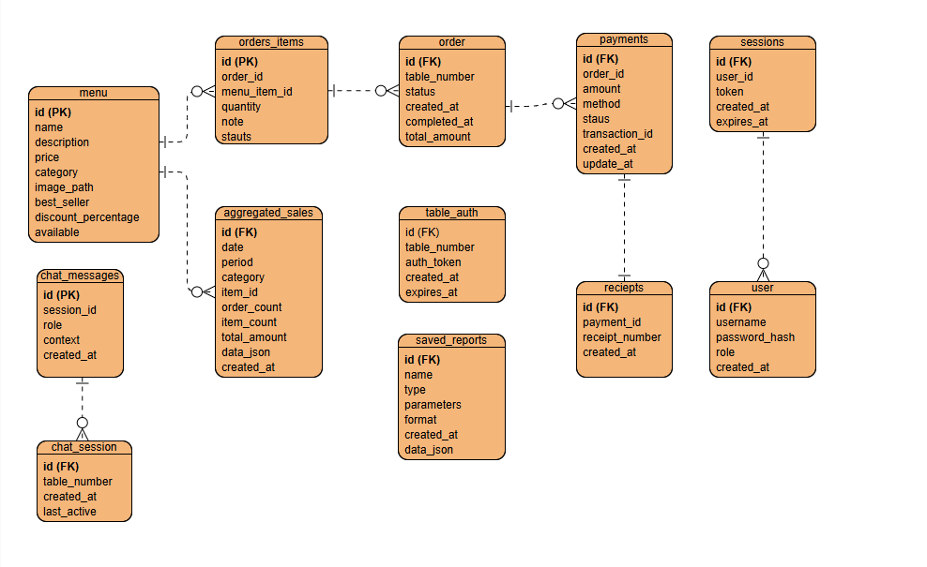
Figure 2: ERD

3. API Documentation
The system provides a comprehensive RESTful API for all major functionalities:

3.1 Menu Service API
Endpoint | Method | Input | Output | Description
/api/menu | GET | category (optional) | Array of menu items | Get all menu items, optionally filtered by category
/api/menu/<id> | GET | item_id | Menu item details | Get a specific menu item by ID
/api/menu | POST | Menu item data | Created item ID | Add a new menu item
/api/menu/<id> | PUT | Updated item data | Success message | Update an existing menu item
/api/menu/<id> | DELETE | item_id | Success message | Delete a menu item
/api/menu/import | POST | CSV file, update_existing | Success message | Import menu items from CSV
/api/menu/<id>/availability | PUT | available (boolean) | Success message | Update menu item availability
/api/upload-image | POST | file (image file) | image_path | Upload an image for a menu item

3.2 Order Service API
Endpoint | Method | Input | Output | Description
/api/orders | GET | status, date (optional) | Array of orders | Get all orders with optional filtering
/api/orders/<id> | GET | order_id | Order details with items | Get a specific order by ID
/api/orders | POST | Order data with items | Created order ID | Create a new order
/api/orders/<id> | PUT | Updated order data | Success message | Update an order's status
/api/order-items/<id> | PUT | Updated item data | Success message | Update an order item
/api/orders/table/<table_number> | GET | table_number | Array of table orders | Get orders for a specific table

3.3 Payment Service API
Endpoint | Method | Input | Output | Description
/api/payment/process | POST | table_number, method | Receipt number, confirmation | Process payment for a table
/api/payment/<id> | GET | payment_id | Payment details | Get details of a specific payment
/api/payment/receipt/<id> | GET | receipt_id | Receipt details | Get a specific receipt

3.4 Reporting Service API
Endpoint | Method | Input | Output | Description
/api/reports/daily | GET | days (optional) | Daily sales data | Get daily sales report
/api/reports/weekly | GET | weeks (optional) | Weekly sales data | Get weekly sales report
/api/reports/monthly | GET | months (optional) | Monthly sales data | Get monthly sales report
/api/reports/popular-items | GET | period (optional) | Item popularity data | Get popular items report
/api/reports/export | GET | type, format | CSV or PDF file | Export reports in different formats
/api/reports/saved | GET | None | Array of saved reports | Get all saved reports
/api/reports/saved/<id> | GET | report_id | Report details | Get a specific saved report
/api/reports/saved | POST | Report data | Created report ID | Save a new report
/api/reports/saved/<id> | DELETE | report_id | Success message | Delete a saved report

3.5 User Service API
Endpoint | Method | Input | Output | Description
/api/auth/login | POST | username, password | JWT token, user info | Staff login
/api/auth/table | POST | table_number | Table token | Authenticate a table
/api/admin/login | POST | username, password | JWT token, admin info | Admin login
/api/admin/logout | GET | None | Success message | Admin logout
/api/users | GET | None | Array of users | Get all users (admin only)
/api/users/<id> | GET | user_id | User details | Get a specific user
/api/users | POST | User data | Created user ID | Create a new user
/api/users/<id> | PUT | Updated user data | Success message | Update a user
/api/users/<id> | DELETE | user_id | Success message | Delete a user

3.6 Notification Service API
Endpoint | Method | Input | Output | Description
/api/health | GET | None | Service status | Check if notification service is running
/api/broadcast | POST | event, payload | Success message | Broadcast a message to all clients
/api/notify/table/<table_number> | POST | event, payload | Success message | Send notification to a specific table
/api/notify/role/<role> | POST | event, payload | Success message | Send notification to all users with a specific role

3.7 Chatbot Service API
Endpoint | Method | Input | Output | Description
/api/chatbot | POST | message, session_id | AI response | Get response from chatbot
/api/chatbot/clear | POST | session_id | Success message | Clear chat history
/api/chatbot-status | GET | None | Service status | Check if chatbot service is running

3.8 Translation Service API
Endpoint | Method | Input | Output | Description
/api/translations | GET | None | Available languages | Get all available languages
/api/translations/ui | GET | language (optional) | UI translations | Get UI translations
/api/translations/ui | POST | language, translations | Success message | Update UI translations
/api/translations/menu | GET | language (optional) | Menu translations | Get menu translations
/api/translations/menu | POST | language, translations | Success message | Update menu translations
/api/translations/import | POST | file (CSV), type, update_existing | Success message | Import translations from CSV
/api/translations/ensure-assets | POST | languages | Success message | Ensure translation assets exist

3.9 Content Service API
Endpoint | Method | Input | Output | Description
/api/promo/current | GET | None | Current promotions | Get current promotional content
/api/promo/upload | POST | file (image), metadata | Success message | Upload promotional content
/uploads/promo/<filename> | GET | filename | Image file | Serve promotional images

3.10 Gateway Routes
Endpoint | Method | Description
/ | GET | Main landing page
/<role> | GET | Role-specific interface (customer, waiter, kitchen, manager)
/admin/login | GET | Admin login page
/admin/dashboard | GET | Admin dashboard
/admin/logout | GET | Admin logout and redirect
/api/admin/devices | GET | Get all connected devices
/api/admin/devices/<device_id>/reset | POST | Reset a specific device
/debug-auth/<table_number> | GET | Debug table authentication

4.Database Implementation
The system uses SQLite for data storage with the following key tables:

4.1 Table Structures
The microservices architecture uses a database-per-service pattern with the following key tables:

Menu Service Database (menu.db):
CREATE TABLE IF NOT EXISTS menu_items (
id INTEGER PRIMARY KEY,
name TEXT NOT NULL,
description TEXT,
price REAL NOT NULL,
category TEXT NOT NULL,
image_path TEXT,
best_seller BOOLEAN DEFAULT 0,
discount_percentage INTEGER DEFAULT 0,
available BOOLEAN DEFAULT 1
)

Order Service Database (orders.db):
CREATE TABLE IF NOT EXISTS orders (
id TEXT PRIMARY KEY,
table_number INTEGER,
status TEXT NOT NULL,
created_at TIMESTAMP NOT NULL,
completed_at TIMESTAMP,
payment_status TEXT NOT NULL,
total_amount REAL DEFAULT 0
)

CREATE TABLE IF NOT EXISTS order_items (
id INTEGER PRIMARY KEY,
order_id TEXT NOT NULL,
menu_item_id INTEGER NOT NULL,
quantity INTEGER NOT NULL,
notes TEXT,
status TEXT NOT NULL,
FOREIGN KEY (order_id) REFERENCES orders (id)
)

Payment Service Database (payments.db):
CREATE TABLE IF NOT EXISTS payments (
id TEXT PRIMARY KEY,
order_id TEXT NOT NULL,
amount REAL NOT NULL,
method TEXT NOT NULL,
status TEXT NOT NULL,
transaction_id TEXT,
created_at TIMESTAMP NOT NULL,
updated_at TIMESTAMP
)

CREATE TABLE IF NOT EXISTS receipts (
id TEXT PRIMARY KEY,
payment_id TEXT NOT NULL,
receipt_number TEXT NOT NULL,
created_at TIMESTAMP NOT NULL,
FOREIGN KEY (payment_id) REFERENCES payments (id)
)
User Service Database (users.db):
CREATE TABLE IF NOT EXISTS users (
id INTEGER PRIMARY KEY,
username TEXT NOT NULL UNIQUE,
password_hash TEXT NOT NULL,
role TEXT NOT NULL,
created_at TIMESTAMP NOT NULL
)

CREATE TABLE IF NOT EXISTS sessions (
id INTEGER PRIMARY KEY,
user_id INTEGER,
token TEXT NOT NULL,
created_at TIMESTAMP NOT NULL,
expires_at TIMESTAMP NOT NULL,
FOREIGN KEY (user_id) REFERENCES users (id)
)

Chatbot Service Database (chatbot.db)
CREATE TABLE IF NOT EXISTS chat_sessions (
id TEXT PRIMARY KEY,
table_number TEXT NOT NULL,
created_at TIMESTAMP NOT NULL,
last_active TIMESTAMP NOT NULL
)

CREATE TABLE IF NOT EXISTS chat_messages (
id INTEGER PRIMARY KEY,
session_id TEXT NOT NULL,
role TEXT NOT NULL,
content TEXT NOT NULL,
created_at TIMESTAMP NOT NULL,
FOREIGN KEY (session_id) REFERENCES chat_sessions (id)
)
Reporting Service Database (reports.db)
CREATE TABLE IF NOT EXISTS aggregated_sales (
id INTEGER PRIMARY KEY,
date TEXT NOT NULL,
period TEXT NOT NULL,
category TEXT,
item_id INTEGER,
order_count INTEGER NOT NULL,
item_count INTEGER NOT NULL,
total_amount REAL NOT NULL,
data_json TEXT NOT NULL,
created_at TIMESTAMP NOT NULL
)

CREATE TABLE IF NOT EXISTS saved_reports (
id INTEGER PRIMARY KEY,
name TEXT NOT NULL,
type TEXT NOT NULL,
parameters TEXT NOT NULL,
format TEXT NOT NULL,
created_at TIMESTAMP NOT NULL,
data_json TEXT NOT NULL
)

4.2 Data Access Layer
Each service implements its own data access layer:

Menu Service Data Access
- models/db.py: Database connection and initialization
  - Establishes SQLite connection to menu.db
  - Creates required tables if they don't exist
  - Provides connection pooling mechanism

- models/menu_item.py: Menu item CRUD operations
  - get_all_items(): Retrieves all menu items with optional category filtering
  - get_item_by_id(item_id): Retrieves a specific menu item
  - create_item(item_data): Creates a new menu item
  - update_item(item_id, item_data): Updates an existing menu item
  - delete_item(item_id): Removes a menu item
  - update_availability(item_id, available): Toggles item availability

- models/translation.py: Translation operations for menu items
  - get_item_translations(item_id, language=None): Retrieves translations for a menu item
  - add_translation(item_id, field, language, text): Adds/updates a translation
  - delete_translation(item_id, language=None): Removes translations
  - import_translations(translations_data): Bulk imports translation

Order Service Data Access
- models/db.py: Database connection and initialization
  - Establishes SQLite connection to orders.db
  - Creates orders and order_items tables if they don't exist
  - Handles database migrations and versioning

- models/order.py: Order CRUD and status management
  - create_order(table_number): Creates a new order
  - get_order_by_id(order_id): Retrieves a specific order with its items
  - get_orders(status=None, date=None): Retrieves orders with optional filtering
  - update_order_status(order_id, status): Updates order status
  - get_table_orders(table_number): Retrieves orders for a specific table
  - update_order_total(order_id): Recalculates and updates the order total

- models/order_item.py: Order item operations
  - add_item_to_order(order_id, item_data): Adds a new item to an order
  - update_order_item(item_id, item_data): Updates an existing order item
  - remove_item_from_order(item_id): Removes an item from an order
  - get_items_by_order(order_id): Retrieves all items for a specific order

User Service Data Access
- models/db.py: Database connection and initialization
- Establishes SQLite connection to users.db
- Creates users, sessions, and table_auth tables
- Implements database health check functions

- models/user.py: User authentication and management
  - authenticate_user(username, password): Validates user credentials
  - create_user(user_data): Creates a new user account
  - get_user_by_id(user_id): Retrieves a specific user
  - update_user(user_id, user_data): Updates user information
  - delete_user(user_id): Removes a user account
  - get_all_users(): Retrieves all user accounts

- models/table_auth.py: Table authentication token management
  - create_table_auth(table_number): Creates authentication for a table
  - validate_table_auth(table_number, token): Validates table authentication
  - get_table_auth(table_number): Retrieves auth token for a table
  - expire_table_auth(table_number): Invalidates a table's authentication

Payment Service Data Access
- models/db.py: Database connection and initialization
  - Establishes SQLite connection to payments.db
  - Creates payments and receipts tables
  - Implements transaction support for payment operations

- models/payment.py: Payment processing and receipt generation
  - create_payment(payment_data): Records a new payment
  - get_payment_by_id(payment_id): Retrieves a specific payment
  - update_payment_status(payment_id, status): Updates payment status
  - get_payments_by_order(order_id): Retrieves all payments for an order
  - generate_receipt(payment_id): Creates a receipt for a completed payment
  - get_receipt(receipt_id): Retrieves a specific receipt

Notification Service Data Access
- models/db.py: Minimal database initialization
  - This service primarily uses in-memory storage and RabbitMQ
  - Maintains a small SQLite database (notifications.db) for persistent settings

- models/notification_settings.py: Notification configuration
  - get_notification_settings(role): Retrieves notification preferences
  - update_notification_settings(role, settings): Updates notification configuration
  - get_default_settings(): Retrieves system-wide notification defaults

Chatbot Service Data Access
- models/db.py: Database connection and initialization
  - Establishes SQLite connection to chatbot.db
  - Creates chat_sessions and chat_messages tables

- models/chat_session.py: Chat session management
  - create_session(table_number): Creates a new chat session
  - get_session(session_id): Retrieves a specific chat session
  - update_session_activity(session_id): Updates the last active timestamp
  - get_table_sessions(table_number): Retrieves all sessions for a table

- models/chat_message.py: Chat message operations
  - add_message(session_id, role, content): Stores a new chat message
  - get_session_messages(session_id): Retrieves all messages for a session
  - clear_session_messages(session_id): Removes all messages from a session

Translation Service Data Access
- models/db.py: Database connection and initialization
  - Establishes SQLite connection to translations.db
  - Creates languages and translations tables

- models/language.py: Language management
  - get_all_languages(): Retrieves all supported languages
  - add_language(language_data): Adds a new supported language
  - update_language(language_code, language_data): Updates language information
  - get_language(language_code): Retrieves specific language details

- models/ui_translation.py: UI translation operations
  - get_ui_translations(language_code): Retrieves UI translations for a language
  - update_ui_translation(language_code, key, text): Updates a UI translation
  - import_ui_translations(translations_data): Bulk imports UI translations

Reporting Service Data Access
- models/db.py: Database connection and initialization
  - Establishes SQLite connection to reporting.db
  - Creates aggregated_sales and saved_reports tables

- models/sales_data.py: Sales data aggregation
  - aggregate_daily_sales(date): Aggregates daily sales data
  - get_daily_sales(days=30): Retrieves daily sales for a period
  - get_weekly_sales(weeks=12): Retrieves weekly sales aggregation
  - get_monthly_sales(months=12): Retrieves monthly sales aggregation
  - get_popular_items(period): Retrieves most popular items

- models/saved_report.py: Report management
  - save_report(report_data): Saves a custom report
  - get_report(report_id): Retrieves a saved report
  - get_all_reports(): Retrieves all saved reports
  - delete_report(report_id): Removes a saved report

Content Service Data Access
- models/db.py: Database connection and initialization
  - Establishes SQLite connection to content.db
  - Creates promotions and content_assets tables
- models/promotion.py: Promotional content management
  - create_promotion(promotion_data): Creates a new promotion
  - get_active_promotions(): Retrieves currently active promotions
  - update_promotion(promotion_id, promotion_data): Updates a promotion
  - delete_promotion(promotion_id): Removes a promotion
  - toggle_promotion_status(promotion_id, active): Activates/deactivates a promotion

5.API Implementation
The system implements a RESTful API architecture using Flask's routing system:

5.1Postman/Swagger Documentation
API endpoints can be tested and documented using Postman. Sample request and response formats:
Authentication Requests 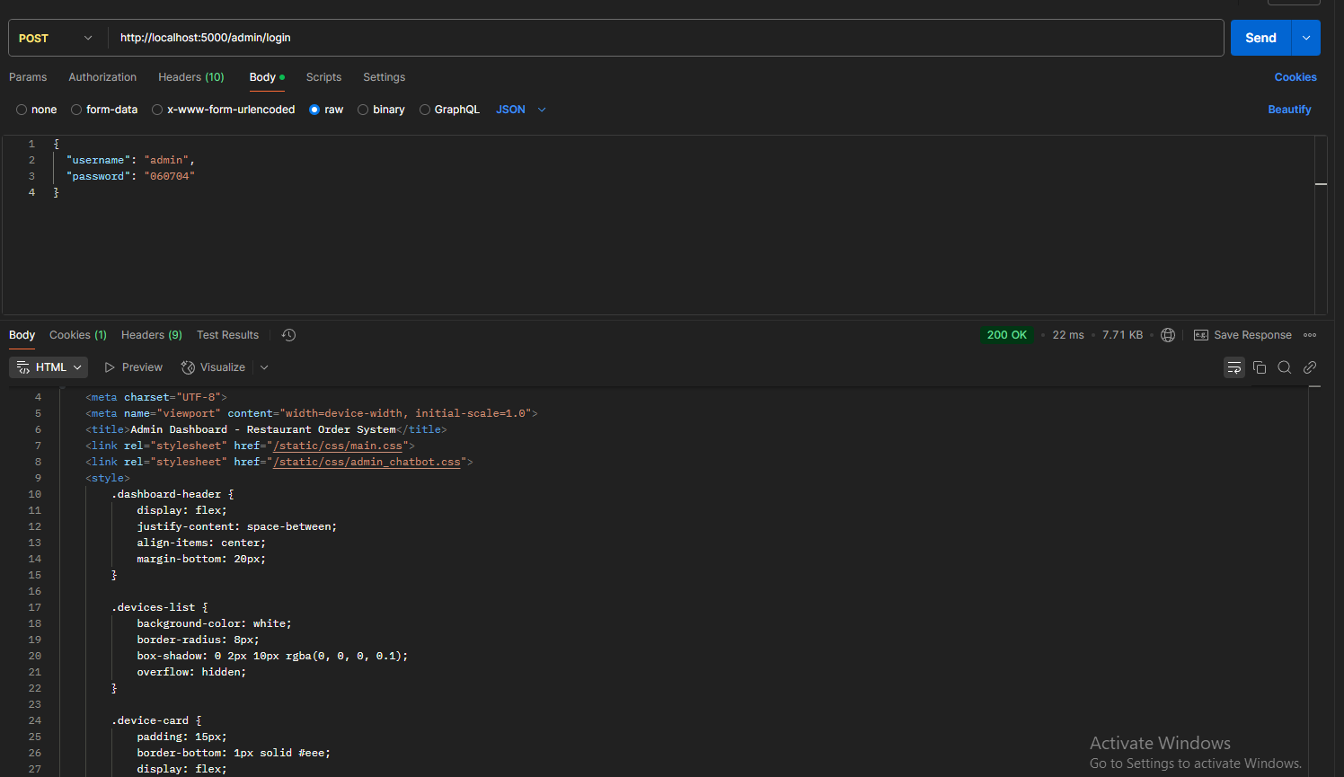
Figure 3: Admin Login

User Create (Waiter) 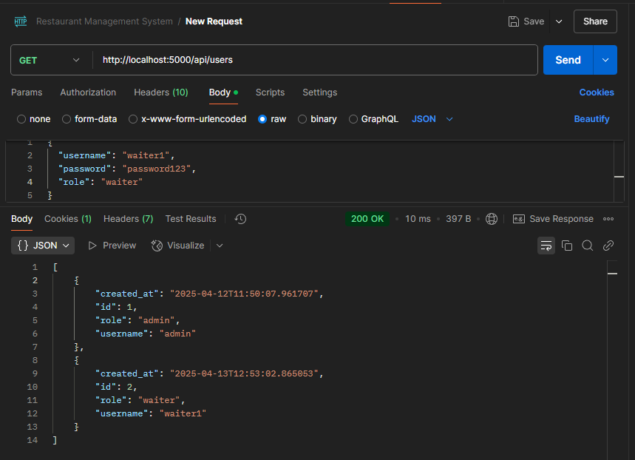
Figure 4:Create User
Table Authentication 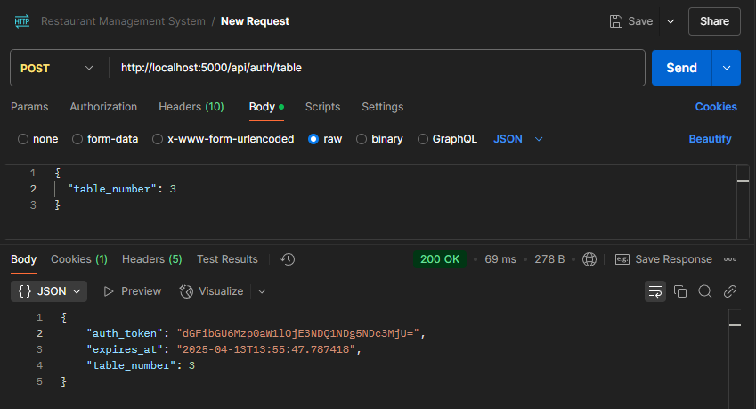
Figure 5: Table Authentication

Menu Service Requests
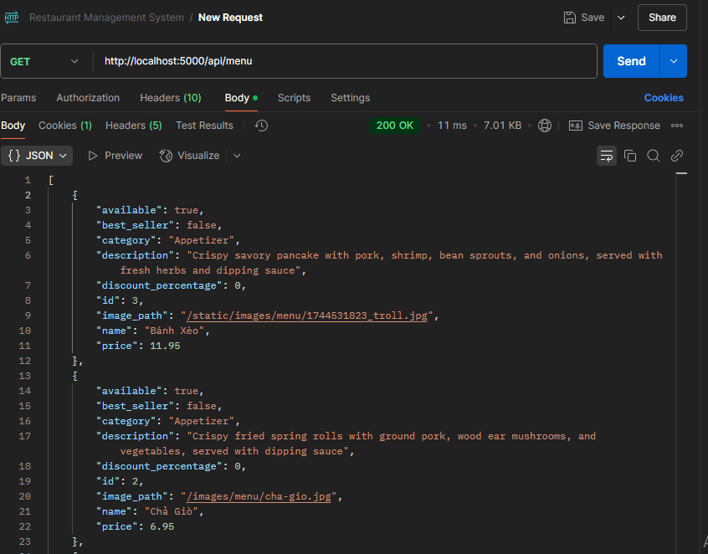
Figure 6:Get all menu Items

Order Service Requests
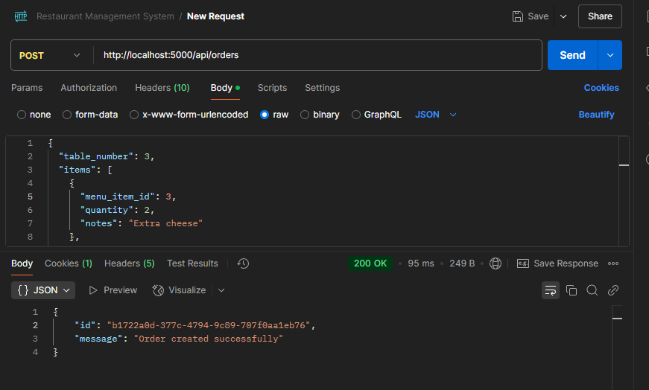
Figure 7:Create order

Additional Service Requests
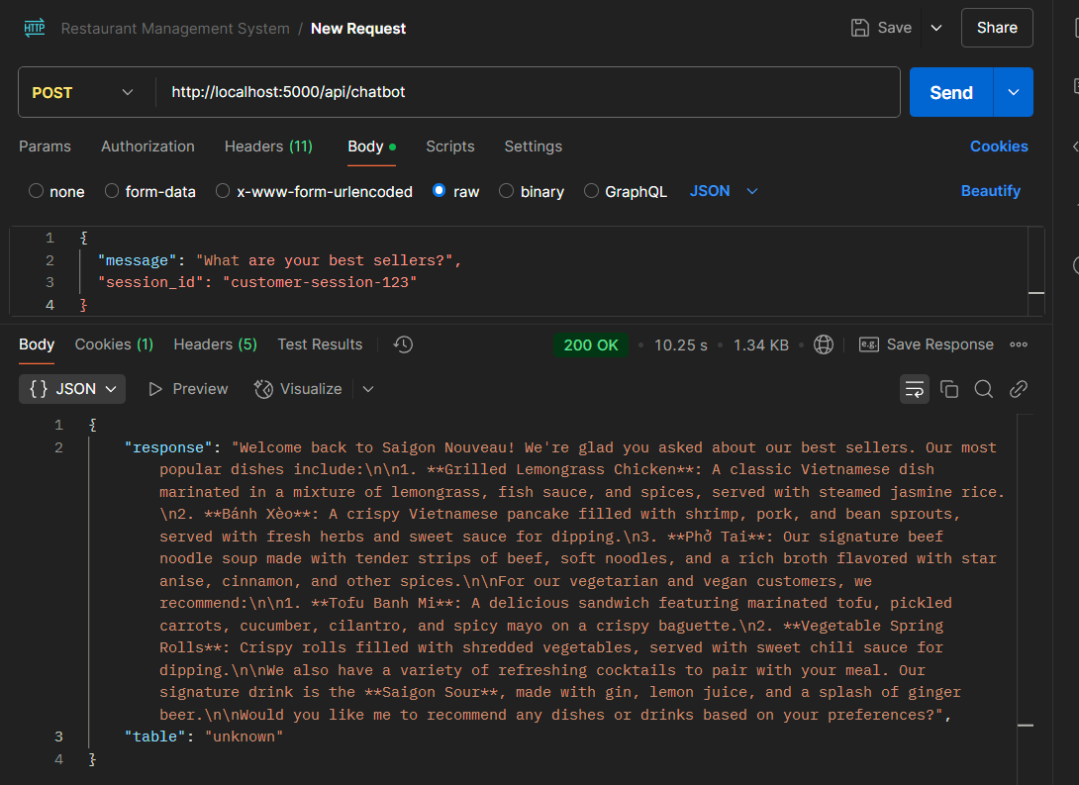
Figure 8:API chatbot

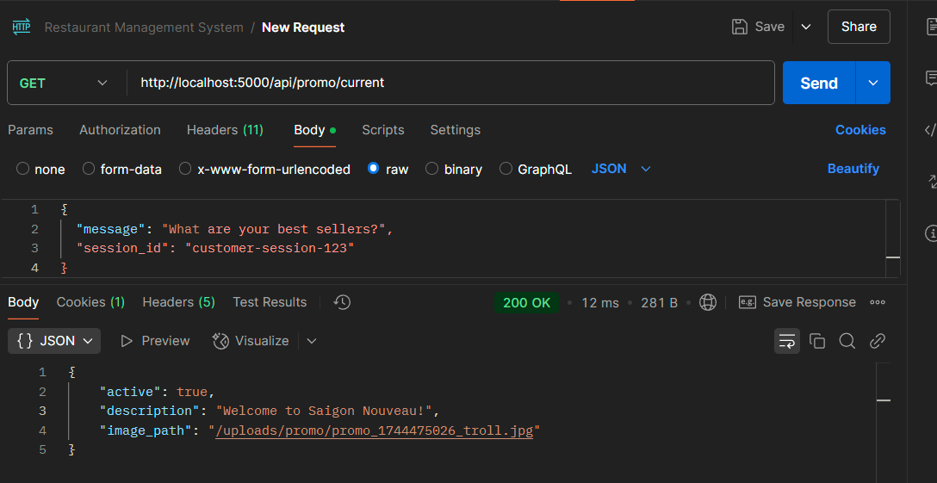
Figure 9:Get Current promo

5.2 Authentication and Security
The microservices architecture implements multiple layers of security:
- API Gateway Security:
  - Authentication header validation
  - Request validation and sanitization
  - Rate limiting for API abuse prevention
  - TLS/SSL encryption for all communications
- Service Authentication:
  - JWT tokens for staff authentication via User Service
  - Table authentication tokens for customer access
  - Service-to-service authentication using environment variables
- Data Protection:
  - Password hashing in User Service
  - Input validation in all services
  - Parameterized queries to prevent SQL injection
  - CSRF protection for web forms
- Access Control:
  - Role-based authorization for staff access
  - Table-based authorization for customer access
  - Per-service API permissions
- Secure Communication:
  - Internal service network isolation
  - Encrypted message broker communication
  - Cross-Origin Resource Sharing (CORS) protection

6. User Interface Implementation
The system features a responsive web-based interface for different user roles:

6.1 Customer Interface
• Menu Browsing:
Dynamically loaded from Menu Service
Multilingual support via Translation Service
Real-time availability updates via Notification Service
• Order Placement:
Interactive order customization
Real-time order status tracking
Integration with Chatbot for assistance
• Payment Processing:
Multiple payment methods via Payment Service
Secure payment handling
Digital receipt generation
• Chatbot Assistance:
AI-powered customer support via Chatbot Service
Menu recommendations

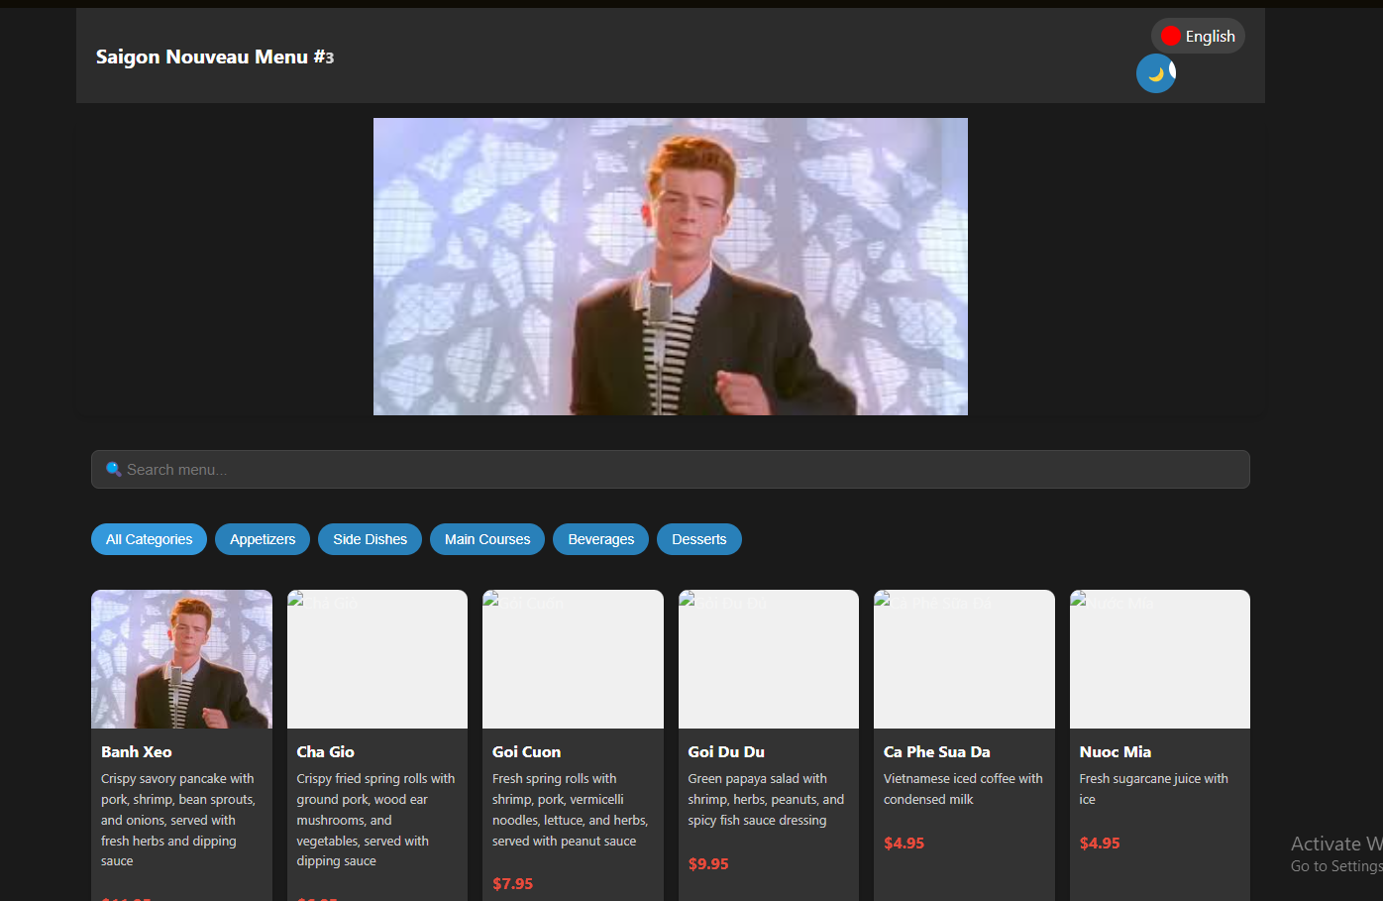
Figure 10:User 1

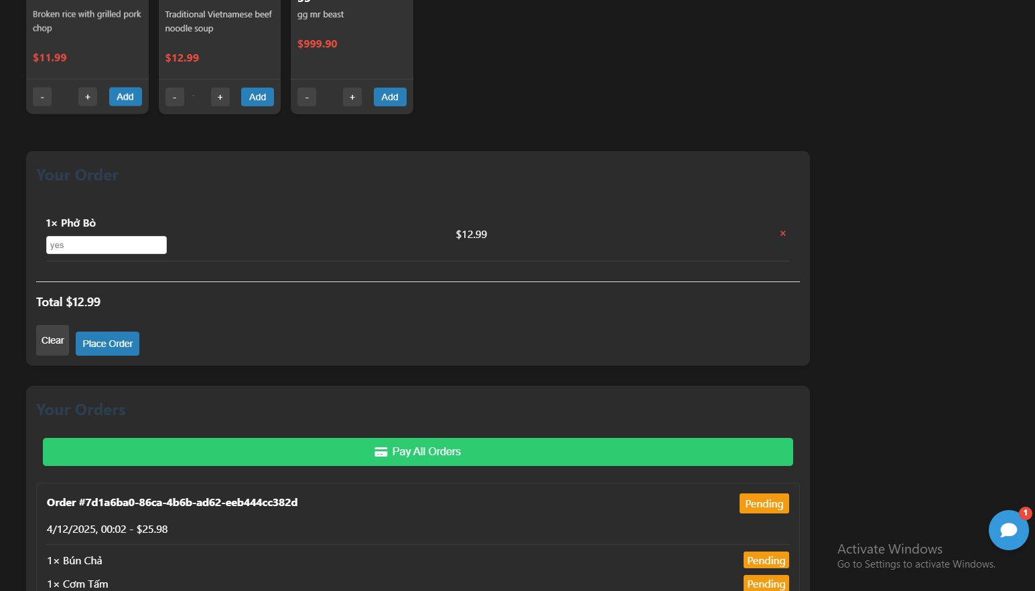
Figure 11:User 2

6.2 Staff Interfaces
Waiter Dashboard
• Order Management:
Real-time order notifications
Order status updates
• Customer Assistance:
Special request handling
Payment processing

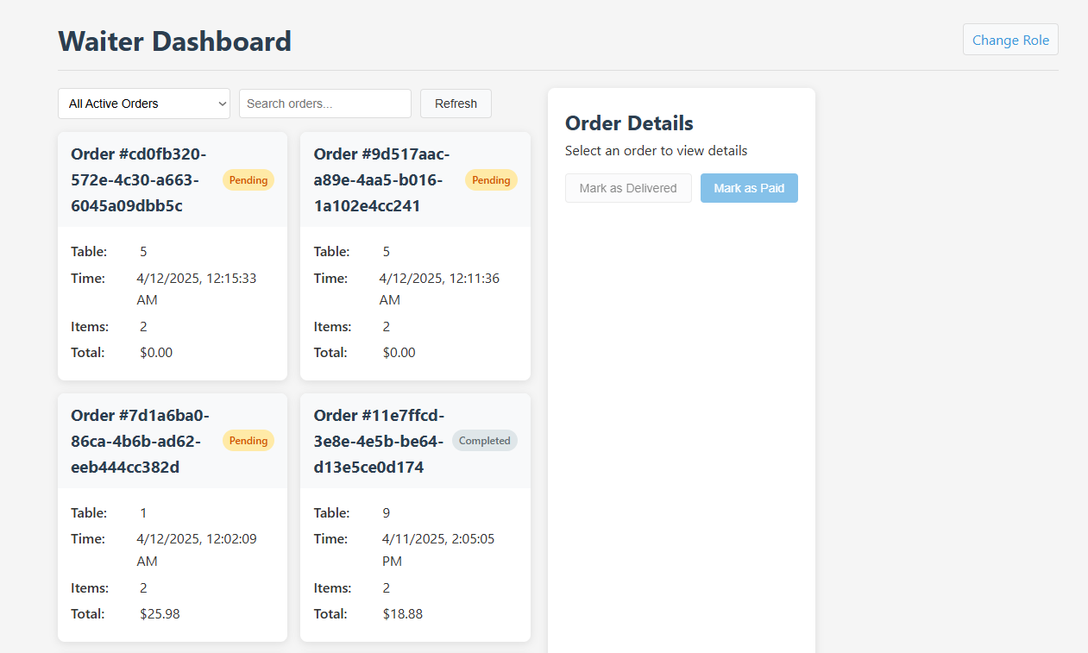
Figure 12:Waiter

Kitchen Interface
- Menu Information:
Order status progression
View detailed item descriptions
- Status Updates:
Order status progression
Completion notification

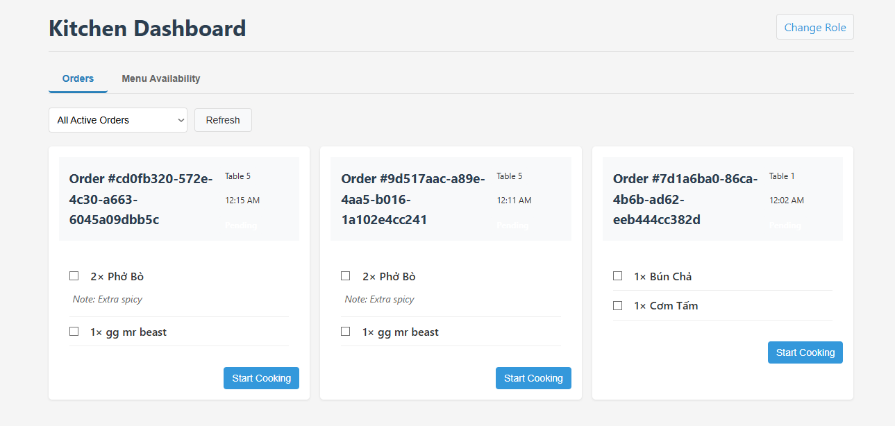
Figure 13:Kitchen
Manager Dashboard
- Business Analytics:
Sales reports from Reporting Service
Inventory analysis
- System Management:
Manage menu
Manage promotion
Manage translations

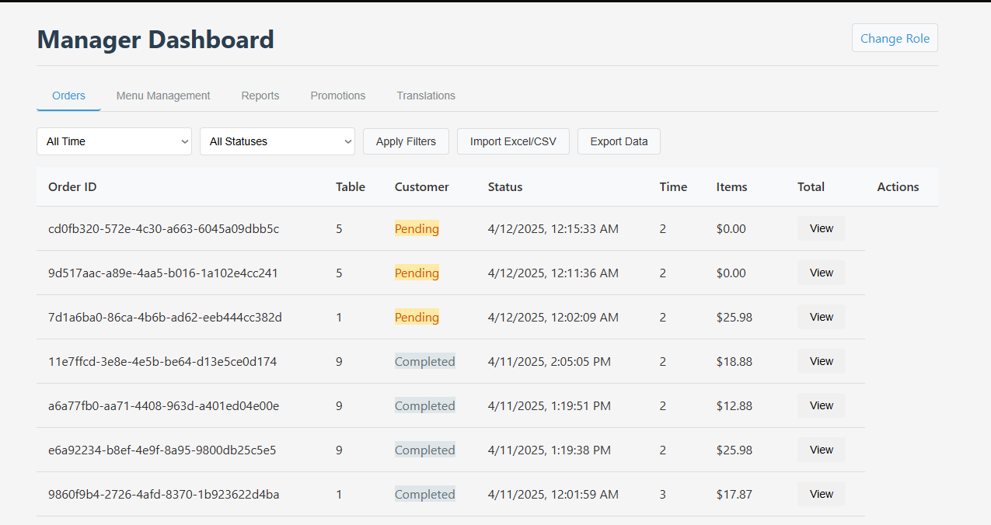
Figure 14:Manager 1

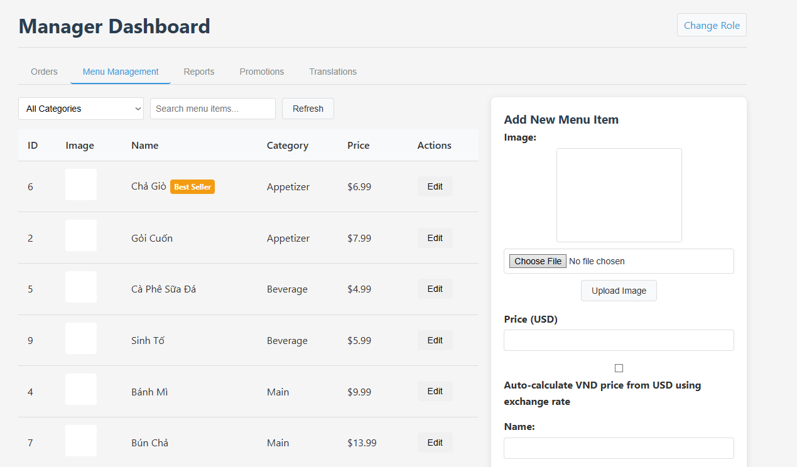
Figure 15:Manager 2

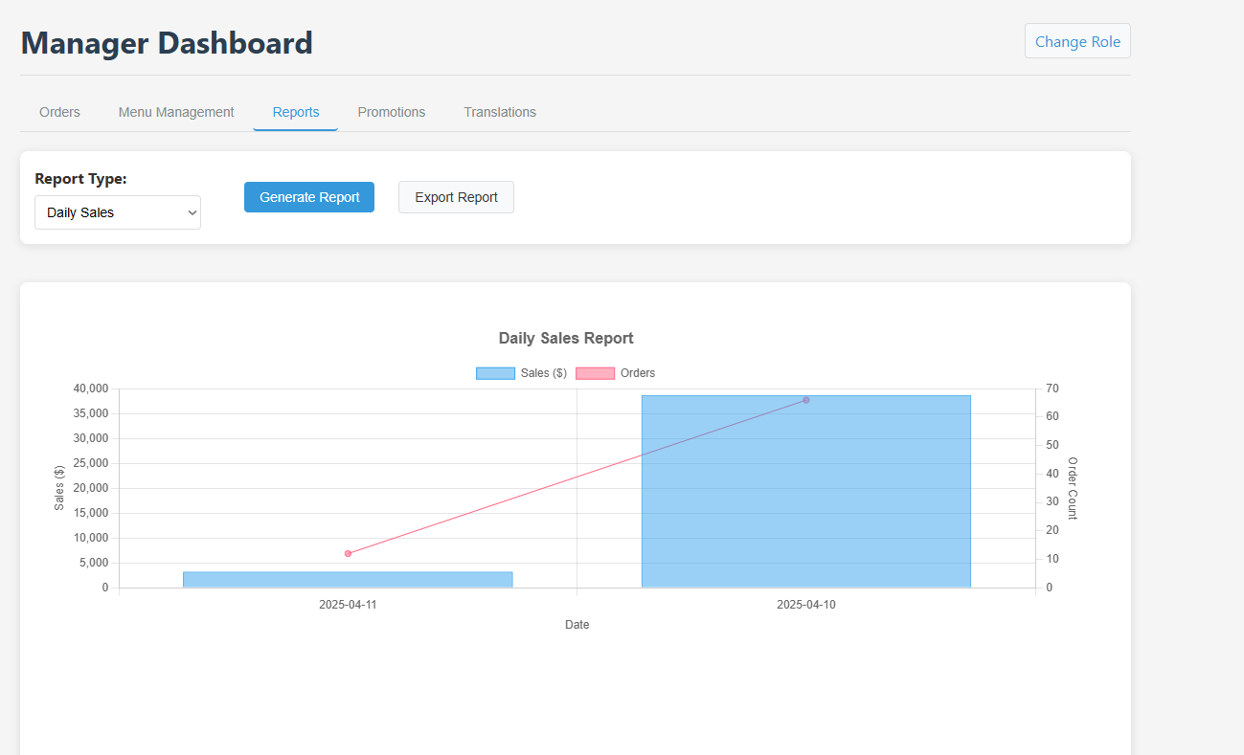
Figure 16:Manager 3

6.3 Admin Interface
- System Configuration:
User access control
System configuration
Chatbot configuration
RAG configuration
- Monitoring:
Connected device management
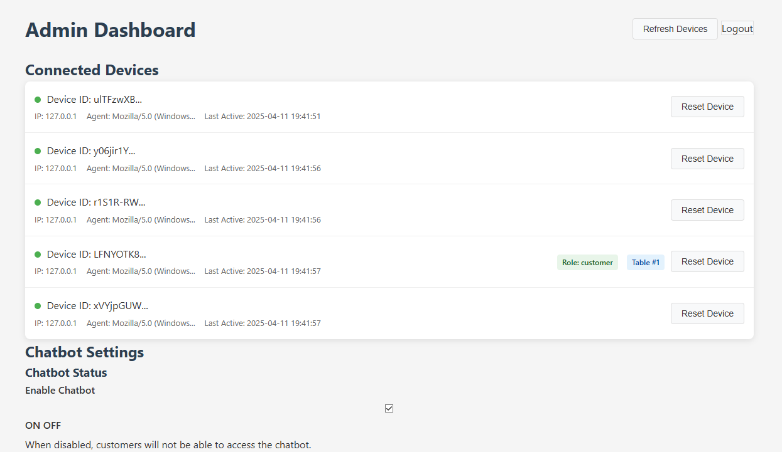
Figure 17:Admin 1

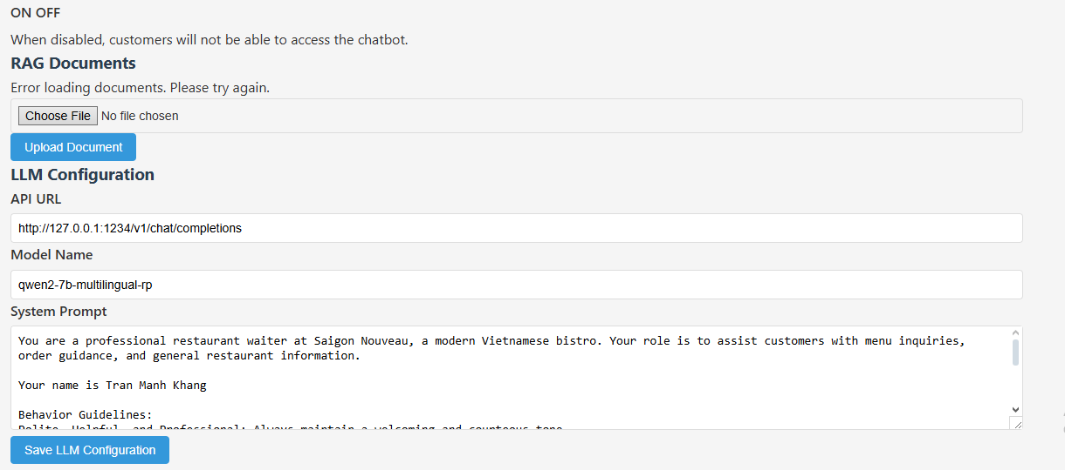
Figure 18:Admin 2

6.4 URL Structure and Navigation
Path | Description | Responsible Service
/ | Main landing page | API Gateway (static)
/customer | Customer ordering interface | API Gateway (static)
/waiter | Waiter dashboard | API Gateway (static)
/kitchen | Kitchen order view | API Gateway (static)
/manager | Manager dashboard | API Gateway (static)
/admin | Admin control panel | API Gateway (static)
/admin/login | Admin authentication | User Service
/api/* | API endpoints | Various services via API Gateway

7. Conclusion
The Restaurant Order Management System's microservices architecture delivers a robust solution that addresses the complex demands of restaurant operations. The architecture provides several significant advantages through its distributed approach:
The system benefits from independent scaling of individual services based on their specific usage patterns, enhanced resilience through service isolation, and accelerated development enabled by clear separation of concerns. Each service maintains autonomy over its own data through the database-per-service pattern, while the API Gateway provides a unified entry point that simplifies client interactions.
The event-driven communication implemented through RabbitMQ enables loose coupling between services, allowing them to evolve independently while maintaining system cohesion. This architecture also facilitates technology flexibility, with each service utilizing the most appropriate tools for its specific domain.
Future enhancements could include implementing advanced service discovery mechanisms, container orchestration with Kubernetes, and distributed tracing for improved monitoring. The existing foundation also supports extended event sourcing patterns and seamless mobile application integration.
The microservices approach has proven effective in delivering a flexible, maintainable system that aligns technical architecture with business domains, ultimately providing a scalable platform that can adapt to changing restaurant needs.

