

Requirement & Design Specification
Online Clothing Shop Website
Version: 1.0

– CanTho, January 2025 –

Record of Changes
Version | Date | A*  M, D | In charge | Change Description
*A - Added M - Modified D - Deleted

Contents
Record of Changes 2
I. Overview 4
1. User Requirements 4
1.1 Actors 4
1.2 Use Cases 4
2. Overall Functionalities 5
2.1 Screens Flow 5
2.2 Screen Descriptions 5
2.3 Screen Authorization 5
2.4 Non-UI Functions 6
3. System High Level Design 6
3.1 Database Design 6
3.2 Code Packages 7
II. Requirement Specifications 8
1. <<Feature Name>> 8
1.1 <<UseCaseCode_UC Name>> 8
2. Common Functions 11
2.1 UC-2_Login System 11
3. Patron Feature 12
3.1 UC-5_Order a Meal 12
3.2 UC-6_Register for Payroll Deduction 13
III. Design Specifications 14
1. <<Feature Name>> 14
1.1 <<SubFeature Name>> 14
1.2 System Access 15
IV. Appendix 19
1. Assumptions & Dependencies 19
2. Limitations & Exclusions 19
3. Business Rules 19
4. .. 19

I. Overview

1. User Requirements

1.1 Actors
# | Actor | Description
1 | Admin | Responsible for managing the website’s backend operations, including product catalog, inventory, and user accounts.
2 | Customer | End-user who browses the clothing shop, searches for products, adds items to the cart, and places orders.
3 | Guest | Unregistered users who can browse the website but cannot make purchases or access personalized features.

1.2 Use Cases

a. Diagram(s)
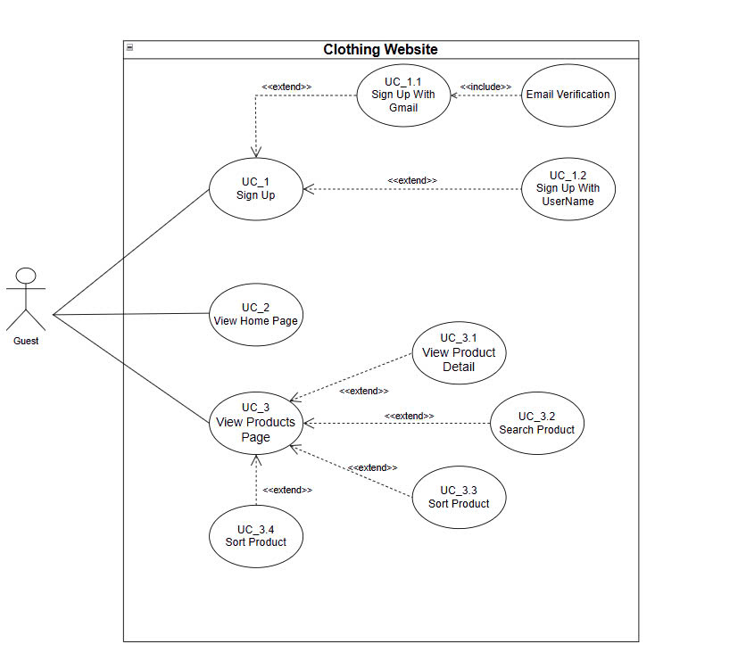
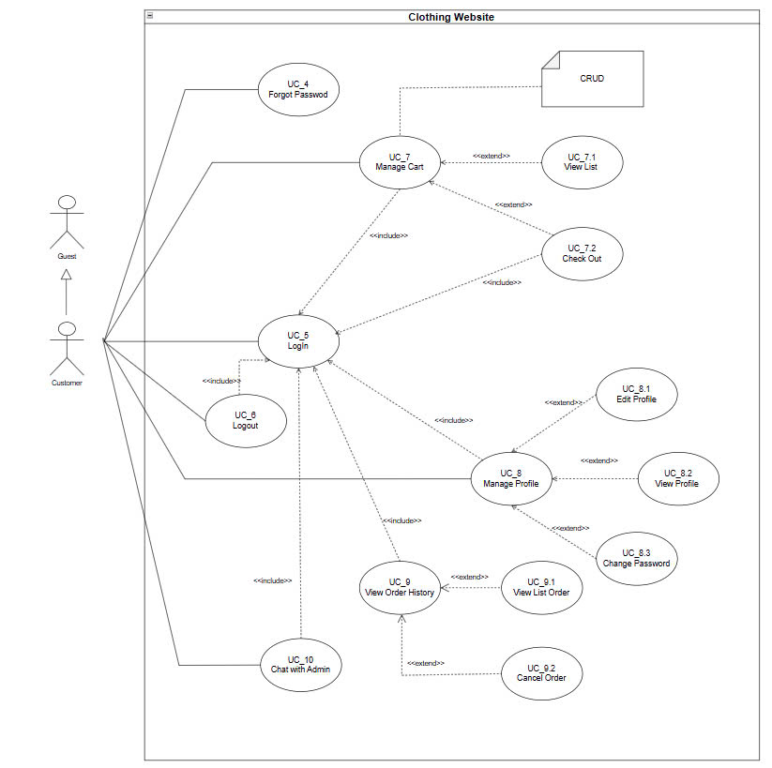
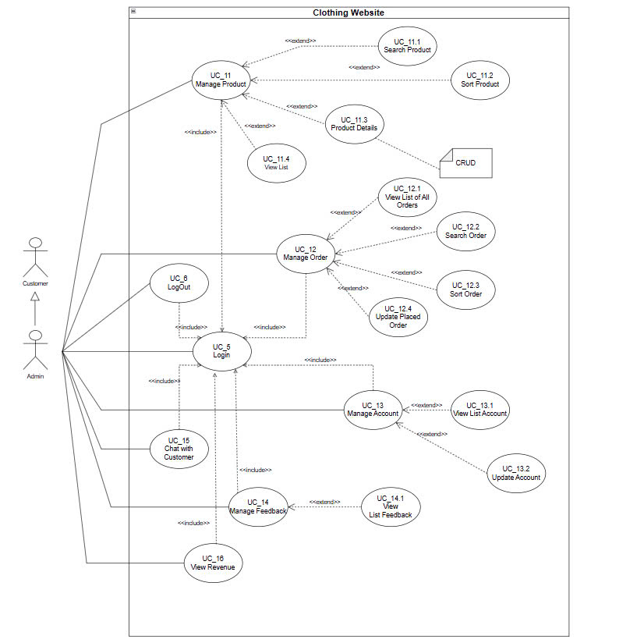

b. Descriptions
ID | Feature | Use Case | Use Case Description
01 | Sign Up | UC-1 Register | Allows a user to create a new account by providing required information.
02 | Sign Up with Gamil | UC-2 Register | Enables users to log into the system for personalized features and order management.
03 | View Home Page | UC-3 Register | Lets users search for specific products using filters like category, price, and size.
04 | View Product Page | UC-4 Register | Allows customers to add items to the cart and place an order.
05 | View Product Detail
06 | Search Product
07 | Sort Product
08 | Password Management
09 | Authentication
10 | Cart

2. Overall Functionalities

2.1 Screens Flow
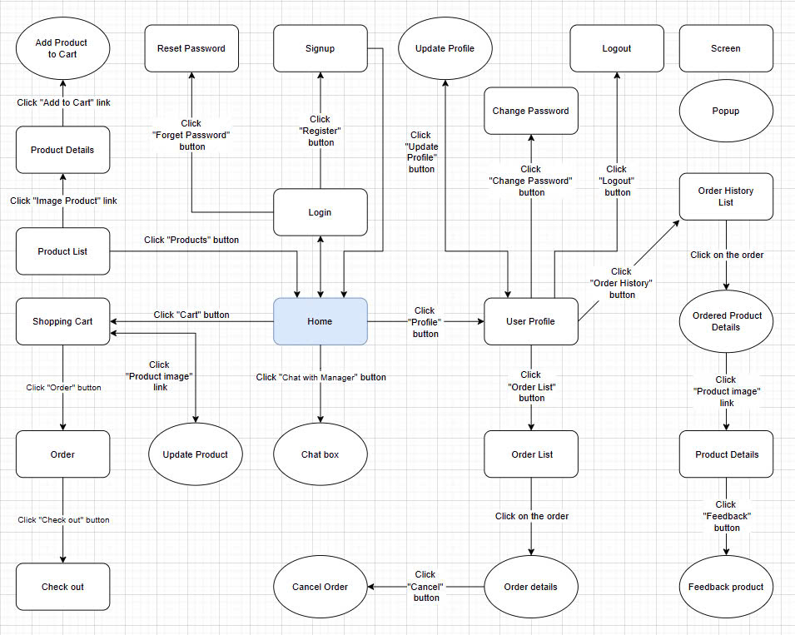

2.2 Screen Descriptions
# | Feature | Screen | Description
1 | Home Page | Home | Displays promotional banners, product categories, and featured products.
2 | Product Details | Product | Provides detailed information about a selected product.
3 | Shopping Cart | Cart | Shows a summary of items added to the cart, along with price calculations.
4 | Checkout | Checkout | Collects user’s shipping and payment information for order processing.
5 | Admin Management | Admin Dashboard | Allows administrators to manage products, view orders, and update inventory.

2.3 Screen Authorization
Screen | Admin | Customer | Guest
Home | ✓ | ✓ | ✓
Product Details | ✓ | ✓ | ✓
Shopping Cart |  | ✓
Checkout |  | ✓
Admin Dashboard | ✓

2.4 Non-UI Functions
# | Feature | System Function | Description
1 | Notification | Email Notification | Sends order confirmation and updates via email
2 | Inventory Sync | Stock Updata | Updates inventory data in real-time after orders are placed
3 | Batch Processing | Data Backup | Periodically backs up user and order data

3. System High Level Design

3.1 Database Design
[Provide the tables relationship like example below]

a. Database Schema
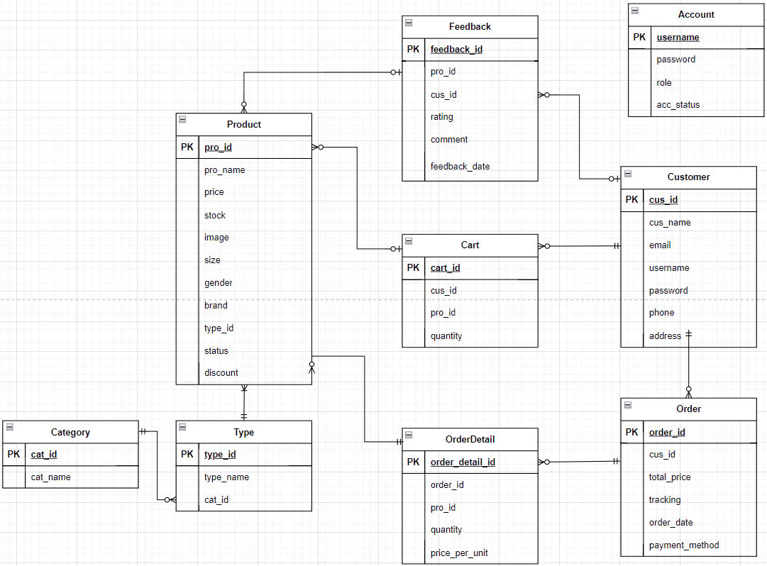

b. Table Descriptions
No | Table | Description
01 | Users | Contains user account information such as username, email, and password.
02 | Product | Stores product details, including name, description, price, and stock level.
03 | Orders | Tracks customer orders, including items ordered, quantity, price, and delivery details.
04 | Categories | Manages product categories for easy navigation and filtering.

3.2 Code Packages
[Provide the package diagram for each sub-system. The content of this section including the overall package diagram, the explanation, package and class naming conventions in each package. Please see the sample & description table format below]
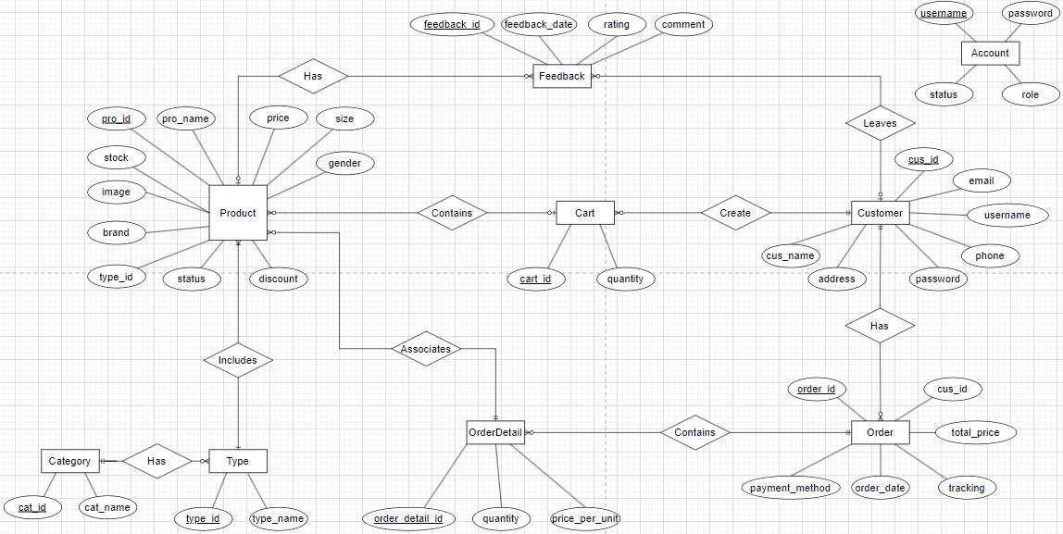
Package descriptions
No | Package | Description
01 | Member_authority | <Description of the package>
02 | registration | <Description of the package>
03 | …

II. Requirement Specifications

1. User Registration(UC-1)

a. Functionalities
Provide the functional description for the use cases using the template/guides below
Functional Description Template
UC ID and Name: | User Registration(UC-1)
Created By: |  | Date Created:
Primary Actor: |  | Secondary Actors: | None
Trigger: | User initiates registration by clicking the "Register" button.
Description:
Preconditions: | User must provide valid registration details such as email and password.
Postconditions: | User is registered, and account is created in the system.
Normal Flow: | - User navigates to registration page.  - User fills in required details.  - System validates input.  - Account is created.
Alternative Flows: | Invalid email or password format: Prompt user to correct errors.
Exceptions: | Email already exists: Show error message.
Priority: | High
Frequency of Use: | Daily
Business Rules:
Other Information:
Assumptions:

b. Business Rules
Provide the business rules those are applied only to the use case
ID | Business Rule | Business Rule Description
BR1 | Password Encoding | User’s password must be encoded with MD5 hashing
BR2
BR3

2. Product Search (UC-3)

a. Functional Description
UC ID and Name: | Product Search (UC-3)
Created By: |  | Date Created: | 16/Jun/2023
Primary Actor: |  | Secondary Actors: | None
Trigger:
Description:
Preconditions:
Postconditions:
Normal Flow
Alternative Flows:
Exceptions:
Priority:
Frequency of Use:
Business Rules:
Other Information:
Assumptions:

b. Business Rules
ID | Business Rule | Business Rule Description
FR1 | Password Encoding | User’s password must be encoded with MD5 hashing
FR2 | Invalid Logging In | User can’t be authenticated to login the system if below cases  - His/her logging-in details are incorrect  - His/her account has not been verified  - His/her account has been locked or blocked
FR3 | Account Locking | If user inputs wrong logging-in details 6 times continuously, his/her account would be locked in 30 minutes

3. Checkout Process (UC-4)

a. Functional Description
ID and Name: | Checkout Process (UC-4)
Created By: | Prithvi Raj | Date Created: | 10/4/13
Primary Actor: | Patron | Secondary Actors: | Cafeteria Inventory System
Description: | A Patron accesses the Cafeteria Ordering System from the corporate intranet or from home, views the menu for a specific date if desired, selects food items, and places an order for a meal to be delivered to a specified location within a specified 15-minute time window.
Trigger: | A Patron indicates that he wants to order a meal
Preconditions: | PRE-1. Patron is logged into COS.  PRE-2. Patron is registered for meal payments by payroll deduction.
Postconditions: | POST-1. Meal order is stored in COS with a status of “Accepted”.  POST-2. Inventory of available food items is updated to reflect items in this order.  POST-3. Remaining delivery capacity for the requested time window is updated.
Normal Flow: | 5.0 Order a Single Meal  - Patron asks to view menu for a specific date. (see 5.0.E1, 5.0.E2)  - COS displays menu of available food items and the daily special.  - Patron selects one or more food items from menu. (see 5.1)  - Patron indicates that meal order is complete. (see 5.2)  - COS displays ordered menu items, individual prices, and total price, including taxes and delivery charge.  - Patron either confirms meal order (continue normal flow) or requests to modify meal order (return to step 2).  - COS displays available delivery times for the delivery date.  - Patron selects a delivery time and specifies the delivery location.  - Patron specifies payment method.  - COS confirms acceptance of the order.  - COS sends Patron an email message confirming order details, price, and delivery instructions.  - COS stores order, sends food item information to Cafeteria Inventory System, and updates available delivery times.
Alternative Flows: | 5.1 Order multiple identical meals  - Patron requests a specified number of identical meals. (see 5.1.E1)  - Return to step 4 of normal flow.  5.2 Order multiple meals  - Patron asks to order another meal.  - Return to step 1 of normal flow.
Exceptions: | 5.0.E1 Requested date is today and current time is after today’s order cutoff time  1. COS informs Patron that it’s too late to place an order for today.  2a. If Patron cancels the meal ordering process, then COS terminates use case.  2b. Else if Patron requests another date, then COS restarts use case.  5.0.E2 No delivery times left  1. COS informs Patron that no delivery times are available for the meal date.  2a. If Patron cancels the meal ordering process, then COS terminates use case.  2b. Else if Patron requests to pick the order up at the cafeteria, then continue with normal flow, but skip steps 7 and 8.  5.1.E1 Insufficient inventory to fulfill multiple meal order  1. COS informs Patron of the maximum number of identical meals he can order, based on current available inventory.  2a. If Patron modifies number of meals ordered, then Return to step 4 of normal flow.  2b. Else if Patron cancels the meal ordering process, then COS terminates use case.
Priority: | High
Frequency of Use: | Approximately 300 users, average of one usage per day. Peak usage load for this use case is between 9:00 A.M. and 10:00 A.M. local time.
Business Rules: | BR-1, BR-2, BR-3, BR-4, BR-11, BR-12, BR-33
Other Information: | - Patron shall be able to cancel the meal ordering process at any time prior to confirming it.  - Patron shall be able to view all meals he ordered within the previous six months and repeat one of those meals as the new order, provided that all food items are available on the menu for the requested delivery date. (Priority = M)  - The default date is the current date if the Patron is using the system before today’s order cutoff time. Otherwise, the default date is the next day that the cafeteria is open.
Assumptions: | Assume that 15 percent of Patrons will order the daily special (source: previous 6 months of cafeteria data).

b. Business Rules
None

3.2 UC-6_Register for Payroll Deduction

a. Functional Description
ID and Name: | UC-6 Register for Payroll Deduction
Created By: | Nancy Anderson | Date Created: | 9/15/13
Primary Actor: | Patron | Secondary Actors: | Payroll System
Description: | Cafeteria patrons who use the COS and have meals delivered must be registered for payroll deduction. For noncash purchases made through the COS, the cafeteria will issue a payment request to the Payroll System, which will deduct the meal costs from the next scheduled employee payday direct deposit.
Trigger: | Patron requests to register for payroll deduction, or Patron says yes when COS asks if he wants to register
Preconditions: | PRE-1. Patron is logged into COS.
Postconditions: | POST-2. Patron is registered for payroll deduction.
Normal Flow: | 6.0 Register for Payroll Deduction  - COS asks Payroll System if Patron is eligible to register for payroll deduction.  - Payroll System confirms that Patron is eligible to register for payroll deduction.  - COS asks Patron to confirm his desire to register for payroll deduction.  - If so, COS asks Payroll System to establish payroll deduction for Patron.  - Payroll System confirms that payroll deduction is established.  - COS informs Patron that payroll deduction is established.
Alternative Flows: | None
Exceptions: | 6.0.E1 Patron is not eligible for payroll deduction  6.0.E2 Patron is already enrolled for payroll deduction
Priority: | High
Business Rules: | BR-86 and BR-88 govern an employee’s eligibility to enroll for payroll deduction.
Other Information: | Expect high frequency of executing this use case within first 2 weeks after system is released.

b. Business Rules
None

III. Design Specifications

1. UI Design

1.1 User Login Screen

a. <<Screen/Function Name>>
[Provide brief description of the screen/function + related UC here and other details as in the sub-sections]

UI Design
[This is to describe the UI layout (Mockup prototype) & descriptions for screen fields/components]
<<Mockup prototype>>
Field Name | Field Type | Description
Field Group Name
Email | Text Box | <<Field description & data initializing design>>

Database Access
[Provide the design description for the screen/function to access the database here: what table the screen/function would access, which transactions does it make (C-Create, R-Read, U-Update, or D-Delete), and how/purpose of the access (by providing Description and SQL commands)]
Table | CRUD | Description
<<Table Name>> | <<transaction(s)>> | <<Table access description: purpose, how,…>>
..

SQL Commands
[Provide the detailed SQL (select, insert, update...) which are used in implementing the screen/function]

1.2 System Access

a. User Login
This screen allows user to be authenticated to the system screens/functionalities.
Related use cases:
- UC02_Login System

UI Design
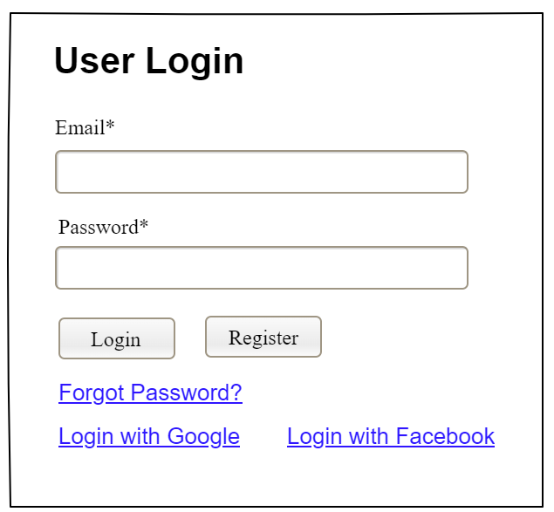

Field Name | Field Type | Description
Email* | Text Box | This is for user to input valid email address for logging in
Password* | Password Box | This is for user to input password for logging in
Login | Button | User clicks to authenticate him/herself into the system with provided email & password
Register | Button | User clicks to redirect to the User Register page for registering new user account to access the system
Forgot Password? | Hyperlink | User clicks to redirect to the Password Reset page for resetting his/her forgot password
Login with Google | Hyperlink | Allow user to login with his/her Google account
Login with Facebook | Hyperlink | Allow user to login with his/her Facebook account

Database Access
Table | CRUD | Description
User | R | Verify UserName & Password information
Setting, User | R | Specify the authorizations of the logged-in user

SQL Commands:
1/ Verify UserName & Password information
SELECT user_id, full_name, email, image_url, status
FROM user WHERE user_name = ? AND password = ?

2/ Specify the authorizations of the logged-in user
SELECT mapped_values FROM setting WHERE setting_id = ?
SELECT setting_name, mapped_values FROM setting WHERE setting_id IN (?)

b. Setting List

UI Design
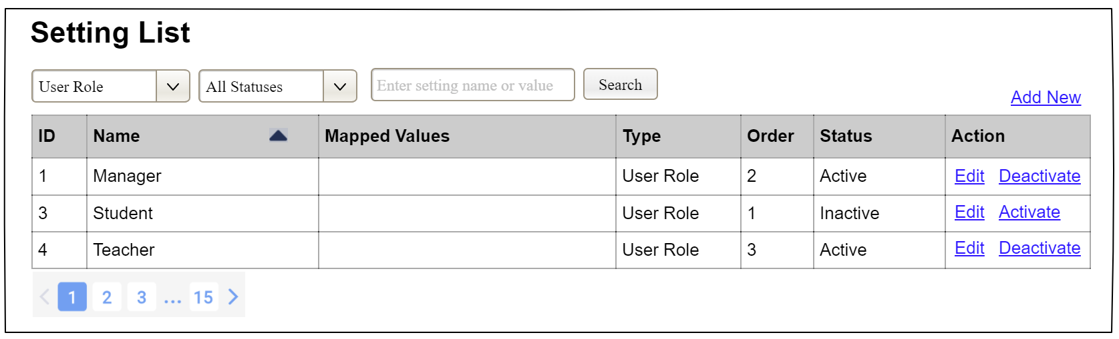

Field Name | Field Type | Description
Search Fields
Setting Type | Combo Box  Single-Choice | Filled with the list of current active setting types  Allow to filter the list by setting type;  Default value is “All Types”
Setting Status | Combo Box  Single-Choice | Values: All Statuses (default), Active, and Inactive  Allow to filter the list by status  Default value: “All Statuses”
Search Phase | Text Box  String (30) | Allow to search using the name or map values  Default value: blank
Search | Button | Click to refresh the list with the defined filter(s) and search phrase.
Add New | Hyperlink | Click to open the Setting Details page for adding new setting (master data)
Data Table
ID | Integer | Auto-increased identifier of the setting
Name | Text | Name of the setting
Mapped Values | Text | Supplementary information for the setting
Type | Text | Type of the setting
Order | Integer | Display order of the setting: the order of the setting type, displayed among the list of settings with the same type
Data Actions
Edit | icon | Click to open the Setting Details page for updating the relevant setting (master data)
Activate | icon | Shown when the data status is inactive. This is to activate the relevant setting (master data)
Deactivate | Ion | Shown when the data status is active. This is to deactivate the relevant setting (master data)

Database Access
Table | CRUD | Description
Setting | RU | Query the list of current settings from the database  Update status of a specific setting

SQL Commands:
1/ Query the list of current settings from the database
SELECT setting_id, setting_name, mapped_values, type_id, display_order, status
FROM setting WHERE (setting_type = ?) AND (status = ?) AND (setting_name LIKE ?)

2/ Update status of a specific setting
UPDATE setting SET status = ? WHERE setting_id = ?

c. Setting Details

UI Design
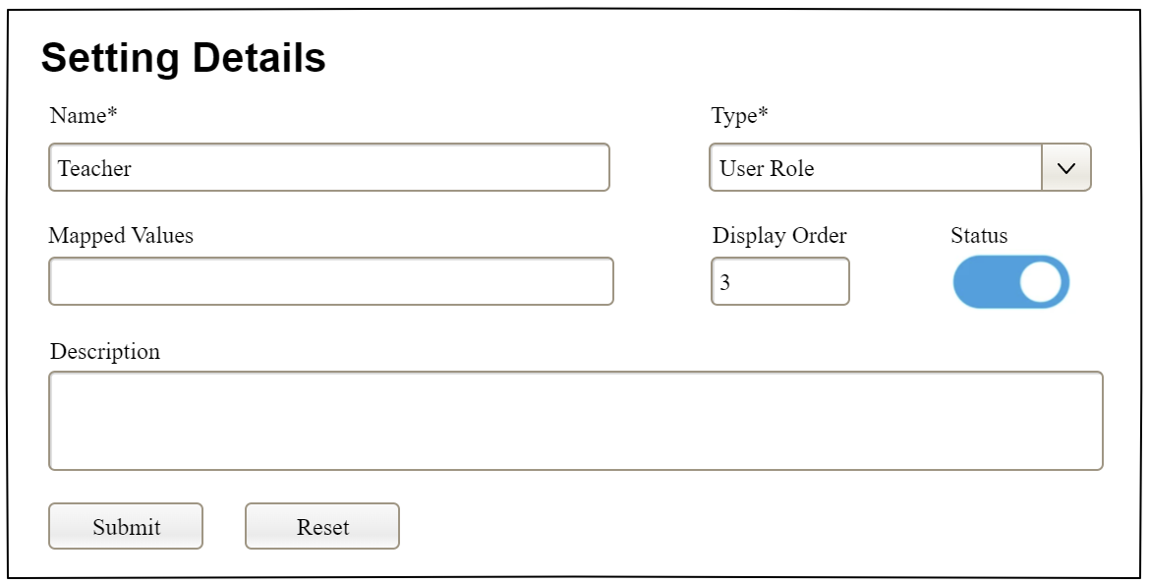

Field Name | Field Type | Description
Name* | Text Box  String (20) | Name of the setting
Type* | Combo Box  (Single Choice) | Type of the setting, filled with the list of setting types  Default value: the first type in the list
Mapped Values | Text Box  String (50) | Supplementary information for the setting (if any)
Order | Text Box  Integer (>=0) | Display order of the setting: the order of the setting type, displayed among the list of settings with the same type
Status | On/Off button | Status of the setting: Active or Inactive  Default value: Active
Description | Text Area  String (200) | Description of the setting
Submit | Button | Click to store new or updated setting details
Reset | Button | Click to reset the changes use has made on the screen fields back to the initial values when the screen is loaded

Database Access
…

IV. Appendix

1. Assumptions & Dependencies
[Record any assumptions that were made when conceiving the project and writing this vision and scope document. Note any major dependencies the project must rely upon for success, such as specific technologies, third-party vendors, development partners, or other business relationships.]
<<Sample:
AS-1: Systems with appropriate user interfaces will be available for cafeteria employees to process the expected volume of meals ordered.
AS-2: Cafeteria staff and vehicles will be available to deliver all meals for specified delivery time slots within 15 minutes of the requested delivery time.
DE-1: If a restaurant has its own on-line ordering system, the Cafeteria Ordering System must be able to communicate with it bi-directionally.
>>

2. Limitations & Exclusions
[Identify any product features or characteristics that a stakeholder might anticipate, but which are not planned to be included in the new product]

3. Business Rules
[Provide common business rules that you must follow. The information can be provided in the table format as the sample below]
<<Sample
ID | Category | Rule Definition
BR-01 | Constraints | Delivery time windows are 15 minutes, beginning on each quarter hour.
BR-02 | Constraints | Deliveries must be completed between 10:00 A.M. and 2:00 P.M. local time, inclusive.
BR-03 | Facts | All meals in a single order must be delivered to the same location.
BR-04 | Facts | All meals in a single order must be paid for by using the same payment method.
BR-11 | Constraints | If an order is to be delivered, the patron must pay by payroll deduction.
BR-12 | Computations | Order price is calculated as the sum of each food item price times the quantity of that food item ordered, plus applicable sales tax, plus a delivery charge if a meal is delivered outside the free delivery zone.
>>

4. ..

