docker --version

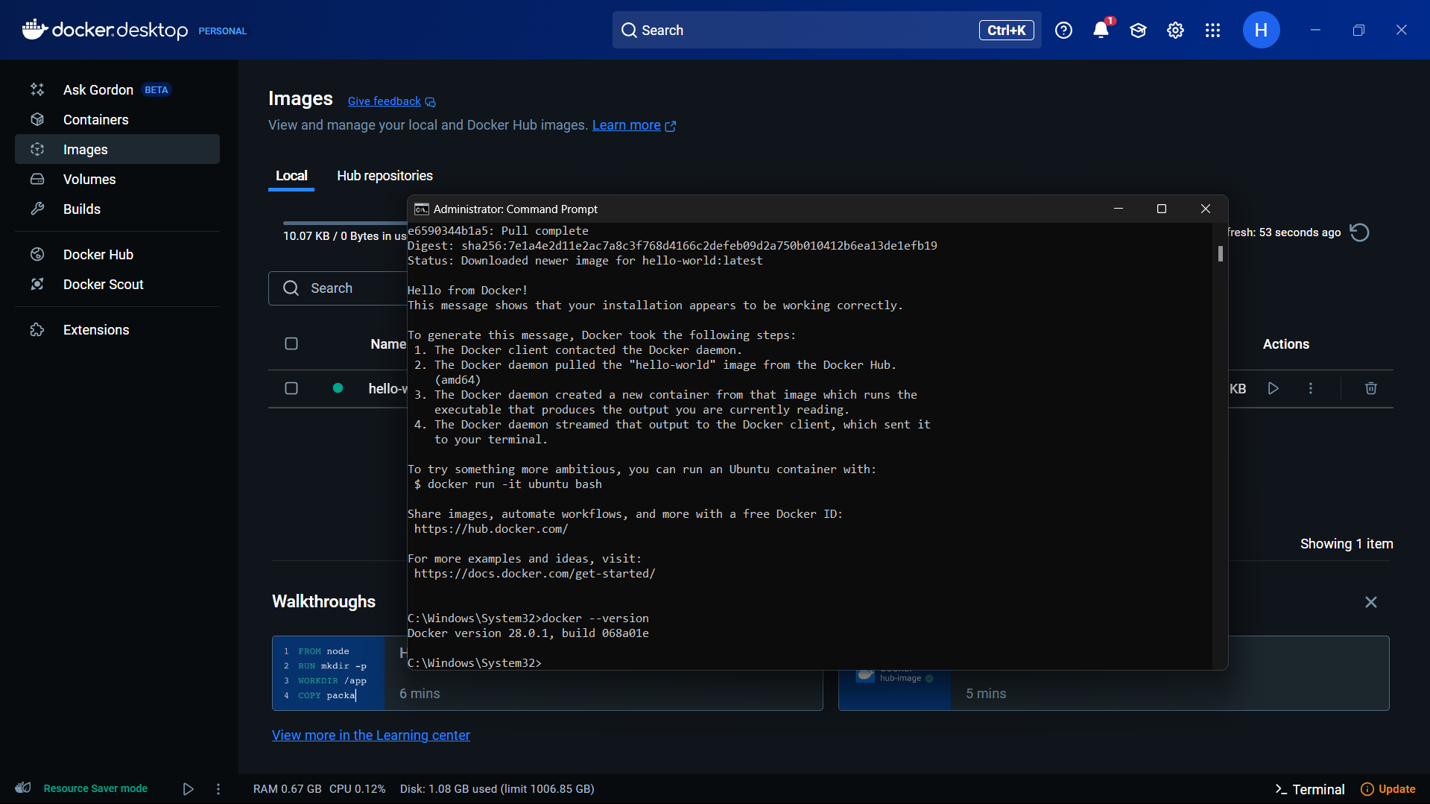

docker run hello-world

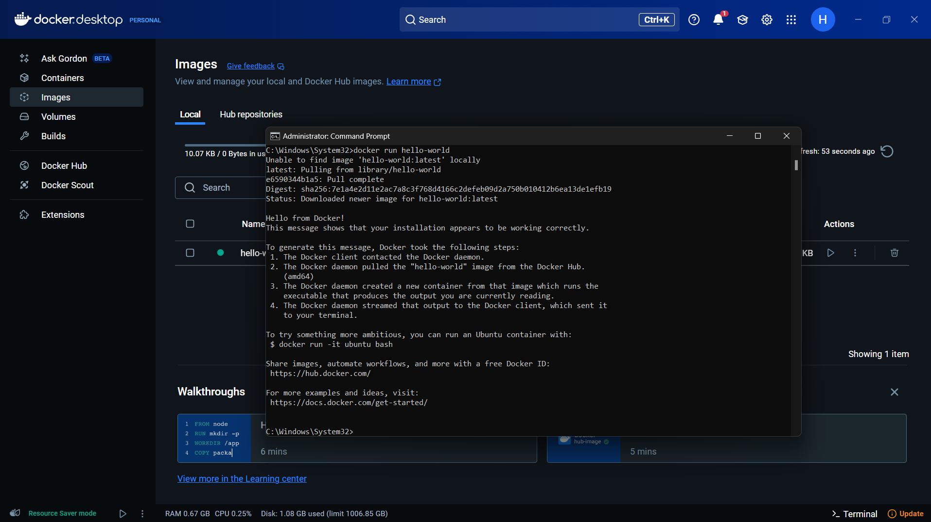

Docker pull nginx

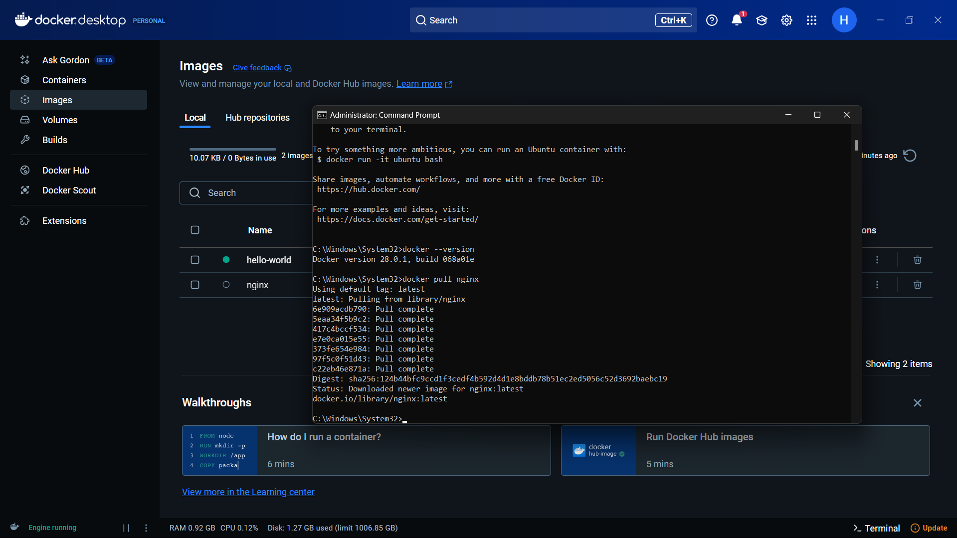

docker images

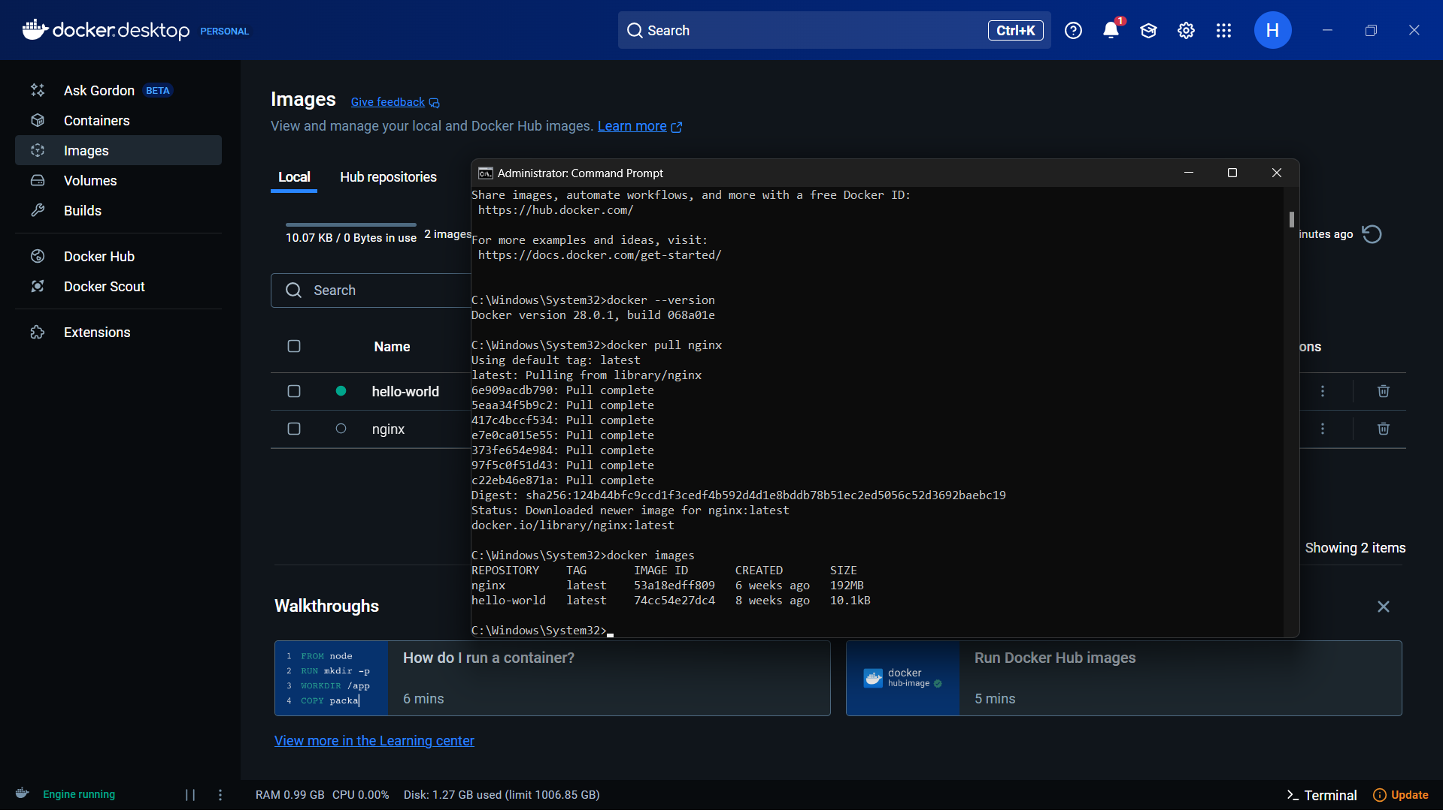

docker run -d nginx

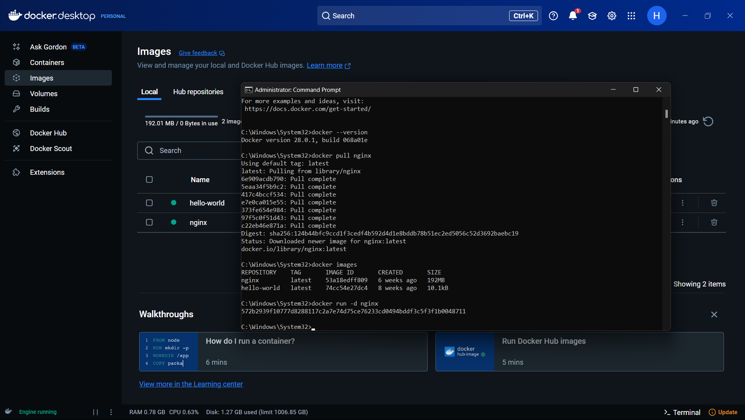

docker ps

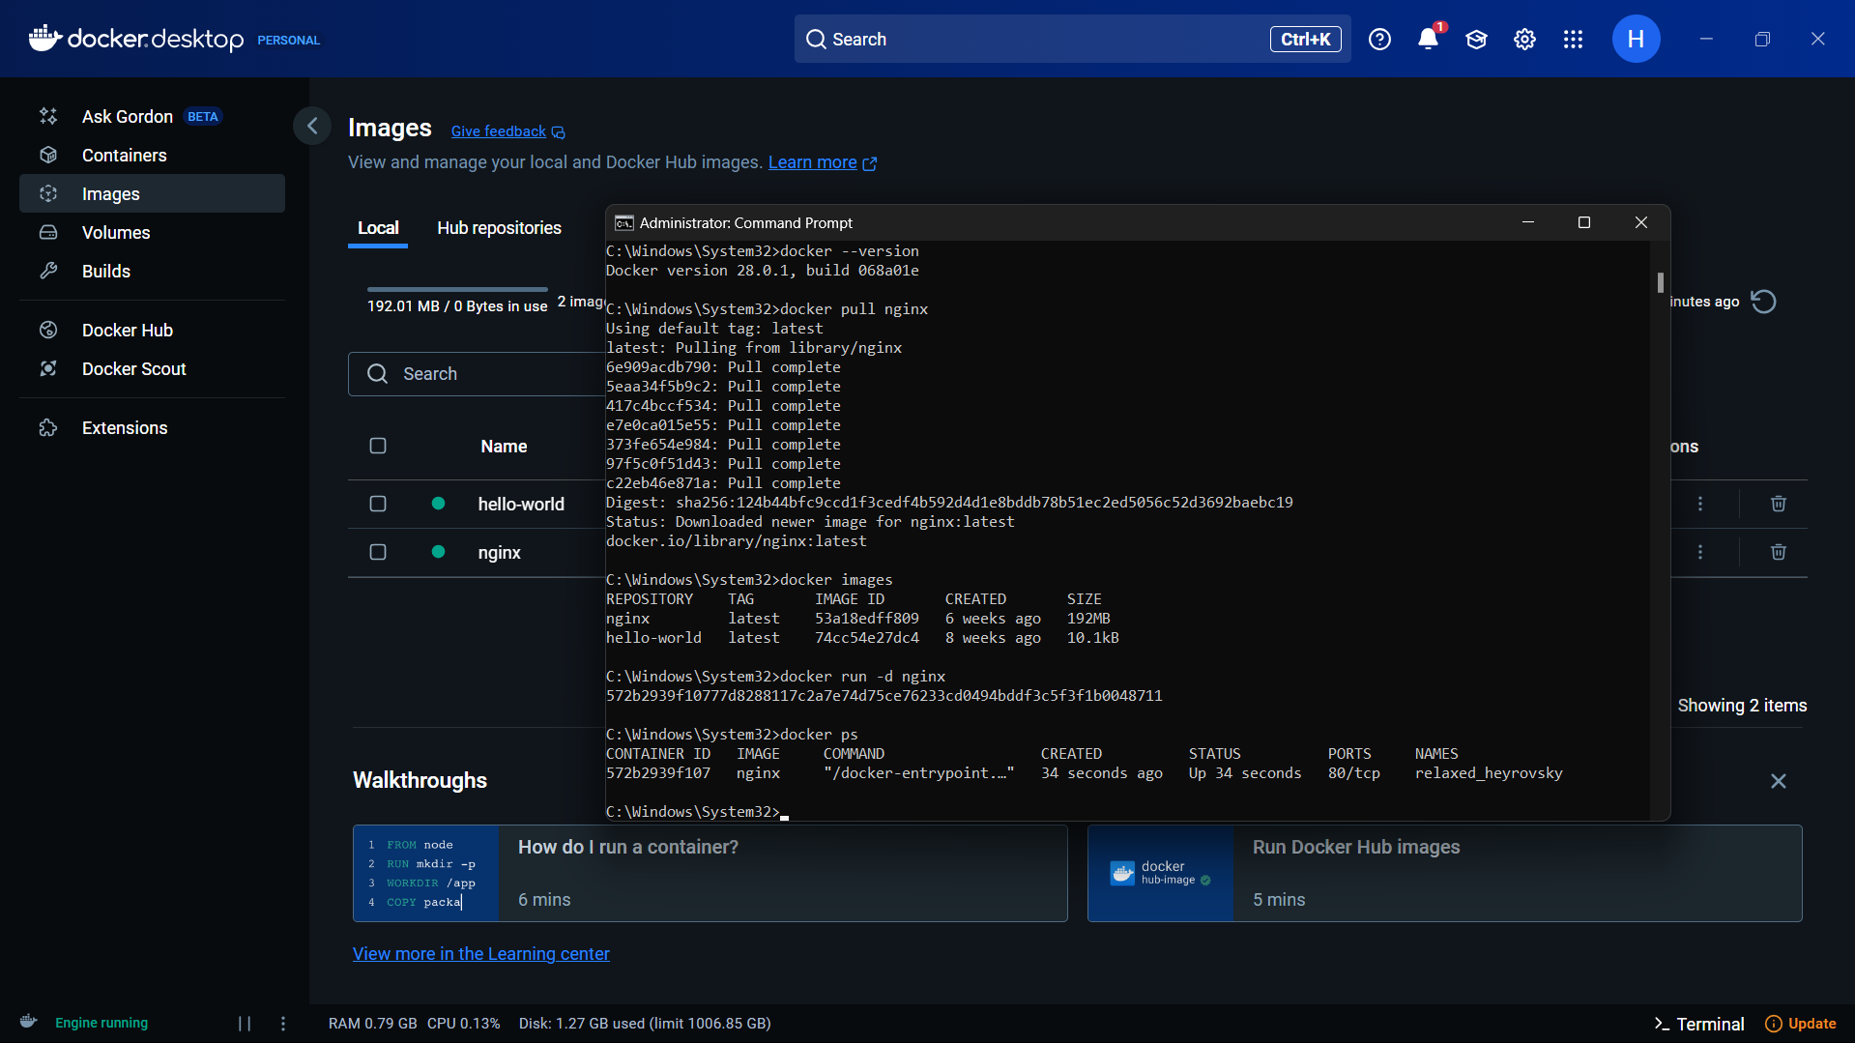

docker ps -a

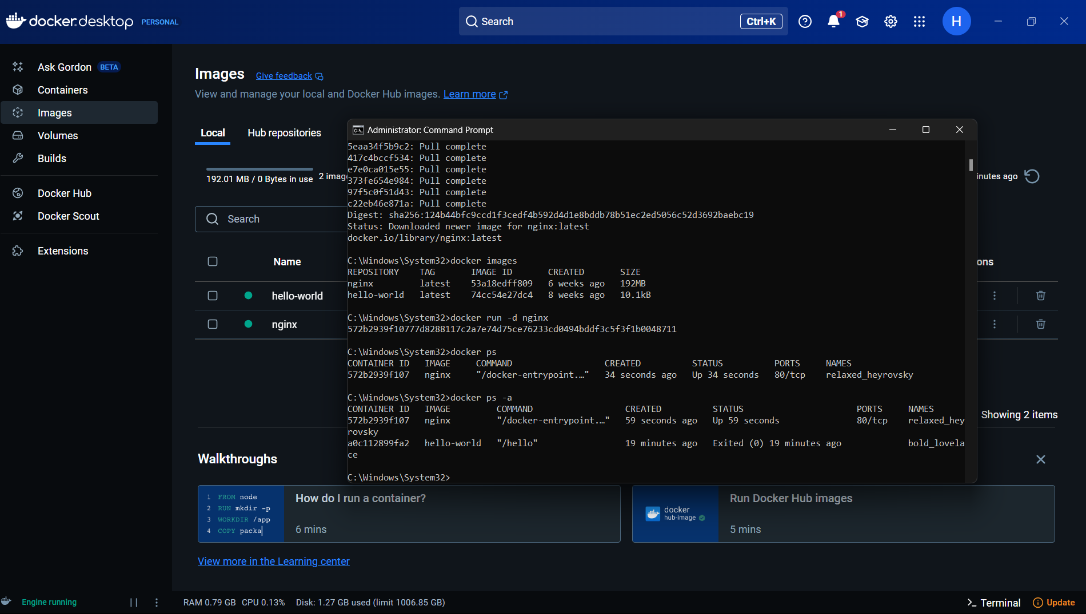

docker logs <container_id>

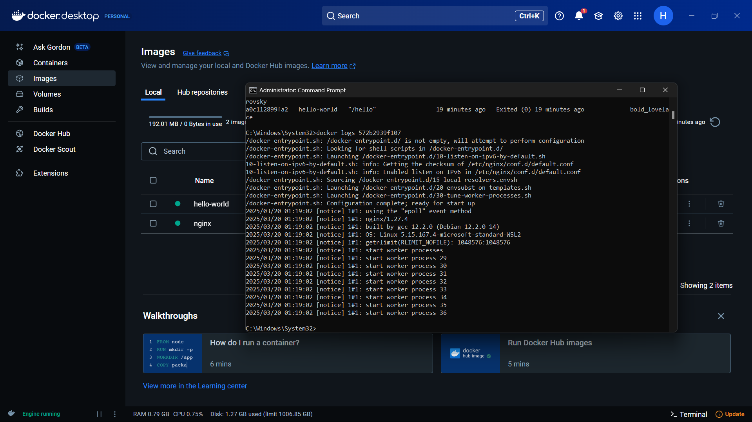

docker exec -it <container_id> /bin/sh

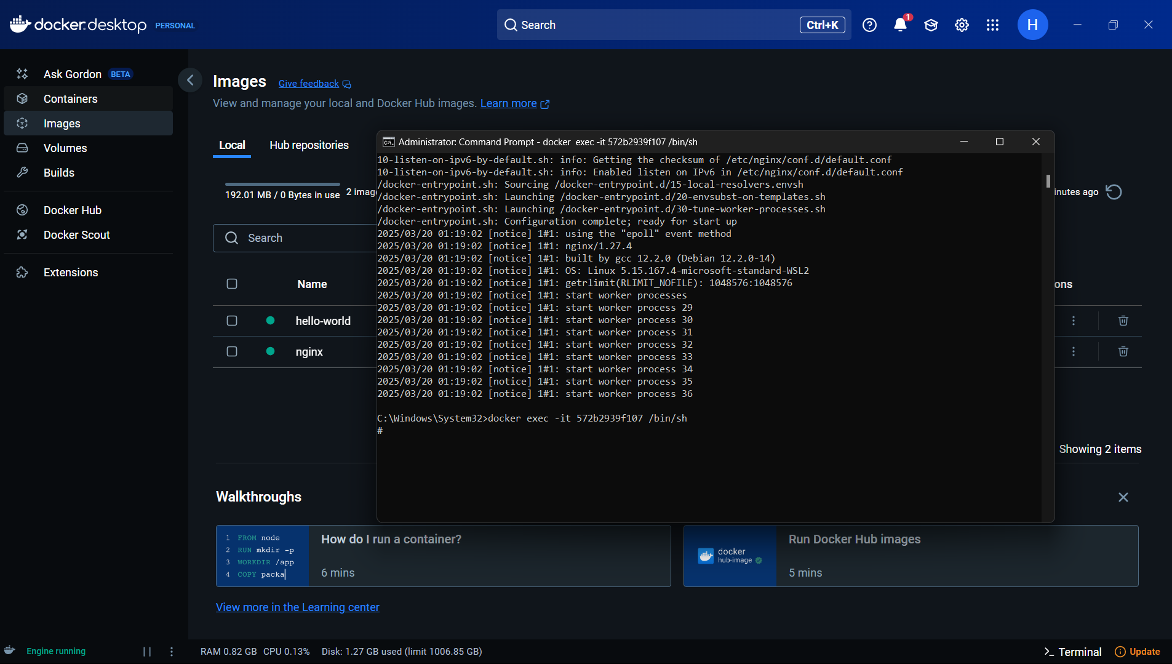

docker stop <container_id>

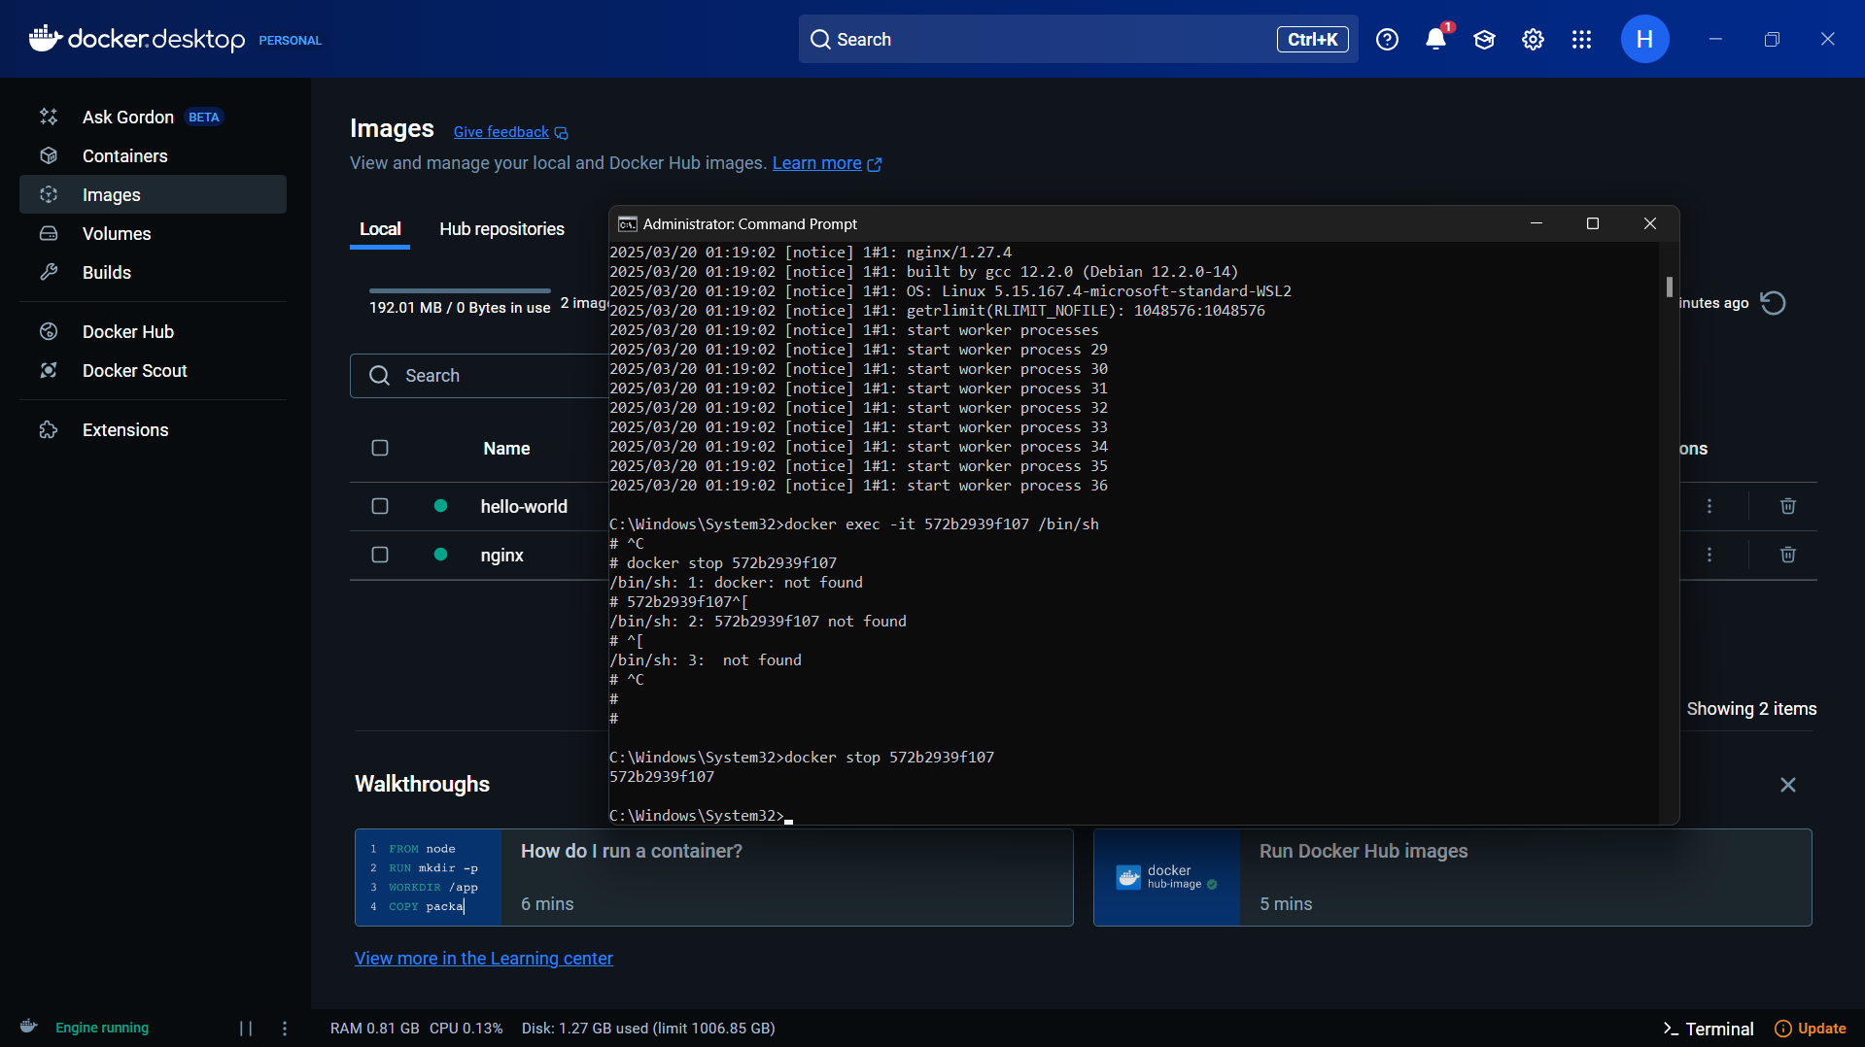

docker restart <container_id>

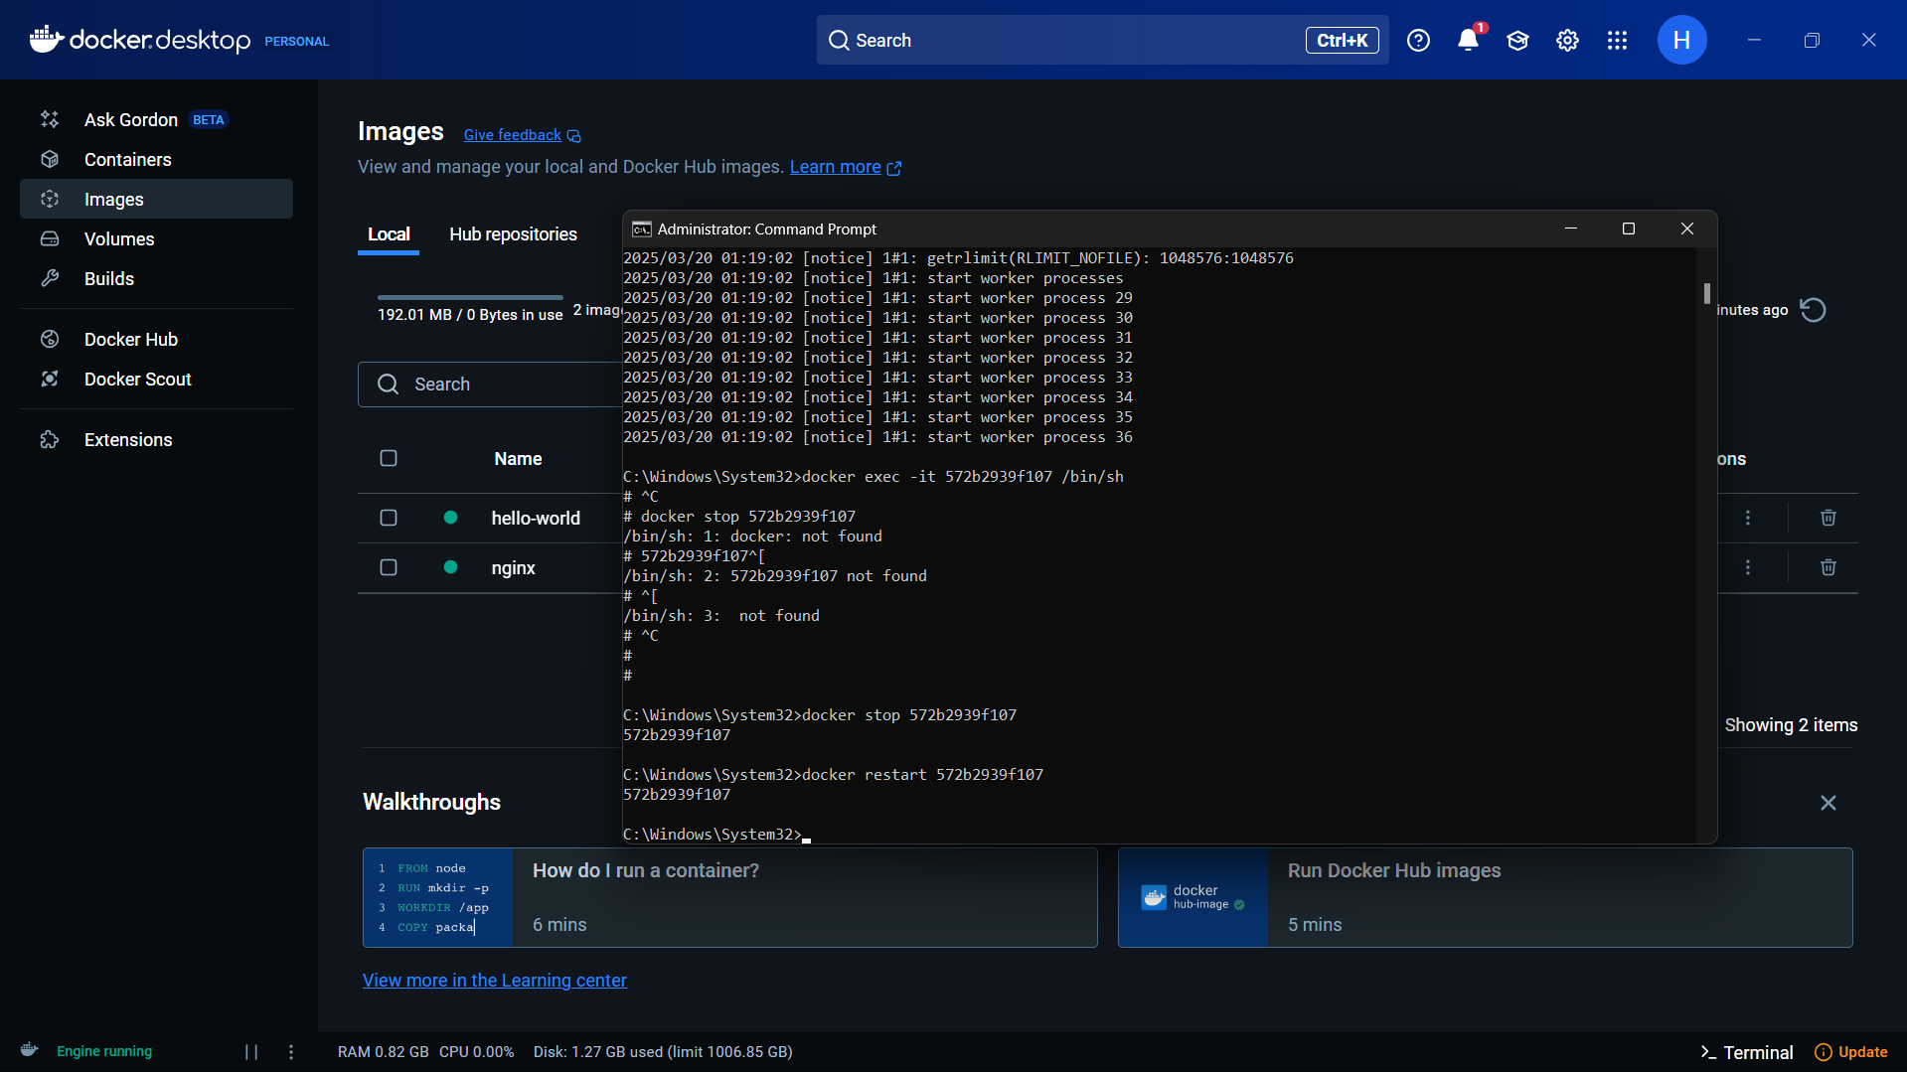

docker rm <container_id>

docker container prune

docker rmi <image_id>

docker image prune -a

docker run -d -p 8080:80 nginx

docker inspect <container_id>

docker run -d -v mydata:/data nginx

docker volume ls

docker volume prune

docker run -d --name my_nginx nginx

docker stats

docker network ls

docker network create my_network

docker run -d --network my_network --name my_container nginx

docker network connect my_network my_nginx

docker run -d -e MY_ENV=hello_world nginx

docker logs -f my_nginx

FROM nginx

COPY index.html /usr/share/nginx/html/index.html

docker build -t my_nginx_image .

docker run -d -p 8080:80 my_nginx_image