Trần Hữu Phúc – 21003025

//JavaScript Fundamentals – Part 1

//Coding Challenge #1

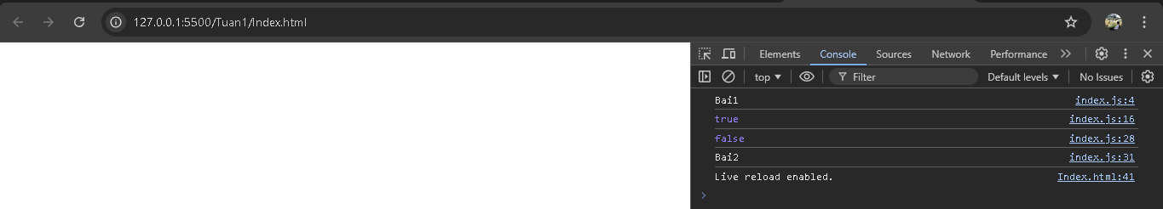

//Coding Challenge #2