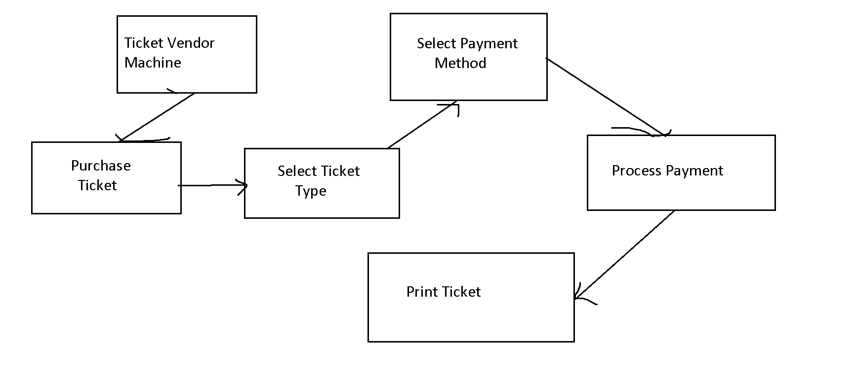

In this Use Case diagram, there is one actor, which is the user who wants to purchase a ticket from the machine. The machine offers one use case, which is "Purchase Ticket". This use case has several steps:

* Select Ticket Type: The user selects the type of ticket they want to purchase, such as a one-way ticket or a round-trip ticket.
* Select Payment Method: The user selects the payment method they want to use, such as cash or credit card.
* Process Payment: The machine processes the payment according to the selected payment method.
* Print Ticket: The machine prints the purchased ticket.

Overall, this Use Case diagram represents the basic functionality of a Ticket Vendor Machine.