Hardhome

videogame design document

# Index

Contents

Index 1

Title 1

Credits 1

Approval 1

Space and story 2

Main Story 2

Playable Characters……………………………………………………………………………………………………………………………….2

Non-Playable Characters……………………………………………………………………………………………………………………….3

# Title

Hardhome

# Credits

Hugo Oswaldo García Pérez        A00815354

Rubén Alejandro López Charles    A00819291

José Antonio Alemán Salazar        A01196565

Eduardo de la Garza A001380293

# Approval

The Project idea has been presented and approved by September 2017.

# Space and Story

## Main Story

Humanity has been conquered many decades ago by superior entities known as the Enlightened. What is left of humanity lives inside the walls of a city that both protect them from the monsters outside them, whose origins are unknown, and keep them controlled. The main character, Kos, discovers the truth that there is civilization outside those walls and embarks into an adventure to find the rest of the humanity that lives undercover known as The Wings of Liberty, a rebel organization led by The Order that seeks to regain the freedom stolen in the world’s conquest.

## Playable characters

Kos, a young man that gets involved into a series of events that led him to awake a deep hate for the Enlightened and to seek the truth. He is just an average man.

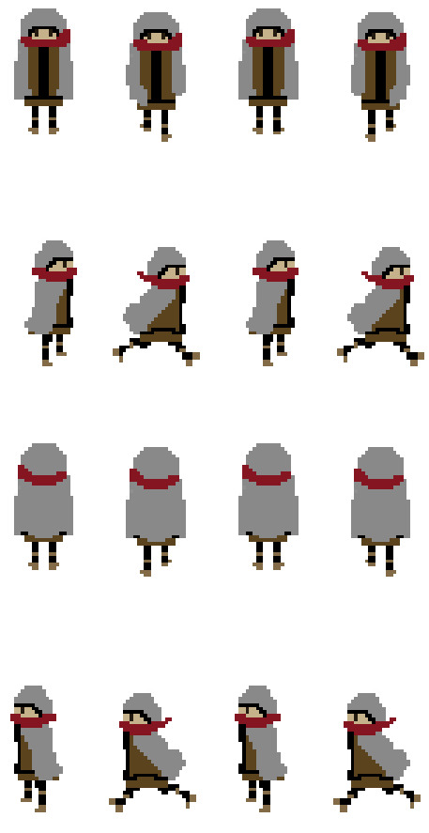

## Non-Playable characters

The Enlightened, superior entities unknown in the most part for the humans. The only things known is that they demand humans at will and random, that they possess a big quantity of eyes, superior physical strength and knowledge. It is said that they are “transcended” entities.

The Order Knights, members of an elite group that leads The Wings of Liberty. They protect humanity from whatever endangers it. They have a set of distinctive armor and weapons.

