

**Elementary Programming with C**

| **Semester:** 1 |  | **Curriculum Code:** 7023 |
| --- | --- | --- |
|  |  |  |
| **Duration:** 90 minutes |  | **Total Marks:** 20 |



Practical Examination Paper

**Question 01:** Write a program that does the following steps: (**12 points**)

* Display your student number and full name on the screen (**4 points**)
* Input an integer n, that has 2 digits from keyboard (does not need to check input). Calculate sum of all even number q (0 < q <=  )
* **Example: if n=25 then sum(q) = 2 + 4 + 6 + 8 + 10 + 12 = 42**
* Display all integer k (0<k<n), that has double digits (**4 points**)

**Example: if n=25 then list k: 11, 22**

* Accept another integer 0<m<n with checked input (**2 points**)
* List all common divisors of m and n (**1 point**)
* Calculate T = 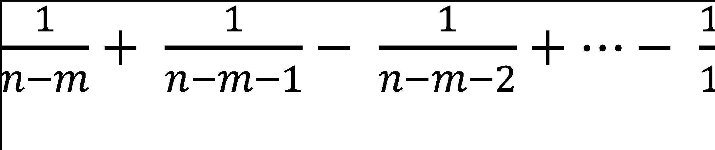 (**1 point**)

| **Example output** |
| --- |
| **0121001, Nguyen Van An**  **Enter n: 25**  **Sum(q) = 42**  **List k: 11, 22**  **Enter m: a**  **Incorrect input!**  **Enter m: 2a**  **Trailing character!**  **Enter m: 39**  **Out of range!**  **Enter m: 24**  **List common divisor = 1**  **T = -0.653211** |

**Question 02:** Implement functions with the following prototypes: (**12 points**)

**void fun1(int n);**

If 0<= n <= 9, function reads the number n, otherwise do nothing (**4 points**)

**Example: n = 0 – print: zero, n = 1 – print: one, n = 2 – print: two…**

**void fun2(int n);**

If n <100 function reads the number n. Otherwise do nothing. (**4 points**)

**Example: n = 9 – print: nine, n=15 – print: fifteen, n = 25 – print: twenty five**

Test your functions with the following main()

| **int main()**  **{**  **printf(“Test fun1\n”);**  **printf(“\nfun1(-1): ”, fun1(-1));**  **printf(“\nfun1(10): ”, fun1(10));**  **printf(“\nfun1(1): ”, fun1(1));**  **printf(“\n\nTest fun2\n”);**  **printf(“\nfun2(9): ”, fun2(9));**  **printf(“\nfun2(10): ”, fun2(10));**  **printf(“\nfun2(15): ”, fun2(15));**  **printf(“\nfun2(25): ”, fun2(25));**  **getch();**  **}** |
| --- |

| **Example output** |
| --- |
| **Test fun1**  **fun1(-1):**  **fun1(10):**  **fun1(1): one**  **Test fun2**  **fun2(9): nine**  **fun2(10): ten**  **fun2(15): fifteen**  **fun2(25): twenty five** |