Examination

QUESTION PAPER

Curriculum: ACCP202xxx
Subject: IASF

Duration: 90 minutes
Total Marks: 20

MODULE TEST PRACTICAL

Welcome to the Exam Attendant Application project. In this project, you will use your skills and knowledge to develop a web-based application by using Spring framework that allows users to create, manage, take, and grade online exams. You will use a predefined database that contains some basic tables for storing and retrieving exam data. You will also implement some functionalities that meet the project requirements.

The predefined database that you will use for this project has the following tables:

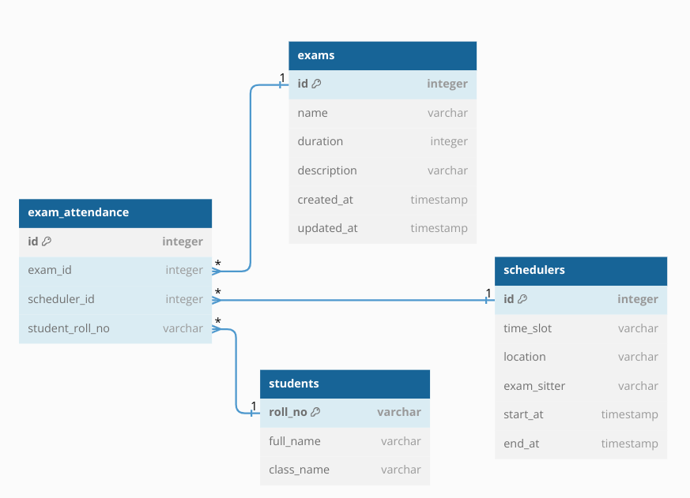

[2p]Home page:
On the home page of the exam application system. Here you can see an image that shows a sample exam question and answer. You can also access two other links from this page:
- If you want to view the existing exams that you can take or review, click on the View Exams link. This will take you to the exam list page, where you can see the details and status of each exam.


List All Exams:
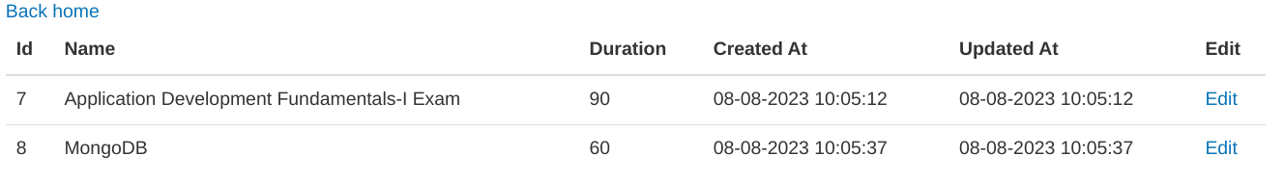
On the All exam page of the exam application system. Here you can see and manage all the exams that you have created or taken. You can also do the following actions from this page:
- [4.5p]View the details of each exam, such as the Id, Name, Duration, Description, Created At and Updated At. You can also see when each exam was created and updated, in the format of dd-MM-yyyy hh:mm:ss.
- [0.5p]Return to the home page of the system by clicking on the Back home link at the top of the page. This will take you back to the main page where you can access other features and functions of the system.
- [3.5p]Edit link: This link will take you to a page where you display Exam information, such as Name, Duration, Description and you can modify the details and content of the exam that you have selected. You can change the Name, Duration, Description of the exam.

Edit exam:
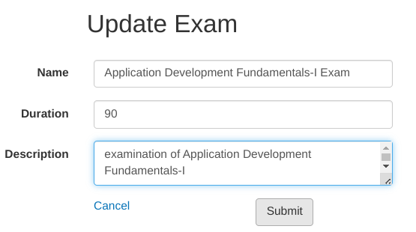
On the Edit Exam page of the exam application system. Here you can update or modify the selected exam with your own information. You need to fill in the following fields:
- [3p]All textboxes are mandatory and cannot be empty. If you leave it blank, you will see an error message next to it. You also need to keep the inputted values while displaying error messages.
- [1p]Duration: The time limit for taking your exam, in minutes. This field is mandatory and cannot be empty. If you leave it blank, you will see an error message next to it. Please enter a positive number for your exam duration.
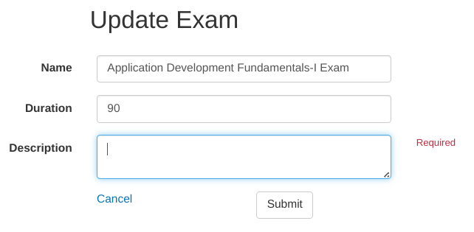
After filling in the fields, you can click on one of the following buttons:
- [0.5p]Cancel: This button will cancel your exam creation and take you back to the All Exam page, where you can see and manage all the exams that you have created or taken.
- [5p]Submit: This button will save the information that you have entered for your exam into the exams table in the database. In addition to the columns such as name, duration, and description, you also need to set the current time as the value for the updated_at column. This will indicate when your exam was last modified.

