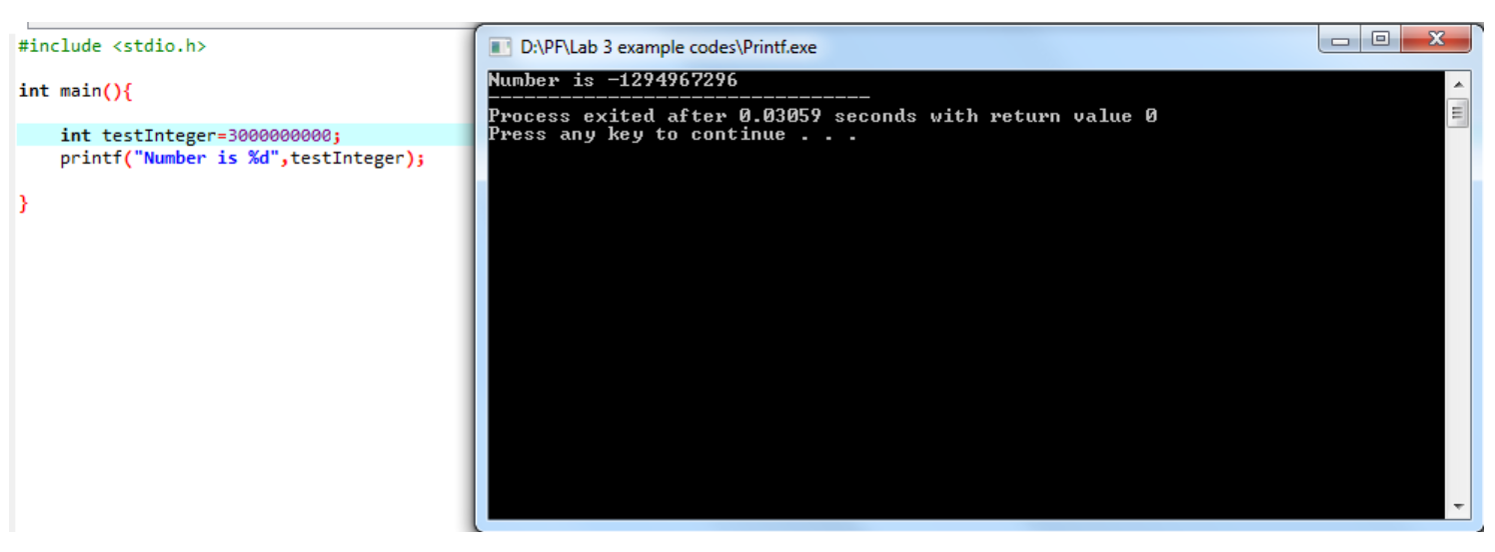

3000000000 is a very large number that cannot be represented in 32 bit and thus an overflow error occurs.