PRACTICAL EXAM – SWD392 – SPR26
Student ID: | [StudentID] | Date / Time: | [dd/mm/yyyy – hh:mm]
Exam Code: | SWD392_PE_SPR26 | Architecture: | Layered Architecture

Question 1: Class Diagram (3.0 points)
Your Class Diagram:
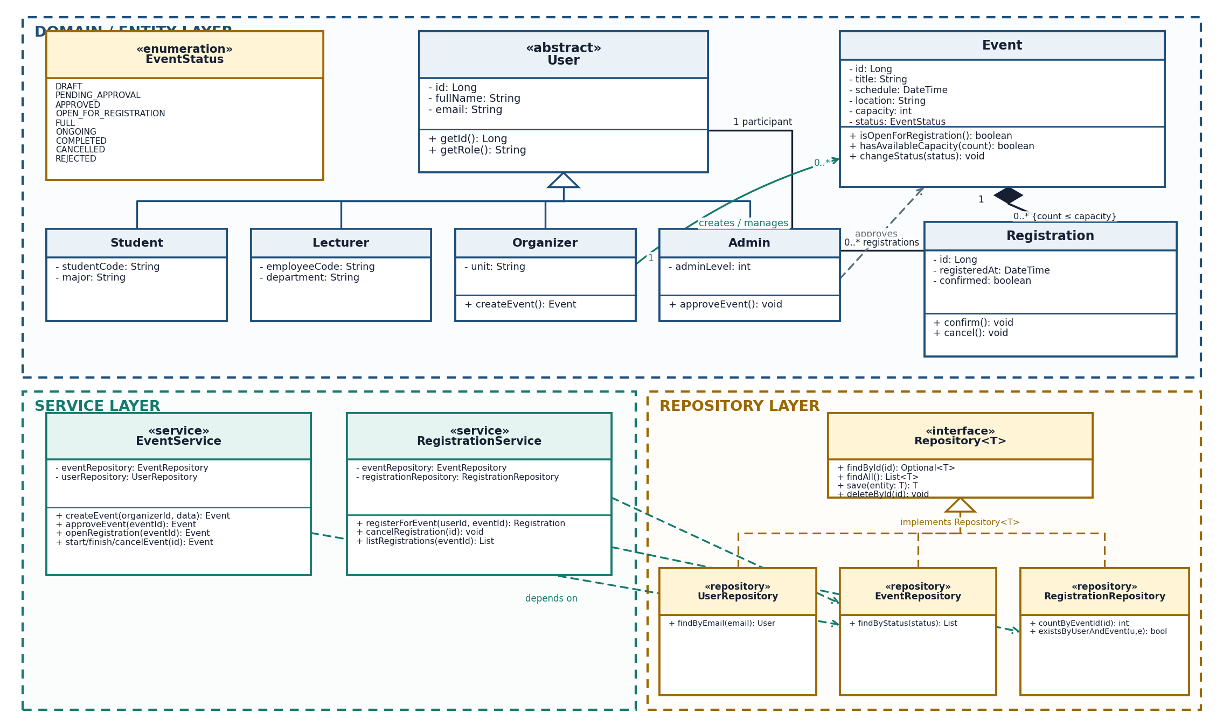
Brief Explanation: The model follows Layered Architecture. User is an abstract base class specialized by Student, Lecturer, Organizer, and Admin. Each Registration links exactly one participant to one Event, while Event composition owns its registrations and enforces count ≤ capacity. EventStatus defines the event lifecycle. EventService and RegistrationService contain business rules; repository classes implement the generic Repository<T> interface, and service dependencies point only to repositories.

Question 2: Sequence Diagram – Register for Event (4.0 points)
Your Diagram (Sequence Diagram):
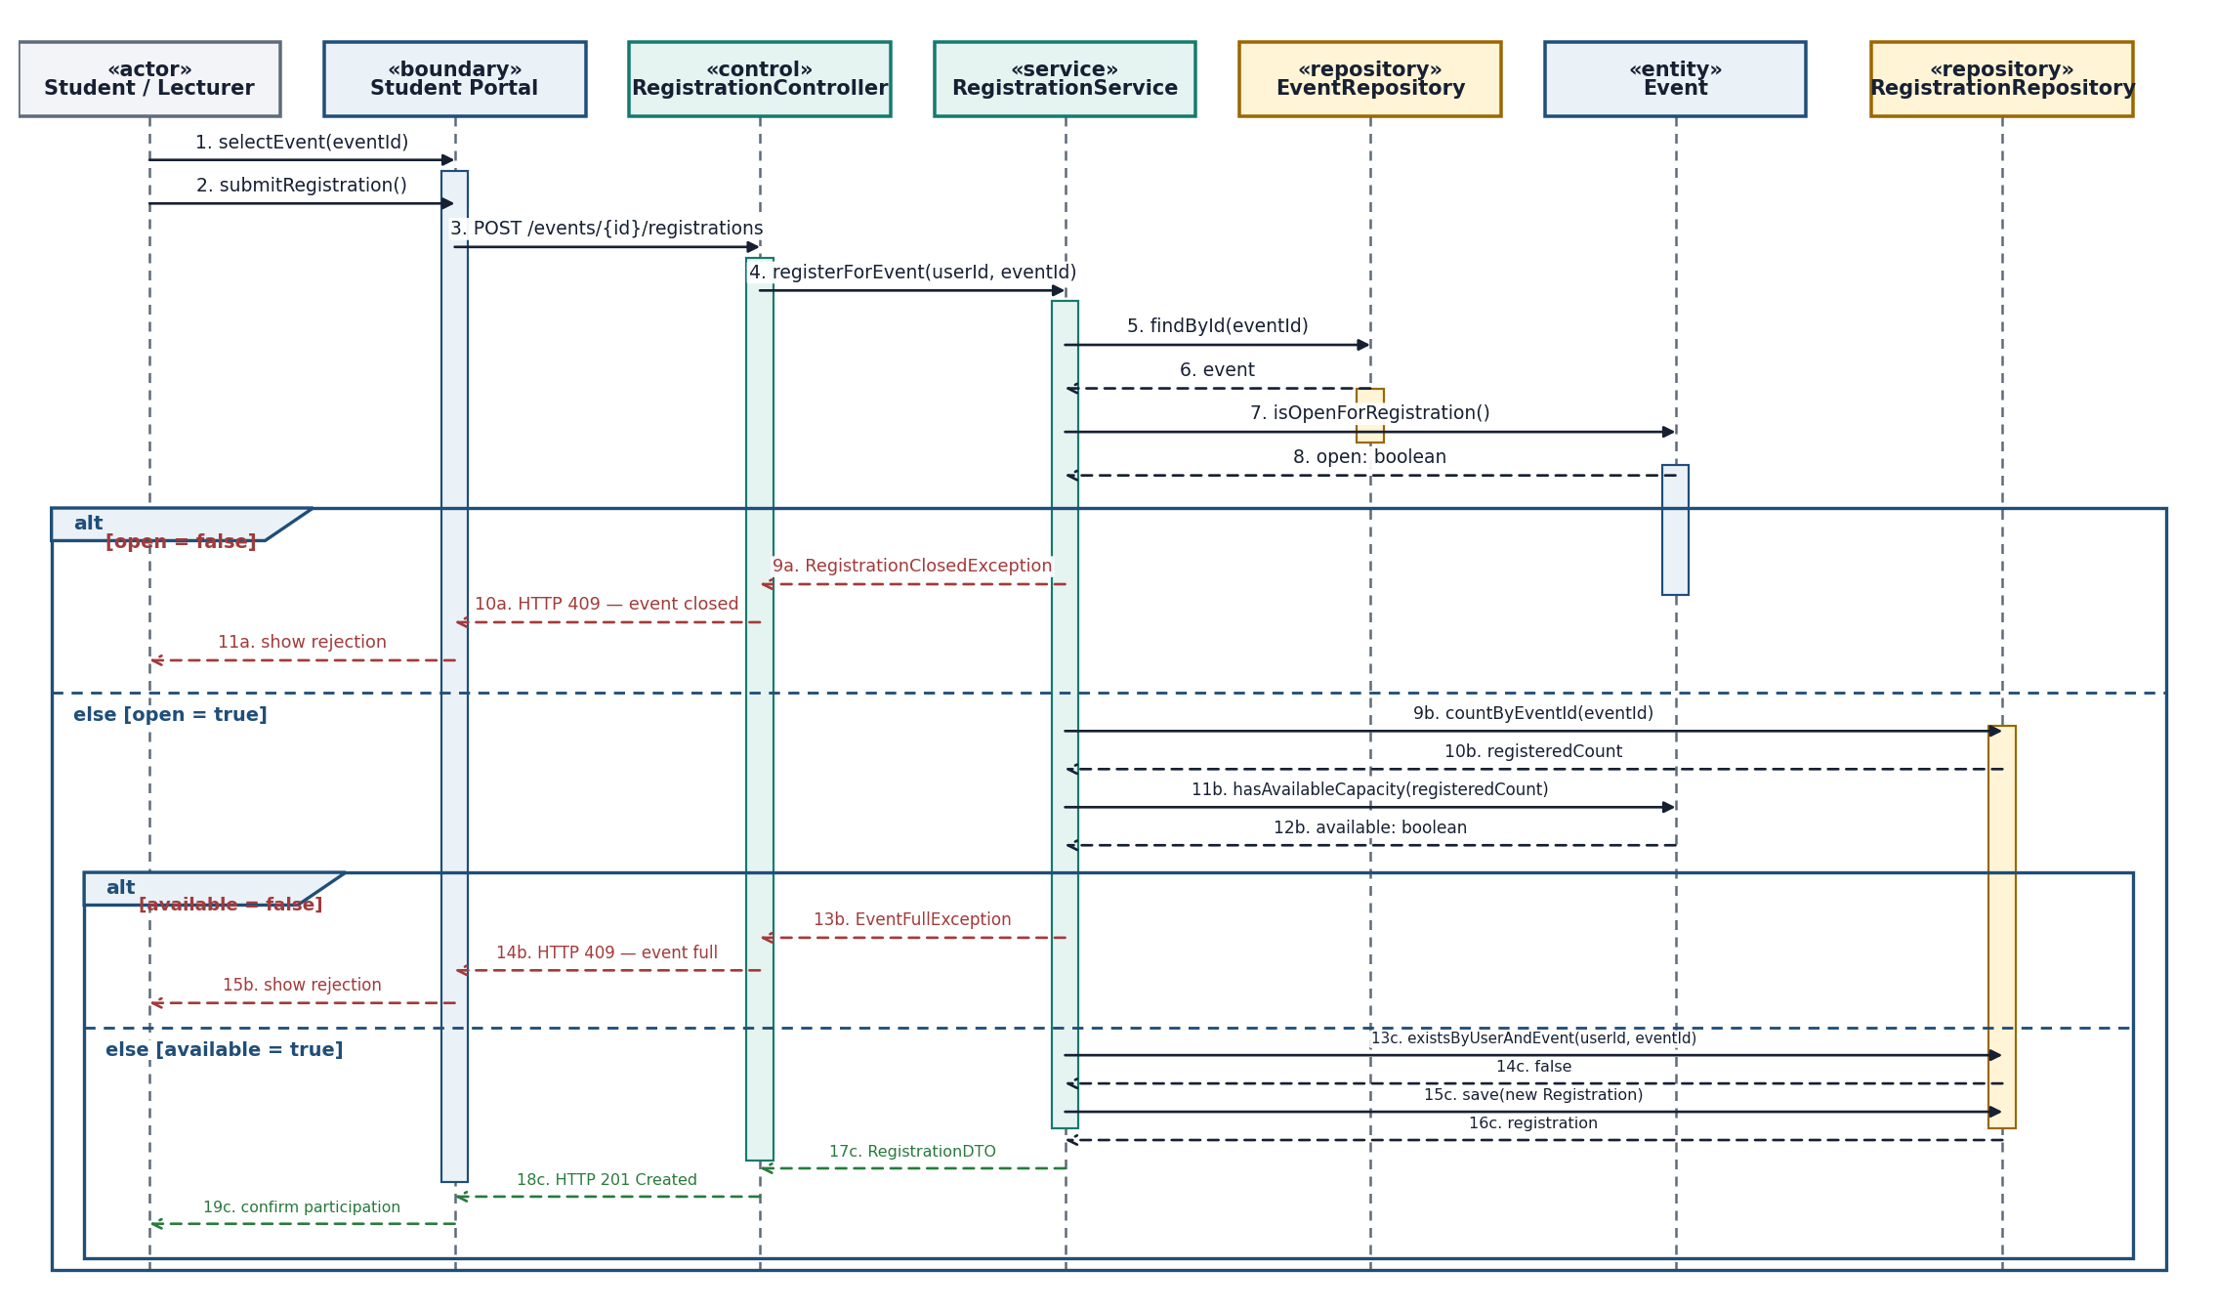
Brief Explanation: A student or lecturer submits the request through the Student Portal and RegistrationController. RegistrationService retrieves the Event through EventRepository, asks the domain entity whether registration is open and capacity remains, and saves a Registration through RegistrationRepository. The outer alt fragment rejects a closed event; the nested alt fragment rejects a full event. Only the successful branch persists the registration and returns HTTP 201 with confirmation.

Question 3: State-chart Diagram – Event Lifecycle (3.0 points)
Your Diagram (Statechart Diagram):
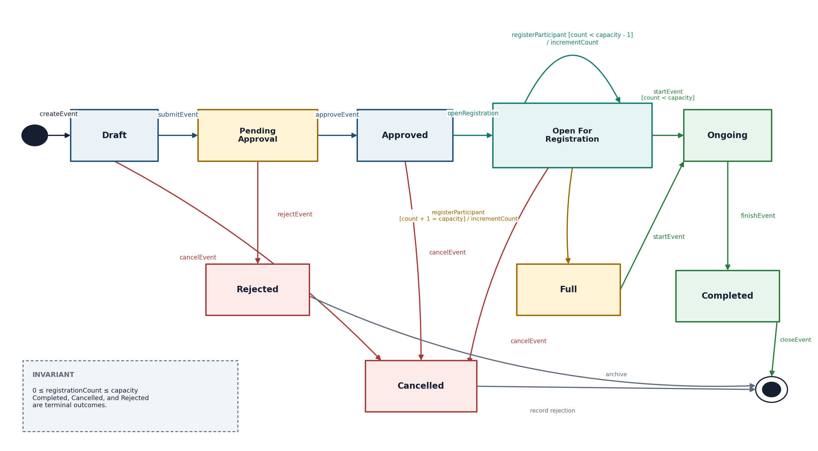
Brief Explanation: The lifecycle begins at Draft. submitEvent sends the event to Pending Approval; approveEvent enables Open For Registration. registerParticipant either keeps the event open or moves it to Full when the capacity guard is met. startEvent, finishEvent, rejectEvent, and cancelEvent create the required normal and alternative paths. Completed, Cancelled, and Rejected are terminal outcomes, and the invariant prevents registrations from exceeding capacity.
END OF SUBMISSION

