1) Target Candidate Retrieval and Target Disambiguation
This diagram shows the flow from the raw user request to either:
- automatic target selection
- or asking the user to choose when multiple targets are plausible
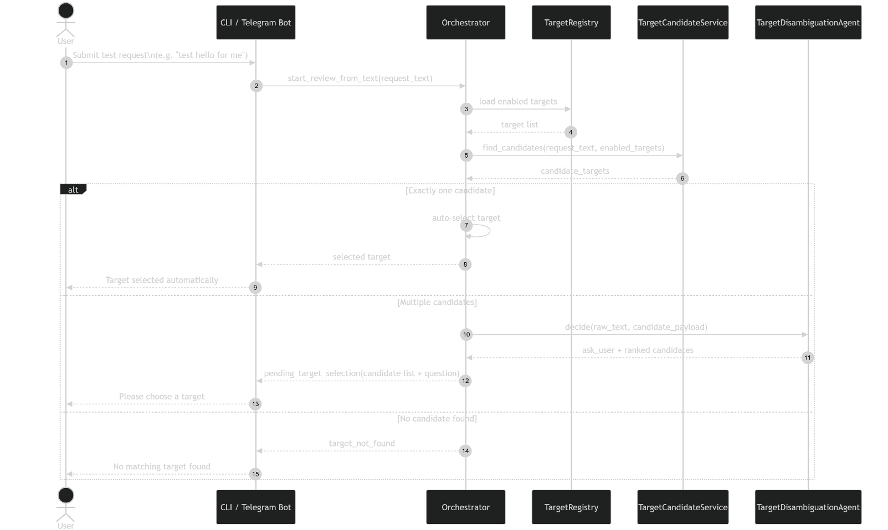

2) Target Selection Continuation After User Choice
This diagram covers the branch where the user must explicitly choose a target from multiple candidates.
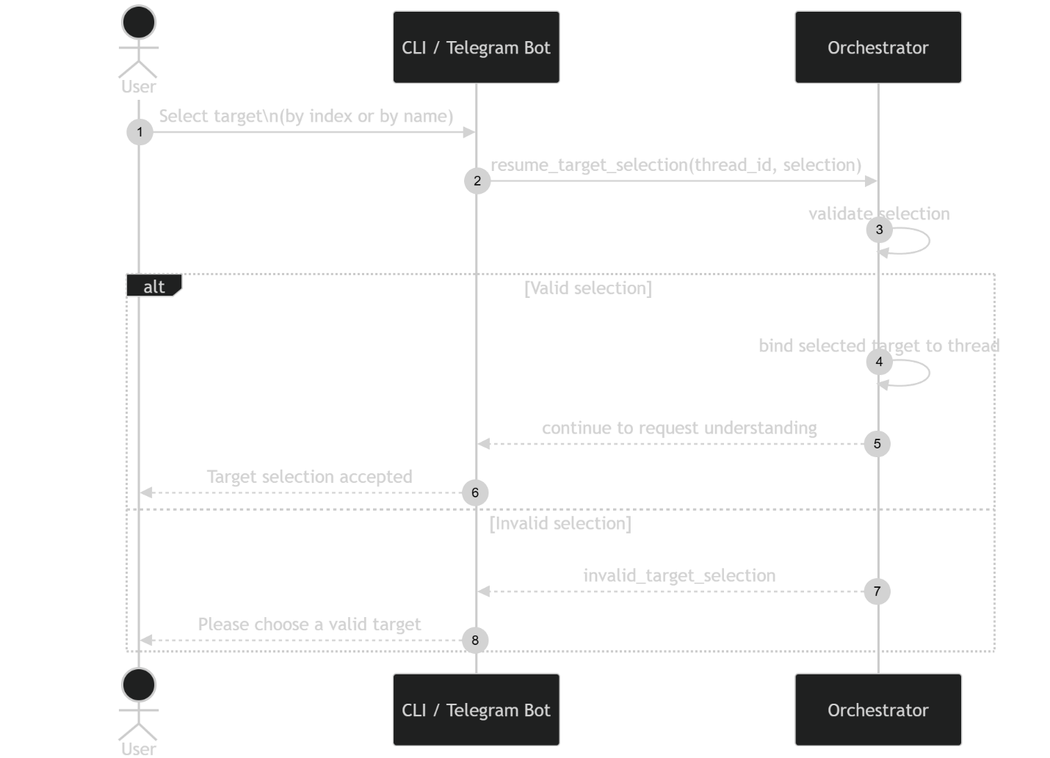

3) Request Understanding and Scope Resolution — Specific Function
This diagram shows the case where the target is known and the user explicitly requests a valid function.
Example:
- “test the image generation function of hello_world”
- “test /posts GET on cms_local”
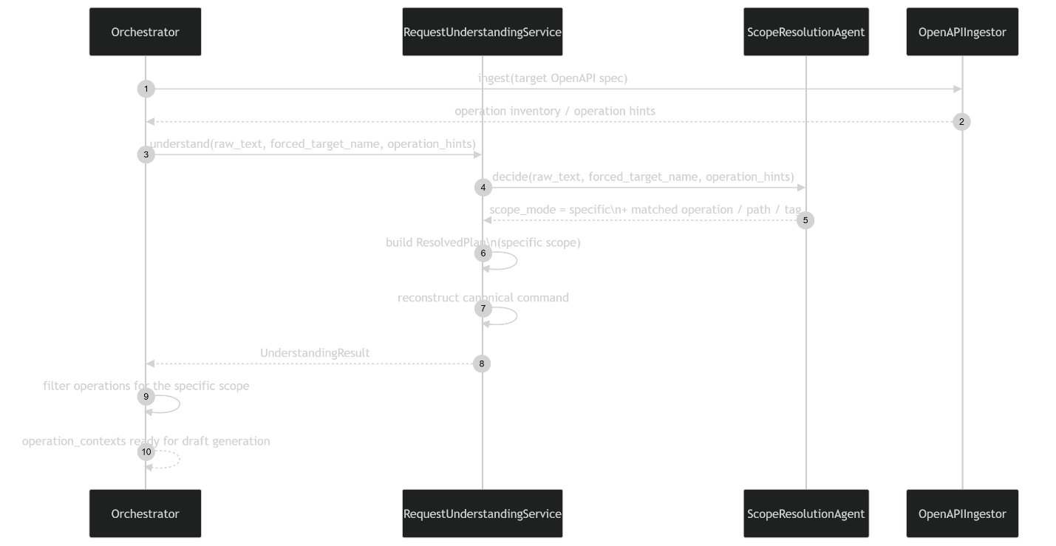

4) Request Understanding and Scope Resolution — All Functions in Target
This is the critical behavior when the user does not specify a concrete function.
Example:
- “test hello for me”
- “test target hello_world”
Expected meaning:
- test the whole target
- do not arbitrarily pick one endpoint
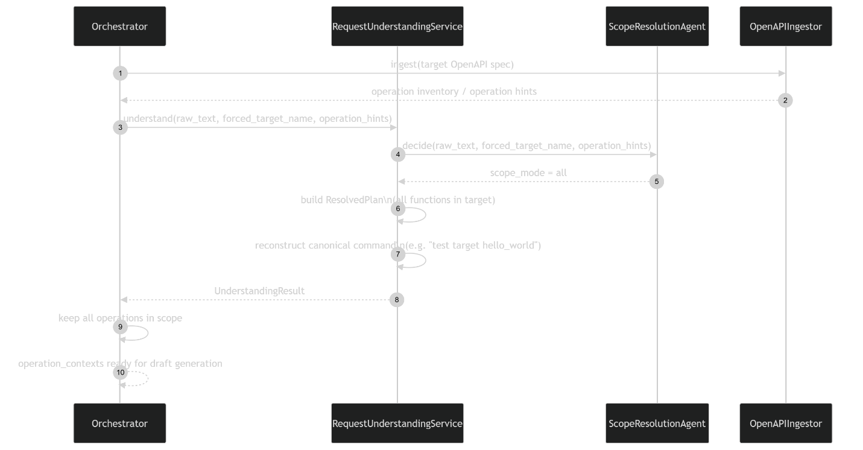

5) Request Understanding and Scope Resolution — Invalid Function
This diagram shows the case where the user asks for a function that does not exist or cannot be mapped to the target’s operations.
Example:
- “test payment on hello_world” when payment does not exist
Expected behavior:
- do not guess
- do not silently fall back to all
- report the available functions

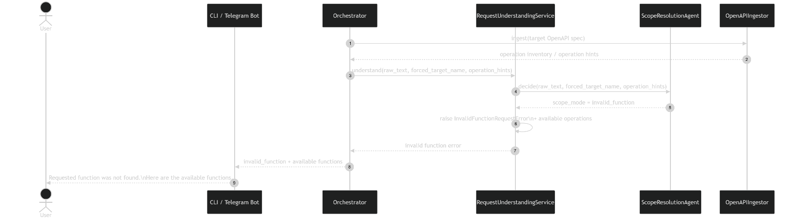
6) AI Draft Test Case Generation and Initial Review
This diagram shows the flow after target and scope are resolved, and the system begins generating draft test cases for review.
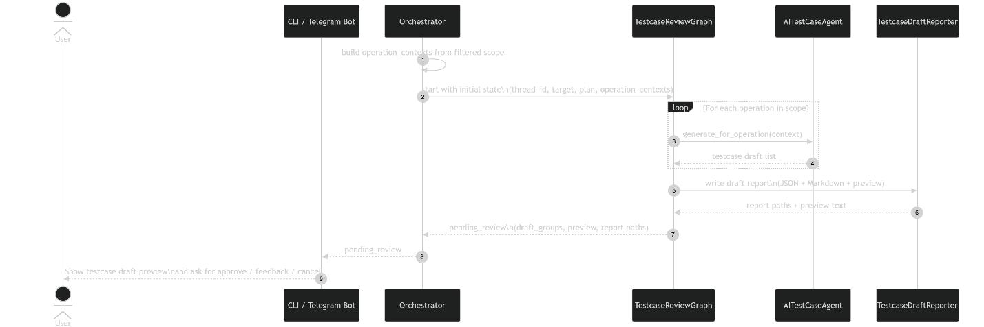

7) Review Feedback and Scope Refinement
This diagram shows what happens when the user provides review feedback and the system must determine whether the scope should stay the same or be changed.
Examples of feedback:
- “only test image generation”
- “add post creation as well”
- “remove YT and FB”
- “test all again”
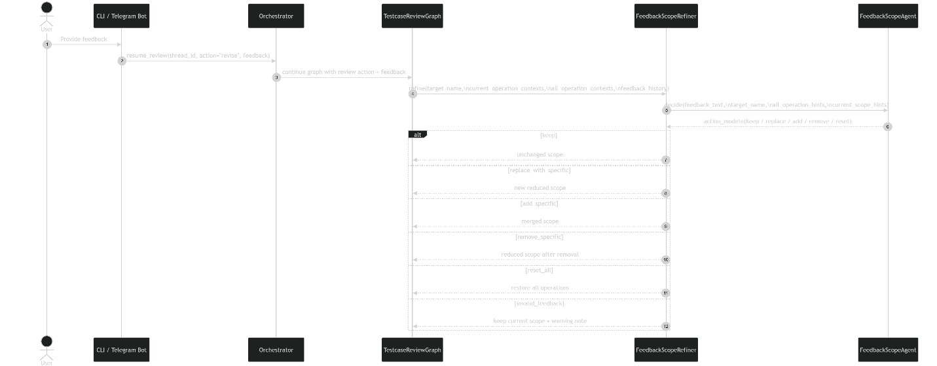

8) Regenerated Draft After Feedback
This diagram continues from the previous one and shows how the refined scope leads to draft regeneration.
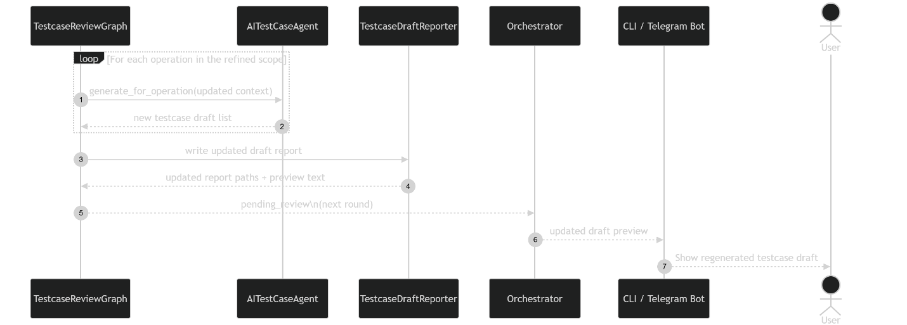

9) Final Review Decision — Approve or Cancel
This small final diagram shows how the review loop ends.
