# ACKNOWLEDGEMENT

We would like to acknowledge and give our warmest thanks to our mentor Assoc Prof. Huỳnh Thái Hoàng, who made this work possible. His guidance and support have carried us through all the stages of writing this project.

We would also like to give special thanks to all our friends and family as a whole for their continuous support and understanding when undertaking our research and writing our project. Your supports are what sustained us to come this far in the process.

Lastly, we would like to thank all the teachers in the Electrical & Electronic Engineering faculty for imparting valuable knowledge and experience so that we could complete this project.

Due to our lack of experience in practical application, it is unavoidable that there shall be some mistakes and errors in this project. Thus, we are willing to listen to any recommendations and guidance.

# What is YOLO ?

* YOLO stands for You Only Look Once and is an extremely fast object detection framework using a single convolutional network. YOLO is frequently faster than other object detection systems because it looks at the entire image at once as opposed to sweeping it pixel-by-pixel.
* YOLO does this by breaking an image into a grid, and then each section of the grid is classified and localized (i.e. the objects and structures are established). Then, it predicts where to place bounding boxes. Predicting these bounding boxes is done with regression-based algorithms, as opposed to a classification-based one.
* Generally, classification-based algorithms are completed in two steps: first, selecting the Region Of Interest (ROI), then applying the convolutional neural network (CNN) to the regions selected to detect object(s).
* YOLO's regression algorithm predicts the bounding boxes for the whole image at once, which is what makes it dramatically faster and gives it the clever name to boot.

## YOLO architecture

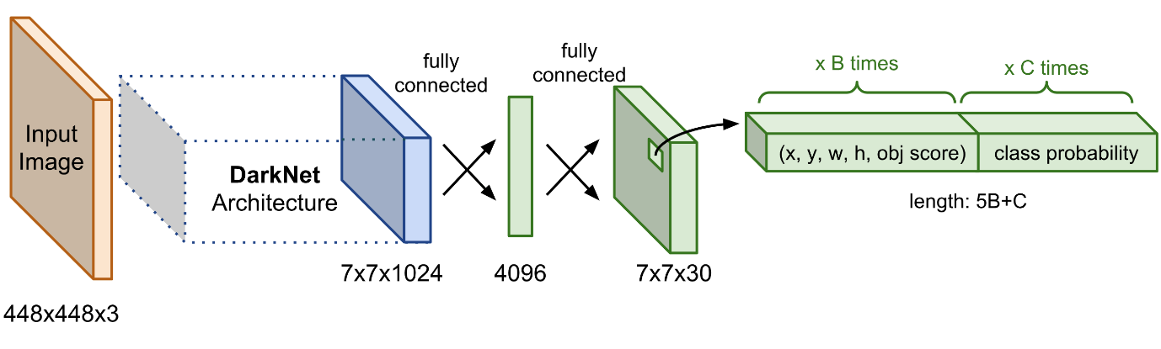

## YOLOv5

* The [fifth iteration](https://github.com/ultralytics/yolov5) of the most popular object detection algorithm was released shortly after YOLOv4, but this time by [Glenn Jocher](https://docs.ultralytics.com/). First time ever, YOLO used the PyTorch deep learning framework, which aroused a lot of controversy among the users.
* The official article couldn’t be announced, because YOLOv5 does not implement or invent any novel techniques. It is just the PyTorch extension of YOLOv3. Such a situation was used by Ultranytics company and spread the word about the “new YOLO” version under its patronage. The fact is, that the YOLOv5 webpage is very clear and nicely built and written, with a lot of tutorials and tips on training and using the YOLOv5 models because there are also five pre-trained models available, ready for use.

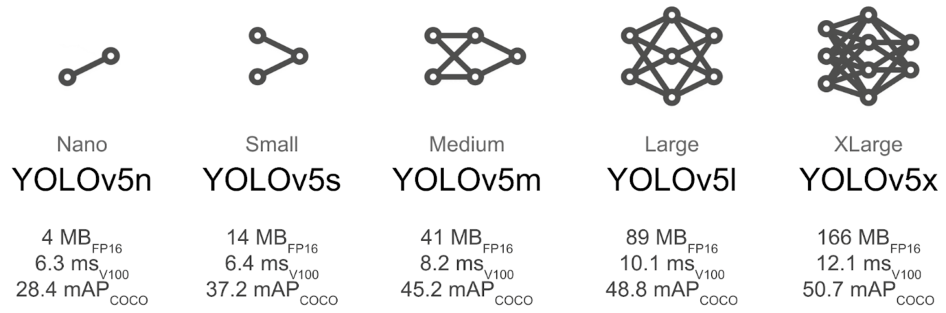

# References

1. <https://appsilon.com/object-detection-yolo-algorithm/#anchor-2>
2. <https://phamdinhkhanh.github.io/2020/03/09/DarknetAlgorithm.html>
3. <https://towardsdatascience.com/the-practical-guide-for-object-detection-with-yolov5-algorithm-74c04aac4843>
4. <https://viblo.asia/p/sau-khi-bo-duoc-anchor-trong-tuong-lai-object-detection-se-bo-duoc-hoan-toan-nms-gAm5yE7V5db>
5. <https://wandb.ai/onlineinference/YOLO/reports/YOLOv5-Object-Detection-on-Windows-Step-By-Step-Tutorial---VmlldzoxMDQwNzk4>