FINAL PRACTICAL EXAM
PRM393 – Mobile Application Development with Flutter
VARIANT D – CAMPUS EQUIPMENT LOAN
A device catalogue and equipment-loan request application with remote object creation.
STUDENT NAME | ____________________________________________________________
Duration | 90 Minutes Practical + 8–12 Minutes Oral Validation
Architecture | Clean Architecture + Riverpod
Resources | AI, Internet, Flutter/Dart docs, GitHub, Postman/curl
Submission | One ZIP named StudentID_FullName_PRM393_VariantD.zip submitted to EduNext

AI Usage Rule
AI is allowed as a software engineering assistant. Every submitted implementation must be explainable, testable, and adjustable. During oral validation, code that works but cannot be located or explained may lose points from the corresponding exam part.

EXAM REGULATIONS
- This is an individual examination. Sharing code, files, screenshots, prompts, answers, or communicating with other students during the exam is prohibited.
- Using another student’s work, a complete pre-built solution, or a project prepared before the exam that directly solves the assigned tasks is not allowed.
- All required screenshots and test evidence must be inserted into this document. Screenshots do not replace a working and complete source-code submission.
- Submit one correctly named ZIP file to EduNext before the deadline. Late, corrupted, password-protected, or incorrectly structured submissions may be penalized.
- Any academic-integrity violation will be handled according to the university’s examination regulations.

Scenario and Remote API
Build a small campus equipment-loan application. Students browse available devices, inspect device information, enter a loan period and purpose, and submit a loan request to the remote API.
Purpose | Method | Endpoint
Load devices | GET | https://api.restful-api.dev/objects
Load one device | GET | https://api.restful-api.dev/objects/{id}
Submit loan request | POST | https://api.restful-api.dev/objects
Important behavior of the POST endpoint
The public RESTful API accepts a flexible name + data object and returns the created object with an id and createdAt timestamp. Use the POST response itself as the success criterion; do not depend on a later catalogue GET to identify the request.
POST example
Endpoint: https://api.restful-api.dev/objects
Header: Content-Type: application/json
Request body:
{
"name": "Campus Equipment Loan Request",
"data": {
"deviceId": "7",
"studentId": "SE1819",
"borrowDate": "2026-08-01",
"returnDate": "2026-08-07",
"purpose": "Mobile app demo",
"deposit": 50,
"status": "pending"
}
}
A successful response should return HTTP 200/201 and JSON containing id, name, data, and createdAt. The app must use the returned response to show the Request Result screen.

Required Clean Architecture project structure
lib/
|-- app/ # app.dart, router.dart, providers.dart
|-- core/
| `-- constants/ error/ network/ storage/ utils/
|-- features/
| |-- equipment/
| | |-- data/ # datasources/, models/, repositories/
| | |-- domain/ # entities/, repositories/, usecases/
| | `-- presentation/ # providers/, pages/, widgets/
| `-- loan_request/
| |-- data/ # datasources/, models/, repositories/
| |-- domain/ # entities/, repositories/, usecases/
| `-- presentation/ # providers/, pages/, widgets/
`-- main.dart
test/
`-- core/ and features/{equipment,loan_request}/
Equivalent naming is acceptable, but Data, Domain, and Presentation responsibilities must remain separated. Widgets must not call HTTP clients or local storage directly.

UI Design Reference – Follow These Screens
Implement the same information hierarchy, main actions, screen flow, and card layout. Minor icon/font differences are acceptable.
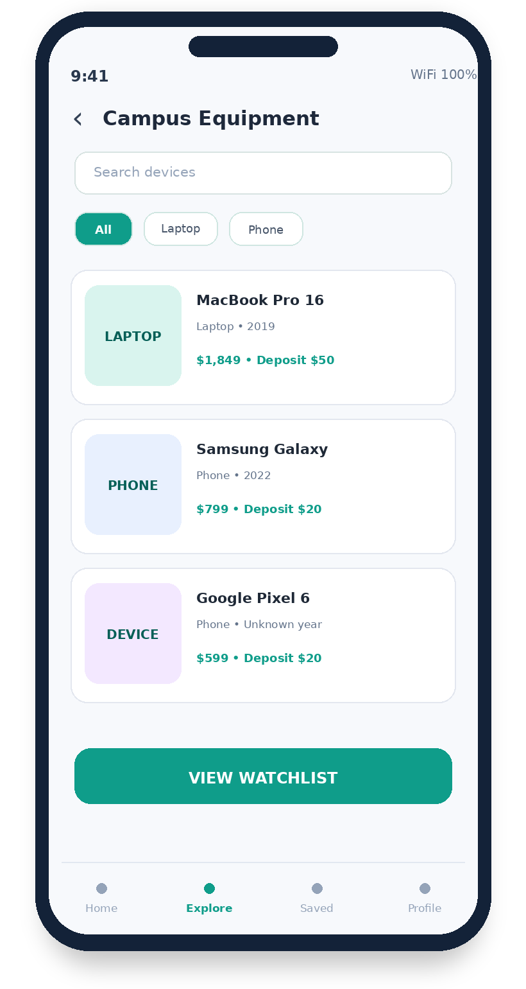  A – Device Catalogue | 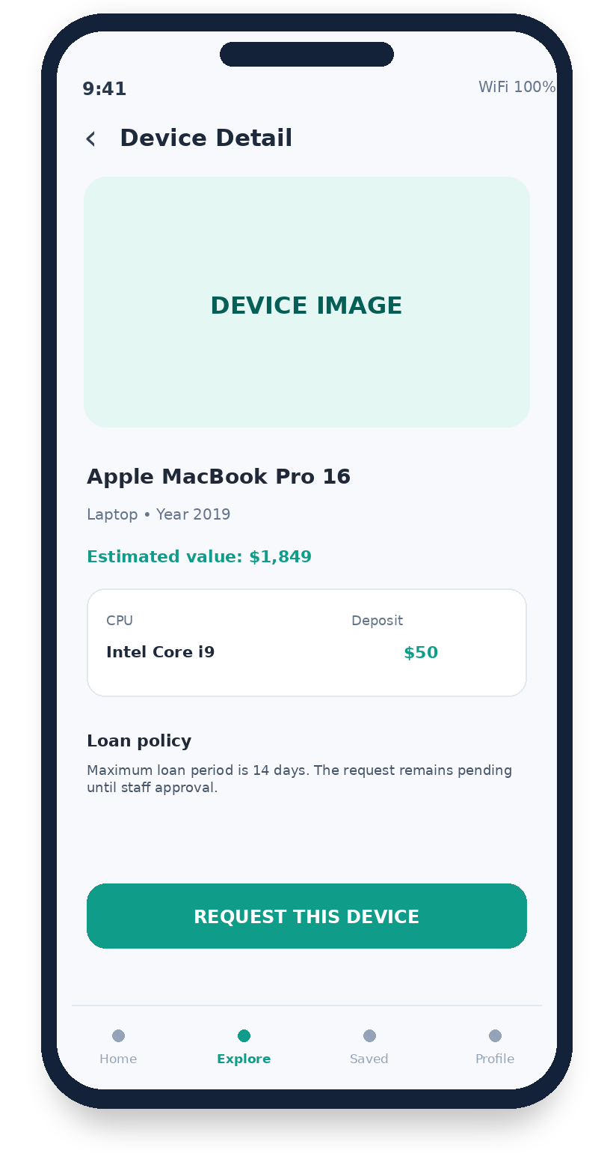  B – Device Detail
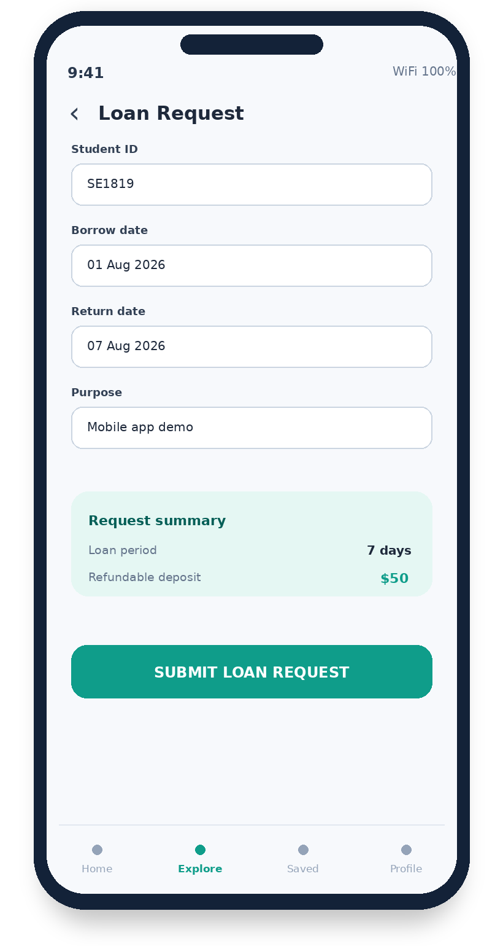  C – Loan Request Form | 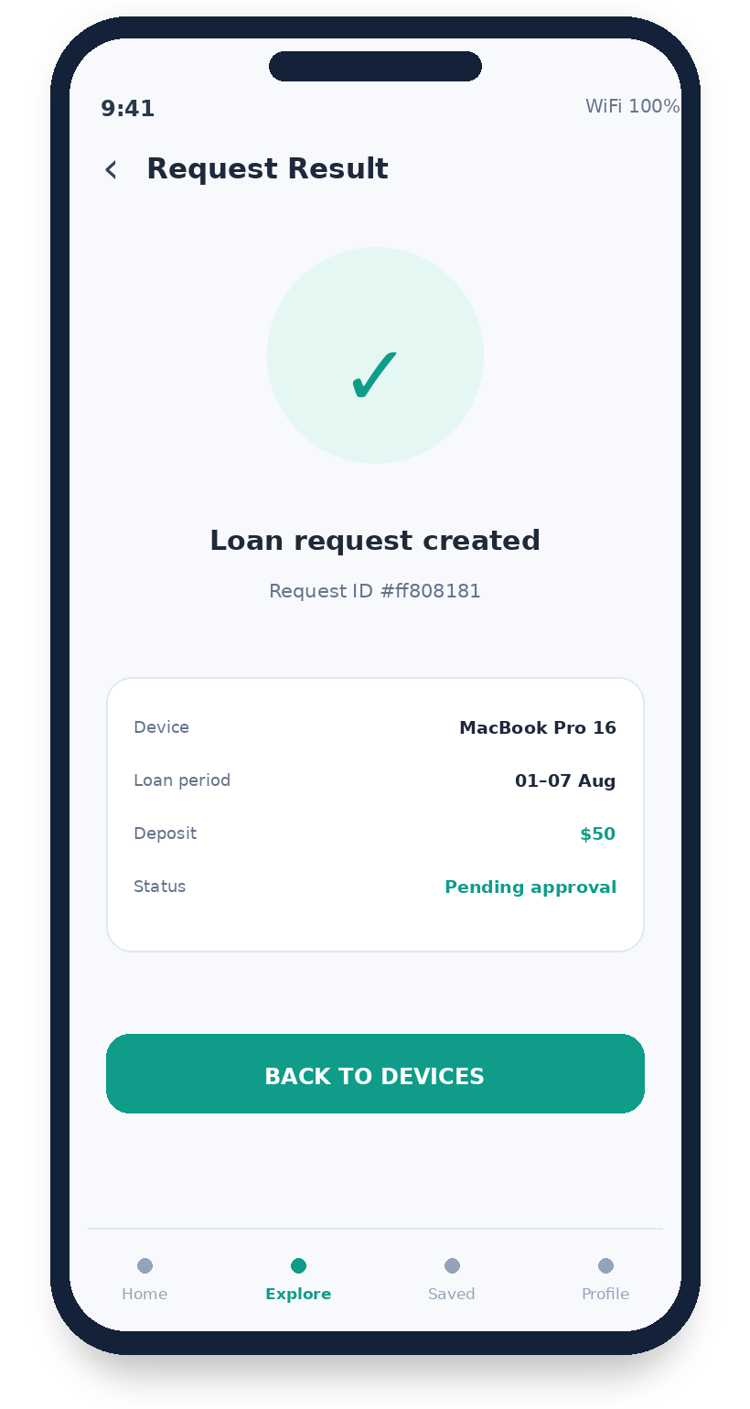  D – Request Result

PART 1 – CORE APPLICATION | 35 POINTS
Task 1.1 – Build the designed workflow (35 minutes)
Implement the four screens. Load devices from the remote API, manage the loan form with Riverpod, and create the loan request with POST.
- Device catalogue with loading, error, empty, refresh, name, inferred category, year, price, and estimated deposit.
- Device detail that safely displays optional/missing data and provides a Request Loan action.
- Loan form with student ID, borrow date, return date, purpose, validation, and deposit summary.
- POST /objects uses name and a nested data object containing the exact loan-request payload.
- Success screen shows the returned request id, createdAt, dates, deposit, and pending status.
Task 1.2 – Architecture explanation (5 minutes)
In one concise answer, trace one device with optional nested data from remote JSON to the detail UI, then trace one loan request from button tap to success/error UI.
Architecture trace
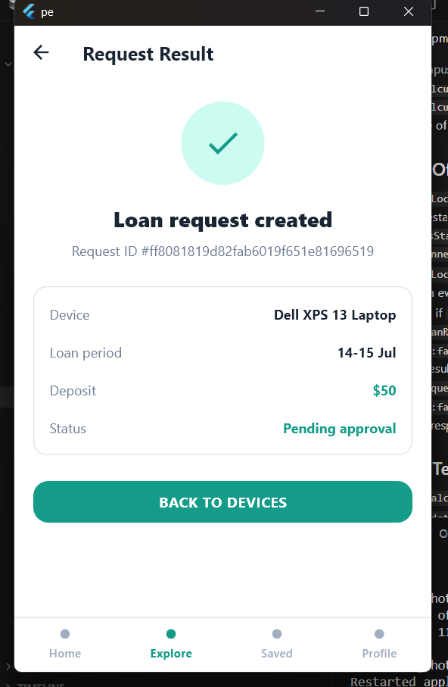
Evidence to paste
Catalogue/error state | Device detail with missing-data fallback
PASTE SCREENSHOT / TEST OUTPUT HERE | PASTE SCREENSHOT / TEST OUTPUT HERE
Validated loan request form | POST request result
PASTE SCREENSHOT / TEST OUTPUT HERE | PASTE SCREENSHOT / TEST OUTPUT HERE

PART 2 – CHANGE REQUEST SPRINT | 20 POINTS
Implement the four changes without rewriting the project. For each change, keep business logic outside Widgets where practical.
Change Request #1 – Debounced search (3 minutes)
Search devices by name with a 400 ms debounce. Typing must not call the remote API repeatedly.
Focused question: Which provider owns the query and cancellation/debounce lifecycle?
Answer / implementation note
Change Request #2 – Compare list (3 minutes)
Allow at most two devices to be added to a comparison list and persist the selected ids after restart.
Focused question: Where is the two-device limit enforced?
Answer / implementation note
Change Request #3 – Loan-period validation (3 minutes)
Borrow date cannot be in the past, return date must be later, and the period cannot exceed 14 days.
Focused question: Which domain rule or use case validates the dates?
Answer / implementation note
Change Request #4 – Deposit and name sorting (3 minutes)
Add Deposit-Low-to-High and Name-A-to-Z sorting while preserving the original API order.
Focused question: How are missing price values handled consistently during sorting?
Answer / implementation note

Evidence to paste and quick verification (3 minutes)
Debounced search and comparison list | Date validation and sorting
PASTE SCREENSHOT / TEST OUTPUT HERE | PASTE SCREENSHOT / TEST OUTPUT HERE

PART 3 – OFFLINE SUPPORT | 15 POINTS
Task 3.1 – Offline implementation (7 minutes)
Cache the latest device catalogue, persist the loan-request draft, and keep the app useful when the network is unavailable.
- Remote failure with cache → show cached devices and an offline banner.
- Selected device, dates, student ID, purpose, and deposit survive app restart.
- Offline submission is saved as a Pending Loan Request, not as a remotely created request.
- Retry sends the original nested data payload exactly once when the network returns.
Task 3.2 – Focused design question (3 minutes)
What device snapshot, date values, payload fields, and local idempotency key must be stored so a pending request can be retried safely after the UI has changed?
Offline design answer
Evidence to paste
Cached devices and offline banner | Restored draft and pending request
PASTE SCREENSHOT / TEST OUTPUT HERE | PASTE SCREENSHOT / TEST OUTPUT HERE

PART 4 – TESTING & BUG DETECTION | 10 POINTS
Task 4.1 – Automated tests (8 minutes)
Write focused tests using fakes/mocks or Riverpod overrides. Do not use the live network inside automated tests.
- Unit test for the $50/$20 deposit rule, including missing price data.
- Unit test for past dates, reversed dates, and the 14-day maximum.
- Mapper/repository test for missing nested fields and device-cache fallback.
- Widget test: rapid Submit taps produce only one fake POST call.
Task 4.2 – Focused explanation (2 minutes)
Choose one test that catches a realistic equipment-loan bug. State the bug, why the test fails before the fix, and why it passes after the fix.
Bug and test explanation
Evidence to paste
Failing loan test | Passing loan test
PASTE SCREENSHOT / TEST OUTPUT HERE | PASTE SCREENSHOT / TEST OUTPUT HERE

PART 5 – SOURCE CODE READING & MODIFICATION | 20 POINTS
Selected open-source project: Flutter MVVM Architecture
GitHub: https://github.com/jitsm555/Flutter-MVVM
This repository demonstrates a compact Flutter MVVM implementation with separated Model, View, and ViewModel responsibilities. Students must inspect the actual source, identify the state-update mechanism and data-access path used by the project, and use exact file, class, and method names in every explanation.
Task 5.1 – Clone, run, and map the MVVM responsibilities (5 points)
Clone the repository, run flutter pub get and flutter run, and capture the application running. Create a concise architecture map that identifies the exact View, ViewModel, Model, service/API utility, and dependency or state-listening mechanism used in the source.
Run command, device, setup note, and screenshot evidence
PASTE RUNNING APP SCREENSHOT AND COMMANDS HERE
Task 5.2 – Trace loading and compare with the exam architecture (5 points)
Trace the initial data-loading flow from the exact screen/widget through the ViewModel and model/service layer back to the rendered UI, including loading and error behavior. Then compare one important difference between this MVVM implementation and Clean Architecture + Riverpod used in the equipment-loan exam project.
Exact MVVM loading flow and architecture comparison
WRITE THE TRACE WITH EXACT SOURCE REFERENCES HERE

PART 5 – CONTINUED | 20 POINTS
Task 5.3 – Add search state to the ViewModel (5 points)
Add case-insensitive search for the main visible list. Keep the query and derived filtered results in the ViewModel, debounce input by approximately 300–500 ms, avoid mutating the original model list, and make clearing the query restore all items. Add a focused ViewModel test.
Task 5.4 – Add refresh/error recovery and a focused test (5 points)
Add pull-to-refresh or an equivalent explicit refresh action. While refreshing, preserve existing visible data when possible; on failure, show a retryable error without replacing valid cached/current data with an empty list. Add a focused ViewModel or widget test for success and failure recovery.
Evidence to paste for Tasks 5.3–5.4
Title-sorting UI and changed files | Complete-Visible confirmation UI
PASTE SCREENSHOT / CODE OR TEST OUTPUT HERE | PASTE SCREENSHOT / CODE OR TEST OUTPUT HERE
Sorting model test output | Confirmation and filtered-update test output
PASTE SCREENSHOT / CODE OR TEST OUTPUT HERE | PASTE SCREENSHOT / CODE OR TEST OUTPUT HERE

ORAL VALIDATION – APPLIED TO PARTS 1–5 | 5–7 QUESTIONS  AFTER PRACTICAL
Oral Validation Rule
The five exam parts already total 100 points; oral validation has no separate point allocation.
After the practical exam, the lecturer will ask 5–7 questions related to any requirement, source file, architecture decision, API behavior, offline flow, automated test, open-source review, AI evidence, or a short open-ended/live-code situation.
The student must open the exact submitted file and demonstrate the relevant code while answering. If an answer is incorrect, cannot be demonstrated, or shows insufficient understanding, the lecturer deducts points from the corresponding Part 1–5 criterion.
If a student completes all visible functions but cannot correctly answer any oral question, the final score is capped at 50/100. Partial understanding results in proportional deductions only from the affected parts.

Submission Instructions – ZIP and EduNext
- 1. Create one parent folder named StudentID_FullName_PRM393_VariantD.
- 2. Put the complete Flutter project in source_code/ (include lib/, test/, integration_test/ if used, pubspec.yaml, and README.md). Do not include build/, .dart_tool/, .git/, or IDE cache folders.
- 3. Put the completed exam document with screenshots and test outputs in exam_document/ and name it StudentID_FullName_Exam.docx.
- 4. Put prompts or exported conversations and at least one verified AI correction/rejection in ai_evidence/. Zip the parent folder as StudentID_FullName_PRM393_VariantD.zip, open the ZIP once to verify it, and submit that single ZIP file to the correct EduNext assignment before the deadline.
Important submission note: run flutter clean in the Flutter project before copying or zipping the source_code folder.
Required ZIP structure:
StudentID_FullName_PRM393_VariantD.zip
└── StudentID_FullName_PRM393_VariantD/
├── source_code/
├── exam_document/
└── ai_evidence/

Grading Summary
Exam Part | Maximum Points | Student Self-Score | Lecturer Score
Part 1 – Core application | 35 | ________ | ________
Part 2 – Change requests | 20 | ________ | ________
Part 3 – Offline support | 15 | ________ | ________
Part 4 – Testing and bug detection | 10 | ________ | ________
Part 5 – Source code reading and modification | 20 | ________ | ________
TOTAL | 100 | ________ / 100 | ________ / 100

