ACADEMIC TECHNICAL REFERENCE

HYDRAULICS FORMULA HANDBOOK
Fundamental Relations, Physical Interpretation, and Worked Examples
Academic Edition
24 thematic chapters • 59 governing equations
SI units • 24 scientific schematics • 48 worked examples
English academic edition • 22 July 2026

Note: This is a learning reference. Real designs must follow applicable standards, manufacturer data, and discipline-specific engineering review.

Abstract
This handbook consolidates fundamental equations used in fluid statics, internal flow, open-channel flow, pumps, hydraulic transients, and porous-media seepage. Each chapter states the physical scope and assumptions, defines symbols in SI units, presents editable two-dimensional Word equations, supplies a formula-driven schematic, and develops two worked examples. The material is intended for engineering education and preliminary technical analysis; design decisions must be verified against applicable standards and project-specific data.
Keywords: hydraulics; fluid mechanics; pipe flow; open-channel flow; pumps; hydraulic transients; seepage.

How to use this handbook
Recommended sequence: Read “When to use”, confirm the assumptions, identify known and unknown quantities, and only then substitute values. Convert all inputs to consistent SI units first.
- Pressure: Pa or kPa; head: metres of the stated fluid.
- Discharge: m³/s; velocity: m/s; diameter and length: m.
- Use empirical coefficients only with the definition and test conditions that produced them.
- Worked results are rounded appropriately; small differences may arise from rounding.

Notation and conventions
- All calculations use SI units unless explicitly stated otherwise.
- Gauge and absolute pressures are identified explicitly; they must not be mixed in one energy or cavitation calculation.
- Vector quantities are indicated by an arrow accent; section-average scalar quantities are typeset in italic mathematical notation.
- Equation numbers follow the form (chapter.equation). Figures and tables are numbered by chapter.
- Numerical answers are rounded to a practical engineering precision after calculation, not during intermediate steps.

Contents
- Density, specific weight, and pressure
- Hydrostatic pressure and pressure head
- Hydrostatic force and center of pressure
- Buoyancy and floating equilibrium
- Discharge, velocity, and continuity
- Extended Bernoulli equation
- Torricelli velocity and orifice discharge
- Reynolds number and flow regime
- Darcy-Weisbach major head loss
- Friction factor: laminar, Colebrook, and Swamee-Jain
- Minor loss and equivalent length
- Hazen-Williams water-pipe loss
- Linear momentum and force at bends or jets
- Pump head and power
- Pump affinity laws
- NPSH and cavitation check
- Hydraulic radius, Manning, and Chezy
- Rectangular and trapezoidal channel geometry
- Specific energy, Froude number, and critical depth
- Hydraulic jump in a rectangular channel
- Sharp-crested weir discharge
- Tank drawdown time
- Joukowsky water hammer
- Darcy law for porous-media seepage

1. Density, specific weight, and pressure
GOVERNING EQUATIONS
$ρ=\frac{m}{V}$ | (1.1)
$γ=ρ g$ | (1.2)
$p=\frac{F}{A}$ | (1.3)
Scope of application: Use these definitions to convert between fluid mass, volume, weight, normal force, and average pressure. They supply the material properties used by most later equations.
Assumptions and limitations: The fluid is homogeneous within the volume considered. The pressure relation gives an average pressure when the force is normal to and uniformly distributed over the area.
Table 1.1. Nomenclature
Symbol | Meaning | Unit
$ρ$ | Mass density | $kg m^{-3}$
$m$ | Fluid mass | $kg$
$V$ | Fluid volume | $m^{3}$
$γ$ | Specific weight | $N m^{-3}$
$g$ | Gravitational acceleration, normally 9.81 | $m s^{-2}$
$p$ | Average pressure | $Pa$
$F$ | Normal force | $N$
$A$ | Loaded area | $m^{2}$
Figure 1.1. Formula concept diagram
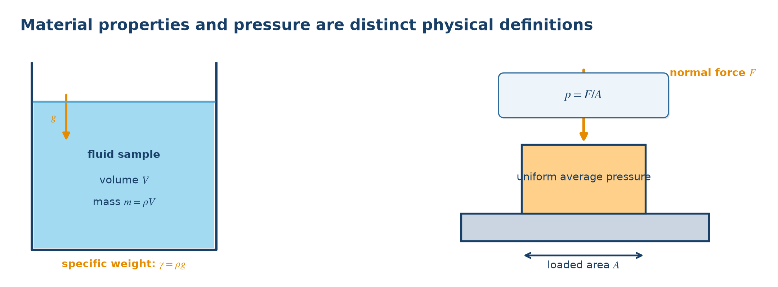
Figure 1.1. Physical meaning and variables used by the governing equations. Source: author-generated schematic.
Engineering note: For engineering calculations, water is often approximated by ρ = 1,000 kg/m³ and γ = 9,810 N/m³.

1.1 Worked examples
Example 1.1. A tank contains 2.5 m³ of water. Find its mass and weight.
Physical model: Density links mass to volume; specific weight links weight to volume.
Governing equation:
$m = ρV and G = mg = γV$
Substitution:
$m = 1,000×2.5; G = 2,500×9.81$
Result:
$m = 2,500 kg; G = 24,525 N = 24.525 kN$
Interpretation: The tank structure must support approximately 24.5 kN from the water alone.
Example 1.2. A piston carries 12 kN over an area of 0.015 m². Find the average pressure.
Physical model: A normal load is distributed over a known piston area.
Governing equation:
$p = F/A$
Substitution:
$p = 12,000/0.015$
Result:
$p = 800,000 Pa = 800 kPa$
Interpretation: The hydraulic fluid beneath the piston experiences an average gauge pressure of 800 kPa.

2. Hydrostatic pressure and pressure head
GOVERNING EQUATIONS
${p=p}_{0}+ρ gh$ | (2.1)
$p_{gauge}=ρ gh$ | (2.2)
$h_{p}=\frac{p}{γ}$ | (2.3)
Scope of application: Use for a stationary liquid to find pressure at depth or to express pressure as an equivalent liquid-column height.
Assumptions and limitations: The fluid is at rest and its density is effectively constant. Depth h is vertical. Keep absolute and gauge pressure definitions consistent.
Table 2.1. Nomenclature
Symbol | Meaning | Unit
$p$ | Pressure at the point | $Pa$
$p_{0}$ | Pressure at the free surface | $Pa$
$h$ | Vertical depth below free surface | $m$
$h_{p}$ | Pressure head | m of fluid
$ρ$ | Fluid density | $kg m^{-3}$
$γ$ | Specific weight ρg | $N m^{-3}$
Figure 2.1. Formula concept diagram
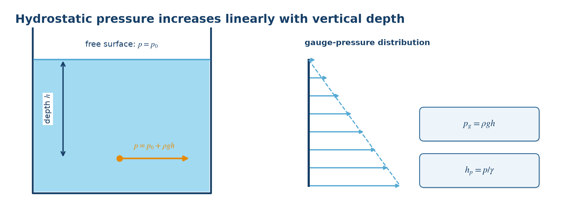
Figure 2.1. Physical meaning and variables used by the governing equations. Source: author-generated schematic.
Engineering note: In an open tank, p₀ is atmospheric; using gauge pressure makes p₀ = 0. One metre of water head is about 9.81 kPa.

2.1 Worked examples
Example 2.1. Find the gauge pressure 6 m below the free surface of water.
Physical model: The water is stationary in an open reservoir.
Governing equation:
$pgauge = ρgh$
Substitution:
$p = 1,000×9.81×6$
Result:
$p = 58,860 Pa = 58.86 kPa$
Interpretation: Gauge pressure increases linearly with depth and is zero at the open free surface.
Example 2.2. A gauge reads 245 kPa in a water line. Express this as water head.
Physical model: Pressure must be converted to an equivalent column height.
Governing equation:
$hp = p/(ρg)$
Substitution:
$hp = 245,000/(1,000×9.81)$
Result:
$hp = 24.97 mH₂O$
Interpretation: The measured pressure can support a static water column approximately 25 m high.

3. Hydrostatic force and center of pressure
GOVERNING EQUATIONS
$F=ρ{ gh}_{c}A$ | (3.1)
$h_{cp}{=h}_{c}+\frac{I_{G}}{h_{c}A}$ | (3.2)
Scope of application: Use for the resultant liquid force on a vertical plane gate, wall, panel, or hatch, and for the depth at which that resultant acts.
Assumptions and limitations: The surface is plane and vertical, the liquid is homogeneous, and free-surface pressure is uniform. A differently inclined surface requires coordinates measured along the plane and the appropriate inclination factor.
Table 3.1. Nomenclature
Symbol | Meaning | Unit
$F$ | Hydrostatic resultant | $N$
$h_{c}$ | Depth of area centroid | $m$
$A$ | Loaded plane area | $m^{2}$
$h_{cp}$ | Depth of center of pressure | $m$
$I_{G}$ | Second moment of area about the horizontal centroidal axis | $m^{4}$
Figure 3.1. Formula concept diagram
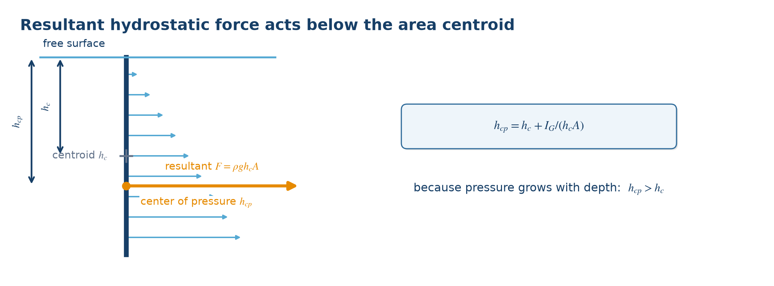
Figure 3.1. Physical meaning and variables used by the governing equations. Source: author-generated schematic.
Engineering note: Because pressure grows with depth, the center of pressure lies below the geometric centroid for a vertical submerged surface.

3.1 Worked examples
Example 3.1. A vertical rectangular gate is 2 m wide and 3 m high, with its top at the water surface. Find the resultant force.
Physical model: Hydrostatic pressure varies linearly, but its resultant equals pressure at the centroid times area.
Governing equation:
$F = ρghcA$
Substitution:
$hc = 1.5 m, A = 2×3 = 6 m²; F = 1,000×9.81×1.5×6$
Result:
$F = 88,290 N = 88.29 kN$
Interpretation: The gate support system must resist an 88.29 kN horizontal resultant.
Example 3.2. For the same gate, find the center-of-pressure depth.
Physical model: Use the center-of-pressure relation for a vertical rectangle.
Governing equation:
$hcp = hc + IG/(hcA), with IG = bh³/12$
Substitution:
$IG = 2×3³/12 = 4.5 m⁴; hcp = 1.5 + 4.5/(1.5×6)$
Result:
$hcp = 2.00 m below the free surface$
Interpretation: The resultant acts below the centroid at 1.5 m, consistent with the triangular pressure distribution.

4. Buoyancy and floating equilibrium
GOVERNING EQUATIONS
$F_{B}=ρ{ gV}_{displaced}$ | (4.1)
$F_{B}=W$ | (4.2)
Scope of application: Use for submerged bodies, floats, pontoons, underground tanks, and uplift checks.
Assumptions and limitations: The surrounding fluid is at rest. Vdisplaced is the displaced-fluid volume. Floating stability also requires a separate moment/metacentric check.
Table 4.1. Nomenclature
Symbol | Meaning | Unit
$F_{B}$ | Buoyant force | $N$
$V_{displaced}$ | Displaced-fluid volume | $m^{3}$
$W$ | Body weight | $N$
$ρ$ | Fluid density | $kg m^{-3}$
Figure 4.1. Formula concept diagram
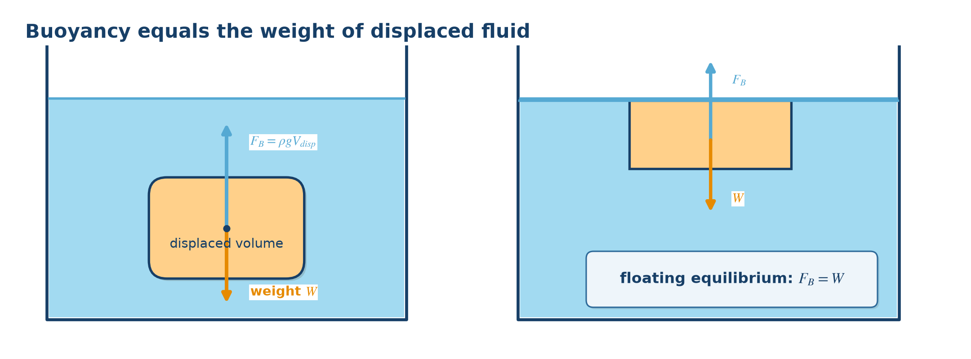
Figure 4.1. Physical meaning and variables used by the governing equations. Source: author-generated schematic.
Engineering note: Buoyant force acts vertically upward through the centroid of the displaced volume, called the center of buoyancy.

4.1 Worked examples
Example 4.1. A sealed body of volume 0.08 m³ is fully submerged in water. Find its buoyant force.
Physical model: A fully submerged body displaces its complete external volume.
Governing equation:
$FB = ρgVdisplaced$
Substitution:
$FB = 1,000×9.81×0.08$
Result:
$FB = 784.8 N upward$
Interpretation: Compare this force with the body weight to determine whether it rises, sinks, or remains neutrally buoyant.
Example 4.2. A 300 kg float rests in fresh water. Find its displaced volume.
Physical model: A floating body is in vertical force equilibrium.
Governing equation:
$ρgVdisplaced = mg, therefore Vdisplaced = m/ρ$
Substitution:
$Vdisplaced = 300/1,000$
Result:
$Vdisplaced = 0.300 m³$
Interpretation: The float must immerse until it displaces 0.300 m³ of water.

5. Discharge, velocity, and continuity
GOVERNING EQUATIONS
$Q=\frac{V}{t}=Av$ | (5.1)
$A_{1}v_{1}{=A}_{2}v_{2}$ | (5.2)
$Σ{ Q}_{in}=Σ{ Q}_{out}$ | (5.3)
Scope of application: Use to convert discharge and mean velocity, analyze a change in pipe diameter, or balance flows at a junction.
Assumptions and limitations: Area is normal to the flow and v is the section-average velocity. A₁v₁ = A₂v₂ assumes steady incompressible flow with no branch between the sections.
Table 5.1. Nomenclature
Symbol | Meaning | Unit
$Q$ | Volumetric discharge | $m^{3} s^{-1}$
$V$ | Fluid volume | $m^{3}$
$t$ | Time | $s$
$A$ | Flow area | $m^{2}$
$v$ | Mean velocity | $m s^{-1}$
$D$ | Internal diameter; A = πD²/4 | $m$
Figure 5.1. Formula concept diagram
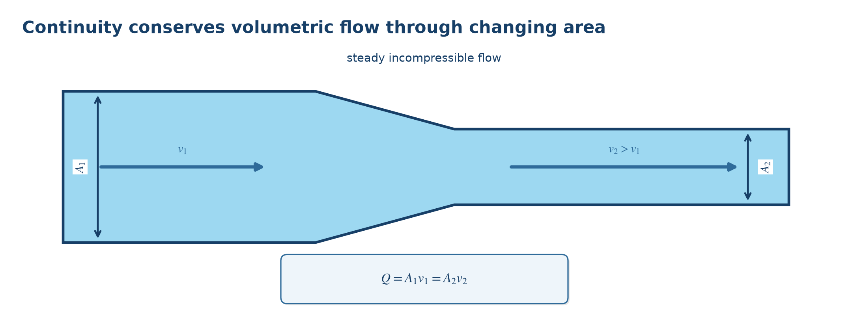
Figure 5.1. Physical meaning and variables used by the governing equations. Source: author-generated schematic.
Engineering note: At a junction, conservation of mass requires total inflow to equal total outflow for steady incompressible operation.

5.1 Worked examples
Example 5.1. A 0.20 m diameter pipe conveys 0.05 m³/s. Find the mean velocity.
Physical model: A full circular pipe has a known flow area.
Governing equation:
$v = Q/A and A = πD²/4$
Substitution:
$A = π(0.20)²/4 = 0.03142 m²; v = 0.05/0.03142$
Result:
$v = 1.59 m/s$
Interpretation: This is the cross-sectional average, not the local centerline velocity.
Example 5.2. A pipe contracts from 0.20 m to 0.10 m diameter. If v₁ = 1.2 m/s, find v₂.
Physical model: Steady water flow has the same discharge through both sections.
Governing equation:
$A₁v₁ = A₂v₂, so v₂ = v₁(D₁/D₂)²$
Substitution:
$v₂ = 1.2(0.20/0.10)²$
Result:
$v₂ = 4.8 m/s$
Interpretation: Halving diameter reduces area to one-quarter, so velocity rises by a factor of four.

6. Extended Bernoulli equation
GOVERNING EQUATIONS
$z_{1}+\frac{p_{1}}{γ}+α_{1}\frac{v_{1}^{2}}{2g}{+H}_{p}{=z}_{2}+\frac{p_{2}}{γ}+α_{2}\frac{v_{2}^{2}}{2g}{+H}_{t}{+h}_{L}$ | (6.1)
Scope of application: Use for energy balance between two sections to find pressure, velocity, pump head, turbine head, or system loss.
Assumptions and limitations: Steady, effectively incompressible flow; points lie on the same streamline or use section-averaged correction factors. Use one elevation datum and one pressure reference.
Table 6.1. Nomenclature
Symbol | Meaning | Unit
$z$ | Elevation head | $m$
$\frac{p}{γ}$ | Pressure head | $m$
$\frac{α{ v}^{2}}{2g}$ | Velocity head | $m$
$H_{p}$ | Pump head added | $m$
$H_{t}$ | Turbine head removed | $m$
$h_{L}$ | Total head loss | $m$
$α$ | Kinetic-energy correction factor | -
Figure 6.1. Formula concept diagram
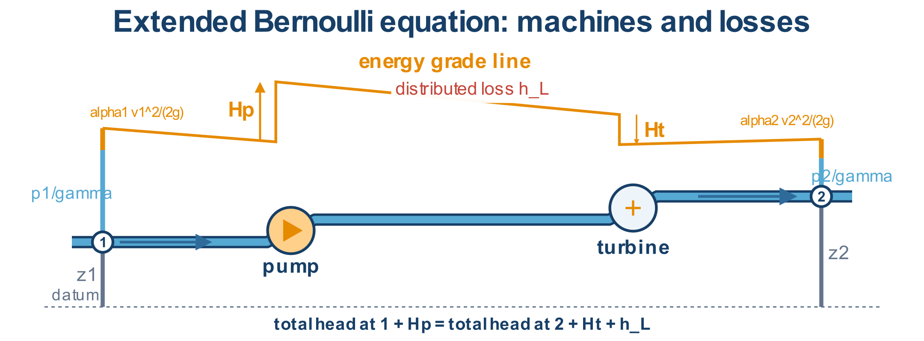
Figure 6.1. Physical meaning and variables used by the governing equations. Source: author-generated schematic.
Engineering note: Between two large open reservoirs, both surface velocities and gauge pressures are approximately zero, leaving elevation, pump head, and loss terms.

6.1 Worked examples
Example 6.1. Two open reservoirs differ in level by 18 m and the connecting system loses 5 m. Find the required pump head.
Physical model: Apply Bernoulli between the two free surfaces; both are open and nearly stationary.
Governing equation:
$z₁ + Hp = z₂ + hL, so Hp = (z₂-z₁)+hL$
Substitution:
$Hp = 18+5$
Result:
$Hp = 23 m$
Interpretation: The pump must add 23 m of total head at the design flow.
Example 6.2. In a horizontal lossless water pipe, p₁ = 250 kPa, v₁ = 2 m/s, and v₂ = 5 m/s. Find p₂.
Physical model: Elevation and loss terms cancel; changing velocity exchanges pressure head and velocity head.
Governing equation:
$p₁/γ + v₁²/(2g) = p₂/γ + v₂²/(2g)$
Substitution:
$p₂ = 250,000 + 1,000(2²-5²)/2$
Result:
$p₂ = 239,500 Pa = 239.5 kPa$
Interpretation: Acceleration through the smaller section reduces static pressure by 10.5 kPa.

7. Torricelli velocity and orifice discharge
GOVERNING EQUATIONS
$v_{ideal}=\sqrt{2gh}$ | (7.1)
${v=C}_{v}\sqrt{2gh}$ | (7.2)
${Q=C}_{d}A\sqrt{2gh}$ | (7.3)
Scope of application: Use for a free jet issuing through a small opening in a tank wall or floor under a liquid head.
Assumptions and limitations: The tank is large enough that free-surface velocity is negligible; free surface and jet are at the same pressure; h is measured to the opening center.
Table 7.1. Nomenclature
Symbol | Meaning | Unit
$v_{ideal}$ | Ideal jet velocity | $m s^{-1}$
$C_{v}$ | Velocity coefficient | -
$C_{d}$ | Discharge coefficient | -
$A$ | Opening area | $m^{2}$
$h$ | Head above opening center | $m$
Figure 7.1. Formula concept diagram
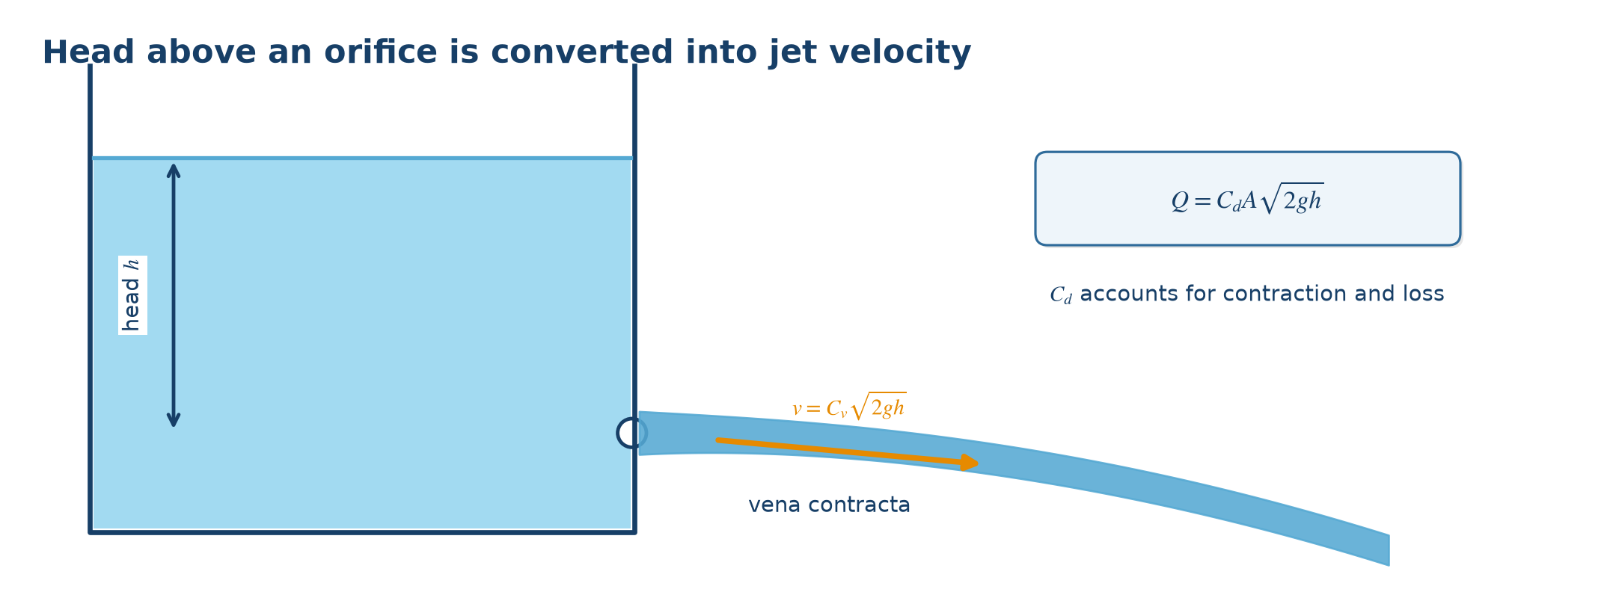
Figure 7.1. Physical meaning and variables used by the governing equations. Source: author-generated schematic.
Engineering note: Cd accounts for jet contraction and energy loss; do not assume Cd = 1 for a real sharp-edged opening.

7.1 Worked examples
Example 7.1. A 50 mm opening is 4 m below the water surface. With Cd = 0.62, find discharge.
Physical model: A small sharp-edged opening discharges freely from a large tank.
Governing equation:
$Q = Cd(πD²/4)√(2gh)$
Substitution:
$Q = 0.62[π(0.05)²/4]√(2×9.81×4)$
Result:
$Q = 0.0108 m³/s = 10.8 L/s$
Interpretation: The real flow is 62% of the ideal area-velocity product represented by Cd.
Example 7.2. Find the ideal jet speed under 2.5 m of water head.
Physical model: Use the ideal conversion of potential head to velocity head.
Governing equation:
$v = √(2gh)$
Substitution:
$v = √(2×9.81×2.5)$
Result:
$v = 7.00 m/s$
Interpretation: A real jet will be slightly slower when Cv is below one.

8. Reynolds number and flow regime
GOVERNING EQUATIONS
$Re=\frac{ρ vD}{μ}=\frac{vD}{ν}$ | (8.1)
$D_{h}=\frac{4A}{P_{w}}$ | (8.2)
Scope of application: Use to classify laminar, transitional, or turbulent flow and select an appropriate friction relation.
Assumptions and limitations: D and v must describe the same section. Use internal diameter for a full circular pipe and hydraulic diameter for a noncircular full duct.
Table 8.1. Nomenclature
Symbol | Meaning | Unit
$Re$ | Reynolds number | -
$μ$ | Dynamic viscosity | $Pa·s$
$ν$ | Kinematic viscosity μ/ρ | $m^{2} s^{-1}$
$D_{h}$ | Hydraulic diameter | $m$
$P_{w}$ | Wetted perimeter | $m$
Figure 8.1. Formula concept diagram
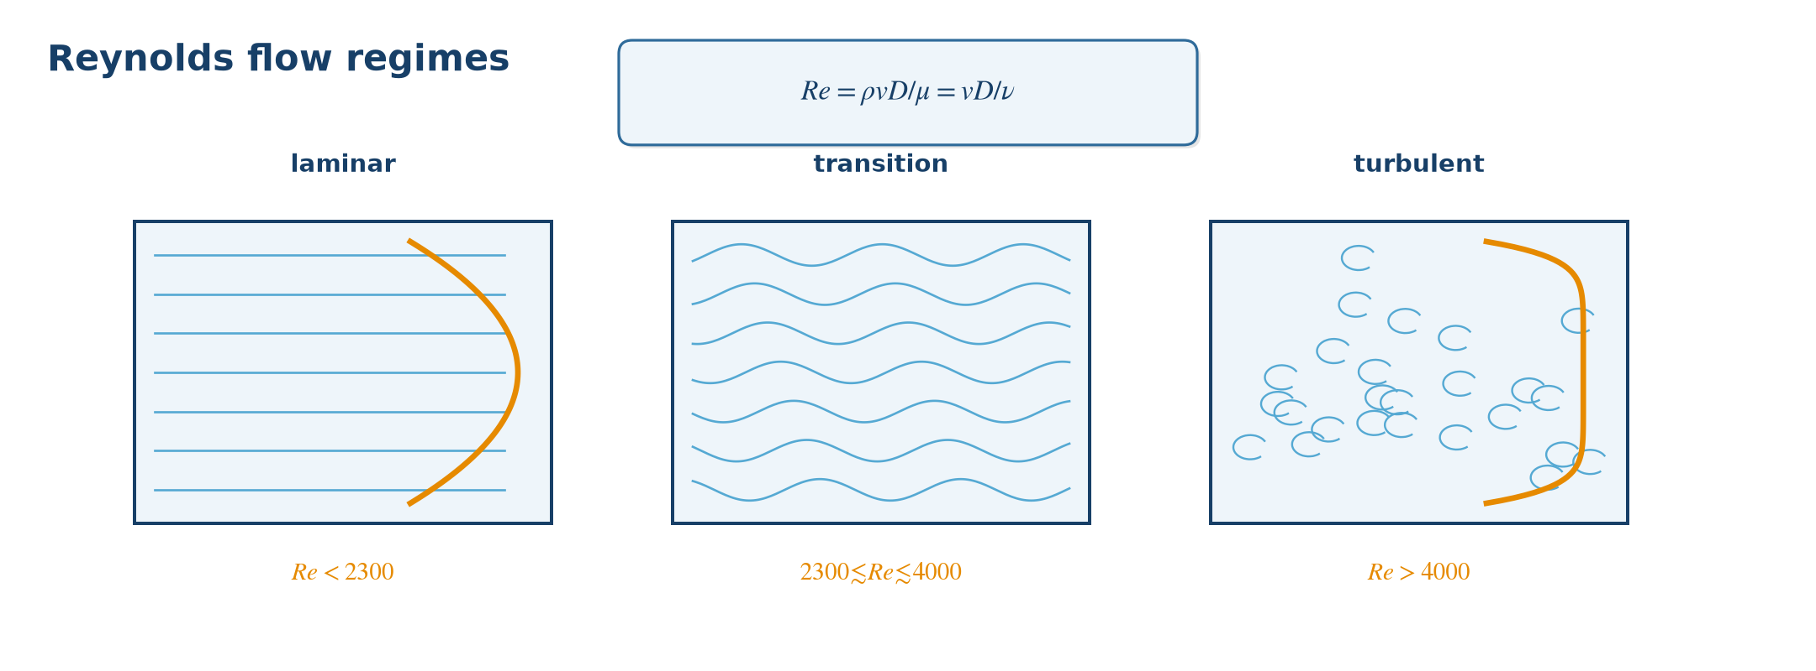
Figure 8.1. Physical meaning and variables used by the governing equations. Source: author-generated schematic.
Engineering note: For pipe flow: Re < 2,300 is usually laminar; Re > 4,000 is usually turbulent; the interval is transitional.

8.1 Worked examples
Example 8.1. Water with ν = 1.0×10⁻⁶ m²/s flows at 0.8 m/s in a 0.05 m pipe. Find Re and classify the flow.
Physical model: The full circular pipe uses its internal diameter as characteristic length.
Governing equation:
$Re = vD/ν$
Substitution:
$Re = 0.8×0.05/(1.0×10⁻⁶)$
Result:
$Re = 40,000$
Interpretation: Because Re > 4,000, the flow is turbulent.
Example 8.2. Find the hydraulic diameter of a full square duct with 0.10 m sides.
Physical model: A noncircular full duct uses Dh = 4A/Pw.
Governing equation:
$Dh = 4(s²)/(4s)$
Substitution:
$Dh = 4(0.10²)/(4×0.10)$
Result:
$Dh = 0.10 m$
Interpretation: For a full square duct, hydraulic diameter equals the side length.

9. Darcy-Weisbach major head loss
GOVERNING EQUATIONS
$h_{f}=f\frac{L}{D}\frac{v^{2}}{2g}$ | (9.1)
$J=\frac{h_{f}}{L}$ | (9.2)
Scope of application: Use for friction loss along a full pipe carrying water or another fluid, in laminar or turbulent flow.
Assumptions and limitations: Steady full-pipe flow with constant diameter over the analyzed reach. Use the Darcy friction factor consistent with Re and relative roughness.
Table 9.1. Nomenclature
Symbol | Meaning | Unit
$h_{f}$ | Major head loss | $m$
$f$ | Darcy friction factor | -
$L$ | Pipe length | $m$
$D$ | Internal diameter | $m$
$v$ | Mean velocity | $m s^{-1}$
$J$ | Hydraulic gradient | $m m^{-1}$
Figure 9.1. Formula concept diagram
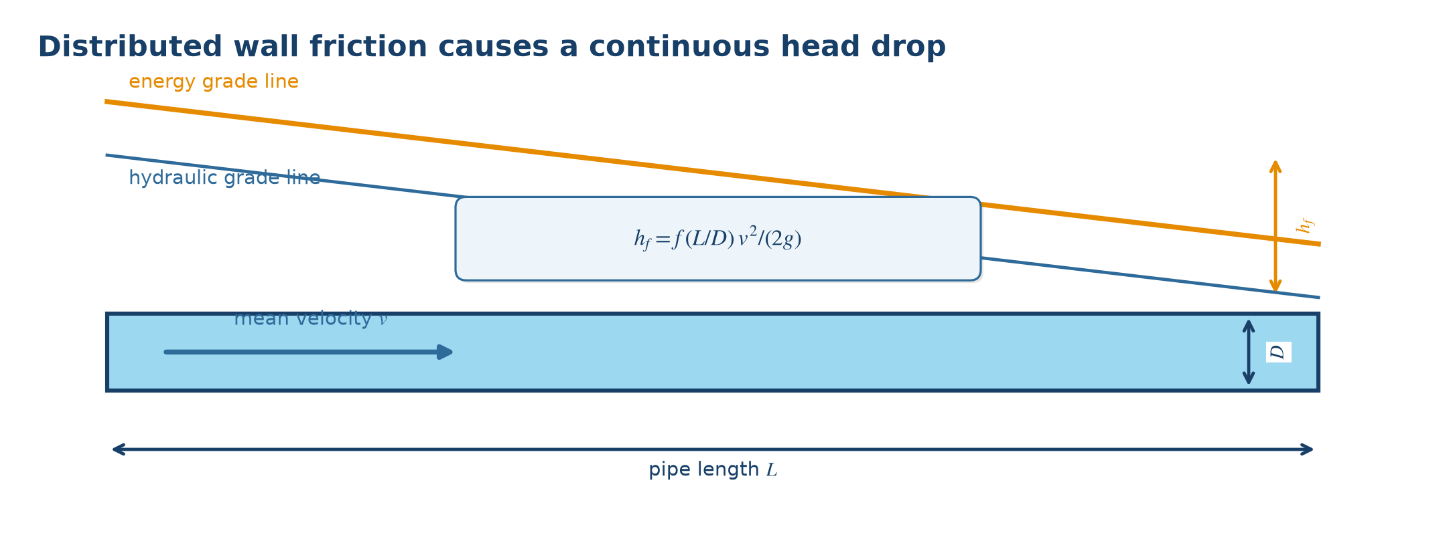
Figure 9.1. Physical meaning and variables used by the governing equations. Source: author-generated schematic.
Engineering note: Do not confuse Darcy and Fanning friction factors; fDarcy = 4fFanning.

9.1 Worked examples
Example 9.1. A 120 m pipe has D = 0.15 m, v = 1.8 m/s, and f = 0.022. Find hf.
Physical model: The loss is distributed along a constant-diameter full pipe.
Governing equation:
$hf = f(L/D)v²/(2g)$
Substitution:
$hf = 0.022(120/0.15)(1.8²/(2×9.81))$
Result:
$hf = 2.91 m$
Interpretation: The energy grade line drops 2.91 m along this reach.
Example 9.2. A 500 m pipe loses 7.5 m of head. Find the hydraulic gradient.
Physical model: Hydraulic gradient is head loss per unit pipe length.
Governing equation:
$J = hf/L$
Substitution:
$J = 7.5/500$
Result:
$J = 0.015 m/m = 1.5\%$
Interpretation: The system loses 1.5 m of head per 100 m of this pipe.

10. Friction factor: laminar, Colebrook, and Swamee-Jain
GOVERNING EQUATIONS
$f_{laminar}=\frac{64}{Re}$ | (10.1)
$\frac{1}{\sqrt{f}}=-2\log_{10}(\frac{ε}{3.7D}+\frac{2.51}{Re\sqrt{f}})$ | (10.2)
$f_{SJ}=\frac{0.25}{[\log_{10}(\frac{ε}{3.7D}+\frac{5.74}{{Re}^{0.9}})]^{2}}$ | (10.3)
Scope of application: Use to obtain the Darcy friction factor required by Darcy-Weisbach: 64/Re for laminar flow; Colebrook or Swamee-Jain for turbulent flow.
Assumptions and limitations: Colebrook is implicit and requires iteration. Swamee-Jain is an explicit turbulent-flow approximation. ε and D must use the same unit.
Table 10.1. Nomenclature
Symbol | Meaning | Unit
$f$ | Darcy friction factor | -
$Re$ | Reynolds number | -
$ε$ | Absolute wall roughness | $m$
$\frac{ε}{D}$ | Relative roughness | -
Figure 10.1. Formula concept diagram
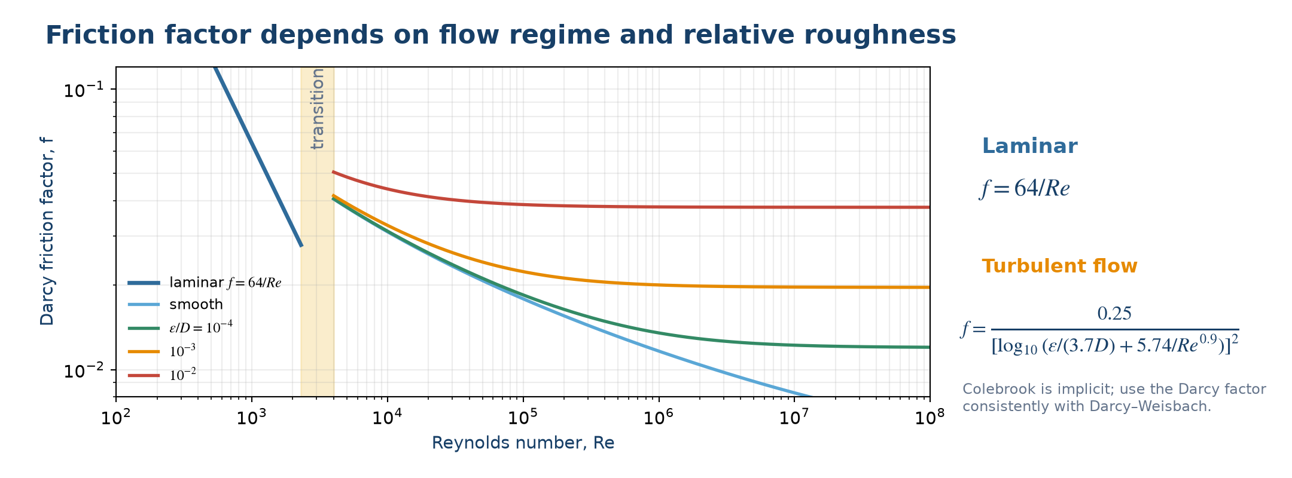
Figure 10.1. Physical meaning and variables used by the governing equations. Source: author-generated schematic.
Engineering note: The transitional range is unstable; avoid relying on a single deterministic friction factor between approximately Re = 2,300 and 4,000.

10.1 Worked examples
Example 10.1. A laminar pipe flow has Re = 1,600. Find f.
Physical model: Re is below 2,300, so use the laminar relation.
Governing equation:
$f = 64/Re$
Substitution:
$f = 64/1,600$
Result:
$f = 0.040$
Interpretation: This f is the Darcy friction factor for use in Darcy-Weisbach.
Example 10.2. For Re = 100,000 and ε/D = 0.001, estimate f with Swamee-Jain.
Physical model: The flow is turbulent and relative roughness is known.
Governing equation:
$f = 0.25/[log₁₀(ε/(3.7D)+5.74/Re⁰·⁹)]²$
Substitution:
$f = 0.25/[log₁₀(0.001/3.7+5.74/100000⁰·⁹)]²$
Result:
$f ≈ 0.0223$
Interpretation: This explicit estimate can be inserted directly into Darcy-Weisbach.

11. Minor loss and equivalent length
GOVERNING EQUATIONS
$h_{m}=K\frac{v^{2}}{2g}$ | (11.1)
$h_{L}{=h}_{f}+Σ{ h}_{m}$ | (11.2)
$L_{e}=\frac{KD}{f}$ | (11.3)
Scope of application: Use for elbows, tees, valves, entrances, exits, contractions, and expansions that cause localized disturbance.
Assumptions and limitations: K must correspond to the fitting geometry, opening, and reference velocity. K values may be summed directly only when they use the same reference velocity.
Table 11.1. Nomenclature
Symbol | Meaning | Unit
$h_{m}$ | Minor head loss | $m$
$K$ | Minor-loss coefficient | -
$L_{e}$ | Equivalent straight-pipe length | $m$
$f$ | Darcy friction factor | -
$D$ | Pipe diameter | $m$
Figure 11.1. Formula concept diagram
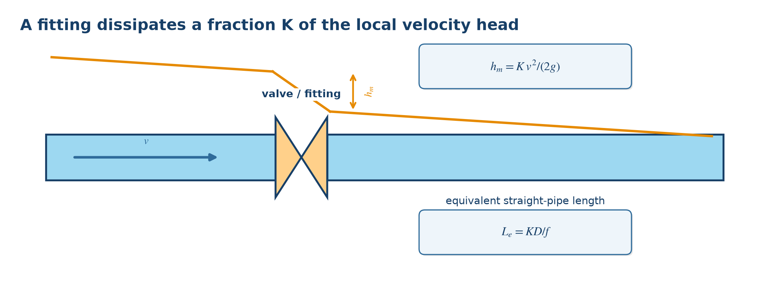
Figure 11.1. Physical meaning and variables used by the governing equations. Source: author-generated schematic.
Engineering note: In short piping systems with many fittings, minor losses can exceed straight-pipe loss.

11.1 Worked examples
Example 11.1. A valve has K = 4.0 and the reference velocity is 2.5 m/s. Find hm.
Physical model: The valve produces a localized velocity-head loss.
Governing equation:
$hm = Kv²/(2g)$
Substitution:
$hm = 4.0(2.5²)/(2×9.81)$
Result:
$hm = 1.27 m$
Interpretation: The valve consumes 1.27 m of total head at this velocity.
Example 11.2. An elbow has K = 0.9 in a D = 0.10 m pipe with f = 0.02. Find equivalent length.
Physical model: Convert the fitting loss into an equal Darcy-Weisbach straight-pipe loss.
Governing equation:
$Le = KD/f$
Substitution:
$Le = 0.9×0.10/0.02$
Result:
$Le = 4.5 m$
Interpretation: The elbow has the same head loss as about 4.5 m of this straight pipe.

12. Hazen-Williams water-pipe loss
GOVERNING EQUATIONS
$h_{f}=10.67\frac{{LQ}^{1.852}}{C^{1.852}D^{4.87}}$ | (12.1)
Scope of application: Use for rapid engineering estimates of friction loss in full water-supply pipes when a Hazen-Williams C value is available.
Assumptions and limitations: Primarily for water at ordinary temperatures. In this SI form Q is m³/s and D and L are metres. Do not apply indiscriminately to viscous liquids.
Table 12.1. Nomenclature
Symbol | Meaning | Unit
$h_{f}$ | Head loss | $m$
$L$ | Pipe length | $m$
$Q$ | Water discharge | $m^{3} s^{-1}$
$C$ | Hazen-Williams coefficient | -
$D$ | Internal diameter | $m$
Figure 12.1. Formula concept diagram
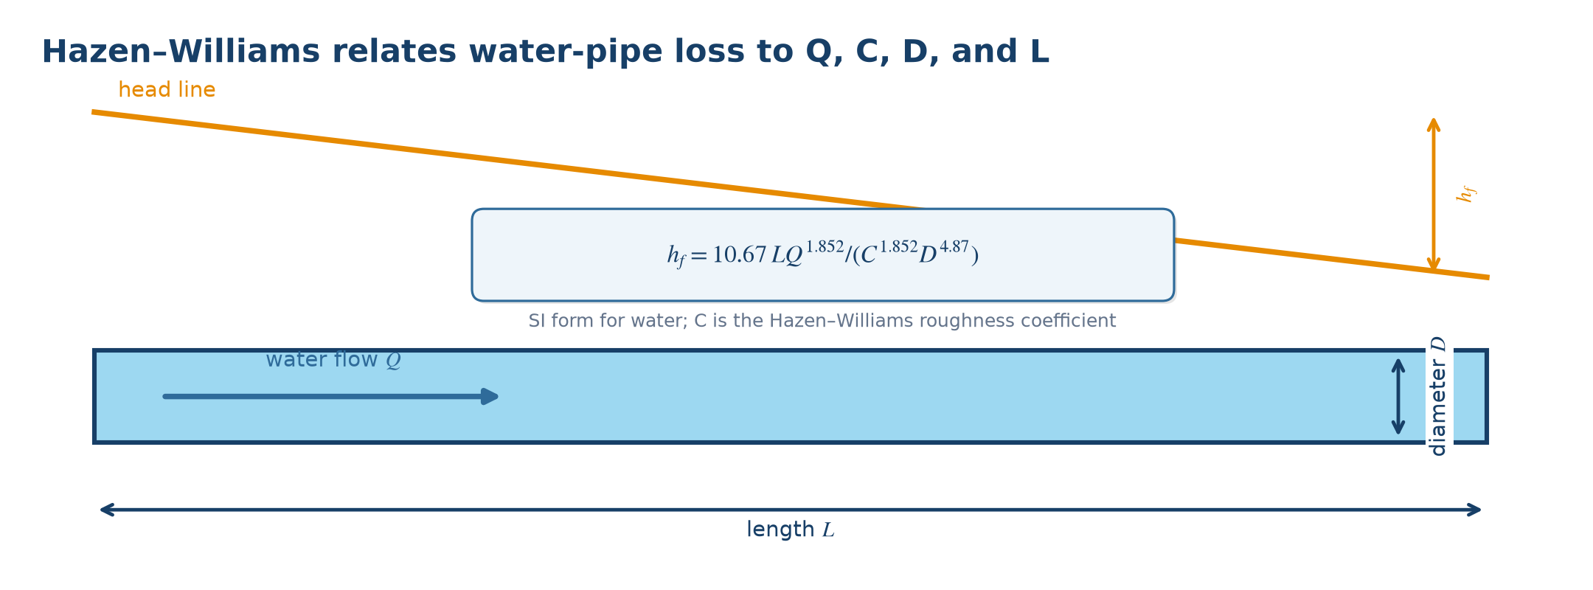
Figure 12.1. Physical meaning and variables used by the governing equations. Source: author-generated schematic.
Engineering note: C decreases as many pipes age or accumulate deposits. Use a design value appropriate to material and condition, not only a new-pipe value.

12.1 Worked examples
Example 12.1. For L = 100 m, D = 0.15 m, Q = 0.03 m³/s, and C = 130, find hf.
Physical model: This is a full water pipe with a specified Hazen-Williams coefficient.
Governing equation:
$hf = 10.67LQ¹·⁸⁵²/(C¹·⁸⁵²D⁴·⁸⁷)$
Substitution:
$hf = 10.67(100)(0.03¹·⁸⁵²)/(130¹·⁸⁵²×0.15⁴·⁸⁷)$
Result:
$hf ≈ 2.02 m$
Interpretation: The 100 m pipe reach consumes approximately 2.02 m of head.
Example 12.2. If Q doubles while L, D, and C stay fixed, by what factor does hf change?
Physical model: Only the discharge term changes.
Governing equation:
$hf,2/hf,1 = (Q₂/Q₁)¹·⁸⁵²$
Substitution:
$hf,2/hf,1 = 2¹·⁸⁵²$
Result:
$hf,2/hf,1 ≈ 3.61$
Interpretation: Doubling flow more than triples loss because the exponent is greater than one.

13. Linear momentum and force at bends or jets
GOVERNING EQUATIONS
$Σ \vec{F}=ρ Q({\vec{V}}_{2}-{\vec{V}}_{1})$ | (13.1)
Scope of application: Use to calculate anchor force at a bend, nozzle, reducer, or jet-deflection device.
Assumptions and limitations: Define a control volume, coordinate directions, and signs. External forces include pressure, weight, and support reaction. The simple form assumes steady flow and section-average velocities.
Table 13.1. Nomenclature
Symbol | Meaning | Unit
$Σ\vec{F}$ | Net external force on the fluid | $N$
$ρ Q$ | Mass flow rate | $kg s^{-1}$
${\vec{V}}_{1}, {\vec{V}}_{2}$ | Inlet and outlet velocity vectors | $m s^{-1}$
Figure 13.1. Formula concept diagram
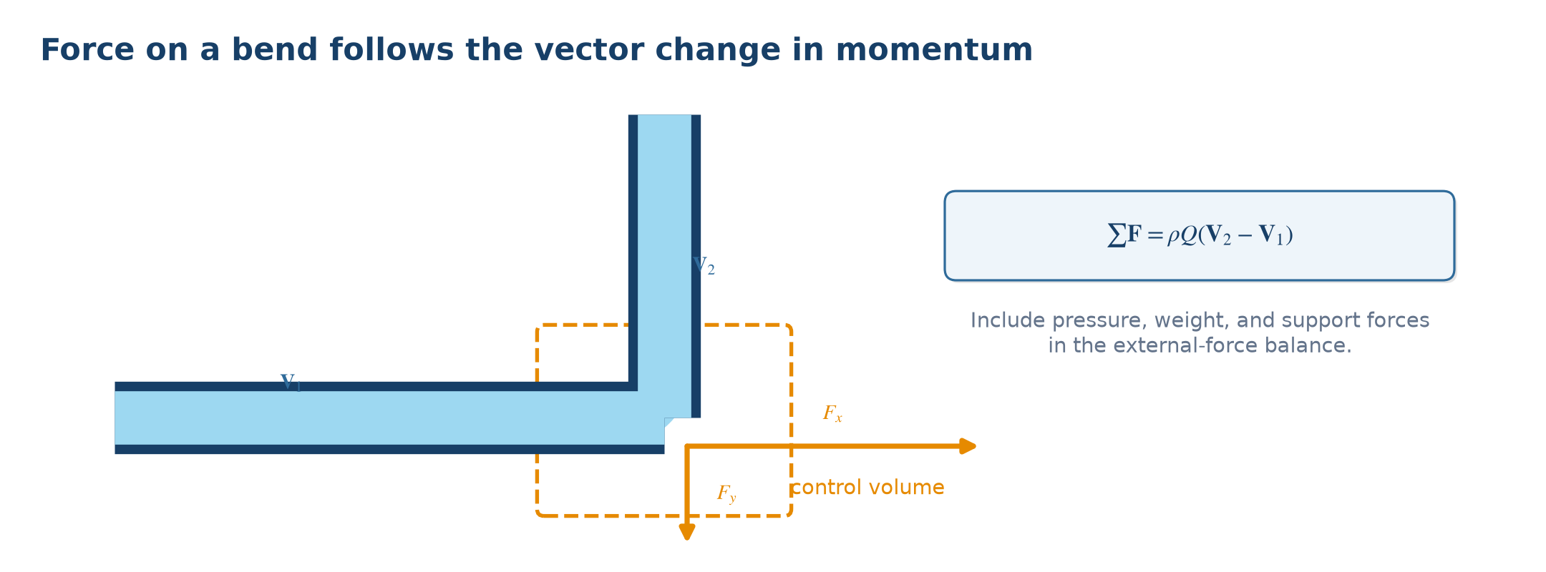
Figure 13.1. Physical meaning and variables used by the governing equations. Source: author-generated schematic.
Engineering note: The force exerted by the fluid on the pipe is equal and opposite to the force exerted by the pipe on the fluid.

13.1 Worked examples
Example 13.1. A water jet with Q = 0.02 m³/s and v = 15 m/s is stopped in its original direction. Find the force.
Physical model: The outlet velocity component in the jet direction becomes zero.
Governing equation:
$F = ρQ(0-v); force magnitude on the plate = ρQv$
Substitution:
$F = 1,000×0.02×15$
Result:
$F = 300 N$
Interpretation: The jet pushes the plate with 300 N in the original jet direction.
Example 13.2. The same ideal jet is reversed by 180°. Find the force magnitude in the original direction.
Physical model: Velocity changes from +v to −v, a change of −2v.
Governing equation:
$|F| = ρQ|−v−(+v)| = 2ρQv$
Substitution:
$F = 2×1,000×0.02×15$
Result:
$F = 600 N$
Interpretation: Complete reversal doubles the momentum change compared with merely stopping the jet.

14. Pump head and power
GOVERNING EQUATIONS
$P_{h}=ρ gQH$ | (14.1)
$P_{in}=\frac{ρ gQH}{η}$ | (14.2)
$H_{p}{=H}_{static}{+h}_{L}+\frac{Δ p}{γ}+\frac{Δ{(v}^{2})}{2g}$ | (14.3)
Scope of application: Use for preliminary pump sizing, hydraulic power, and required input power at a specified duty point.
Assumptions and limitations: H is total pump head at the analyzed discharge. Use efficiency as a decimal and include all elevation, pressure, velocity, and loss terms.
Table 14.1. Nomenclature
Symbol | Meaning | Unit
$P_{h}$ | Hydraulic power delivered to fluid | $W$
$P_{in}$ | Input power | $W$
$Q$ | Discharge | $m^{3} s^{-1}$
$H$ | Pump total head | $m$
$η$ | Overall efficiency | -
$H_{static}$ | Static elevation difference | $m$
Figure 14.1. Formula concept diagram
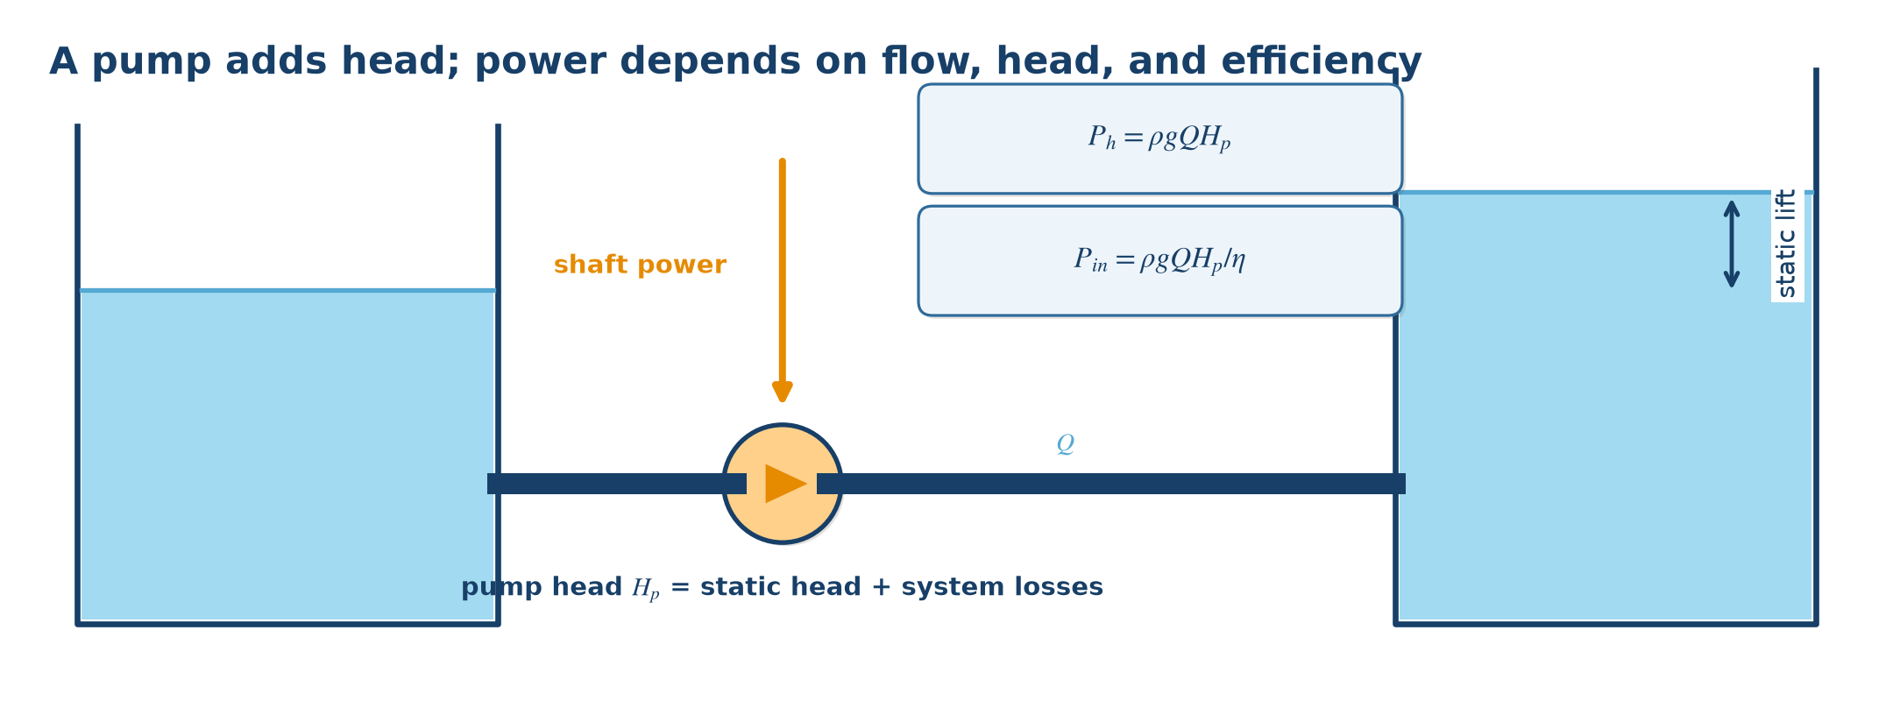
Figure 14.1. Physical meaning and variables used by the governing equations. Source: author-generated schematic.
Engineering note: Motor selection also requires allowance and a check across the full manufacturer performance curve, not only one duty point.

14.1 Worked examples
Example 14.1. A pump delivers Q = 0.04 m³/s at H = 30 m with η = 0.75. Find input power.
Physical model: Input power exceeds hydraulic power because efficiency is below one.
Governing equation:
$Pin = ρgQH/η$
Substitution:
$Pin = 1,000×9.81×0.04×30/0.75$
Result:
$Pin = 15,696 W ≈ 15.70 kW$
Interpretation: A motor must provide at least this shaft/input demand plus the selected design allowance.
Example 14.2. Two open reservoirs differ in elevation by 12 m; system loss is 4.5 m. Find pump head.
Physical model: Apply Bernoulli between the large free surfaces.
Governing equation:
$Hp = Hstatic + hL$
Substitution:
$Hp = 12+4.5$
Result:
$Hp = 16.5 m$
Interpretation: The required duty point is the design flow at 16.5 m total head.

15. Pump affinity laws
GOVERNING EQUATIONS
$\frac{Q_{2}}{Q_{1}}=\frac{n_{2}}{n_{1}}$ | (15.1)
$\frac{H_{2}}{H_{1}}=(\frac{n_{2}}{n_{1}})^{2}$ | (15.2)
$\frac{P_{2}}{P_{1}}=(\frac{n_{2}}{n_{1}})^{3}$ | (15.3)
Scope of application: Use to estimate performance changes when the rotational speed of the same pump changes.
Assumptions and limitations: Pump geometry and fluid remain unchanged and efficiency does not change greatly. Use manufacturer curves for large departures from the original speed.
Table 15.1. Nomenclature
Symbol | Meaning | Unit
$Q$ | Discharge | $m^{3} s^{-1} or m^{3} h^{-1}$
$H$ | Pump head | $m$
$P$ | Power | W or kW
$n$ | Rotational speed | $rpm$
Figure 15.1. Formula concept diagram
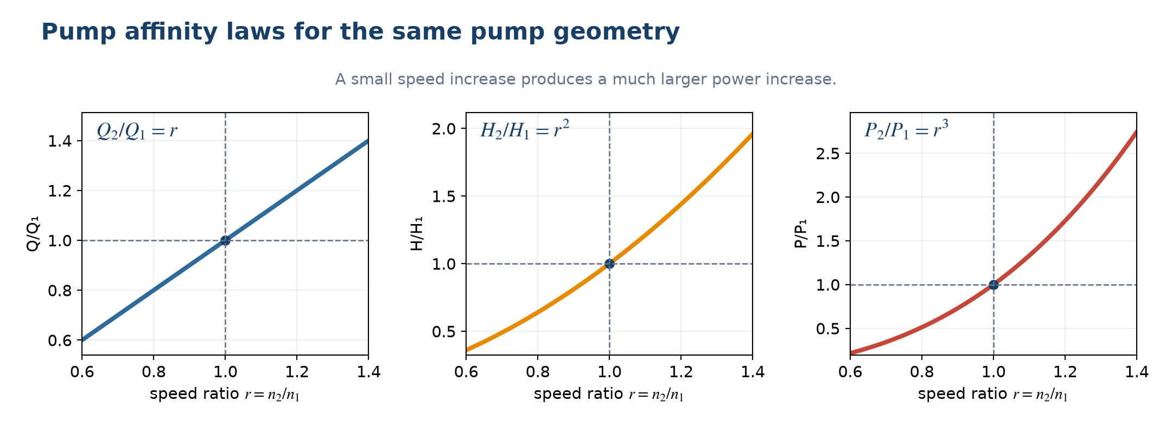
Figure 15.1. Physical meaning and variables used by the governing equations. Source: author-generated schematic.
Engineering note: Power follows the cube of speed, so a modest speed increase can produce a large power increase.

15.1 Worked examples
Example 15.1. A pump produces 40 m³/h at 1,500 rpm. Estimate Q at 1,800 rpm.
Physical model: Use the discharge-speed affinity law for the same pump.
Governing equation:
$Q₂ = Q₁(n₂/n₁)$
Substitution:
$Q₂ = 40(1,800/1,500)$
Result:
$Q₂ = 48 m³/h$
Interpretation: A 20% speed increase produces approximately 20% more discharge under affinity-law assumptions.
Example 15.2. At 1,500 rpm a pump produces H = 25 m and P = 5 kW. Estimate H and P at 1,800 rpm.
Physical model: Head follows speed squared and power follows speed cubed.
Governing equation:
$H₂ = H₁r²; P₂ = P₁r³, where r = n₂/n₁$
Substitution:
$r = 1.2; H₂ = 25(1.2²); P₂ = 5(1.2³)$
Result:
$H₂ = 36 m; P₂ = 8.64 kW$
Interpretation: A 20% speed increase raises head by 44% and power by 72.8%.

16. NPSH and cavitation check
GOVERNING EQUATIONS
${NPSH}_{A}=\frac{p_{atm}}{γ}{+z}_{s}{-h}_{L,suction}-\frac{p_{v}}{γ}$ | (16.1)
${NPSH}_{A}{>NPSH}_{R}+margin$ | (16.2)
Scope of application: Use to assess pump-suction cavitation risk and to choose suction elevation, pipe size, or operating temperature.
Assumptions and limitations: All pressure heads are absolute and use one datum. zs is positive when the source free surface lies above the pump centerline under this sign convention. Obtain NPSHR from the pump manufacturer at the actual duty.
Table 16.1. Nomenclature
Symbol | Meaning | Unit
${NPSH}_{A}$ | Available NPSH from system | $m$
${NPSH}_{R}$ | Required NPSH from pump | $m$
$p_{atm}$ | Absolute atmospheric pressure | $Pa$
$p_{v}$ | Absolute vapor pressure | $Pa$
$z_{s}$ | Source level relative to pump centerline | $m$
$h_{L,suction}$ | Suction-line head loss | $m$
Figure 16.1. Formula concept diagram
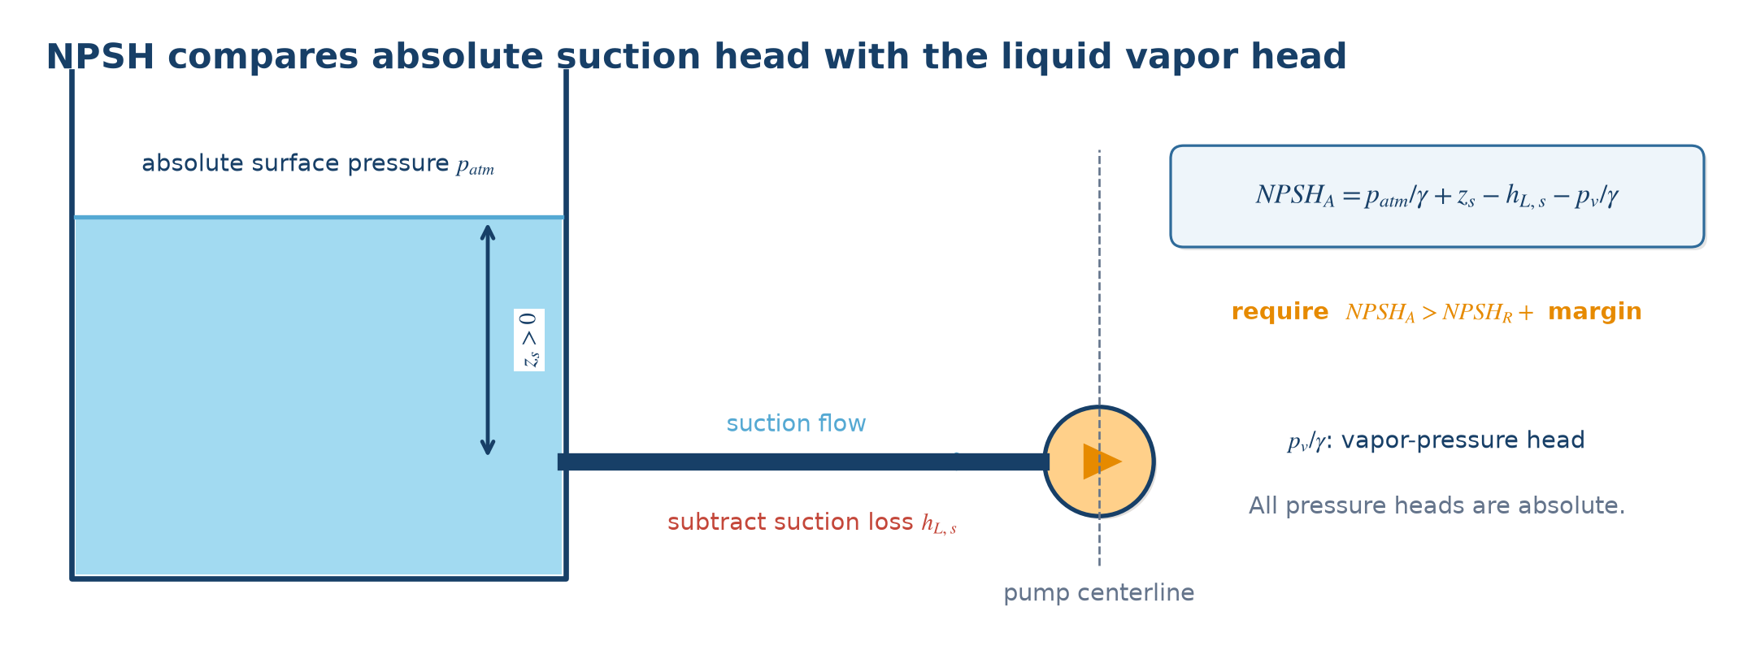
Figure 16.1. Physical meaning and variables used by the governing equations. Source: author-generated schematic.
Engineering note: Higher liquid temperature increases vapor pressure and reduces NPSHA. Never substitute gauge pressure for absolute pressure in this check.

16.1 Worked examples
Example 16.1. Given patm/γ = 10.3 m, zs = 2.0 m, suction loss = 1.1 m, and pv/γ = 0.3 m, find NPSHA.
Physical model: Sum the absolute-pressure and elevation contributions, then subtract suction loss and vapor head.
Governing equation:
$NPSHA = patm/γ + zs − hL,suction − pv/γ$
Substitution:
$NPSHA = 10.3+2.0−1.1−0.3$
Result:
$NPSHA = 10.9 m$
Interpretation: The system supplies 10.9 m of net head above vapor pressure at the pump suction.
Example 16.2. NPSHA = 4.2 m and NPSHR = 3.5 m. A 1.0 m margin is required. Does the system pass?
Physical model: Compare available NPSH with required NPSH plus margin.
Governing equation:
$Pass if NPSHA ≥ NPSHR + margin$
Substitution:
$Required available value = 3.5+1.0 = 4.5 m$
Result:
$4.2 m < 4.5 m; shortfall = 0.3 m$
Interpretation: The system fails the stated margin even though NPSHA is slightly above bare NPSHR.

17. Hydraulic radius, Manning, and Chezy
GOVERNING EQUATIONS
$R_{h}=\frac{A}{P_{w}}$ | (17.1)
$v=\frac{1}{n}R_{h}^{\frac{2}{3}}S^{\frac{1}{2}}$ | (17.2)
$Q=Av$ | (17.3)
$v=C\sqrt{R_{h}S}$ | (17.4)
Scope of application: Use for steady uniform flow in open channels, ditches, and partially full conduits.
Assumptions and limitations: Flow is approximately steady and uniform, energy slope is close to bed slope, and the selected roughness represents actual surface condition. Do not apply directly through rapidly varied transitions.
Table 17.1. Nomenclature
Symbol | Meaning | Unit
$R_{h}$ | Hydraulic radius | $m$
$A$ | Wetted flow area | $m^{2}$
$P_{w}$ | Wetted perimeter | $m$
$n$ | Manning roughness | $s m^{-\frac{1}{3}}$
$S$ | Energy slope | $m m^{-1}$
$C$ | Chezy coefficient | $m^{\frac{1}{2}} s^{-1}$
Figure 17.1. Formula concept diagram
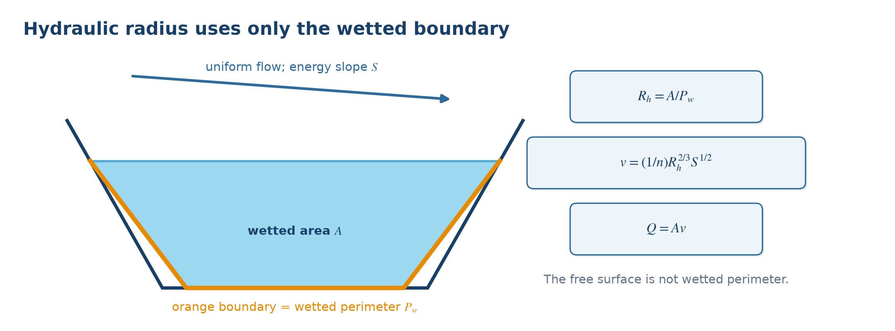
Figure 17.1. Physical meaning and variables used by the governing equations. Source: author-generated schematic.
Engineering note: Hydraulic radius is area divided by wetted perimeter; it is not the geometric radius. For a very wide channel, Rh approaches flow depth.

17.1 Worked examples
Example 17.1. A rectangular channel has b = 2 m and y = 1 m. Find A, Pw, and Rh.
Physical model: Use rectangular-channel geometry.
Governing equation:
$A = by; Pw = b+2y; Rh = A/Pw$
Substitution:
$A = 2×1; Pw = 2+2×1; Rh = 2/4$
Result:
$A = 2 m²; Pw = 4 m; Rh = 0.50 m$
Interpretation: Only the bed and sidewalls touching water contribute to wetted perimeter.
Example 17.2. For that channel, n = 0.015 and S = 0.001. Find Q by Manning.
Physical model: The channel is assumed to carry steady uniform flow.
Governing equation:
$Q = A(1/n)Rh²ᐟ³S¹ᐟ²$
Substitution:
$Q = 2(1/0.015)(0.50²ᐟ³)(0.001¹ᐟ²)$
Result:
$Q ≈ 2.66 m³/s$
Interpretation: This is the normal-flow discharge for the stated depth, slope, and roughness.

18. Rectangular and trapezoidal channel geometry
GOVERNING EQUATIONS
$Rectangle: A=by, { P}_{w}=b+2y, T=b$ | (18.1)
$Trapezoid: A=y(b+my), { P}_{w}=b+2y\sqrt{{1+m}^{2}}, T=b+2my$ | (18.2)
Scope of application: Use to obtain the geometric inputs required by Manning, Chezy, Froude, and channel-design calculations.
Assumptions and limitations: m is horizontal-to-vertical side slope. The trapezoidal formulas assume equal slopes on both sides.
Table 18.1. Nomenclature
Symbol | Meaning | Unit
$b$ | Bottom width | $m$
$y$ | Flow depth | $m$
$m$ | Side slope, horizontal/vertical | -
$T$ | Top width | $m$
$A$ | Wetted area | $m^{2}$
$P_{w}$ | Wetted perimeter | $m$
Figure 18.1. Formula concept diagram
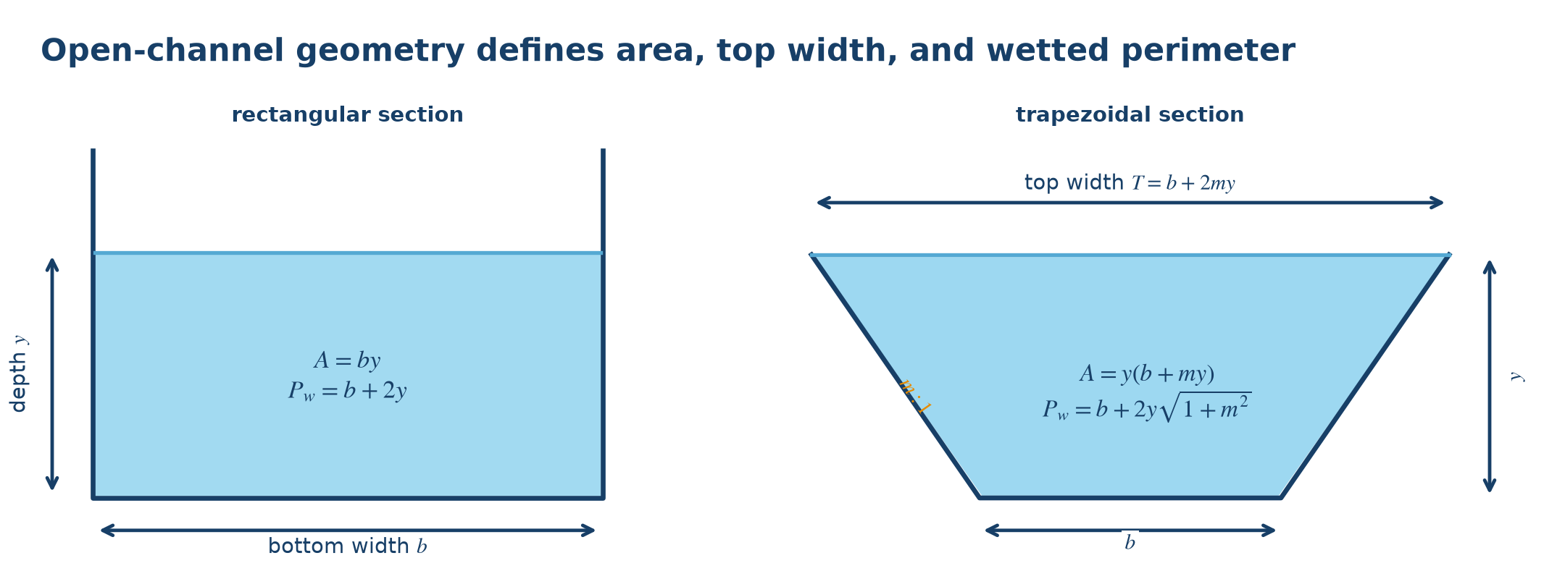
Figure 18.1. Physical meaning and variables used by the governing equations. Source: author-generated schematic.
Engineering note: For an asymmetric channel, calculate each side length separately rather than using the factor of two.

18.1 Worked examples
Example 18.1. A rectangular channel has b = 3 m and y = 1.2 m. Find A and Pw.
Physical model: Use the rectangular section formulas.
Governing equation:
$A = by; Pw = b+2y$
Substitution:
$A = 3×1.2; Pw = 3+2×1.2$
Result:
$A = 3.6 m²; Pw = 5.4 m$
Interpretation: The free surface is not part of the wetted perimeter.
Example 18.2. A trapezoidal channel has b = 2 m, y = 1.5 m, and m = 1.5. Find A, T, and Pw.
Physical model: Both side slopes are 1.5 horizontal to 1 vertical.
Governing equation:
$A = y(b+my); T = b+2my; Pw = b+2y√(1+m²)$
Substitution:
$A = 1.5(2+1.5×1.5); T = 2+2×1.5×1.5; Pw = 2+2×1.5√(1+1.5²)$
Result:
$A = 6.375 m²; T = 6.50 m; Pw = 7.408 m$
Interpretation: These values can now be used to compute Rh = A/Pw and channel capacity.

19. Specific energy, Froude number, and critical depth
GOVERNING EQUATIONS
$E=y+\frac{v^{2}}{2g}$ | (19.1)
$Fr=\frac{v}{\sqrt{{gD}_{h}}}$ | (19.2)
$q=\frac{Q}{b}$ | (19.3)
$y_{c}=(\frac{q^{2}}{g})^{\frac{1}{3}}$ | (19.4)
$E_{min}=\frac{3}{2}y_{c}$ | (19.5)
Scope of application: Use to classify subcritical, critical, or supercritical open-channel flow and compute critical depth in a rectangular channel.
Assumptions and limitations: Dh = A/T is open-channel hydraulic depth. The stated critical-depth expression applies only to a rectangular channel. Specific energy is measured relative to the local bed.
Table 19.1. Nomenclature
Symbol | Meaning | Unit
$E$ | Specific energy | $m$
$Fr$ | Froude number | -
$D_{h}$ | Hydraulic depth A/T | $m$
$q$ | Discharge per unit width | $m^{2} s^{-1}$
$y_{c}$ | Critical depth | $m$
Figure 19.1. Formula concept diagram
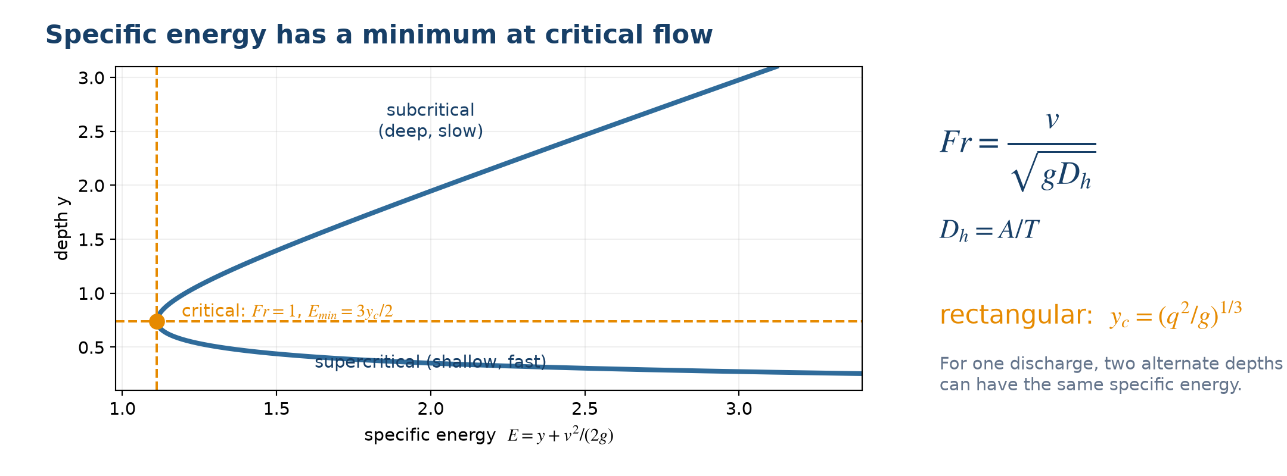
Figure 19.1. Physical meaning and variables used by the governing equations. Source: author-generated schematic.
Engineering note: Fr < 1 is subcritical, Fr = 1 is critical, and Fr > 1 is supercritical.

19.1 Worked examples
Example 19.1. A rectangular channel has y = 0.8 m and v = 3.5 m/s. Find Fr and classify the flow.
Physical model: For a rectangular channel, hydraulic depth equals y.
Governing equation:
$Fr = v/√(gy)$
Substitution:
$Fr = 3.5/√(9.81×0.8)$
Result:
$Fr = 1.25$
Interpretation: Because Fr > 1, the flow is supercritical and disturbances cannot travel far upstream.
Example 19.2. A 4 m wide rectangular channel carries Q = 8 m³/s. Find critical depth.
Physical model: Compute unit discharge, then use the rectangular critical-depth equation.
Governing equation:
$q = Q/b; yc = (q²/g)¹ᐟ³$
Substitution:
$q = 8/4 = 2 m²/s; yc = (2²/9.81)¹ᐟ³$
Result:
$yc = 0.742 m$
Interpretation: At this depth the Froude number is one and specific energy is minimum for the discharge.

20. Hydraulic jump in a rectangular channel
GOVERNING EQUATIONS
$\frac{y_{2}}{y_{1}}=\frac{1}{2}[\sqrt{{1+8Fr}_{1}^{2}}-1]$ | (20.1)
$Δ E=\frac{{(y}_{2}{-y}_{1})^{3}}{{4y}_{1}y_{2}}$ | (20.2)
Scope of application: Use to find conjugate depths and dissipated energy when supercritical flow changes to subcritical flow in a stilling basin.
Assumptions and limitations: Rectangular channel, nearly horizontal bed, stable jump, and negligible boundary friction over the short jump length. Fr₁ is evaluated before the jump.
Table 20.1. Nomenclature
Symbol | Meaning | Unit
$y_{1}$ | Upstream supercritical depth | $m$
$y_{2}$ | Downstream conjugate depth | $m$
${Fr}_{1}$ | Upstream Froude number | -
$Δ E$ | Specific-energy loss | $m$
Figure 20.1. Formula concept diagram
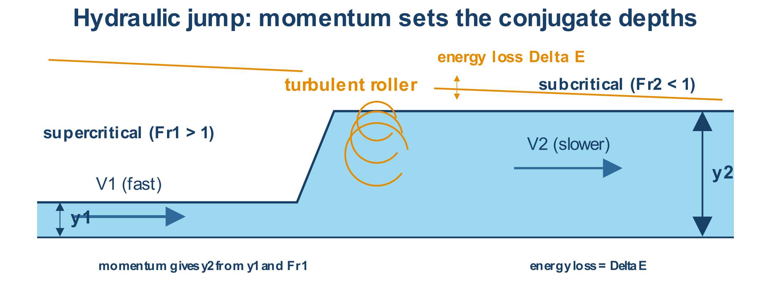
Figure 20.1. Physical meaning and variables used by the governing equations. Source: author-generated schematic.
Engineering note: The downstream depth is not arbitrary; it is the conjugate depth determined by upstream momentum.

20.1 Worked examples
Example 20.1. Given y₁ = 0.40 m and Fr₁ = 4.0, find y₂.
Physical model: Use the conjugate-depth relation for a rectangular hydraulic jump.
Governing equation:
$y₂ = y₁·0.5[√(1+8Fr₁²)−1]$
Substitution:
$y₂ = 0.40×0.5[√(1+8×4²)−1]$
Result:
$y₂ = 2.072 m$
Interpretation: The depth increases by more than five times as the flow becomes subcritical.
Example 20.2. Using y₁ = 0.40 m and y₂ = 2.072 m, find ΔE.
Physical model: Use the hydraulic-jump energy-loss expression.
Governing equation:
$ΔE = (y₂−y₁)³/(4y₁y₂)$
Substitution:
$ΔE = (2.072−0.40)³/(4×0.40×2.072)$
Result:
$ΔE ≈ 1.41 m$
Interpretation: The turbulent roller dissipates about 1.41 m of specific energy.

21. Sharp-crested weir discharge
GOVERNING EQUATIONS
$Q_{rect}=\frac{2}{3}C_{d}b\sqrt{2g}H^{\frac{3}{2}}$ | (21.1)
$Q_{V-notch}=\frac{8}{15}C_{d}tan(\frac{θ}{2})\sqrt{2g}H^{\frac{5}{2}}$ | (21.2)
Scope of application: Use to measure or estimate open-channel flow over sharp-crested rectangular or triangular weirs.
Assumptions and limitations: Approach flow is calm, crest is sharp, nappe is ventilated, and H is measured sufficiently upstream above the crest elevation. Cd must match geometry and contraction.
Table 21.1. Nomenclature
Symbol | Meaning | Unit
$Q$ | Discharge | $m^{3} s^{-1}$
$C_{d}$ | Discharge coefficient | -
$b$ | Rectangular crest width | $m$
$H$ | Head above crest | $m$
$θ$ | V-notch included angle | degree or rad consistent with tan
Figure 21.1. Formula concept diagram
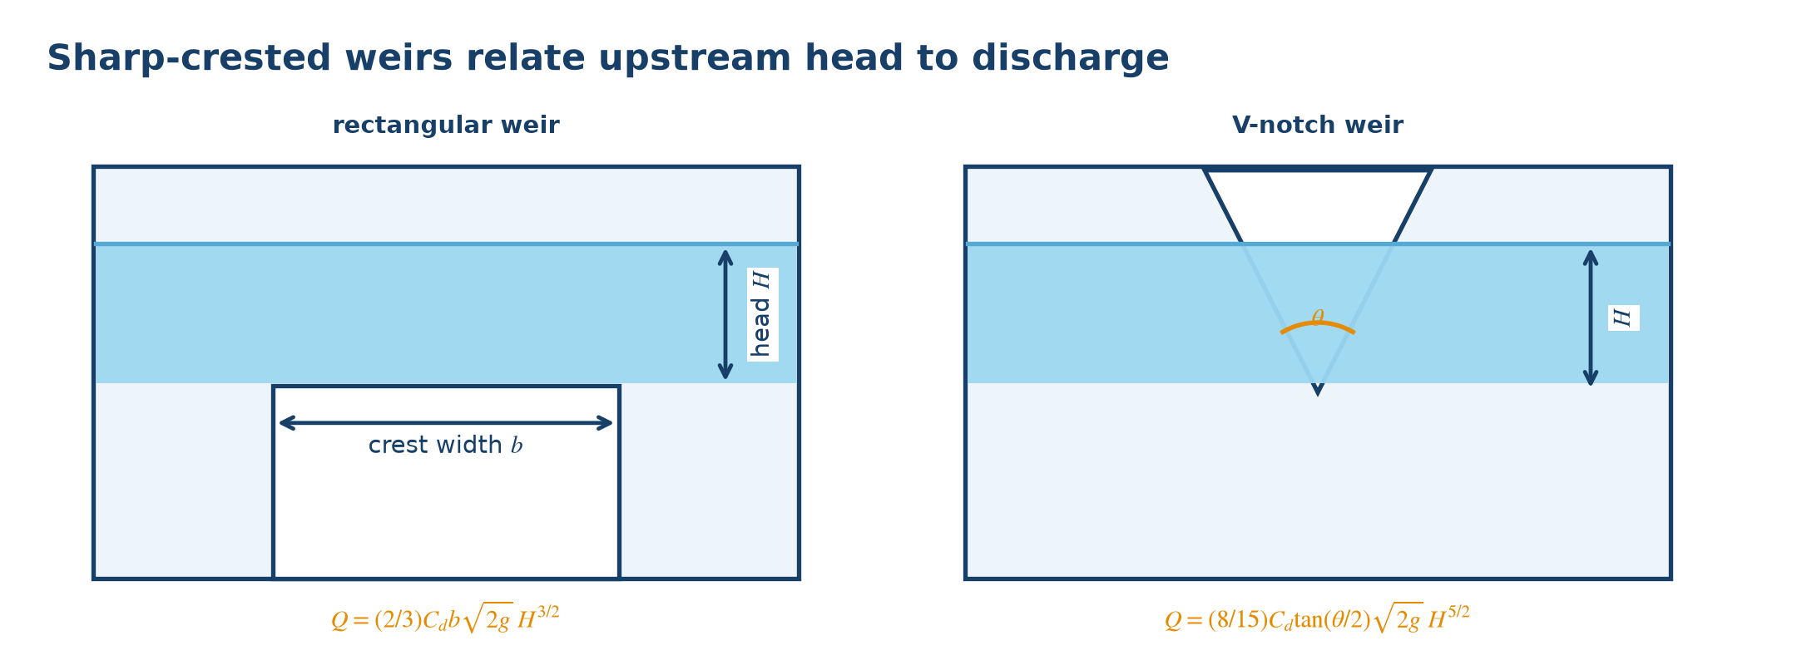
Figure 21.1. Physical meaning and variables used by the governing equations. Source: author-generated schematic.
Engineering note: A V-notch is more sensitive at low flows because discharge varies with H to the 5/2 power.

21.1 Worked examples
Example 21.1. A rectangular weir has b = 1.2 m, H = 0.30 m, and Cd = 0.62. Find Q.
Physical model: Use the sharp-crested rectangular-weir relation.
Governing equation:
$Q = (2/3)Cd b√(2g)H³ᐟ²$
Substitution:
$Q = (2/3)(0.62)(1.2)√(2×9.81)(0.30³ᐟ²)$
Result:
$Q = 0.361 m³/s$
Interpretation: The result assumes a ventilated free nappe and the stated coefficient.
Example 21.2. A 90° V-notch has H = 0.25 m and Cd = 0.60. Find Q.
Physical model: Use the V-notch formula with tan(θ/2) = tan45° = 1.
Governing equation:
$Q = (8/15)Cd tan(θ/2)√(2g)H⁵ᐟ²$
Substitution:
$Q = (8/15)(0.60)(1)√(2×9.81)(0.25⁵ᐟ²)$
Result:
$Q = 0.0443 m³/s$
Interpretation: The triangular notch provides useful sensitivity at this relatively small flow.

22. Tank drawdown time
GOVERNING EQUATIONS
$t=\frac{{2A}_{t}}{C_{d}a\sqrt{2g}}(\sqrt{h_{1}}-\sqrt{h_{2}})$ | (22.1)
Scope of application: Use to find the time for a constant-plan-area tank level to fall from h₁ to h₂ through a small opening.
Assumptions and limitations: Tank area At is constant and much larger than opening area a; Cd is constant; tank is open and discharges freely; h is measured above the opening center.
Table 22.1. Nomenclature
Symbol | Meaning | Unit
$t$ | Drawdown time | $s$
$A_{t}$ | Tank plan area | $m^{2}$
$a$ | Opening area | $m^{2}$
$C_{d}$ | Discharge coefficient | -
$h_{1}{, h}_{2}$ | Initial and final heads | $m$
Figure 22.1. Formula concept diagram
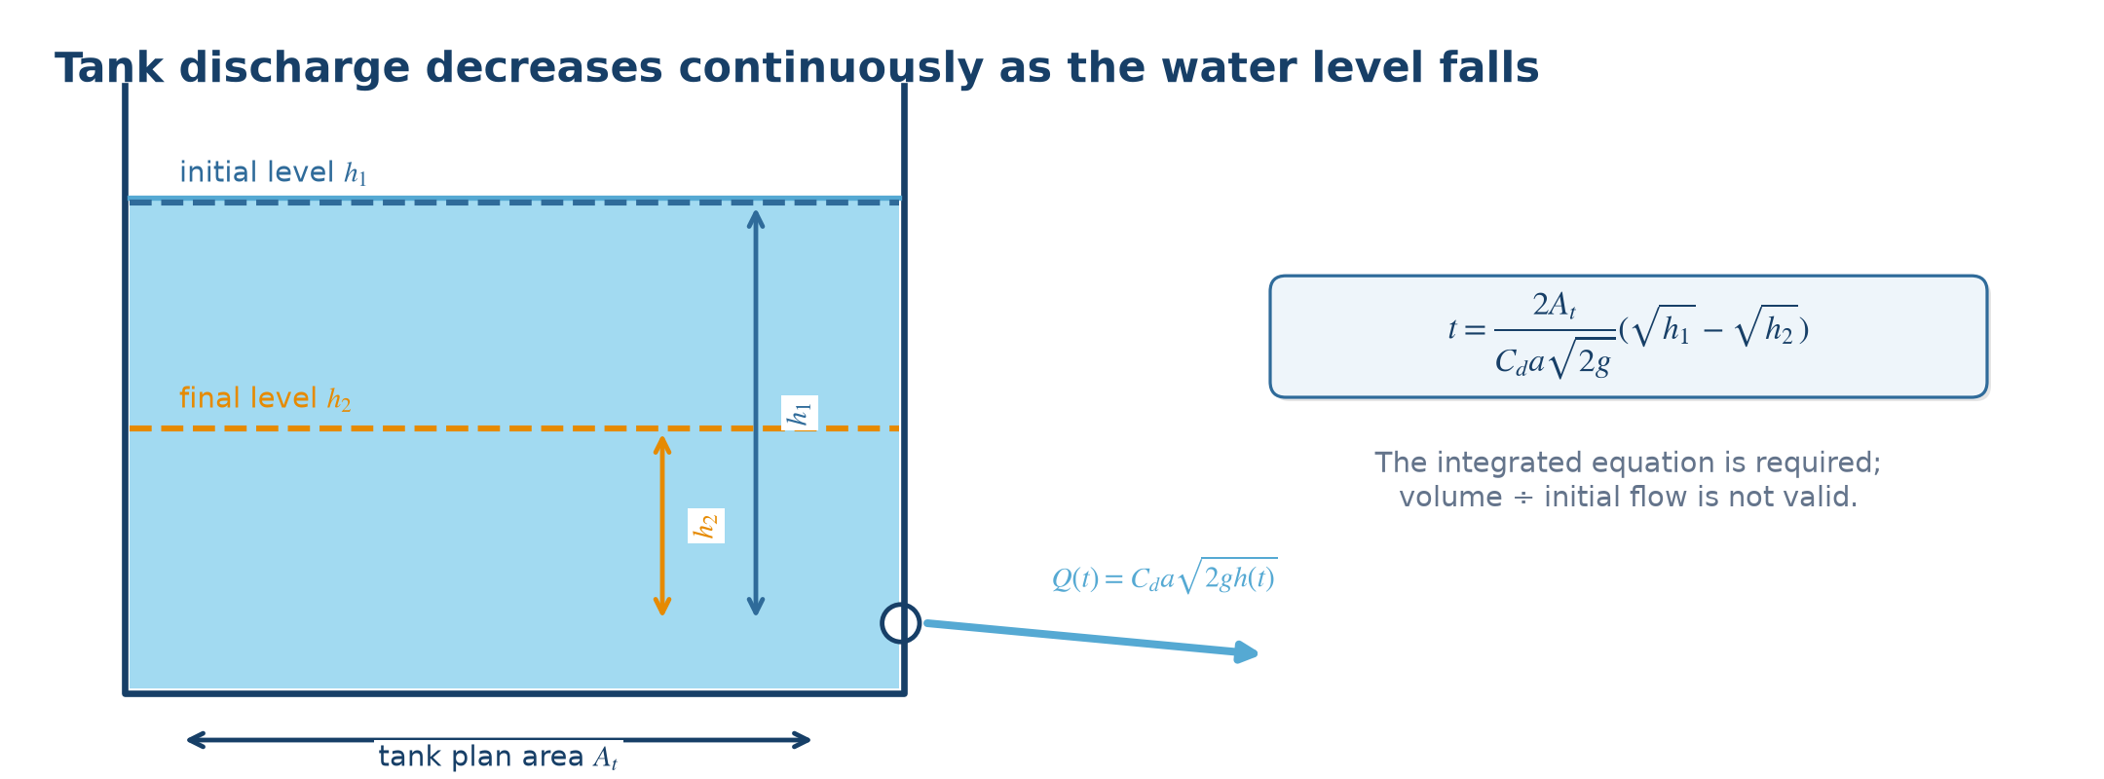
Figure 22.1. Physical meaning and variables used by the governing equations. Source: author-generated schematic.
Engineering note: Do not use a constant-flow volume/time estimate because discharge decreases continuously as the level falls.

22.1 Worked examples
Example 22.1. A tank has At = 5 m² and a = 0.01 m². With Cd = 0.62, find the time for h to fall from 3 m to 1 m.
Physical model: The head and therefore the orifice discharge vary during drainage.
Governing equation:
$t = [2At/(Cd a√(2g))](√h₁−√h₂)$
Substitution:
$t = [2×5/(0.62×0.01√(2×9.81))](√3−√1)$
Result:
$t = 266.6 s = 4.44 min$
Interpretation: The integrated drawdown equation accounts for the falling discharge.
Example 22.2. For the same tank, find the idealized time to drain from h = 1 m to the opening center.
Physical model: Set h₁ = 1 m and h₂ = 0 in the same drawdown relation.
Governing equation:
$t = [2At/(Cd a√(2g))](√1−√0)$
Substitution:
$t = [10/(0.62×0.01√19.62)](1)$
Result:
$t = 364.1 s = 6.07 min$
Interpretation: The last metre takes longer than expected from a constant initial flow because velocity approaches zero near empty.

23. Joukowsky water hammer
GOVERNING EQUATIONS
$Δ p=ρ aΔ v$ | (23.1)
$Δ H=\frac{aΔ v}{g}$ | (23.2)
$t_{c}=\frac{2L}{a}$ | (23.3)
Scope of application: Use for a first estimate of rapid pressure change caused by fast valve closure, pump trip, or sudden velocity change in a pipe.
Assumptions and limitations: The Joukowsky relation represents rapid change in an elastic liquid-pipe system. For closure slower than tc, use a slow-closure/transient model. Real systems include friction, air, cavitation, and wave reflection.
Table 23.1. Nomenclature
Symbol | Meaning | Unit
$Δ p$ | Pressure change | $Pa$
$a$ | Pressure-wave speed | $m s^{-1}$
$Δ v$ | Velocity change | $m s^{-1}$
$Δ H$ | Head change | $m$
$t_{c}$ | Critical closure time | $s$
$L$ | Pipe length | $m$
Figure 23.1. Formula concept diagram
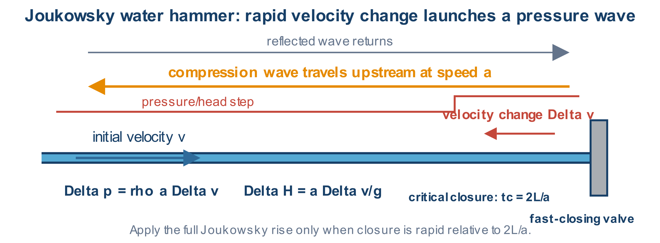
Figure 23.1. Physical meaning and variables used by the governing equations. Source: author-generated schematic.
Engineering note: Check both positive surge pressure and negative pressure that may cause column separation or cavitation.

23.1 Worked examples
Example 23.1. Water in a pipe has a = 1,000 m/s and velocity decreases by 1.5 m/s. Find Δp and ΔH.
Physical model: Treat the velocity reduction as a rapid Joukowsky event.
Governing equation:
$Δp = ρaΔv; ΔH = aΔv/g$
Substitution:
$Δp = 1,000×1,000×1.5; ΔH = 1,000×1.5/9.81$
Result:
$Δp = 1.50 MPa; ΔH = 152.9 m$
Interpretation: A seemingly modest velocity change can create a very large transient pressure rise.
Example 23.2. A pipe is 800 m long and wave speed is 1,000 m/s. Find critical closure time.
Physical model: A pressure wave must travel to the boundary and return.
Governing equation:
$tc = 2L/a$
Substitution:
$tc = 2×800/1,000$
Result:
$tc = 1.6 s$
Interpretation: A closure completed in less than about 1.6 s is classified as rapid for this line.

24. Darcy law for porous-media seepage
GOVERNING EQUATIONS
$Q=kAi=kA\frac{Δ h}{L}$ | (24.1)
$v_{D}=\frac{Q}{A}=ki$ | (24.2)
$v_{s}=\frac{v_{D}}{n_{e}}$ | (24.3)
Scope of application: Use for laminar seepage through saturated soil or another porous medium and to distinguish Darcy velocity from pore velocity.
Assumptions and limitations: Flow is laminar and the saturated medium can be represented by hydraulic conductivity k. Use directional conductivity for anisotropic material.
Table 24.1. Nomenclature
Symbol | Meaning | Unit
$Q$ | Seepage discharge | $m^{3} s^{-1}$
$k$ | Hydraulic conductivity | $m s^{-1}$
$A$ | Area normal to seepage | $m^{2}$
$i$ | Hydraulic gradient Δh/L | -
$v_{D}$ | Darcy velocity | $m s^{-1}$
$v_{s}$ | Average pore velocity | $m s^{-1}$
$n_{e}$ | Effective porosity | -
Figure 24.1. Formula concept diagram
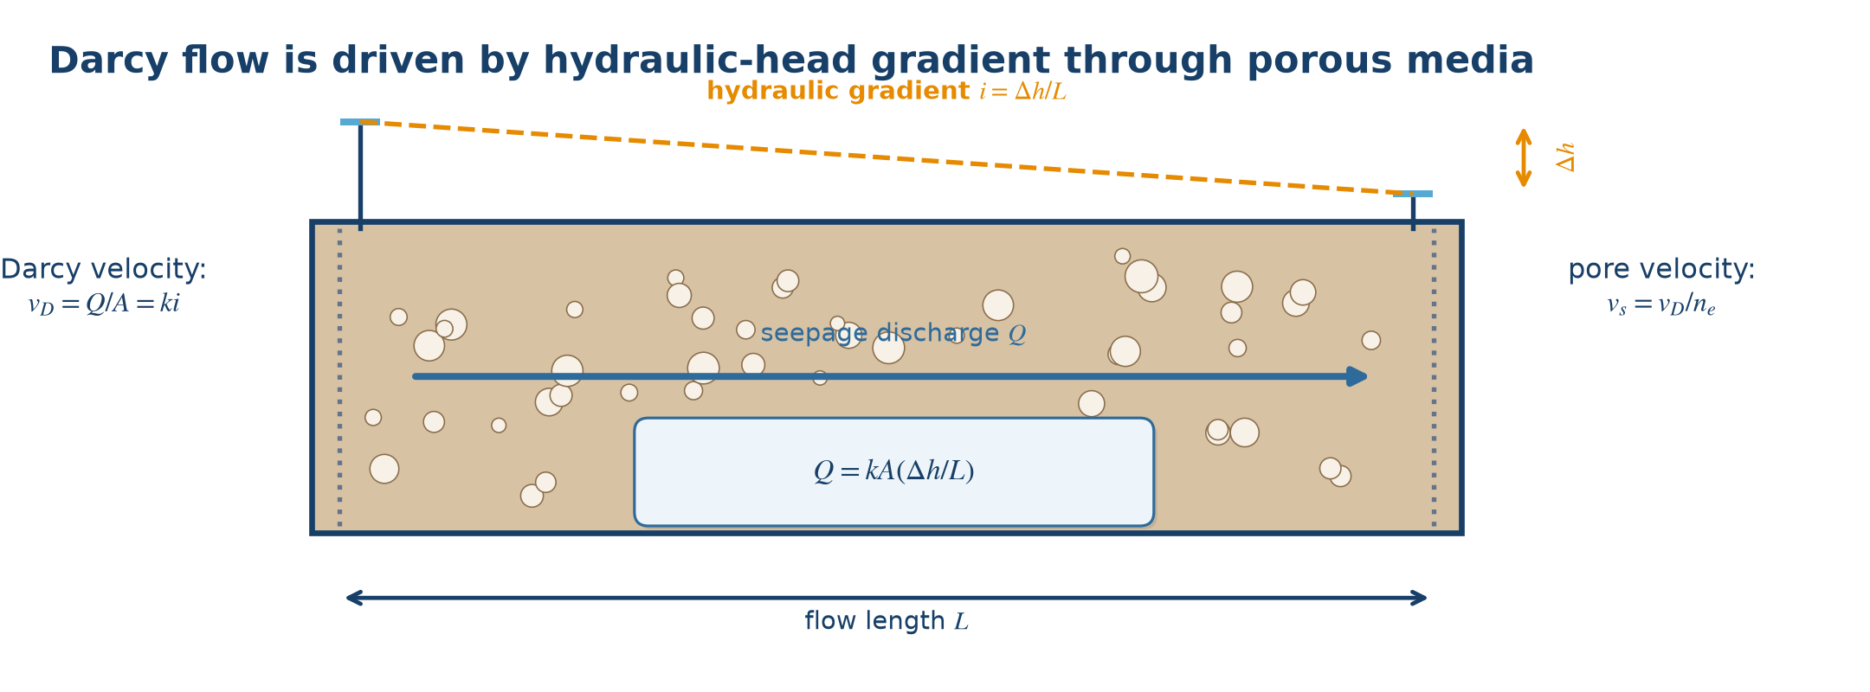
Figure 24.1. Physical meaning and variables used by the governing equations. Source: author-generated schematic.
Engineering note: Darcy velocity divides flow by the total specimen area and is therefore lower than the mean velocity through connected pores.

24.1 Worked examples
Example 24.1. A soil specimen has k = 2×10⁻⁵ m/s, A = 0.50 m², Δh = 1.2 m, and L = 3 m. Find Q.
Physical model: The saturated specimen is modeled by one-dimensional Darcy flow.
Governing equation:
$Q = kA(Δh/L)$
Substitution:
$Q = 2×10⁻⁵×0.50×(1.2/3)$
Result:
$Q = 4.0×10⁻⁶ m³/s$
Interpretation: This equals 4.0 mL/s through the specimen.
Example 24.2. For k = 2×10⁻⁵ m/s, i = 0.4, and ne = 0.32, find vD and vs.
Physical model: First find Darcy velocity, then correct for the fraction of area occupied by connected pores.
Governing equation:
$vD = ki; vs = vD/ne$
Substitution:
$vD = 2×10⁻⁵×0.4; vs = 8×10⁻⁶/0.32$
Result:
$vD = 8.0×10⁻⁶ m/s; vs = 2.5×10⁻⁵ m/s$
Interpretation: The pore-water velocity is higher because flow passes only through the effective pore area.

References
[1] White, F. M., and Xue, H. Fluid Mechanics, 9th ed. McGraw Hill, ISBN 978-1-260-25831-8.
[2] Çengel, Y. A., and Cimbala, J. M. Fluid Mechanics: Fundamentals and Applications, 4th ed., 2024 release. McGraw Hill.
[3] Gerhart, A. L., Hochstein, J. I., and Gerhart, P. M. Munson, Young and Okiishi's Fundamentals of Fluid Mechanics, 9th ed. Wiley, 2020, ISBN 978-1-119-68945-4.
[4] Chow, V. T. Open-Channel Hydraulics. McGraw-Hill, 1959.
[5] Idelchik, I. E. Handbook of Hydraulic Resistance, 3rd ed. CRC Press, 1994.
Reference note: Equations and examples in this handbook are synthesized for instruction from standard fluid-mechanics relationships. Empirical coefficients must be selected from the governing standard, manufacturer data, or validated project-specific sources.

Appendix A. Quick conversions
Quantity | Conversion
1 m³/s | 1,000 L/s = 3,600 m³/h
1 L/s | 3.6 m³/h
1 bar | 100 kPa
1 mH₂O | ≈ 9.81 kPa ≈ 0.0981 bar
1 MPa | ≈ 101.97 mH₂O
Engineering water | ρ ≈ 1,000 kg/m³; γ ≈ 9,810 N/m³

Appendix B. Problem-solving checklist
- Sketch the system and identify the sections or points of interest.
- State the assumptions: steady or unsteady, full pipe or open channel, gauge or absolute pressure.
- Convert every input to one consistent unit system.
- Select a formula whose assumptions match the physical situation and identify empirical coefficients.
- Substitute values with units; check dimensions and order of magnitude.
- Check velocity, pressure, cavitation, stability, and applicable design limits.

