**Trial and feedback**

14/05/2024

Beginning of project

Start to implement demo Grid

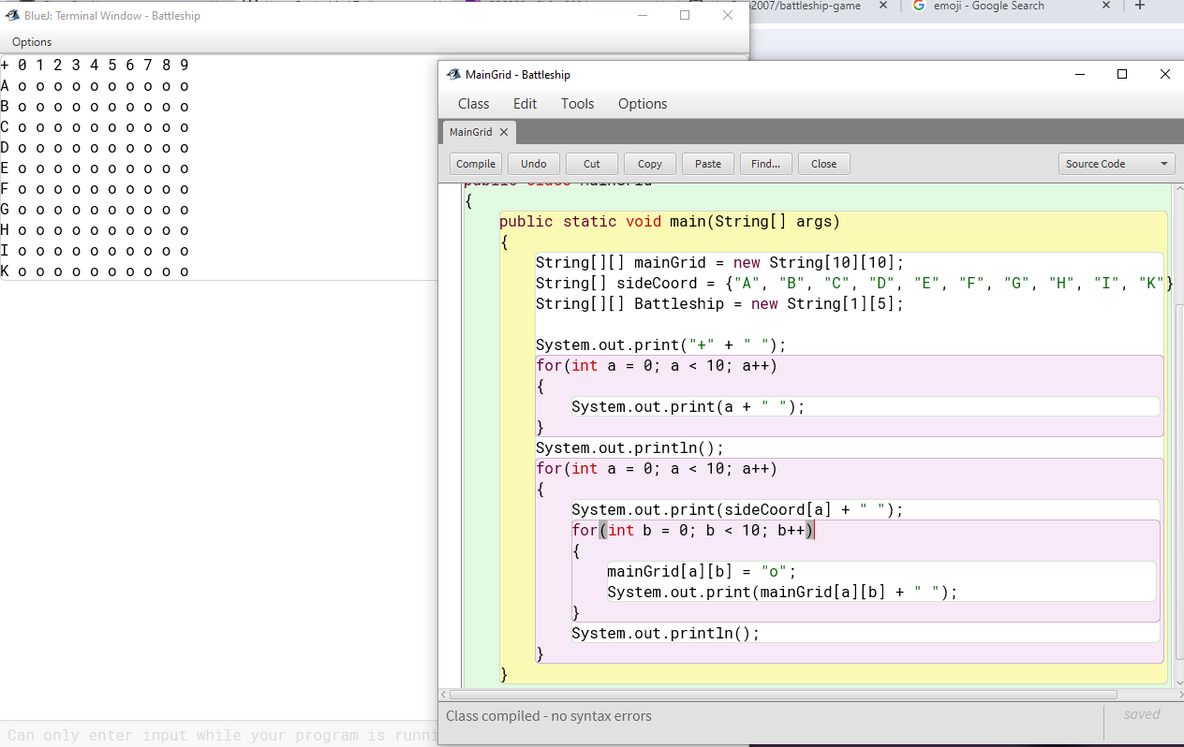

Feedbacks:

“Start the number on top row from one”

“I would remove the + because it looks quite annoying”

*Mr Fairhall*

Grid v1.0.1

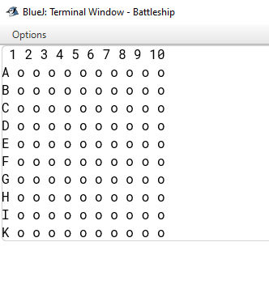

15/05/2024

Start to implement ships

Take the main grid and input each coordinate there for the ships

Using letter to display the ships

B: Battleship – C: Carrier – C: Cruiser – S: Submarine – D: Destroyer

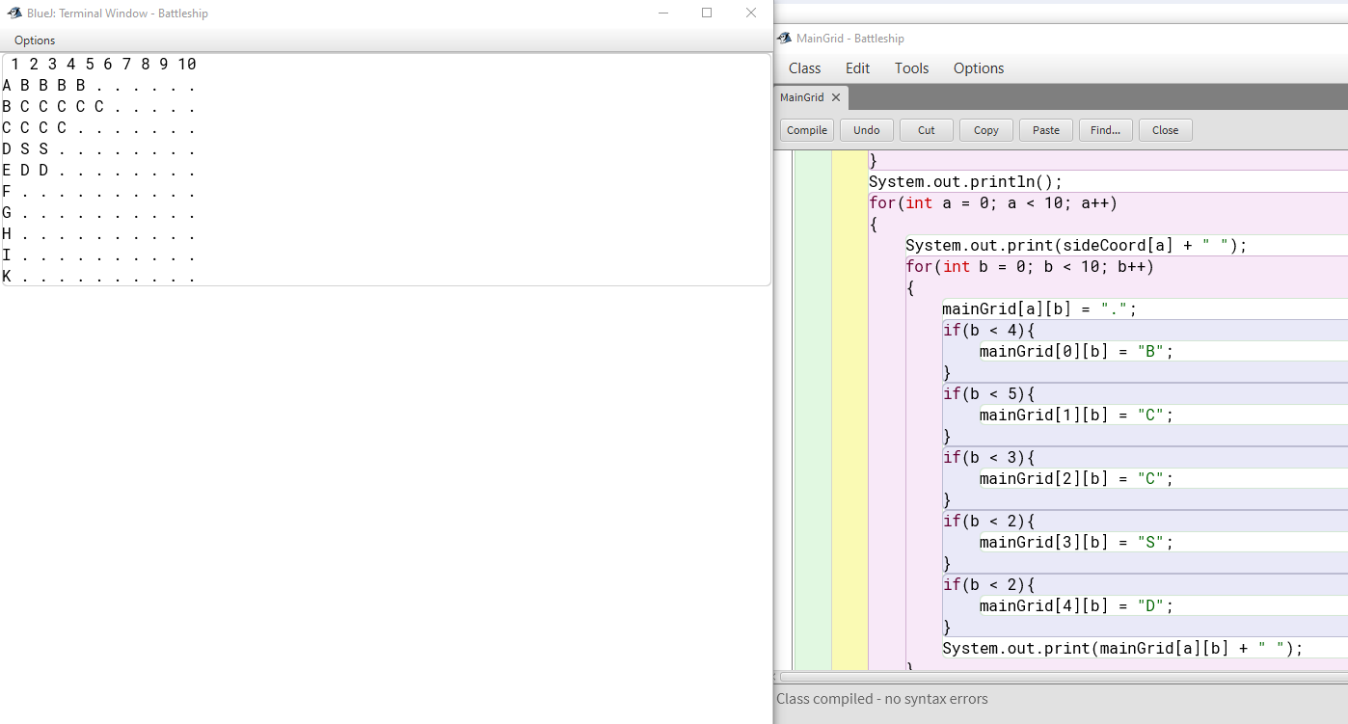

Replace the star squares into period squares for better viewing of the ships.

18/5/2024

Planning to implement moving ship mechanic

Create a copy of the old file specifically for testing moving ship mechanic. Keeping only 1 ship in for ease of configuring,

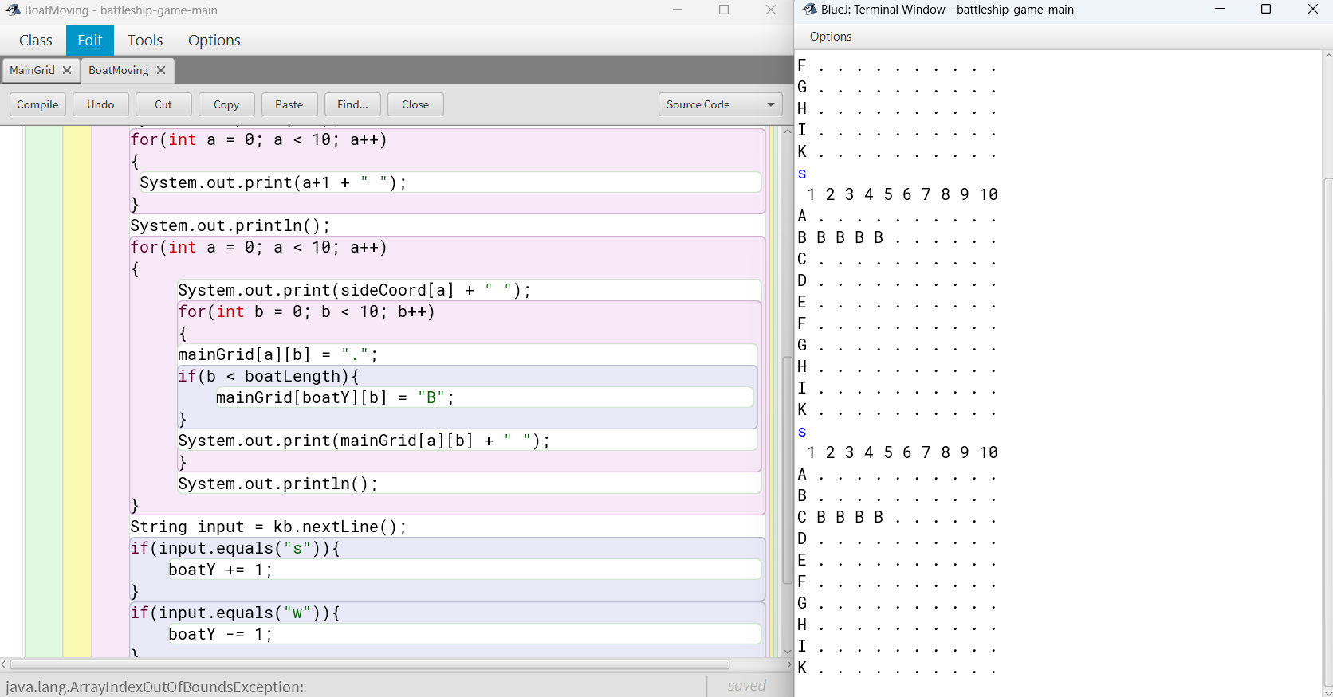Ship moving demo

The ship can move up and down. There’s still error when the ship got out of bound. Planning to fix that after implementing rotation and working in conjunction with other ships.

19/05/2024

After some configuration with the if statement that manage the coordinate of the ship, the ship can move up down and sideways.

Ship can disappear when go sideway to edge of grid. Error still appear and crash the software when ship move out of grid up or down.



20/05/2024

Creating a new copy file in order to implement rotation.

Optimized the old moving code to make use of ‘methods’.

User input is now placed in main while MainGrid() is created to contain the code that deals with moving the ship. The parameter of MainGrid() is then used to input variables from input form main.

21/05/2024

Rotation partially implemented. The ship can rotate with the key “r” and “t”. I am finding a way to use only one key to rotate.

Planning to split user input into another method to expect with another ship in the future.