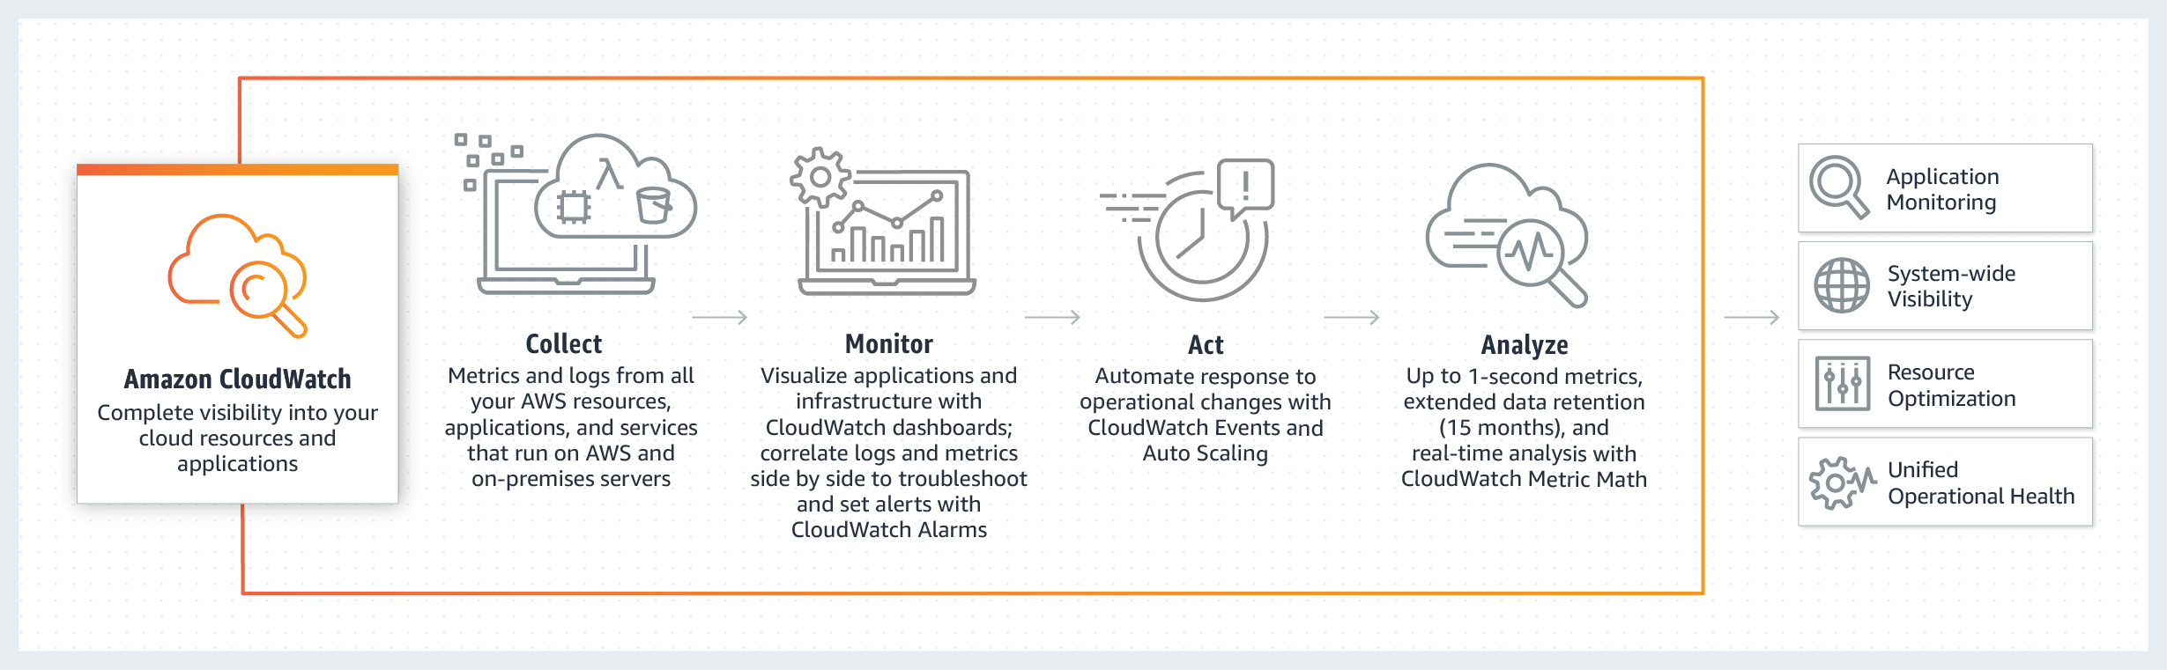
AWS Personal Health Dashboard
AWS Personal Health Dashboard provides alerts and remediation guidance when AWS is experiencing events that may impact you. While the Service Health Dashboard displays the general status of AWS services, Personal Health Dashboard gives you a personalized view into the performance and availability of the AWS services underlying your AWS resources.
The dashboard displays relevant and timely information to help you manage events in progress, and provides proactive notification to help you plan for scheduled activities. With Personal Health Dashboard, alerts are triggered by changes in the health of AWS resources, giving you event visibility, and guidance to help quickly diagnose and resolve issues.

AWS Cloud​Formation
AWS CloudFormation gives you an easy way to model a collection of related AWS and third-party resources, provision them quickly and consistently, and manage them throughout their lifecycles, by treating infrastructure as code. A CloudFormation template describes your desired resources and their dependencies so you can launch and configure them together as a stack. You can use a template to create, update, and delete an entire stack as a single unit, as often as you need to, instead of managing resources individually. You can manage and provision stacks across multiple AWS accounts and AWS Regions.
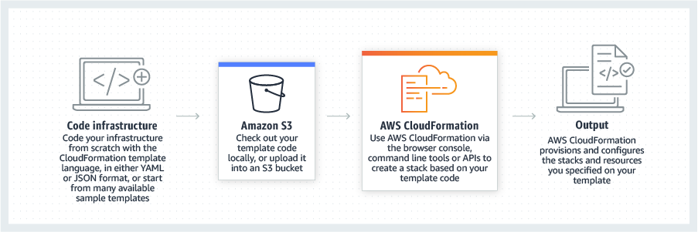
Amazon Simple Notification Service
Fully managed pub/sub messaging, SMS, email, and mobile push notifications
Amazon Simple Notification Service (Amazon SNS) is a fully managed messaging service for both application-to-application (A2A) and application-to-person (A2P) communication.

The A2A pub/sub functionality provides topics for high-throughput, push-based, many-to-many messaging between distributed systems, microservices, and event-driven serverless applications. Using Amazon SNS topics, your publisher systems can fanout messages to a large number of subscriber systems including Amazon SQS queues, AWS Lambda functions and HTTPS endpoints, for parallel processing. The A2P functionality enables you to send messages to users at scale via SMS, mobile push, and email.
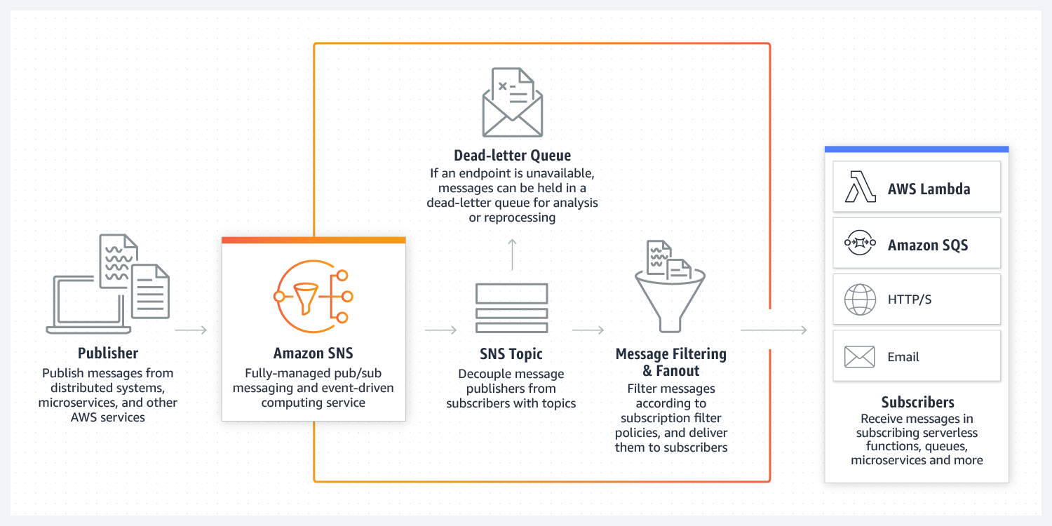
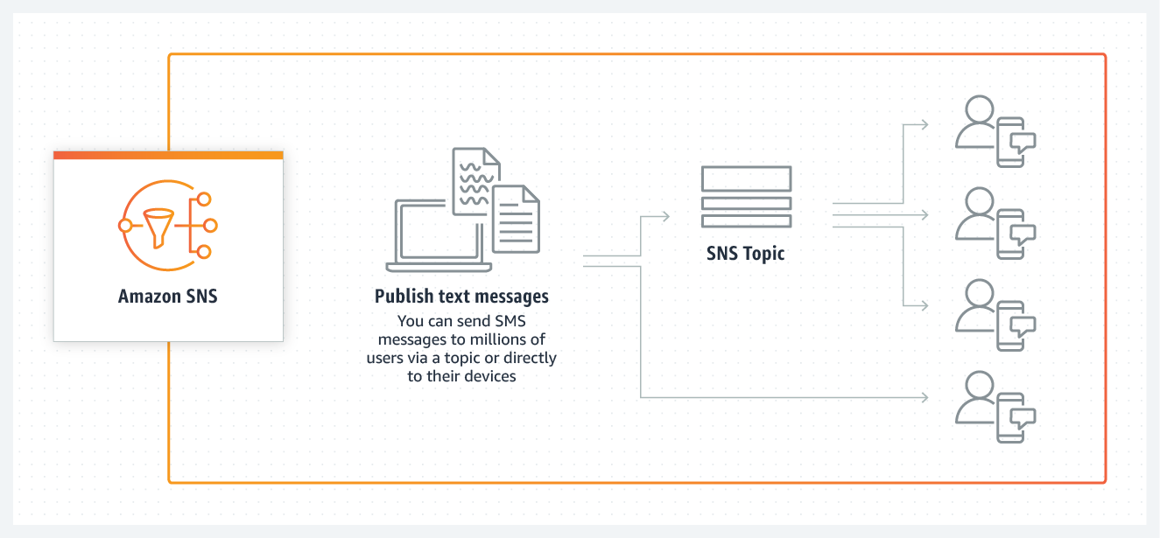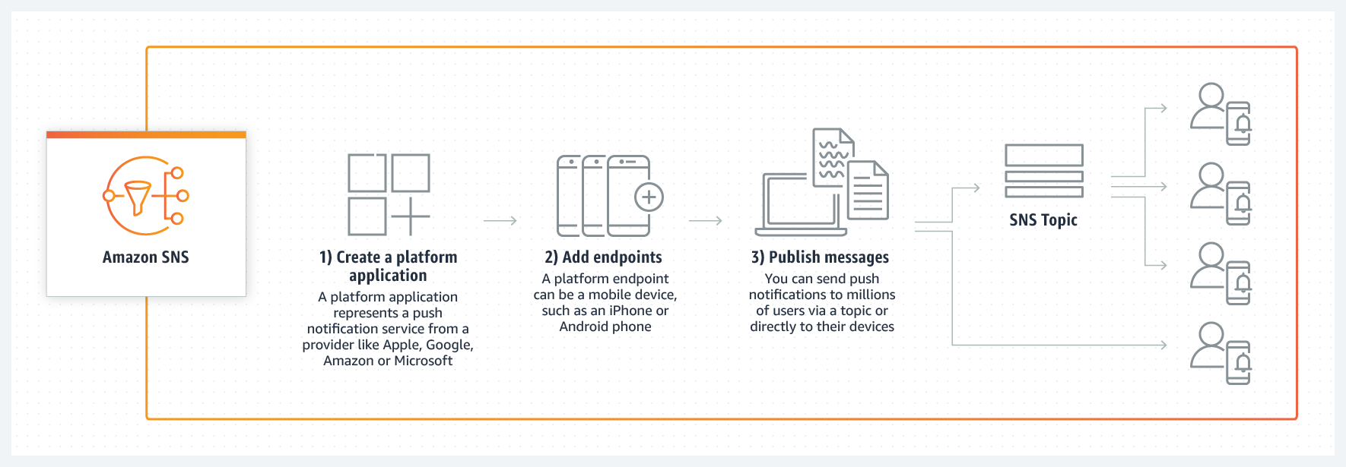
AWS CloudTrail
Track user activity and API usage
AWS CloudTrail is a service that enables governance, compliance, operational auditing, and risk auditing of your AWS account. With CloudTrail, you can log, continuously monitor, and retain account activity related to actions across your AWS infrastructure. CloudTrail provides event history of your AWS account activity, including actions taken through the AWS Management Console, AWS SDKs, command line tools, and other AWS services. This event history simplifies security analysis, resource change tracking, and troubleshooting. In addition, you can use CloudTrail to detect unusual activity in your AWS accounts. These capabilities help simplify operational analysis and troubleshooting.
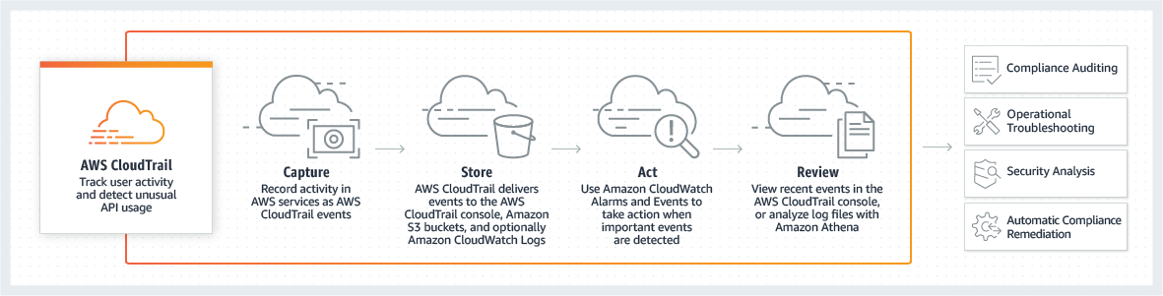
AWS Config
Record and evaluate configurations of your AWS resources
AWS Config is a service that enables you to assess, audit, and evaluate the configurations of your AWS resources. Config continuously monitors and records your AWS resource configurations and allows you to automate the evaluation of recorded configurations against desired configurations. With Config, you can review changes in configurations and relationships between AWS resources, dive into detailed resource configuration histories, and determine your overall compliance against the configurations specified in your internal guidelines. This enables you to simplify compliance auditing, security analysis, change management, and operational troubleshooting.
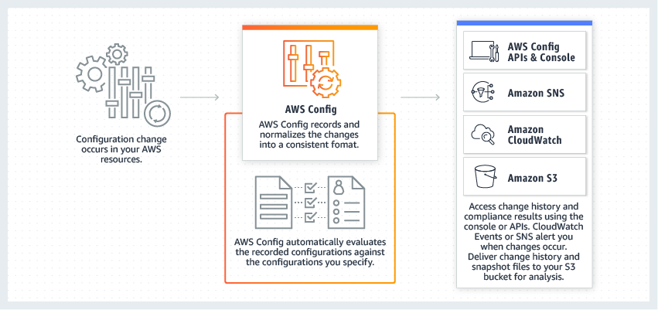
Amazon Virtual Private Cloud
Provision a logically isolated section of the AWS cloud where you can launch AWS resources in a virtual network that you define
Amazon Virtual Private Cloud (Amazon VPC) lets you provision a logically isolated section of the AWS Cloud where you can launch AWS resources in a virtual network that you define. You have complete control over your virtual networking environment, including selection of your own IP address range, creation of subnets, and configuration of route tables and network gateways. You can use both IPv4 and IPv6 in your VPC for secure and easy access to resources and applications.
You can easily customize the network configuration of your Amazon VPC. For example, you can create a public-facing subnet for your web servers that have access to the internet. You can also place your backend systems, such as databases or application servers, in a private-facing subnet with no internet access. You can use multiple layers of security, including security groups and network access control lists, to help control access to Amazon EC2 instances in each subnet.

AWS Direct Connect
AWS Direct Connect is a cloud service solution that makes it easy to establish a dedicated network connection from your premises to AWS. Using AWS Direct Connect, you can establish private connectivity between AWS and your datacenter, office, or colocation environment, which in many cases can reduce your network costs, increase bandwidth throughput, and provide a more consistent network experience than Internet-based connections.
AWS Direct Connect lets you establish a dedicated network connection between your network and one of the AWS Direct Connect locations. Using industry standard 802.1q VLANs, this dedicated connection can be partitioned into multiple virtual interfaces. This allows you to use the same connection to access public resources such as objects stored in Amazon S3 using public IP address space, and private resources such as Amazon EC2 instances running within an Amazon Virtual Private Cloud (VPC) using private IP space, while maintaining network separation between the public and private environments. Virtual interfaces can be reconfigured at any time to meet your changing needs.

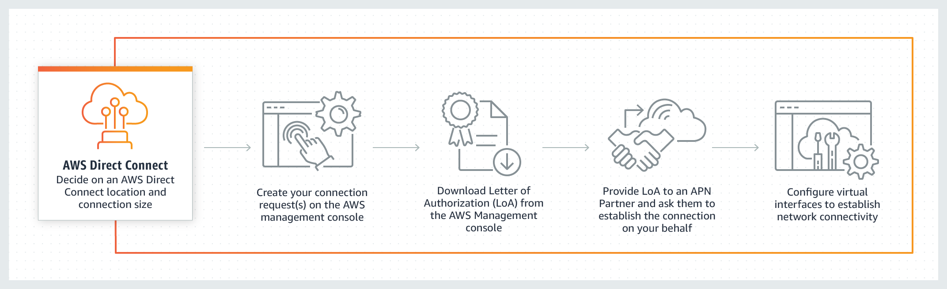
Amazon Route 53
A reliable and cost-effective way to route end users to Internet applications
Amazon Route 53 is a highly available and scalable cloud Domain Name System (DNS) web service. It is designed to give developers and businesses an extremely reliable and cost effective way to route end users to Internet applications by translating names like www.example.com into the numeric IP addresses like 192.0.2.1 that computers use to connect to each other. Amazon Route 53 is fully compliant with IPv6 as well.
Amazon Route 53 effectively connects user requests to infrastructure running in AWS – such as Amazon EC2 instances, Elastic Load Balancing load balancers, or Amazon S3 buckets – and can also be used to route users to infrastructure outside of AWS. You can use Amazon Route 53 to configure DNS health checks to route traffic to healthy endpoints or to independently monitor the health of your application and its endpoints. Amazon Route 53 Traffic Flow makes it easy for you to manage traffic globally through a variety of routing types, including Latency Based Routing, Geo DNS, Geoproximity, and Weighted Round Robin—all of which can be combined with DNS Failover in order to enable a variety of low-latency, fault-tolerant architectures. Using Amazon Route 53 Traffic Flow’s simple visual editor, you can easily manage how your end-users are routed to your application’s endpoints—whether in a single AWS region or distributed around the globe. Amazon Route 53 also offers Domain Name Registration – you can purchase and manage domain names such as example.com and Amazon Route 53 will automatically configure DNS settings for your domains.

Amazon CloudWatch
Observability of your AWS resources and applications on AWS and on-premises
Amazon CloudWatch is a monitoring and observability service built for DevOps engineers, developers, site reliability engineers (SREs), and IT managers. CloudWatch provides you with data and actionable insights to monitor your applications, respond to system-wide performance changes, optimize resource utilization, and get a unified view of operational health. CloudWatch collects monitoring and operational data in the form of logs, metrics, and events, providing you with a unified view of AWS resources, applications, and services that run on AWS and on-premises servers. You can use CloudWatch to detect anomalous behavior in your environments, set alarms, visualize logs and metrics side by side, take automated actions, troubleshoot issues, and discover insights to keep your applications
running smoothly.
AWS Data Pipeline
Easily automate the movement and transformation of data.
AWS Data Pipeline is a web service that helps you reliably process and move data between different AWS compute and storage services, as well as on-premises data sources, at specified intervals. With AWS Data Pipeline, you can regularly access your data where it’s stored, transform and process it at scale, and efficiently transfer the results to AWS services such as Amazon S3, Amazon RDS, Amazon DynamoDB, and Amazon EMR.
AWS Data Pipeline helps you easily create complex data processing workloads that are fault tolerant, repeatable, and highly available. You don’t have to worry about ensuring resource availability, managing inter-task dependencies, retrying transient failures or timeouts in individual tasks, or creating a failure notification system. AWS Data Pipeline also allows you to move and process data that was previously locked up in on-premises data silos.

Amazon Macie
Discover and protect your sensitive data at scale
Amazon Macie is a fully managed data security and data privacy service that uses machine learning and pattern matching to discover and protect your sensitive data in AWS.
As organizations manage growing volumes of data, identifying and protecting their sensitive data at scale can become increasingly complex, expensive, and time-consuming. Amazon Macie automates the discovery of sensitive data at scale and lowers the cost of protecting your data. Macie automatically provides an inventory of Amazon S3 buckets including a list of unencrypted buckets, publicly accessible buckets, and buckets shared with AWS accounts outside those you have defined in AWS Organizations. Then, Macie applies machine learning and pattern matching techniques to the buckets you select to identify and alert you to sensitive data, such as personally identifiable information (PII). Macie’s alerts, or findings, can be searched and filtered in the AWS Management Console and sent to Amazon EventBridge, formerly called Amazon CloudWatch Events, for easy integration with existing workflow or event management systems, or to be used in combination with AWS services, such as AWS Step Functions to take automated remediation actions. This can help you meet regulations, such as the Health Insurance Portability and Accountability Act (HIPAA) and General Data Privacy Regulation (GDPR). You can get started with Amazon Macie by leveraging the 30-day free trial for bucket evaluation. The trial includes 30-days of Amazon S3 bucket inventory and bucket-level security and access control assessment at no cost. Note that sensitive data discovery is not included in the 30-day free trial for bucket evaluation.
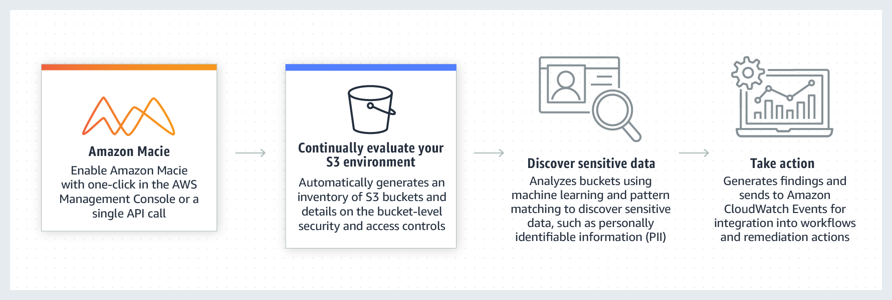
Amazon Inspector
Automated security assessment service to help improve the security and compliance of applications deployed on AWS
Amazon Inspector is an automated security assessment service that helps improve the security and compliance of applications deployed on AWS. Amazon Inspector automatically assesses applications for exposure, vulnerabilities, and deviations from best practices. After performing an assessment, Amazon Inspector produces a detailed list of security findings prioritized by level of severity. These findings can be reviewed directly or as part of detailed assessment reports which are available via the Amazon Inspector console or API.
Amazon Inspector security assessments help you check for unintended network accessibility of your Amazon EC2 instances and for vulnerabilities on those EC2 instances. Amazon Inspector assessments are offered to you as pre-defined rules packages mapped to common security best practices and vulnerability definitions. Examples of built-in rules include checking for access to your EC2 instances from the internet, remote root login being enabled, or vulnerable software versions installed. These rules are regularly updated by AWS security researchers.

AWS Elastic Beanstalk
Easy to begin, Impossible to outgrow
AWS Elastic Beanstalk is an easy-to-use service for deploying and scaling web applications and services developed with Java, .NET, PHP, Node.js, Python, Ruby, Go, and Docker on familiar servers such as Apache, Nginx, Passenger, and IIS.
You can simply upload your code and Elastic Beanstalk automatically handles the deployment, from capacity provisioning, load balancing, auto-scaling to application health monitoring. At the same time, you retain full control over the AWS resources powering your application and can access the underlying resources at any time.
There is no additional charge for Elastic Beanstalk - you pay only for the AWS resources needed to store and run your applications.
Amazon Relational Database Service (RDS)
Set up, operate, and scale a relational database in the cloud with just a few clicks.
Amazon Relational Database Service (Amazon RDS) makes it easy to set up, operate, and scale a relational database in the cloud. It provides cost-efficient and resizable capacity while automating time-consuming administration tasks such as hardware provisioning, database setup, patching and backups. It frees you to focus on your applications so you can give them the fast performance, high availability, security and compatibility they need.
Amazon RDS is available on several database instance types - optimized for memory, performance or I/O - and provides you with six familiar database engines to choose from, including Amazon Aurora, PostgreSQL, MySQL, MariaDB, Oracle Database, and SQL Server. You can use the AWS Database Migration Service to easily migrate or replicate your existing databases to Amazon RDS.

AWS Lambda
Run code without thinking about servers. Pay only for the compute time you consume.
AWS Lambda lets you run code without provisioning or managing servers. You pay only for the compute time you consume.
With Lambda, you can run code for virtually any type of application or backend service - all with zero administration. Just upload your code and Lambda takes care of everything required to run and scale your code with high availability. You can set up your code to automatically trigger from other AWS services or call it directly from any web or mobile app.

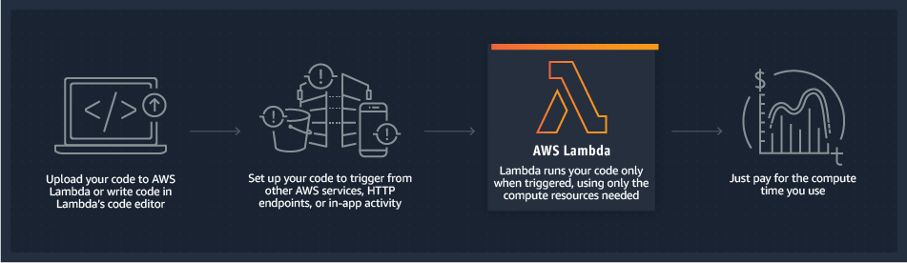
Amazon CloudFront
Fast, highly secure and programmable content delivery network (CDN)
Amazon CloudFront is a fast content delivery network (CDN) service that securely delivers data, videos, applications, and APIs to customers globally with low latency, high transfer speeds, all within a developer-friendly environment. CloudFront is integrated with AWS – both physical locations that are directly connected to the AWS global infrastructure, as well as other AWS services. CloudFront works seamlessly with services including AWS Shield for DDoS mitigation, Amazon S3, Elastic Load Balancing or Amazon EC2 as origins for your applications, and Lambda@Edge to run custom code closer to customers’ users and to customize the user experience. Lastly, if you use AWS origins such as Amazon S3, Amazon EC2 or Elastic Load Balancing, you don’t pay for any data transferred between these services and CloudFront.
You can get started with the Content Delivery Network in minutes, using the same AWS tools that you're already familiar with: APIs, AWS Management Console, AWS CloudFormation, CLIs, and SDKs. Amazon's CDN offers a simple, pay-as-you-go pricing model with no upfront fees or required long-term contracts, and support for the CDN is included in your existing AWS Support subscription.
AWS Auto Scaling
Application scaling to optimize performance and costs
AWS Auto Scaling monitors your applications and automatically adjusts capacity to maintain steady, predictable performance at the lowest possible cost. Using AWS Auto Scaling, it’s easy to setup application scaling for multiple resources across multiple services in minutes. The service provides a simple, powerful user interface that lets you build scaling plans for resources including Amazon EC2 instances and Spot Fleets, Amazon ECS tasks, Amazon DynamoDB tables and indexes, and Amazon Aurora Replicas. AWS Auto Scaling makes scaling simple with recommendations that allow you to optimize performance, costs, or balance between them. If you’re already using Amazon EC2 Auto Scaling to dynamically scale your Amazon EC2 instances, you can now combine it with AWS Auto Scaling to scale additional resources for other AWS services. With AWS Auto Scaling, your applications always have the right resources at the right time.
It’s easy to get started with AWS Auto Scaling using the AWS Management Console, Command Line Interface (CLI), or SDK. AWS Auto Scaling is available at no additional charge. You pay only for the AWS resources needed to run your applications and Amazon CloudWatch monitoring fees.
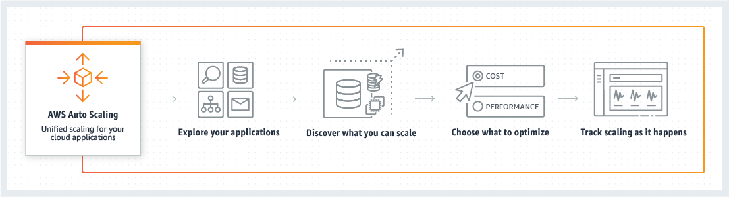
AWS Step Functions
Assemble functions into business-critical applications
AWS Step Functions is a serverless function orchestrator that makes it easy to sequence AWS Lambda functions and multiple AWS services into business-critical applications. Through its visual interface, you can create and run a series of checkpointed and event-driven workflows that maintain the application state. The output of one step acts as an input to the next. Each step in your application executes in order, as defined by your business logic.
Orchestrating a series of individual serverless applications, managing retries, and debugging failures can be challenging. As your distributed applications become more complex, the complexity of managing them also grows. Step Functions automatically manages error handling, retry logic, and state. With its built-in operational controls, Step Functions manages sequencing, error handling, retry logic, and state, removing a significant operational burden from your team.
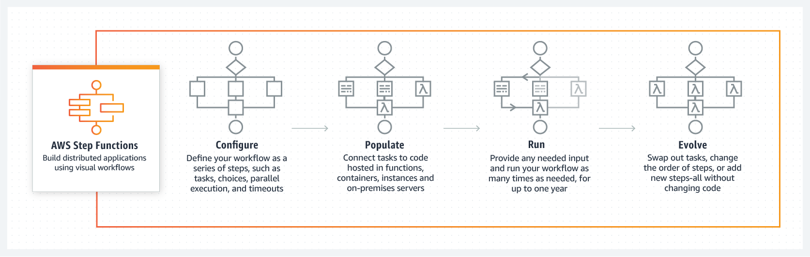
Amazon EC2
Secure and resizable compute capacity to support virtually any workload
Amazon Elastic Compute Cloud (Amazon EC2) is a web service that provides secure, resizable compute capacity in the cloud. It is designed to make web-scale cloud computing easier for developers. Amazon EC2’s simple web service interface allows you to obtain and configure capacity with minimal friction. It provides you with complete control of your computing resources and lets you run on Amazon’s proven computing environment.
Amazon EC2 offers the broadest and deepest compute platform with choice of processor, storage, networking, operating system, and purchase model. We offer the fastest processors in the cloud and we are the only cloud with 400 Gbps ethernet networking. We have the most powerful GPU instances for machine learning training and graphics workloads, as well as the lowest cost-per-inference instances in the cloud. More SAP, HPC, Machine Learning, and Windows workloads run on AWS than any other cloud. Click here to learn What's New with Amazon EC2.

AWS Fargate
Serverless compute for containers
AWS Fargate is a serverless compute engine for containers that works with both Amazon Elastic Container Service (ECS) and Amazon Elastic Kubernetes Service (EKS). Fargate makes it easy for you to focus on building your applications. Fargate removes the need to provision and manage servers, lets you specify and pay for resources per application, and improves security through application isolation by design.
Fargate allocates the right amount of compute, eliminating the need to choose instances and scale cluster capacity. You only pay for the resources required to run your containers, so there is no over-provisioning and paying for additional servers. Fargate runs each task or pod in its own kernel providing the tasks and pods their own isolated compute environment. This enables your application to have workload isolation and improved security by design. This is why customers such as Vanguard, Accenture, Foursquare, and Ancestry have chosen to run their mission critical applications on Fargate.
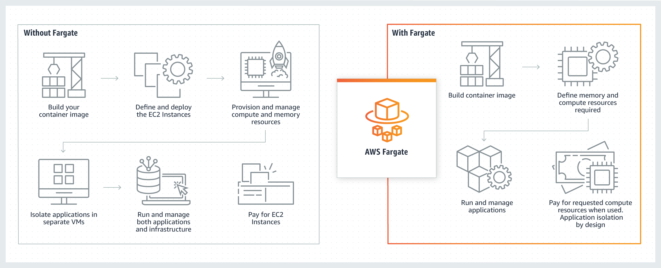
AWS Outposts
Run AWS infrastructure and services on premises for a truly consistent hybrid experience
AWS Outposts is a fully managed service that offers the same AWS infrastructure, AWS services, APIs, and tools to virtually any datacenter, co-location space, or on-premises facility for a truly consistent hybrid experience. AWS Outposts is ideal for workloads that require low latency access to on-premises systems, local data processing, data residency, and migration of applications with local system interdependencies.
AWS compute, storage, database, and other services run locally on Outposts, and you can access the full range of AWS services available in the Region to build, manage, and scale your on-premises applications using familiar AWS services and tools.
Coming soon, a VMware variant of AWS Outposts will be available. VMware Cloud on AWS Outposts delivers a fully managed VMware Software-Defined Data Center (SDDC) running on AWS Outposts infrastructure on premises.
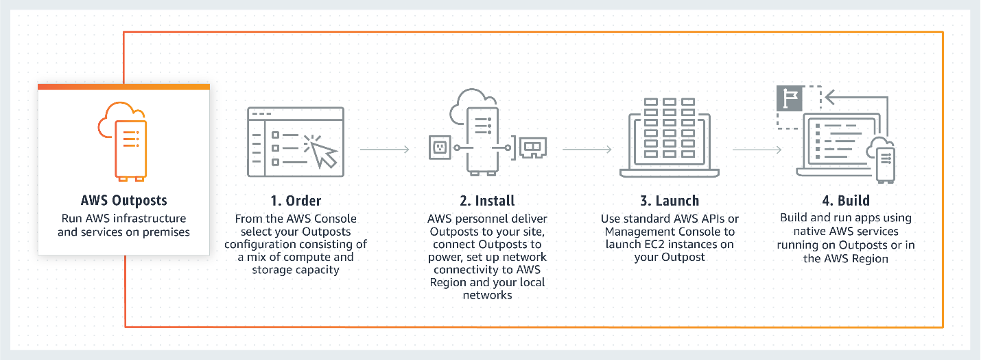

Amazon Aurora
MySQL and PostgreSQL-compatible relational database built for the cloud. Performance and availability of commercial-grade databases at 1/10th the cost.
Amazon Aurora is a MySQL and PostgreSQL-compatible relational database built for the cloud, that combines the performance and availability of traditional enterprise databases with the simplicity and cost-effectiveness of open source databases.
Amazon Aurora is up to five times faster than standard MySQL databases and three times faster than standard PostgreSQL databases. It provides the security, availability, and reliability of commercial databases at 1/10th the cost. Amazon Aurora is fully managed by Amazon Relational Database Service (RDS), which automates time-consuming administration tasks like hardware provisioning, database setup, patching, and backups.
Amazon Aurora features a distributed, fault-tolerant, self-healing storage system that auto-scales up to 128TB per database instance. It delivers high performance and availability with up to 15 low-latency read replicas, point-in-time recovery, continuous backup to Amazon S3, and replication across three Availability Zones (AZs).
Visit the Amazon RDS Management Console to create your first Aurora database instance and start migrating your MySQL and PostgreSQL databases.
AWS Pricing Calculator
Estimate the cost for your architecture solution.
Configure a cost estimate that fits your unique business or personal needs with AWS products and services.
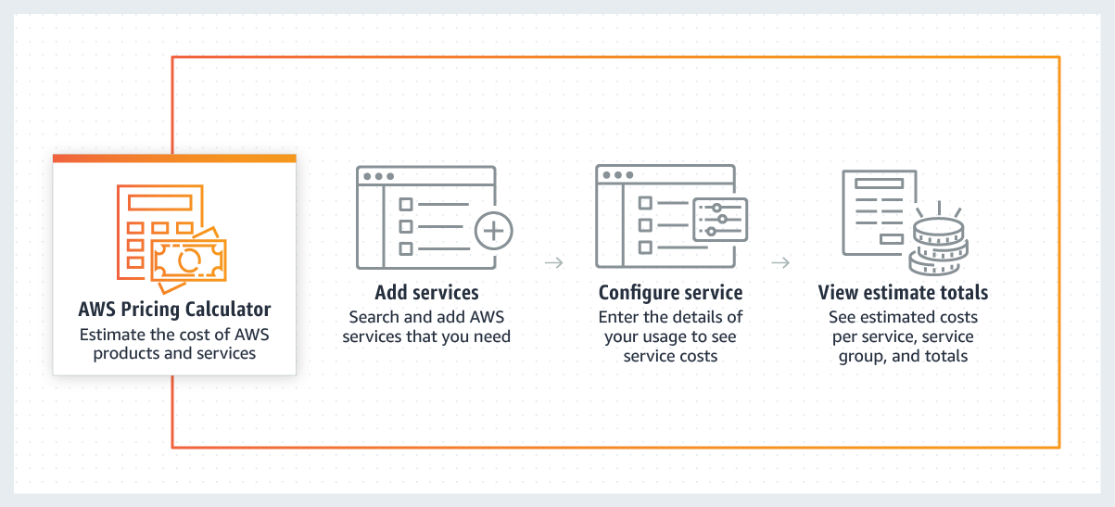
AWS Organizations
Centrally manage and govern your environment as you scale your AWS resources
AWS Organizations helps you centrally manage and govern your environment as you grow and scale your AWS resources. Using AWS Organizations, you can programmatically create new AWS accounts and allocate resources, group accounts to organize your workflows, apply policies to accounts or groups for governance, and simplify billing by using a single payment method for all of your accounts.
In addition, AWS Organizations is integrated with other AWS services so you can define central configurations, security mechanisms, audit requirements, and resource sharing across accounts in your organization. AWS Organizations is available to all AWS customers at no additional charge.
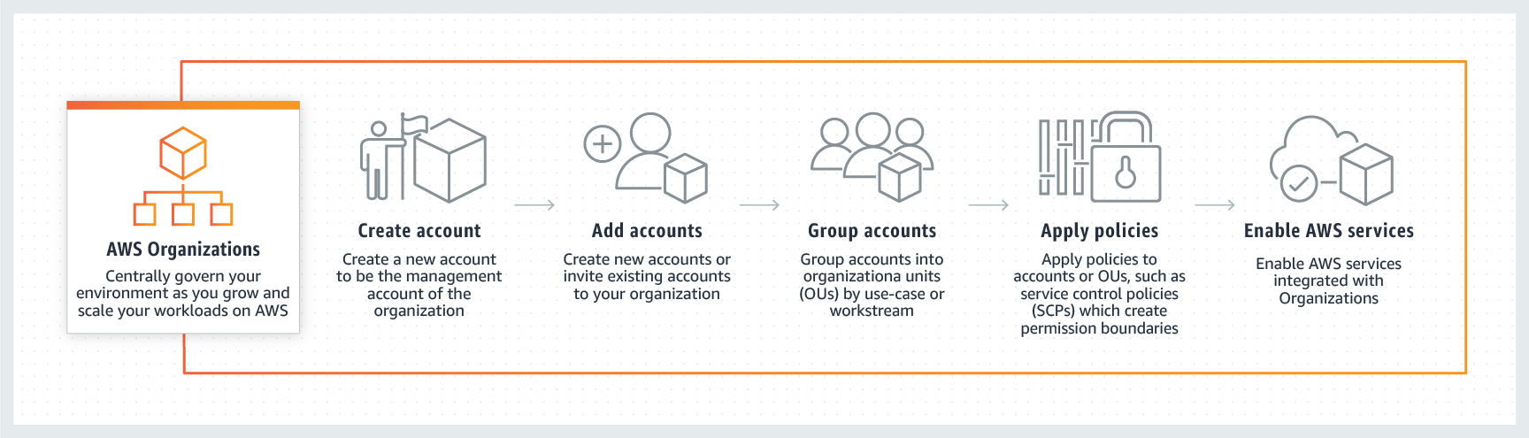
AWS Trusted Advisor
Reduce costs, increase performance, and improve security
AWS Trusted Advisor is an online tool that provides you real time guidance to help you provision your resources following AWS best practices. Trusted Advisor checks help optimize your AWS infrastructure, increase security and performance, reduce your overall costs, and monitor service limits. Whether establishing new workflows, developing applications, or as part of ongoing improvement, take advantage of the recommendations provided by Trusted Advisor on a regular basis to help keep your solutions provisioned optimally.
AWS Basic Support and AWS Developer Support customers get access to 6 security checks (S3 Bucket Permissions, Security Groups - Specific Ports Unrestricted, IAM Use, MFA on Root Account, EBS Public Snapshots, RDS Public Snapshots) and 50 service limit checks. AWS Business Support and AWS Enterprise Support customers get access to all 115 Trusted Advisor checks (14 cost optimization, 17 security, 24 fault tolerance, 10 performance, and 50 service limits) and recommendations. For a complete list of checks and descriptions, explore Trusted Advisor Best Practices.

AWS Well-Architected
Learn, measure, and build using architectural best practices
AWS Well-Architected helps cloud architects build secure, high-performing, resilient, and efficient infrastructure for their applications and workloads. Based on five pillars — operational excellence, security, reliability, performance efficiency, and cost optimization — AWS Well-Architected provides a consistent approach for customers and partners to evaluate architectures, and implement designs that can scale over time.
The AWS Well-Architected Framework started as a single whitepaper but has expanded to include domain-specific lenses, hands-on labs, and the AWS Well-Architected Tool. The AWS WA Tool, available at no cost in the AWS Management Console, provides a mechanism for regularly evaluating your workloads, identifying high risk issues, and recording your improvements.
AWS has an ecosystem of hundreds of members of the Well-Architected Partner Program. Engage a partner in your area to help you analyze and review your applications.

